INDOOR AIR QUALITY ASSESSMENT

Massachusetts Department of Public Health
Central Regional Health Office
180 Beaman Street
West Boylston, Massachusetts

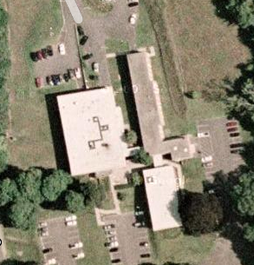

Prepared by:
Massachusetts Department of Public Health
Bureau of Environmental Health
Indoor Air Quality Program
August 2010

Background/Introduction
At the request of William O’Connell, Regional Director of the Massachusetts Department of Public Health’s Office of Health Communities’ Central Regional Health Office (CRHO), the Massachusetts Department of Public Health (MDPH), Bureau of Environmental Health (BEH) conducted an indoor air quality (IAQ) assessment at the CRHO located at 180 Beaman Street, West Boylston, Massachusetts. The request was prompted by concerns of respiratory irritation and mold growth due to chronic water infiltration. On January 8, 2010, Lisa Hébert and James Tobin, Environmental Analysts/Regional Inspectors for BEH’s IAQ Program made a visit to the CRHO to conduct a preliminary assessment. On February 19, 2010, Michael Feeney, Director of BEH’s IAQ Program and Ms. Hébert completed the assessment.
The CRHO is a two-story brick building that forms one wing of a three-wing complex. The wing that houses the CRHO (east wing) was originally built as John Augustus Hall, which housed the Worcester County Training School for Boys. The complex was subsequently converted to a state Division of Youth Services residential facility and more recently converted to state office space. The CRHO has occupied the east wing since 1991. The CRHO currently occupies the entire first floor and seven offices on the second floor. Additional offices on the second floor as well as the remaining two wings in the complex are currently occupied by the Massachusetts Department of Conservation and Recreation and are not the subject of this assessment. Windows are openable throughout the building.

Methods
Air tests for carbon monoxide, carbon dioxide, temperature and relative humidity were conducted with the TSI, Q-Trak, IAQ Monitor, Model 7565. Floor temperatures were taken with a Ryobi® IR001 infrared thermometer. Air tests for airborne particle matter with a diameter less than 2.5 micrometers were taken with the TSI, DUSTTRAK™ Aerosol Monitor Model 8520. BEH staff also performed visual inspection of building materials for water damage and/or microbial growth.

Results
The CRHO has an employee population of 26 and is visited by five to ten individuals daily. Tests were taken during normal operations and results appear in Tables 1 and 2.

Discussion

Ventilation
It can be seen from Table 1 that carbon dioxide levels were below 800 parts per million (ppm) in 17 of 25 areas surveyed indicating adequate air exchange in the majority of areas evaluated. However, it is important to note that the only means for creating airflow in the building is via the use of openable windows. Rooms are warmed using radiant heating coils that exist within the floor deck. The majority of rooms on the first floor are cooled in summer months by an air handling unit (AHU), which circulates conditioned air by means of ducted ceiling-mounted air diffusers and return vents (Picture 1). Many of the air diffusers have been blocked reportedly by occupants, which may be an indication of a lack of thermal comfort (Picture 2). The air filter used for the AHU does not fit properly, an oversized filter has been cut to fit within the unit. The remaining offices are cooled by means of window-mounted air conditioners.
No outside air is introduced into the air handling system. The building is configured in a manner to use cross-ventilation to provide comfort for building occupants. It is equipped with windows on opposing exterior walls. Passive wall vents are located on the interior walls of many offices on the first and second floors (Picture 3). These passive wall vents enable room occupants to close the hallway door while maintaining a pathway for airflow. This design allows airflow to enter an open window, pass through a room and subsequently pass through the wall vent into the hallway. Airflow then enters the hallway, passing through the opposing room’s passive wall vent and into the room, finally exiting the building on the leeward side (opposite the windward side). With all windows and passive wall vents open, airflow can be maintained in the building regardless of the direction of the wind.
The system fails if the windows are closed or if passive vents are obstructed. Rooms that are not opposite other rooms would have increased difficulty in creating cross-ventilation and some means to increase air movement is warranted (e.g., fan in an open window). Wall vents were obstructed in many locations (Picture 4). In order to create airflow, hallway doors need to be open. With a lack of fresh air supply and/or exhaust ventilation, any interior pollutants will remain inside the building and be continuously re-circulated. This type of situation can lead to air quality/comfort complaints.
The Massachusetts Building Code requires that each room have a minimum ventilation rate of 20 cubic feet per minute (cfm) per occupant of fresh outside air or openable windows (SBBRS, 1997; BOCA, 1993). The ventilation must be on at all times that the room is occupied. Providing adequate fresh air ventilation with open windows and maintaining the temperature in the comfort range during the cold weather season is impractical. Mechanical ventilation is usually required to provide adequate fresh air ventilation.
Carbon dioxide is not a problem in and of itself. It is used as an indicator of the adequacy of the fresh air ventilation. As carbon dioxide levels rise, it indicates that the ventilating system is malfunctioning or the design occupancy of the room is being exceeded. When this happens, a buildup of common indoor air pollutants can occur, leading to discomfort or health complaints. The Occupational Safety and Health Administration (OSHA) standard for carbon dioxide is 5,000 parts per million parts of air (ppm). Workers may be exposed to this level for 40 hours/week, based on a time-weighted average (OSHA, 1997).
The MDPH uses a guideline of 800 ppm for publicly occupied buildings. A guideline of 600 ppm or less is preferred in schools due to the fact that the majority of occupants are young and considered to be a more sensitive population in the evaluation of environmental health status. Inadequate ventilation and/or elevated temperatures are major causes of complaints such as respiratory, eye, nose and throat irritation, lethargy and headaches. For more information concerning carbon dioxide, consult Appendix A.
Indoor temperature measurements ranged from 68º F to 79º F on January 8, 2010, which were slightly above and below the MDPH recommended comfort range in several areas surveyed (Table 1). Indoor temperature measurements ranged from 73 º F to 80 º F on February 19, 2010, which were above the MDPH recommended comfort range in 21 of 29 areas surveyed (Table 2). The MDPH recommends that indoor air temperatures be maintained in a range of 70º F to 78º F in order to provide for the comfort of building occupants. In many cases concerning indoor air quality, fluctuations of temperature in occupied spaces are typically experienced, even in a building with an adequate fresh air supply.
As previously mentioned, the CRHO is heated by means of radiant heat. Radiant heat is created by circulating hot water through piping or tubing embedded within the floor deck. The occupied space subsequently warms from the floor upward. Floor temperature measurements ranged from 68 º F to 98 º F (Table 2).
The relative humidity measured in the building ranged from 11 to 21 percent and 13 to 20 respectively on the days of the IAQ assessment, which were below the MDPH recommended comfort range in all areas surveyed during both days of the assessment (Tables 1 and 2). The MDPH recommends a comfort range of 40 to 60 percent for indoor air relative humidity. Relative humidity levels in the building would be expected to drop during the winter months due to heating. For buildings in New England, periods of low relative humidity during the winter are often unavoidable.

Microbial/Moisture Concerns
The assessment was prompted by concerns of water infiltration from chronic roof leaks. One leak was impacting the Rural Health Office (Room 202) (Picture 5). As a result, rain water has repeatedly entered the building and spilled onto the carpeted floor. Water damage was visible on the ceiling, vent pipe and carpeting (Pictures 5 and 6). BEH staff were informed that several repairs had been made to address the leak, including replacing a sizable section (~120 square feet) of the roof only months earlier.
At the time of the preliminary assessment, CRHO staff indicated that the problem had been resolved. However, since that time, it has become apparent to staff that the leak has recurred. Efforts to pursue funding for replacement of the entire roof are reportedly underway. A roof leak is also apparent over the hallway that connects the CRHO with the building to its west. Water-damaged ceiling tiles, peeling paint and efflorescence were observed in this hall (Picture 7). Efflorescence is a characteristic sign of water intrusion, but it is not mold growth. As penetrating moisture works its way through mortar around brick, it leaves behind characteristic white, powdery mineral deposits.
The US Environmental Protection Agency (US EPA) and the American Conference of Governmental Industrial Hygienists (ACGIH) recommend that porous materials be dried with fans and heating within 24 to 48 hours of becoming wet (US EPA, 2001; ACGIH, 1989). If not dried within this time frame, mold growth may occur. Once mold has colonized porous materials, they are difficult to clean and should be removed and discarded.
BEH staff examined the exterior of the building to identify breaches in the building envelope and/or other issues that could provide a source of water penetration. Several potential sources were identified:
- Cracked masonry and missing mortar were observed (Picture 8);
- Efflorescence was observed on exterior brick;
- Window sealant and expansion joint sealant were deteriorated;
- Sealant on rear door casing was in disrepair;
- Peeling paint was identified on windows;
- Moss was observed on the ground adjacent to the building. Moss is a sign of chronic dampness and can hold moisture against brick to accelerate decomposition of the curtain wall;
- The area surrounding some ACs has been retrofitted with plexiglass. In some cases, the sealant has deteriorated, (both interior and exterior) (Picture 9);
- Plywood surrounding some ACs was saturated with water. ACs were not covered for the winter; and
- At the juncture of masonry and expansion joints, roof components do not meet in the same plane and adjacent sealant is in disrepair (Picture 10).
The aforementioned conditions represent potential water penetration sources. Over time, these conditions can undermine the integrity of the building envelope and provide a means of water entry into the building via capillary action through foundation concrete and masonry (Lstiburek & Brennan, 2001). In addition, these breaches may provide a means for pests/rodents to enter the building.

Other IAQ Evaluations
Indoor air quality can be negatively influenced by the presence of respiratory irritants, such as products of combustion. The process of combustion produces a number of pollutants. Common combustion emissions include carbon monoxide, carbon dioxide, water vapor, and smoke (fine airborne particle material). Of these materials, exposure to carbon monoxide and particulate matter with a diameter of 2.5 micrometers (μm) or less (PM2.5) can produce immediate, acute health effects upon exposure. To determine whether combustion products were present in the indoor environment, BEH staff obtained measurements for carbon monoxide and PM2.5.

Carbon Monoxide
Carbon monoxide is a by-product of incomplete combustion of organic matter (e.g., gasoline, wood and tobacco). Exposure to carbon monoxide can produce immediate and acute health effects. Several air quality standards have been established to address carbon monoxide and prevent symptoms from exposure to these substances. The MDPH established a corrective action level concerning carbon monoxide in ice skating rinks that use fossil-fueled ice resurfacing equipment. If an operator of an indoor ice rink measures a carbon monoxide level over 30 ppm, taken 20 minutes after resurfacing within a rink, that operator must take actions to reduce carbon monoxide levels (MDPH, 1997).
The American Society of Heating Refrigeration and Air-Conditioning Engineers (ASHRAE) has adopted the National Ambient Air Quality Standards (NAAQS) as one set of criteria for assessing indoor air quality and monitoring of fresh air introduced by HVAC systems (ASHRAE, 1989). The NAAQS are standards established by the US EPA to protect the public health from six criteria pollutants, including carbon monoxide and particulate matter (US EPA, 2006). As recommended by ASHRAE, pollutant levels of fresh air introduced to a building should not exceed the NAAQS levels (ASHRAE, 1989). The NAAQS were adopted by reference in the Building Officials & Code Administrators (BOCA) National Mechanical Code of 1993 (BOCA, 1993), which is now an HVAC standard included in the Massachusetts State Building Code (SBBRS, 1997). According to the NAAQS, carbon monoxide levels in outdoor air should not exceed 9 ppm in an eight-hour average (US EPA, 2006).
Carbon monoxide should not be present in a typical, indoor environment. If it is present, indoor carbon monoxide levels should be less than or equal to outdoor levels. Outdoor carbon monoxide levels measured on January 8, 2010, were non-detect (ND) (Table 1). No measureable levels of carbon monoxide were detected in the building (Table 1).

Particulate Matter
The US EPA has established NAAQS limits for exposure to particulate matter. Particulate matter is airborne solids that can be irritating to the eyes, nose and throat. The NAAQS originally established exposure limits to particulate matter with a diameter of 10 μm or less (PM10). According to the NAAQS, PM10 levels should not exceed 150 microgram per cubic meter (μg/m³) in a 24-hour average (US EPA, 2006). These standards were adopted by both ASHRAE and BOCA. Since the issuance of the ASHRAE standard and BOCA Code, US EPA established a more protective standard for fine airborne particles. This more stringent PM2.5 standard requires outdoor air particle levels be maintained below 35 μg/m³ over a 24-hour average (US EPA, 2006). Although both the ASHRAE standard and BOCA Code adopted the PM10 standard for evaluating air quality, MDPH uses the more protective PM2.5 standard for evaluating airborne particulate matter concentrations in the indoor environment.
The outdoor PM2.5 concentration measured on January 8, 2010, was 2 μg/m³ (Table 1). PM2.5 levels measured indoors ranged from 1 to 10 μg/m³ (Table 1), which were below the NAAQS PM2.5 level of 35 μg/m³. Frequently, indoor air levels of particulates (including PM2.5) can be at higher levels than those measured outdoors. A number of mechanical devices and/or activities that occur in buildings can generate particulate during normal operations. Sources of indoor airborne particulates may include but are not limited to particles generated during the operation of fan belts in the HVAC system, cooking in the cafeteria stoves and microwave ovens; use of photocopiers, fax machines and computer printing devices; operation of an ordinary vacuum cleaner and heavy foot traffic indoors.

Other Conditions
Other conditions that can affect indoor air quality were observed during the assessment. Upon entering the building, an odor was observed similar in nature to urea/ammonia. A plausible explanation for this odor relates to carpeting installed on top of floors with radiant heating. The high temperatures observed on the floor (Table 2), heat the carpeting and backing as well as the adhesive and cause vapors to be released. These odors may cause respiratory irritation/symptoms in sensitive individuals.
Floor drains and a nonfunctioning water fountain were both observed to have dry traps (Picture 11). The purpose of a drain trap is to prevent drainage system gases and sulfur-like odors from entering the occupied space. When water is poured into a trap, an air-tight seal is created by the water in the U-bend section of the pipe. These drains must have water poured into the traps at least twice a week to maintain the integrity of the seal. Without water, the drain opens the room to the drainage system. If a mechanical device (e.g., a fan) depressurizes the room, air, gas and odors can be drawn from the drainage system into the room. The effect of this phenomenon can be increased if heavy rains cause an air backup in the drainage system. These gasses/odors can also potentially enter the CRHO via an improperly capped sewer line observed in the vaccine storage area (Picture 12).
Open utility holes were observed throughout the building (Picture 13). An open pipe was also observed in the foyer which terminated in one of the storage areas. Open utility holes can provide a means of egress for odors, fumes, dusts and vapors between rooms and floors.
Signs of bird roosting and nesting materials were observed beneath ACs on the exterior of the building (Pictures 9 and 14). Birds can be a source of disease, and bird wastes and feathers can contain mold and bacteria, which can be irritating to the respiratory system. No obvious signs of bird roosting inside the building or in ventilation components were noted by BEH staff or reported by occupants.
Heavy dust accumulation was noted on the filter to the AHU. As previously mentioned, a number of rooms also had window-mounted ACs, which are normally equipped with filters. HVAC filters should be cleaned or changed as per manufacturer’s instructions to avoid the build-up and re-aerosolization of dirt, dust and particulate matter. Gypsum wallboard (GW) in the first floor hallway is in disrepair (Picture 11). This condition may allow dust and debris to enter the occupied space.
Fluorescent light bulbs were stored in an area subject to damage (Picture 15). These bulbs contain and release mercury when broken; therefore, they must be stored, utilized and disposed of with care. The Massachusetts Department of Environmental Protection’s guidance document may be found at: http://www.mass.gov/dep/toxics/stypes/cflclnup.htm .
Papers, files and cardboard were observed on flat surfaces in some offices. Stored items provide a source for dusts to accumulate. Items should be relocated and/or be cleaned periodically to avoid excessive dust build up, which can cause respiratory irritation. In addition, a small space heater was noted on the floor in close proximity to documents. This condition constitutes a fire hazard (Picture 16).

Conclusions/Recommendations
The conditions noted at the building raise a number of indoor air quality issues. The general building conditions, maintenance, work hygiene practices, and the lack of mechanical ventilation, if considered individually, present conditions that could degrade indoor air quality. When combined, these conditions can serve to further degrade indoor air quality. Some of these conditions can be remedied by actions of building occupants. Other remediation efforts will require alteration to the building structure and equipment. For these reasons, a two-phase approach is recommended for remediation. The first consists of short-term measures to improve air quality and the second consists of long-term measures that will require planning and resources to adequately address overall indoor air quality concerns.

Short-Term Recommendations
- Open windows (weather permitting) to temper rooms and provide fresh outside air during non-air conditioning weather. Care should be taken to ensure windows are properly closed at night and weekends to avoid the freezing of pipes and potential flooding.
- Remove obstructions from passive wall vents and/or open office doors in order to facilitate airflow within the building.
- Supplement fresh air by operating window-mounted air conditioners in the “fan only” “fresh air” mode, which introduces outside air by mechanical means.
- Change filters for air-handling equipment (AHUs, ACs) as per the manufacturer’s instructions or more frequently if needed. Provide properly fitting filters to avoid filter bypass.
- Continue to monitor areas of the building for roof leaks, make repairs and change water-damaged ceiling tiles as necessary. Disinfect areas of water leaks with an appropriate antimicrobial.
- Remove water-damaged carpeting from room 202 and consider replacing with a floor covering that is impervious to water (i.e. floor tiles).
- Remove space heater from room 205.
- Repair cracked masonry and missing/damaged mortar.
- Repair deteriorated window, door casing and expansion joint sealant in accordance with EPA regulations.
- Repair or replace deteriorated sealant on plexiglass windows.
- For buildings in New England, periods of low relative humidity during the winter are often unavoidable. Therefore, scrupulous cleaning practices should be adopted to minimize common indoor air contaminants whose irritant effects can be enhanced when the relative humidity is low. To control dusts, a high efficiency particulate arrestance (HEPA) filter equipped vacuum cleaner in conjunction with wet wiping of all surfaces is recommended. Avoid the use of feather dusters. Drinking water during the day can help ease some symptoms associated with a dry environment (throat and sinus irritations).
- Seal exterior portion of air conditioners in order to prevent unconditioned air and moisture from entering the building envelope.
- Contact local building commissioner to evaluate the structure of the roof at expansion joint on the west side of the building. Make repairs as needed.
- Pour water into drains twice a week (or as needed) to maintain an airtight seal. Properly cap open drain lines.
- Seal spaces around utility holes and breaches in walls/floors and ceilings with an appropriate fire-rated sealant.
- Remove bird roosting and nesting materials from beneath air conditioners. Clean and disinfect surfaces with an appropriate antimicrobial.
- Relocate or consider reducing the amount of materials stored in offices to allow for more thorough cleaning. Clean items regularly with a wet cloth or sponge to prevent excessive dust build-up.
- Clean accumulated dust and debris periodically from the surface of air diffusers, exhaust vents and blades of personal and ceiling fans.
- Refer to resource manual and other related indoor air quality documents located on the MDPH’s website for further building-wide evaluations and advice on maintaining public buildings. These documents are available at: http://mass.gov/dph/iaq.

Long-term Recommendations
- Consider replacing roof.
- Consider installing HVAC system to introduce fresh air into the building and exhaust stale air out of the building.
- Consider removal of carpets in offices with radiant heat. Prior to removal, determine whether the floor tiles beneath contain asbestos, and if so, their condition. If necessary, asbestos floor tiles must be remediated in compliance with applicable state and federal regulations.

References
ACGIH. 1989. Guidelines for the Assessment of Bioaerosols in the Indoor Environment. American Conference of Governmental Industrial Hygienists, Cincinnati, OH.
ASHRAE. 1989. Ventilation for Acceptable Indoor Air Quality. American Society of Heating, Refrigeration and Air Conditioning Engineers. ANSI/ASHRAE 62-1989.
BOCA. 1993. The BOCA National Mechanical Code/1993. 8th ed. Building Officials and Code Administrators International, Inc., Country Club Hill, IL.
Lstiburek, J. & Brennan, T. 2001. Read This Before You Design, Build or Renovate. Building Science Corporation, Westford, MA. U.S. Department of Housing and Urban Development, Region I, Boston, MA.
MDPH. 1997. Requirements to Maintain Air Quality in Indoor Skating Rinks (State Sanitary Code, Chapter XI). 105 CMR 675.000. Massachusetts Department of Public Health, Boston, MA.
OSHA. 1997. Limits for Air Contaminants. Occupational Safety and Health Administration. Code of Federal Regulations. 29 C.F.R 1910.1000 Table Z-1-A.
SBBRS. 1997. Mechanical Ventilation. State Board of Building Regulations and Standards. Code of Massachusetts Regulations. 780 CMR 1209.0.
US EPA. 2001. “Mold Remediation in Schools and Commercial Buildings”. Office of Air and Radiation, Indoor Environments Division, Washington, DC. EPA 402-K-01-001. March 2001. Available at: http://www.epa.gov/iaq/molds/mold_remediation.html
US EPA. 2006. National Ambient Air Quality Standards (NAAQS). US Environmental Protection Agency, Office of Air Quality Planning and Standards, Washington, DC. http://www.epa.gov/air/criteria.html.
Picture 1

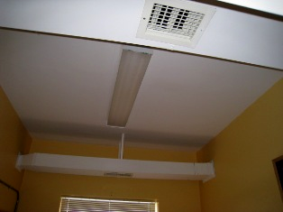

Air Supply Diffuser and Return

Picture 2

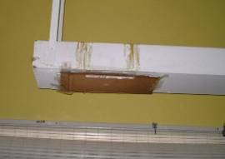

Obstructed Air Diffuser

Picture 3

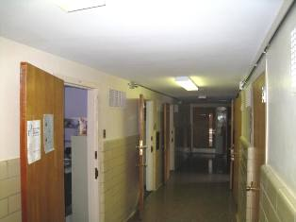

Passive Wall Vents in Hallway

Picture 4

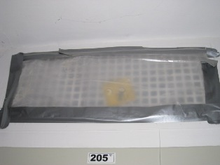

Passive Wall Vent Obstruction

Picture 5

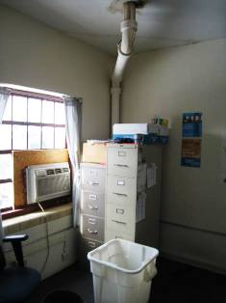

Water Damaged Ceiling, Note Bucket to Collect Water

Picture 6

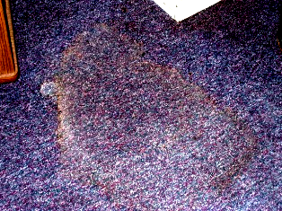

Water Damaged Carpet
Picture 7

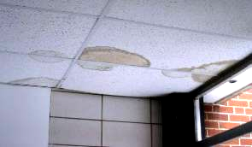

Water Damaged Ceiling Tiles

Picture 8

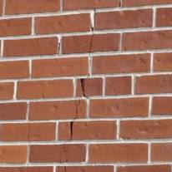

Cracked Masonry and Mortar

Picture 9

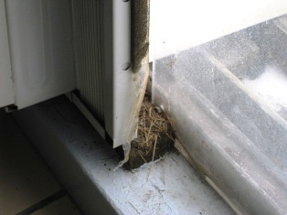

Deteriorated Sealant Adjacent to Plexiglass, Note Bird Nesting Materials

Picture 10

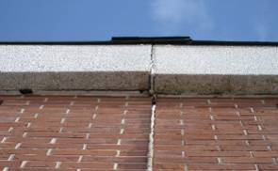

Junction of Expansion Joint and Roof

Picture 11

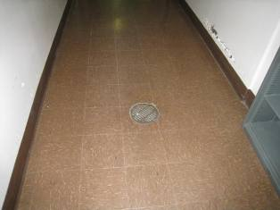

Floor Drain With Dry Trap
Note Broken Sheetrock on Adjacent Wall
Picture 12

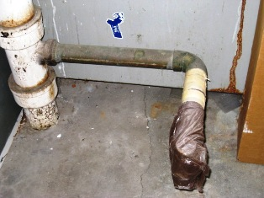

Improperly Sealed Plumbing into Drain Line

Picture 13

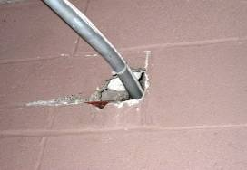

Open Utility Hole

Picture 14

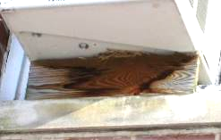

Bird Nesting Material Below Air Conditioner

Picture 15

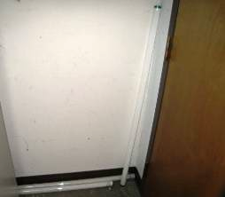

Fluorescent Light Bulb Storage

Picture 16

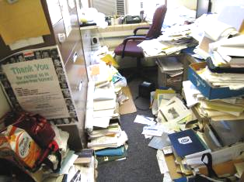

Paper Accumulation in Office
Note Electric Heater in Close Proximity
Location | Occupants  in Room | Carbon  Dioxide  (ppm) | Temp  (°F) | Relative  Humidity  (%) | Carbon Monoxide  (ppm) | PM2.5  (µg/m3) | Windows  Openable | Ventilation |  | Remarks
 |  |  |  |  |  |  |  | Supply | Exhaust | Remarks
Outside  (Background) | - | 383 | 32 | 49 | ND | 2 | - | - | - | Cloudy, overcast, light snow
Room 116 | 1 | 764 | 77 | 16 | ND | 1 | Y | N | N | DO
Lobby (in front of gym) | 0 | 513 | 68 | 17 | ND | 7 | N | N | N
Room 124 | 0 | 753 | 70 | 20 | ND | 10 | Y | Y | Y | DO, space heater
Room 123 | 1 | 1038 | 77 | 19 | ND | 5 | Y | Y | Y | DO
Room 121 | 1 | 821 | 77 | 18 | ND | 10 | Y | Y | Y
Room 120 | 0 | 758 | 72 | 20 | ND | 5 | Y  1/1 open | Y | Y | DO, PF, space heater, window does not close
Room 118 | 1 | 907 | 77 | 17 | ND | 5 | Y | Y | Y | DO, FC, paper
Room 117 | 0 | 860 | 78 | 15 | ND | 8 | Y | Y | Y | DO
Room 115 | 0 | 817 | 78 | 15 | ND | 6 | Y | Y | Y
Room 113 | 1 | 730 | 78 | 15 | ND | 6 | Y | Y | Y
Room 111 | 0 | 691 | 78 | 14 | ND | 8 | Y | Y | Y | DO
Room 109 | 0 | 603 | 78 | 14 | ND | 5 | Y | Y | Y | DO
Room 110 | 2 | 810 | 78 | 15 | ND | 6 | Y | N | Y | DO, AC, cooler on carpet
Room 107 | 1 | 820 | 78 | 17 | ND | 6 | Y | Y | Y | DO, personal heater, broken window
Room 108  Copy Room | 0 | 675 | 79 | 13 | ND | 6 | N | N | Y  off | DO
Room 105 | 1 | 690 | 78 | 14 | ND | 5 | Y | Y | Y | DO
Room 106 | 1 | 712 | 79 | 13 | ND | 5 | Y | N | N
Room 104 | 1 | 681 | 78 | 13 | ND | 7 | Y | N | N | DO, plants
Room 103 | 0 | 451 | 75 | 11 | ND | 7 | Y | N | Y  off | DO, AC
Room 102 | 1 | 558 | 77 | 14 | ND | 7 | Y | N | N | DO, personal heater, plants
Room 202 | 0 | 747 | 74 | 15 | ND | 7 | Y | N | N | DO, AC, WD ceiling, WD carpet
Room 204 | 1 | 710 | 69 | 21 | ND | 6 | N | N | N | DO, AC
Room 207 | 0 | 840 | 71 | 20 | ND | 5 | N | N | N | DO, AC
Room 203 | 0 | 754 | 72 | 18 | ND | 5 | Y | N | N | DO
Room 201 | 0 | 736 | 71 | 18 | ND | 6 | N | N | N | Breaches around window

Location | Temp  (°F) | Relative Humidity  (%) | Floor Temp  (°F) | Remarks
Room 124 | 79 | 15 | 91
Room 123 | 79 | 15 | 88 | Rippled carpet
Room 122 | 78 | 15 | 87
Room 121 | 79 | 15 | 89
Room 120 | 79 | 15 | 85 | Rippled carpet
Room 118 | 79 | 15 | 88 | Rippled carpet
Room 117 | 79 | 15 | 90
Room 115 | 79 | 14 | 86
Room 116 | 79 | 15 | 89
Room 114 | 79 | 15 | 98 | No carpet
Room 113 | 79 | 14 | 89
Room 111 | 79 | 15 | 91 | Rippled carpet
Room 109 | 79 | 14 | 90
Room 107 | 79 | 14 | 89 | Rippled carpet
Kitchen | 79 | 15 | 91
Room 105 | 79 | 14 | 84 | Plush carpet
Room 108  (copy room) | 80 | 14 | 91 | No carpet
Room 106 | 80 | 14 | 91
Room 104 | 79 | 14 | 83 | Rippled carpet
Room 103 | 80 | 13 | 83 | Refrigerators
Room 102 | 80 | 13 | 94 | No carpet
Lobby/foyer | 79 | 14 | 68
Room 202 | 74 | 14 | 81 | Window open, water-damaged carpet/ceiling
Room 204 | 73 | 15 | 84
Room 201 | 74 | 16 | 86
Room 203 | 74 | 16 | 88 | No carpet, window open
Room 206 | 74 | 17 | 79
Room 207 | 74 | 20 | 90
Room 205 | 75 | 20 | 86 | Paper accumulation; space heater on floor

