INDOOR AIR QUALITY ASSESSMENT

Department of Public Health
Southeastern Regional Health Office
1736 Purchase Street
New Bedford, MA 02740

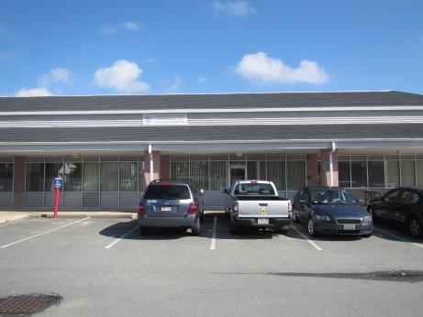

Prepared by:
Massachusetts Department of Public Health
Bureau of Environmental Health
Indoor Air Quality Program
March 2016

EXECUTIVE SUMMARY
On February 24, 2016 at approximately 1 pm, Southeastern Regional Health Office (SERHO) staff reportedly detected “fumes” reportedly coming from an adjacent vacant space within the building. SERHO staff reported that construction workers could be seen using small metal spray cans in the adjacent space, with no apparent ventilation or barriers in place. The Bureau of Environmental Health’s Indoor Air Quality (BEH/IAQ) Program conducted an indoor air quality (IAQ) assessment on February 25, 2016 and found all IAQ parameters to be within the normal guidelines; however a number of potential pathways were noted. These pathways should be sealed. Additionally, construction/renovation type work should be conducted during unoccupied hours, while using proper containment/depressurization methods.

BACKGROUND
Building: | Department of Public Health –Southeastern Regional Health Office (SERHO)
Address: | 1736 Purchase Street, New Bedford, MA
Assessment Requested by: | Ron O’Connor, Director, DPH SERHO
Reason for Request: | Concerns related to construction-generated pollutants from adjacent work space
Date of Assessment: | February 25, 2016
Massachusetts Department of Public Health/Bureau of Environmental Health (MDPH/BEH) Staff Conducting Assessment: | Jason Dustin, Environmental Analyst, Indoor Air Quality (IAQ) Program
Date Building Constructed: | 2005
Building Description: | The building is a small strip mall having steel and concrete block construction
Building Population: | Approximately 20 employees work at this office. Members of the public visit daily.

METHODS
Please refer to the IAQ Manual for methods, sampling procedures, and interpretation of results (MDPH, 2015).

RESULTS and DISCUSSION
The following is a summary of indoor air testing result (Table 1).
- Carbon dioxide levels were below the MDPH recommended level of 800 parts per million (ppm) in all of the areas surveyed, indicating adequate air exchange.
- Temperature was within the MDPH recommended range of 70°F to 78°F in all areas surveyed.
- Relative humidity was within or just below the MDPH recommended range of 40 to 60% in all areas tested.
- Carbon monoxide levels were non-detectable in all areas tested.
- Particulate matter (PM2.5) concentrations measured were below the National Ambient Air Quality (NAAQS) level of 35 μg/m³ in all areas tested.
- Total Volatile Organic Compounds (TVOCs) were non-detectable in all areas tested.

Ventilation
Fresh air is provided by rooftop air-handling units (AHUs) and ducted to supply air diffusers in cubicle areas and offices (Picture 1). Air is returned to the AHUs via ducted vents in the ceiling (Picture 2). SERHO staff reported thermal comfort concerns, particularly in areas adjacent to windows. Use of adjustable blinds and shades and/or the application of tinted window film should help to prevent heat complaints due to solar gain.
Other staff expressed temperature concerns due to variations of the heating, ventilating, and air-conditioning (HVAC) system settings. AHUs are regulated by thermostats, which staff reportedly adjust to improve comfort. Some occupants stated that the normal setting for the HVAC fan is “auto,” which provides intermittent air circulation rather than continuous circulation provided for the fan “on” setting. However, thermostats were corrected to the “on” setting (Picture 3), reportedly to provide additional ventilation after the detection of “fumes” from ongoing construction in the adjoining space. The BEH/IAQ Program recommends that thermostats be set to the fan “on” setting during occupied periods to provide continual air circulation and filtration.
Most offices and some meeting rooms had supply air vents but did not have exhaust air vents in these rooms. Common exhaust vents are located in main hallways of the SERHO space. During meetings in these rooms it is recommended to keep the door slightly open to allow the stale air to be drawn from the room and reduce the likelihood of IAQ complaints. Where privacy is crucial, the doors of these rooms should be undercut 1-2 inches to allow air to pressurize out form the room into the hallway. A passive vent installed in the door achieves the same goal.
The kitchen area did not appear to have a local exhaust vent. Kitchen exhaust vents are recommended to remove odors, heat, and smoke produced from the use of microwaves and toasters.

Microbial/Moisture Concerns
BEH/IAQ staff noted the presence of water staining under the sink in the break room (Picture 4). It was not clear whether the leak is from the plumbing or from containers of liquids under the sink. This area should be cleaned and monitored for future leaks. Any necessary repairs should be made promptly to avoid wetting porous building materials. Containers of compatible liquids should be stored together in a waterproof container.
SERHO staff reported the occasional presence of a musty odor in meeting room #132. According to staff reports, a previous water leak had occurred above the ceiling tile system in this room. The ceiling tiles have since been replaced. SERHO staff were uncertain if carpets were dried with fans following this event. BEH/IAQ staff did not detect any musty odor or visible signs of mold colonization in the carpeting at the time of the assessment. This area should be monitored. If any musty odors persist in the room, a more invasive inspection of the carpet should take place (i.e., lifting corner of carpet where leak occurred).
The US Environmental Protection Agency (US EPA) and the American Conference of Governmental Industrial Hygienists (ACGIH) recommends that porous materials be dried with fans and heating within 24 to 48 hours of becoming wet (US EPA, 2001; ACGIH, 1989). If porous materials are not dried within this time frame, mold growth may occur.

Other IAQ Evaluations
As previously indicated, the purpose of this site visit was to respond to odor concerns. On February 24, 2016 at approximately 1 pm, SERHO staff reportedly detected “fumes” coming from an adjacent vacant space in the building. SERHO staff reported that construction workers could be seen next door using small metal spray cans with no apparent ventilation or barriers in place. The reports described an “acetone” odor that reportedly caused eye and respiratory irritation in some occupants. The contractors reportedly opened the doors of the vacant space after receiving complaints of the odor from SERHO staff members. SERHO staff also reportedly set the HVAC fan setting to “on” to increase ventilation in the space.
As mentioned previously, no VOCs were detected by BEH/IAQ staff most likely due to the dissipation and dilution of the substance prior to this assessment. The walls of the vacant space did not appear to have been finished/painted (Picture 5) so it is likely that the product used was some type of solvent or primer. Workers were not present, so BEH/IAQ staff could not inquire about specific products used.
BEH/IAQ staff noted several potential pathways through which odors and dust would most likely travel.
- A hole, which appears to be recently punched through the shared wall, had an extension cord running from the vacant space and plugged into a SERHO office outlet. The hole was not well sealed, and light could be seen coming from the adjacent vacant space that was under construction (Picture 6).
- The GW shared wall extends up to the corrugated roof deck but it could not be determined if the spaces between the corrugated roof deck have been sealed on either side of the shared wall (Picture 7).
- Air could be felt coming from electrical outlets on the shared wall between the two units.
These pathways should be sealed to prevent pollutants from traveling to occupied spaces.
It is recommended that any type of construction work producing odors, VOCs, and dust be performed during unoccupied hours and that proper containment/depressurization methods be implemented in the future. Typically the construction side is depressurized with exhaust fans while the occupied side is pressurized using HVAC fans and adequate fresh air supply. Refer to the MDPH guideline “Methods Used to Reduce/Prevent Exposure to Construction/Renovation Generated Pollutants in Occupied Buildings” (MDPH, 2006) for additional best practices.
BEH/IAQ staff noted an electrical cord resting on top of a toaster. This cord appeared melted due to the heat from the toaster (Picture 8). Foul odors, smoke, and an electrical hazard could result from this situation. It is recommended that a new toaster be installed in a manner which does not impact the electrical supply cord.
Cleaning products, air freshening sprays, and scented products were also observed in a number of areas. Deodorizing agents do not remove materials causing odors, but rather mask odors that may be present in the area. Cleaners and scented products contain chemicals that can be irritating to the eyes, nose, and throat of sensitive individuals. Additionally, many air fresheners contain 1,4-dichlorobenzene, a VOC which may cause reductions in lung function (NIH, 2006).
In some areas, accumulation of items, including papers, boxes, and personal items were found stored on desks, tables, and counters. Large numbers of items provide a source for dusts to accumulate. These items make it difficult for custodial staff to clean. Items should be relocated and/or cleaned periodically to avoid excessive dust build up.
Dusty supply vents were observed in several areas (Picture 9). Dust can be irritating to the eyes, nose and respiratory tract. These items should be cleaned periodically in order to prevent them from serving as a source of aerosolized particulate matter. In addition, it should be verified that HVAC filters are changed semiannually (e.g., per heating/cooling season) utilizing MERV 9 pleated filters or higher to ensure removal of airborne dusts.
Plants were observed in some areas. Plants can be a source of pollen and mold, which can serve as respiratory irritants for some sensitive individuals. Plants should be properly maintained and equipped with drip pans to prevent water damage to porous building materials and be located away from ventilation sources to prevent the aerosolization of dirt, pollen, or mold.
The rear exit door for the SERHO office lacked a tight-fitting gasket around the door frame. Light could be seen around the door (Picture 10). Weather stripping or a tight-fitting door gasket should be installed to prevent moisture, odors, and pollutants from entering the space.

CONCLUSIONS/RECOMMENDATIONS
Based on conditions observed at the time of assessment, the following recommendations are provided.
- Perform construction work involving strong odors, VOCs, and dust during unoccupied hours.
- Seal pathways between the shared wall between the two space (hole in GW, gaps around electrical outlets, verify spaces in corrugated roof deck have been sealed).
- Consult with MDPH “Methods Used to Reduce/Prevent Exposure to Construction/Renovation Generated Pollutants in Occupied Buildings” (MDPH, 2006)” for proper containment and depressurization/pressurization techniques.
- Operate thermostats in the fan ‘on’ setting during occupied periods to allow for continuous fresh air circulation and filtration.
- Consider installing a new kitchen toaster in a manner that does not impact the electrical supply cord.
- Clean the area under the kitchen sink and monitor for future leaks. Any necessary repairs should be made promptly to avoid wetting porous building materials. Compatible liquids/cleaners should be kept in waterproof containers.
- Continue to monitor meeting room #132. If reported musty odor continues, a more invasive inspection of the carpeting should be performed (i.e., lifting the corner of carpeting where water leak occurred).
- To reduce the likelihood of IAQ complaints, offices and meeting rooms having only supply vents should have doors left partially open during meetings. Alternately, have doors undercut 1-2” or have a passive vent installed.
- Consider installing a local kitchen exhaust vent to eject odors and smoke produced from the use of microwaves and toasters.
- Limit temperature adjustments so that temperatures remain within the MDPH recommended temperature range of 70°F to 78°F. Adjust or change supply diffusers to avoid draft complaints.
- Use adjustable blinds and shades and/or the application of tinted window film to help prevent heat complaints due to solar gain.
- Consider limiting the use of hand sanitizer, dry erase boards, air fresheners/deodorizers and harsh/scented cleaning products, which can cause eye, nose, and throat irritations to sensitive individuals.
- Relocate or consider reducing the amount of stored materials to allow for more thorough cleaning. Clean items regularly with a wet cloth or sponge to prevent excessive dust build-up.
- Clean supply and return vents as well as personal fans periodically of accumulated dust.
- Verify that HVAC filters are changed semiannually (e.g., per heating/cooling season) utilizing MERV 9 or higher pleated filters.
- Weather stripping or a tight-fitting door gasket should be installed around the rear exit door frame to prevent moisture, odors, and pollutants from entering the space.
- Maintain plants and drip pans. Plants should be located away from ventilation sources to prevent aerosolization of dirt, pollen, or mold.
- For buildings in New England, periods of low relative humidity during the winter are often unavoidable. Therefore, scrupulous cleaning practices should be adopted to minimize common indoor air contaminants whose irritant effects can be enhanced when the relative humidity is low. To control for dusts, a high efficiency particulate arrestance (HEPA) filter equipped vacuum cleaner in conjunction with wet wiping of all surfaces is recommended. Avoid the use of feather dusters. Drinking water during the day can help ease some symptoms associated with a dry environment (throat and sinus irritations).
- Refer to resource manual and other related indoor air quality documents located on the MDPH’s website for further building-wide evaluations and advice on maintaining public buildings. These documents are available at http://mass.gov/dph/iaq.

REFERENCES
ACGIH, 1989. Guidelines for the Assessment of Bioaerosols in the Indoor Environment. American Conference of Governmental Industrial Hygienists, Cincinnati, OH.
MDPH. 2006. Massachusetts Department of Public Health. Methods Used to Reduce/Prevent Exposure to Construction/Renovation Generated Pollutants in Occupied Buildings. Boston, MA.
MDPH. 2015. Massachusetts Department of Public Health. “Indoor Air Quality Manual: Chapters I-III”. Available from http://www.mass.gov/eohhs/gov/departments/dph/programs/environmental-health/exposure-topics/iaq/iaq-manual/
NIH. 2006. Chemical in Many Air Fresheners May Reduce Lung Function. NIH News. National Institute of Health. July 27, 2006. http://www.nih.gov/news/pr/jul2006/niehs-27.htm
US EPA. 2001. “Mold Remediation in Schools and Commercial Buildings”. Office of Air and Radiation, Indoor Environments Division, Washington, DC. EPA 402-K-01-001. March 2001. Available at:
http://www.epa.gov/mold/mold-remediation-schools-and-commercial-buildings-guide

Picture 1
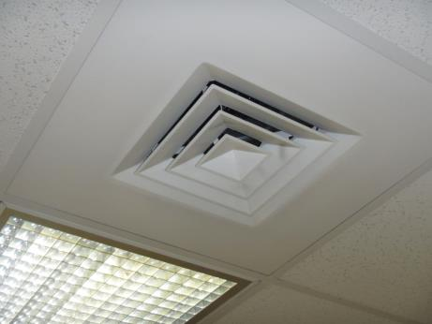
Supply air diffuser
Picture 2
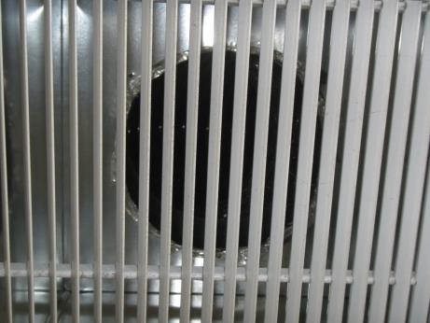
Ducted ceiling exhaust vent
Picture 3
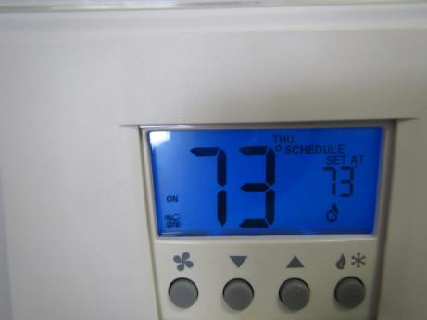
Thermostat showing correct fan setting of “on”
Picture 4
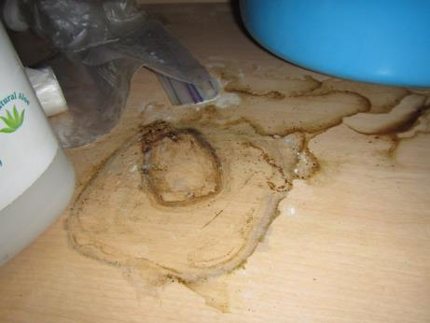
Water staining under kitchen sink
Picture 5
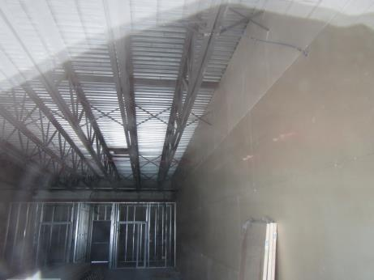
Vacant space adjacent to SERHO office (note unfinished GW)
Picture 6
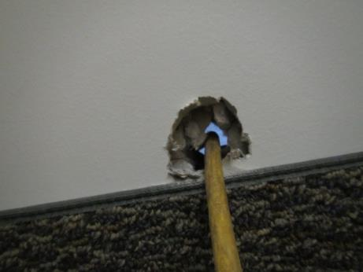
Hole in shared wall showing light from vacant space and power cord
Picture 7
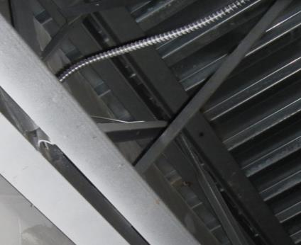
GW against corrugated roof decking does not appear to be sealed in spaces
Picture 8
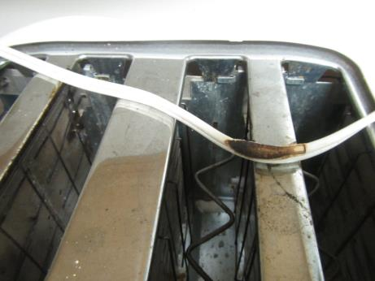
Melted electrical cord on top of toaster
Picture 9
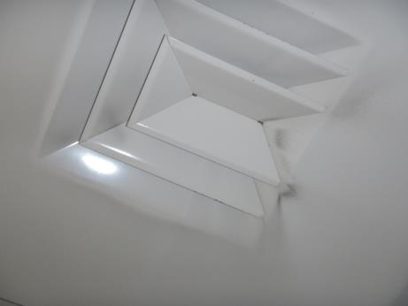
Dust accumulated on supply vent
Picture 10
Gaps around rear exit door; note light penetrating (arrow)
Location | Carbon  Dioxide  (ppm) | Carbon Monoxide  (ppm) | Temp  (°F) | Relative  Humidity  (%) | TVOCs  (ppm) | PM2.5  (µg/m³) | Occupants  in Room | Windows  Openable | Ventilation |  |  | Remarks
 |  |  |  |  |  |  |  |  | Intake | Exhaust
Background (outside) | 382 | 1.1 | 56 | 60 | ND | 14 | - | - | - |  | - | Cloudy, windy, vehicle traffic on Purchase St.
130-office | 546 | ND | 71 | 45 | ND | 4 | 0 | N | Y |  | N | Dusty supply vent
111 | 584 | ND | 72 | 45 | ND | 4 | 0 | N | Y |  | N
110 | 594 | ND | 72 | 45 | ND | 5 | 0 | N | Y |  | N | Printed brochures
109 | 565 | ND | 72 | 44 | ND | 5 | 0 | N | Y |  | N | AI
108 | 537 | ND | 72 | 44 | ND | 5 | 0 | N | Y |  | N | Cube vacant
107 | 579 | ND | 72 | 44 | ND | 4 | 0 | N | Y |  | N | Cube vacant, AI
129 | 550 | ND | 73 | 43 | ND | 5 | 0 | N | Y |  | N | AI, DEM
114 | 560 | ND | 73 | 42 | ND | 5 | 0 | N | Y |  | Y | Plants, exhaust vents along inner hall
116 | 554 | ND | 74 | 42 | ND | 6 | 2 | N | Y |  | Y
122 | 553 | ND | 74 | 41 | ND | 5 | 2 | N | Y |  | Y
124 | 535 | ND | 75 | 40 | ND | 6 | 2 | N | Y |  | Y | DEM, plant
135 kitchen | 510 | ND | 76 | 39 | ND | 5 | 0 | N | Y |  | N | CPs, leak under sink?,  Melted cord on toaster
New Bedford meeting room | 540 | ND | 76 | 39 | ND | 7 | 0 | N | Y |  | Y
126 | 531 | ND | 76 | 39 | ND | 5 | 0 | N | Y |  | Y
128 small meeting | 515 | ND | 76 | 39 | ND | 4 | 0 | N | Y |  | N
127 Brockton | 532 | ND | 76 | 38 | ND | 5 | 0 | N | Y |  | N | Slightly ajar tile
Reception | 587 | ND | 76 | 40 | ND | 5 | 1 | N | Y |  | N | Disinfecting wipes
132 meeting | 579 | ND | 75 | 39 | ND | 5 | 0 | N | Y |  | N | Former water damage concerns, no exhaust
106 | 551 | ND | 75 | 39 | ND | 5 | 0 | N | Y |  | N

