WATER DAMAGE INVESTIGATION

Massachusetts Department of Public Utilities
1 South Station
Boston, Massachusetts

Prepared by:
Massachusetts Department of Public Health
Bureau of Environmental Health
Indoor Air Quality Program
July 2015

Background/Introduction
At the request of Ms. Dianne Handrahan, Chief Financial Officer, Massachusetts Department of Public Utilities (DPU), an indoor environmental investigation was conducted at the DPU office located at 1 South Station, Boston, Massachusetts. The Massachusetts Department of Public Health (MDPH), Bureau of Environmental Health (BEH) conducted the investigation in response to concerns related to visible mold growth and asthma. On July 7, 2015, a site visit was made by Jason Dustin, Environmental Analyst/Inspector in BEH’s Indoor Air Quality (IAQ) Program. Mr. Dustin was accompanied by Ms. Handrahan and Ms. Theresa Kelly, Human Resources Director, DPU.

Methods
BEH/IAQ staff performed a visual inspection of building materials for water damage and/or microbial growth. Moisture content of porous building materials (i.e., gypsum wallboard, wood and carpeting) was measured using a Delmhorst, BD-2000 Model Moisture Detector. Air tests for temperature and relative humidity were taken with the TSI, Q-Trak, IAQ Monitor 7565. Testing results are included as Table 1.

Results and Discussion
Water Damage
Visible mold growth was observed on a wall adjacent to the fourth floor lunch room (Pictures 1 to 3). Moisture measurements for this area showed that the gypsum wallboard (GW) and carpeting were dry at the time of the investigation. DPU staff reported that approximately two years ago there was a flood from a broken water cooler valve in the lunch room (Picture 4). The water had reportedly saturated the wall and carpet tiles in the area surrounding the lunch room. Building occupants reported that no efforts were made to mechanically dry (e.g., fans/heat) these moistened areas. Two file cabinets were recently moved to reveal mold on the wall, rust on the bottom of the file cabinets and rust stains on the carpet (Picture 5). Building occupants reported that one area of the wall was cleaned by building maintenance personnel with a bleach solution (Picture 6) while the other area of mold growth was partially covered with a clear plastic bag. Surface cleaning of GW is not a recommended remediation practice for mold since the interior surface of the wall was also likely moistened resulting in mold colonization.
The US Environmental Protection Agency (US EPA) and the American Conference of Governmental Industrial Hygienists (ACGIH) recommends that porous materials (e.g., wallboard, carpeting, ceiling tiles) be dried with fans and heating within 24 to 48 hours of becoming wet (US EPA, 2001; ACGIH, 1989). If porous materials are not dried within this time frame, mold growth may occur. Once mold has colonized porous materials, they are difficult to clean and should be removed.
In an effort to identify any additional sources of moisture above the water damaged GW in the fourth floor lunch room, BEH/IAQ staff examined the fifth floor of the DPU space. Fifth floor walls were dry in the area immediately above the fourth floor lunch room. However, BEH/IAQ staff observed extensive water damage to ceiling tiles and walls in other areas of the fifth floor (Pictures 7 to 17). This water damage is reportedly related to ongoing roof leaks above the fifth floor office space and is not likely associated with the mold on the fourth floor as it was some distance away.
DPU building staff reported that half of the roof had recently been replaced. The remainder of the roof is scheduled to be replaced. The leaks have reportedly been ongoing for a considerable period of time prior to this assessment.
Of note is that the HVAC system uses a ceiling plenum for the exhaust/return ventilation system (Picture 18). As a result, any microbial growth, particulates or odors from the ceiling tiles that are not captured by the air handling unit (AHU) filters, have the potential to be distributed throughout the work space.
Other Issues
It was reported that there have been repeated complaints of temperature/comfort issues with the heating, ventilation and air conditioning (HVAC) system. The humidity level was above comfort guidelines in some areas at the time of the assessment (Table 1). The relationship between temperature and relative humidity is known as the heat index. As indoor temperature rises, the addition of humid air increases occupant discomfort and generates heat complaints. If moisture levels are decreased, the comfort of the individuals increases. It is important to note that the operation of AC systems provide cooling as well as remove moisture from the air. Elevated humidity for extended periods of time also increases the likelihood of mold colonization.
In addition, the HVAC system was not operating at the time of this assessment on the fourth floor. This is likely due to the thermostat being set to the “auto” setting rather than the “on” setting. MDPH recommends that all thermostat fans be set to the “on” setting to provide for continuous ventilation and air filtration.

Conclusions/Recommendations
In view of the findings at the time of the visit, the following recommendations are made:
- Water-damaged carpeting, ceiling tiles, GW and insulation should be removed in a manner consistent with recommendations found in “Mold Remediation in Schools and Commercial Buildings” published by the US Environmental Protection Agency (US EPA, 2001).
- Due to the scope of water infiltration/water-damaged materials, a flooding restoration/remediation specialist should be consulted to coordinate remediation activities and develop a plan specifically designed for the conditions at the DPU.
- Completely seal area of visible mold growth with polyethylene sheeting and tape to minimize any exposure until remediation can begin.
- Any worker with a respiratory illness should be temporarily relocated to an unaffected area.
- During remediation the following steps should be taken to reduce exposure to remediation debris, odors and/or airborne particulate matter:
- Remediation work should be done during unoccupied periods;
- Remove furniture and personal items or cover employee workstations in areas of remediation to protect items and facilitate cleanup;
- Place water-damaged/mold-colonized materials in plastic bags for transport;
- Ensure AHUs are deactivated and/or seal vents temporarily in remediation areas during removal/remediation;
- Once removal/remediation is complete, clean areas/surfaces in remediation area with a high efficiency particulate arrestance (HEPA) filter equipped vacuum cleaner in conjunction with wet wiping of all non-porous surfaces.
- Once leaks are repaired and remediation is complete, replace water-damaged building materials and install new filters in the AHUs.

References
ACGIH. 1989. Guidelines for the Assessment of Bioaerosols in the Indoor Environment. American Conference of Governmental Industrial Hygienists, Cincinnati, OH.
US EPA. 2001. Mold Remediation in Schools and Commercial Buildings. US Environmental Protection Agency, Office of Air and Radiation, Indoor Environments Division, Washington, D.C. EPA 402-K-01-001. http://www.epa.gov/iaq/molds/mold_remediation.htm
Picture

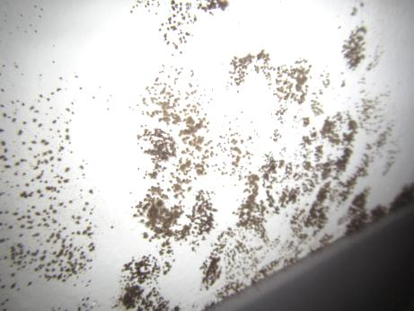

Visible mold on wall adjacent to the 4th floor lunch room

Picture 2

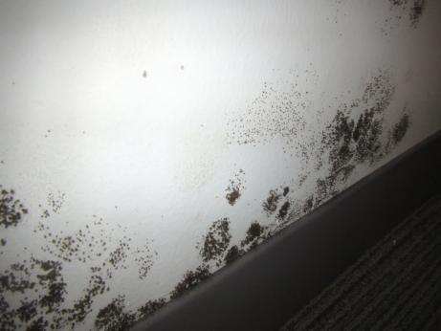

Visible mold on wall adjacent to the 4th floor lunch room
Picture 3

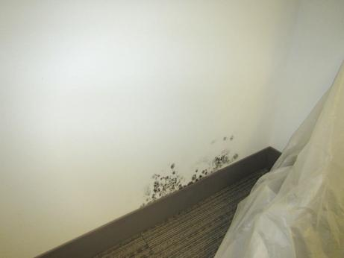

Mold colonization showing plastic sheeting that was loosely draped over wall

Picture 4

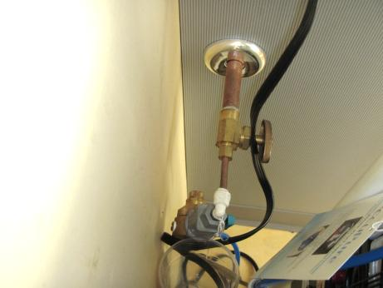

Water cooler valve (4th floor lunch room) adjacent to mold-colonized wall
Picture 5

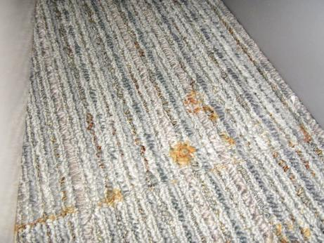

Rust stains on carpet beneath metal file cabinets

Picture 6

Mold staining visible after cleaning surface with bleach
Picture 7

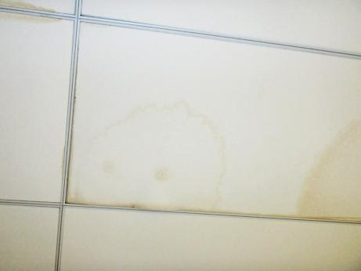

Water-damaged ceiling tiles in Hearing Room A
Picture 8

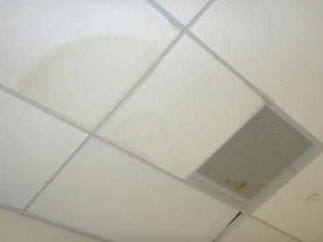

Water-damaged ceiling tiles (Hearing Room A); note rusting on return vent and newly replaced tiles due to tiles disintegrating & collapsing
Picture 9

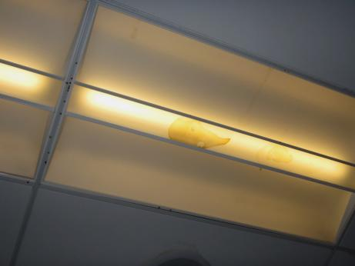

Water damaged around/in light fixtures (Hearing Room A)

Picture 10

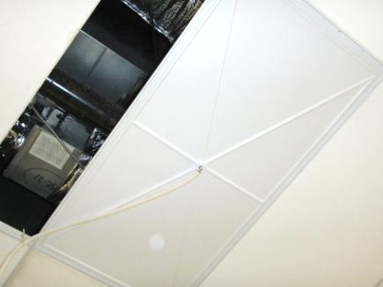

Water-funneling ceiling tile to capture and direct chronic water leaks into barrels (Hearing Room A)
Picture 11

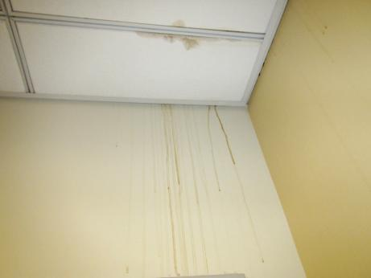

Water-damaged ceiling tiles and wallboard (Hearing Room hallway)

Picture 12

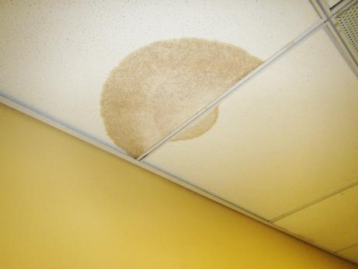

Water-damaged ceiling tiles (Hearing Room hallway)
Picture 13

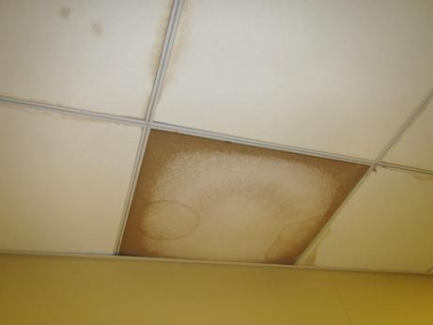

Water-damaged ceiling tiles and wall (Hearing Room hallway)

Picture 14

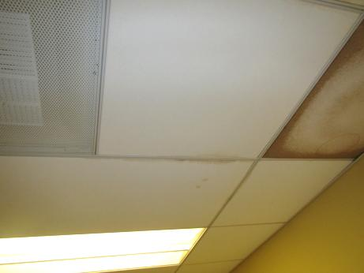

Water-damaged Ceiling tiles (Hearing Room hallway)
Picture 15

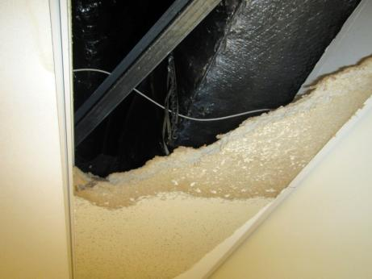

Water-damaged/broken ceiling tile (Interview Room 1)

Picture 16

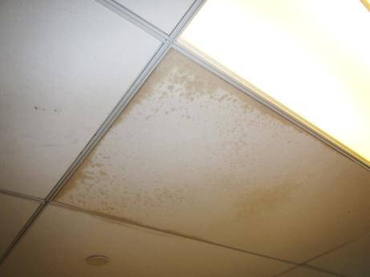

Water-damaged ceiling tiles 5th floor
Picture 17

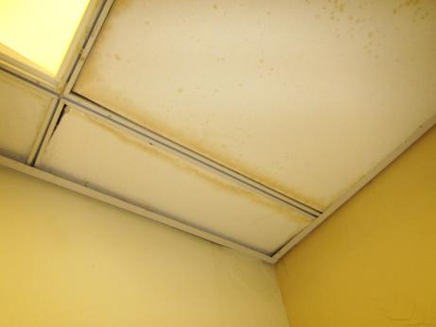

Water-damaged ceiling tiles/wallboard (5th floor)

Picture 18

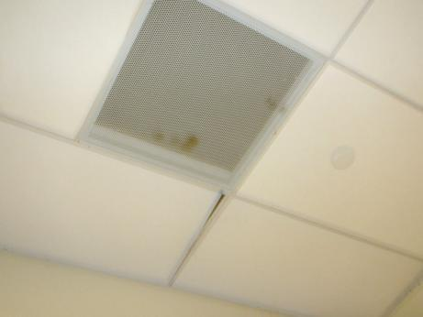

Non-ducted return vent (5th floor) utilize ceiling plenum for return air
Location | Temp  (°F) | Relative  Humidity  (%) | Windows  Openable | Ventilation |  |  | Remarks
 |  |  |  | Intake | Exhaust
Background (outdoors near DPU) | 81 | 76 | - | - |  | - | Humid, traffic
Outside 4th Floor Lunch Room | 75 | 67 | N | Y |  | Y | Visible mold on wall, rust staining on carpet beneath file cabinet, historic flood from water cooler in area, wall dry, elevated humidity, ventilation off during visit
5th Floor Lunch Room Area | - | - | - | - |  | - | Walls dry, no visible WD
Hearing Room A | 74 | 54 | N | Y |  | Y | Extensive WD CTs, WD GW, WD carpet, ventilation on
Hearing Hallway | 73 | 57 | N | Y |  | Y | Extensive WD CTs, WD GW, WD carpet, ventilation on
Interview Room 1 | - | - | - | - |  | - | WD CTs, Broken/MT
Conference Room 5 West | - | - | - | - |  | - | WD CTs
Finance Division  Rear | 75 | 69 | N | Y |  | Y | WD CTs, elevated humidity
Finance Division  Center | 75 | 68 | N | Y |  | Y | Elevated humidity
Finance Division  Front | 75 | 67 | N | Y |  | Y | Elevated humidity

The ceiling plenum is the space between the ceiling tiles and the roof/floor decking.

