INDOOR AIR QUALITY ASSESSMENT
Plymouth Department of Public Works
Annex Building
169 Camelot Drive
Plymouth, Massachusetts
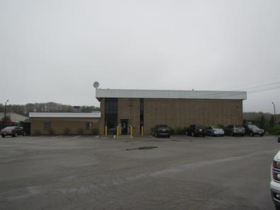
Prepared by:
Massachusetts Department of Public Health
Bureau of Environmental Health
Indoor Air Quality Program
May 2017

BACKGROUND
Building: | Plymouth Department of Public Works Annex Building
Address: | 169 Camelot Drive, Plymouth
Assessment Requested by: | Derek Brindisi, Assistant Town Manager, Town of Plymouth
Reason for Request: | Respiratory symptoms and general indoor air quality (IAQ) concerns, with a focus on airborne particulates
Date of Assessment: | May 2, 2017
Massachusetts Department of Public Health/Bureau of Environmental Health (MDPH/BEH) Staff Conducting Assessment: | Cory Holmes, Environmental Analyst/Inspector IAQ Program
Date of Building Construction: | 1988, with interior office buildout ~ 3 months ago
Building Description: | Two story concrete building housing offices attached to a garage/work area
Building Population: | 5-10 employees
Windows: | Non openable

METHODS
Please refer to the IAQ Manual and appendices for methods, sampling procedures, and interpretation of results (MDPH, 2015).

RESULTS and DISCUSSION
The following is a summary of indoor air testing results (Table 1).
- Carbon dioxide levels were below the MDPH recommended level of 800 parts per million (ppm) in all areas surveyed.
- Temperature was slightly below the MDPH recommended range of 70°F to 78°F in a few areas.
- Relative humidity was above the MDPH recommended range of 40 to 60% in all areas tested and reflective of outside conditions (100% - rain).
- Carbon monoxide levels were non-detectable (ND) in all areas tested.
- Total Volatile Organic Compound levels were ND in all areas tested.
- Particulate matter (PM2.5) concentrations measured were below the National Ambient Air Quality (NAAQS) level of 35 μg/m³ in all areas tested. Since building occupants specifically had concerns of airborne particles, particulate testing is further explained below.

Particulate Matter
Indoor air quality can be negatively influenced by the presence of respiratory irritants, such as airborne particulates related to construction debris and/or vehicle operations. Common construction/renovation pollutants and combustion emissions include carbon monoxide, carbon dioxide, water vapor and fine airborne particle material. Of these materials, exposure to carbon monoxide and particulate matter with a diameter of 2.5 micrometers (μm) or less (PM2.5) can produce immediate, acute health effects upon exposure. To determine whether measurable levels of these products were present in the indoor environment, BEH/IAQ staff obtained measurements for carbon monoxide and PM2.5. As stated above, no measurable levels of carbon monoxide were detected.
The US EPA has established NAAQS limits for exposure to particulate matter. Particulate matter includes airborne solids that can be irritating to the eyes, nose and throat. The NAAQS originally established exposure limits to PM with a diameter of 10 μm or less (PM10). In 1997, US EPA established a more protective standard for fine airborne particulate matter with a diameter of 2.5 μm or less (PM2.5). This more stringent PM2.5 standard requires outdoor air particle levels be maintained below 35 μg/m³ over a 24-hour average (US EPA, 2006). Although both the ASHRAE standard and BOCA Code adopted the PM10 standard for evaluating air quality, MDPH uses the more protective PM2.5 standard for evaluating airborne PM concentrations in the indoor environment.
Outdoor PM2.5 concentrations were measured at 23 μg/m³ (Table 1). PM2.5 levels measured in the building ranged from 8 to 18 μg/m³ (Table 1), which were below the NAAQS PM2.5 level of 35 μg/m³. Frequently, indoor air levels of particulates (including PM2.5) can be at higher levels than those measured outdoors. A number of activities that occur indoors and/or mechanical devices can generate particulate matter during normal operations. Sources of indoor airborne particulates may include but are not limited to particles generated during the operation of fan belts in the HVAC system, use of stoves and/or microwave ovens in kitchen areas; use of photocopiers, fax machines and computer printing devices; operation of an ordinary vacuum cleaner and heavy foot traffic indoors.

Ventilation
The heating, ventilation and air conditioning (HVAC) system consists of an air handling unit (AHU) located in the garage (Picture 1). The unit supplies heated air to occupied spaces via wall or ceiling vents and returns air back to the unit via wall/ceiling vents. The system does not provide AC, therefore window or portable units are utilized to provide cooling during spring/summer months. The AHU was closely examined and did not appear to have the ability to introduce fresh/outside air. The Massachusetts Building Code requires a minimum ventilation rate of 20 cubic feet per minute (cfm) per occupant of fresh outside air or have openable windows in each room (SBBRS, 1997; BOCA, 1993).
Of significance to IAQ was the configuration of combustion air for the AHU. In order to facilitate proper combustion, a source of oxygen is needed. It appears that the oxygen source for the AHU is connected into a “Y” joint that is shared with the exhaust vent (Picture 2). In this configuration, it is possible that products of combustion from the exhaust vent can be readily drawn back into the AHU. Because there is no mechanical source of fresh air in the building, this situation may be contributing to degraded IAQ. The design/installation of the AHU should be evaluated by an HVAC engineering firm for proper operation.
The filters in the AHU were examined. The mesh-style filter (Picture 3) has minimal efficiency to remove airborne particulates and is not recommended. The MDPH recommends pleated filters with a Minimum Efficiency Reporting Value (MERV) of 8, which are adequate in filtering out pollen and mold spores (ASHRAE, 2012). Note, however, that an increase in filtration can cause stress on equipment, which needs to be evaluated to determine if the higher-rated filters will allow adequate function. Filters should also be changed two to four times a year, or as the manufacture’s recommendations.
The building is equipped with a garage/work area where vehicles can be driven in and the door closed. The garage is outfitted with a local exhaust system to remove vehicle exhaust/airborne pollutants, which consist of a large exhaust fan (Picture 4) and a louvered supply vent (Picture 5) to provide make-up air. It was reported that the supply make-up louvers were inoperable at the time of assessment.
Restrooms are equipped with local exhaust vents to remove excess moisture and odors. It was reported by staff that these vents are insufficient to remove odors. In addition, the vents are activated by light switch, which deactivates upon exit when lights are shut off.

Microbial/Moisture Concerns
A number of areas in the building had water-damaged ceiling tiles (Table 1, Pictures 6 through 8). Stained or damaged ceiling tiles indicate roof or plumbing leaks. Tiles should be replaced once leaks are found and repaired.
Bubbling paint was noted on the gypsum wallboard of the Water Department Break/Meeting Room (Picture 9). Moisture testing results indicated that the material was slightly moist. No visible mold was observed. This area should be scraped, repainted and closely monitored for further moisture exposure.
Visible mold growth was observed in and on the refrigerator in the garage. Visible mold growth/staining was seen on the exterior of the refrigerator (Picture 10) and on gaskets (Picture 11). The mold growth is most likely due to condensation from exposure to temperature extremes in the non-conditioned garage, particularly since garage doors are left open most of the time.

Other Conditions
Other conditions that can affect IAQ were observed during the assessment. Several offices and stairwells were carpeted. Carpets should be cleaned annually (or semi-annually in soiled/high traffic areas) in accordance with Institute of Inspection, Cleaning and Restoration Certification (IICRC) recommendations, (IICRC, 2012). However, carpeting was believed to be original and therefore over 20 + years old. The service life of carpeting is approximately 10-11 years (IICRC, 2002). In many areas, carpeting was observed to be worn and stained. Carpeting of this age and condition becomes increasingly difficult to clean and maintain and may be a source of particulate matter to the indoor environment. Regular cleaning with a high efficiency particulate air (HEPA) filtered vacuum in combination with an annual cleaning will help to reduce accumulation and potential aerosolization of materials from carpeting.
Several supply, exhaust, and return vents were observed to have accumulated dust/debris. If exhaust vents are not functioning, backdrafting can occur, which can re-aerosolize accumulated dust particles. Supply vents can aerosolize accumulated dust once activated.
Spaces were observed around doors to office space that lead into the garage (Picture 12). These breaches can serve as pathways for garage pollutants to enter occupied areas, particularly if the local exhaust system is not operating.
Open utility holes were observed in the Water Superintendent’s office (Pictures 13 and 14). These spaces can provide a pathway for odors and particulates from wall cavities into occupied areas.
A missing ceiling tile was observed with exposed fiberglass insulation in the first floor restroom, which is also located above a food station (Picture 15). Missing ceiling tiles can create pathways for dust/debris in the ceiling plenum into occupied areas. Fiberglass insulation can provide a source of eye, skin and respiratory irritation.
Finally, portable and window-mounted ACs are equipped with filters. The filters examined were occluded with dust/debris (Table 1, Picture 16) and should be cleaned as per the manufactures’ recommendations or more frequently if needed.

CONCLUSIONS and RECOMMENDATIONS
In view of the findings at the time of the visit, the following recommendations are made:
- Contact HVAC engineer to evaluate configuration of “Intake/Exhaust” pipes of AHU (Picture 2). Make repairs/adjustments as needed.
- Provide fresh air to the space to comply with building code. This can be done in two ways; install openable windows and/or retrofit HVAC system with a fresh air intake vent.
- Upgrade filters in AHU to MERV 8 or higher and change a minimum of twice per year (e.g., between heating/cooling seasons) or as per the manufacturer’s instructions.
- Examine restroom exhaust vents for proper operation, increase capabilities as needed.
- Make repairs to the louvered fresh air supply vent for the local exhaust system in the garage/work area.
- Consider adopting a balancing schedule of every 5 years for all mechanical ventilation systems, as recommended by ventilation industrial standards (SMACNA, 1994).
- For buildings in New England, periods of low relative humidity during the winter are often unavoidable. Therefore, scrupulous cleaning practices should be adopted to minimize common indoor air contaminants whose irritant effects can be enhanced when the relative humidity is low. To control for dusts, a high efficiency particulate arrestance (HEPA) filter equipped vacuum cleaner in conjunction with wet wiping of all surfaces is recommended. Avoid the use of feather dusters. Drinking water during the day can help ease some symptoms associated with a dry environment (throat and sinus irritation).
- Replace water-damaged ceiling tiles after leaks are discovered and repaired.
- Clean mold growth from refrigerator and gaskets in garage/work area. If they cannot be adequately cleaned, consider replacing gaskets. Consider relocating refrigerator inside office space (not garage).
- Determine/mitigate source of moisture in Water Department Break/Meeting Room. Scrape, repaint bubbled wall and monitor for further water damage and/or mold growth. Remove/replace if necessary.
- Seal open utility holes (e.g., Picture 13) with a fire-rated sealant.
- Replace missing ceiling tiles (e.g., first floor restroom Picture 15) to prevent exposure to dust/debris/fiberglass.
- Clean portable fans, supply, exhaust and return vents periodically of accumulated dust.
- Clean carpeting annually or semi-annually in soiled high traffic areas as per the recommendations of the Institute of Inspection, Cleaning and Restoration Certification (IICRC, 2012).
- Replace old worn carpeting past its useful life (> 10-11 years).
- Tighten seals around doors leading off the garage/work area. Repair/replace weather-stripping on/around doors, as well as any other areas in the building where light or drafts can be seen/detected.
- Clean AC filters prior to the cooling season and as needed.
- Ensure ACs are draining properly either outdoors or into proper receptacle.
- Refer to resource manual and other related indoor air quality documents located on the MDPH’s website for further building-wide evaluations and advice on maintaining public buildings. These documents are available at http://mass.gov/dph/iaq.

REFERENCES
ASHRAE. 2012. American Society of Heating, Refrigeration and Air Conditioning Engineers (ASHRAE) Standard 52.2-2012 -- Method of Testing General Ventilation Air-Cleaning Devices for Removal Efficiency by Particle Size (ANSI Approved). 2012.
BOCA. 1993. The BOCA National Mechanical Code/1993. 8th ed. Building Officials and Code Administrators International, Inc., Country Club Hill, IL.
IICRC. 2002. Institute of Inspection, Cleaning and Restoration Certification. A Life-Cycle Cost Analysis for Floor Coverings in School Facilities.
IICRC. 2012. Institute of Inspection, Cleaning and Restoration Certification. Carpet Cleaning: FAQ. Retrieved from http://www.iicrc.org/consumers/care/carpet-cleaning.
MDPH. 2015. Massachusetts Department of Public Health. Indoor Air Quality Manual: Chapters I-III. Available at: http://www.mass.gov/eohhs/gov/departments/dph/programs/environmental-health/exposure-topics/iaq/iaq-manual/.
SBBRS. 1997. Mechanical Ventilation. State Board of Building Regulations and Standards. Code of Massachusetts Regulations. 80 CMR 1209.0
SMACNA. 1994. HVAC Systems Commissioning Manual. 1st ed. Sheet Metal and Air Conditioning Contractors’ National Association, Inc., Chantilly, VA.
Picture 1
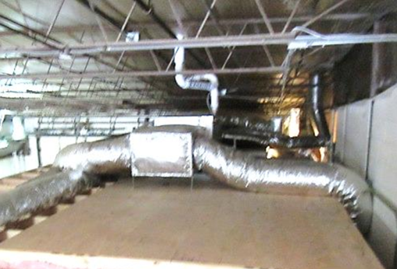
Air handling unit (AHU)
Picture 2
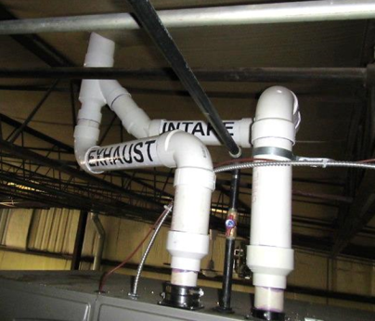
Oxygen source for the AHU is connected into a “Y” joint that is shared
with the exhaust vent
Picture 3
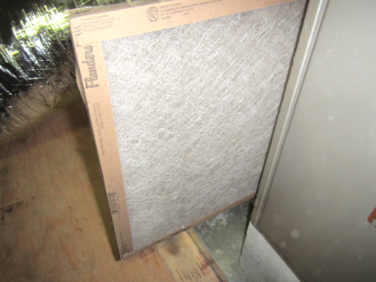
Mesh AHU filter
Picture 4
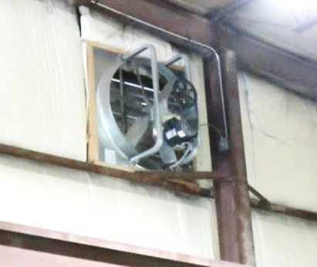
Local exhaust vent for garage/work area
Picture 5
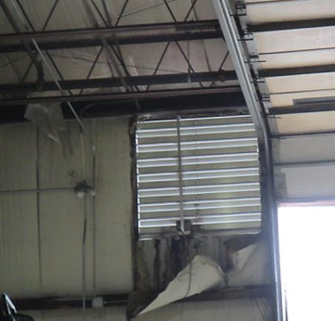
Louvered make-up/supply vent
Picture 6
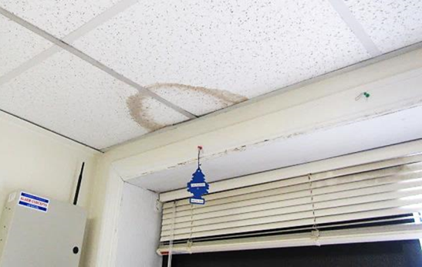
Water-damaged ceiling tiles
Picture 7
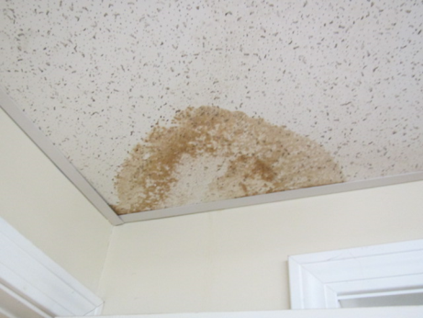
Water-damaged ceiling tile
Picture 8
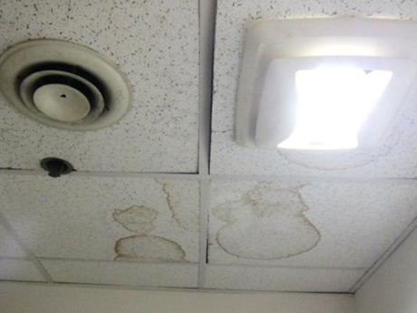
Water-damaged ceiling tiles
Picture 9
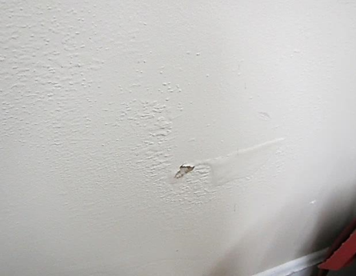
Bubbling paint on wall of the Water Department Break/Meeting Room
Picture 10
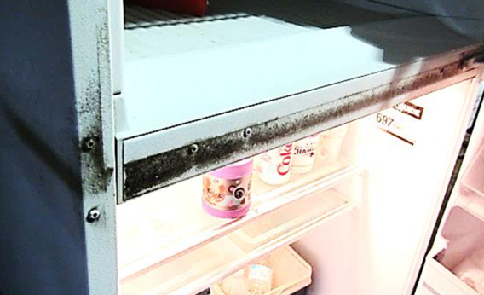
Visible mold growth (dark staining) on refrigerator in garage
Picture 11
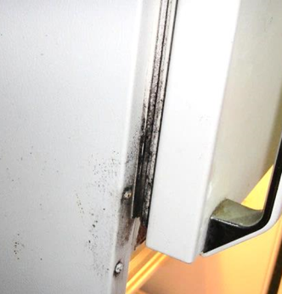
Visible mold growth (dark staining) on refrigerator in garage
Picture 12
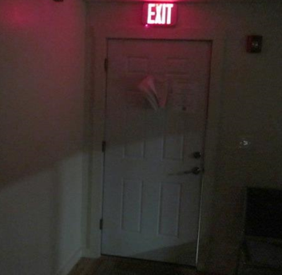
Light penetrating around door leading to garage
Picture 13
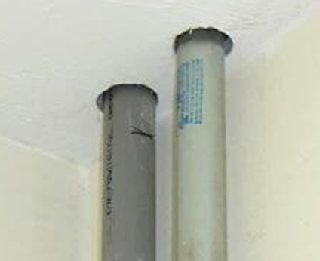
Open utility holes around pipes in the ceiling of Water Superintendent's office
Picture 14
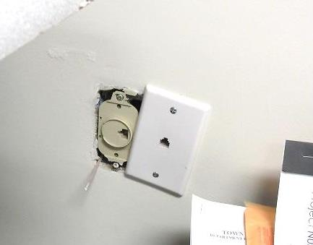
Open utility holes around pipes in the ceiling of Water Superintendent's office
Picture 15
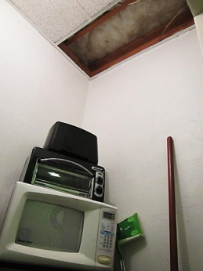
Missing ceiling tile/exposed fiberglass insulation above food station
Picture 16
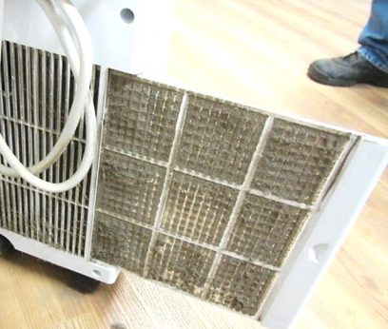
AC filter for portable unit in Water Department Break/Meeting Room
Location | Carbon  Dioxide  (ppm) | Carbon Monoxide  (ppm) | Temp  (°F) | Relative  Humidity  (%) | TVOCs  (ppm) | PM2.5  (µg/m³) | Occupants  in Room | Windows  Openable | Ventilation |  |  | Remarks
 |  |  |  |  |  |  |  |  | Intake | Exhaust
Background (outdoors) | 360 | ND | 63 | 90-100 | ND | 23 |  |  |  |  |  | Rainy, windy, cool
Water Division Reception Area | 529 | ND | 67 | 81 | ND | 18 | 2 | N | N |  | N | Window AC-filter dirty
Water Division Office | 696 | ND | 70 | 78 | ND | 17 | 4 | N | N |  | N
Parks and Forestry | 566 | ND | 71 | 71 | ND | 11 | 0 | N | N |  | N | PC, carbon monoxide monitor, old thermostat
Women’s Restroom |  |  |  |  |  |  |  | N | N |  | Y | Exhaust on light switch
Restroom |  |  |  |  |  |  |  | N | N |  | Y | Exhaust on light switch, storage closet-missing CT exposed fiberglass insulation
Parks Superintendent | 502 | ND | 74 | 64 | ND | 10 | 0 | N | N |  | N | Window AC-filter dirty
Water Superintendent | 508 | ND | 74 | 65 | ND | 9 | 0 | N | N |  | N | Window AC, utility holes, dust/debris/cobwebs-windowsill, heat duct-disconnected and plugged with plastic bucket
Cross Connection Office | 516 | ND | 73 | 63 | ND | 8 | 0 | N | N |  | N | Stucco-chunks/debris on floor (few pieces), spaces around door, windows into garage
Water Department Garage | 483 | ND | 67 | 74 | ND | 9 | 0 | N | N |  | N | Garage door open
Water Department Break/Meeting Room | 439 | ND | 68 | 68 | ND | 8 | 0 | N | N |  | N | Portable AC unit-drain?, bubbling paint on GW-slightly moist

