INDOOR AIR QUALITY ASSESSMENT

Hull Department of Public Works
9 Nantasket Avenue
Hull, MA

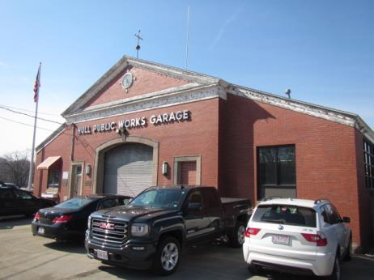

Prepared by:
Massachusetts Department of Public Health
Bureau of Environmental Health
Indoor Air Quality Program
April 2018
BACKGROUND
Building: | Hull Department of Public Works (DPW) Garage
Address: | 9 Nantasket Avenue  Hull, MA
Assessment Coordinated via: | Hull Board of Health and Department of Public Works
Reason for Request: | General indoor air quality (IAQ) assessment
Date of Assessment: | March 1, 2018
Massachusetts Department of Public Health/Bureau of Environmental Health (MDPH/BEH) Staff Conducting Assessment: | Cory Holmes, Environmental Analyst/Inspector, IAQ Program
Date Building Constructed: | 1949
Building Description: | Red brick and concrete block public works garage. The building mainly consists of a large vehicle/maintenance bay, with office space and staff areas built out.
Windows: | Few openable

Methods
Please refer to the IAQ Manual for methods, sampling procedures, and interpretation of results (MDPH, 2015).

IAQ Testing Results
The following is a summary of indoor air testing results (Table 1):
- Carbon dioxide: levels were above the MDPH recommended level of 800 parts per million (ppm) in the Reception and Director offices, indicating a lack of air exchange in these areas. This is explained further in the Ventilation section of this report.
- Temperature: in office areas was within or close to the MDPH recommended range of 70°F to 78°F, temperatures in the garage/bay areas was lower due to open doors.
- Relative humidity: was within or close the MDPH recommended range of 40 to 60% in all areas tested the day of assessment.
- Carbon monoxide: Low levels ranging from 2-7 ppm were measured inside the building. The level of 7 ppm was measured near the fuel-powered pressure washer, which was started briefly. Exposure to elevated levels of carbon monoxide can produce immediate and acute health effects.
- Particulate matter (PM2.5): Particulate matter is airborne solids that can be irritating to the eyes, nose and throat. Concentrations measured were above the NAAQS level of 35 μg/m³ in all areas tested the day of assessment. Outdoor levels were elevated due to nearby traffic conditions and wood burning/smoke particulates in the area. Indoor levels were elevated due to open doors to the outside as well as numerous sources of particulates (i.e., vehicles, fuel-powered equipment, parts washers, dirt/dust conditions) indoors.
- Total Volatile Organic Compounds (TVOCs): levels indoors ranged from 2 to 10 ppm. Exposure to low levels of TVOCs may produce eye, nose, throat, and/or respiratory irritation in some sensitive individuals. It is important to note that measureable levels of TVOCs would be expected in an industrial work setting, however, good depressurization/ventilation techniques should be employed to minimize/reduce exposure.

Ventilation
A heating, ventilating, and air conditioning (HVAC) system has several functions. First it provides heating and, if equipped, cooling. Second, it is a source of fresh air. Finally, an HVAC system will dilute and remove normally-occurring indoor environmental pollutants not only by introducing fresh air, but also by filtering the airstream and ejecting stale air to the outdoors via exhaust ventilation. Even if an HVAC system is operating as designed, point sources of respiratory irritation may exist and cause symptoms in sensitive individuals. The following analysis examines and identifies components of the HVAC system and likely sources of respiratory irritant/allergen exposure from water damage, aerosolized dust, and/or chemicals found in the indoor environment.
No mechanical ventilation system that introduces fresh air exists in the office areas of the building. The sole source of fresh air is openable windows. The Reception office has an openable window; the Director’s office does not. The Director’s office has a passive grill (transfer air vent) in the door that is open to the Reception office (Picture 1).
The common/staff areas or main garage also have no mechanical source of fresh air supply. Vintage photographs show that the building was originally designed with exhaust vents (Picture 2). It appears that the original exhaust system was eliminated when the roof of the building was replaced (Pictures 3 and 4). A wall-mounted exhaust fan is installed on the upper/rear wall of the building (Picture 5), however it appears that a loft was built around the fan (Picture 6). Airflow to the fan is further restricted by a solid block wall in the garage (Picture 7). In order for an exhaust fan to properly function, a source of air is needed (makeup air). No make-up air vent for the exhaust fan could be identified, save for opening the garage doors.

Microbial/Moisture Concerns
BEH/IAQ staff was asked to examine the DPW for water damage due to staff concerns regarding mold. It is important to note that the building is primary constructed of materials such as concrete and brick which are materials that are unlikely to support mold growth, even when exposed to periodic water leaks.
Several inches of standing water and saturated porous materials were observed in the former boiler room (Pictures 8 and 9), which is a separate structure attached to the rear of the main DPW garage. The boiler room is a concrete unit (Picture 10) that is not used anymore. The metal exterior door to the boiler room was severely corroded, with large gaps that can allow drafts, moisture and pests to enter the main garage building.
Other potential sources of water penetration in the occupied areas of the building were noted:
- Open utility holes in exterior walls (Picture 11);
- Gaps/spaces beneath garage doors (Picture 12);
- Portable AC for Director’s office is installed in interior wall directly over porous materials (Picture 13).
These conditions may be a source of water/leaks in the building.

Other Conditions
It is important to note that this building is a functioning vehicle maintenance and repair facility. Employees must work with various products that likely contain hazardous materials that are related to maintenance and repair of vehicles. For this reason, in order to properly train staff, documents for products containing hazardous materials [called Safety Data Sheets (SDS)] should be obtained from the manufacturer. The SDS lists exposure limits to chemicals; proper protective equipment; proper ventilation recommendations for use of the product as well as emergency response information. Staff should be trained in the safe handling of materials that have SDS. As noted previously, the IAQ staff conducted air sampling for TVOCs using a photo ionization detector (PID). The PID will identify the presence of detectable volatile organic compounds (VOCs), but does not differentiate between specific VOCs that may be present. Therefore the air sampling for TVOCs only indicate that there may be a source of exposure in the workplace and should not be used to determine compliance of US Occupational Safety and Health Administration (OSHA) regulations regarding hazardous materials Permissible Exposure Limits (PELs).
During the course of the assessment, a number of sources of pollutants were noted:
- Vehicle exhaust that consists of carbon monoxide, particulates and soot (Picture 14);
- Spills on the floor likely fluid related to vehicle operations and maintenance, including diesel fuel, motor oil and other vehicle liquids which contain volatile organic compounds (VOCs) (Pictures 14, 15 and 16);
- Rubber/petroleum odors from tire storage (Picture 17);
- Odors/VOCs from degreasers, parts washer and maintenance/cleaning chemicals (Pictures 18 through 21);
- Unventilated welding station (Picture 22);
- Fuel-powered industrial pressure washer (Picture 23);
- Emergency generator, although vented outside the exhaust pipe contains at least four 90-degree angles (Picture 24). In general, every 90-degree angle reduces air velocity by half, in addition every 16 feet of piping reduces air velocity by half as well.

Other conditions that can affect IAQ were observed during the assessment. The staff restroom at the rear of the garage has a sewer gas vent pipe that is disconnected (Picture 25). In addition, the exhaust vent for the bathroom vents inside the building (Pictures 26 and 27). Restrooms should be properly vented to the outside to remove excess moisture and odors.
Finally, dead birds/nesting materials were observed along the exterior of the building (Pictures 28 and 29). No active birds/nests were observed/reported inside the building. Certain molds/bacteria and diseases are associated with bird waste and can be of concern for immuno-compromised individuals.

CONCLUSIONS/RECOMMENDATIONS
A number of building conditions observed may contribute to poor IAQ. These conditions/issues combined with a lack of a mechanical ventilation system for fresh air supply and exhaust capabilities can play a role in causing and/or exacerbating respiratory symptoms.
Correcting some of the issues may take significant planning and capital resources. In view of these findings, two sets of recommendations are made: short-term measures that may be implemented as soon as practicable and long-term measures that will require planning and resources to address overall IAQ concerns.

Short-Term Recommendations
- Provide local exhaust for fume/VOC-generating activities such as welding and parts washing and in-particular the fuel-powered pressure washer.
- Activate the local exhaust fan in loft to help remove vehicle exhaust, odors and fumes.
- Seal any holes/breaches/pathways (e.g., spaces under doors) to office/work areas to prevent garage pollutants from migrating into non-garage areas. Install weather-stripping and door sweeps on doors.
- Consider installing digital readout carbon monoxide detectors in occupied areas of the building.
- Install weather-stripping on garage doors, if doors cannot be made tight to prevent drafts/moisture/pests, repair or consider replacing. Ensure tightness of doors by monitoring for light penetration and drafts around doorframes.
- Install openable window in Director’s office or provide mechanical source of fresh air (e.g., air handling unit).
- Ensure all AC units (i.e., wall unit in Director’s office) are draining properly outside or into a drain, sink, etc. Clean/maintain filters for these units regularly as recommended by the manufacturer.
- Make repairs to sewer gas vent pipe for staff restroom and ensure it is vented properly to outside of building.
- Ensure staff restroom exhaust is vented properly to outside the building.
- Seal all breaches/utility holes on the exterior of the building to prevent, drafts, moisture and pest entry.
- For buildings in New England, periods of low relative humidity during the winter are often unavoidable. Therefore, scrupulous cleaning practices should be adopted to minimize common indoor air contaminants whose irritant effects can be enhanced when the relative humidity is low. Use a vacuum cleaner equipped with a high efficiency particulate arrestance (HEPA) filter in conjunction with wet wiping to remove dust from all surfaces. Avoid the use of feather dusters. Drinking water during the day can help ease some symptoms associated with a dry environment (throat and sinus irritations).
- Remove and discard all water-damaged stored materials in the boiler room. Any items to be preserved should be inspected for water damage and cleaned before being stored in a dry location. Avoid storing anything in the boiler room unless the building has been renovated to be water-tight and dry inside.
- Remove birds/nests/wastes from exterior of building.
- To address issues related to compliance with OSHA hazardous materials regulations, please contact the Massachusetts Department of Labor Standards OSHA Consultation Program Technical Support, which can be contacted via this link: https://www.mass.gov/service-details/osha-consultation-program-technical-support
- Refer to resource manual and other related indoor air quality documents located on the MDPH’s website for further building-wide evaluations and advice on maintaining public buildings. These documents are available at http://mass.gov/dph/iaq.

Long Term Recommendations
- Contact an HVAC engineering firm for a building-wide evaluation to provide local exhaust solutions for the main vehicle maintenance area, as well as individual work stations/functions (e.g., welding, pressure washer, parts washer, oil/fueling stations).
- Consider installing an HVAC system in the office areas that supplies fresh/outside air as well as exhaust.
- Consider replacing ill-fitting garage/bay doors to prevent uncontrolled drafts, moisture and pests.
- Examine the feasibility of relocating the emergency generator outdoors, if not feasible, determine if a more efficient means to exhaust out of building (e.g., straight pipe vs several 90-degree angles).
- Since the boiler room is no longer in use, consider removing structure and filling in the space. If area is to be utilized for storage, make repairs to building envelope to make it watertight, replace door and provide proper drainage. Until the building has been renovated, do not use for storage.

REFERENCES
MDPH. 2015. Massachusetts Department of Public Health. “Indoor Air Quality Manual: Chapters I-III”. Available from http://www.mass.gov/eohhs/gov/departments/dph/programs/environmental-health/exposure-topics/iaq/iaq-manual/
Picture 1
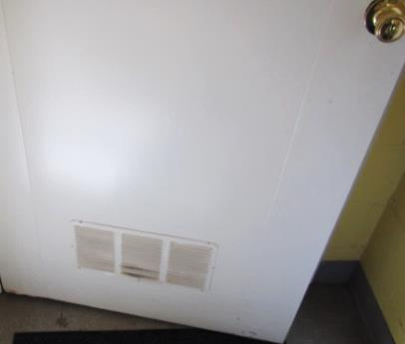
Passive grill in Director’s door
Picture 2
Vintage photo of Hull Public Works Garage, arrows indicate rooftop exhaust vents
Picture 3
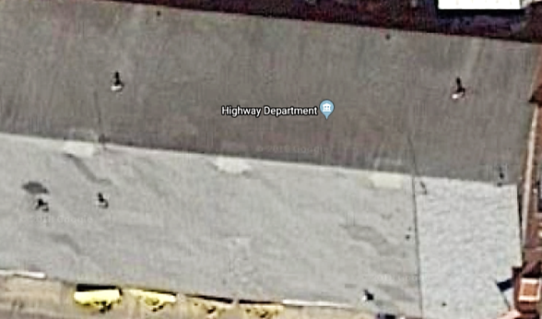
Modern aerial photo of Hull Public Works Garage, Note light/square areas where former exhaust vents were located (arrows)
Picture 4
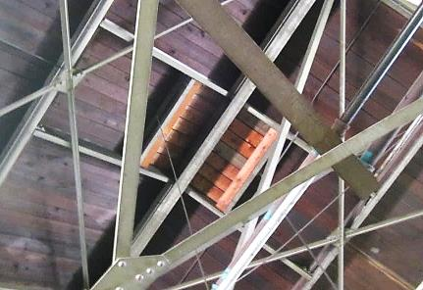
Area of former exhaust vent, square light colored wood in center
Picture 5
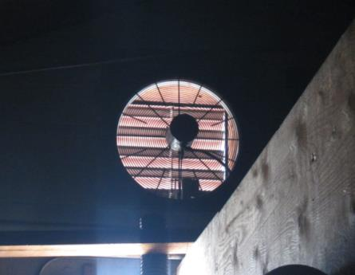
Local exhaust vent on upper rear wall of building
Picture 6
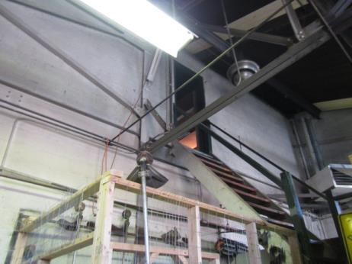
Loft built around local exhaust vent shown in Picture 4
Picture 7
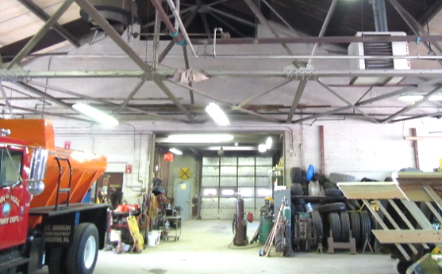
Concrete block wall inside garage
Picture 8
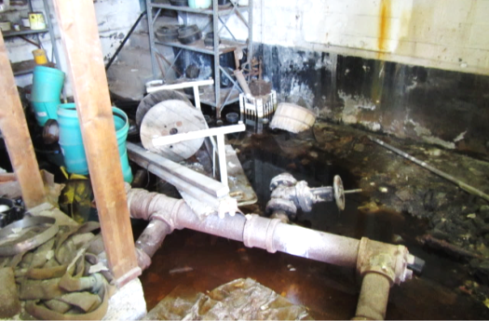
Several inches of standing water in former boiler room
Picture 9
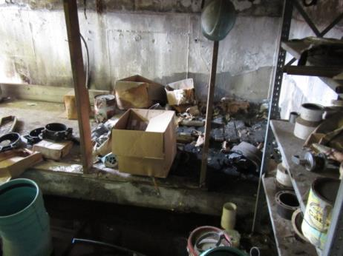
Wet/mold-colonized porous materials in former boiler room
Picture 10
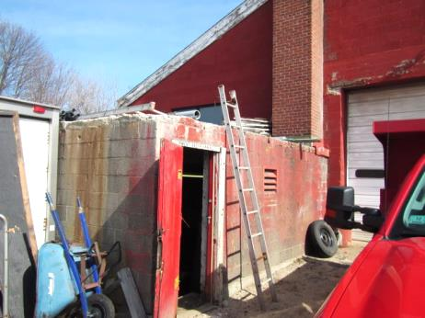
Former boiler room structure at rear of building
Picture 11
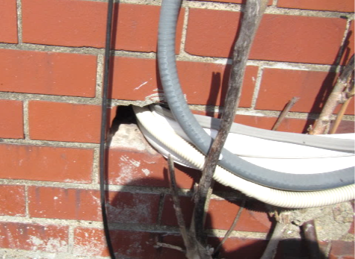
Open utility holes in exterior wall
Picture 12
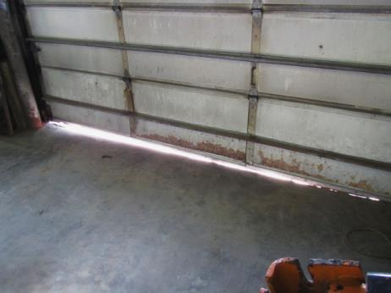
Spaces below garage doors
Picture 13
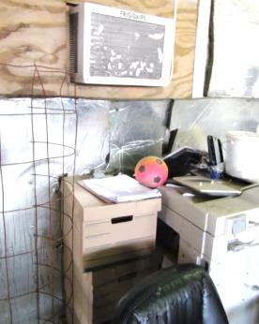
Portable AC installed in interior wall directly above porous materials
Picture 14
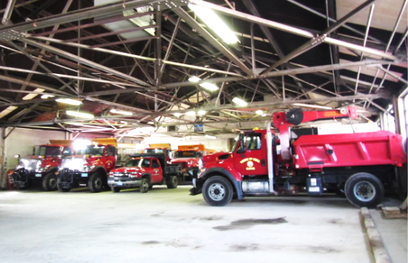
DPW service fleet inside garage
Picture 15
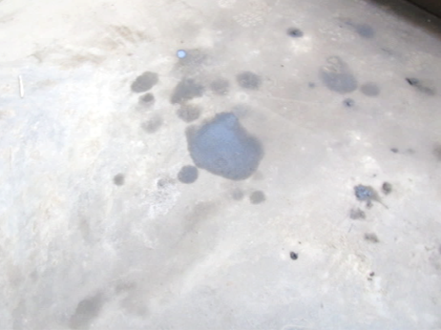
Fuel/oil spills/stains
Picture 16
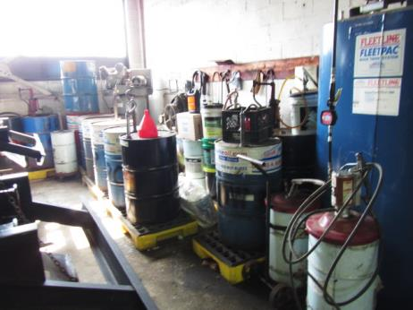
50-gallon drums/oil station
Picture 17
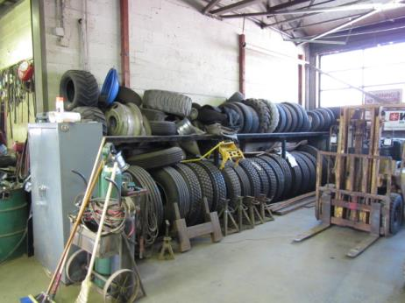
Tire storage
Picture 18
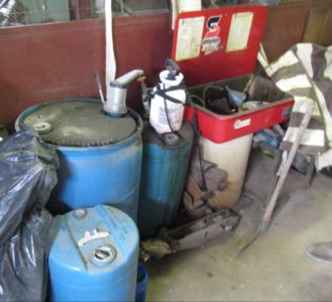
Degreasers/parts washing station
Picture 19
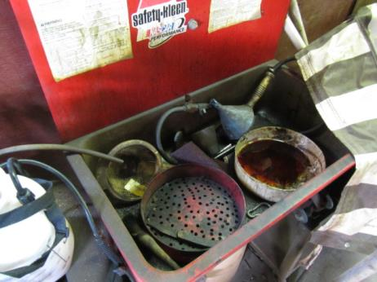
Parts washing station
Picture 20
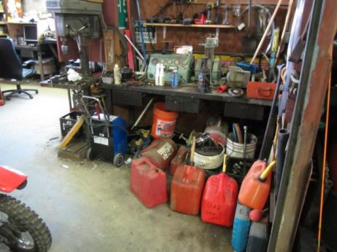
Gasoline/fuel containers
Picture 21
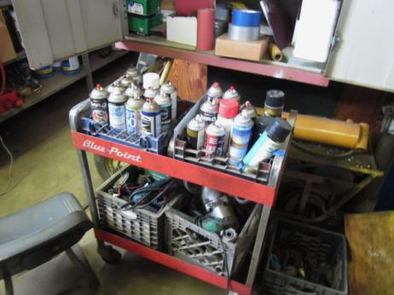
Cleaning/maintenance chemicals
Picture 22
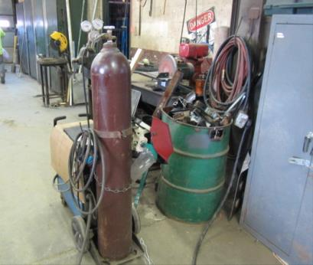
Unventilated welding station
Picture 23
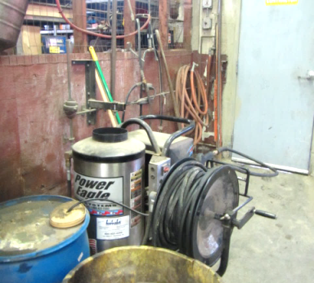
Fuel-powered industrial pressure washer
Picture 24
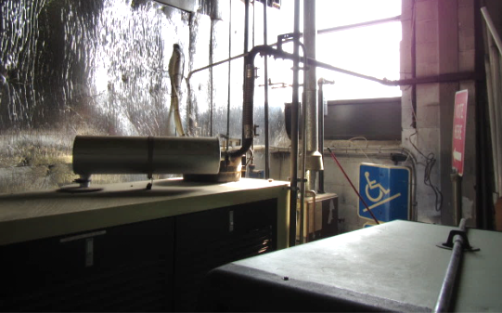
Emergency generator inside garage; note the number of right angles (four total) in exhaust pipe before exiting
Picture 25
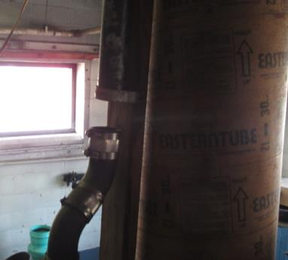
Disconnected sewer gas vent pipe for staff restroom
Picture 26
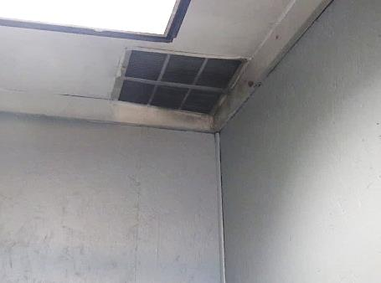
Exhaust vent for staff restroom
Picture 27
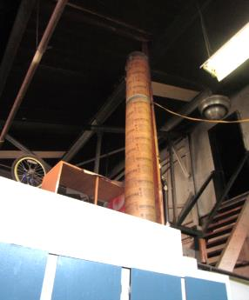
Cardboard (sonar tube) exhaust vent for restroom with end inside building
Picture 28
Dead bird and nesting materials
Picture 29
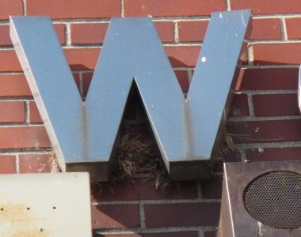
Bird wastes and nesting materials

Location | Carbon  Dioxide  (ppm) | Carbon Monoxide  (ppm) | Temp  (°F) | Relative  Humidity  (%) | PM2.5  (µg/m³) | TVOCs  (ppm) | Occupants  in Room | Windows  Openable | Ventilation |  | Remarks
 |  |  |  |  |  |  |  |  | Supply | Exhaust
Background | 392 | ND | 61 | 39 | 29-45 | ND |  |  |  |  | Clear, warm, breezy
Main Garage Area | 466 | 1 | 65 | 40 | 44 | 3 | 2 | N | N | N | Spaces under garage doors, wall-mounted AC drains indoors, emergency generator (inside) exhaust piped outside (many angles), welding station-no local exhaust, parts washers, oil/chem stains concrete, gas cans/oil stations, degreasers, etc.
Rear Garage Area | 500 | 7 | 65 | 40 | 44 | 10 (parts washer, maintenance chemicals) | 0 | N | N | Y | Exhaust in loft area, fuel powered pressure washer
Restroom |  |  |  |  |  |  |  | N | N | Y | Exhaust not ducted outside, sewer vent pipe breached
Break Area | 520 | 1 | 66 | 39 | 47 | 3 | 4 | N | N | N
Loft/Sign Making Area | 555 | 1 | 70 | 37 | 46 | 8 | 0 | N | N | Y
Reception/Office | 928 | 1 | 69 | 45 | 12 | 2 | 1 | Y | N | N | Wall-mounted AC unit
Director’s Office | 816 | 1 | 74 | 39 | 23 | 2 | 0 | N | Y  Passive | N | Wall-mounted AC and window AC interior wall (drains inside garage)
Boiler Room (Former) |  |  |  |  |  |  |  |  |  |  | Storage, old parts, 3-4 inches of standing water, saturated cardboard boxes, damaged exterior door/spaces/light penetrating, holes in wall-light penetrating

