INDOOR AIR QUALITY ASSESSMENT

Department of Public Works
Garage Complex
321 Rear Charger Street
Revere, Massachusetts

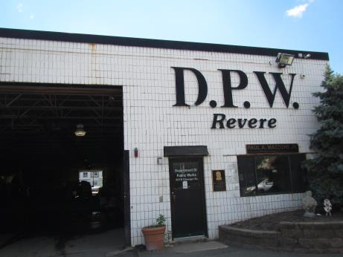

Prepared by:
Massachusetts Department of Public Health
Bureau of Environmental Health
Indoor Air Quality Program
August 2016

BACKGROUND
Building: | Department of Public Works Garage Complex (DPWG)
Address: | 321 Rear Charger Street, Revere
Assessment Contacts: | Donald Goodwin, Superintendent, DPW  Nick Catinazzo, Director of Municipal Inspections
Reason for Request: | Employee complaints about air quality and water damage
Date of Assessment: | 7/19/2016
Massachusetts Department of Public Health/Bureau of Environmental Health (MDPH/BEH) Staff Conducting Assessment: | Jason Dustin, Environmental Analyst/Inspector, Indoor Air Quality (IAQ) Program
Date of Building Construction: | 1975
Building Description: | Cinderblock walls with tar & gravel flat roof
Building Population: | Approximately 6 in offices with a number of additional field personnel
Windows: | Some openable

Methods
Please refer to the IAQ Manual and appendices for methods, sampling procedures, and interpretation of results (MDPH, 2015).

IAQ Testing Results
The following is a summary of indoor air testing results (Table 1).
- Carbon dioxide levels were above 800 parts per million (ppm) in both main office areas, indicating inadequate air exchange in office areas at the time of assessment.
- Temperature was within the MDPH recommended range of 70°F to 78°F in office areas but slightly above in garage and break room areas.
- Relative humidity was within the MDPH recommended range of 40 to 60% in all areas tested.
- Carbon monoxide levels were non-detect (ND) throughout the DPWG. It should be noted that no vehicles were idling in the garage during testing and garage doors were open at the time.
- Particulate matter (PM2.5) concentrations ranged from 31 to 60 μg/m³ in the building. Most of these readings were at/below the NAAQS guideline of 35 μg/m³ except for the Foreman’s office.
- Total Volatile Organic Compounds (TVOCs) levels were non-detect during the testing.

Ventilation
Carbon dioxide levels were above 800 ppm in the two main offices indicating inadequate fresh air exchange in these areas (Table 1). The air handling unit (AHU) in the office area is mounted above the ceiling and did not appear to have a fresh air intake, serving only to filter, heat/cool, and recirculate the air (Picture 1). The MDPH typically recommends having mechanical ventilation with a fresh air supply to dilute common indoor air pollutants.
Carbon dioxide levels were below 800 ppm in the garage areas, which do not have mechanical ventilation. These areas are heated by large ceiling-mounted gas heaters (Picture 2) which appear to be older and non-vented; they should be inspected regularly to ensure proper functioning and safety. Fresh air is supplied primarily by opening garage doors.
The garage building has four ceiling-mounted general exhaust fans (Pictures 3 and 4) that are operated manually (e.g., during vehicle idling or welding). There are no make-up air vents to introduce fresh air during the operation of these exhaust fans. Ideally, a make-up air vent would be sited on the wall opposite the exhaust. Instead, in the main garage, it was reported that DPW staff sometimes open the garage door nearest the exhaust vent. This will provide make-up air but may not be effective at transferring/removing air from other areas of the large garage that are not within the path of cross ventilation.

Other IAQ Evaluations
Under normal conditions, a garage/public works facility can have several sources of environmental pollutants present from the operation of vehicles. These sources of pollutants can include:
- Vehicle exhaust containing carbon monoxide and soot;
- Vapors from diesel fuel, motor oil and other vehicle liquids which contain VOCs;
- VOCs and odors from painting and equipment repair;
- Fumes from welding; and
- Dusts from cutting, sanding, drilling and other activities.
Of particular importance is vehicle exhaust, which involves the process of combustion. Local mechanical exhaust ventilation systems are typically installed in garages to remove airborne pollutants (e.g., odors, fumes, carbon monoxide and other products of combustion) during vehicle idling. These systems are designed to collect vehicle exhaust directly at the source and remove it from the building, minimizing exposure. Vehicle idling indoors should be performed only when absolutely necessary and if needed should be done utilizing a tailpipe mechanical exhaust system. The DPWG was not equipped with a tailpipe mechanical exhaust system.
Carbon monoxide should not be present in a typical, indoor environment. If it is present, indoor carbon monoxide levels should be less than or equal to outdoor levels. As previously mentioned, carbon monoxide measurements at the DPWG were ND. No vehicle traffic or idling was noted during the testing and gas-fired heaters were not operating.
As shown in Table 1, the PM2.5 particulate measurements in the garage area were near or above the NAAQS guideline of 35 μg/m³. At the time of the visit, background measurement for PM2.5 was 29 μg/m³ likely due to the industrial area in which the DPWG is located. Elevated levels of particulate matter may also result from dust-generating activities and aerosolization of accumulations of dust by air movement.
Air conditioning (AC) unit filters were noted to be occluded with dust. AC filters/units should be cleaned regularly to avoid aerosolizing particulate matter which could serve as a respiratory irritant or a microbial growth medium. One AC unit draws air from the garage (Picture 5). This unit should be set to recirculate only or relocated to avoid drawing in garage pollutants.
AHU filters should also be changed as needed. In addition, wet-wiping and HEPA vacuuming of occupied spaces will greatly reduce particulate matter/irritants in the space.
Pathways for vehicle exhaust and other pollutants to move from bays into adjacent/occupied areas were identified. Gaps under doors separating the garage bays from occupied space were observed. These doors, as well as other access points off the mechanic bays, should be kept closed and fitted with weather stripping and door sweeps so that no light is visible around the door edges.
Many missing ceiling tiles and gaps around utilities were noted as well (Pictures 6 through 8). Gaps or breaches in the walls and ceilings of occupied areas that lead to the mechanic bays should be properly sealed to avoid the intrusion of particulate matter, odors and water vapor into occupied areas.
The left side bathroom was observed to be in poor condition and had an abandoned urinal (Picture 9). Repairs should be made to plumbing fixtures or they should be properly capped to avoid the trap from drying out and serving as a pathway for sewer gases into the DPWG.

Microbial/Moisture Concerns
In order for building materials to support mold growth, a source of water exposure is necessary. Factors to consider include:
- DPW garages are normally exposed to moisture from vehicles and activities;
- Most building materials at the DPWG are made from materials that are not conducive to mold growth (e.g., concrete walls and flooring). However, debris and paint on these concrete walls may support microbial growth (Pictures 10 and 11);
- DPW staff reported that the garage roof has had chronic water leaks for many years;
- BEH/IAQ staff noted tarps being used to shelter the office area from leaks (Picture 13);
- The building envelope was noted to be in poor condition with holes and breaches in the roof, concrete block walls, and doors (Pictures 14 through 16);
- Numerous water-damaged ceiling tiles and other porous items were noted in occupied areas (Pictures 17 through 19);
- Standing water was observed in the garage in multiple areas due to a recent rain event (Picture 20);
- DPW staff reported that DEP had previously ordered that the floor drains be sealed to prevent pollution to the nearby marsh;
- Condensation was observed on supply vents in office areas. This is evidence that warm, moist air is entering office spaces while the air conditioning is in use (Pictures 21 and 22). Condensation may accumulate and chronically moisten porous items within the office area.
All of the above are sources of water exposure at the DPWG. Cardboard boxes and other porous materials were observed directly on the floor of the DPWG (Picture 12). These should be stored on shelves or otherwise elevated to prevent wetting from garage activities or condensation, which can lead to water damage and mold growth.

Conclusions/Recommendations
It was noted during the visit that the City of Revere is in the process of performing a feasibility study to determine if remodeling, replacement or other activities should be performed related to this building. In view of that and the findings at the time of the visit, the following recommendations are divided into short-term measures that can be performed fairly readily and long-term measures that will require an outlay of time and capital funds if the building is to be remodeled:

Short-term measures
- Continue with feasibility study for this building and plans to provide for temporary modular office space for employees while renovations or demolition/construction is ongoing.
- Refrain from vehicle idling indoors unless absolutely necessary.
- Utilize existing exhaust ventilation whenever combustion may occur (e.g., vehicle emissions, welding, etc.). Use open doors opposite of vehicle/fan to provide for more effective cross ventilation and controlled make-up air.
- Consider adding properly placed make-up air louvres especially for use during winter months when doors are normally closed.
- To ensure proper functioning and safety, older garage heaters should be inspected regularly.
- Keep doors closed that separate garage bays from office/break areas. Install weather stripping and door sweeps so that no light is visible beneath or around them to prevent products of combustion and unconditioned air from entering these areas.
- Regularly remove standing water from the DPWG with vacuum truck or other effective method.
- Gaps or breaches in the walls and ceilings of occupied areas that lead to the garage bays should be properly sealed to avoid the intrusion of particulate matter, odors and water vapor into occupied areas. Missing ceiling tiles should also be replaced.
- Water-damaged ceiling tiles, insulation or other porous items (carpeting, gypsum wall board, paper/boxes, etc.) should be removed in a manner consistent with recommendations found in “Mold Remediation in Schools and Commercial Buildings” published by the US Environmental Protection Agency (US EPA, 2001).
- Clean debris, loose paint, and likely microbial growth on rear cinderblock wall. Lead-safe practices may be necessary due to the age of the building.
- Make necessary repairs to any plumbing fixtures in bathrooms or cap and properly abandon them to avoid dry drain traps and possible sewer odors in the DPWG.
- Regularly clean AC unit filters to prevent aerosolizing particulate matter.
- Regularly inspect the AHU filter and change on an as needed basis (or at least quarterly). Provide the highest MERV rated filter that the manufacture recommends due to the high background particulate matter in the area and garage activities.
- Window AC units could potentially be set to “fan only” to provide a limited amount of fresh air during temperate weather to those areas equipped with these units except for the unit which is directly connected to the garage bays. This unit should be set to recirculate only or removed/relocated to avoid entrainment of garage pollutants.
- Do not store porous materials (e.g., cardboard boxes) directly on floors; elevate/place on pallets or shelving to prevent water damage and mold growth.
- For buildings in New England, periods of low relative humidity during the winter are often unavoidable. Therefore, scrupulous cleaning practices should be adopted to minimize common indoor air contaminants whose irritant effects can be enhanced when the relative humidity is low. To control for dusts, a high efficiency particulate arrestance (HEPA) filter equipped vacuum cleaner in conjunction with wet wiping of all surfaces is recommended. Avoid the use of feather dusters. Drinking water during the day can help ease some symptoms associated with a dry environment (throat and sinus irritation).
- Refer to resource manual and other related indoor air quality documents located on the MDPH’s website for further building-wide evaluations and advice on maintaining public buildings. These documents are available at http://mass.gov/dph/iaq.

Long-term measures
- Consider adding specialized vehicle exhaust (direct at tailpipe) if indoor idling is frequently required.
- If deciding to renovate the DPWG, the building envelope, including the roof, walls, windows and doors should be inspected and repaired/replaced to exclude moisture, and pests.
- Consider hiring a ventilation contractor to add fresh air capability to the existing AHU which serves the office areas. Also, consider adding an AHU unit with fresh air intake to the left side of the building including the break room/lounge and foreman’s office. This will help dilute any common indoor air pollutants and slightly pressurize the offices to further prevent entry of garage pollutants.

REFERENCES
Massachusetts Department of Public Health (MDPH). 2015. Indoor Air Quality Manual: Chapters I-III. Available at: http://www.mass.gov/eohhs/gov/departments/dph/programs/environmental-health/exposure-topics/iaq/iaq-manual/.
US EPA. 2001. Mold Remediation in Schools and Commercial Buildings. US Environmental Protection Agency, Office of Air and Radiation, Indoor Environments Division, Washington, D.C. EPA 402-K-01-001. http://www.epa.gov/mold/mold-remediation-schools-and-commercial-buildings-guide.
Picture 1
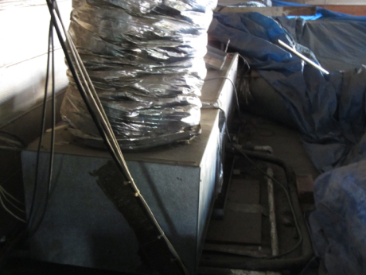
AHU mounted above office areas does not appear to have fresh air intake
Picture 2
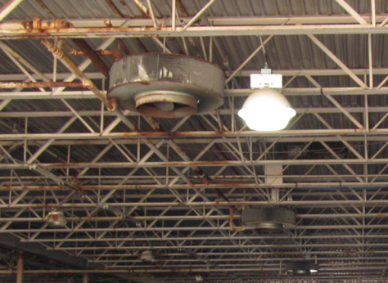
Gas-fired garage heaters
Picture 3
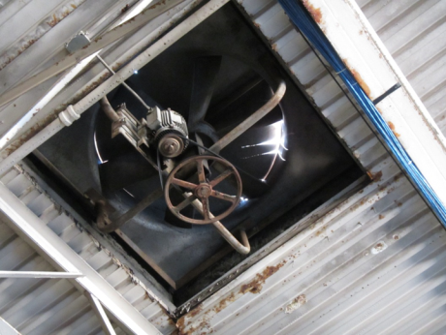
Ceiling-mounted general exhaust fan
Picture 4
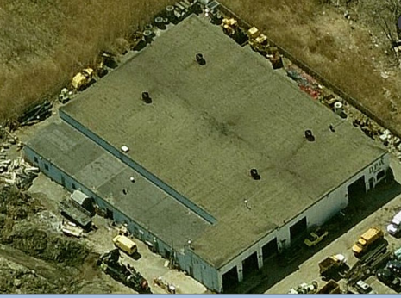
DPW garage roof showing four exhaust vents (arrows)
Picture 5
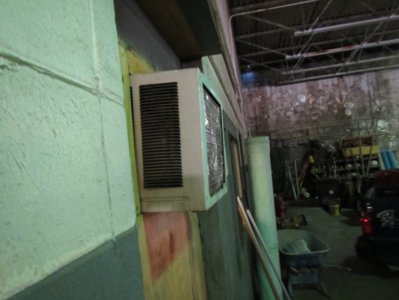
Air conditioning unit leading to garage
Picture 6
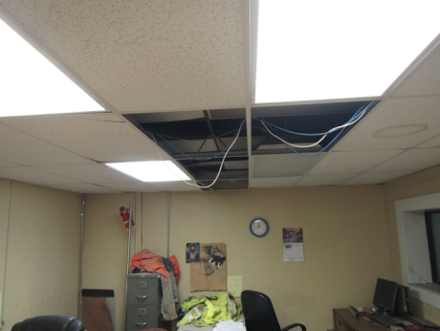
Missing ceiling tiles in DPWG occupied area
Picture 7
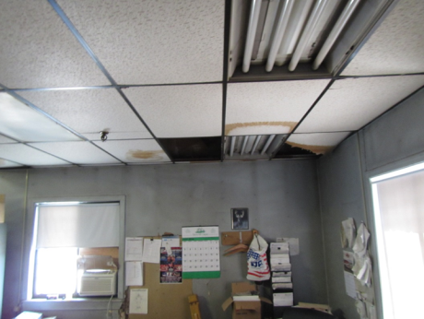
Missing/water-damaged ceiling tiles
Picture 8
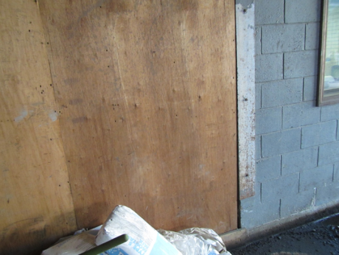
Gaps in wall of storage addition leading to office areas
Picture 9
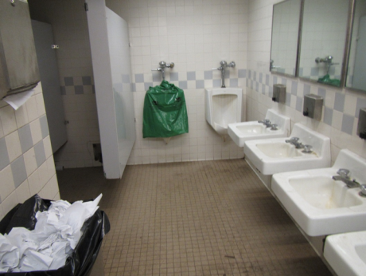
Bathroom with broken urinal
Picture 10
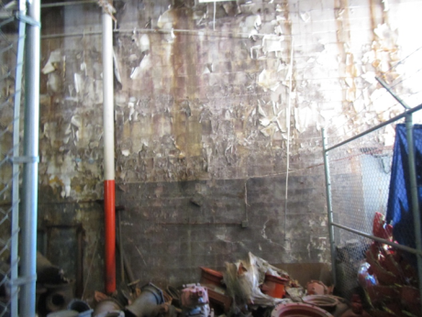
Concrete block wall with peeling paint, debris, and possible microbial growth
Picture 11
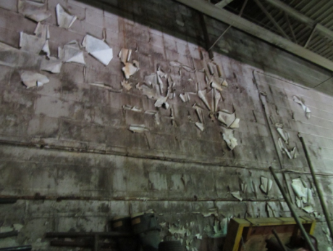
Concrete block with peeling paint, debris, and possible microbial growth
Picture 12
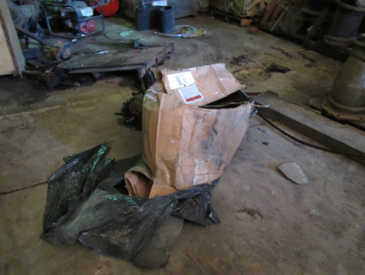
Water-damaged cardboard stored directly on garage floor
Picture 13
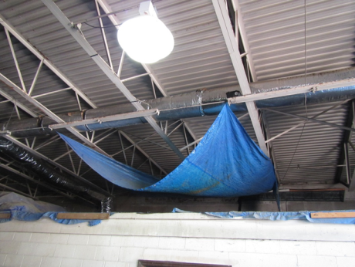
Tarps being used to shed leaking water away from office area below
Picture 14
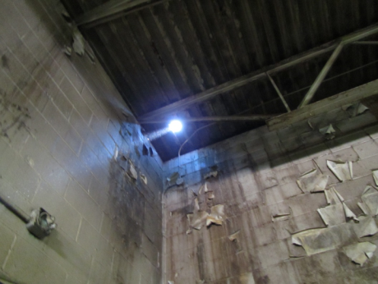
Hole in roof showing penetrating daylight and chronic water damage
Picture 15
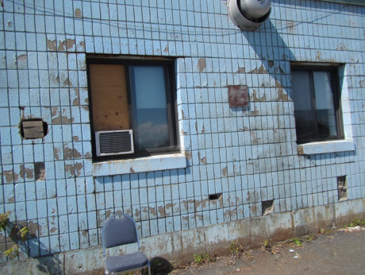
Deteriorating exterior walls of the DPW garage showing open holes
Picture 16
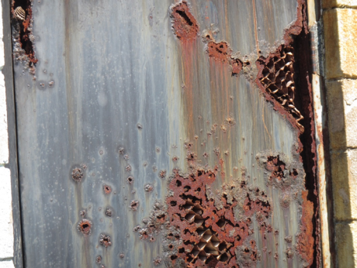
Badly corroded rear exterior door
Picture 17
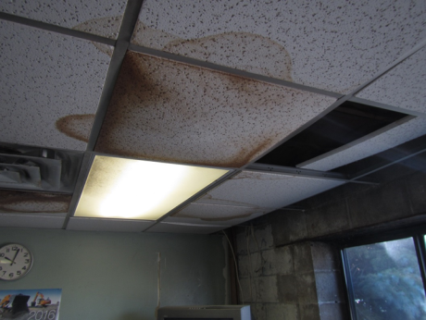
Water-damaged (and missing) ceiling tiles in DPW office
Picture 18
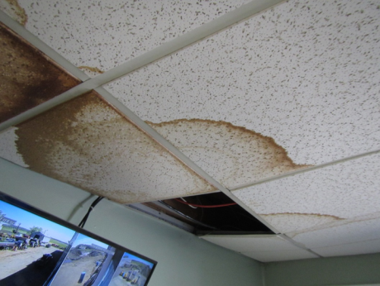
Water-damaged (and missing) ceiling tiles in DPW office
Picture 19
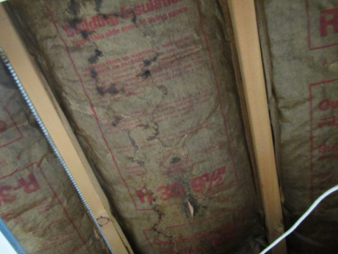
Water-damaged paper-backed insulation in DPW office
Picture 20
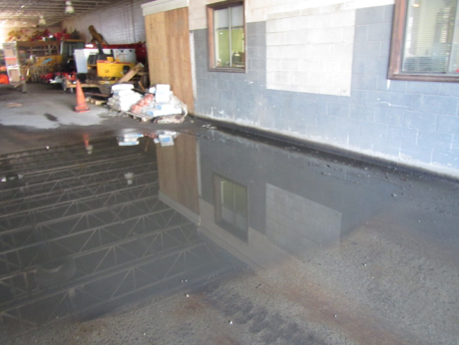
Standing water outside of DPW office area
Picture 21
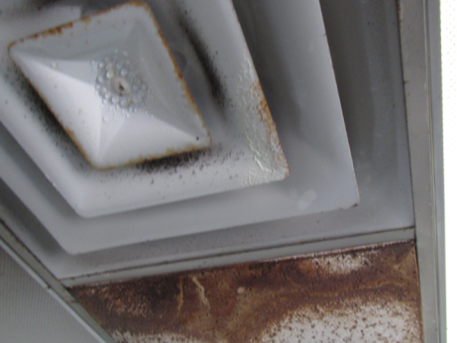
Condensation on supply vent (also note badly water-damaged ceiling tile)
Picture 22
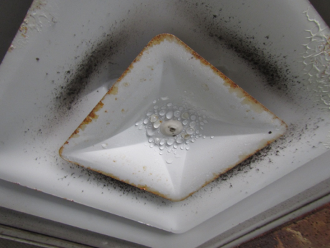
Close up of condensation droplets on supply vent
Location | Carbon  Dioxide  (ppm) | Carbon Monoxide  (ppm) | Temp  (°F) | Relative  Humidity  (%) | PM2.5  (µg/m³) | TVOCs  (ppm) | Occupants  in Room | Windows  Openable | Ventilation |  | Remarks
 |  |  |  |  |  |  |  |  | Supply | Exhaust
Background | 436 | ND | 83 | 43 | 29 | ND | - | - | - | - | Sunny, light breeze
Main Office | 1281 | ND | 74 | 50 | 35 | ND | 4 | Y | Y | N | Multiple MTs & WD CTs, condensation on supply vents
General Office | 1237 | ND | 71 | 49 | 31 | ND | 4 | Y | Y | Y | 1 Return for all office areas, multiple WD CTs, MTs
Main Garage - center | 426 | ND | 79 | 49 | 34 | ND | 3 | Doors open | N | Y | 4 ceiling exhaust vents, chronic water leaks, standing water, no floor drains
Main Garage - rear | 476 | ND | 80 | 50 | 37 | ND | 3 | Doors open | N | Y | Standing water, WD walls, peeling paint and debris with likely microbial growth, WD porous items on floor
Break Room | 644 | ND | 81 | 54 | 35 | ND | 2 | N | N | N | Very dusty, no AHU, MTs
Lounge | 614 | ND | 81 | 54 | 30 | ND | 3 | Y | N | N | MTs
Foreman’s Office | 559 | ND | 80 | 54 | 60 | ND | 1 | Y | Y off | N | Rubber couplings, parts, CPs, dusty

