INDOOR AIR QUALITY ASSESSMENT

Holyoke DPW
Pellisier Building
63 Canal Street
Holyoke, MA

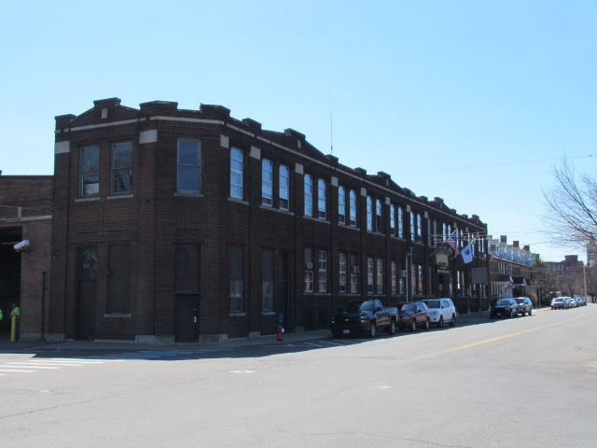

Prepared by:
Massachusetts Department of Public Health
Bureau of Environmental Health
Indoor Air Quality Program
August 2016
BACKGROUND
Building: | Holyoke Department of Public Works (DPW), Pellissier Building
Address: | 63 Canal Street  Holyoke, MA
Assessment Requested by: | Marcus Gabrieli, Safety Inspector Holyoke Department of Public Works
Reason for Request: | Mold/water damage in the building
Date of Assessment: | April 15, 2016
Massachusetts Department of Public Health/Bureau of Environmental Health (MDPH/BEH) Staff Conducting Assessment: | Mike Feeney, Director, Indoor Air Quality (IAQ) Program
Date Building Constructed: | 1900s
Building Description: | Constructed as a trolley barn for the Holyoke Street Railway Company. Now used for vehicle maintenance, storage, and a trash transfer station.
Building Population: | Approximately 8 employees are in offices

Methods
Please refer to the IAQ Manual for methods, sampling procedures, and interpretation of results (MDPH, 2015).

IAQ Testing Results
The following is a summary of indoor air testing results (Table 1).
- Carbon dioxide levels were below the MDPH recommended level of 800 parts per million (ppm) in all areas surveyed, indicating inadequate air exchange in the building.
- Temperature was within or close to the lower limit of the MDPH recommended range of 70°F to 78°F in all occupied areas surveyed.
- Relative humidity was below the MDPH recommended range of 40 to 60% in all areas tested.
- Carbon monoxide levels were non-detectable in all areas tested.
- Particulate matter (PM2.5) concentrations measured were below the National Ambient Air Quality (NAAQS) level of 35 μg/m³ in all areas tested.

Ventilation
A heating, ventilating, and air conditioning (HVAC) system has several functions. First it provides heating and, if equipped, cooling. Second, it is a source of fresh air. Finally, an HVAC system will dilute and remove normally-occurring indoor environmental pollutants not only by introducing fresh air, but also by filtering the airstream and ejecting stale air to the outdoors via exhaust ventilation. Even if an HVAC system is operating as designed, point sources of respiratory irritation may exist and cause symptoms in sensitive individuals. The following analysis examines and identifies components of the HVAC system and likely sources of respiratory irritant/allergen exposure from water damage, aerosolized dust, and/or chemicals found in the indoor environment.
No mechanical ventilation system exists in the office areas of the building. The sole source of fresh air is openable windows. Window-mounted air conditioners are used to provide cooling during hot weather. A number of areas were empty/sparsely populated at the time of the assessment; low occupancy can greatly reduce carbon dioxide levels. Carbon dioxide levels may also rise during cooler months of the heating season.
Vehicle bays, where train trolleys were originally stored, have turbine exhaust vents on the roof (Picture 1) and mechanical exhaust fans that were retrofitted into exterior wall windows.

Microbial/Moisture Concerns
BEH staff were asked to examine the DPW for water damage due to staff concerns and reported health symptoms. It is important to note that the building is primary constructed of materials such as stone, brick, plaster, and hard wood floors. These materials are unlikely to support mold growth, even when exposed to periodic water leaks. BEH staff did note accumulations of powdery, white material in areas with brick and mortar on the second floor of the building (Pictures 2 through 4). The white material is called efflorescence; efflorescence is a characteristic sign of water damage to building materials such as brick, mortar, or plaster, but it is not mold growth. As moisture penetrates and works its way through mortar around brick as well as plaster, water-soluble compounds dissolve, creating a solution. As the solution moves to the surface of the wall, water evaporates, leaving behind white, powdery mineral deposits. This condition indicates that water from the exterior has penetrated into the building. Plaster and brick do not typically support mold growth because these materials are not carbon-based; however, paint, items, or debris near the walls that are moistened may become mold-colonized. When present, efflorescence can be readily cleaned.
A number of occupied offices contain wall-to-wall carpeting. One carpet appears to have been discolored due to repeated exposure to steam from the office radiator (Picture 5). It is also likely that the wall-to-wall carpet is nearly 30 years old. The average service life of carpeting is approximately eleven years (Bishop, 2002). It was unclear if the building has a regular carpet cleaning program. The Institute of Inspection, Cleaning and Restoration Certification (IICRC), recommends that carpeting be cleaned annually (or semi-annually in soiled high traffic areas) (IICRC, 2012).
Water-damaged ceiling tiles were observed above windows in some areas (Picture 6). The US Environmental Protection Agency (US EPA) and the American Conference of Governmental Industrial Hygienists (ACGIH) recommends that porous materials be dried with fans and heating within 24 to 48 hours of becoming wet (US EPA, 2008; ACGIH, 1989). If porous materials are not dried within this time, mold growth may occur.
DPW staff reported a number of water leaks in the garage bays. BEH staff examined the roof and found the following conditions that could contribute to breaches in the roof.
- The front of the building has a roof edge that is topped by a parapet (Picture 7). Parts of the parapet appear to be leaning inwards toward the roof, instead of being perpendicular to the roof. It cannot be determined if this condition was original to the construction of the building or is a sign of progressive movement of the parapet brickwork.
- The back of the roof contains a skylight that appears to be collapsing (Picture 8).
- A large crack in a wall into the garage bay opening was observed near the damaged skylight (Picture 9). Beneath the cracked wall inside the engine bay is a large steel roll-up door. The roll-up door appears to have been retrofitted into the garage bay sometime after the initial construction of the building. It appears that in order to install the roll-up door, the end of a large steel support beam as well as interior wall brickwork was removed (Picture 10 and 11). The crack in Picture 9 is located directly above the removed steel support beam and brickwork.
These conditions may be a source of water leaks in the building. In order to repair thoroughly, repointing of the wall/brickwork will likely be necessary.

Other Conditions
The office area shares an interior wall with the engine bay, which has a number of windows (Picture 12) and doors. Due to wear and age, the windows and doors are not likely to close tightly and likely allow for air from the garage bays to enter into the office areas.

CONCLUSIONS/RECOMMENDATIONS
A number of building conditions observed may contribute to respiratory symptoms reported. These conditions/issues combined with a lack of a mechanical ventilation system for fresh air supply and exhaust capabilities can play a role in causing and/or exacerbating respiratory symptoms described by building occupants.
Correcting some of the issues may take significant planning and capital resources. In view of these findings, two sets of recommendations are made: short-term measures that may be implemented as soon as practicable and long-term measures that will require planning and resources to address overall IAQ concerns.

Short-Term Recommendations
- Seal the holes and seams in windows of the shared wall of the offices and the garage bay. Install weather stripping and door sweeps on doors.
- Install carbon monoxide detectors in each occupied level of the building.
- Remove all water-damaged ceiling tiles in a manner consistent with guideline set forth in the US EPA document, Mold Remediation in Schools and Commercial Buildings.
- Remove carpeting from offices as needed.
- Repair/repaint areas of peeling plaster on walls and the ceiling. If lead paint is a concern, ensure that lead-safe procedures are used in accordance with the Department of Labor Standards Regulations, 454 CMR 22.
- Occupied areas should have either a mechanical ventilation system with fresh air supplies or openable windows; areas with neither should not be used as offices.
- Ensure window air conditioners are maintained regularly including cleaning of the filters and louvers.
- For buildings in New England, periods of low relative humidity during the winter are often unavoidable. Therefore, scrupulous cleaning practices should be adopted to minimize common indoor air contaminants whose irritant effects can be enhanced when the relative humidity is low.
- Use a vacuum cleaner equipped with a high efficiency particulate arrestance (HEPA) filter in conjunction with wet wiping to remove dust from all surfaces. Avoid the use of feather dusters.
- Drinking water during the day can help ease some symptoms associated with a dry environment (throat and sinus irritations).
- Refer to resource manual and other related indoor air quality documents located on the MDPH’s website for further building-wide evaluations and advice on maintaining public buildings. These documents are available at http://mass.gov/dph/iaq.

Long Term Recommendations

- Have a building engineer examine the parapet and wall around and below the skylight to determent the best method for remediating water leakage.
- Have the brickwork throughout the building repointed.
- Examine the feasibility of installing a fresh air supply and exhaust system to the existing HVAC system.

REFERENCES
ACGIH. 1989. Guidelines for the Assessment of Bioaerosols in the Indoor Environment. American Conference of Governmental Industrial Hygienists, Cincinnati, OH.
Bishop, J. 2002. Institute of Inspection, Cleaning and Restoration Certification.: A Life Cycle Cost Analysis for Floor Coverings in School Facilities.
IICRC. 2012. Institute of Inspection, Cleaning and Restoration Certification. Carpet Cleaning: FAQ. Retrieved from http://www.iicrc.org/consumers/care/carpet-cleaning/#faq.
MDPH. 2015. Massachusetts Department of Public Health. “Indoor Air Quality Manual: Chapters I-III”. Available from http://www.mass.gov/eohhs/gov/departments/dph/programs/environmental-health/exposure-topics/iaq/iaq-manual/
US EPA. 2008. Mold Remediation in Schools and Commercial Buildings. US Environmental Protection Agency, Office of Air and Radiation, Indoor Environments Division, Washington, D.C. EPA 402-K-01-001. http://www.epa.gov/mold/mold-remediation-schools-and-commercial-buildings-guide.
Picture 1
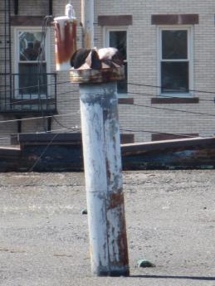
Turbine vent

Picture 2
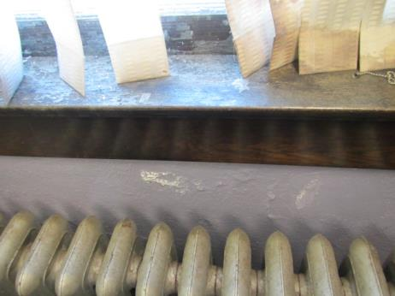
Efflorescence below first floor window underneath paint

Picture 3
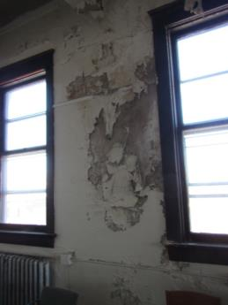
Efflorescence and peeling paint, second floor

Picture 4
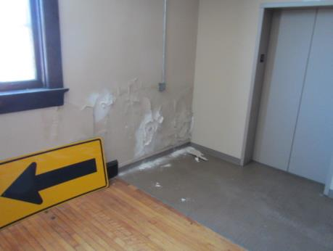
Efflorescence and peeling paint, second floor

Picture 5
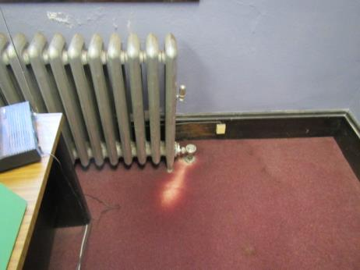
Water-damaged carpet

Picture 6
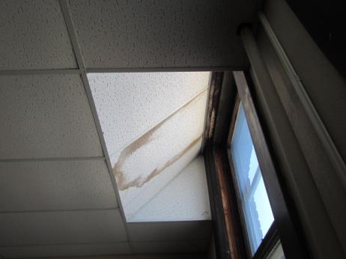
Water-damaged ceiling tile at window

Picture 7
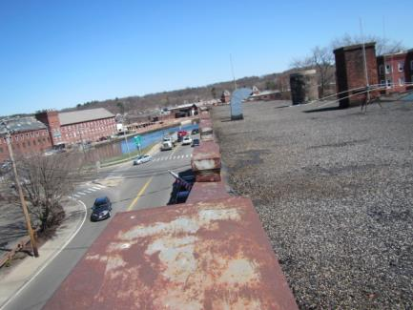
Parapet at front of building

Picture 8
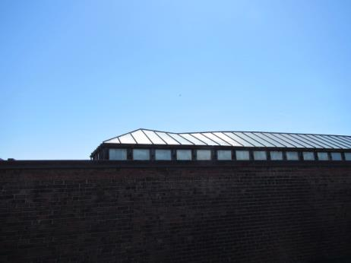
Collapsing skylight

Picture 9
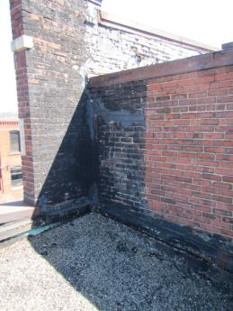
Crack in wall above garage bay

Picture 10
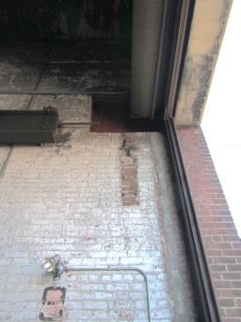
Steel beam
Removed brick
Roll-up door
Location where steel beam removed

Area below roof wall in Picture 9
Picture 11
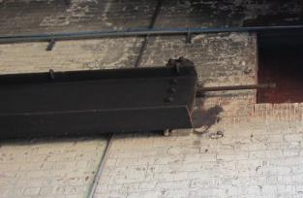
Close-up of cut beam, note uneven end

Picture 12
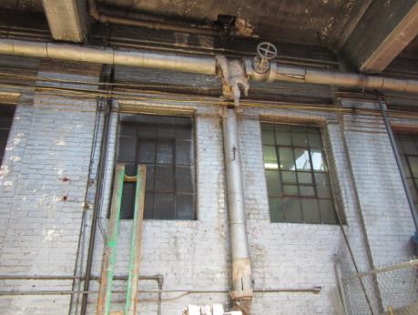
Shared windows between vehicle area and office areas

Location | Carbon  Dioxide  (ppm) | Carbon Monoxide  (*ppm) | Temp  (°F) | Relative  Humidity  (%) | PM2.5  (µg/m3) | Occupants  in Room | Windows  Openable | Ventilation |  | Remarks
 |  |  |  |  |  |  |  | Intake | Exhaust
Background | 420 | ND | 67 | 22 | 7
Show room | 616 | ND | 72 | 18 | 13 | 0 | Y | N | N | Window-mounted air conditioner
Outdoor superintendent | 610 | ND | 72 | 18 | 12 | 1 | Y | N | N | Window-mounted air conditioner
Main office | 670 | ND | 72 | 22 | 18 | 1 | Y | N | N | Window-mounted air conditioner
Safe | 695 | ND | 70 | 23 | 12 | 0 | Y | N | N
Waiting room | 667 | ND | 69 | 22 | 15 | 0 | Y | N | N
Office manager | 582 | ND | 69 | 21 | 16 | 0 | Y | N | N | Window-mounted air conditioner, water-damaged carpet, water-damaged wall
General superintendent | 514 | ND | 68 | 20 | 14 | 0 | Y | N | N | Window-mounted air conditioner
Conference room | 520 | ND | 69 | 20 | 14 | 0 | Y | N | N
Sign storage | 560 | ND | 67 | 22 | 12 | 0 | Y | N | N | Water-damaged plaster
Upstairs meeting room | 548 | ND | 65 | 22 | 13 | 0 | Y | N | N | Water-damaged plaster

