INDOOR AIR QUALITY ASSESSMENT

Milton Department of Public Works
629 Randolph Ave
Milton, Massachusetts

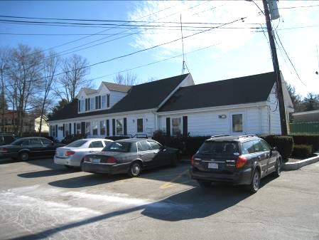

Prepared by:
Massachusetts Department of Public Health
Bureau of Environmental Health
Indoor Air Quality Program
June 2010

Background/Introduction
At the request of Joseph Lynch, Director, Milton Department of Public Works (DPW), the Massachusetts Department of Public Health (MDPH), Bureau of Environmental Health (BEH) provided assistance and consultation regarding indoor air quality concerns at the Milton DPW office located at 629 Randolph Ave, Milton, Massachusetts. The request was prompted by concerns of chronic odors in the engineering area and exacerbation of respiratory symptoms among staff. On February 8, 2010, Cory Holmes, an Environmental Analyst/Regional Inspector for BEH’s Indoor Air Quality (IAQ) Program made a visit to the DPW to conduct an indoor air quality assessment.
A letter detailing conditions observed at the DPW was previously issued, specifically regarding recommendations for remediation of fiberglass insulation contaminated by rodent wastes (MDPH, 2010). This report focuses on general IAQ conditions throughout the DPW.
The DPW is a one-story wooden building with a basement built in the 1940s-1950s. It was reportedly used by a lumber company before it was moved from its original location to 629 Randolph Ave in the 1970s. The DPW has occupied the building for approximately 5-6 years; prior to that, it was used as a storage facility by the town of Milton. The basement is currently used for storage and the building also has a crawlspace attic. Windows are openable throughout the DPW. Window mounted air conditioners are used to provide cooling in summer months.

Method
Air tests for carbon dioxide, temperature, relative humidity and carbon monoxide were conducted with the TSI, Q-Trak, IAQ Monitor, Model 7565. Screening for total volatile organic compounds (TVOCs) was conducted using a Thermo Environmental Instruments Inc., Model 580 Series Photo Ionization Detector (PID). BEH staff also performed a visual inspection of building materials for water damage and/or microbial growth.

Results
The DPW has an employee population of approximately 6-10 and can be visited by up to 10 individuals daily. Tests were taken during normal operations and results appear in Table 1.

Discussion

Ventilation
It can be seen from Table 1 that carbon dioxide levels were below 800 parts per million (ppm) in all areas surveyed, indicating adequate air exchange throughout the building at the time of the assessment. It is important to note that although air exchange appeared adequate, the DPW is not equipped with a mechanical ventilation system, thus the sole source of ventilation is openable windows. However, air conditioners (ACs) examined were equipped with a “fan only” or “exhaust open” setting. In this mode of operation, air conditioning units can provide air circulation by delivering limited outside air into the space without cooling.
The Massachusetts Building Code requires that each room have ventilation to provide fresh outside air or openable windows (SBBRS, 1997; BOCA, 1993). The ventilation must be on at all times that the room is occupied. Providing adequate fresh air ventilation with open windows and maintaining the temperature in the comfort range during the cold weather season is impractical. Mechanical ventilation is usually required to provide adequate fresh air ventilation.
Carbon dioxide is not a problem in and of itself. It is used as an indicator of the adequacy of the fresh air ventilation. As carbon dioxide levels rise, it indicates that the ventilating system is malfunctioning or the design occupancy of the room is being exceeded. When this happens, a buildup of common indoor air pollutants can occur, leading to discomfort or health complaints. The Occupational Safety and Health Administration (OSHA) standard for carbon dioxide is 5,000 parts per million parts of air (ppm). Workers may be exposed to this level for 40 hours/week, based on a time-weighted average (OSHA, 1997).
The MDPH uses a guideline of 800 ppm for publicly occupied buildings. A guideline of 600 ppm or less is preferred in schools due to the fact that the majority of occupants are young and considered to be a more sensitive population in the evaluation of environmental health status. Inadequate ventilation and/or elevated temperatures are major causes of complaints such as respiratory, eye, nose and throat irritation, lethargy and headaches. For more information concerning carbon dioxide, consult Appendix A.
Temperature measurements in occupied areas ranged from 69° F to 72° F, which were slightly below or near the lower end of the MDPH recommended range (Table 1). The MDPH recommends that indoor air temperatures be maintained in a range of 70° F to 78° F in order to provide for the comfort of building occupants. In many cases concerning indoor air quality, fluctuations of temperature in occupied spaces are typically experienced, even in a building with an adequate fresh air supply.
The relative humidity measured in occupied areas ranged from 15 to 18 percent, which was below the MDPH recommended comfort range (Table 1). The MDPH recommends a comfort range of 40 to 60 percent for indoor relative humidity. Relative humidity levels in the building would be expected to drop during the winter months due to heating. The sensation of dryness and irritation is common in a low relative humidity environment. Low relative humidity is a very common problem during the heating season in the northeast part of the United States.

Microbial/Moisture Concerns
In order for building materials to support mold growth, a source of water exposure is necessary. It appears that the DPW has had chronic issues with water penetration through the building envelope, mainly in the form of roof leaks and water penetration through the foundation. It was reported that roof repairs and drainage improvements have been conducted in recent years, which have improved conditions; however significant signs of water damage remain in both the attic and basement. The roof is reportedly over 20 years old, which is near the end of its useful lifespan. Although the roof has been patched/repaired, damaged/degraded shingles and flashing exist in several areas (Picture 1).
BEH staff examined the outside perimeter of the building to identify breaches in the building envelope and/or other conditions that could provide a source of moisture. A number of exterior sources for moisture infiltration were identified:
- Missing/damaged flashing along the roof (Picture 2);
- Damage creating spaces between wooden shingles was observed (Picture 3);
- Paint on exterior fascia board and walls had chipped/peeling paint, exposing wood fibers to moisture which can accelerate decomposition (Pictures 4 and 5);
- Open utility holes (Picture 5), and
- Signs of past water pooling in the basement in the form of efflorescence. Efflorescence is a characteristic sign of water damage but it is not mold growth. As moisture penetrates and works its way through mortar, brick or plaster, water-soluble compounds dissolve, creating a solution. As the solution moves to the surface of the material, the water evaporates, leaving behind white, powdery mineral deposits.
These conditions can undermine the integrity of the building envelope and provide a means of water entry by capillary action into the building through exterior walls, foundation concrete and masonry (Lstiburek & Brennan, 2001). In addition, these breaches in exterior areas can provide a means of drafts and pest entry into the building.
Past flooding also appears to have caused water damage to vinyl floor tiles in the restroom. These tiles should be removed and replaced to avoid a tripping hazard. The US Environmental Protection Agency (US EPA) and the American Conference of Governmental Industrial Hygienists (ACGIH) recommend that porous materials be dried with fans and heating within 24 to 48 hours of becoming wet (US EPA, 2001; ACGIH, 1989). If not dried within this time frame, mold growth may occur. Once mold has colonized porous materials, they are difficult to clean and should be removed/discarded.

Other IAQ Evaluations
Indoor air quality can be negatively influenced by the presence of respiratory irritants, such as products of combustion. The process of combustion produces a number of pollutants. Common combustion emissions include carbon monoxide, carbon dioxide, water vapor and smoke (fine airborne particle material). Of these materials, exposure to carbon monoxide can produce immediate, acute health effects upon exposure. To determine whether combustion products were present in the building environment, BEH staff obtained measurements for carbon monoxide.
Carbon monoxide is a by-product of incomplete combustion of organic matter (e.g., gasoline, wood and tobacco). Exposure to carbon monoxide can produce immediate and acute health effects. Several air quality standards have been established to address carbon monoxide and prevent symptoms from exposure to these substances. The MDPH established a corrective action level concerning carbon monoxide in ice skating rinks that use fossil-fueled ice resurfacing equipment. If an operator of an indoor ice rink measures a carbon monoxide level over 30 ppm, taken 20 minutes after resurfacing within a rink, that operator must take actions to reduce carbon monoxide levels (MDPH, 1997).
The American Society of Heating Refrigeration and Air-Conditioning Engineers (ASHRAE) has adopted the National Ambient Air Quality Standards (NAAQS) as one set of criteria for assessing indoor air quality and monitoring of fresh air introduced by HVAC systems (ASHRAE, 1989). The NAAQS are standards established by the US EPA to protect the public health from six criteria pollutants, including carbon monoxide and particulate matter (US EPA, 2006). As recommended by ASHRAE, pollutant levels of fresh air introduced to a building should not exceed the NAAQS levels (ASHRAE, 1989). The NAAQS were adopted by reference in the Building Officials & Code Administrators (BOCA) National Mechanical Code of 1993 (BOCA, 1993), which is now an HVAC standard included in the Massachusetts State Building Code (SBBRS, 1997). According to the NAAQS, carbon monoxide levels in outdoor air should not exceed 9 ppm in an eight-hour average (US EPA, 2006).
Carbon monoxide should not be present in a typical, indoor environment. If it is present, indoor carbon monoxide levels should be less than or equal to outdoor levels. On the day of the assessment, outdoor carbon monoxide concentrations were non-detect (ND) (Table 1). No measurable levels of carbon monoxide were detected inside the building at the time of the assessment (Table 1).

Volatile Organic Compounds
Indoor air concentrations can be greatly impacted by the use of products containing volatile organic compounds (VOCs). VOCs are carbon-containing substances that have the ability to evaporate at room temperature. Frequently, exposure to low levels of total VOCs (TVOCs) may produce eye, nose, throat and/or respiratory irritation in some sensitive individuals. For example, chemicals evaporating from a paint can stored at room temperature would most likely contain VOCs. In an effort to determine whether VOCs were present in the building, air monitoring for TVOCs was conducted. An outdoor air sample was taken for comparison. Outdoor TVOC concentrations were ND. No measurable levels of TVOCs were detected inside the building at the time of the assessment (Table 1). Please note, TVOC air measurements are only reflective of the indoor air concentrations present at the time of sampling.

Other Conditions
Other conditions that can affect indoor air quality were observed during the assessment. Window-mounted air conditioners (ACs) were observed in some areas (Table 1). These units are normally equipped with filters, which should be cleaned or changed as per manufacturer’s instructions. AC filters had dirt, dust and debris accumulation. In order to prevent equipment from serving as a source of aerosolized particulates, filters should be regularly cleaned (or changed) as needed.

Conclusions/Recommendations
The conditions related to indoor air quality at the DPW raise a number of issues. Some of these conditions can be remedied by actions of building occupants. Other remediation efforts will require alteration to the building structure and equipment. For these reasons, a two-phase approach is recommended. The first consists of short-term measures to improve air quality and the second consists of long-term measures that will require planning and resources to adequately address the overall indoor air quality concerns.

Short-Term Recommendations
- Open windows (weather permitting) to temper rooms and provide fresh outside air. Care should be taken to ensure windows are properly closed at night and weekends to avoid the freezing of pipes and potential flooding.
- Supplement fresh air by operating window-mounted air conditioners in the "fan only" “fresh air” mode, which introduces outside air by mechanical means.
- Replace missing/damaged roof shingles.
- Repair/replace faulty/leaking roof flashing.
- Continue to monitor areas of the building for roof leaks, make repairs and change ceiling tiles as necessary. Disinfect areas of water leaks with an appropriate antimicrobial.
- Repair rotted, cracked and broken wooden clapboards/shingles.
- Repaint exterior surfaces that exhibit peeling paint.
- Seal open utility holes and other breaches around exterior of building.
- Consider having foundation re-pointed and/or waterproofed to prevent further water intrusion.
- Clean efflorescence from basement floors and monitor for further water penetration.
- Replace water damaged floor tiles in restroom.
- For buildings in New England, periods of low relative humidity during the winter are often unavoidable. Therefore, scrupulous cleaning practices should be adopted to minimize common indoor air contaminants whose irritant effects can be enhanced when the relative humidity is low. To control for dusts, a high efficiency particulate arrestance (HEPA) filter equipped vacuum cleaner in conjunction with wet wiping of all surfaces is recommended. Avoid the use of feather dusters. Drinking water during the day can help ease some symptoms associated with a dry environment (throat and sinus irritations).
- Clean/change filters for ACs as per the manufacturer’s instructions or more frequently if needed.
- Refer to resource manual and other related indoor air quality documents located on the MDPH’s website for further building-wide evaluations and advice on maintaining public buildings. These documents are available at: http://mass.gov/dph/iaq.

Long-Term Recommendations
- Continue to make repairs of roof leaks as necessary. Consideration should be made to replace the roof to prevent chronic roof leaks and further water damage.
- Consider consulting with an architect, masonry firm or general contractor regarding the integrity of the building envelope, primarily concerning water penetration through the exterior walls and foundation.

References
ACGIH. 1989. Guidelines for the Assessment of Bioaerosols in the Indoor Environment. American Conference of Governmental Industrial Hygienists, Cincinnati, OH.
ASHRAE. 1989. Ventilation for Acceptable Indoor Air Quality. American Society of Heating, Refrigeration and Air Conditioning Engineers. ANSI/ASHRAE 62-1989.
BOCA. 1993. The BOCA National Mechanical Code/1993. 8th ed. Building Officials and Code Administrators International, Inc., Country Club Hill, IL.
Lstiburek, J. & Brennan, T. 2001. Read This Before You Design, Build or Renovate. Building Science Corporation, Westford, MA. U.S. Department of Housing and Urban Development, Region I, Boston, MA.
MDPH. 1997. Requirements to Maintain Air Quality in Indoor Skating Rinks (State Sanitary Code, Chapter XI). 105 CMR 675.000. Massachusetts Department of Public Health, Boston, MA.
MDPH. 2010. Letter to DPW Director Joseph W. Lynch Regarding Remediation of Fiberglass Insulation Contaminated with Rodent Wastes. Dated February, 23, 2010. Massachusetts Department of Public Health, Boston, MA.
OSHA. 1997. Limits for Air Contaminants. Occupational Safety and Health Administration. Code of Federal Regulations. 29 C.F.R 1910.1000 Table Z-1-A.
SBBRS. 1997. Mechanical Ventilation. State Board of Building Regulations and Standards. Code of Massachusetts Regulations. 780 CMR 1209.0
US EPA. 2001. “Mold Remediation in Schools and Commercial Buildings”. Office of Air and Radiation, Indoor Environments Division, Washington, DC. EPA 402-K-01-001. March 2001. Available at: http://www.epa.gov/iaq/molds/mold_remediation.html
US EPA. 2006. National Ambient Air Quality Standards (NAAQS). US Environmental Protection Agency, Office of Air Quality Planning and Standards, Washington, DC. http://www.epa.gov/air/criteria.html
Picture 1

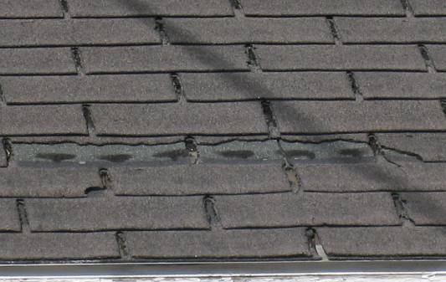

Missing/Damaged Roof Shingles

Picture 2

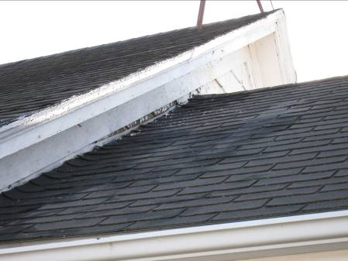

Missing/Damaged Flashing along Roof Junction

Picture 3

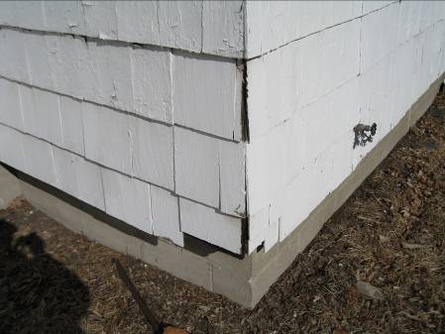

Damaged Wooden Shingles

Picture 4

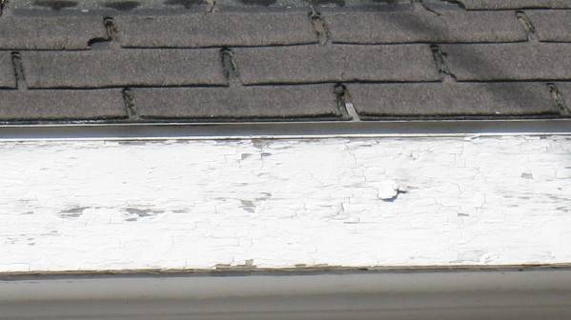

Chipped/Peeling Paint on Fascia Board

Picture 5

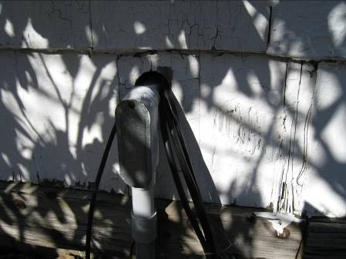

Utility Hole and Chipped/Peeling Paint
Location/ Room | Occupants  in Room | Temp  (°F) | Relative  Humidity  (%) | Carbon  Dioxide  (ppm) | Carbon Monoxide  (ppm) | TVOCs  (ppm) | Windows  Openable | Ventilation |  | Remarks
 |  |  |  |  |  |  |  | Supply | Exhaust | Remarks
background |  | <32 | 22 | 332 | ND | ND |  |  |  | Below freezing, winds: WNW 16-26 MPH, with gusts up to 35 MPH
Engineering | 0 | 69 | 16 | 607 | ND | ND | Y | N | N | Slight odors along north wall, wood paneling removed: fiberglass insulation contaminated with rodent wastes and carcasses
Main Reception Area | 0 | 69 | 16 | 607 | ND | ND | Y | N | N
Center Work Area | 0 | 72 | 16 | 640 | ND | ND | Y | N | N
Bathroom | 0 | 71 | 16 | 680 | ND | ND | Y | N | Y | Floor tiles peeling/damaged from moisture exposure
Town Engineer Office | 0 | 71 | 15 | 650 | ND | ND | Y | N | N | Dusty AC, Filter clogged
DPW Director | 1 | 72 | 18 | 799 | ND | ND | Y | N | N
Basement | 0 | 57 | 22 | 378 | ND | ND | Y | N | N | Efflorescence on cement floor, chronic signs of leaks on walls, floor board/panels
Attic | 0 | 56 | 23 | 392 | ND | ND | N | N | Y | Chronic signs of leaks on walls, floor board, buckets to catch water

