INDOOR AIR QUALITY ASSESSMENT

Stoughton Public Works Department
950 Central Street
Stoughton, Massachusetts

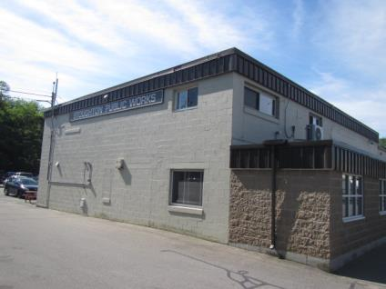

Prepared by:
Massachusetts Department of Public Health
Bureau of Environmental Health
Indoor Air Quality Program
July 2018

BACKGROUND
Building: | Stoughton Public Works Department
Address: | 950 Central Street, Stoughton, MA
Assessment Requested by: | Paul Giffune, Director, Town of Stoughton Facilities Department
Reason for Request: | General indoor air quality (IAQ) and mold concerns.
Date of Assessment: | June 15 and 19, 2018
Massachusetts Department of Public Health/Bureau of Environmental Health (MDPH/BEH) Staff Conducting Assessment: | Cory Holmes, Environmental Analyst/Inspector IAQ Program
Date of Building Construction: | Originally constructed in the 1950s, addition/renovations in the early 2000s.
Building Description: | Two-story concrete building containing offices attached to a garage/work area.
Building Population: | 10 to 15
Windows: | Openable

METHODS
Please refer to the IAQ Manual and appendices for methods, sampling procedures, and interpretation of results (MDPH, 2015).

RESULTS and DISCUSSION
The following is a summary of indoor air testing results (Table 1).
- Carbon dioxide levels were below the MDPH recommended level of 800 parts per million (ppm) in all areas surveyed, which indicates adequate air exchange at the time of assessment.
- Temperature was within the MDPH recommended range of 70°F to 78°F in areas tested.
- Relative humidity was within or very close to the MDPH recommended range of 40 to 60% in all areas tested.
- Carbon monoxide levels were non-detectable (ND) in all areas tested.
- Particulate matter (PM2.5) concentrations measured were below the National Ambient Air Quality (NAAQS) level of 35 μg/m³ in all areas tested.

Ventilation
The heating, ventilation and air conditioning (HVAC) system consists of rooftop handling units (AHUs) (Picture 1). Conditioned air is filtered (Picture 2) and delivered to spaces via ceiling-mounted supply diffusers (Picture 3). Air is drawn into the above ceiling plenum through grates (Picture 4) or wall vents (Picture 5) and returned back to the rooftop units via ductwork. The system does not have the ability to introduce outside air but recirculates only. Fresh/outside air is introduced via windows.
It is important to note that the rooftop HVAC equipment appears to be over 20 years old. Efficient function of equipment of this age is difficult to maintain, since compatible replacement parts are often unavailable. According to the American Society of Heating, Refrigeration and Air-Conditioning Engineering (ASHRAE), the service life for the various components of the HVAC system is between 20 to 30 years, assuming routine maintenance of the equipment (ASHRAE, 1991). Despite attempts to maintain the equipment, the optimal operational lifespan of this equipment may be exceeded.
The filters installed in the AHU at the time of the visit were of a mesh type that do not filter out smaller particulates (Picture 2). The MDPH recommends that AHUs be outfitted with pleated filters of a Minimum Efficiency Reporting Value (MERV) of 8, which are adequate in filtering out pollen and mold spores (ASHRAE, 2012). In addition, filters should be changed 2-4 times a year or in accordance with the manufacture’s recommendations.

Microbial/Moisture Concerns
In order for building materials to support mold growth, a source of water exposure is necessary. The US Environmental Protection Agency (US EPA) and the American Conference of Governmental Industrial Hygienists (ACGIH) recommends that porous materials (e.g., wallboard, carpeting) be dried with fans and heating within 24 to 48 hours of becoming wet (US EPA, 2008; ACGIH, 1989). If porous materials are not dried within this time frame, mold growth may occur.
As previously mentioned, the main reason for the assessment was mold concerns in the “Back Office” on the 2nd floor. At the time of assessment, BEH/IAQ staff performed moisture testing of gypsum wallboard, carpeting, and ceilings in the area of concern. In addition, a visual inspection of building materials for any water damage and/or microbial growth was conducted, including above ceiling tiles. All tested materials were dry at the time of assessment and no water damage, mold growth or associated odors were observed in the area of concern.
A few water-damaged ceiling tiles were observed in other areas (Pictures 6 and 7; Table 1), which can indicate leaks from the building envelope or plumbing system. These tiles should be replaced after the leak is found and repaired.

Other Conditions
Other conditions that can affect IAQ were observed during the assessment. The office areas in the building are carpeted. Carpets should be cleaned annually (or semi-annually in soiled/high traffic areas) in accordance with Institute of Inspection, Cleaning and Restoration Certification (IICRC) recommendations, (IICRC, 2012). Regular cleaning with a high efficiency particulate air (HEPA) filtered vacuum in combination with an annual cleaning will help to reduce accumulation and potential aerosolization of materials from carpeting.
Several supply/return/exhaust vents were observed to have accumulated dust/debris (Pictures 8 and 9). These vents can aerosolize accumulated dust once activated/deactivated and provide a source for mold growth under moist conditions if not cleaned.

CONCLUSIONS and RECOMMENDATIONS
In view of the findings at the time of the visit, the following recommendations are made:
- Change filters in HVAC units 2 to 4 times per year (e.g., between heating/cooling seasons) or as per the manufacturer’s instructions. Upgrade filters in AHUs to MERV 8 or higher.
- As previously discussed, the age, physical deterioration and availability of parts for the rooftop mechanical ventilation system components and controls should be fully evaluated by an HVAC engineering firm to determine the operational lifespan of existing equipment and/or examining the feasibility of repair vs. replacement.
- As a part of repair or replacement, consider systems that will introduce fresh air into the building instead of just recirculating.
- Use openable windows to increase fresh air in the building. Ensure windows have intact screens and are tightly closed at the end of the day.
- Consider adopting a balancing schedule of every 5 years for all mechanical ventilation systems, as recommended by ventilation industrial standards (SMACNA, 1994).
- For buildings in New England, periods of low relative humidity during the winter are often unavoidable. Therefore, scrupulous cleaning practices should be adopted to minimize common indoor air contaminants whose irritant effects can be enhanced when the relative humidity is low. To control for dusts, a high efficiency particulate arrestance (HEPA) filter equipped vacuum cleaner in conjunction with wet wiping of all surfaces is recommended. Avoid the use of feather dusters. Drinking water during the day can help ease some symptoms associated with a dry environment (throat and sinus irritation).
- Replace water-damaged ceiling tiles after leaks are discovered and repaired.
- Clean supply, return, and exhaust vents periodically of accumulated dust.
- Clean carpeting annually or semi-annually in soiled high traffic areas as per the recommendations of the Institute of Inspection, Cleaning and Restoration Certification (IICRC, 2012).
- Refer to resource manual and other related indoor air quality documents located on the MDPH’s website for further building-wide evaluations and advice on maintaining public buildings. These documents are available at http://mass.gov/dph/iaq.

REFERENCES
ACGIH. 1989. Guidelines for the Assessment of Bioaerosols in the Indoor Environment. American Conference of Governmental Industrial Hygienists, Cincinnati, OH.
ASHRAE. 1991. ASHRAE Applications Handbook, Chapter 33 “Owning and Operating Costs”. American Society of Heating, Refrigeration and Air Conditioning Engineers, Atlanta, GA.
ASHRAE. 2012. American Society of Heating, Refrigeration and Air Conditioning Engineers (ASHRAE) Standard 52.2-2012 -- Method of Testing General Ventilation Air-Cleaning Devices for Removal Efficiency by Particle Size (ANSI Approved).
IICRC. 2012. Institute of Inspection, Cleaning and Restoration Certification. Carpet Cleaning: FAQ.
MDPH. 2015. Massachusetts Department of Public Health. “Indoor Air Quality Manual: Chapters I-III”. Available at: http://www.mass.gov/eohhs/gov/departments/dph/programs/environmental-health/exposure-topics/iaq/iaq-manual/.
SMACNA. 1994. HVAC Systems Commissioning Manual. 1st ed. Sheet Metal and Air Conditioning Contractors’ National Association, Inc., Chantilly, VA.
US EPA. 2008. “Mold Remediation in Schools and Commercial Buildings”. Office of Air and Radiation, Indoor Environments Division, Washington, DC. EPA 402-K-01-001. September 2008. Available at: https://www.epa.gov/mold/mold-remediation-schools-and-commercial-buildings-guide.
Picture 1
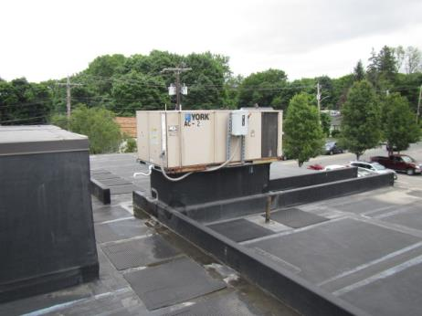
Rooftop air handling unit (AHU)
Picture 2
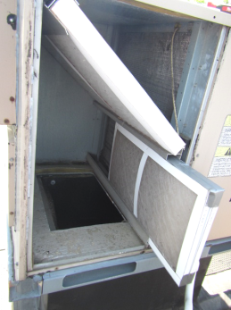
Mesh-type filters in rooftop AHU
Picture 3
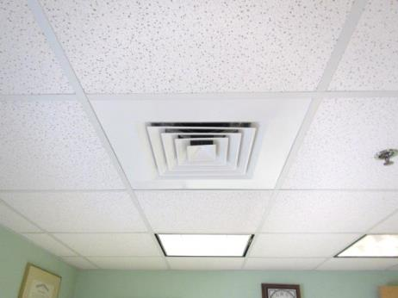
Ceiling-mounted supply diffuser
Picture 4
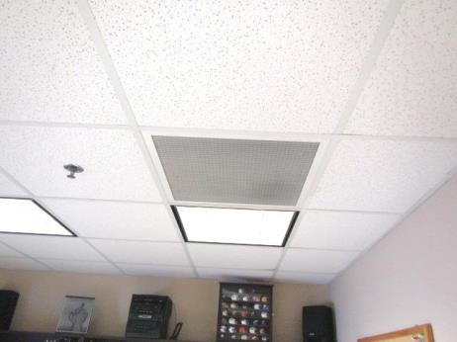
Ceiling-mounted return grate
Picture 5
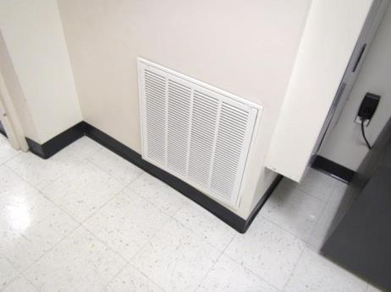
Wall-mounted return vent
Picture 6
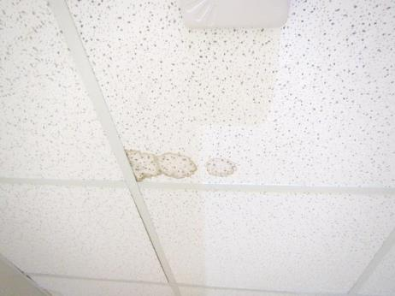
Water-damaged ceiling tile
Picture 7
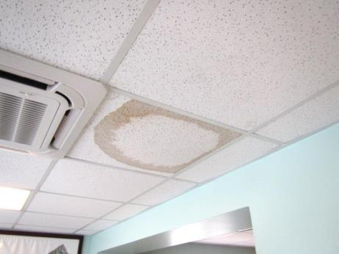
Water-damaged ceiling tile
Picture 8
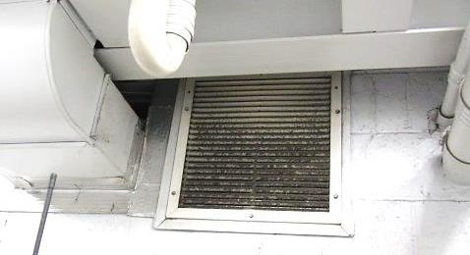
Dust/debris on vent in the staff breakroom on 1st floor
Picture 9
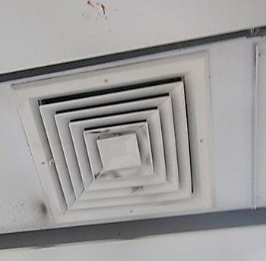
Dust/Debris on/around supply diffuser

Location | Carbon  Dioxide  (ppm) | Carbon Monoxide  (ppm) | Temp  (°F) | Relative  Humidity  (%) | PM2.5  (µg/m³) | TVOCs  (ppm) | Occupants  in Room | Windows  Openable | Ventilation |  | Remarks
 |  |  |  |  |  |  |  |  | Supply | Exhaust
Background | 386 | ND | 77 | 61 | 18 | ND
2nd Floor
Foreman’s Room | 634 | ND | 76 | 43 | 10 | ND | 2 | N | Y | Y | Carpeting
Superintendent’s Office | 704 | ND | 74 | 42 | 11 | ND | 2 | Y | Y | Y | DO, carpeting-stained
McNulty Office | 656 | ND | 73 | 39 | 24 | ND | 0 | Y | Y | Y | DO, carpeting
Gair Office | 649 | ND | 71 | 42 | 7 | ND | 0 | N | Y | Y | DO, carpeting
Men’s Restroom |  |  |  |  |  |  |  | N | Y  Door | Y | Dusty exhaust vent
Director’s Office | 678 | ND | 71 | 39 | 19 | ND | 0 | Y | Y | Y | Carpeting, dehumidifier
Plan Room | 620 | ND | 71 | 40 | 13 | ND | 0 | Y | Y | N
Back Office | 603 | ND | 71 | 39 | 7 | ND | 0 | Y | Y | Y | No current signs of water damage or visible mold growth in room or above ceiling. Moisture testing of ceiling, walls, carpet all normal (i.e., dry)
2nd Floor Hallway | 583 | ND | 71 | 40 | 10 | ND | 0 | N | Y | Y | WD CT
1st Floor
Break Room | 446 | ND | 71 | 54 | 10 | ND | 0 | Y | Y | Y | Dust/debris on vents
DPW Service | 627 | ND | 72 | 53 | 11 | ND | 0 | N | Y | Y | 2 WD CTs
DPW Office | 655 | ND | 73 | 50 | 10 | ND | 4 | Y | Y | Y | Carpeting
Copy Room | 602 | ND | 72 | 47 | 8 | ND | 0 | Y | Y | Y | Carpeting

The service life is the median time during which a particular system or component of …[an HVAC]… system remains in its original service application and then is replaced. Replacement may occur for any reason, including, but not limited to, failure, general obsolescence, reduced reliability, excessive maintenance cost, and changed system requirements due to such influences as building characteristics or energy prices (ASHRAE, 1991).

