**INDOOR AIR QUALITY ASSESSMENT**

**Department of Public Works**

**Garage Complex**

**55R Summer Street**

**Lynnfield, Massachusetts**

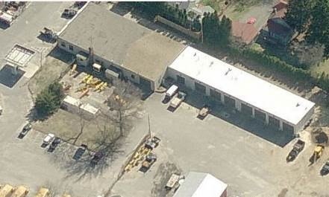

Prepared by:

Massachusetts Department of Public Health

Bureau of Environmental Health

Indoor Air Quality Program

March 2016

# BACKGROUND

|  |  |
| --- | --- |
| Building: | Department of Public Works Garage Complex (DPWG) |
| Address: | 55R Summer Street, Lynnfield |
| Assessment Contacts: | Andrew Lafferty, Lynnfield DPW Director & Kristen Esposito McCrae, R.S., Lynnfield Health Director |
| Reason for Request: | DPW employee complaints Re: ventilation and air quality |
| Date of Assessment: | 1/26/2016 |
| Massachusetts Department of Public Health/Bureau of Environmental Health (MDPH/BEH) Staff Conducting Assessment: | Jason Dustin, Environmental Analyst/Inspector, Indoor Air Quality (IAQ) Program |
| Date of Building Construction: | 1947, 1990 & 2014 |
| Building Description: | Cinderblock/brick with metal addition |
| Building Population: | 15 |
| Windows: | unopenable |

# METHODS

Please refer to the IAQ Manual and appendices for methods, sampling procedures, and interpretation of results (MDPH, 2015).

# RESULTS and DISCUSSION

The following is a summary of indoor air testing results (Table 1).

* ***Carbon dioxide*** levels were below 800 parts per million (ppm) in all but one area surveyed, indicating adequate air exchange for the population at the time of assessment.
* ***Temperature*** was below the MDPH recommended range of 70°F to 78°F in most areas.
* ***Relative humidity*** was below the MDPH recommended range of 40 to 60% in most areas.
* ***Carbon monoxide*** levels ranged from non-detect (ND) to 2.5 ppm, which were below the National Ambient Air Quality Standards (NAAQS) guideline of 9 ppm as well as the American Conference of Governmental Industrial Hygienists (ACGIH) industrial (garage) guideline of 25 ppm. A diesel truck was noted to be idling inside during testing.
* ***Particulate matter (PM2.5)*** concentrations ranged from 28 to 247 μg/m3 in the old garage building. Most of these readings were above the NAAQS guideline of 35 μg/m3 likely due to a diesel vehicle idling in the building during testing.
* ***Total Volatile Organic Compounds (TVOCs)*** levels ranged from 0.5 to 1.1 ppm. These low levels of TVOCs are likely attributed to typical garage activities involving solvents and fuel/oils.

This sampling indicates that the exhaust ventilation system does not provide for adequate air exchange in the older part of the garage building during vehicle idling or other combustion related activities (e.g., welding).

**Ventilation**

It can be seen from Table 1 that carbon dioxide levels were below 800 ppm in all areas surveyed except for the second floor main office. The old garage building does not have mechanical ventilation to introduce fresh air into the space and is heated7 by a large gas-fired furnace unit (Picture 1). Fresh air is supplied primarily by opening garage doors and infiltration through gaps in the building envelope. Window air conditioning (AC) units could potentially be set to “fan only” to provide a limited amount of fresh air to those areas equipped with these, but this would prove impractical during winter months.

The old garage building has one general exhaust fan (Picture 2) that is operated manually on an as-needed basis (e.g., vehicle idling or welding). There is no make-up air supply vent to introduce fresh air during the operation of this exhaust fan. Ideally, a make-up air supply vent would be sited on the wall *opposite* the exhaust fan to allow the fan to clear and eject products of combustion from the garage, while replacing the ejected air with fresh air from the supply vent. Instead, in the main part of the old garage, it was reported that DPW staff sometimes open the garage door nearest the exhaust vent. This will provide make-up air but may not be effective at clearing emissions, etc. from other areas of the large garage that are not within this limited path of cross ventilation. As suggested by DPW personnel, separating the old garage into “zones” with each having an exhaust fan and a make-up air vent on the wall opposite the fans would be the most effective method to both isolate a work area and to clear products of combustion from a space.

The new building addition of the DPWG is equipped with mechanical ventilation including new air handling units (AHU) with make-up air capabilities (Picture 3). In addition, the new building is equipped with specialized local exhaust and general exhaust that is activated by an automated carbon monoxide control system (Picture 4). It was unclear at the time of assessment what carbon monoxide setting triggers the automated exhaust ventilation system. It should be noted that carbon monoxide detectors require regular maintenance and calibration. Also, it was reported by DPW personnel that some areas of the new garage are awaiting connection to the automated carbon monoxide exhaust control panel as well as final permitting for the new garage before the new system and garage can be fully utilized.

**Specialized Local Exhaust**

Under normal conditions, a garage/public works facility can have several sources of environmental pollutants present from the operation of vehicles. These sources of pollutants can include:

* Vehicle exhaust containing carbon monoxide and soot;
* Vapors from diesel fuel, motor oil and other vehicle liquids which contain VOCs;
* Water vapor from vehicle washing equipment; and
* Rubber odors from new vehicle tires.

Of particular importance is vehicle exhaust, which involves the process of combustion. Local mechanical exhaust ventilation systems are installed in some areas of the new garage to remove airborne pollutants (e.g., odors, fumes, carbon monoxide and other products of combustion) during vehicle idling (Picture 5). The system is designed to collect vehicle exhaust directly at the source and remove it from the building, minimizing exposure. Vehicle idling indoors should be performed only when absolutely necessary and if needed should be done utilizing the tailpipe mechanical exhaust system.

Of the materials produced by the process of combustion, carbon monoxide can produce immediate, acute health effects upon exposure. The US Environmental Protection Agency has established National Ambient Air Quality Standards (NAAQS) for exposure to carbon monoxide in outdoor air. Carbon monoxide levels in outdoor air must be maintained below 9 ppm over a twenty-four hour period in order to meet this standard (US EPA, 2006). Carbon monoxide should not be present in a typical, indoor environment. If it is present, indoor carbon monoxide levels should be less than or equal to outdoor levels. However, in an industrial setting where carbon monoxide exposure is normally occurring (e.g., garages, warehouses, shipping/receiving), several work place safety standards exist to reduce exposure. The National Institute for Occupational Safety and Health (NIOSH) recommended exposure limit (REL) for carbon monoxide is 35 ppm as an 8-hour TWA and 200 ppm as a ceiling [NIOSH 1992]. The American Conference of Governmental Industrial Hygienists (ACGIH) has a carbon monoxide threshold limit value (TLV) of 25 ppm as a TWA for an 8-hour workday and 40-hour workweek (ACGIH, 1994).

Outdoor carbon monoxide measurements were ND. Carbon monoxide levels indoors at the DPWG measured ND to 2.5 ppm (Table 1), most likely the result of exhaust emissions from diesel vehicles operating in the garage. Measurement for airborne particulates in combination with carbon monoxide measurements were taken to identify combustion products. The combustion of fossil fuels can produce particulate matter that is of a small diameter (2.5 μm) which can penetrate into the lungs and subsequently cause irritation. For this reason, a device that can measure particles of a diameter of 2.5 μm or less was used to identify pollutant pathways from vehicles into occupied areas. As shown in Table 1, the highest carbon monoxide reading measured at the DPWG was only 2.5 ppm in the bay of the running diesel truck in the old garage. This reading was well below the NAAQS guideline of 9 ppm. However, the PM2.5 particulate measurements were well above the NAAQS guideline of 35 μg/m3 even in adjacent areas of the new garage.

This highlights several important issues to consider. First, even with very low carbon monoxide levels, the automated exhaust system in the new garage may not activate and may allow high particulate counts to exist when diesel vehicles are operated in the facility. Since diesel vehicles emit much lower carbon monoxide concentrations than gasoline vehicles but much higher particulate levels, having an automated vehicle exhaust system that is activated solely by carbon monoxide concentrations may not be the ideal exposure reduction strategy. Consideration should be given to door activated or timed exhaust activation, especially if a large percentage of vehicles serviced have diesel engines. Also, the higher PM2.5 readings further stress the need to seal any pathways to adjacent areas during vehicle idling.

## Pathways

Pathways for vehicle exhaust and other pollutants to move from bays into adjacent/occupied areas were identified, primarily in the old garage area. Gaps under doors separating the old garage bay from occupied space were observed (Picture 6). These doors, as well as other access points off the mechanic bays, should be kept closed and fitted with weather stripping and door sweeps so that no light is visible around the door edges.

The first floor corner office also had a connecting room with a storage loft hatch that was open to the old garage (Picture 7). This and any other gaps or breaches (Pictures 8 and 9) in the walls and ceilings of occupied areas that lead to the mechanic bays should be properly sealed to avoid the intrusion of particulate matter, odors and water vapor into occupied areas.

## Microbial/Moisture Concerns

In order for building materials to support mold growth, a source of water exposure is necessary. Factors to consider include:

* DPW garages are normally exposed to moisture from vehicles and activities;
* Most building materials at the DPWG are made from materials that are not conducive to mold growth (e.g., concrete walls and flooring);
* Cardboard boxes and other porous materials were observed directly on the floor of the DPWG (Picture 10). Cardboard boxes and other porous materials should be elevated to prevent wetting from garage activities or condensation, which can lead to water damage and mold growth;
* DPW staff reported that the old garage had a new roof installed approximately two years ago;
* The AC unit in the second floor main office of the old garage was missing a filter (Picture 11). This filter should be replaced to avoid the accumulation of dust and debris in the unit which together with condensation has the potential to support microbial growth. AC filters/units should also be cleaned regularly to avoid aerosolizing particulate matter which could serve as a respiratory irritant;

# CONCLUSIONS and RECOMMENDATIONS

In view of the findings at the time of the visit, the following recommendations are made:

1. Refrain from vehicle idling indoors unless absolutely necessary. Idling should be done utilizing the tailpipe mechanical exhaust system in the new garage.
2. Utilize existing exhaust ventilation whenever combustion activities are performed (e.g., vehicle emissions, welding, etc.).
3. Install a make-up air supply vent on the wall opposite of the existing exhaust fan to allow the fan to more effectively clear and eject products of combustion in the old garage. Due to the size of the old garage, consideration should be given to installing additional exhaust fans and make-up vents as needed. If feasible, separation of the old garage into “zones” with barriers in between may provide the most effective exposure reduction method for this area.
4. Keep doors closed that separate garage bays from office/break areas. Install weather stripping and door sweeps so that no light is visible beneath or around them to prevent products of combustion from entering these areas.
5. Ensure hatch door is tightly closed leading to storage loft in the corner office/parts room. Any other gaps or breaches in the walls and ceilings of occupied areas that lead to the mechanic bays should be properly sealed to avoid the intrusion of particulate matter, odors and water vapor into occupied areas.
6. Consider expediting the remaining punch list for completion of the new garage ventilation system so that permitting can be finalized and this area be utilized.
7. Consider installing a manual/timed override switch or a door activated switch for the automated carbon monoxide exhaust system in the new garage. This is especially necessary when diesel vehicles are being serviced due to their low carbon monoxide level but high particulate levels.
8. Ensure that the carbon monoxide sensors in the new garage are maintained and calibrated regularly according to manufacturer recommendations.
9. Do not store porous materials (e.g., cardboard boxes, paper items) directly on floors; elevate/place on pallets or shelving to prevent water damage and mold growth. Discard any existing water-damaged porous materials.
10. Window AC units could potentially be set to “fan only” to provide a limited amount of fresh air to those areas equipped with these units.
11. For buildings in New England, periods of low relative humidity during the winter are often unavoidable. Therefore, scrupulous cleaning practices should be adopted to minimize common indoor air contaminants whose irritant effects can be enhanced when the relative humidity is low. To control for dusts, a high efficiency particulate arrestance (HEPA) filter equipped vacuum cleaner in conjunction with wet wiping of all surfaces is recommended. Avoid the use of feather dusters. Drinking water during the day can help ease some symptoms associated with a dry environment (throat and sinus irritation).
12. Refer to resource manual and other related indoor air quality documents located on the MDPH’s website for further building-wide evaluations and advice on maintaining public buildings. These documents are available at <http://mass.gov/dph/iaq>.

# REFERENCES

ACGIH. 1994. Threshold limit values for chemical substances and physical agents and biological exposure indices for 1994-1995. Cincinnati, OH: American Conference of Governmental Industrial Hygienists.

IICRC. 2012. Institute of Inspection, Cleaning and Restoration Certification. Carpet Cleaning: FAQ. Retrieved from <http://www.iicrc.org/consumers/care/carpet-cleaning/#faq>.

Massachusetts Department of Public Health (MDPH). 2015. Indoor Air Quality Manual: Chapters I-III. Available at: <http://www.mass.gov/eohhs/gov/departments/dph/programs/environmental-health/exposure-topics/iaq/iaq-manual/>.

NFPA. 1997. Fire Protection Handbook. 18th ed. Cote, A.E., ed. National Fire Protection Association, Quincy, MA.

NIOSH. 1992. Recommendations for occupational safety and health: Compendium of policy documents and statements. Cincinnati, OH: U.S. Department of Health and Human Services, Public Health Service, Centers for Disease Control, National Institute for Occupational Safety and Health. DHHS (NIOSH) Publication No. 92-100.

US EPA. 2006. National Ambient Air Standards (NAAQS). US Environmental Protection Agency, Office of Air Quality Planning and Standards, Washington, DC. <https://www.epa.gov/criteria-air-pollutants/naaqs-table>.

**Picture 1**

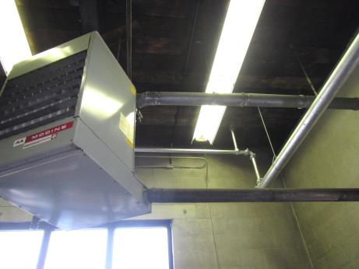

**Separate combustion heater in old garage**

**Picture 2**

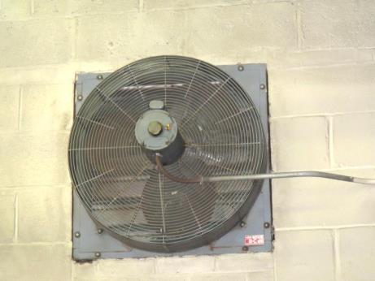

**Exhaust vent in old garage**

**Picture 3**

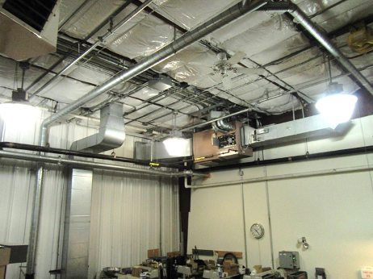

**AHU showing exhaust and supply duct work**

**Picture 4**

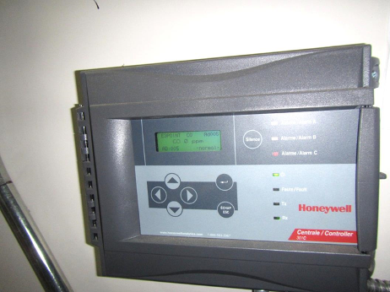

**Control panel for CO activated exhaust system**

**Picture 5**

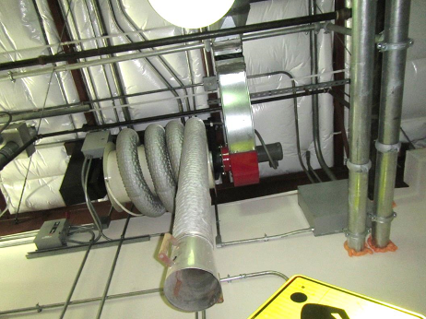

**Specialized local exhaust for tailpipe connection**

**Picture 6**

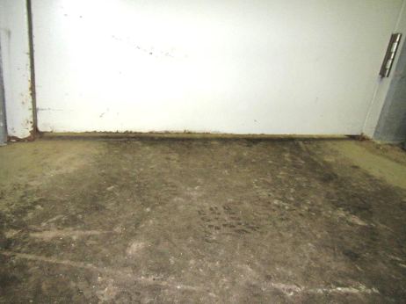

**Door to occupied space showing large gap beneath**

**Picture 7**

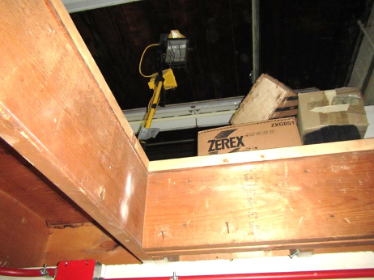

**Open hatch to storage loft that connects to garage/occupied space**

**Picture 8**

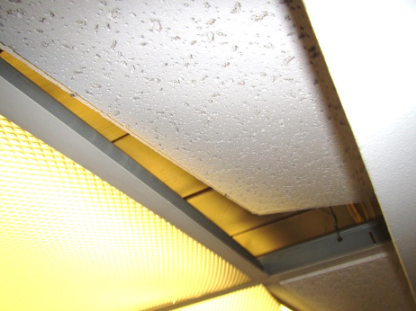

**Ajar ceiling tile provides breach to occupied space**

**Picture 9**

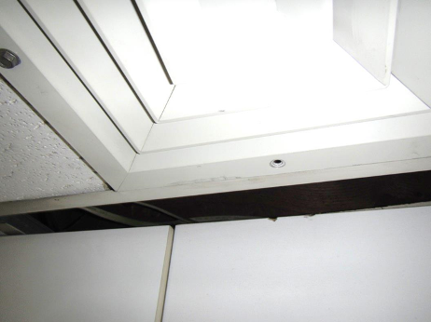

**Gaps in ceiling/wall interface**

**Picture 10**

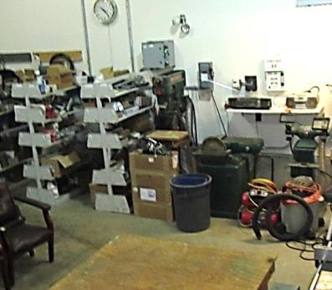

**Cardboard boxes directly on floor**

**Picture 11**

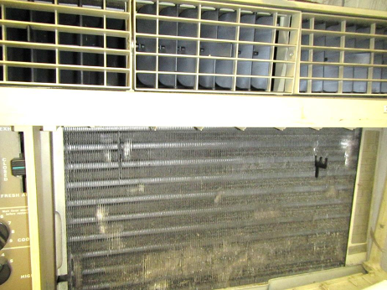

**AC unit in main office missing filter**

| Location | **Carbon**  **Dioxide**  **(ppm)** | **Carbon Monoxide**  **(ppm)** | **Temp**  **(°F)** | **Relative**  **Humidity**  **(%)** | **TVOCs**  **(ppm)** | **PM2.5**  **(µg/m3)** | **Occupants**  **in Room** | **Windows**  **Openable** | **Ventilation** | | | **Remarks** |
| --- | --- | --- | --- | --- | --- | --- | --- | --- | --- | --- | --- | --- |
| **Intake** | **Exhaust** | |
| Background (outside) | 367 | ND | 49 | 24 | ND | 7 | - | - | - | | - |  |
| Old garage- near offices | 710 | 1.6 | 64 | 43 | 0.7-1.1 | 107 | 3 | N | N | | Y | Exhaust vent off- no make-up air supply |
| Old garage- middle | 664 | 2.5 | 63 | 36 | ND | 247 | 2 | N | N | | N | Diesel truck running, garage door open |
| Carpenter shop- new building | 627 | 1.3 | 65 | 35 | 0.5-1.1 | 89 | 2 | N | Y | | Y | New ventilation & exhaust system, needs finishing |
| Mechanic bay- new building | 531 | 0.7 | 67 | 30 | ND | 29 | 2 | N | Y | | Y | New exhaust/ventilation w/ CO detector not hooked into panel, new AHU |
| Wash bay- new building | 453 | 1.3 | 61 | 33 | ND | 7 | 2 | N | Y | | Y | Door open, new exhaust/ventilation |
| Future 5 Bay Mechanic space-new building | 511 | ND | 65 | 34 | ND | 12 | 2 | N | Y | | Y | New exhaust/ventilation installed; awaiting permitting |
| Parks & Rec | 580 | ND | 59 | 38 | 1.0 | 7 | 2 | N | N | | N | Lawn mower & landscaping equipment, gasoline cans |
| Kitchen | 561 | 1.3 | 67 | 36 | ND | 28 | 2 | N | N | | N |  |
| Main office (2nd floor) | 1411 | 1.4 | 69 | 43 | ND | 40 | 4 | Y | Y | | N | AC, pathways, passive wall vent, DO |
| Lounge/locker room | 608 | 1.8 | 72 | 30 | ND | 34 | 2 | N | Y | | N |  |
| 1st floor corner office | 578 | 1.8 | 72 | 30 | ND | 42 | 2 | N | N | | N | Gap under door, parts room loft door open to garage |