INDOOR AIR QUALITY ASSESSMENT

Department of Public Works
35 Parsonage Street
Marshfield, MA

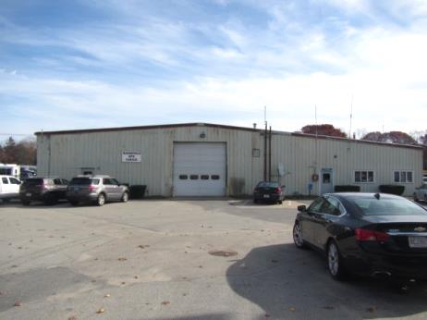

Prepared by:
Massachusetts Department of Public Health
Bureau of Environmental Health
Indoor Air Quality Program
November 2018
BACKGROUND
Building: | Department of Public Works (DPW) Garage
Address: | 35 Parsonage Street, Marshfield, MA
Assessment Coordinated via: | Paul Tomkavage, Department of Public Works and Peter Falabella, Marshfield Board of Health
Reason for Request: | General indoor air quality (IAQ) assessment, bird nesting/wastes
Date of Assessment: | November 8, 2018
Massachusetts Department of Public Health/Bureau of Environmental Health (MDPH/BEH) Staff Conducting Assessment: | Cory Holmes, Environmental Analyst/Inspector, IAQ Program
Date Building Constructed: | 1964 expanded 1976
Building Description: | Aluminum sided concrete block public works garage. The building mainly consists of large vehicle/maintenance bays, with office space and storage/staff areas built out for the Water Department, Cemetery Maintenance, Sign and Highway division.
Windows: | Few openable in office space

Methods
Please refer to the IAQ Manual for methods, sampling procedures, and interpretation of results (MDPH, 2015).

IAQ Testing Results
The following is a summary of indoor air testing results (Table 1):
- Carbon dioxide: levels were above the MDPH recommended level of 800 parts per million (ppm) in the Office, indicating a lack of air exchange in these areas.
- Temperature: was below the MDPH recommended range of 70°F to 78°F in all areas tested, due to open doors.
- Relative humidity: was within or close the MDPH recommended range of 40 to 60% in all areas tested the day of assessment.
- Carbon monoxide: levels were non-detectable (ND) in all areas assessed.
- Particulate matter (PM2.5): concentrations measured were below the National Ambient Air Quality Standard (NAAQS) level of 35 μg/m³ in all areas assessed except the Water Department storage area, which was subject to vehicle exhaust during the assessment.
- Total Volatile Organic Compounds (TVOCs): levels were ND in all areas assessed. It is important to note that measureable levels of TVOCs may occur in an industrial work setting, however, good depressurization/ventilation techniques should be employed to minimize/reduce exposure.

Ventilation
A heating, ventilating, and air conditioning (HVAC) system has several functions. First it provides heating and, if equipped, cooling. Second, it is a source of fresh air. Finally, an HVAC system will dilute and remove normally-occurring indoor environmental pollutants not only by introducing fresh air, but also by filtering the airstream and ejecting stale air to the outdoors via exhaust ventilation. Even if an HVAC system is operating as designed, point sources of respiratory irritation may exist and cause symptoms in sensitive individuals. The following analysis examines and identifies components of the HVAC system and likely sources of respiratory irritant/allergen exposure from water damage, aerosolized dust, and/or chemicals found in the indoor environment.
No mechanical ventilation system to introduce fresh air exists in the office areas of the building. The sole source of fresh air is openable windows. Heat is provided by baseboard and wall-mounted units. Air conditioning that recirculates air is provided by a mechanical system that consist of air handling units (AHUs) located in a loft above the office space (Picture 1). Conditioned air is provided by ceiling-mounted supply diffusers (Picture 2) and controlled via a thermostat. Both of the AHUs had missing panels, which can draw unfiltered air into the unit to be distributed to occupied areas. The facility has chronic issues with bird infestation and several dead birds along with bird waste were noted on/around the AHUs (Pictures 3 through 6). IAQ staff recommended to both Mr. Tomkavage and Mr. Falabella that these units should NOT BE ACTIVATED until they are inspected/cleared and cleaned/disinfected if needed by an appropriate cleaning contractor experienced in bird waste removal and cleaning. More about health issues concerning bird waste is discussed further in this report.
The filters in the AHUs were examined. The mesh-style filter (Picture 7) has minimal efficiency to remove airborne particulates and is not recommended. The MDPH recommends pleated filters with a Minimum Efficiency Reporting Value (MERV) of 8, which are adequate in filtering out pollen and mold spores (ASHRAE, 2012). Note, however, that an increase in filtration can cause stress on equipment, which needs to be evaluated to determine if the higher-rated filters will allow adequate function. Filters should also be changed two to four times a year, or per the manufacture’s recommendations. It is also important to note that the box of filters stored in this area was covered in dust/debris and open to potential contamination (Picture 8), thus should be discarded.
Finally, The AHUs appear to be at least 20 years old. Efficient function of equipment of this age is difficult to maintain, since compatible replacement parts are often unavailable. According to the American Society of Heating, Refrigeration, and Air-Conditioning Engineering (ASHRAE), the service life of this type of unit is 15-20 years, assuming routine maintenance of the equipment (ASHRAE, 1991). It appears the optimal operational lifespan of this equipment has been exceeded.
The garage/work areas have local exhaust fans throughout the building (Picture 9). In order for an exhaust fan to properly function, a source of air is needed (makeup air). No make-up air vents for the exhaust fans could be identified, apart from opening the garage doors.

Microbial/Moisture Concerns
It is important to note that the building is primary constructed of materials such as concrete and brick which are materials that are unlikely to support mold growth, even when exposed to periodic water leaks. However, porous materials used/stored within the facility can be subject to mold growth, especially if wetted repeatedly. In addition, water can damage equipment and machinery in the building. Water-damaged ceiling tiles, roofing and other signs of leakage were observed throughout the building (Pictures 10 through 16), as well as numerous containers set to catch leaks (Pictures 17 through 19). Other potential sources of water penetration were noted:
- Open utility holes/damage to exterior walls where light could be seen penetrating (Pictures 20 through 24);
- Gaps/spaces beneath exterior and garage doors (Picture 25 through 27);
- Damaged/corroded exterior/garage doors (Pictures 27 through 29);
- Breaches in damaged skylights and windows (Pictures 30 and 31); and
- Clogged/damaged/disconnected gutters and downspouts (Pictures 32 through 34).
These conditions may be a source of water/leaks damaging stored and building materials, such as drywall in the men’s restroom (Picture 35), as well as serving as a pathway for pests/animals in the building.

Bird Wastes
Of primary note were dead birds and bird wastes observed inside the building (Pictures 3 through 6, 36, and 37). Bird wastes in a building raise concerns over diseases that may be caused by exposure to bird wastes. These conditions warrant clean up of bird waste and appropriate disinfection.
Certain molds are associated with bird waste and are of concern for immune compromised individuals. Diseases of the respiratory tract may also result from exposure to bird waste. Exposure to bird wastes is thought to be associated with the development of hypersensitivity pneumonitis in some individuals. Psittacosis (bird fancier's disease) is another condition closely associated with exposure to bird wastes in bird raising and other occupational settings. While immune compromised individuals have an increased risk of health impacts following exposure to the materials in bird wastes, these impacts may also occur in healthy individuals exposed to these materials.
The methods to be employed in clean up of a bird waste problem depends on the amount of waste and the types of materials contaminated and may warrant evaluation by a professional cleaning contractor. In less severe cases, the cleaning of the contaminated material with a solution of sodium hypochlorite has been an effective disinfectant (CDC, 1998). Disinfection of non-porous materials can be readily accomplished with this material. Porous materials contaminated with bird waste should be examined by a professional restoration contractor to determine if the material is salvageable. Where a porous material has been colonized with mold, it is recommended that the material be discarded (ACGIH, 1989).
The protection of both the cleaner and other occupants present in the building must be considered as part of the overall remedial plan. Where cleaning solutions are to be used, the “cleaner” is required to be trained in the use of personal protective methods and equipment (to prevent either the spread of disease from the bird wastes and/or exposure to cleaning chemicals). In addition, the method used to clean up bird waste may result in the aerosolization of particulates that can spread to occupied areas via openings (doors, etc.) or by the ventilation system. Methods to prevent the spread of bird waste particulates to occupied areas or into ventilation ducts must be employed. In these instances, the result can be similar to the spread of renovation-generated dusts and odors in occupied areas. To prevent this, the cleaner should employ the methods listed in the SMACNA Guidelines for Containment of Renovation in Occupied Buildings (SMACNA, 1995).

Other Concerns
It is important to note that this building is a functioning vehicle maintenance and repair facility. Employees must work with various products that contain hazardous materials. For this reason, in order to properly train staff, documents for products containing hazardous materials [called Safety Data Sheets (SDS)] should be obtained from the manufacturer. The SDS lists exposure limits to chemicals; proper protective equipment; proper ventilation recommendations for use of the product as well as emergency response information. Staff should be trained in the safe handling of materials that have SDS.
During the course of the assessment, a number of sources of pollutants were noted:
- Vehicle exhaust that consists of carbon monoxide, particulates and soot;
- Spills on the floor that may be related to vehicle operations and maintenance fluids, including diesel fuel, motor oil and other vehicle liquids which contain volatile organic compounds (VOCs) (Picture 38);
- Rubber/petroleum odors from tire storage;
- Odors/VOCs from degreasers, parts washer and maintenance/cleaning chemicals (Pictures 39 and 40); and
- Unventilated welding station (Picture 41).

Finally, several areas were missing light covers (Table 1; Picture 42). Modern fluorescent bulbs contain mercury, which can be released if they are accidentally broken.

CONCLUSIONS/RECOMMENDATIONS
A number of building conditions observed may contribute to poor IAQ, mainly bird/pest infestation and building envelope integrity. These conditions combined with a lack of a mechanical ventilation system for fresh air supply and exhaust capabilities can play a role in causing and/or exacerbating respiratory symptoms.
Correcting some of the issues may take significant planning and capital resources. In view of these findings, two sets of recommendations are made: short-term measures that may be implemented as soon as practicable and long-term measures that will require planning and resources to address overall IAQ concerns.

Short-Term Recommendations
- Do not use/activate AC system in office area until the AHUs/ductwork can be evaluated by an HVAC engineering firm to determine if they have been contaminated by birds/wastes.
- Contact both an animal/wildlife extraction specialist with expertise in bird removal and a professional cleaning contractor specializing in animal wastes/biohazards to evaluate the extent of bird roosting and devise a thorough removal/clean-up plan.
- Discard any HVAC filters that were not properly stored.
- When the HVAC systems can be put back on line, ensure they are equipped with well-fitted filters. If the systems will operate with them, use filters with a MERV rating of 8 to provide better removal of dust, mold spores and pollen.
- Provide local exhaust for fume/VOC-generating activities such as welding, including activating local exhaust fans; make repairs where necessary. If possible, provide make-up air vents, or continue to open doors when local exhaust is in use.
- Seal any holes/breaches/pathways (e.g., damaged skylights, holes in exterior walls) to prevent uncontrolled drafts/moisture and pest entry.
- Ensure any containers used to catch leaks are monitored and emptied regularly to prevent stagnant water and odors.
- Consider installing digital readout carbon monoxide detectors in occupied areas of the building.
- Install weather-stripping on exterior and garage/bay doors, if doors cannot be made tight to prevent drafts/moisture/pests, repair or consider replacing. Ensure tightness of doors by monitoring for light penetration and drafts around doorframes.
- Remove water-damaged drywall in men’s restroom.
- Remove and discard all water-damaged stored materials. Any items to be preserved should be inspected for water damage and cleaned before being stored in a dry location.
- Make repairs to damaged/exposed fiberglass insulation on pipes.
- Clean dust/debris from restroom exhausts and ensure they are vented properly to outside the building.
- Ensure Safety Data Sheets are available in a centralized location for any potentially hazardous products used and that staff are trained in the use of such materials, including the use of personal protective equipment when needed. Ensure good housekeeping for storage and handling of materials.
- Replace missing light covers.
- To address issues related to compliance with OSHA hazardous materials regulations, please contact the Massachusetts Department of Labor Standards OSHA Consultation Program Technical Support, which can be contacted via this link: https://www.mass.gov/service-details/osha-consultation-program-technical-support
- For buildings in New England, periods of low relative humidity during the winter are often unavoidable. Therefore, scrupulous cleaning practices should be adopted to minimize common indoor air contaminants whose irritant effects can be enhanced when the relative humidity is low. Use a vacuum cleaner equipped with a high efficiency particulate arrestance (HEPA) filter in conjunction with wet wiping to remove dust from all surfaces. Avoid the use of feather dusters. Drinking water during the day can help ease some symptoms associated with a dry environment (throat and sinus irritations).
- Remove and discard old/soiled carpeting (e.g., Water Dept. lounge/loft).
- Refer to resource manual and other related indoor air quality documents located on the MDPH’s website for further building-wide evaluations and advice on maintaining public buildings. These documents are available at http://mass.gov/dph/iaq.

Long Term Recommendations
- Contact an HVAC engineering firm for a building-wide evaluation to provide local exhaust/proper make-up air solutions for the main vehicle maintenance area, as well as individual work stations/functions (e.g., welding, pressure washer, parts washer, oil/fueling stations).
- Consider replacing HVAC system in the office areas with one that supplies fresh/outside air as well as exhaust.
- Consider replacing ill-fitting garage and exterior doors to prevent uncontrolled drafts, moisture and pests.
- Remove/replace damaged skylights and insulated ceiling panels.
- Make repairs/replace gutter/downspout drainage system.

REFERENCES
ACGIH. 1989. Guidelines for the Assessment of Bioaerosols in the Indoor Environment. American Conference of Governmental Industrial Hygienists, Cincinnati, OH.

ASHRAE. 1991. American Society of Heating, Refrigerating, and Air-Conditioning Engineers (ASHRAE). ASHRAE Applications Handbook, Chapter 33 “Owning and Operating Costs”. American Society of Heating, Refrigeration and Air Conditioning Engineers, Atlanta, GA.

ASHRAE. 2012. American Society of Heating, Refrigeration and Air Conditioning Engineers. (ASHRAE). Standard 52.2-2012 -- Method of Testing General Ventilation Air-Cleaning Devices for Removal Efficiency by Particle Size (ANSI Approved).
CDC. 1998. Compendium of Measures to Control Chlamydia psittaci Infection Among Human (Psittacosis and Pet Birds (Avian Chlamydiosis), 1998. MMWR 47:RR-10. July 10, 1998.

MDPH. 2015. Massachusetts Department of Public Health. “Indoor Air Quality Manual: Chapters I-III”. Available from http://www.mass.gov/eohhs/gov/departments/dph/programs/environmental-health/exposure-topics/iaq/iaq-manual/
SMACNA. 1995. IAQ Guidelines for Occupied Buildings Under Construction. 1st ed. Sheet Metal and Air Conditioning Contractors’ National Association, Inc., Chantilly, VA.
Picture 1
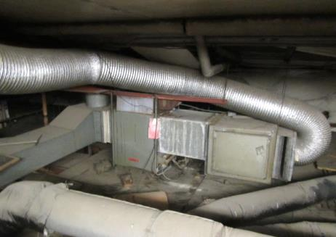
One of two air handling units (AHUs) above office space, note age/condition of unit and open panels
Picture 2
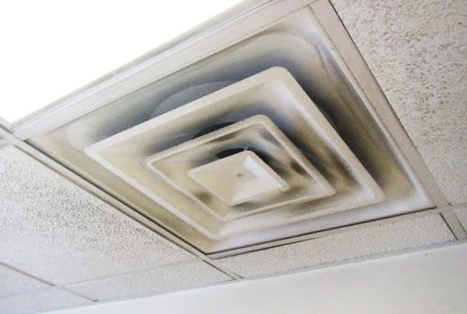
AC supply diffuser in office, note dust/debris on louvers
Picture 3
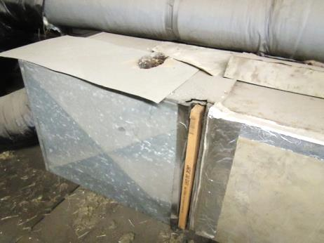
Dead bird and open filter panel on AHU (arrows)
Picture 4
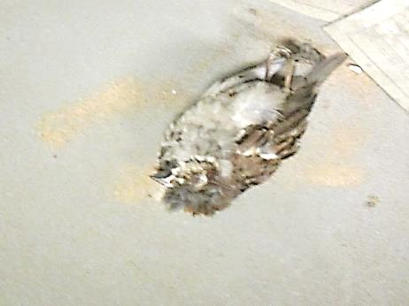
Close-up of dead bird on AHU
Picture 5
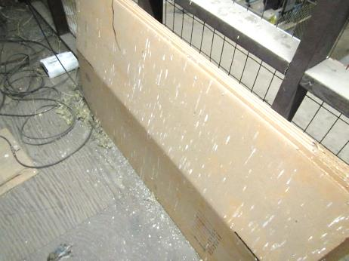
Dead bird (arrow) wastes and nesting materials near AHU/loft
Picture 6
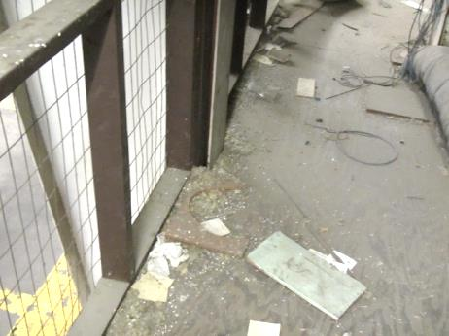
Bird wastes and nesting materials near AHU/loft
Picture 7
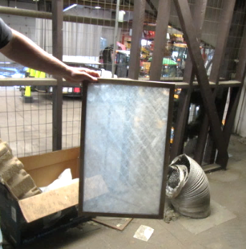
Low efficiency mesh filter
Picture 8
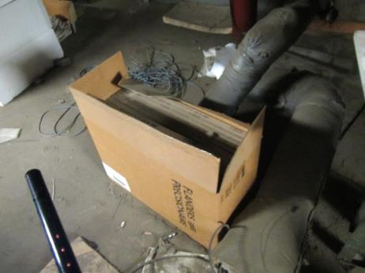
Open box of filters in loft above office
Picture 9
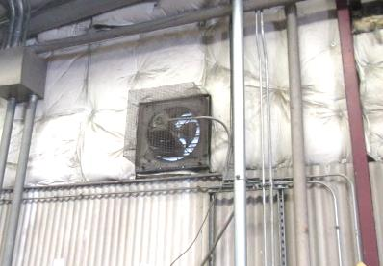
Local exhaust vent
Picture 10
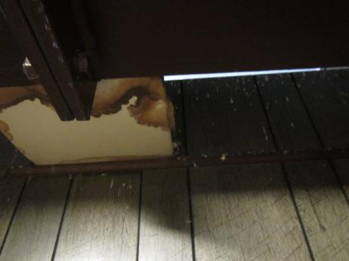
Water-damaged ceiling tile and bird wastes on wall
Picture 11
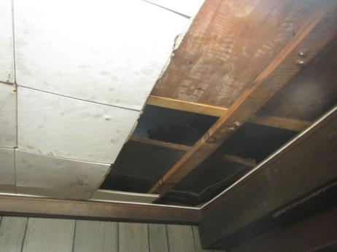
Failing/water-damaged ceiling
Picture 12
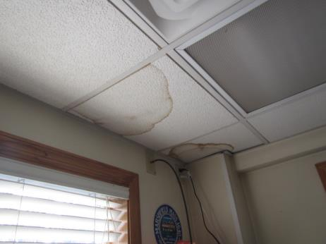
Water-damaged ceiling tiles
Picture 13
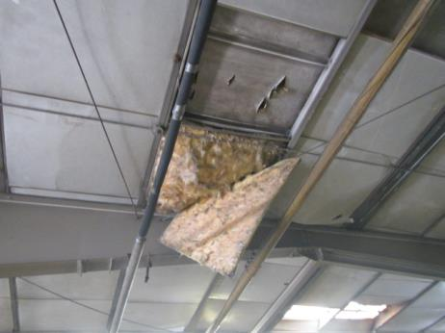
Failing insulated ceiling tiles
Picture 14
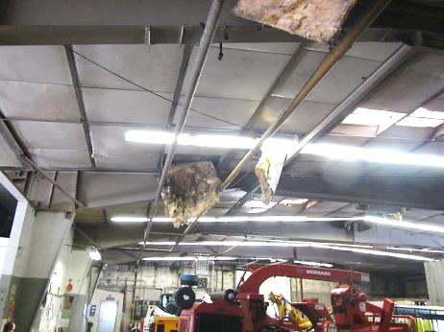
Failing insulated ceiling tiles
Picture 15
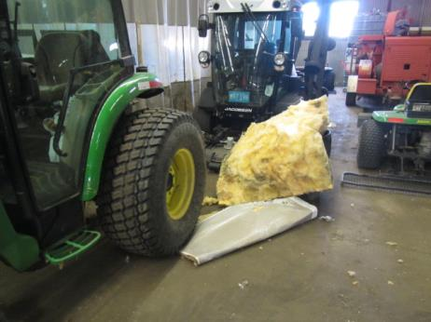
Insulated ceiling panels on the floor of garage
Picture 16
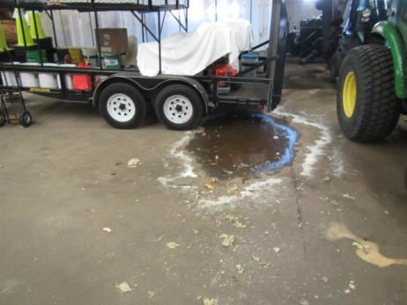
Active leak/puddle in garage, note tarp to protect equipment on trailer
Picture 17
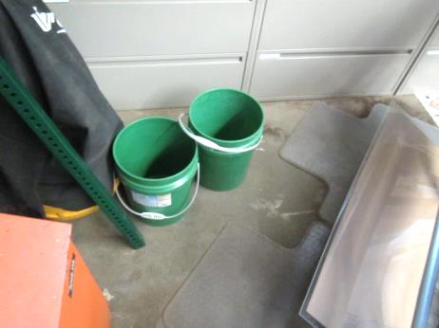
Buckets to catch leaks
Picture 18
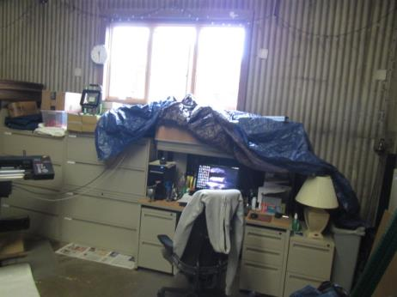
Tarp indoors to protect office materials
Picture 19
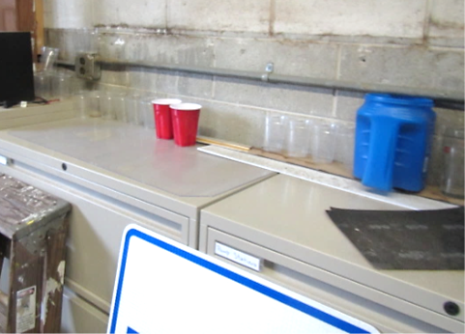
Cups/containers to catch leaks
Picture 20
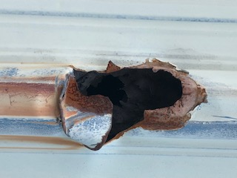
Hole/damaged exterior wall
Picture 21
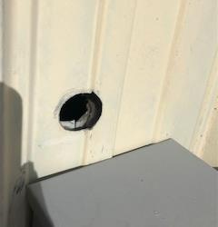
Open utility hole in exterior wall
Picture 22
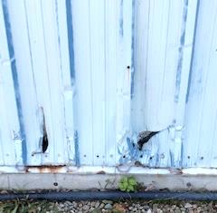
Damaged exterior wall
Picture 23
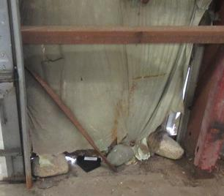
Interior view of damaged wall, note large rocks used to block holes
Picture 24
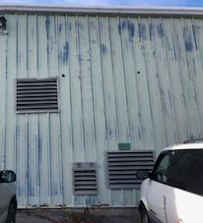
Holes left open after pipes removed (arrows)
Picture 25
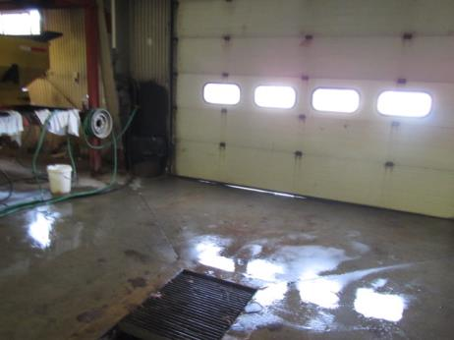
Gaps/light under garage door
Picture 26
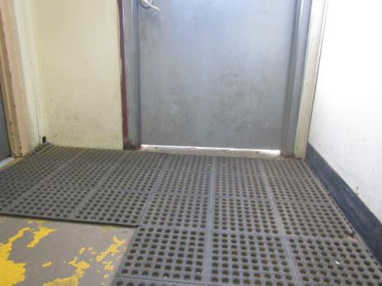
Gap/light penetrating beneath exterior door
Picture 27
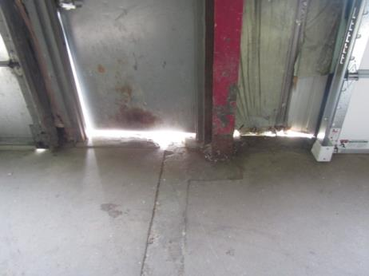
Gaps/light penetrating around door/damaged wall
Picture 28
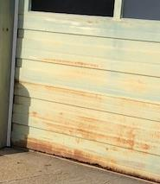
Rusted/corroded garage door
Picture 29
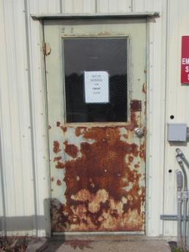
Damaged/corroded exterior door
Picture 30
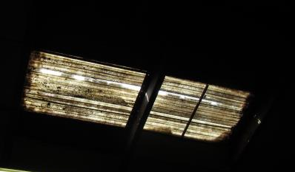
Breach in damaged skylight, note it runs the entire length
Picture 31
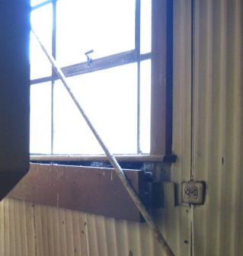
Breach between windowsill and wall
Picture 32
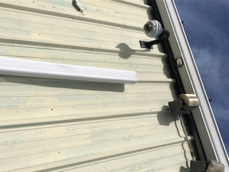
Disconnected downspout
Picture 33
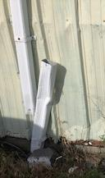
Disconnected downspout
Picture 34
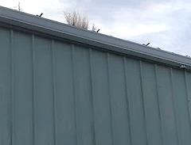
Plant growth in gutter
Picture 35
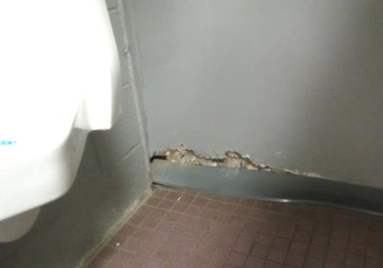
Water-damaged drywall in men’s restroom
Picture 36
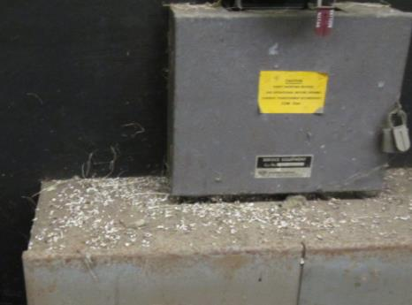
Bird wastes/nesting material on flat surfaces
Picture 37
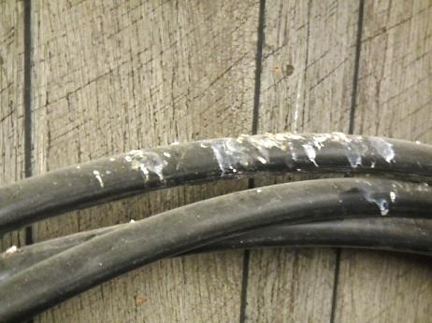
Bird wastes
Picture 38
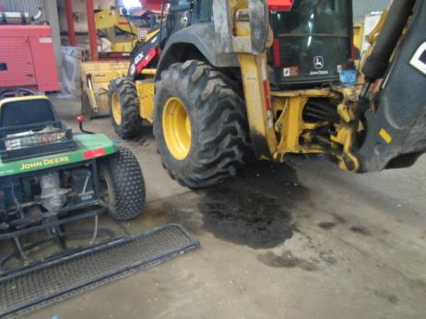
Vehicles and soiled concrete
Picture 39
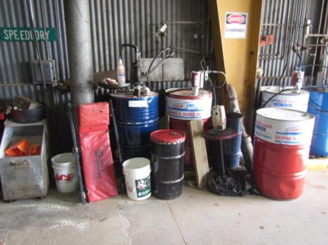
Chemical station/storage
Picture 40
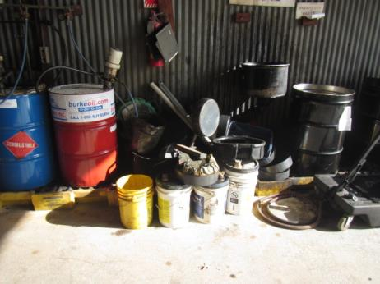
Chemical station/storage
Picture 41
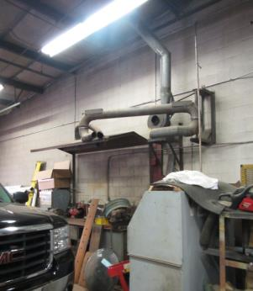
Abandoned/inoperable local exhaust system in welding bay
Picture 42
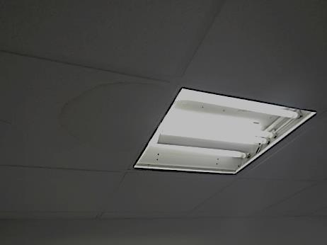
Missing light covers in office area
Location | Carbon  Dioxide  (ppm) | Carbon Monoxide  (ppm) | Temp  (°F) | Relative  Humidity  (%) | PM2.5  (µg/m³) | TVOCs  (ppm) | Occupants  in Room | Windows  Openable | Ventilation |  | Remarks
 |  |  |  |  |  |  |  |  | Supply | Exhaust
Background | 397 | ND | 57 | 36 | 3 | ND |  |  |  |  | Sunny, cool
Maintenance Foreman Office | 564 | ND | 69 | 43 | 38 | ND | 4 | N | N | N | Dust/debris flat surfaces
DPW Garage Bay | 436 | ND | 66 | 38 | 23 | ND | 0 | N | N | N | Exposed fiberglass/failing ceiling panels, bird infestation/wastes, open breaches to the exterior (walls/skylights)
Water Department Workshop | 449 | ND | 64 | 41 | 18 | ND | 0 | N | N | N
Water Dept Storage Loft/Lounge | 509 | ND | 65 | 43 | 73* | ND | 0 | N | N | N | Bird infestation, WD ceiling, active leaks, old/soiled carpeting, *elevated PM2.5 due to vehicle startup/exhaust
Sign Shop | 467 | ND | 64 | 44 | 14 | ND | 1 | N | N | N | Chronic leaks-containers/tarps over equipment, local exhaust-reportedly inoperable
Office Area | 1046 | ND | 69 | 43 | 10 | ND | 4 | Y | N | N | Missing light covers, dust/debris-vents, AF, WD CT
Women’s restroom |  |  |  |  |  |  |  | N | N | Y | Dusty exhaust vent
HVAC Loft |  |  |  |  |  |  |  |  |  |  | Dead birds, missing panel cover, filters in dirty/dusty box-open, bird wastes/nesting materials
Men’s restroom |  |  |  |  |  |  |  | Y | N | Y | WD drywall, active leaks reported through wall, exposed fiberglass insulation-pipes
Break Room | 621 | ND | 69 | 34 | 27 | ND | 8 | Y | N | N | Light penetrating through wall, AT
Cemetery Maint | 479 | ND | 68 | 41 | 13 | ND | 0 | N | N | N | Light penetrating through wall, flammable/gas storage, WD floors/active leaks, storage loft chained off/off limits-safety reasons
Welding Bay | 456 | ND | 67 | 30 | 8 | ND | 0 | N | N | N | Inoperable local exhaust system
Oil Room | 422 | ND | 66 | 34 | 12 | ND | 0 | N | N | Y | Switch-activated local exhaust system
DPW Maintenance Area | 602 | ND | 66 | 33 | 5 | ND | 4 | N | N | N | CF, space under door
Air Compressor Room | 404 | ND | 65 | 30 | 4 | ND | 0 | N | N | N | Holes in wall-pipe removal
Parts/Tire Storage | 437 | ND | 66 | 32 | 8 | ND | 0 | N | N | Y | Local exhaust
Mechanic’s Break Room/Parts Storage | 492 | ND | 66 | 32 | 14 | ND | 0 | N | N | Y | Local exhaust
Exterior Notes |  |  |  |  |  |  |  |  |  |  | Damage/holes in walls, gutters/downspouts damaged-not connected/clogged, open utility holes

The service life is the median time during which a particular system or component of …[an HVAC]… system remains in its original service application and then is replaced. Replacement may occur for any reason, including, but not limited to, failure, general obsolescence, reduced reliability, excessive maintenance cost, and changed system requirements due to such influences as building characteristics or energy prices (ASHRAE, 1991).

