INDOOR AIR QUALITY ASSESSMENT

Department of Revenue
Shetland Park
35 Congress Street
Salem, MA

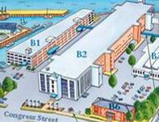

Prepared by:
Massachusetts Department of Public Health
Center for Environmental Health
Emergency Response/Indoor Air Quality Program
February 2007

Background/Introduction
At the request of Donald Trudell, Deputy Director of Facilities, Massachusetts Department of Revenue (DOR), the Massachusetts Department of Public Health (MDPH), Center for Environmental Health (CEH) conducted an indoor air quality assessment at the Salem DOR office located in the Shetland Park Office Complex, 35 Congress Street. The request was prompted by concerns regarding an unidentified odor that occurred on Thursday January 18, 2007 in the west wing of the DOR offices, as well as ongoing complaints of eye and respiratory irritation by occupants of that area of the DOR offices.
On February 5, 2007, a visit to conduct an indoor air quality assessment was made to the DOR offices by Cory Holmes, an Environmental Analyst in CEH’s Emergency Response/Indoor Air Quality (ER/IAQ) Program. Mr. Holmes was accompanied by Edward Carney, DOR Project Manager, during the assessment.
The DOR offices are located on the third floor of a four-story office building that was reportedly constructed as a shoe factory in the late 1800s to early 1900s. The DOR occupied areas were reportedly renovated prior to occupancy and are separated into three main areas; the east, central and west wings. The DOR has occupied the east and central wings since 2002. Occupants in the west wing have occupied their space since 2004. The three wings are of similar layout, with offices located around the perimeter and work stations separated by floor dividers located at the center of each wing. Offices and common areas have dropped ceiling tile systems. Central work areas have approximately 15 foot-high concrete ceilings. Windows are openable throughout the DOR space.
DOR staff in the west wing had previously reported odor incidents and IAQ concerns. In response to these concerns, DOR administration staff contacted ATC Associates, an environmental consulting firm, to conduct an IAQ inspection in August 2006. The ATC report recommended: (1) cleaning of carpeting using high temperature steam and vacuuming with a vacuum cleaner equipped with a high efficiency particulate arrestance (HEPA) filter; (2) replacing water-stained ceiling tiles; (3) investigating and repairing active leaks; and (4) storing water coolers/bottles/refrigerators on plastic sheeting to protect carpeting (ATC, 2006).

Methods
Tests for carbon dioxide, temperature and relative humidity were conducted with a TSI, Q-Trak, IAQ Monitor, Model 8551. Screening for total volatile organic compounds (TVOCs) was conducted using a Hnu, Model 102 Snap-on Photo Ionization Detector (PID). CEH staff also performed visual inspection of building materials for water damage and/or microbial growth.

Results
The DOR offices have a combined employee population of approximately 135 with approximately 50 staff occupying the west wing. The tests were taken during normal operations. Areas where tests were taken are indicated by room/office number, function or occupant’s last name. Test results appear in Table 1.

Discussion
Ventilation
It can be seen from Table 1 that carbon dioxide levels were above 800 parts per million (ppm) in all areas surveyed on the day of the assessment, indicating less than optimal air exchange throughout the space occupied by the DOR. It is important to note that the assessment was conducted on an extremely cold day (12 ºF), with a wind chill below 0 ºF. During these types of temperature extremes, fresh air drawn into the heating, ventilating and air-conditioning (HVAC) system is often reduced to prevent freezing/damage of HVAC system components. Limiting fresh air intake either by mechanical and/or natural means (e.g., closing of windows) can contribute to an increase in carbon dioxide levels.
Fresh, heated air is supplied to all areas of the DOR by air-handling units (AHUs) suspended from the ceiling (Picture 1). Fresh air is drawn into the AHUs through air intakes located on the exterior of the building (Picture 2 and 3). Ceiling-mounted air diffusers ducted to the AHUs distribute fresh tempered air to the spaces (Pictures 4 and 5). Return air is drawn into ceiling-mounted vents equipped with pleated air filters (Pictures 6 and 7). Some return air is ducted back to AHUs, where it is mixed with fresh air and redistributed to the office space. Return air can also be exhausted out of the building through exhaust vents located on the exterior of the building (Picture 8). Exhaust vents on the exterior of the building were equipped with wind shields to prevent re-entrainment of exhausted air.
Digital wall-mounted thermostats control the HVAC system. Each thermostat has fan settings of “on” and “automatic”. Thermostats were set to the “automatic” setting in the west wing during the assessment. The automatic setting on the thermostat activates the HVAC system at a preset temperature. Once the preset temperature is reached, the HVAC system is deactivated. Therefore, no mechanical ventilation is provided until the thermostat re-activates the system. Without a continuous source of fresh outside air and removal via the exhaust/return system, indoor environmental pollutants can build-up and lead to indoor air quality/comfort complaints.
To maximize air exchange, the MDPH recommends that both supply and exhaust ventilation operate continuously during periods of occupancy. In order to have proper ventilation with a mechanical supply and exhaust system, the systems must be balanced to provide an adequate amount of fresh air to the interior of a room while removing stale air from the room. It is recommended that HVAC systems be re-balanced every five years to ensure adequate air systems function (SMACNA, 1994). The date of the last balancing of these systems was not available at the time of the assessment but should have occurred prior to occupation.
The Massachusetts Building Code requires that each area have a minimum ventilation rate of 20 cubic feet per minute (cfm) per occupant of fresh outside air or openable windows (SBBRS, 1997; BOCA, 1993). The ventilation must be on at all times that the room is occupied. Providing adequate fresh air ventilation with open windows and maintaining the temperature in the comfort range during the cold weather season is impractical. Mechanical ventilation is usually required to provide adequate fresh air ventilation.
Carbon dioxide is not a problem in and of itself. It is used as an indicator of the adequacy of the fresh air ventilation. As carbon dioxide levels rise, it indicates that the ventilating system is malfunctioning or the design occupancy of the room is being exceeded. When this happens, a buildup of common indoor air pollutants can occur, leading to discomfort or health complaints. The Occupational Safety and Health Administration (OSHA) standard for carbon dioxide is 5,000 parts per million parts of air (ppm). Workers may be exposed to this level for 40 hours/week, based on a time-weighted average (OSHA, 1997).
The MDPH uses a guideline of 800 ppm for publicly occupied buildings. A guideline of 600 ppm or less is preferred in schools due to the fact that the majority of occupants are young and considered to be a more sensitive population in the evaluation of environmental health status. Inadequate ventilation and/or elevated temperatures are major causes of complaints such as respiratory, eye, nose and throat irritation, lethargy and headaches. For information concerning carbon dioxide, please see Appendix A.
Temperature readings ranged from 71º F to 76 º F, which were within the MDPH recommended comfort guidelines on the day of the assessment. The MDPH recommends that indoor air temperatures be maintained in a range of 70 º F to 78 º F in order to provide for the comfort of building occupants. In many cases concerning indoor air quality, fluctuations of temperature in occupied spaces are typically experienced, even in a building with an adequate fresh air supply.
The relative humidity measured in the building ranged from 16 to 19 percent, which was below the MDPH recommended comfort range in all areas. The MDPH recommends a comfort range of 40 to 60 percent for indoor air relative humidity. Relative humidity levels in the building would be expected to drop during the winter months due to heating. The sensation of dryness and irritation is common in a low relative humidity environment. Low relative humidity is a very common problem during the heating season in the northeast part of the United States.

Microbial/Moisture Concerns
Water-stained ceiling tiles were observed in a few areas (Table 1). A stained tile in the corner of Mr. Auerbach’s office reportedly occurred after a recent, heavy, wind-driven rain, indicating an active leak. Several stained tiles in the east wing appeared to be from condensation due to the staining pattern which appears to follow the contour of a horizontal pipe (Picture 9). Water-damaged ceiling tiles can provide a source for mold and should be replaced after a water leak is discovered and repaired.
As previously noted by ATC, a number of areas had refrigerators, water coolers and water containers placed directly on carpeting. Refrigerators can generate condensation during operation; water spillage or overflow of cooler catch basins can result in the wetting of the carpet. In addition, some coolers had residue/build-up in the reservoir. These reservoirs are designed to catch excess water during operation and should be emptied/cleaned regularly to prevent microbial and/or bacterial growth.
Spaces were observed between the counter and sink backsplashes in the kitchen. If not watertight, water can penetrate through these seams. Water penetration and chronic exposure of porous and wood-based materials can cause these materials to swell and show signs of water damage. Several areas contained plants. Plants, soil and drip pans can serve as sources of mold growth, and thus should be properly maintained.
The US Environmental Protection Agency (US EPA) and the American Conference of Governmental Industrial Hygienists (ACGIH) recommends that porous materials be dried with fans and heating within 24 to 48 hours of becoming wet (US EPA, 2001; ACGIH, 1989). If porous materials are not dried within this time frame, mold growth may occur. Water-damaged porous materials cannot be adequately cleaned to remove mold growth. The application of a mildewcide to moldy porous materials is not recommended.

Odor Investigation
As previously mentioned, the assessment was prompted primarily due to odor concerns. DOR staff had reported an “unusual smell” to DOR management and facilities staff on Thursday January 18, 2007. Some occupants described the odor as “egg salad”. Shetland Management toured the space with DOR staff to investigate, but reportedly no point source of the odor was identified. The windows were opened and the odor reportedly dissipated within several hours. Although the source of odors could not be identified, Shetland management reportedly agreed to clean all the vents and install “wind-shields” on the exhaust vents to prevent potential backdrafting (Picture 8).
At approximately 3:00 pm the following day, Friday January 19, 2007, an odor complaint was anonymously reported to the Salem Fire Department (SFD). According to the SFD incident report, a number of occupants from the west wing were experiencing dizziness, burning of the eyes, upset stomachs and facial rash outbreaks when SFD responded (SFD, 2007; Appendix B). Occupants of the west wing reported that they had been experiencing these symptoms over a long time span (SFD, 2007). The SFD subsequently contacted the Salem Health Department (SHD) and an ambulance service to assist in the investigation; no occupants were transported to medical facilities. The SFD incident report did not indicate the presence of any detectible odors nor recommendations for mitigation (e.g., venting) (SFD, 2007). However, the incident report provided by the SHD mentioned that an odor was present, and the odor was attributed to a cleaning agent (SHD, 2007; Appendix C). The SHD recommended opening windows and/or using fans to dissipate the odor (SHD, 2007).
At the time of the CEH assessment, no other odors/complaints were reported by DOR staff, and CEH staff did not detect any odors. To investigate previous odor complaints, CEH staff conducted screening for total volatile organic compounds (TVOCs). VOCs are carbon-containing substances that have the ability to evaporate at room temperature. For example, chemicals evaporating from a paint can stored at room temperature would most likely contain VOCs. Frequently, exposure to low levels of VOCs may produce eye, nose, throat and/or respiratory irritation in some sensitive individuals. In an effort to determine whether VOCs were present, air monitoring was conducted throughout the DOR space. Outdoor TVOC concentrations were non-detect (ND) (Table 1). Indoor TVOC concentrations throughout the DOR were also ND (Table 1). Please note, TVOC air measurements are only reflective of the indoor air concentrations present at the time of sampling.

Other IAQ Evaluations
Indoor air quality can be negatively influenced by the presence of respiratory irritants, such as products of combustion. The process of combustion produces a number of pollutants. Common combustion emissions include carbon monoxide, carbon dioxide, water vapor and smoke (fine airborne particle material). Carbon monoxide is a by-product of incomplete combustion of organic matter (e.g., gasoline, wood and tobacco). Exposure to carbon monoxide can produce immediate and acute health affects.
Carbon monoxide is a by-product of incomplete combustion of organic matter (e.g., gasoline, wood and tobacco). Exposure to carbon monoxide can produce immediate and acute health affects. Several air quality standards have been established to address carbon monoxide and prevent symptoms from exposure to these substances. The MDPH established a corrective action level concerning carbon monoxide in ice skating rinks that use fossil-fueled ice resurfacing equipment. If an operator of an indoor ice rink measures a carbon monoxide level over 30 ppm, taken 20 minutes after resurfacing within a rink, that operator must take actions to reduce carbon monoxide levels (MDPH, 1997).
The American Society of Heating Refrigeration and Air-Conditioning Engineers (ASHRAE) has adopted the National Ambient Air Quality Standards (NAAQS) as one set of criteria for assessing indoor air quality and monitoring of fresh air introduced by HVAC systems (ASHRAE, 1989). The NAAQS are standards established by the US EPA to protect the public health from six criteria pollutants, including carbon monoxide and particulate matter (US EPA, 2006). As recommended by ASHRAE, pollutant levels of fresh air introduced to a building should not exceed the NAAQS levels (ASHRAE, 1989). The NAAQS were adopted by reference in the Building Officials & Code Administrators (BOCA) National Mechanical Code of 1993 (BOCA, 1993), which is now an HVAC standard included in the Massachusetts State Building Code (SBBRS, 1997). According to the NAAQS, carbon monoxide levels in outdoor air should not exceed 9 ppm in an eight-hour average (US EPA, 2006).
Carbon monoxide should not be present in a typical, indoor environment. If it is present, indoor carbon monoxide levels should be less than or equal to outdoor levels. CEH staff conducted air sampling for carbon monoxide. Outdoor carbon monoxide concentrations were ND (Table 1). Carbon monoxide levels measured inside were also ND (Table 1).
Several other conditions that can affect indoor air quality were observed during the assessment. Plug-in air fresheners were observed in one area. Air fresheners contain chemicals that can be irritating to certain sensitive individuals. In addition, air fresheners do not remove materials causing odors, but rather mask odors, which may be present in the area. VOC-containing cleaning materials were observed to clean personnel work areas (Picture 10). This cleaning agent contains several VOCs (e.g., isopropyl alcohol and monoethanolamine) that can be irritating to the eyes, nose and throat (3M, 2000) (Picture 11).
Occupants expressed concerns about the potential of odors/materials migrating from adjacent areas (i.e., offices that share a common wall/floor/ceiling with the DOR). However, no consistent complaints or patterns of specific odors related to adjacent business were reported; therefore odor migration is unlikely. In addition, the HVAC systems for each of the business at Shetland Park are self-contained within each work space; therefore they do not share common ductwork, which would further indicate that odor migration is unlikely.
Finally, although supply and return vents in common work areas had been cleaned, exhaust vents in restrooms were observed to be occluded with dust and debris (Picture 12). Picture 13 demonstrates such dust accumulation, which can greatly inhibit airflow.

Conclusions/Recommendations
As discussed at the time of the CEH assessment, no odors were detected and measurements for TVOCs and CO were non-detectable. However, carbon dioxide levels indicated a lack of adequate air exchange, which can allow odors that may be present to persist/linger, leading to IAQ complaints. In the event of future reports of odors, three sources are likely:
- Inside DOR space: air fresheners, cleaners, cooking odors, personal products such as nail polish removers, etc.
- Outside DOR space: pollutants such as vehicle exhaust drawn in through air intakes on the exterior of the building); and/or
- Adjacent to the DOR space: odors from surrounding space/hallway.

In the event of future odor complaints, the following investigative/mitigation steps should be taken:
- Observe conditions directly outside the building to rule out external sources.
- Observe conditions inside DOR space and consult with staff to determine if any personal/cleaning products were used or cooking in progress.
- Work with building management/maintenance staff to identify and seal any potential pathways between adjacent businesses, such as utility holes in ceilings/floors/walls.
- Install door sweeps on hallway doors to prevent odor migration from the hallway.

General Air Quality Recommendations
In addition to the recommendations made by ATC, the following additional recommendations are made to improve indoor air quality:
- Operate ventilation systems continuously. Set thermostat controls to the fan “on” position to provide constant supply and exhaust ventilation during periods of occupancy.
- Use openable windows to supplement airflow and control for comfort (with the exception of periods of high outdoor relative humidity to avoid condensation problems). Care should be taken to ensure windows are properly closed at night and weekends to avoid pipe freezing and potential flooding (during winter months).
- Contact the building’s HVAC consultant to determine whether the existing fresh air intake system can be adjusted to increase outside air intake.
- Consider balancing mechanical ventilation systems every five years as per ventilation industrial standards (SMACNA, 1994).
- For buildings in New England, periods of low relative humidity during the winter are often unavoidable. Therefore, scrupulous cleaning practices should be adopted to minimize common indoor air contaminants whose irritant effects can be enhanced when the relative humidity is low. To control for dusts, a high efficiency particulate arrestance (HEPA) filter equipped vacuum cleaner in conjunction with wet wiping of all surfaces is recommended. Drinking water during the day can help ease some symptoms associated with a dry environment (throat and sinus irritations).
- Ensure leaks are repaired and replace water-stained ceiling tiles. Take measures to reduce condensation generation on pipes (e.g., inspect insulation).
- Examine sink countertop and backsplash areas for water damage and/or mold growth. Disinfect and replace as necessary. Seal breaches to prevent damage.
- Continue to change HVAC filters on current schedule or more frequently if needed.
- Clean supply, return and exhaust vents periodically of accumulated dust.
- Refrain from or reduce the use of VOC-containing cleaning materials.
- Refrain from using air fresheners and deodorizers to prevent exposure to VOCs.
- Consider cleaning carpeting annually (or semi-annually in soiled high traffic areas) as per the recommendations of the Institute of Inspection, Cleaning and Restoration Certification (IICRC). Copies of the IICRC fact sheet can be downloaded at: http://www.cleancareseminars.com/carpet_cleaning_faq4.htm (IICRC, 2005)
- Refer to resource manuals and other related indoor air quality documents for further building-wide evaluations and advice on maintaining public buildings. Copies of these materials are located on the MDPH’s website: http://mass.gov/dph/indoor_air.
References
3M. 2000. Material Safety Data Sheet (MSDS Document No: 10-0157-7). 3M Brand Desk and Office Cleaner 573. Minnesota Mining and Manufacturing Company. St. Paul, Minnesota.
ACGIH. 1989. Guidelines for the Assessment of Bioaerosols in the Indoor Environment. American Conference of Governmental Industrial Hygienists, Cincinnati, OH.
ASHRAE. 1989. Ventilation for Acceptable Indoor Air Quality. American Society of Heating, Refrigeration and Air Conditioning Engineers. ANSI/ASHRAE 62-1989
ATC. 2006. ATC Associates, Inc. Indoor Air Quality/Microbial Investigation Report, 35 Congress Street, Salem MA. ATC Project No.: 60.31879.001. Dated September 28, 2006.
BOCA. 1993. The BOCA National Mechanical Code/1993. 8th ed. Building Officials and Code Administrators International, Inc., Country Club Hill, IL. Section M-308.1.1.
IICRC. 2005. Carpet Cleaning FAQ 4 Institute of Inspection, Cleaning and Restoration Certification. Institute of Inspection Cleaning and Restoration, Vancouver, WA.
MDPH. 1997. Requirements to Maintain Air Quality in Indoor Skating Rinks (State Sanitary Code, Chapter XI). 105 CMR 675.000. Massachusetts Department of Public Health, Boston, MA.
OSHA. 1997. Limits for Air Contaminants. Occupational Safety and Health Administration. Code of Federal Regulations. 29 C.F.R 1910.1000 Table Z-1-A.
SBBRS. 1997. Mechanical Ventilation. State Board of Building Regulations and Standards. Code of Massachusetts Regulations. 780 CMR 1209.0
SFD. 2007. Salem Fire Department. Incident Response Report. 35 Congress Street, Salem MA. January 19, 2007.
SHD. 2007. Incident Response Report. 35 Congress Street, Salem MA. January 22, 2007.
SMACNA. 1994. HVAC Systems Commissioning Manual. 1st ed. Sheet Metal and Air Conditioning Contractors’ National Association, Inc., Chantilly, VA.
US EPA. 2001. Mold Remediation in Schools and Commercial Buildings. US Environmental Protection Agency, Office of Air and Radiation, Indoor Environments Division, Washington, D.C. EPA 402-K-01-001. March 2001.
US EPA. 2006. National Ambient Air Quality Standards (NAAQS). US Environmental Protection Agency, Office of Air Quality Planning and Standards, Washington, DC. http://www.epa.gov/air/criteria.html.
Picture 1

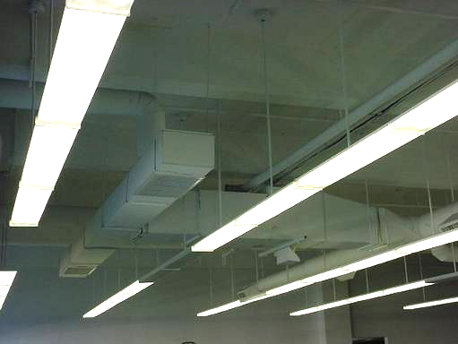

AHU Suspended from the Ceiling

Picture 2

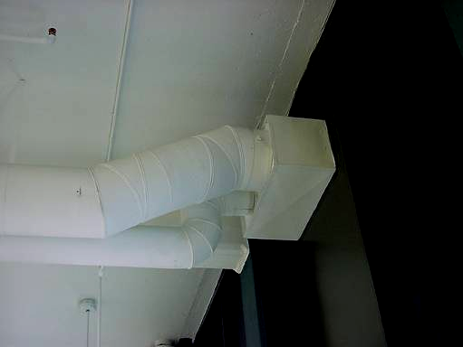

Interior View of Air Intake Ducts/Vent, 3rd Floor DOR
Picture 3

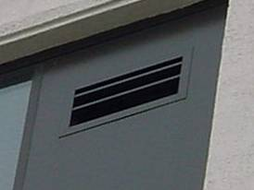

Fresh Air Intake for HVAC System on Exterior of Building

Picture 4

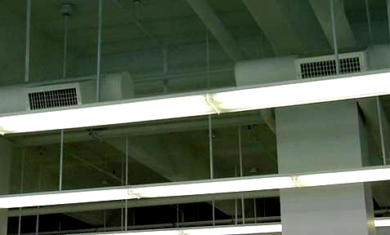

Ducted Air Diffusers in Central Work Areas
Picture 5

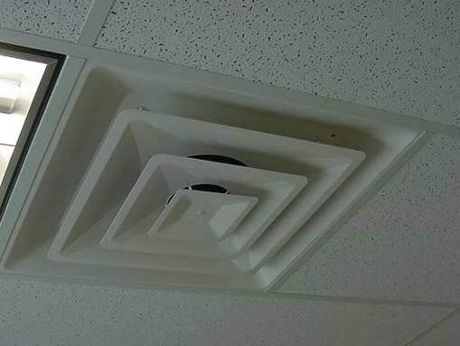

Example of Multi-Directional Air Diffuser in Offices and Common Areas with Dropped Ceilings

Picture 6

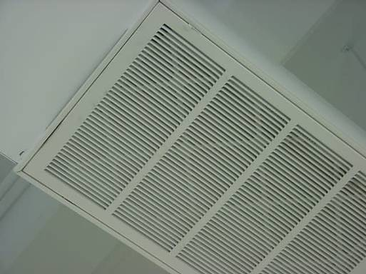

Return Vent with Pleated Air Filter Installed
Picture 7

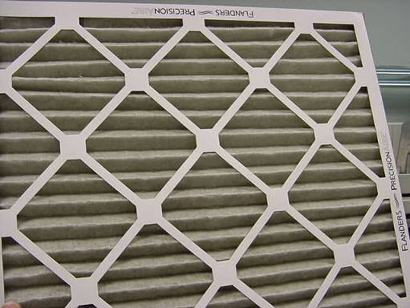

Pleated Air Filter

Picture 8

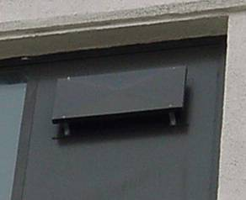

Exhaust Vent with Wind Shield Installed to Prevent Backdrafting
Picture 9

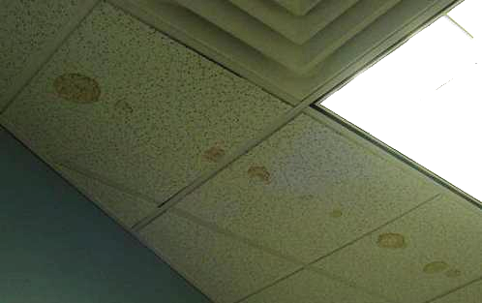

Water-Stained Ceiling Tiles, like from Pipe Condensation

Picture 10

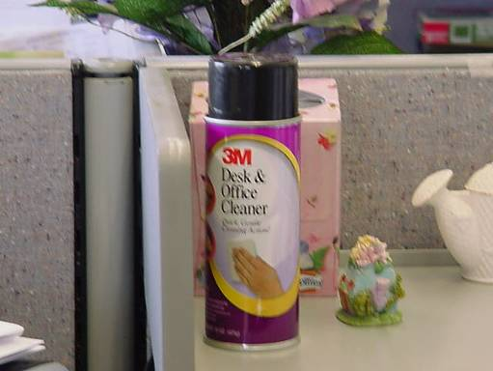

VOC-Containing Spray Cleaner

Picture 11

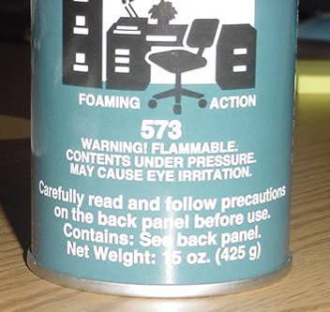

Close-up of Warning Label on Cleaning Material used at DOR

Picture 12

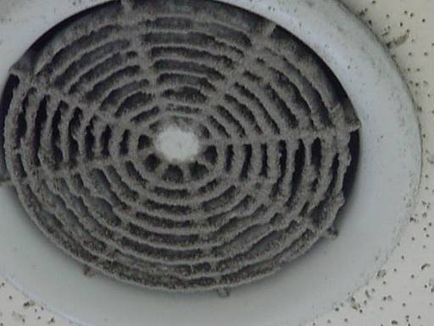

Dust Accumulation on Restroom Exhaust Vent
Picture 13

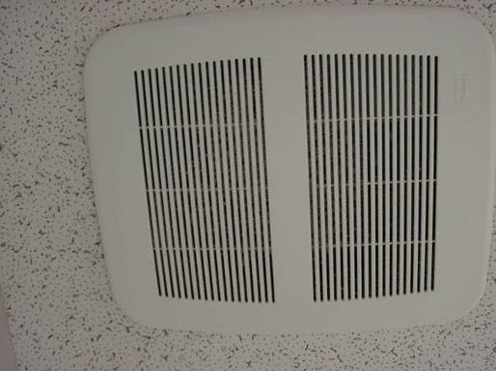

Dust Accumulation on Restroom Exhaust Vent, Note Slots were Obstructed Inhibiting Airflow

Location | Carbon  Dioxide  (*ppm) | Carbon  Monoxide  (*ppm) | TVOCs  (*ppm) | Temp  (°F) | Relative  Humidity  (%) | Occupants  in Room | Windows  Openable | Ventilation |  | Remarks
Background | 370 | ND | ND | 12 | 17 |  |  |  |  | Cold, clear, winds WSW 15-25 mph
West Wing
Auerbach | 1232 | ND | ND | 71 | 19 | 2 | Y | Y | Y | 1 WD CT-corner-active leak reported
Forcellati | 1198 | ND | ND | 72 | 18 | 1 | N | Y | Y | 1 WD CT
Artuso | 1201 | ND | ND | 73 | 18 | 0 | N | Y | Y
Office 5 | 1109 | ND | ND | 73 | 18 | 1 | N | Y | Y
Imperato | 1041 | ND | ND | 73 | 17 | 0 | N | Y | Y
Rubin | 1046 | ND | ND | 73 | 18 | 2 | N | Y | Y
Bachini | 1061 | ND | ND | 73 | 17 | 3 | Y | Y | Y | PFs
Malone | 1071 | ND | ND | 72 | 17 | 2 | Y | Y | Y
Joslin | 1087 | ND | ND | 72 | 18 | 3 | N | Y | Y
Adams | 1138 | ND | ND | 72 | 18 | 0 | N | Y | Y
Conference Room | 1020 | ND | ND | 73 | 17 | 1 | N | Y | Y
Pagliuca | 1105 | ND | ND | 73 | 17 | 3 | Y | Y | Y
Diaz | 1095 | ND | ND | 73 | 17 | 3 | Y | Y | Y
Magno | 1125 | ND | ND | 72 | 17 | 2 | Y | Y | Y
Central Wing
Palumbo | 1070 | ND | ND | 73 | 17 | 5 | N | Y | Y
Poole | 1077 | ND | ND | 73 | 17 | 0 | Y | Y | Y
Schrimpf | 1098 | ND | ND | 73 | 18 | 2 | N | Y | Y
McNamara | 1159 | ND | ND | 73 | 18 | 1 | N | Y | Y
Vacca | 1105 | ND | ND | 73 | 17 | 1 | N | Y | Y
DeShales | 1125 | ND | ND | 74 | 17 | 1 | Y | Y | Y
Davis | 1219 | ND | ND | 73 | 18 | 3 | Y | Y | Y
Menton | 1098 | ND | ND | 74 | 17 | 0 | Y | Y | Y
Gillis | 1146 | ND | ND | 74 | 17 | 0 | N | Y | Y
Comfort | 1148 | ND | ND | 73 | 17 | 1 | Y | Y | Y
Brown | 1183 | ND | ND | 73 | 17 | 4 | Y | Y | Y
Gaffee | 1172 | ND | ND | 74 | 17 | 3 | N | Y | Y
Laspina | 1142 | ND | ND | 74 | 18 | 1 | N | Y | Y
File Room | 969 | ND | ND | 73 | 17 | 0 | N | Y | Y
Reception | 1128 | ND | ND | 73 | 18 | 1 | N | Y | Y
Interview Room 1 | 1085 | ND | ND | 72 | 17 | 0 | N | Y | Y
Conference Room 1 | 1058 | ND | ND | 72 | 17 | 0 | N | Y | Y
Conference Room 2 | 1058 | ND | ND | 72 | 16 | 4 | N | Y | Y | DEM
Kitchen | 1201 | ND | ND | 72 | 18 | 7 | Y | Y | Y | Space between sink countertop and backsplash
Mail Room | 1154 | ND | ND | 72 | 18 | 0 | N | Y | Y | Dusty vents
Ho | 1132 | ND | ND | 72 | 17 | 0 | N | Y | Y
Khan | 1141 | ND | ND | 72 | 17 | 0 | N | Y | Y
East Wing
Peterson | 1236 | ND | ND | 73 | 18 | 2 | Y | Y | Y
Baltodano | 1259 | ND | ND | 73 | 18 | 3 | Y | Y | Y | Water cooler on carpet
Quintal | 1265 | ND | ND | 73 | 18 | 1 | Y | Y | Y
Crist | 1250 | ND | ND | 72 | 17 | 0 | Y | Y | Y
Gargas | 1273 | ND | ND | 74 | 18 | 0 | Y | Y | Y
Famiglietti | 1244 | ND | ND | 74 | 17 | 0 | Y | Y | Y
Congdon | 1264 | ND | ND | 74 | 18 | 1 | Y | Y | Y
Fowler | 1313 | ND | ND | 75 | 17 | 3 | N | Y | Y
Clark | 1248 | ND | ND | 75 | 17 | 1 | N | Y | Y | 7 WD CT near interior wall/exit
Barcroft | 1262 | ND | ND | 76 | 17 | 3 | N | Y | Y
Howard | 1228 | ND | ND | 76 | 17 | 2 | N | Y | Y
Prak | 1244 | ND | ND | 76 | 17 | 1 | N | Y | Y
Abdelmesseh | 1165 | ND | ND | 75 | 16 | 0 | N | Y | Y
Reczek | 1147 | ND | ND | 75 | 16 | 0 | N | Y | Y | Plug-in air freshener
Dirlinger | 1171 | ND | ND | 75 | 16 | 1 | N | Y | Y | PF
Woodbury | 1233 | ND | ND | 76 | 17 | 0 | N | Y | Y | 4 WD CT
Miller | 1252 | ND | ND | 76 | 17 | 0 | N | Y | Y | Plant
Hentz | 1240 | ND | ND | 76 | 17 | 1 | N | Y | Y
Vincent | 1247 | ND | ND | 76 | 17 | 0 | N | Y | Y
Stephan | 1270 | ND | ND | 76 | 17 | 1 | N | Y | Y
Walston | 1235 | ND | ND | 76 | 17 | 0 | N | Y | Y
Women’s Restroom |  |  |  |  |  | 0 | N | N | Y | Dusty exhaust vents

Appendix B
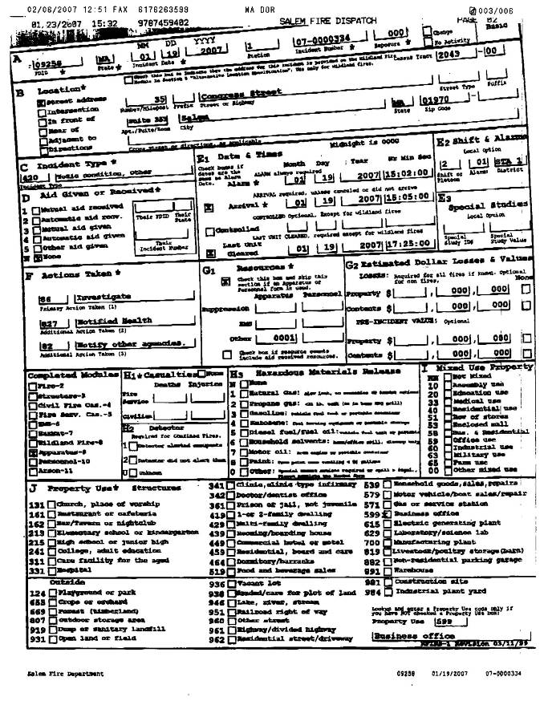

Appendix B (Cont.)

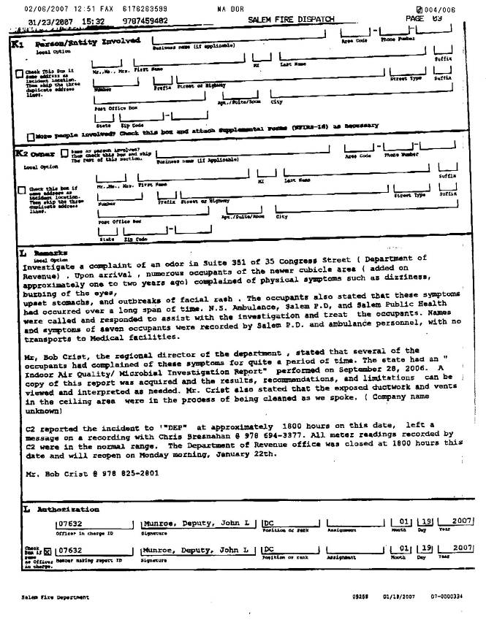

Appendix C
