INDOOR AIR QUALITY ASSESSMENT

Department of Revenue
Shetland Park
35 Congress Street
Salem, MA

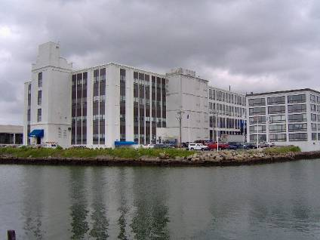

Prepared by:
Massachusetts Department of Public Health
Bureau of Environmental Health
Emergency Response/Indoor Air Quality Program
June 2007

Background/Introduction
At the request of the Service Employees International Union (SEIU), the National Association of Government Employees (NAGE), Massachusetts State Coordinated Bargaining Council (MSCBC), the Massachusetts Department of Public Health (MDPH), Bureau of Environmental Health (BEH) conducted an indoor air quality (IAQ) assessment at the Massachusetts Department of Revenue (DOR) located in the Shetland Park Office Complex, 35 Congress Street, Salem, Massachusetts. The request was prompted by continual concerns regarding indoor air quality and the potential for an association with health impacts among some employees in the building.
In a formal request from Kevin Preston, Director of the MSCBC, BEH was asked specifically to interview five DOR employees regarding their health status. Mr. Preston also requested that the balance of DOR staff be surveyed about work related concerns. In follow up to this request and prior to further indoor environmental tests being conducted, a meeting was convened to discuss the range of indoor environmental issues and employee health concerns. On April 2, 2007, Suzanne K. Condon, Associate Commissioner and Director of the BEH met with representatives from the Human Resource Division, Labor Relations, senior management and facilities staff for DOR, representatives from NAGE, SEIU, union stewards and employees from the DOR Salem offices.
At that meeting, a variety of health and environmental matters were discussed and the approach to addressing them was outlined. Indoor environmental testing would include tests/evaluations of mold and moisture, particulate matter, review of material safety data sheets (MSDS’) for other operators in the building and possible pathways of entry for emissions to enter the occupied space of the building housing the DOR. MDPH also committed to interviewing several staff (≤ ten) who were identified as having more serious health concerns (respiratory problems including occupational asthma).
Results of staff interviews related to health status (and/or review of medical records by the MDPH consulting physician) will be provided in a separate follow-up report. BEH staff previously visited the building in February 2007, and issued a report detailing conditions observed at that time, as well as recommendations to improve IAQ (MDPH, 2007).

Methods
In addition to sampling and analysis of accumulated material on the surfaces identified by DOR staff, BEH staff conducted numerous tests for several IAQ parameters. Tests for carbon dioxide, temperature and relative humidity were conducted with a TSI, Q-Trak, IAQ Monitor, Model 8551. Screening for total volatile organic compounds (TVOCs) was conducted using a Hnu, Model 102 Snap-on Photo Ionization Detector (PID). Air tests for airborne particle matter with a diameter less than 2.5 micrometers (PM2.5) were taken with the TSI, DUSTTRAK™ Aerosol Monitor Model 8520. BEH staff also performed visual inspection of building materials for water damage and/or microbial growth. Moisture content of porous building materials (i.e., gypsum wallboard, ceiling tiles and carpeting), was measured with Delmhorst, BD-2000 Model, Moisture Detector with a Delmhorst Standard Probe. Tape samples were also collected and are discussed later in this section.
On April 25, 2007 BEH staff conducted real-time testing for relative humidity, temperature, carbon dioxide, carbon monoxide, TVOCs, and PM2.5. These results are listed in Table 1. In addition, 24-hour monitoring for each IAQ parameter was conducted in a central area located in the west wing from April 25 to April 29, 2007 (TVOCs were measured from April 25 to May 1, 2007) and from May 1 to May 4, 2007 in a specified office (#124). Due to an equipment malfunction (TVOCs), office 124 was tested again for all IAQ parameters during the period of May 10 to May 15, 2007. Test results for 24-hour monitoring are included in Tables 2-9.
Concurrent with the 24-hour monitoring, BEH staff created an “IAQ Log Book” for DOR staff to record any IAQ/comfort concerns experienced during the monitoring. The log resided at the reception desk during the monitoring in the west wing from April 25 to May 1, 2007; and in office 124 during the May 1 to May 4, 2007 and May 10 to May 15, 2007 monitoring periods. The purpose of the log book was to compare any IAQ observations (e.g., chemical odors/incidents, temperature extremes) with test results recorded during monitoring in the specific areas.
As mentioned previously, BEH staff were asked to collect tape samples of accumulated materials on building surfaces for direct microscopic examination. These areas were selected in areas of concern and specifically pointed out by Laura Adams, Union Steward and other DOR staff. In accordance with methods developed previously in collaboration with the Harvard School of Public Health Microbiology Department, tape samples were taken by applying clear adhesive tape to the sample surface, mounting the tape onto microscope slides, and sealing the slides in plastic zip lock bags. These slides were forwarded to a Microbiology Laboratory at the University of Massachusetts in Amherst for microbial analysis. These results are included as Table 10.

Results
The DOR offices have a combined employee population of approximately 135. Real-time tests were taken during normal operations (i.e., during the work day). The approximate area of testing is indicated by room/office number, function or occupant’s last name. In addition, monitoring parameters were measured at approximate 15-minute intervals 24-hours per day for several days (Tables 2-9).

Discussion
Ventilation
It can be seen from Table 1 that carbon dioxide levels were above 800 parts per million (ppm) in all but two areas surveyed on April 25, 2007, indicating less than optimal air exchange throughout the majority of space occupied by the DOR. Results of 24-hour monitoring for carbon dioxide are as follows:
- West Wing: The average carbon dioxide reading for the April 25 to April 29, 2007 monitoring period was 535 ppm. Minimum: 387 ppm; maximum: 1,019 ppm (Table 2).
- Office 124: The average carbon dioxide reading for the May 1 to May 4, 2007 monitoring period was 634 ppm. Minimum: 404 ppm; maximum: 1,149 ppm (Table 3).
- Office 124: The average carbon dioxide reading for the May 10 to May 15, 2007 monitoring period was 534 ppm. Minimum: 389 ppm; maximum: 1,151 ppm (Table 4).
Fresh, heated air is supplied to all areas occupied by the DOR by air-handling units (AHUs) suspended from the ceiling (Picture 1). Fresh air is drawn into the AHUs through air intakes located on the exterior of the building (Picture 2). Ceiling-mounted air diffusers ducted to the AHUs distribute fresh tempered air to the occupied areas (Picture 3). Return air is drawn into ceiling-mounted vents (Picture 4). Some return air is ducted back to AHUs, where it is mixed with fresh air and redistributed to the office space. Air is also exhausted out of the building through vents located on the exterior of the building (Picture 5). Exhaust vents on the exterior of the building were equipped with wind shields to prevent re-entrainment of exhausted air.
Of note is the configuration of the exhaust ventilation. Each ceiling suspended AHU is fueled by natural gas, which allows the AHU to warm the air and subsequently provide it to the occupied space (Blueprint 1). The exhaust from the firebox is vented into a duct equipped with a flue damper, which is connected to ductwork connected to a power vent (Blueprint 2, Picture 6). The power vent expels the products of combustion through exhaust vents located on the exterior wall of the building. It is not possible to determine whether the power vents are operating when the heating system is operating. Since a major product of combustion is carbon dioxide, previous carbon dioxide measurements conducted in the facility may be reflective of these pollutants venting into the DOR through the flue damper (Picture 7) when/if the power vents are deactivated. The purpose of the flue vents in a system with a mechanical power vent is unclear, since the power vent would aid in drawing products of combustion without the addition of air from the building interior. Typically, installation of this type of AHU furnace does not depict a flue damper on the exhaust vent for this equipment (Figure 1) (Carrier Corporation, 1994). It is also unclear from where combustion air for each AHU firebox is drawn. Examination of the blueprints and visual inspection by BEH staff did not indicate a separate duct to provide outside air for the AHUs. Under these circumstances, it must be presumed, unless otherwise demonstrated, that combustion air for the AHUs is drawn from the building’s interior. Combustion air should be drawn directly from outdoors to ensure an adequate supply of oxygen exists to support the burning of fuel. Without an adequate oxygen supply, fuel cannot burn cleanly and pollutants and odors of natural gas are produced. These related pollutants/odors can then be drawn into the interior of the building by the operation of the HVAC system, if the power vents are not drawing efficiently and/or are disabled.
Digital wall-mounted thermostats control the HVAC system. Each thermostat has fan settings of “on” and “automatic”. The automatic setting on the thermostat activates the HVAC system at a preset temperature. Once the preset temperature is reached, the HVAC system is deactivated. Therefore, no mechanical ventilation is provided until the thermostat re-activates the system. Without a continuous source of fresh outside air and removal via the exhaust/return system, indoor environmental pollutants can build-up and lead to indoor air quality/comfort complaints. It was reported that on Friday April 27, 2007, the system was deactivated by Shetland Park staff in the central wing due to temperature complaints from the air-conditioning system. The following Monday, April 30, 2007, Shetland Park staff reportedly reactivated the system to the fan “on” mode.
The restroom mechanical exhaust vents did not appear to be operating during the April 25, 2007 assessment. Exhaust ventilation is necessary in restrooms to remove moisture and to prevent restroom odors from penetrating into adjacent areas.
To maximize air exchange, the MDPH recommends that both supply and exhaust ventilation operate continuously during periods of occupancy. In order to have proper ventilation with a mechanical supply and exhaust system, the systems must be balanced to provide an adequate amount of fresh air to the interior of a room while removing stale air from the room. It is recommended that HVAC systems be re-balanced every five years to ensure adequate air systems function (SMACNA, 1994). The date of the last balancing of these systems should have occurred prior to occupation.
The Massachusetts Building Code requires that each area have a minimum ventilation rate of 20 cubic feet per minute (cfm) per occupant of fresh outside air or openable windows (SBBRS, 1997; BOCA, 1993). The ventilation must be on at all times that the room is occupied. Providing adequate fresh air ventilation with open windows and maintaining the temperature in the comfort range during the cold weather season is impractical. Mechanical ventilation is usually required to provide adequate fresh air ventilation.
Carbon dioxide is not a problem in and of itself. It is used as an indicator of the adequacy of the fresh air ventilation. As carbon dioxide levels rise, it indicates that the ventilating system is malfunctioning or the design occupancy of the room is being exceeded. When this happens, a buildup of common indoor air pollutants can occur, leading to discomfort or health complaints. The Occupational Safety and Health Administration (OSHA) standard for carbon dioxide is 5,000 parts per million parts of air (ppm). Workers may be exposed to this level for 40 hours/week, based on a time-weighted average (OSHA, 1997).
The MDPH uses a guideline of 800 ppm for publicly occupied buildings. A guideline of 600 ppm or less is preferred in schools due to the fact that the majority of occupants are young and considered to be a more sensitive population in the evaluation of environmental health status. Inadequate ventilation and/or elevated temperatures are major causes of complaints such as respiratory, eye, nose and throat irritation, lethargy and headaches. For information concerning carbon dioxide, please see Appendix A.
Temperature readings on April 25, 2007 ranged from 68º F to 75 º F, which were within or close to the lower range of the MDPH recommended comfort guidelines (Table 1). The MDPH recommends that indoor air temperatures be maintained in a range of 70 º F to 78 º F in order to provide for the comfort of building occupants. In many cases concerning indoor air quality, fluctuations of temperature in occupied spaces are typically experienced, even in a building with an adequate fresh air supply. Several complaints were recorded in the IAQ complaint log regarding cold temperatures from the operation of the air conditioning (AC) system during the April 25 to April 29, 2007 monitoring period.
Results of 24-hour monitoring for temperature are as follows:
- West Wing: The average temperature reading for the April 25 to April 29, 2007 monitoring period was 72 º F. Minimum: 69 º F; maximum: 74 º F (Table 2).
- Office 124: The average temperature reading for the May 1 to May 4, 2007 monitoring period was 73 º F. Minimum: 71 º F; maximum: 74 º F (Table 3).
- Office 124: The average temperature reading for the May 10,-May 15, 2007 monitoring period was 75 º F. Minimum: 73 º F; maximum: 79 º F (Table 4).
These results were within or close to the lower level of the MDPH recommended comfort guidelines.
The relative humidity measured on April 25, 2007 ranged from 20 to 38 percent, which was below the MDPH recommended comfort range (Table 1). The MDPH recommends a comfort range of 40 to 60 percent for indoor air relative humidity. Relative humidity levels in the building would be expected to drop during the winter months due to heating. The sensation of dryness and irritation is common in a low relative humidity environment. Low relative humidity is a very common problem during the heating season in the northeast part of the United States.
Results of 24-hour monitoring for relative humidity are as follows:
- West Wing: The average relative humidity reading for the April 25 to April 29, 2007 monitoring period was 32%. Minimum: 24%; maximum: 37% (Table 2).
- Office 124: The average relative humidity reading for the May 1 to May 4, 2007 monitoring period was 27%. Minimum: 21%; maximum: 34% (Table 3).
- Office 124: The average relative humidity reading for the May 10 to May 15, 2007 monitoring period was 33%. Minimum: 23%; maximum: 34% (Table 4).

Microbial/Moisture Concerns
Musty odors were detected during the April 25, 2007 assessment and reported several times in the IAQ complaint log during the April 25 to 29, 2007 monitoring period. The DOR office space appears to be experiencing water penetration through the exterior walls and/or window systems. Similar water damage likely occurs when the building is subjected to wind driven rain during nor’easters. The DOR offices are located in the northeast quadrant of the third floor of the building, which would be on the windward side of the structure during nor’easters (Picture 8). The exterior wall system of the DOR office appears to be solid brick without a curtain wall, which is typical of industrial buildings of this sort. This type of wall system is prone to water penetration through the wall system, which can allow for moistening of carpeting and associated musty odors and/or mold growth.
Evidence of water penetration was found behind plastic coving on the exterior walls, which had efflorescence build-up (Picture 9). Efflorescence is a salt found in brick and mortar that dissolves in water. When the salt solution migrates to the surface of a wall, the water evaporates, leaving behind a white powder. This powder is not mold growth, but is a sign that water is moving through brickwork. Since the plastic coving is water impermeable, the moisture likely accumulates behind this barrier, which in turn wets the carpeting. In addition, each window has staining on the paint beneath the corners of many window frames, indicating water penetration either through the window frames or through open windows (Pictures 10 and 11). The presence of hogs in several windows indicates an ongoing water penetration problem.
During the course of the MDPH assessment, carpet was found moistened in the west section of the office (Pictures 13). The likely source of water moistening the carpet is a leak that appears to originate from ductwork (Picture 14). Prior to the April 25, 2007 visit by BEH staff, the last rainstorm with NNE winds that may have moistened the exterior walls of the DOR office occurred on April 19, 2007 (Weather Underground, 2007), indicating that the carpet was likely wet for at least seven days. Other evidence also suggests that carpets have been moistened during other events. Picture 15 depicts an incident that shows water passing beneath cubicles and possibly moistening floor dividers. In order to properly dry the carpet, temporarily removing the cubicle walls would be recommended. In order to avoid flooding from occupants on the fourth floor, all pipe penetrations in the DOR ceiling and fourth floor should be sealed on both sides of the penetration with a water proof sealant.
Along with the moistened carpeting, the operation of the air-conditioning (AC) system may be contributing to musty odors. The odor was not detected by BEH staff during subsequent visits, when the AC system was not operating. Certain components to the AC system can be susceptible to microbial growth due to moisture accumulation in drip pans, condensate pumps and hoses. Therefore these components should be properly cleaned and/or serviced prior to operation during the cooling season. Please note that the ability of the HVAC system to drain moisture can be directly affected by unconditioned sources of moist air in the DOR spaces. This condition likely occurs when the HVAC system is in cooling mode and windows are open. In order to reduce water accumulation in the AHU, windows must remain closed when the HVAC system is in cooling mode. Other sources of moist air (e.g., a hole found in the ceiling of the records room) should be properly sealed.
The US Environmental Protection Agency (US EPA) and the American Conference of Governmental Industrial Hygienists (ACGIH) recommends that porous materials be dried with fans and heating within 24 to 48 hours of becoming wet (US EPA, 2001; ACGIH, 1989). If porous materials are not dried within this time frame, mold growth may occur. Water-damaged porous materials cannot be adequately cleaned to remove mold growth. The application of a mildewcide to moldy porous materials is not recommended.
As with the previous MDPH assessment, water-stained ceiling tiles were still observed in a few areas (Table 1), indicating current or historical leaks through the building envelope. An active leak was reported in the legal department in the left hand corner of the space against the wall. BEH staff examined the area on May 1 and again on May 4, 2007 and found the area dry with no visible mold or associated odors detected.

Other IAQ Evaluations
Transient Odors
DOR staff reported a variety of odors: including natural gas, musty/mold-like odors, maple syrup, sewer odor and a strong, irritating odor outside the main door of the DOR. BEH staff repeatedly detected a strong orange/citrus-like odor in the main hallway over the course of several visits to the building. BEH staff evaluated MSDS’ for cleaning materials used by Shetland Park maintenance staff and observed that two products in particular, contains citric acid as a key ingredient. As denoted in previous sections of this report, the source of the natural gas odor is likely the HVAC system and the source of musty/mold odors is likely repeated moistening of carpet and/or AC system components. The source of intermittent sewer and maple syrup odor may be related to the plumbing system. A catering/food establishment exists directly below the DOR offices. Materials poured into the drain (e.g., maple syrup) can become a source of odor if any breaches exist in the drain system, particularly if a series of vertical drain pipes are located along the exterior wall of the DOR office space. The older drain pipes are installed in a series of hub end pipes [with a smooth end inserted into the bell end (a hub)] to create a joint which is sealed. If the pipe seal dries out or the breach is compromised, odors can enter the DOR space. New drain pipes are held together using a rubber gasket held in place with a screw clamp (a shield strap) (Picture 16). If these pipes are slightly misaligned or damaged, spaces can develop beneath the gasket of the shield strap to allow for drain odors to enter occupied areas.
The identification of odors is difficult due to the lack of consistency between description of odors and a lack of discernable patterns. In the event of future odor complaints, the following investigative/mitigation steps should be taken [note: these steps were previously included in the February 2007 MDPH IAQ report (MDPH, 2007) and are reiterated below for emphasis]:
- Observe conditions directly outside the building to rule out external sources (e.g., painting, vehicle exhaust).
- Observe conditions inside DOR space and consult with staff to determine if any personal/cleaning products were used or if cooking was/is in progress.
- Work with building management/maintenance staff to identify and seal any potential pathways between adjacent businesses, such as utility holes in ceilings/floors/walls (e.g., records room ceiling plenum).
- Install door sweeps on hallway doors to prevent odor migration from the hallway.
Using these methods, identification of odor patterns, elimination of odorous materials and elimination of pathways for odor penetration into the DOR offices should decrease the occurrence of odors.

Other IAQ Evaluations
Several members of DOR staff raised concerns regarding the possible presence of coal dust and/or products of combustion within the building. The typical size of coal dust particle is in a range of 1 to 100 micrometers (μm) in diameter (TETB, 2005) and dusts that have a diameter of 10 to 15 µm “do not penetrate beyond the upper airway” (Speizer, 1994). Therefore, the presence of dust of a diameter less than 10 μm would be the type that would cause respiratory symptoms, despite the source of said particle.
Indoor air quality can be negatively influenced by the presence of respiratory irritants, such as products of combustion. The process of combustion produces a number of pollutants. Common combustion emissions include carbon monoxide, carbon dioxide, water vapor and smoke (fine airborne particle material). Health effects resulting from exposure to coal dust is usually associated with the mining industry. However, coal dust may also be generated by the bulk movement of materials. Of these materials, exposure to carbon monoxide and particulate matter with a diameter of 2.5 μm or less (PM2.5) can produce immediate, acute health effects upon exposure. To determine whether combustion products or airborne particulate matter related to coal dust was present, BEH staff obtained measurements for carbon monoxide and PM2.5.

Carbon Monoxide
Carbon monoxide is a by-product of incomplete combustion of organic matter (e.g., gasoline, wood and tobacco). Exposure to carbon monoxide can produce immediate and acute health affects. Several air quality standards have been established to address carbon monoxide and prevent symptoms from exposure to these substances. The MDPH established a corrective action level concerning carbon monoxide in ice skating rinks that use fossil-fueled ice resurfacing equipment. If an operator of an indoor ice rink measures a carbon monoxide level over 30 ppm, taken 20 minutes after resurfacing within a rink, that operator must take actions to reduce carbon monoxide levels (MDPH, 1997).
The American Society of Heating Refrigeration and Air-Conditioning Engineers (ASHRAE) has adopted the National Ambient Air Quality Standards (NAAQS) as one set of criteria for assessing indoor air quality and monitoring of fresh air introduced by HVAC systems (ASHRAE, 1989). The NAAQS are standards established by the US EPA to protect the public health from six criteria pollutants, including carbon monoxide and particulate matter (US EPA, 2006). As recommended by ASHRAE, pollutant levels of fresh air introduced to a building should not exceed the NAAQS levels (ASHRAE, 1989). The NAAQS were adopted by reference in the Building Officials & Code Administrators (BOCA) National Mechanical Code of 1993 (BOCA, 1993), which is now an HVAC standard included in the Massachusetts State Building Code (SBBRS, 1997). According to the NAAQS, carbon monoxide levels in outdoor air should not exceed 9 ppm in an eight-hour average (US EPA, 2006).
Carbon monoxide should not be present in a typical, indoor environment. If it is present, indoor carbon monoxide levels should be less than or equal to outdoor levels. During the April 25, 2007 assessment, outdoor carbon monoxide concentrations were non-detect (ND) (Table 1). Carbon monoxide levels measured throughout the DOR were ND (Table 1). In addition, at no time were carbon monoxide levels detected above 1 ppm or the NAAQS of 9 ppm for carbon monoxide (Tables 1 to 4). Results of 24-hour monitoring for carbon dioxide are as follows:
- West Wing: no measurable levels of carbon monoxide were recorded over the April 25 to April 29, 2007 monitoring period (Table 2).
- Office 124: A maximum measurement of 1 ppm was recorded in office 124 over the May 1 to May 4, 2007 monitoring period (Table 3).
- Office 124: no measurable levels of carbon monoxide were recorded over the May 10 to May 15, 2007 monitoring period (Table 4).

Particulate Matter (PM2.5)
The US EPA has established NAAQS limits for exposure to particulate matter. Particulate matter is airborne solids that can be irritating to the eyes, nose and throat. The NAAQS originally established exposure limits to particulate matter with a diameter of 10 μm or less (PM10). According to the NAAQS, PM10 levels should not exceed 150 microgram per cubic meter (μg/m³) in a 24-hour average (US EPA, 2006). These standards were adopted by both ASHRAE and BOCA. Since the issuance of the ASHRAE standard and BOCA Code, US EPA proposed a more protective standard for fine airborne particles. This more stringent PM2.5 standard requires outdoor air particle levels be maintained below 35 μg/m³ over a 24-hour average (US EPA, 2006). Although both the ASHRAE standard and BOCA Code adopted the PM10 standard for evaluating air quality, MDPH uses the PM2.5 standard for evaluating airborne particulate matter concentrations in the indoor environment to be more conservative.
On April 25, 2007, outdoor PM2.5 concentrations were measured at 9 μg/m³ (Table 1). PM2.5 levels within the DOR ranged from 5 to 9 μg/m³, which were below the NAAQS of 35 μg/m³ (Table 1). At no time during the 24-hour monitoring were PM2.5 measurements above the US EPA ambient air quality standard. Results of 24-hour monitoring for PM2.5 levels are as follows:
- West Wing: The average PM2.5 level for the April 25 to April 29, 2007 monitoring period was 6 μg/m³. Minimum: 3 μg/m³; maximum: 11 μg/m³ (Table 5).
- Office 124: The average PM2.5 level for the May 1 to May 4, 2007 monitoring period was 4 μg/m³. Minimum: 3 μg/m³; maximum: 12 μg/m³ (Table 6).
- Office 124: The average PM2.5 level for the May 10 to May 15, 2007 monitoring period was 6 μg/m³. Minimum: 2 μg/m³; maximum: 20 μg/m³ (Table 7).
Frequently, indoor air levels of particulates can be at higher levels than those measured outdoors. A number of mechanical devices and/or activities that occur indoors can generate particulates during normal operation. Sources of indoor airborne particulate may include but are not limited to particles generated during the operation of fan belts in the HVAC system, cooking in the cafeteria stoves and microwave ovens; use of photocopiers, fax machines and computer printing devices, operating an ordinary vacuum cleaner and heavy foot traffic indoors.

TVOCs
Indoor air quality can also be negatively influenced by the presence of materials containing volatile organic compounds (VOCs). VOCs are carbon-containing substances that have the ability to evaporate at room temperature. Frequently, exposure to low levels of total VOCs (TVOCs) may produce eye, nose, throat and/or respiratory irritation in some sensitive individuals. Typical sources of VOCs from indoor sources include photocopiers, cleaners, health care/beauty products, dry erase materials, permanent markers, combustion sources, fabrics/textiles and paints.
In an effort to determine whether VOCs were present in the building, air monitoring for TVOCs was conducted. Outdoor TVOC concentrations on April 25, 2007 were ND (Table 1). Real-time measurements taken during the April 25, 2007 assessment for indoor TVOCs were also ND (Table 1). Results of 24-hour monitoring for TVOCs are as follows:
- West Wing: TVOCs measurements for the April 25 to May 1, 2007 monitoring period ranged from a minimum of 0.0 ppm to a maximum of 2.4 ppm (Table 8).
- Office 124: TVOCs measurements for the May 10 to May 15, 2007 monitoring period ranged from a minimum of 0.0 ppm to a maximum of 1.3 ppm (Table 9).
Several possible sources of measurable TVOCs exist in the DOR space. Of note is the use of a citrus-type carpet cleaner used in the building (particularly in the main hallway outside of DOR space) and plug-in air fresheners (Picture 17). These materials contain VOCs and can provide a source of irritation, particularly in sensitive individuals.

Direct Particulate Microscopic Analysis
Occupants expressed concerns about the accumulation of material on a number of surfaces throughout the DOR space, including vents, ductwork and staining on a pipe that has a history of leaks (Pictures 18 through 22). The direct microscopic analysis method of samples taken from these surfaces was used to provide an assessment of both biological (e.g., mold and spores) as well as non-biological debris (e.g., dust, particulates and fibers). As seen from Table 10, the identity of materials found in four of the five samples taken are materials that can be found in a typical office space (e.g., skin scales, textile fibers, soil-like particles, starch granules and carbon-like particles). The carbon–like particles seen in two of the samples appear to be consistent with diesel exhaust soot (personal conversation with Michael Muilenberg, 2007), the source of which is likely the continuous truck traffic that circles the building during business hours. The likely means for these particles to enter the building is through open windows or entrainment by the HVAC system. Sample 5 was taken in an area with dark staining on the underside of a pipe that occupants thought to be mold growth (Picture 22). The staining was determined to be a rust-like material (Table 10).

Conclusions/Recommendations
Based on reports from DOR occupants, observations by BEH staff and IAQ test results, it appears that several possible sources of odors exist within the DOR space, including musty odors from chronically moistened carpet and/or the AC system, possible natural gas odors from the gas-fired AHUs, and odors from drains along the exterior wall. Based on the PM2.5 air sampling results, it does not appear that the DOR office space is subject to coal dust contamination. The results of air sampling for PM2.5, TVOCs and carbon monoxide as well as direct microscopic examination of tape/bulk samples are typical of those found in most indoor office environments. Carbon dioxide levels do indicate a lack of poor air exchange during full occupancy, which likely allows odors and other indoor environmental pollutants that may be present to persist/linger, leading to IAQ/comfort complaints.
In order to improve IAQ within the DOR, implementation all applicable recommendations listed in previous ATC and MDPH reports (ATC, 2006; MDPH, 2007), particularly those regarding steps for investigating transient odors within DOR occupied areas. In addition to the recommendations made previously, the following additional recommendations are made to improve indoor air quality:

- Carpet and coving along all exterior walls should be removed. Carpeting should be removed in a manner consistent with recommendations in “Mold Remediation in Schools and Commercial Buildings” published by the US Environmental Protection Agency (US EPA, 2001). This document is available from the US EPA website: http://www.epa.gov/iaq/molds/mold_remediation.html. Replace with a non-porous material (e.g., non-slip surface).
- Install carbon monoxide detectors in all areas services by the HVAC system.
- Contact an independent ventilation engineer for an examination of the HVAC system to ascertain whether the power vent system is sufficient for removing products of combustion from the building. Remediation of the system may include:
- Removal of flapper vents from the exhaust system of each AHU;
- Installation of combustion air vents for each AHU;
- Operation of the power vent continuously when AHUs are in heating mode.
- Examine the integrity of all drains present in the DOR space by contacting a licensed plumber to conduct a smoke test. This activity should be conducted during non-business hours, after consultation with the Salem Fire Department. If any breaches are found, repair to render pipes water (and air) tight.
- Seal spaces around all utility and plumbing holes in the DOR floor/ceiling (e.g., open utility hole above ceiling plenum in the records room) with a waterproof sealant.
- Discontinue the use of strong scented air fresheners/cleaners (e.g., citrus cleaner in main hallway) in the building. Consider having the carpeting in main hallway professionally cleaned to remove/reduce residual odors.
- Restore exhaust ventilation in restrooms to remove odors and moisture.
- Continue to coordinate with building management, administration, HVAC vendor and DOR staff to achieve/maintain optimal comfort levels.
- Contact the building’s HVAC consultant to inspect interior components of the AC system susceptible to mold growth (e.g., drip pans, condensate pumps and hoses). Clean, disinfect and/or replace as necessary. This should be done as part of a preventative maintenance program prior to the start of the cooling season.
- Seal open seams around ductwork to prevent leakage and dust/debris accumulation. Clean accumulated dust/debris from these areas.
- Consider appointing a building liaison (and alternate) to coordinate efforts, facilitate communication and relay building-related concerns between occupants, administration and Shetland Park personnel.
- Refer to resource manuals and other related indoor air quality documents for further building-wide evaluations and advice on maintaining public buildings. Copies of these materials are located on the MDPH’s website: http://mass.gov/dph/indoor_air.

References
ACGIH. 1989. Guidelines for the Assessment of Bioaerosols in the Indoor Environment. American Conference of Governmental Industrial Hygienists, Cincinnati, OH.
ASHRAE. 1989. Ventilation for Acceptable Indoor Air Quality. American Society of Heating, Refrigeration and Air Conditioning Engineers. ANSI/ASHRAE 62-1989
ATC. 2006. ATC Associates, Inc. Indoor Air Quality/Microbial Investigation Report, 35 Congress Street, Salem MA. ATC Project No.: 60.31879.001. Dated September 28, 2006.
BOCA. 1993. The BOCA National Mechanical Code/1993. 8th ed. Building Officials and Code Administrators International, Inc., Country Club Hill, IL. Section M-308.1.1.
Carrier Corporation. 1994. Product Data 58ZAV Weathermaker® 8000 Delux High-Efficiency Downflow/ Horizontal Gas Furnace. Carrier Corporation, Syracuse, New York. http://www.xpedio.carrier.com/idc/groups/public/documents/techlit/58zav-3pd.pdf

MDPH. 1997. Requirements to Maintain Air Quality in Indoor Skating Rinks (State Sanitary Code, Chapter XI). 105 CMR 675.000. Massachusetts Department of Public Health, Boston, MA.

OSHA. 1997. Limits for Air Contaminants. Occupational Safety and Health Administration. Code of Federal Regulations. 29 C.F.R 1910.1000 Table Z-1-A.
MDPH. 2007. Indoor Air Quality Report for DOR Offices at 35 Congress Street, Dated February 2007. Massachusetts Department of Public Health, Center for Environmental Health, Boston, MA.

SBBRS. 1997. Mechanical Ventilation. State Board of Building Regulations and Standards. Code of Massachusetts Regulations. 780 CMR 1209.0
SEIU. 2007. Letter from Kevin Preston Director, Massachusetts State Coordinated Bargaining Council to Matt Hale, Assistant Director, Office of Employee Relations Re: Health and Safety-Shetland Office Park-Salem, MA. Dated March 26, 2007
SMACNA. 1994. HVAC Systems Commissioning Manual. 1st ed. Sheet Metal and Air Conditioning Contractors’ National Association, Inc., Chantilly, VA.
Speizer, F. E. 1994. Chapter 219 Environmental Lung Diseases. Harrison’s Principles of Internal Medicine, 13th Ed., Isselbacher, K.J., Braunwald, E., Wilson, J.D., Martin, J.B., Fauci, A.S., Kasper, D.L., ed. McGraw-Hill, Inc. pp.1177.
TETB. 2005. Particle Sizes. The Engineers Tool Box. http://www.engineeringtoolbox.com/particle-sizes-d_934.html
US EPA. 2001. Mold Remediation in Schools and Commercial Buildings. US Environmental Protection Agency, Office of Air and Radiation, Indoor Environments Division, Washington, D.C. EPA 402-K-01-001. March 2001.
US EPA. 2006. National Ambient Air Quality Standards (NAAQS). US Environmental Protection Agency, Office of Air Quality Planning and Standards, Washington, DC. http://www.epa.gov/air/criteria.html.
Weather Underground. 2007. History for Beverly, Massachusetts April 2007. http://www.wunderground.com/history/airport/KBVY/2007/4/18/DailyHistory.html?req_city=NA&req_state=NA&req_statename=NA
Picture 1

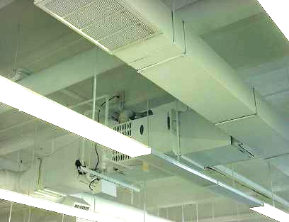

Ceiling Mounted AHU

Picture 2

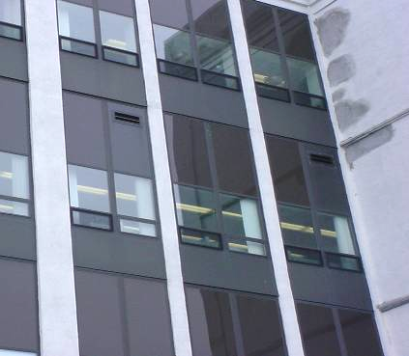

AHU Fresh Air Intake
Picture 3

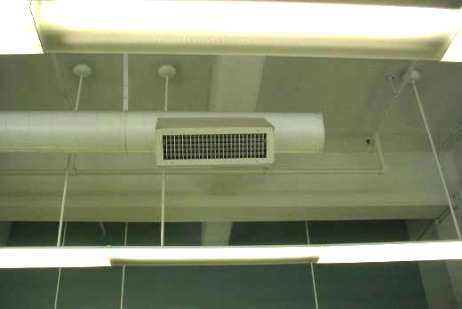

Example of Fresh Air Diffuser

Picture 4

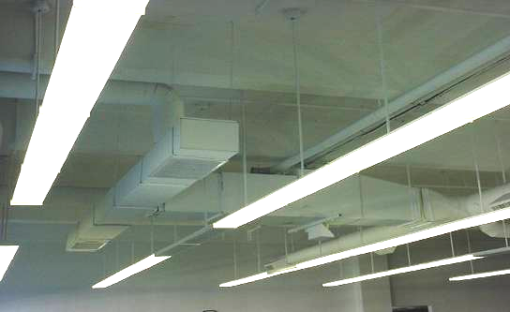

Example of Return Air Vent
Picture 5

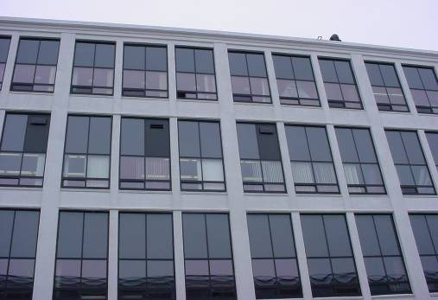

Example of Exterior Wall Exhaust Vent

Picture 6

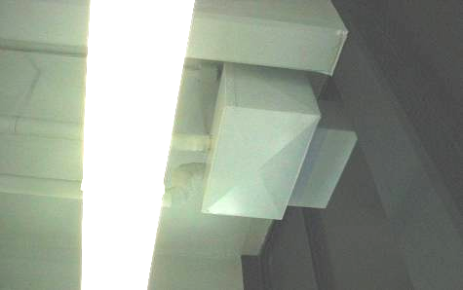
Example of Power Vent

Picture 7

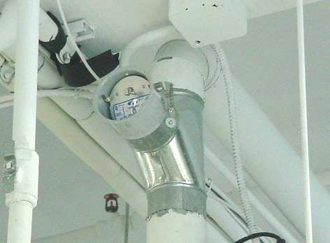

Example of Flue Damper on AHU

Picture 8

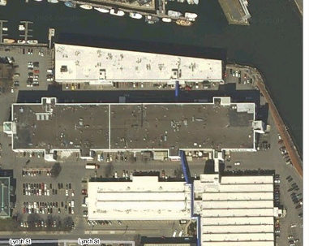

Aerial View of DOR Office Building (Arrow Indicates Location of Northeast Wind Impingement on Building)

Picture 9

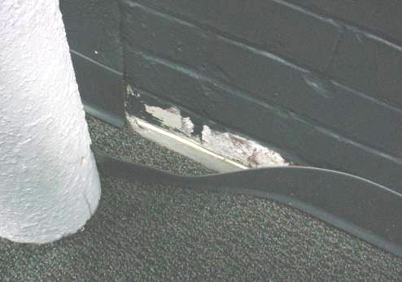

Efflorescence behind Wall Coving On Exterior Wall

Picture 10

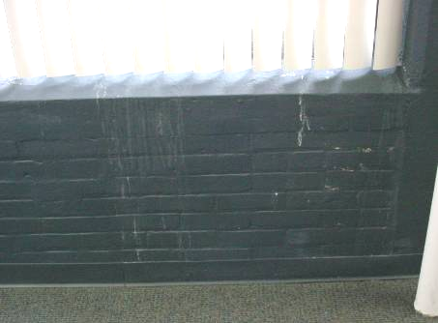

Example of Water Staining Around Windows
Picture 11

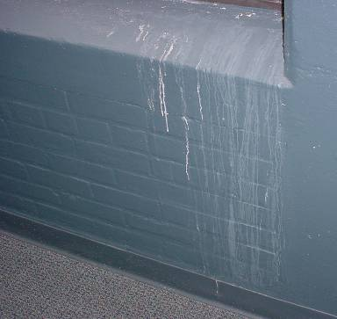

Example of Water Staining Around Windows, Note Efflorescence, Which Likely Indicates Water behind the Paint

Picture 12

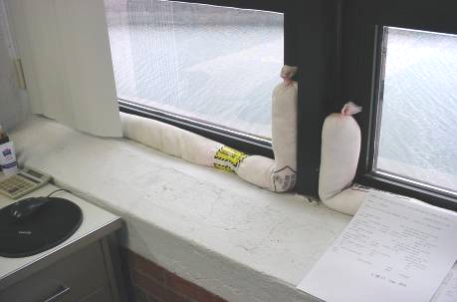

Hogs on Window Sill
Picture 13

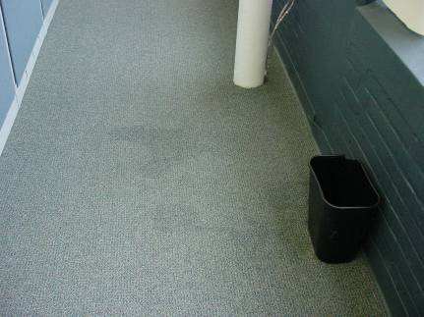

Moistened Carpet in DOR Office

Picture 14

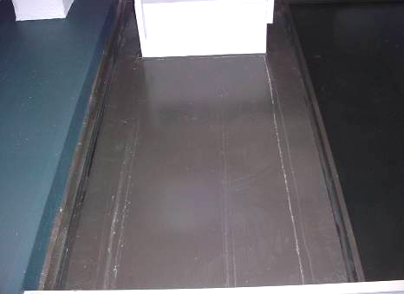

Water Leak Stains from Duct above Stain in Picture 12

Picture 15

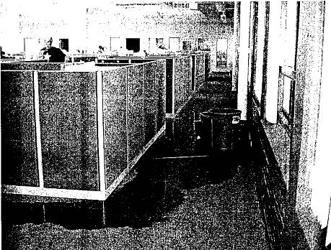

Picture of Flooding in DOR Reportedly Taken by DOR Employee

Picture 16

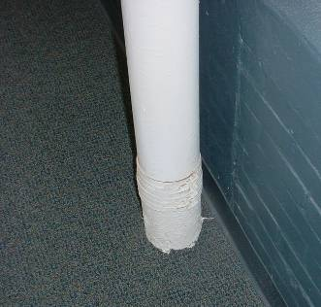

New Style of Drain (Shield Strap)

Picture 17
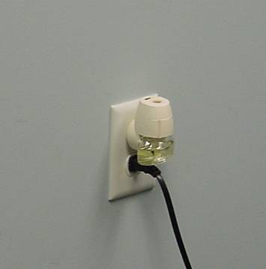

Plug-in Air Freshener

Picture 18

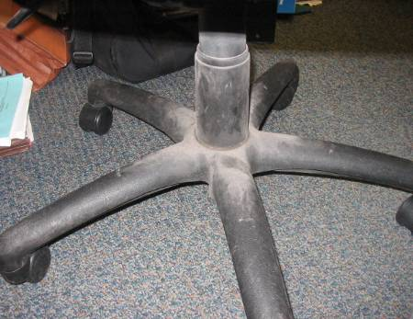

Tape/Bulk Item Sampled: Chair Leg E. Stephan’s Office
Picture 19

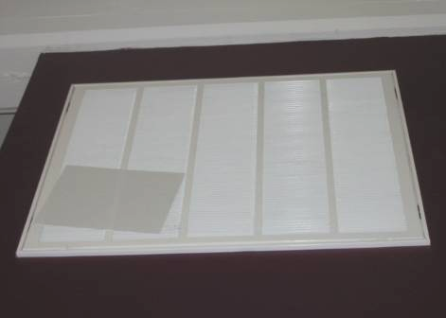

Tape/Bulk Item Sampled: Return Vent above Cravotta Desk, Paper on surface of Vent Indicates Draw of Air into the Vent

Picture 20

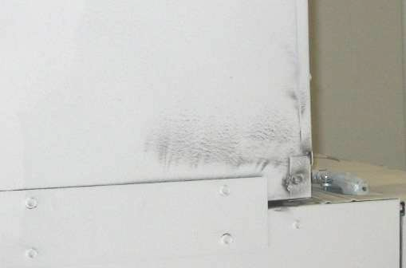

Tape/Bulk Item Sampled: Duct above Deacon Desk
Picture 21

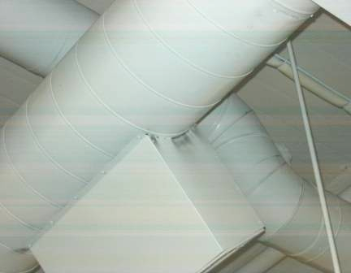

Tape/Bulk Item Sampled: Duct near T. Kneeland Desk

Picture 22

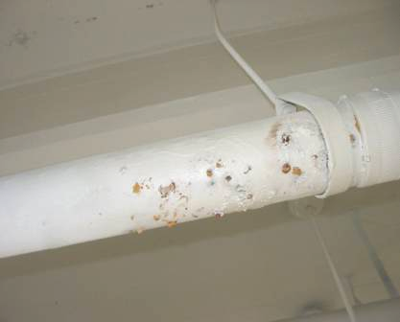

Tape/Bulk Item Sampled: Water Pipe above D. Comfort Desk
Location/ Room | Occupants  in Room | Temp  (°F) | Relative  Humidity  (%) | Carbon  Dioxide  (ppm) | Carbon Monoxide  (ppm) | TVOCs  (ppm) | PM2.5  (µg/m3) | Windows  Openable | Ventilation |  | Remarks
 |  |  |  |  |  |  |  |  | Supply | Exhaust | Remarks
background |  | 60 | 33 | 388 | ND | ND | 9
WEST WING |  |  |  |  |  |  |  |  |  |  | Elevated moisture content along exterior wall carpet
Auerbach | 0 | 72 | 28 | 916 | ND | ND | 7 | Y | Y | Y | 1 CT corner by window, plant, DO, low (e.g., normal moisture measurement)
Forcellati | 0 | 72 | 26 | 842 | ND | ND | 7 | N | Y | Y | 1 CT, DO
Artuso | 1 | 72 | 26 | 783 | ND | ND | 6 | N | Y | Y | DO
Room 5 Paternity Project | 1 | 73 | 26 | 849 | ND | ND | 6 | N | Y | Y | DO
Room 6  Temp Office | 1 | 73 | 25 | 835 | ND | ND | 6 | N | Y | Y | DO, dust-exhaust vent
Imperato | 0 | 72 | 28 | 889 | ND | ND | 6 | N | Y | Y
Saccardo | 0 | 71 | 26 | 951 | ND | ND | 7 | N | Y | Y
Rubin | 0 | 71 | 26 | 924 | ND | ND | 6 | N | Y | Y
Bachini | 0 | 71 | 27 | 942 | ND | ND | 6 | N | Y | Y
Lembo | 0 | 71 | 27 | 912 | ND | ND | 6 | N | Y | Y
Goldridge | 0 | 71 | 27 | 876 | ND | ND
Costa | 0 | 71 | 27 | 901 | ND | ND | 6 | N | Y | Y
Musto | 0 | 71 | 27 | 918 | ND | ND | 7 | N | Y | Y
Pagliuca | 0 | 68 | 28 | 907 | ND | ND | 6 | N | Y | Y
Sanchez | 1 | 69 | 29 | 911 | ND | ND | 7 | N | Y | Y
Kreticos | 1 | 69 | 28 | 928 | ND | ND | 7 | Y | Y | Y
Magno | 0 | 69 | 28 | 911 | ND | ND | 6 | N | Y | Y
Nemeth | 0 | 69 | 28 | 920 | ND | ND | 7 | N | Y | Y
Central Wing
Gonzalez | 1 | 68 | 29 | 908 | ND | ND | 8 | N | Y | Y
File Room | 0 | 70 | 28 | 816 | ND | ND | 6 | N | Y | Y
Poole | 1 | 70 | 27 | 783 | ND | ND | 6 | Y | Y | Y
Schrimpf | 0 | 72 | 20 | 947 | ND | ND | 8 | Y | Y | Y
Kaplan | 0 | 73 | 27 | 1055 | ND | ND | 6 | N | Y | Y
Contrada | 1 | 74 | 27 | 1008 | ND | ND | 6 | N | Y | Y
McLaughlin | 1 | 74 | 26 | 998 | ND | ND | 6 | Y | Y | Y
O’Donnell | 0 | 74 | 26 | 980 | ND | ND | 6 | Y | Y | Y
McCular | 1 | 73 | 26 | 1001 | ND | ND | 5 | N | Y | Y
Kneeland | 1 | 73 | 26 | 1005 | ND | ND | 7 | N | Y | Y
Morin | 1 | 73 | 27 | 1027 | ND | ND | 6 | Y | Y | Y | Pipe leak above desk of neighboring cubicle-dark staining
Nardone | 1 | 73 | 26 | 1072 | ND | ND | 6 | Y | Y | Y
Georges-Speechley | 1 | 73 | 26 | 1042 | ND | ND | 6 | N | Y | Y
Helman | 0 | 73 | 26 | 1037 | ND | ND | 7 | N | Y | Y
Laspina | 1 | 73 | 26 | 1000 | ND | ND | 7 | N | Y | Y
Nardone  (wall side) | 1 | 72 | 26 | 1015 | ND | ND | 7 | Y | Y | Y
Mail Room | 0 | 72 | 27 | 1038 | ND | ND | 7 | N | N | N
Lunch Room | 0 | 73 | 28 | 1332 | ND | ND | 7 | N | Y | N
Men’s Room |  |  |  |  |  |  |  | N | N | Y | Exhaust-weak/off?
Women’s Room |  |  |  |  |  |  |  | N | N | Y | Exhaust-weak/off?
EAST WING
Ho | 0 | 74 | 27 | 1160 | ND | ND | 7 | N | Y | Y
Khan | 1 | 73 | 27 | 1092 | ND | ND | 6 | N | Y | Y
Hoyt | 0 | 73 | 26 | 1012 | ND | ND | 7 | Y | Y | Y
McHale | 0 | 73 | 27 | 1085 | ND | ND | 7 | Y | Y | Y
Stackpole | 1 | 74 | 27 | 1105 | ND | ND | 7 | Y | Y | Y
Quintal | 1 | 74 | 27 | 1131 | ND | ND | 6 | N | Y | Y
Garcas | 0 | 75 | 27 | 1136 | ND | ND | 5 | Y | Y | Y
Famiglietti | 0 | 74 | 27 | 1105 | ND | ND | 6 | Y | Y | Y | Water damaged papers/boxes window leaks
Congdon | 0 | 74 | 27 | 1093 | ND | ND | 5 | Y | Y | Y
Parisi | 1 | 74 | 27 | 1124 | ND | ND | 7 | N | Y | Y
Hernandez | 1 | 75 | 27 | 1104 | ND | ND | 6 | N | Y | Y
Pisctatelli | 0 | 74 | 26 | 1088 | ND | ND | 6 | N | Y | Y
Schwartz | 0 | 73 | 26 | 1072 | ND | ND | 6 | N | Y | Y
Greeley | 1 | 74 | 27 | 1079 | ND | ND | 7 | N | Y | Y
Woodbury | 1 | 74 | 27 | 1128 | ND | ND | 7 | N | Y | N | Temp (warm)/ventilation complaints (stuffy)
Dinatale | 2 | 75 | 26 | 1340 | ND | ND | 6 | N | Y | N
Hentz | 1 | 75 | 26 | 1172 | ND | ND | 6 | N | Y | Y
Vincent | 1 | 73 | 26 | 1156 | ND | ND | 7 | N | Y | Y
Walston | 0 | 74 | 27 | 1137 | ND | ND | 8 | N | Y | Y
Reception | 1 | 74 | 27 | 1139 | ND | ND | 7 | N | Y | Y
Rao (#124) | 0 | 70 | 27 | 1159 | ND | ND | 7 | N | Y | Y
Crist | 1 | 73 | 35 | 1385 | ND | ND | 7 | Y | Y | Y | 3 water damaged CTs, occasional window leaks-driving rain
Dirlinger | 0 | 70 | 38 | 1185 | ND | ND | 6 | N | Y | Y
Stephan | 0 | 69 | 38 | 1196 | ND | ND | 6 | N | Y | Y
Reczek | 0 | 69 | 37 | 1181 | ND | ND | 6 | N | Y | Y
Abdelmesseh | 0 | 68 | 36 | 1110 | ND | ND | 9 | N | Y | Y

Table 2

Results of 24-hour Monitoring in West Wing, DOR
35 Shetland Park
Dates: April 25, 2007 – April 29, 2007

Start Time/Date: 2:49 PM 04/25/2007
Stop Time/Date: 2:49 PM 04/29/2007
Logging Interval: 15 Minutes

Parameter | Average | Minimum | Date/Time | Maximum | Date/Time
Carbon Dioxide | 535 ppm* | 387 ppm | 2:34 PM 04/29/2007 | 1019 ppm | 12:19 PM 04/26/2007
Carbon Monoxide | 0 ppm | 0 ppm | 3:04 PM 04/25/2007 | 0 ppm | 3:04 PM 04/25/2007
Temperature | 71.5 °F | 69.4 °F | 8:19 AM 04/29/2007 | 74.0 °F | 4:19 PM 04/27/2007
Relative Humidity | 31.8% | 23.8% | 6:04 PM 04/26/2007 | 36.8% | 3:19 AM 04/29/2007
*ppm = parts per million

Comfort Guidelines
Carbon Dioxide: | < 600 ppm = preferred | Temperature: | 70 - 78 °F
 | 600 - 800 ppm = acceptable | Relative Humidity: | 40 - 60%
 | > 800 ppm = indicative of ventilation problems

Table 3

Results of 24-hour Monitoring in Office 124,
DOR 35 Shetland Park
Dates: May 1, 2007 – May 4, 2007

Start Time/Date: 10:22 AM 05/01/2007
Stop Time/Date: 10:52 AM 05/04/2007
Logging Interval: 15 Minutes

Parameter | Average | Minimum | Date/Time | Maximum | Date/Time
Carbon Dioxide | 634 ppm* | 404 ppm | 6:37 AM 05/02/2007 | 1149 ppm | 12:52 PM 05/02/2007
Carbon Monoxide | 0 ppm | 0 ppm | 10:37 AM 05/01/2007 | 1 ppm | 3:07 PM 05/02/2007
Temperature | 72.6 °F | 71 °F | 11:07 PM 05/02/2007 | 74.2 °F | 10:52 AM 05/04/2007
Relative Humidity | 27 % | 21.1 % | 7:37 AM 05/04/2007 | 34.4 % | 12:37 PM 05/02/2007
*ppm = parts per million

Comfort Guidelines
Carbon Dioxide: | < 600 ppm = preferred | Temperature: | 70 - 78 °F
 | 600 - 800 ppm = acceptable | Relative Humidity: | 40 - 60%
 | > 800 ppm = indicative of ventilation problems

Table 4

Results of 24-hour Monitoring in Office 124,
DOR 35 Shetland Park
Dates: May 10, 2007 – May 15, 2007

Start Time/Date: 11:23 AM 05/10/2007
Stop Time/Date: 11:08 AM 05/15/2007
Logging Interval: 15 Minutes

Parameter | Average | Minimum | Date/Time | Maximum | Date/Time
Carbon Dioxide | 534 ppm* | 389 ppm | 6:38 PM 05/13/2007 | 1151 ppm | 11:38 AM 05/10/2007
Carbon Monoxide | 0 ppm | 0 ppm | 11:38 AM 05/10/2007 | 1 ppm | 11:38 AM 05/10/2007
Temperature | 74.7 °F | 72.8 °F | 1:53 PM 05/14/2007 | 78.5 °F | 3:08 AM 05/11/2007
Relative Humidity | 33.3 % | 23.3 % | 7:38 AM 05/14/2007 | 34.4 % | 11:53 AM 05/10/2007
*ppm = parts per million

Comfort Guidelines
Carbon Dioxide: | < 600 ppm = preferred | Temperature: | 70 - 78 °F
 | 600 - 800 ppm = acceptable | Relative Humidity: | 40 - 60%
 | > 800 ppm = indicative of ventilation problems

Table 5

Results of Results of 24-hour Monitoring for Airborne Particulates (PM2.5)*
in West Wing, DOR 35 Shetland Park
Dates: April 25, 2007 – April 29, 2007

Start Time/Date: | 2:50 PM 04/25/2007
Stop Time/Date: | 2:50 PM 04/29/2007
Logging Interval: | 15 Minutes
Average: | 6 µg/m3
Minimum Date/Time: | 3 µg/m3 3:05 PM 04/25/2007
Maximum Date/Time: | 11 µg/m3 1:35 PM 04/28//2007
*US EPA proposed standard for fine airborne particles (PM2.5) standard requires outdoor air particulate levels
be maintained below 35 μg/m³ over a 24-hour average (US EPA, 2006).

Table 6

Results of Results of 24-hour Monitoring for Airborne Particulates (PM2.5)* in Office 124,
DOR 35 Shetland Park
Dates: May 1, 2007 – May 4, 2007

Start Time/Date: | 10:22 AM 05/01/2007
Stop Time/Date: | 10:52 AM 05/04/2007
Logging Interval: | 15 Minutes
Average: | 4 µg/m3
Minimum Date/Time: | 3 µg/m3 10:37 AM 5/1/2007
Maximum Date/Time: | 12 µg/m3 3:37 PM 5/2/2007
*US EPA proposed standard for fine airborne particles (PM2.5) standard requires outdoor air particulate levels
be maintained below 35 μg/m³ over a 24-hour average (US EPA, 2006).

Table 7

Results of Results of 24-hour Monitoring for Airborne Particulates (PM2.5)* in Office 124,
DOR 35 Shetland Park
Dates: May 10, 2007 – May 15, 2007

Start Time/Date: | 11:23 AM 05/10/2007
Stop Time/Date: | 11:08 AM 05/15/2007
Logging Interval: | 15 Minutes
Average: | 6 µg/m3
Minimum Date/Time: | 2 µg/m3 12:53 PM 5/12/2007
Maximum Date/Time: | 20 µg/m3 2:38 AM 5/12/2007
*US EPA proposed standard for fine airborne particles (PM2.5) standard requires outdoor air particulate levels
be maintained below 35 μg/m³ over a 24-hour average (US EPA, 2006).

Table 8

Results of 24-hour Monitoring for TVOCs in West Wing,
DOR 35 Shetland Park
Dates: April 25, 2007 – April 29, 2007

Start Time/Date: | 2:59 PM 04/25/2007
Stop Time/Date: | 10:43 AM 05/01/2007
Logging Interval: | 15 Minutes
Average: | 0.5 ppm
Minimum Date/Time: | 0.0 ppm 3:14 PM 04/25/2007
Maximum Date/Time: | 2.4 ppm 4:14 AM 04/29/2007

Table 9

Results of 24-hour Monitoring for TVOCs in Office 124,
DOR 35 Shetland Park
Dates: May 10, 2007 – May 15, 2007

Start Time/Date: | 11:31 AM 05/10/2007
Stop Time/Date: | 11:28 AM 05/15/2007
Logging Interval: | 15 Minutes
Average: | 0.6 ppm
Minimum Date/Time: | 0.0 ppm 11:31 AM 05/10/2007
Maximum Date/Time: | 1.3 ppm 11:46 AM 05/15/2007

Table 10

Results of Tape Samples, Salem DOR, 35 Congress Street
Samples Taken April 25, 2007
Direct Microscopic Examination by Aerobiology Instruction & Research*, Amherst, MA

Sample  # | Location in Room | Fungal Growth and Relative Contamination Level | Miscellaneous Fungal Spores/Pollen (#observed) | General Assessment/Comments
1 | Stephan Office: accumulated particulate on base of chair/legs | None | hyphal fragments (6)  pollen (2) | No mold spores detected, abundant skin scales and textile fibers; some soil-like particles and starch
2 | West Wing: Return vent above Cravotta desk | None | pollen (2) | No mold spores detected, two stripes of “debris” along tape, mostly skin scales, many starch granules and soil-like, carbon like particles, few fibers
3 | West Wing: Underside of ventilation duct above Deacon desk | None | Basidiospores (6)  smut spores (4)  hyphal fragments (3) | No abundance of unusual types of mold/spores, abundant skin scales; many soil-like fibers and starch granules
4 | Central Wing: Side of ventilation duct near T. Kneeland desk | None | Basidiospores (3)  pollen (5) | No abundance of unusual types of mold/spores, abundant skin scales; many soil-and carbon-like particles; many starch granules and fibers
5 | Central Wing: Staining on underside of water damaged pipe | None | pollen (1) | No mold spores detected, pollen, abundant rust-like and other colorless (salt-like?) material
* Pan American Aerobiology Certification Board certified analyst: ML Muilenberg, MS
- Basidiospores: spores produced by a group of fungi called Basidiomycetes, (e.g., mushrooms, wood-rotting fungi)
- smut spores: refer to spores produced by smut fungi (e.g., plant pathogens).
- hyphal fragments – filamentous structures (hyphae) that make up the body of molds
- Miscellaneous fungal spores may be due to settling or accumulation; this does not indicate fungal growth. Number following fungal type is only an indication of the relative number observed.
Blueprint 1
AHU Description Table from Plans for DOR Salem Office Indicating Each AHU Combusts Natural Gas

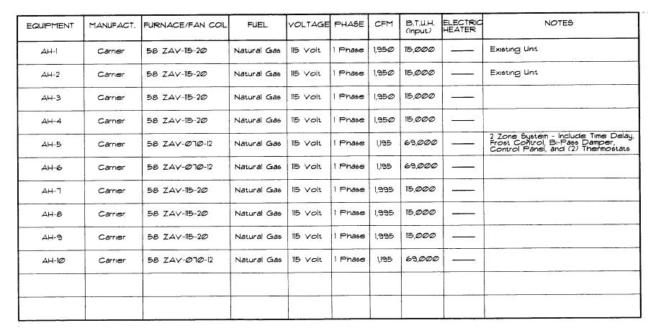

Blueprint 2
West Wing HVAC System Schematic Indicating Power Vents Installed on AHUs (Dotted Line Box)

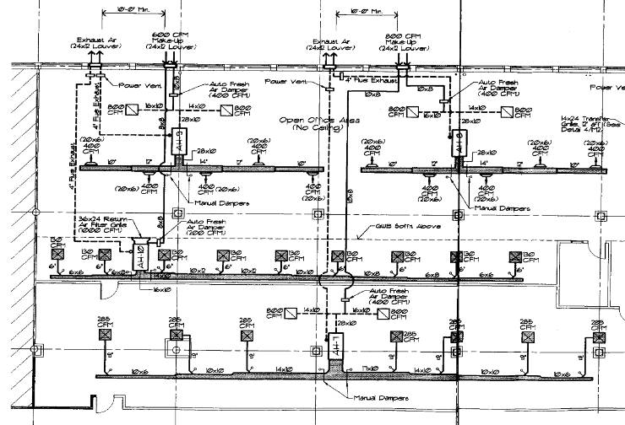
Figure 1

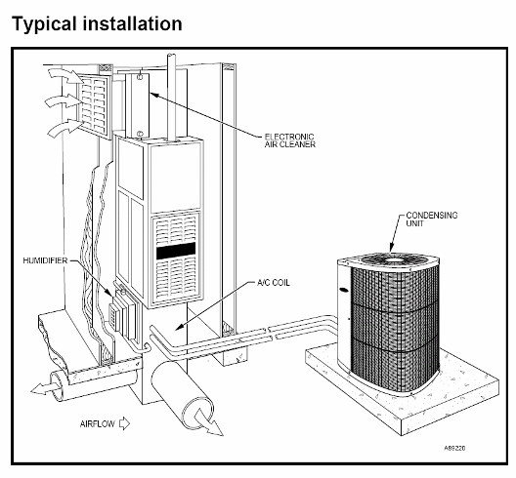

58ZAV Weathermaker® 8000 Delux High-Efficiency Downflow/Horizontal Gas Furnace, Note absence of flue damper above unit on combustion vent pipe (see arrow in bold) (Carrier Corporation, 1994)

A hog is a cloth tube filled with an absorbent material (Picture 11)

