INDOOR AIR QUALITY ASSESSMENT

Department of Revenue Office
218 South Main Street
Fall River, MA

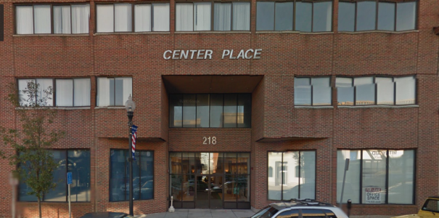

Prepared by:
Massachusetts Department of Public Health
Bureau of Environmental Health
Indoor Air Quality Program
August 2016

Background
Building: | Department of Revenue Office (DOR)
Address: | 218 South Main Street, Fall River
Assessment Requested by: | Joshua Martin, Deputy Director, Office of Facilities Management, Massachusetts Department of Revenue
Reason for Request: | General indoor air quality (IAQ) for lease renewal.
Date of Assessment: | July 13, 2016
Massachusetts Department of Public Health/Bureau of Environmental Health (MDPH/BEH) Staff Conducting Assessment: | Ruth Alfasso, Environmental Engineer/Inspector, IAQ Program
Building Description: | Four-story brick building in the middle of a city block. DOR is a tenant on the 3rd floor. Other office tenants occupy part of the third floor and adjacent floors.
Building Population: | Approximately 40 employees.
Year of Construction: | The building is a multi-level brick structure constructed in 1940 as a movie theater. The building became office space in the late 1980s, and has undergone a number of renovations since that time. The DOR has occupied a portion of the 3rd floor of this building since 1991.
Windows: | Some windows appeared openable, but are reportedly not used

Methods
Please refer to the IAQ Manual for methods, sampling procedures, and interpretation of results (MDPH, 2015).

IAQ Testing Results
The following is a summary of indoor air testing results (Table 1).
- Carbon dioxide levels were below 800 parts per million (ppm) in all the areas assessed, indicating adequate fresh air in the space.
- Temperature was within the recommended range of 70°F to 78°F in all areas assessed.
- Relative humidity was within the recommended range of 40% to 60% in all areas assessed.
- Carbon monoxide levels were non-detectable in all indoor areas assessed.
- Fine particulate matter (PM2.5) concentrations measured were below the National Ambient Air Quality Standard (NAAQS) level of 35 μg/m³ in all areas assessed.

The assessment results indicate that the ventilation system is providing adequate fresh air for the occupancy in the building. Note that many areas had low occupancy, which can reduce carbon dioxide levels. To maximize air exchange, the BEH recommends that mechanical ventilation systems operate continuously during periods of occupancy. Without the ventilation system operating as designed, normally occurring pollutants cannot be diluted or removed, causing them to build up and lead to IAQ/comfort complaints.

Ventilation
A heating, ventilating, and air conditioning (HVAC) system has several functions. First it provides heating and, if equipped, cooling. Second, it is a source of fresh air. Finally, an HVAC system will dilute and remove normally occurring indoor environmental pollutants not only by introducing fresh air, but also by filtering the airstream and ejecting stale air to the outdoors via exhaust ventilation. Even if an HVAC system is operating as designed, point sources of respiratory irritation may exist and cause symptoms in sensitive individuals. The following analysis examines and identifies components of the HVAC system and likely sources of respiratory irritant/allergen exposure from water damage, aerosolized dust, and/or chemicals found in the indoor environment.
Fresh air is provided by air handling units (AHUs) located on the roof. Air from the AHUs is filtered, heated/cooled, and delivered to rooms via ducted supply vents (Picture 1). Air is returned/exhausted through return vents (Picture 2).
Thermostats in the office were observed set to the “occupied” setting (Picture 3) in most areas, with the exception of currently unoccupied “annex” storage area. The occupied setting should provide continuous air circulation during occupied hours, even when no temperature adjustments are needed. If the annex is reoccupied in the future, this thermostat setting will need to be adjusted.
It is recommended that HVAC systems be re-balanced every five years to ensure adequate air systems function (SMACNA, 1994). It was unknown when the last time these systems had been balanced.

Microbial/Moisture Concerns
The backsplash behind the kitchen sink had a gap (Picture 4), which can allow water to damage the materials underneath/behind and potentially lead to microbial growth. Signs of water leakage or condensation were observed under the sink (Picture 5). Porous items stored under the sink can also become water-damaged.
Several small refrigerators and water coolers were located in carpeted areas (Picture 6 and 7). Spills or leaks from these appliances can moisten the carpet, leading to odors and microbial growth. A gasket on a small refrigerator was found stained with debris/microbial growth (Picture 8). Refrigerators should be kept clean, and gaskets should be cleaned regularly with a mild antimicrobial solution.
Plants were observed in offices (Picture 9; Table 1). Plants can be a source of pollen and mold, which can be respiratory irritants to some individuals. Plants should be properly maintained and equipped with drip pans to prevent water damage to porous materials. Plants should also be located away from air diffusers to prevent the aerosolization of dirt, pollen, and mold.

Other IAQ Evaluations
Exposure to low levels of total volatile organic compounds (TVOCs) may produce eye, nose, throat, and/or respiratory irritation in some sensitive individuals. To determine if VOCs were present, BEH/IAQ staff examined rooms for products containing VOCs. BEH/IAQ staff noted air fresheners, hand sanitizers, and cleaners in use within the building (Table 1). All of these products have the potential to be irritants to the eyes, nose, throat, and respiratory system of sensitive individuals.
The offices were mostly carpeted. Carpets should be cleaned annually (or semi-annually in soiled/high traffic areas) in accordance with Institute of Inspection, Cleaning, and Restoration Certification (IICRC) recommendations (IICRC, 2012).
In some offices, the accumulation of items such as paper, boxes, and decorative items make it harder for custodial staff to clean. Personal fans, heaters, and air purifiers were seen in offices (Table 1). Some of these items were dusty, which can allow dust to be reaerosolized when the units operate. In addition, air purifiers may have filters that need changing or cleaning and should be maintained in accordance with manufacturer’s instructions.

Conclusions/Recommendations
Based on observations at the time of assessment, the following is recommended:
- Operate supply and exhaust ventilation continuously in all areas during occupied periods. If the “annex” area is to be reoccupied, ensure that thermostat settings are adjusted to the occupied setting.
- Have the HVAC system balanced every 5 years in accordance with SMACNA recommendations (SMACNA, 1994).
- Repair/seal the sink backsplash. Ensure sink is not leaking underneath and avoid storing porous materials under the sink.
- Place refrigerators and water dispensing equipment in areas without carpeting or use a waterproof mat underneath them.
- Ensure refrigerators including door gaskets are kept clean.
- Keep plants in good condition, avoid overwatering, and avoid placing them on porous items such as carpets or paper.
- Reduce use of cleaning products, sanitizers, and scented products.
- Clean carpeting in accordance with IICRC recommendations (IICRC, 2012).
- Reduce stored materials and store in an organized manner to allow for thorough cleaning.
- Clean supply and exhaust vents, personal fans, and heaters regularly to prevent aerosolization of debris.
- Maintain air purifiers and filter changes in accordance with manufacturer’s instructions.
- Refer to resource manual and other related IAQ documents located on the MDPH’s website for further building-wide evaluations and advice on maintaining public buildings. These documents are available at: http://mass.gov/dph/iaq.

References
IICRC. 2012. Institute of Inspection, Cleaning and Restoration Certification. Carpet Cleaning: FAQ. Retrieved from: http://www.iicrc.org/consumers/care/carpet-cleaning/#faq.
MDPH. 2015. Massachusetts Department of Public Health. Indoor Air Quality Manual: Chapters I-III. Available at: http://www.mass.gov/eohhs/gov/departments/dph/programs/environmental-health/exposure-topics/iaq/iaq-manual/.
SMACNA. 1994. HVAC Systems Commissioning Manual. 1st ed. Sheet Metal and Air Conditioning Contractors’ National Association, Inc., Chantilly, VA.
Picture 1
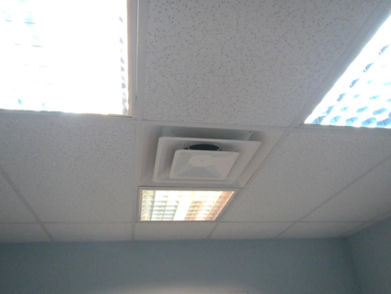
Supply vent
Picture 2
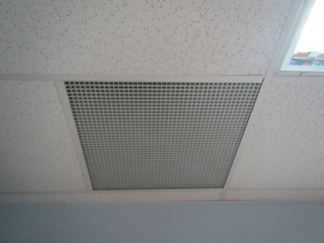
Return/exhaust vent
Picture 3
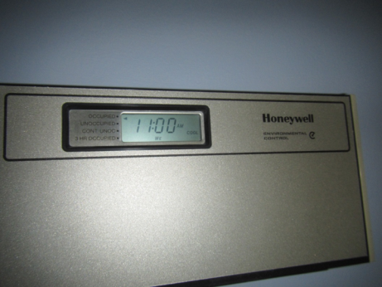
Thermostat set to “occupied” (arrow)
Picture 4
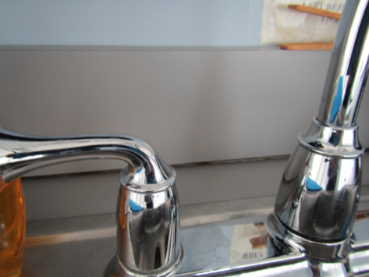
Open gap on kitchen sink backsplash
Picture 5
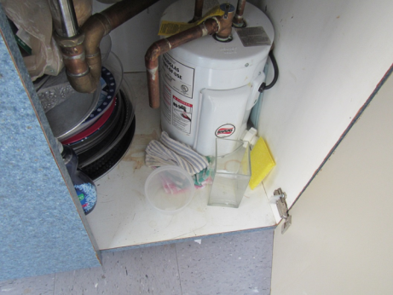
Water stains and porous items under sink
Picture 6
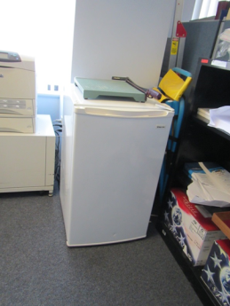
Small refrigerator on carpet
Picture 7
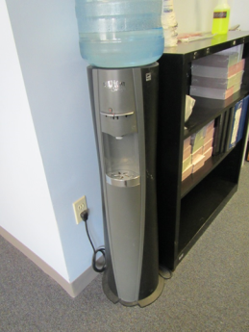
Water cooler on carpet
Picture 8
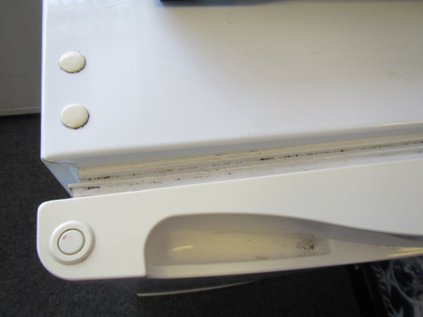
Stained refrigerator gasket
Picture 9
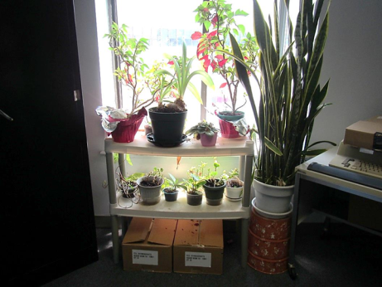
Plants, note debris on cardboard boxes stored underneath

Location | Carbon  Dioxide  (ppm) | Carbon Monoxide  (ppm) | Temp  (°F) | Relative  Humidity  (%) | PM2.5  (µg/m³) | Occupants  in Room | Windows  Openable | Ventilation |  | Remarks
 |  |  |  |  |  |  |  | Supply | Exhaust
Background | 320 | ND | 85 | 55 | 22 |  |  |  |  | Street level, warm and humid
Large Conference Room | 639 | ND | 74 | 48 | 2 | 1 | N | Y | Y | Carpet
Powers cube office | 552 | ND | 74 | 50 | 2 | 0 | N | Y | N | Plants, water cooler and fridge on carpet
Front area/reception | 713 | ND | 74 | 52 | 3 | 3 | N | Y | Y
Waiting | 637 | ND | 73 | 50 | 3 | 0 | N | Y | Y
Bissionnelle cube area | 497 | ND | 72 | 51 | 4 | 1 | N | Y | Y
Rodriguez cube area | 482 | ND | 72 | 52 | 4 | 0 | N | Y | Y | Water cooler on carpet, plant
Tavares cube area | 459 | ND | 72 | 52 | 4 | 0 | N | Y | Y | Food
Kitchen | 444 | ND | 72 | 52 | 4 | 0 | N | Y | Y | NC, fridge, microwave (2) with items on top
Andrade cube area | 458 | ND | 74 | 55 | 4 | 0 | N | Y | Y | PF
Szeto cube areas | 518 | ND | 74 | 56 | 4 | 0 | N | Y | Y | HS, scented products, PF, food
Margarida (large cube) | 497 | ND | 75 | 58 | 4 | 0 | N | Y | Y | PF/heater
Danilowicz cube area | 507 | ND | 76 | 59 | 4 | 2 | N | Y | Y | PF on, boxes on floor
McGrath cube area | 797 | ND | 76 | 58 | 4 | 0 | N | Y | Y | Plants, PF, AI-wall
Small conference room | 524 | ND | 74 | 56 | 3 | 0 | N | Y | Y
Allard cube area | 511 | ND | 74 | 60 | 4 | 3 | N | Y | Y | CP, books, AI, food, water cooler on carpet
Flowers cube area | 567 | ND | 75 | 59 | 4 | 1 | N | Y | Y
Sheehan | 554 | ND | 74 | 58 | 4 | 0 | N | Y | Y | CP/AF, heater/AP
“annex” | 491 | ND | 76 | 55 | 2 | 0 | N | Y | Y | Boxes on floor, area is vacant, was only occupied a short time and may be returned to landlord, thermostat set on “unoccupied” in this area

