INDOOR AIR QUALITY ASSESSMENT

Department of Revenue
99 South Main Street, 2nd floor
Fall River, MA

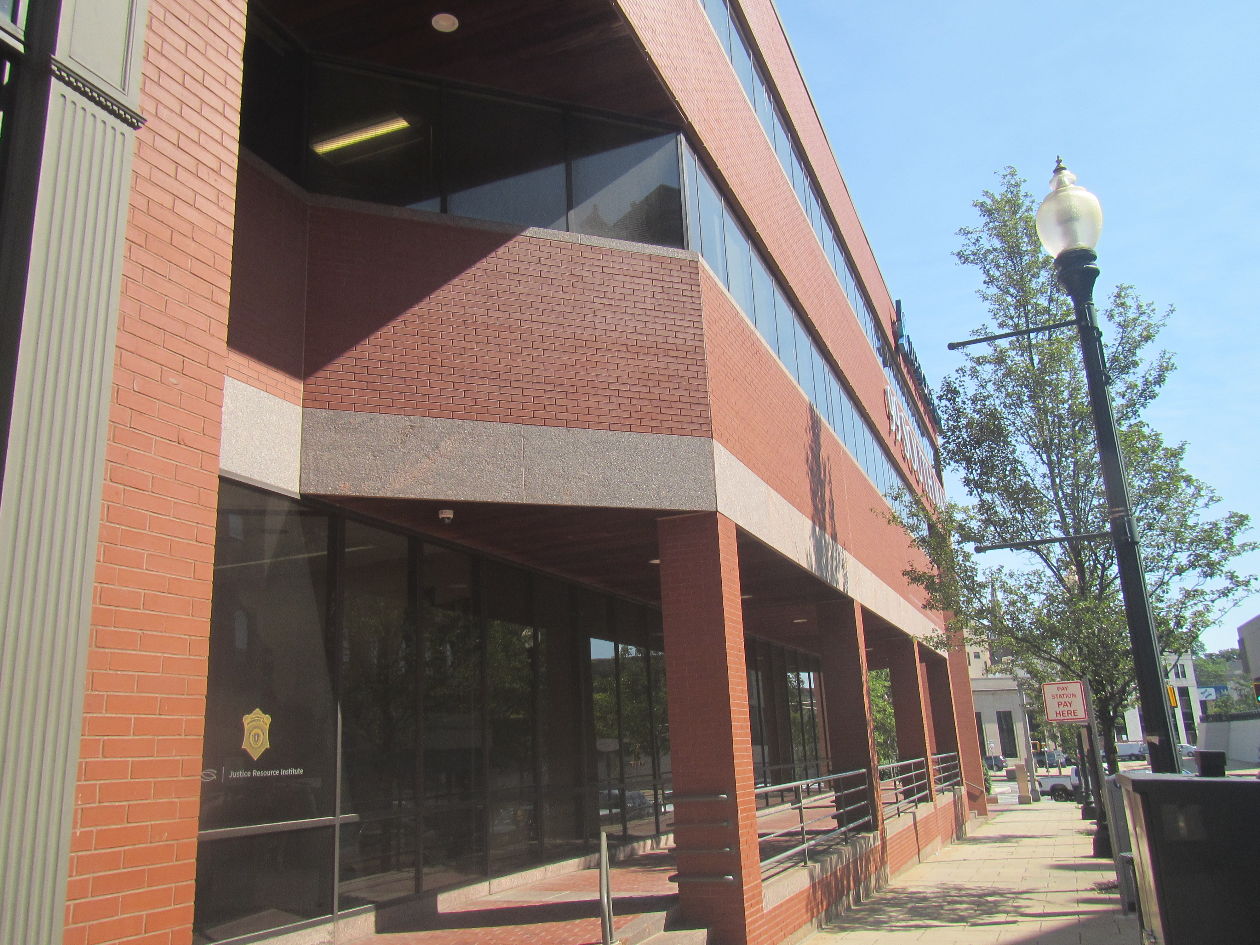

Prepared by:
Massachusetts Department of Public Health
Bureau of Climate and Environmental Health
Indoor Air Quality Program
August 2023

BACKGROUND
Building: | Department of Revenue (DOR)
Address: | 99 South Main Street, Fall River MA
Assessment Requested by: | Joshua Martin, Director, Office of  Facilities Management, Massachusetts  DOR
Reason for Request: | Part of a regular program of indoor air quality (IAQ) inspections of DOR workspaces
Date of Assessment: | July 11, 2023
Massachusetts Department of Public Health/Bureau of Environmental Health (MDPH/BCEH) Staff Conducting Assessment: | Ruth Alfasso, Environmental  Engineer/Inspector, IAQ Program
Building Description: | The DOR occupies an office suite on the 2nd floor of a three-story brick and glass office building in a central business district of Fall River. The building was originally built in the late 1800s and significantly renovated in the 1980s. The DOR offices are primarily hoteling space, with offices, cubicles, and meeting rooms, a copy room and break room.
Windows: | Windows are not openable

METHODS
Please refer to the IAQ Manual for methods, sampling procedures, and interpretation of results (MDPH, 2015). Note that this building was previously visited in 2018 after DOR moved to this location from a nearby location in Fall River. Previous reports can be found here: https://www.mass.gov/info-details/indoor-air-quality-reports-cities-and-towns-f#fall-river-

RESULTS AND DISCUSSION
The following is a summary of indoor air testing results (Table 1).
- Carbon dioxide measurements were below the MDPH guideline of 800 parts per million (ppm) indicating adequate fresh air in the space.
- Temperature was within the recommended range of 70°F to 78°F in all areas tested.
- Relative humidity was within the recommended range of 40% to 60% in all areas tested, similar to outside at the time of the assessment.
- Carbon monoxide levels were non-detectable (ND) in all areas tested.
- Fine particulate matter (PM2.5) concentrations were below the National Ambient Air Quality Standard (NAAQS) level of 35 μg/m³ in all areas tested.
- Total Volatile Organic Compounds (TVOC) were not-detectable (ND).

Ventilation
Note that the DOR is moving towards a “hoteling” or “touchdown space” model for offices, where an individual checks out a desk for the day when they are in the office and has no set work location. All desks and workstations in this office are assigned by reservation on a daily basis.
A heating, ventilating, and air conditioning (HVAC) system has several functions. First, it provides heating and, if equipped, cooling. Second, it is a source of fresh air. Finally, an HVAC system will dilute and remove normally occurring indoor environmental pollutants by not only introducing fresh air, but also filtering the airstream and ejecting stale air to the outdoors via exhaust ventilation. Even if an HVAC system is operating as designed, point sources of respiratory irritation may exist and affect symptoms in sensitive individuals. The following analysis examines and identifies components of the HVAC system and likely sources of respiratory irritant/allergen exposure due to water damage, aerosolized dust, and/or chemicals found in the indoor environment.
Fresh air is provided by air handling units (AHUs), which could not be examined at the time of the assessment. Air from the AHUs is filtered, heated/cooled, and delivered to rooms via ducted supply vents (Picture 1). Air is drawn through return vents and returned to the AHUs. Very few obvious return or exhaust vents were identified during this assessment. It’s possible the same style of vent is used for both supply and return, or that many areas (e.g., offices, conference rooms) lack a return vent. Both supply and return or exhaust ventilation is necessary to maintain IAQ during occupied periods. Additional heat is provided by radiators along some exterior walls.
The ventilation system should be on and operating to supply fresh air continuously during occupied periods. Without adequate fresh air supply and removal of stale air, common indoor air pollutants can build up and cause irritation.
It is recommended that HVAC systems be re-balanced every five years to ensure adequate air systems function (SMACNA, 1994). The system was most likely balanced in 2018 when DOR moved to this location, however it is unknown if balancing has taken place since then. System balancing should also be conducted when office space is significantly reconfigured.
A notice in the elevator of the building stated that the building HVAC system was using an in-duct germicidal ultraviolet (UV) system to deactivate microbial contamination. This “Bio WallTM” system by Sanuvox has been listed by the California Air Resources Board (CARB) which means it has been tested for electrical safety and that it produces low or no ozone (CARB, 2023). In-duct UV systems need regular maintenance of the lamps to ensure they are working.

Microbial/Moisture Concerns
No water-damaged ceiling tiles or other water-damaged materials were noted in the office. Water dispensers are located on carpet in several areas (Picture 2). Refrigerators in break rooms and other areas should be cleaned regularly to prevent odors caused by spills and spoiled food. Food preparation equipment such as microwaves and toasters should also be cleaned regularly.

Other IAQ Concerns
Because of the hoteling design of this office, there are no personal items on desks in the office, and very little clutter was found. This can make it easier for custodial staff to clean.
Sampling for total volatile organic compounds (TVOC) was conducted, with all readings being non-detectable (ND). An examination was conducted for products that may be a source of VOCs in indoor air. Products such as dry erase markers, hand sanitizers, and other cleaners were found in offices and common areas (Picture 3; Table 1). In the absence of adequate fresh air and exhaust ventilation, VOCs from these products can build up and lead to irritation of the mucous membranes or irritating odors.
Lockers are present in this location for staff to store work-related and personal items. Lockers should be cleaned out periodically to prevent odors or pest issues due to storage of food or other items.
As mentioned above, most areas of this office are carpeted. Carpets should be cleaned regularly in accordance with Institute of Inspection, Cleaning and Restoration Certification (IICRC) recommendations (IICRC, 2012).

CONCLUSIONS/RECOMMENDATIONS
The following are recommendations made to maintain IAQ:

Ventilation recommendations
- Operate supply and exhaust ventilation in all areas during occupied periods.
- Ensure filters are replaced on HVAC units at least twice a year. If feasible, use filters with a minimum efficiency rating value (MERV) of 8 or better.
- Ensure thermostats office-wide are set in a consistent manner, including nighttime and weekend setbacks.
- Consider reviewing space plans and adding additional return vents where needed.
- It is recommended that HVAC systems be re-balanced every five years to ensure adequate air systems function (SMACNA, 1994).
- Building management should be maintaining the in-duct UV system in accordance with manufacturer’s instructions.

Water damage recommendations
- Consider moving refrigerators and water dispensers to areas without carpeting or use a waterproof mat underneath.
- Keep refrigerators and other food-preparation appliances clean.

Other recommendations
- Periodically clean dust from supply and return vents, radiators, and fans.
- Use VOC-containing products in areas with good ventilation and keep tightly closed when not in use. Avoid products with strong scents and avoid mixing incompatible products.
- Ensure lockers are cleaned out periodically.
- Clean carpeting in accordance with IICRC recommendations (IICRC, 2012).
- For buildings in New England, periods of low relative humidity during the winter are often unavoidable. Therefore, scrupulous cleaning practices should be adopted to minimize common indoor air contaminants whose irritant effects can be enhanced when the relative humidity is low. To control dust, a high efficiency particulate arrestance (HEPA) filter equipped vacuum cleaner in conjunction with wet wiping of all surfaces is recommended. Avoid the use of feather dusters. Drinking water during the day can help ease some symptoms associated with a dry environment (throat and sinus irritations).
- Refer to resource manual and other related IAQ documents located on the MDPH’s website for further building-wide evaluations and advice on maintaining public buildings. These documents are available at: http://mass.gov/dph/iaq.

REFERENCES
CARB, 2023. List of CARB-Certified Air Cleaning Devices. California Air Resources Board https://ww2.arb.ca.gov/list-carb-certified-air-cleaning-devices.

IICRC. 2012. Institute of Inspection, Cleaning and Restoration Certification. Carpet Cleaning: FAQ.
MDPH. 2015. Massachusetts Department of Public Health. Indoor Air Quality Manual: Chapters I-III. Available at: https://www.mass.gov/lists/indoor-air-quality-manual-and-appendices.
SMACNA. 1994. HVAC Systems Commissioning Manual. 1st ed. Sheet Metal and Air Conditioning Contractors’ National Association, Inc., Chantilly, VA.

Picture 1
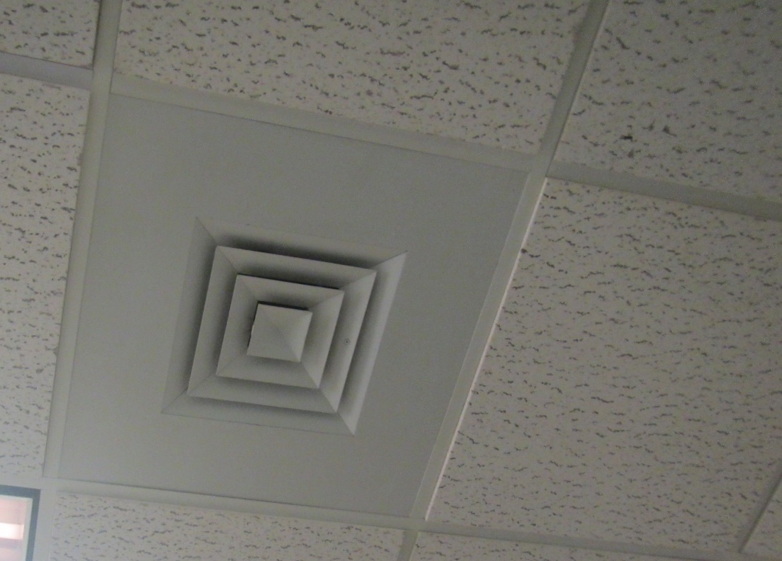
Typical ceiling-mounted vent; both supply and return vents may look the same
Picture 2
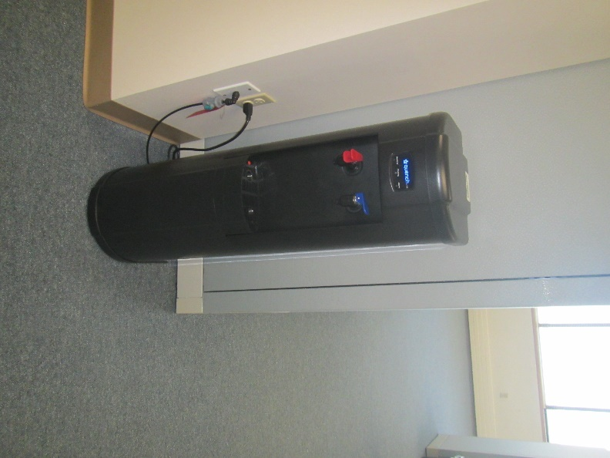
Water cooler on carpet
Picture 3
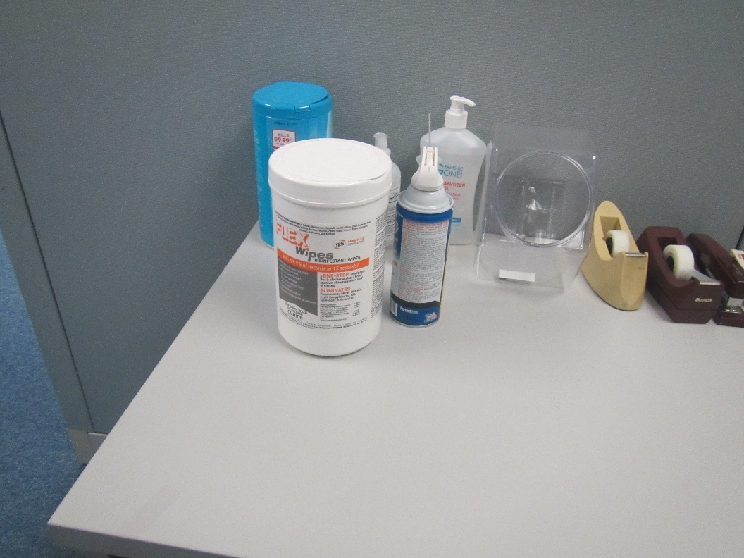
Cleaning supplies and sanitizers
Location | Carbon  Dioxide  (ppm) | Carbon Monoxide  (ppm) | Temp  (°F) | Relative  Humidity  (%) | PM2.5  (µg/m³) | TVOC  (ppm) | Occupants  in Room | Windows  Openable | Ventilation |  | Remarks
 |  |  |  |  |  |  |  |  | Supply | Exhaust
Background | 387 | ND | 82 | 58 | 7 |  |  |  |  |  | Outside front of building, with traffic and pedestrians, sunny and warm
Conference room 2 | 523 | ND | 74 | 55 | ND | ND | 0 | N | Y |  | 2 supply-style vents, no obvious exhaust
Copy room | 545 | ND | 71 | 60 | ND | ND | 0 | N | N | N | NC
Cube 202 | 560 | ND | 71 | 59 | ND | ND | 0 | N | Y | Y
Cubes 203-208 | 580 | ND | 71 | 59 | ND | ND | 0 | N | Y | Y
Cubes 209-214 | 580 | ND | 72 | 59 | ND | ND | 3 | N | Y | Y
Cubes 215-219 | 518 | ND | 72 | 59 | ND | ND | 2 | N | Y | Y
Cubes 220-225 | 588 | ND | 71 | 60 | ND | ND | 1 | N | Y | Y
Cubes 226-231 | 596 | ND | 71 | 60 | ND | ND | 4 | N | Y | Y
Cubes 232-234 | 600 | ND | 71 | 60 | ND | ND | 1 | N | Y | Y
Reception inside | 572 | ND | 71 | 60 | ND | ND | 0 | N | Y | Y
Cubes 236-242 | 542 | ND | 71 | 59 | ND | ND | 0 | N | Y | Y | Copier, HS
Conference room 1 | 533 | ND | 71 | 59 | ND | ND | 0 | N | Y | N | DEM
Office 2 | 607 | ND | 71 | 60 | ND | ND | 1 | N | Y | N | HS
Kitchen/locker area | 606 | ND | 72 | 60 | ND | ND | 1 | N | Y | Y | NC, fridge, toaster, microwave, sink, food
Wellness room | 582 | ND | 71 | 59 | ND | ND | 0 | N | Y | N | Carpeted
Office 1 | 670 | ND | 71 | 60 | ND | ND | 2 | N | Y | N

