INDOOR AIR QUALITY ASSESSMENT

Department of Revenue
DIB file room, floor 1A
MITC Building
200 Arlington Street
Chelsea, MA

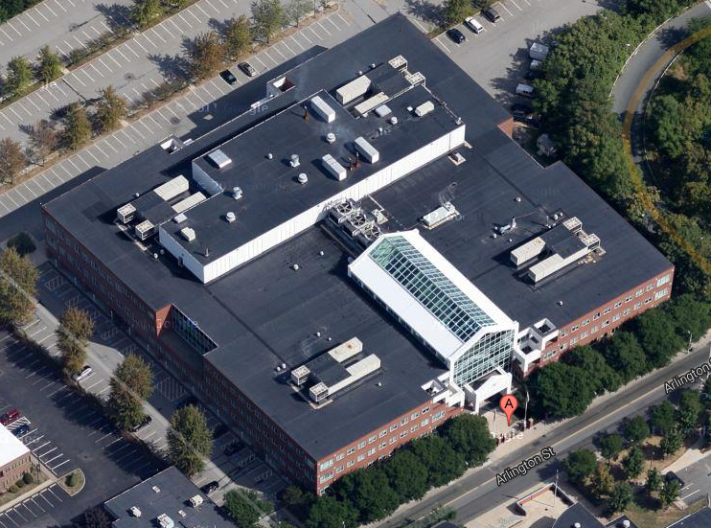

Prepared by:
Massachusetts Department of Public Health
Bureau of Environmental Health
Indoor Air Quality Program
September 2022

BACKGROUND
Building: | Department of Revenue (DOR)
Address: | 200 Arlington Street, Chelsea, MA
Assessment Requested by: | Joshua Martin, Director, Office of  Facilities Management, Massachusetts  DOR
Reason for Request: | Indoor air quality (IAQ)/mold concerns in the DIB file room on floor 1A
Date of Assessment: | September 7, 2022
Massachusetts Department of Public Health/Bureau of Environmental Health (MDPH/BEH) Staff Conducting Assessment: | Ruth Alfasso, Environmental  Engineer/Inspector, IAQ Program
Building Description: | The MITC is a large glass, brick, and concrete building with four floors completed in 1995. The space assessed is a large warehouse-type room used for storing documents on open shelving.
Windows: | Not openable

This building has been visited by the IAQ program several times in the past, including several full assessments of the entire building. Reports from those assessments are available by request.

METHODS
Please refer to the IAQ Manual for methods, sampling procedures, and interpretation of results (MDPH, 2015).

RESULTS AND DISCUSSION
Measurements for IAQ parameters were taken inside the training room:
- Carbon dioxide was measured at 506 ppm, which is below the 800 parts per million (ppm) preferred level indicating adequate fresh air in the space. This room is only occupied intermittently, and it was unoccupied before the measurement was taken. Levels of carbon dioxide would be expected to increase with occupancy.
- Temperature was measured at 69°F, which is below the recommended range of 70°F to 78°F.
- Relative humidity was measured at 68%, which is above the recommended range of 40% to 60% in all areas assessed. This is reflective of outdoor conditions. Dew points calculated on temperature and humidity were similar inside and outside.
- Carbon monoxide levels were non-detectable (ND) in the area assessed.
- Fine particulate matter (PM2.5) concentrations measured at < 0.2 μg/m³, which is below the National Ambient Air Quality Standard (NAAQS) level of 35 μg/m³.

Ventilation
A heating, ventilating, and air conditioning (HVAC) system has several functions. First, it provides heating and, if equipped, cooling. Second, it is a source of fresh air. Finally, an HVAC system will dilute and remove normally occurring indoor environmental pollutants by not only introducing fresh air, but also filtering the airstream and ejecting stale air to the outdoors via exhaust ventilation. Even if an HVAC system is operating as designed, point sources of respiratory irritation may exist and cause symptoms in sensitive individuals. The following analysis examines and identifies components of the HVAC system and likely sources of respiratory irritant/allergen exposure due to water damage, aerosolized dust, and/or chemicals found in the indoor environment.
Fresh air is provided by air handling units (AHUs) located on the roof of the building. Air from the AHUs is filtered, heated/cooled, and delivered to rooms via ducted supply vents (Picture 1). In this room air is drawn through exhaust grills (Picture 2) and removed from the building via the ceiling plenum and a duct to fans on the roof.
The ventilation system should be on and operating to supply fresh air continuously during occupied periods. Without adequate fresh air supply and removal of stale air, common indoor air pollutants can build up and cause irritation.
At the time of the visit, two portable ducted air conditioners were also in use in the space (Picture 3). These were primarily being used to reduce humidity in the space and the plenum above the ceiling tiles.
It is recommended that HVAC systems be re-balanced every five years to ensure adequate air systems function (SMACNA, 1994). It is not known when the last time these systems were balanced.

Microbial/Moisture Concerns

Several water-damaged ceiling tiles were noted in the space (Pictures 4 through 6). Some of these had a dark staining, which may indicate mold growth or breakdown products from exposure of the ceiling tile or decking above to water. Many ceiling tiles were sagging or bowed (Picture 7) which is frequently the result of exposure to chronic high humidity. There was also a faint musty odor in the room.
Several factors make this ceiling prone to water exposure. This room is located directly beneath a large data center. The data center is cooled to a significantly lower temperature than typical indoor air. The data center floor is a raised-type over metal decking (Picture 8). The air-chilling system in the data center cools the metal decking, which then condenses water to drip onto the ceiling tiles. While condensation was not visible on the underside of the decking during the visit, occupants reported that this has happened recently, and the pattern of stains on the ceiling tiles reflect this occurrence.
The ceiling, and potentially files stored in the room, have also been subject to water damage from high humidity. When the relative humidity is above 70% for a significant period of time, water damage can occur on susceptible materials even in the absence of liquid water (ASHRAE, 2019). While the measurement taken during this visit showed relative humidity slightly below 70%, the dew points inside and outside the building were similar, suggesting that the HVAC system has a limited ability to remove water vapor from the air. This has also been observed during previous visits during humid weather. Therefore, during warmer or more humid weather, such as occurred in the days prior to the visit, relative humidity in this space may have been above 70% for several days.
Water-damaged ceiling tiles should be replaced promptly, particularly if they may have become colonized with mold. The ceiling tiles used in this space are a thick acoustic type that may stay wet longer than other types of ceiling tiles. Replacement with a more mildew-resistant tile, or with a thinner tile that will dry faster, may be preferred until the condensation issues can be more permanently fixed.
To permanently alleviate the condensation issue, the metal decking beneath the data center floor needs to be thermally separated from the occupied spaces below using insulation. This is reportedly in the planning stages.
In the interim, steps should continue to be taken to reduce humidity in the occupied space as well as in the ceiling plenum during hot, humid weather. The current use of portable air conditioners to condense water from the indoor air and eject the waste heat into the ceiling plenum can assist in reducing the chance of condensation in this area. If possible, this should be paired with increasing the draw of air via the exhaust system. Otherwise, this may pressurize the ceiling plenum and push air back into occupied space.
The use of dehumidifiers in the occupied space will also help reduce humidity, which will reduce the chance of the stored papers becoming moistened, reduce the discomfort of a damp environment, and reduce dampness-related odors. Dehumidifiers should be sized to fit the space and the amount of humidity to be removed. When dehumidifiers are used, the humidity level should be monitored, and the units turned down or removed so that humidity does not fall below 40% during dehumidifier operation. During the winter heating season, dehumidifiers should not be used, as an excessively dry environment can lead to discomfort. Dehumidifiers should be emptied daily and cleaned regularly so they do not become a source of odors.
Note also that increasing the temperature in the space will reduce the relative humidity. Given the same dewpoint of 58°F, slightly raising the temperature to 73°F from 69°F will decrease the relative humidity to 57°F, so both temperature and humidity would be within the MDPH comfort range.
Most of the flooring in this room has a concrete substrate with floor tiles, some of which have been removed. The flooring temperature was measured in a few areas at 64°F, which is 5°F less than the air temperature. In the experience of the IAQ program, when floor temperatures are more than 5°F less than air temperatures, the floor may collect condensation during humid conditions. Nothing should be stored on the floor in this room to prevent water damage.

Other IAQ Concerns
Dust and debris were observed on top of the large shelves in this room (Picture 1). Dust can be an irritant if it becomes aerosolized and may also allow for mold colonization if moistened. Dust on supply and return vents should also be cleaned periodically.
While most of the floor is tile on concrete as described above, a portion is a raised floor composed of removable flooring segments in a grid (Picture 9). Below this type of floor is a void space used for electric and data cabling and other utilities. The area under these tiles can collect debris and may provide harborage for pests, both of which can lead to odors. These areas should be monitored and cleaned periodically.

CONCLUSIONS AND RECOMMENDATIONS
Building facility staff report that there is a project planned to insulate the data center subfloor. New HVAC units are also to be installed, which may assist in humidity removal. Until these projects are complete, the following is recommended to reduce humidity, condensation, and odors in the DIB storage area:

Ventilation recommendations
- Operate supply and exhaust ventilation in all areas during occupied periods.
- Have the HVAC system balanced every 5 years in accordance with SMACNA recommendations (SMACNA, 1994).
- Ensure filters are replaced on HVAC units at least twice a year. If feasible, use filters with a minimum efficiency rating value (MERV) of 8 or better.
- Increase the temperature setpoint for the DIB storage room to increase comfort and reduce humidity.

Water damage recommendations
- Replace water-damaged ceiling tiles. Consider using tiles that are more resistant to mildew or that are thinner to dry faster until condensation issues are addressed.
- Continue to use portable air conditioners with the exhaust directed into the ceiling plenum during the cooling season. If possible, increase exhaust flow to maintain negative pressure in the plenum.
- Use portable dehumidifiers to reduce humidity until the heating season. Monitor humidity levels during use and keep relative humidity between 40% and 60%. As ambient humidity drops, reduce use of dehumidifiers to avoid low humidity. Maintain units including emptying daily and cleaning in accordance with manufacturers’ recommendations.
- Avoid storing materials on floors to prevent moistening due to condensation.

Other recommendations
- Periodically clean any subfloor areas and monitor for pests.
- Periodically clean dust from the tops of shelves, supply and return vents, and fans.
- For buildings in New England, periods of low relative humidity during the winter are often unavoidable. Therefore, scrupulous cleaning practices should be adopted to minimize common indoor air contaminants whose irritant effects can be enhanced when the relative humidity is low. To control for dusts, a high efficiency particulate arrestance (HEPA) filter equipped vacuum cleaner in conjunction with wet wiping of all surfaces is recommended. Avoid the use of feather dusters. Drinking water during the day can help ease some symptoms associated with a dry environment (throat and sinus irritations).
- Refer to resource manual and other related IAQ documents located on the MDPH’s website for further building-wide evaluations and advice on maintaining public buildings. These documents are available at: http://mass.gov/dph/iaq.

REFERENCES
ASHRAE, 2019. American Society of Heating, Refrigeration and Air Conditioning Engineers (ASHRAE) Ventilation for Acceptable Indoor Air Quality. ANSI/ASHRAE Standard 62.1-2019. Atlanta, GA.
MDPH. 2015. Massachusetts Department of Public Health. Indoor Air Quality Manual: Chapters I-III. Available at: https://www.mass.gov/lists/indoor-air-quality-manual-and-appendices.
SMACNA. 1994. HVAC Systems Commissioning Manual. 1st ed. Sheet Metal and Air Conditioning Contractors’ National Association, Inc., Chantilly, VA.
Picture 1
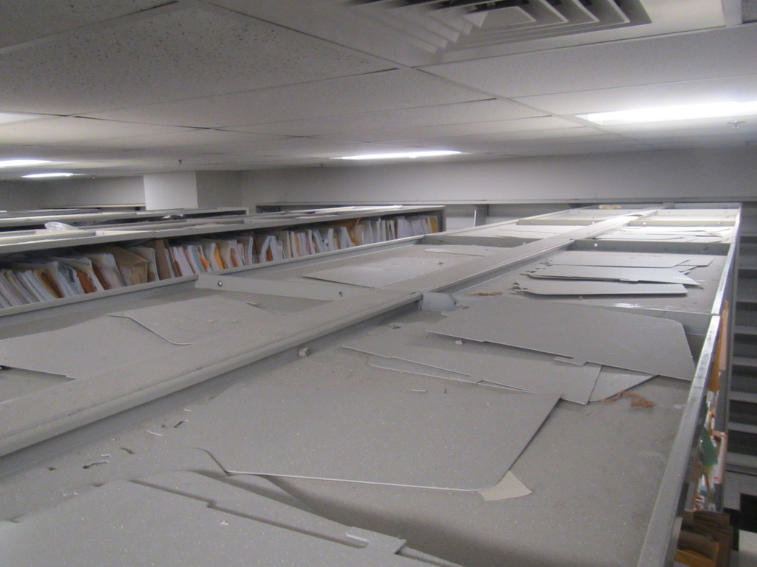
Supply vent (arrow) above shelving, note dust and debris on top of shelves
Picture 2
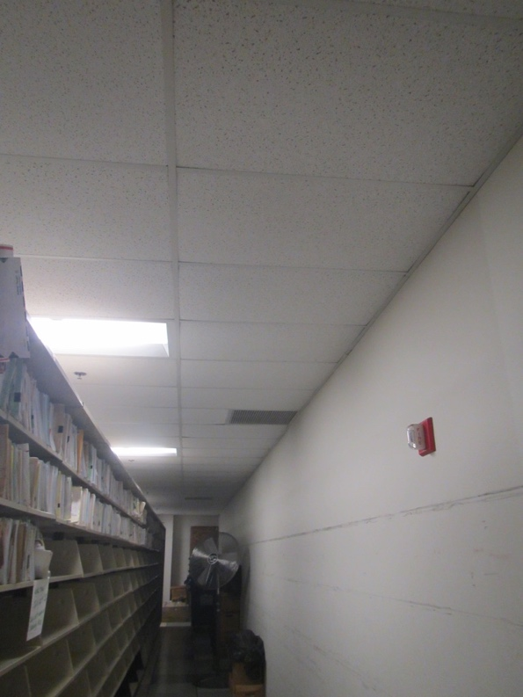
Return grill
Picture 3
Portable air conditioner, note water collection vessel at the bottom
Picture 4
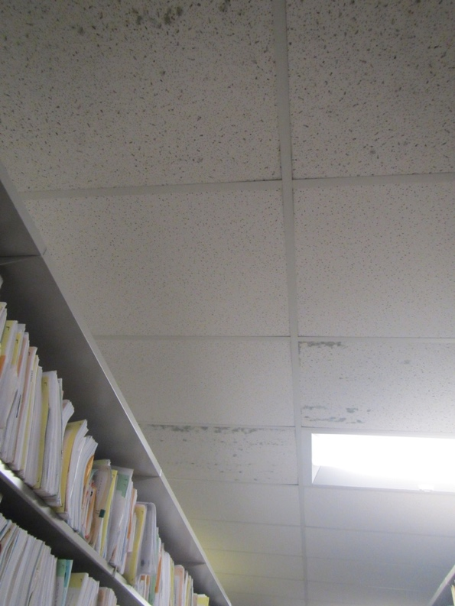
Water-damaged ceiling tiles
Picture 5
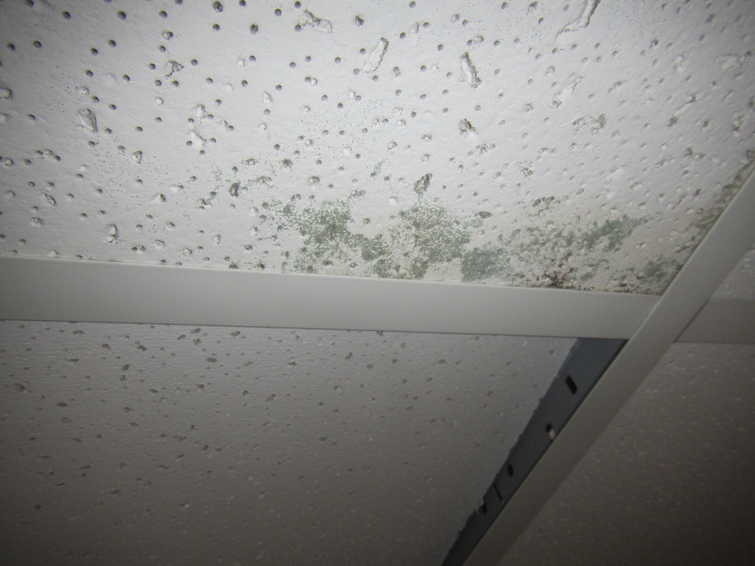
Close up of stained ceiling tile
Picture 6
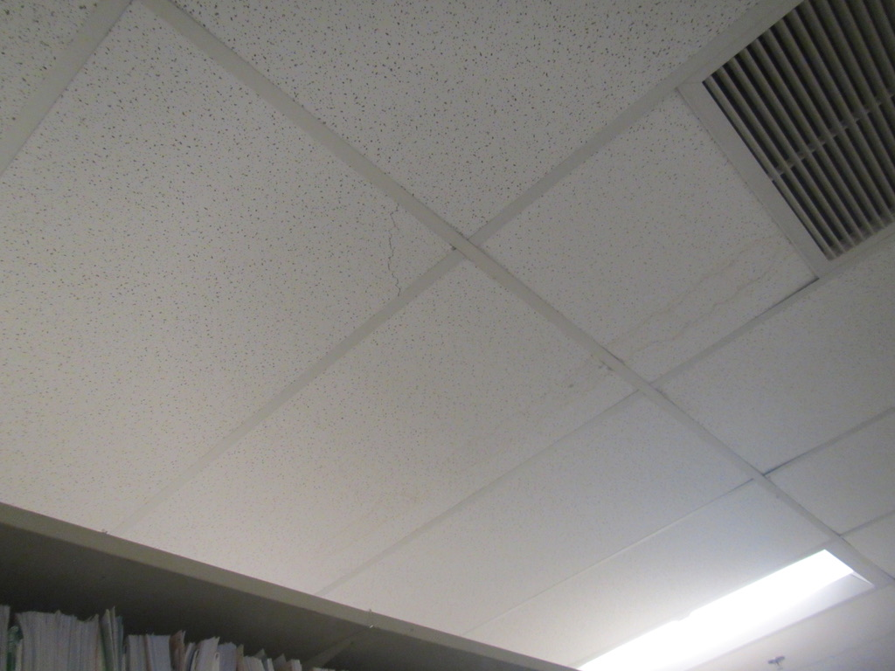
Water-damaged ceiling tile
Picture 7
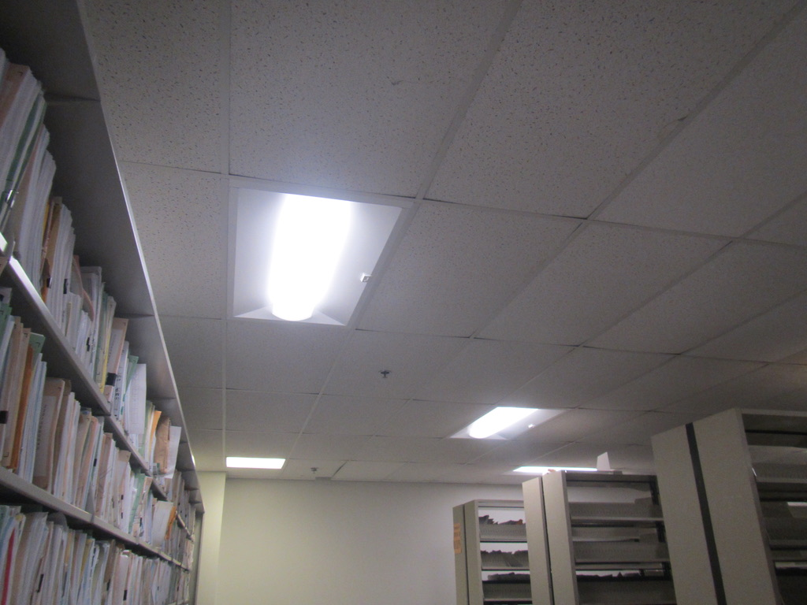
Slight sagging of ceiling tiles
Picture 8
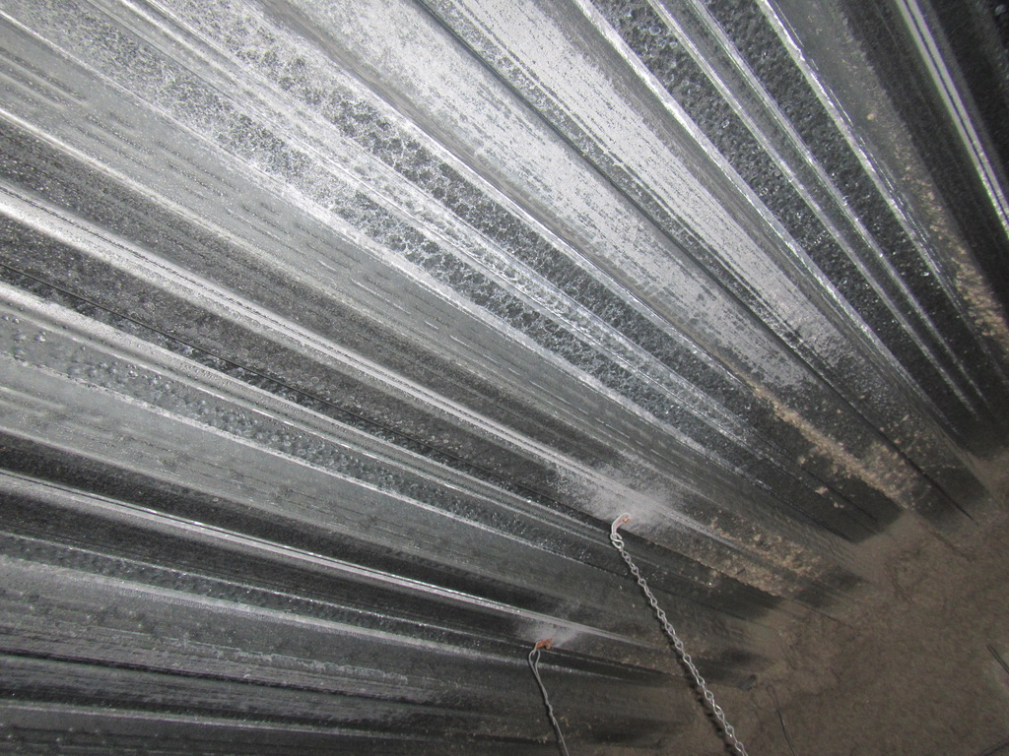
Underside of metal decking for the data center floor above
Picture 9
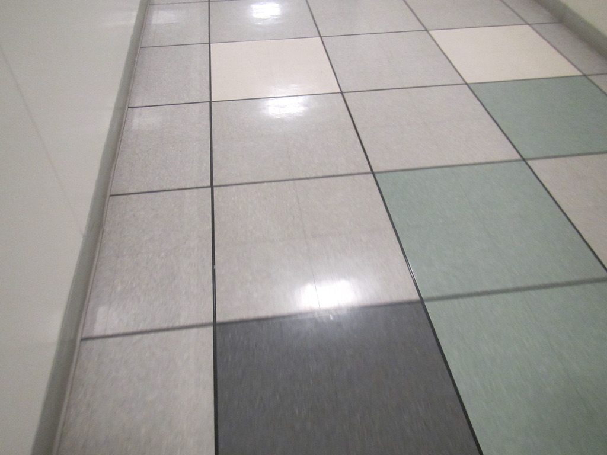
Raised flooring in the hallway outside the DIB storage room,
similar flooring exists in the room

Location | Carbon  Dioxide  (ppm) | Carbon Monoxide  (ppm) | Temp  (°F) | Relative  Humidity  (%) | PM2.5  (µg/m³) | Dew Point  (°F) | Occupants in Room | Floor Temp  (°F) | Windows  Openable | Ventilation |  | Remarks
 |  |  |  |  |  |  |  |  |  | Intake | Exhaust
Background | 347 | ND | 73 | 63 | 6 | 59 |  |  |  |  |  | Parking lot
DIB file room near entrance | 506 | ND | 69 | 68 | ND | 58 | 0-6 | 64 | N | Y | Y | Files on shelves, floor mostly tile on concrete, some floor tiles missing, stained ceiling tiles

