INDOOR AIR QUALITY ASSESSMENT

Department of Revenue
703 West Housatonic Street
Pittsfield, MA

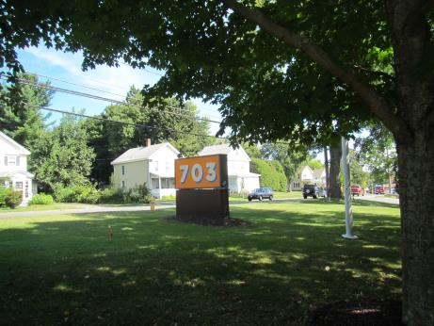

Prepared by:
Massachusetts Department of Public Health
Bureau of Environmental Health
Indoor Air Quality Program
September 2016

Background
Building: | Department of Revenue (DOR)
Address: | 703 West Housatonic Street  Pittsfield, MA
Assessment Requested by: | Joshua Martin, Deputy Director, Office of Facilities Management, Massachusetts DOR
Reason for Request: | Lease renewal IAQ status report
Date of Assessment: | September 20, 2016
Massachusetts Department of Public Health/Bureau of Environmental Health (MDPH/BEH) Staff Conducting Assessment: | Ruth Alfasso, Environmental Engineer/Inspector, IAQ Program
Building Description: | Three to four story building with flat roof originally constructed in 1919. Building contains other office, warehouse and light manufacturing tenants. DOR offices occupy suite 210.
Building Population: | Approximately 12 employees
Windows: | Not openable

Methods
Please refer to the IAQ Manual for methods, sampling procedures, and interpretation of results (MDPH, 2015).

IAQ Testing Results
The following is a summary of indoor air testing results (Table 1).
- Carbon dioxide levels were below 800 parts per million (ppm) in all areas assessed, indicating adequate fresh air in the space.
- Temperature was within the recommended range of 70°F to 78°F in all areas assessed.
- Relative humidity was within the recommended range of 40% to 60% in all areas assessed.
- Carbon monoxide levels were non-detectable in all indoor areas assessed.
- Fine particulate matter (PM2.5) concentrations measured were below the National Ambient Air Quality Standard (NAAQS) level of 35 μg/m³ in all areas assessed.

Ventilation
A heating, ventilating, and air conditioning (HVAC) system has several functions. First, it provides heating and, if equipped, cooling. Second, it is a source of fresh air. Finally, an HVAC system will dilute and remove normally occurring indoor environmental pollutants by not only introducing fresh air, but also filtering the airstream and ejecting stale air to the outdoors via exhaust ventilation. Even if an HVAC system is operating as designed, point sources of respiratory irritation may exist and affect symptoms in sensitive individuals. The following analysis examines and identifies components of the HVAC system and likely sources of respiratory irritant/allergen exposure due to water damage, aerosolized dust, and/or chemicals found in the indoor environment.
Fresh air is provided by air handling units (AHUs). Air from the AHUs is filtered, heated/cooled, and delivered to rooms via ducted supply vents (Picture 1). Air is returned/exhausted through vents in the ceiling (Picture 2).
The assessment results indicate that the ventilation system is providing adequate fresh air for the occupancy in the building. It is recommended that HVAC systems be re-balanced every five years to ensure adequate air systems function (SMACNA, 1994). It is unknown when the last time this system was balanced. In addition, ensure filters on AHUs are changed on a regular schedule at least twice a year.

Microbial/Moisture Concerns
A few water-damaged ceiling tiles were observed in the conference/storage room (Picture 3) and the core facility restroom. The conditions causing the leak should be fixed, and the tiles should be replaced.
Water dispensers were observed in carpeted areas (Picture 4). These appliances may spill or leak and lead to carpet damage and microbial growth. It is recommended that these appliances be located in areas without carpeting or on waterproof mats. The kitchen sink cabinet had water stains, which suggests that leaks or condensation is occurring. The area underneath sinks tends to be a moist environment, so storage of porous items or large amounts of items should be avoided. These areas should be checked periodically for leaks and dampness.
Plants and trees were observed very close to and touching the exterior of the building envelope (Picture 5). This can lead to deterioration of the building envelope due to root infiltration and dampness against the exterior surface. Plants can be a source of debris and pollen to air intakes. Plants should be trimmed away from the building and from overhanging the roof.

Other IAQ Evaluations
Exposure to low levels of total volatile organic compounds (TVOCs) may produce eye, nose, throat, and/or respiratory irritation in some sensitive individuals. To determine if VOCs were present, BEH/IAQ staff examined rooms for products containing VOCs. BEH/IAQ staff noted dry erase materials in use within the building (Table 1). All of these products have the potential to be irritants to the eyes, nose, throat, and respiratory system of sensitive individuals.
A musty or paint-like odor was observed in the hallway outside the office suite. Reportedly, this odor is common in this location and may be due to activities in other tenant areas or the condition of hallway building materials (e.g., carpet). Odors were not detectable inside the DOR space, however, if this condition is a cause of concern to DOR occupants, they should work with building management to ensure ventilation in other units draw odors away from common areas and that carpeting, walls and other building materials are free from microbial growth and odors.
The offices were mostly carpeted. Carpets should be cleaned annually (or semi-annually in soiled/high traffic areas) in accordance with Institute of Inspection, Cleaning and Restoration Certification (IICRC) recommendations, (IICRC, 2012).
In some areas, stored materials and accumulated items make it more difficult for custodial staff to clean. Items should be stored neatly and moved periodically to allow for wet wiping and vacuuming of surfaces.

Conclusions/Recommendations
Based on observations at the time of assessment, the following is recommended:
- Continue to operate supply and exhaust ventilation in all areas during occupied periods.
- Have the HVAC system balanced every 5 years in accordance with SMACNA recommendations (SMACNA, 1994).
- Repair conditions leading to ceiling leaks and water-damaged ceiling tiles, and replace the tiles.
- Consider locating water dispensers in non-carpeted areas or place on a waterproof mat.
- Avoid storing porous items or large amounts of items under sinks and check for leaks and damp conditions regularly.
- Trim plants and trees back from the sides and overhanging the building.
- For buildings in New England, periods of low relative humidity during the winter are often unavoidable. Therefore, scrupulous cleaning practices should be adopted to minimize common indoor air contaminants whose irritant effects can be enhanced when the relative humidity is low. To control for dusts, a high efficiency particulate arrestance (HEPA) filter equipped vacuum cleaner in conjunction with wet wiping of all surfaces is recommended. Avoid the use of feather dusters. Drinking water during the day can help ease some symptoms associated with a dry environment (throat and sinus irritations).
- Change filters on AHUs on a regular schedule at least twice a year.
- Work with building management to reduce odors in shared-space hallways if these odors are of concern.
- Clean carpeting in accordance with IICRC recommendations (IICRC, 2012).
- Reduce accumulated materials on flat surfaces and store in an organized manner to allow for thorough cleaning.
- Refer to resource manual and other related IAQ documents located on the MDPH’s website for further building-wide evaluations and advice on maintaining public buildings.
These documents are available at: http://mass.gov/dph/iaq.

References
IICRC. 2012. Institute of Inspection, Cleaning and Restoration Certification. Carpet Cleaning: FAQ. Retrieved from http://www.iicrc.org/consumers/care/carpet-cleaning/#faq.
MDPH. 2015. Massachusetts Department of Public Health. Indoor Air Quality Manual: Chapters I-III. Available at: http://www.mass.gov/eohhs/gov/departments/dph/programs/environmental-health/exposure-topics/iaq/iaq-manual/.
SMACNA. 1994. HVAC Systems Commissioning Manual. 1st ed. Sheet Metal and Air Conditioning Contractors’ National Association, Inc., Chantilly, VA.
Picture 1

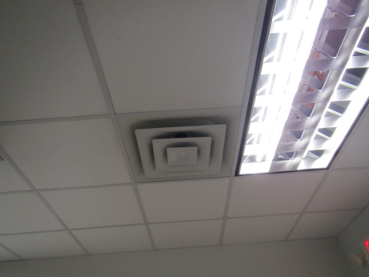

Supply vent

Picture 2

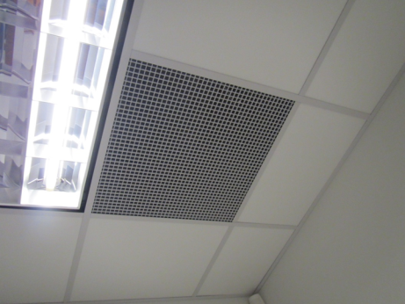

Return/exhaust vent
Picture 3

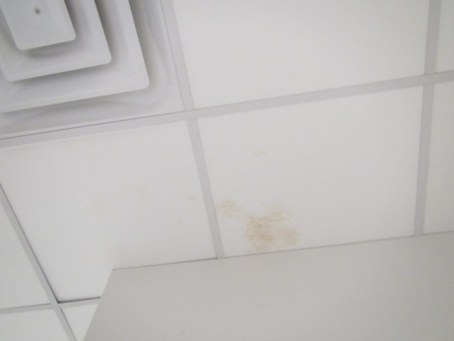

Water-damaged ceiling tile in conference/storeroom

Picture 4

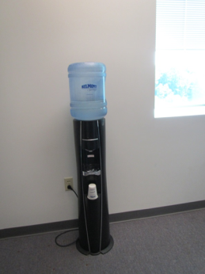

Water cooler on carpet
Picture 5

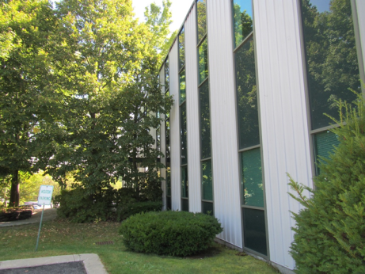

Plants and trees next to the building

Location | Carbon  Dioxide  (ppm) | Carbon Monoxide  (ppm) | Temp  (°F) | Relative  Humidity  (%) | PM2.5  (µg/m³) | Occupants  in Room | Windows  Openable | Ventilation |  | Remarks
 |  |  |  |  |  |  |  | Supply | Exhaust
Background | 352 | ND | 78 | 46 | 8 |  |  |  |  | Sunny
Waiting | 395 | ND | 74 | 59 | 12 | 0 | N | Y | Y
Reception | 442 | ND | 75 | 56 | 12 | 0 | N | Y | Y
Conference/Storage | 419 | ND | 75 | 56 | 12 | 0 | N | Y | Y | WD CT, boxes on floor, NC
Files |  |  |  |  |  |  | N | Y | Y | Carpeted, DEM
Kitchen | 398 | ND | 75 | 59 | 12 | 0 | N | Y | Y | DO, NC, water stain under sink, fridge, microwave and toaster
LeRose | 419 | ND | 74 | 59 | 12 | 0 | N | Y | Y
Alexander | 398 | ND | 74 | 59 | 12 | 0 | N | Y | Y | Food
Speranzo | 407 | ND | 74 | 60 | 12 | 0 | N | Y | Y
Bailot (cubes) | 433 | ND | 75 | 60 | 12 | 1 | N | Y | Y
Elias (cubes) | 420 | ND | 75 | 60 | 12 | 2 | N | Y | Y | WC on carpet, plush items
Keenan (cubes) | 422 | ND | 75 | 59 | 12 | 2 | N | Y | Y | Mail items
Interview | 388 | ND | 74 | 59 | 12 | 0 | N | Y | Y
Hallway |  |  |  |  |  |  |  |  |  | Musty/paint odor, carpeted
Core Restroom |  |  |  |  |  |  | N | Y | Y | WD CT

