**INDOOR AIR QUALITY ASSESSMENT**

**Department of Revenue**

**333 East Street**

**Pittsfield, MA**

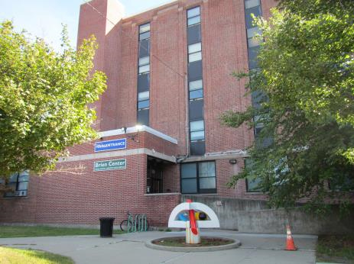

Prepared by:

Massachusetts Department of Public Health

Bureau of Climate and Environmental Health

Indoor Air Quality Program

April 2024

# BACKGROUND

|  |  |
| --- | --- |
| Building: | Department of Revenue (DOR) |
| Address: | 333 East Street, Pittsfield, MA |
| Assessment Requested by: | Bonnie Wells, Property Manager,  Department of Revenue |
| Reason for Request: | General IAQ concerns |
| Date of Assessment: | January 25, 2024 |
| Massachusetts Department of Public Health/Bureau of Environmental Health (MDPH/BEH) Staff Conducting Assessment: | Stefanie Santora, Environmental  Analyst, IAQ Program |
| Building Description: | Multi-story building with a flat roof and brick exterior. Building contains several other state offices, including the Registry of Motor Vehicles |
| Windows: | Not openable |

## This small DOR office space underwent a complete renovation last year, including installation of an HVAC system. All space has been converted to touch-down space for hybrid employees, which was currently unoccupied at the time of the visit.

# METHODS

Please refer to the IAQ Manual for methods, sampling procedures, and interpretation of results (MDPH, 2015).

# RESULTS AND DISCUSSION

The following is a summary of indoor air testing results (Table 1).

* ***Carbon dioxide levels*** were below 800 parts per million (ppm) in all areas assessed, however one area was just under this level indicating a need for increased fresh air as occupancy can increase carbon dioxide levels.
* ***Temperature*** was within the recommended range of 70°F to 78°F in all areas assessed.
* ***Relative humidity*** was below the recommended range of 40% to 60% in all areas assessed, which can be typical of the winter heating season.
* ***Carbon monoxide*** levels were non-detectable in all indoor areas assessed.
* ***Fine particulate matter (PM2.5)*** concentrations measured were below the National Ambient Air Quality Standard (NAAQS) level of 35 μg/m3 in all areas assessed.

## Ventilation

A heating, ventilating, and air conditioning (HVAC) system has several functions. First, it provides heating and, if equipped, cooling. Second, it is a source of fresh air. Finally, an HVAC system will dilute and remove normally occurring indoor environmental pollutants by not only introducing fresh air, but also filtering the airstream and ejecting stale air to the outdoors via exhaust ventilation. Even if an HVAC system is operating as designed, point sources of respiratory irritation may exist and affect symptoms in sensitive individuals.

Thermostats in the DOR were set to the “Fan Auto” position (Picture 1) which will only activate air circulation when heating or cooling is called for by the system. The MDPH IAQ Program recommends that the fan is set to “Fan On” rather than “Auto” during occupancy. This is especially important during temperate weather in spring and fall where heating or cooling may not be called for frequently. In addition to this, setting the fan to “Auto” will increase the fresh air supply, alleviating the potential for elevated carbon dioxide levels.

## Microbial/Moisture Concerns

Water dispensers were observed in carpeted areas (Picture 2). These appliances may spill or leak and lead to carpet damage and microbial growth. It is recommended that these appliances be located in areas without carpeting or on waterproof mats.

## Other IAQ Evaluations

The offices had carpet tiles throughout. Carpet tiles should be cleaned annually (or semi-annually in soiled/high traffic areas) in accordance with Institute of Inspection, Cleaning and Restoration Certification (IICRC) recommendations, (IICRC, 2012).

Exposure to low levels of total volatile organic compounds (TVOCs) may produce eye, nose, throat, and/or respiratory irritation in some sensitive individuals. BCEH/IAQ staff examined the office space for products containing VOCs and noted cleaning products in several areas (Picture 3).

# CONCLUSIONS AND RECOMMENDATIONS

Based on observations at the time of assessment, the following is recommended:

1. Consider locating water dispensers in non-carpeted areas or place on a waterproof mat.
2. Clean carpeting in accordance with IICRC recommendations (IICRC, 2012).
3. Reduce use of products and equipment that create irritating volatile organic compounds (VOCs) and only use in well-ventilated areas. Minimize the use of air fresheners (e.g., plug-ins), deodorizers and scented products.
4. Refer to resource manual and other related IAQ documents located on the MDPH’s website for further building-wide evaluations and advice on maintaining public buildings. These documents are available at: <http://mass.gov/dph/iaq>.

# REFERENCES

IICRC. 2012. Institute of Inspection, Cleaning and Restoration Certification. Carpet Cleaning: FAQ.

MDPH. 2015. Massachusetts Department of Public Health. Indoor Air Quality Manual: Chapters I-III. Available at: [Indoor air quality - manual and appendices | Mass.gov](https://www.mass.gov/lists/indoor-air-quality-manual-and-appendices)

**Picture 1**

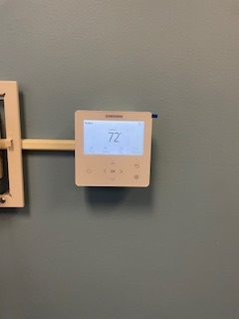

**Thermostat set to “Fan On”**

**Picture 2**

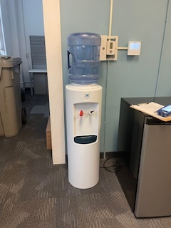

**Water dispenser on carpeted area**

**Picture 3**

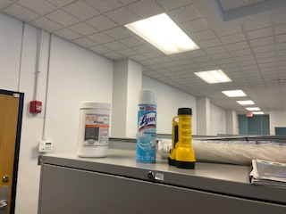

**Cleaning products on shelving unit**

| Location | Carbon  Dioxide  (ppm) | Carbon Monoxide  (ppm) | Temp  (°F) | Relative  Humidity  (%) | PM2.5  (µg/m3) | Occupants  in Room | Windows  Openable | Ventilation | | Remarks |
| --- | --- | --- | --- | --- | --- | --- | --- | --- | --- | --- |
| Supply | Exhaust |
| Background | 489 | 1.9 | 52 | 69 | 4 |  |  |  |  |  |
| Child Support Offices |  |  |  |  |  |  |  |  |  |  |
| Cubes 102 – 107 | 565 | ND | 71 | 34 | ND | 0 | Y | Y | Y |  |
| Cube 109 | 550 | ND | 70 | 34 | ND | 0 | Y | Y | Y |  |
| Conference Room | 615 | ND | 71 | 37 | ND | 0 | Y | Y | Y |  |
| Tax Offices |  |  |  |  |  |  |  |  |  |  |
| Open Cube Area  111 - 114 | 750 | ND | 72 | 35 | ND | 0 | Y | Y | Y |  |