# 

**INDOOR AIR QUALITY ASSESSMENT**

**Massachusetts Department of Revenue**

**18 Chestnut Street**

**Worcester, MA**

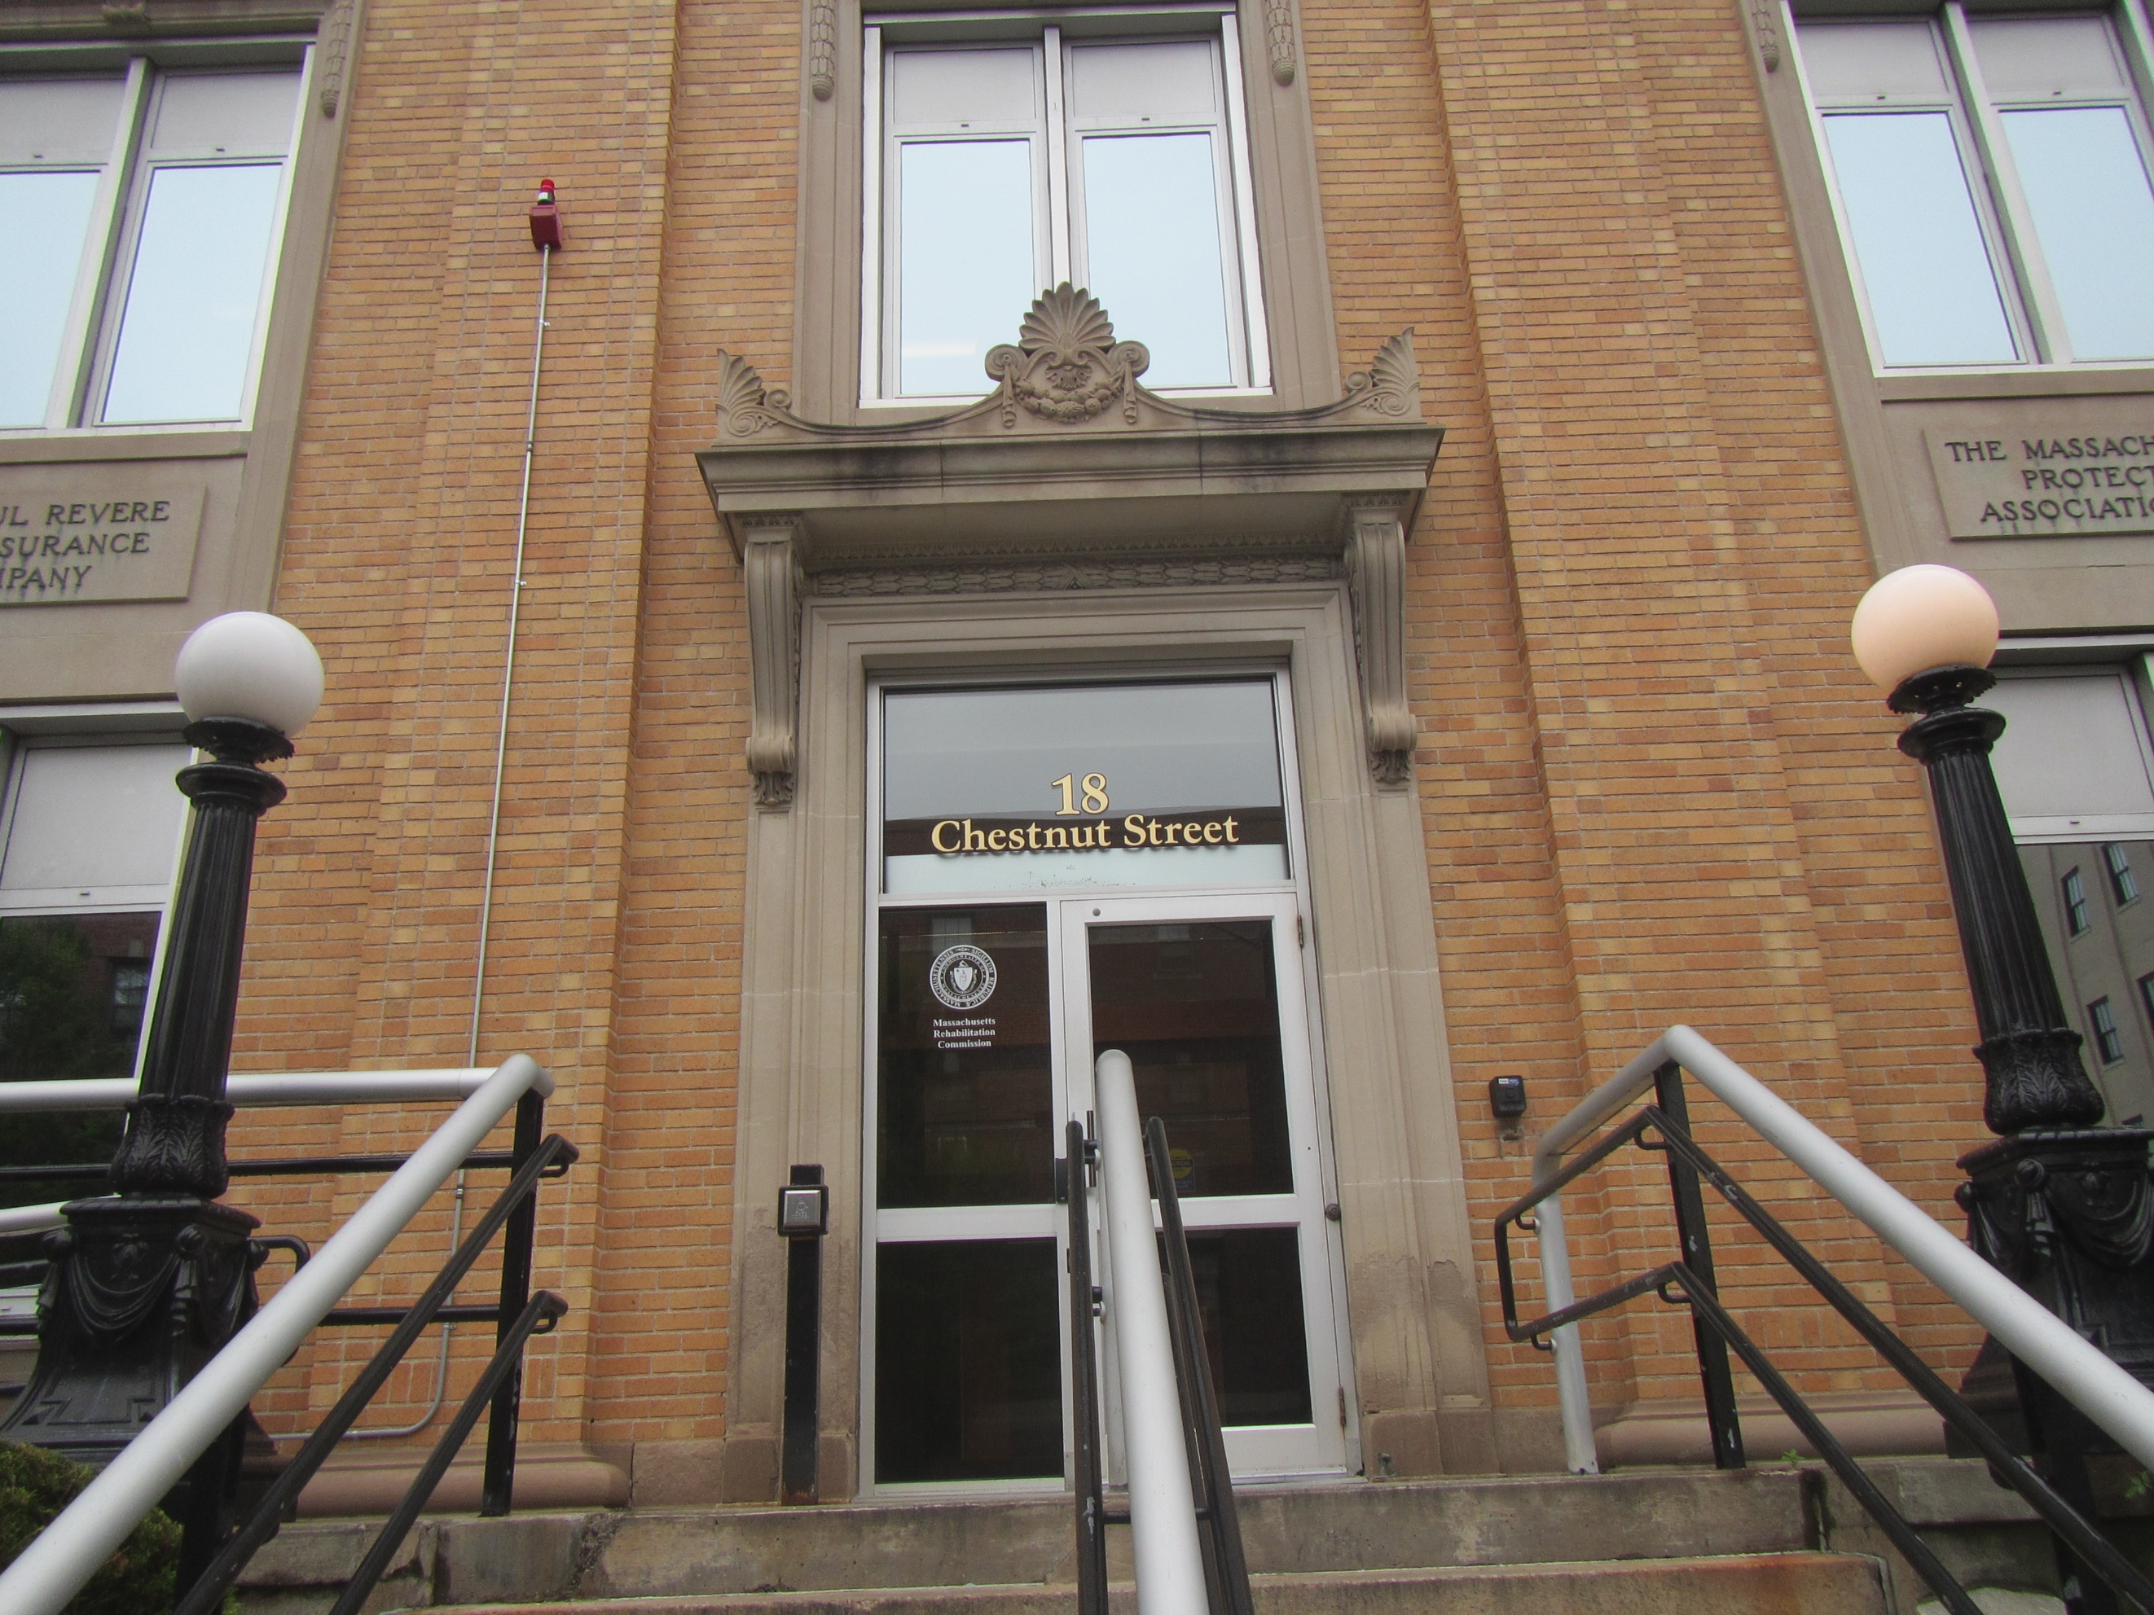

Prepared by:

Massachusetts Department of Public Health

Bureau of Climate and Environmental Health

Indoor Air Quality Program

August 2024

# EXECUTIVE SUMMARY

The Massachusetts Department of Revenue (DOR) has offices on the first floor of the building with an adjacent space undergoing renovations while occupied. A report detailing the findings of the renovation assessment has been previously provided to DOR management and is included as an attachment (Appendix A) to this report. This report is a summary of air testing that was conducted in DOR space.

# BACKGROUND

|  |  |
| --- | --- |
| Building: | Massachusetts Department of Revenue (DOR) |
| Address: | 18 Chestnut Street, Worcester, MA |
| Assessment Requested by: | Joshua Martin, Director, Office of Facilities Management, DOR |
| Reason for Request: | Concerns regarding renovation in adjacent office area while DOR is occupied, and staff concerns regarding off gassing of recently installed building materials in DOR space. |
| Date of Assessment: | July 24, 2024 |
| Massachusetts Department of Public Health/Bureau of Environmental Health (MDPH/BEH) Staff Conducting Assessment: | Michael Feeney, Director and Thomas Murphy, Inspector, Indoor Air Quality (IAQ) Program |
| Building Description: | The DOR space is on the first floor of a multi-story building in downtown Worcester, MA. The office space has been newly renovated. |
| Windows: | Openable |

# METHODS

Air tests for carbon monoxide, temperature, relative humidity, volatile organic compounds (VOCs), and airborne particle matter with a diameter less than 2.5 micrometers were taken with the TSI, Q-Trak XP. IAQ staff also performed a visual inspection of building materials for water damage and/or microbial growth and examined the space for the presence of odors or other environmental concerns. Please refer to the IAQ Manual for methods, sampling procedures, and interpretation of results. (MDPH, 2015).

On the day of the assessment, contractors were drilling holes into cement floors for utility pipes. Other significant renovation activities were occurring in the adjacent space, including metal cutting, wire installation, welding, painting, floor installation and other renovation tasks.

# RESULTS AND DISCUSSION

The following is a summary of indoor air testing results (Table 1).

* ***Carbon dioxide*** levels were below the MDPH guideline of 800 parts per million (ppm) in almost all areas tested, which were close.
* ***Temperature*** was within or close to within the MDPH recommended range of 70°F to 78°F in all areas tested.
* ***Relative humidity*** was above the MDPH recommended range of 40 to 60% in more than half the areas tested indicating the HVAC units may not be operating at proper capacity to reduce moisture in indoor air.
* ***Carbon monoxide*** levels were non-detectable (ND) in all areas tested.
* ***Fine particulate matter (PM2.5)*** concentrations measured were below the National Ambient Air Quality Standard (NAAQS) limit of 35 μg/m3 in all indoor areas tested.
* ***Total Volatile Organic Compounds*** concentrations were ND in occupied spaces.

## Ventilation

A heating, ventilating, and air conditioning (HVAC) system has several functions. First it provides heating and, if equipped, cooling. Second, it is a source of fresh air. Finally, an HVAC system will dilute and remove normally occurring indoor environmental pollutants by not only introducing fresh air, but by filtering the airstream and ejecting stale air to the outdoors via exhaust ventilation. Even if an HVAC system is operating as designed, point sources of respiratory irritation may exist and cause symptoms in sensitive individuals.

The HVAC system currently consists of air handling units (AHUs) which draw in outside air and heat/cool it. Conditioned air is ducted to supply vents and returned via other ducted return vents (Pictures 1 and 2). Ceiling-mounted cassette air conditioning units were observed in some offices (Picture 3; Table 1). It is important to note that some offices had both supply vents and a ceiling-mounted cassette air conditioning unit.

The MDPH IAQ Program recommends AHU filters of a Minimum Efficiency Reporting Value (MERV) of 8, which are adequate in filtering out pollen and mold spores (ASHRAE, 2012). The AHU filters in use at the DOR could not be examined at the time of assessment. Due to the conditions noted in the area under renovation, change of air filters was recommended due to their possible exposure to renovation-generated pollutants. In addition, AHU filters should be changed two or more times annually or per the manufacturer’s recommendations. During filter changes, the AHU cabinet should be cleaned/vacuumed out to remove debris that may be a source of particulates and odors to the indoor air. Lastly, it is recommended that HVAC systems be re-balanced every five years, and whenever significant changes are made to the layout of the office to ensure adequate air systems function (SMACNA, 1994).

## Microbial/Moisture Concerns

No musty odors were observed during the visit. A water-damaged ceiling tile was noted in the DOR office (Picture 4). All water-damaged ceiling tiles should be replaced, and the source of the water damage should be identified and repaired to prevent further issues. At least one water dispenser (Picture 5) was found in a carpeted area. Water dispensers can spill or leak and moisten carpeting. Use of a waterproof mat underneath these types of appliances, or moving them to a non-carpeted area, can help prevent water damage.

Relative humidity was above the comfort range of 60% in DOR offices, which may be attributed by moist air penetration from the renovation area into occupied space. Measures to separate the area under renovation were implemented, which should prevent the draw of humid air into the DOR occupied space. If relative humidity measurements are above the MDPH guideline of 40-60% (Table 1), building occupants may have increased comfort complaints. In addition, the control of relative humidity is necessary to prevent water damage or mold growth to building components.

## Other Sources of Respiratory Irritants

As noted in the previous report specific to the renovations, several pathways for renovation-generated pollutants existed between occupied DOR space and the area under renovation. Of note was an opening for the HVAC system that was drawing air from the renovation side, which could readily capture particulates and VOCs off-gassing from drying adhesives, paints, or other materials in use during renovation (Picture 6). Air testing for VOCs was non-detectable in all DOR spaces after the openings in the renovation space were sealed. (Picture 7).

Missing ceiling tiles were observed in several locations in the office (Picture 8; Table 1). Missing ceiling tiles can allow dust and debris from above the ceiling tile system into occupied areas. Cleaning with a method that does not aerosolize dust should be conducted following activities that disturb ceiling tiles.

# RECOMMENDATIONS

In view of the findings at the time of assessment, the following recommendations are made:

## Renovations

1. Implement recommendations to contain renovation-generated pollutants detailed in the report included as Appendix A.
2. Increase cleaning in all DOR space while renovations are occurring.

## Ventilation recommendations

1. Change AHU filters two to four times annually or per the manufacturer’s instructions. Use MERV 8 or the best quality/highest MERV rated filters that can be used with current equipment.
2. During filter changes, vacuum debris from AHU cabinets.
3. It is recommended that the HVAC systems be rebalanced every five years (SMACNA, 1994).
4. Vacuum/clean dust/debris from supply, return, and exhaust vents as needed.

## Moisture recommendations

1. Work with HVAC vendor/engineer to monitor and adjust temperature set points to better manage/reduce indoor relative humidity and improve comfort.
2. Consider placing a waterproof mat underneath water dispensers to protect carpet from leaks.

## Other recommendations

1. Clean carpeting annually or semi-annually in soiled high traffic areas as per the recommendations of the IICRC (IICRC, 2012).
2. Install ceiling tiles in locations where they are missing and clean any resulting dust and debris.
3. Refer to the resource manual and other related indoor air quality documents located on the MDPH’s website for further building-wide evaluations and advice on maintaining public buildings. These documents are available at <http://mass.gov/dph/iaq>.
4. Implement recommendations made in the previous IAQ assessment if not already completed (Appendix A).

# REFERENCES

ASHRAE. 2012. American Society of Heating, Refrigeration and Air Conditioning Engineers (ASHRAE) Standard 52.2-2012 -- Method of Testing General Ventilation Air-Cleaning Devices for Removal Efficiency by Particle Size (ANSI Approved). 2012.

IICRC. 2012. Institute of Inspection, Cleaning and Restoration Certification. Carpet Cleaning: FAQ.

MDPH. 2015. Massachusetts Department of Public Health. “Indoor Air Quality Manual: Chapters I-III”. Available at: <https://www.mass.gov/lists/indoor-air-quality-manual-and-appendices#indoor-air-quality-manual->.

SMACNA. 1994. HVAC Systems Commissioning Manual. 1st ed. Sheet Metal and Air Conditioning Contractors’ National Association, Inc., Chantilly, VA.

**Picture 1**

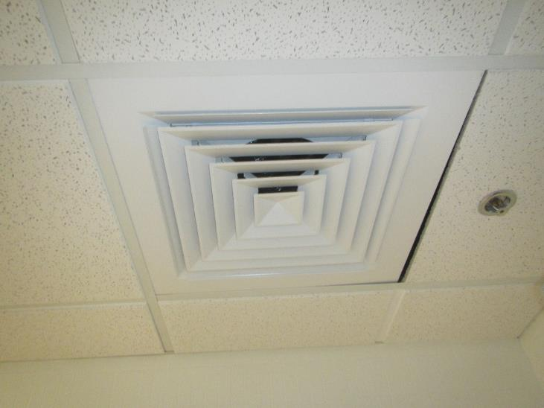

**Supply vent**

**Picture 2**

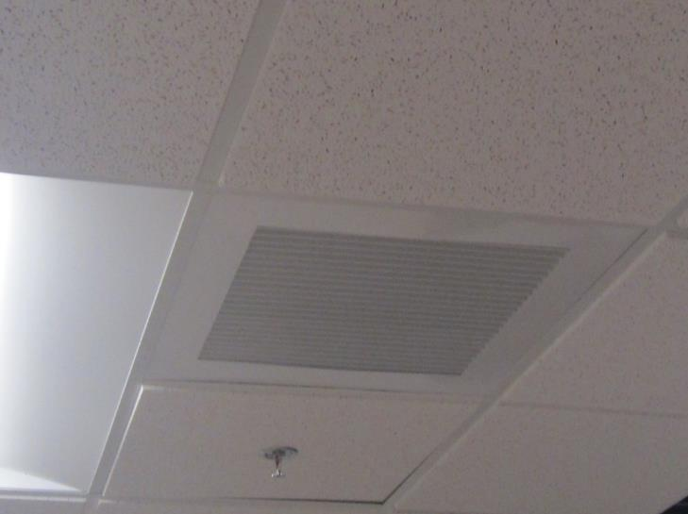

**Return vent**

**Picture 3**

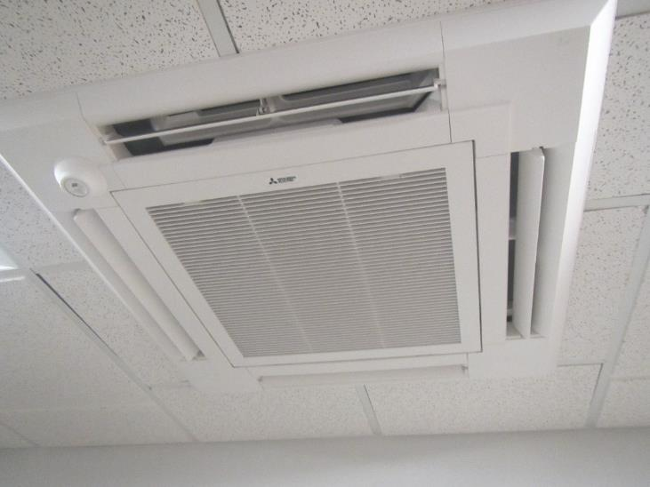

**Ceiling-mounted cassette air conditioning unit**

**Picture 4**

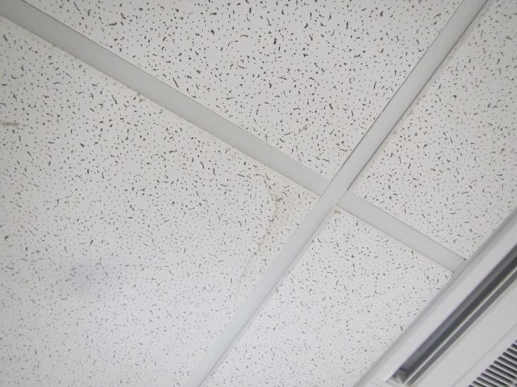

**Water-damaged ceiling tile**

**Picture 5**

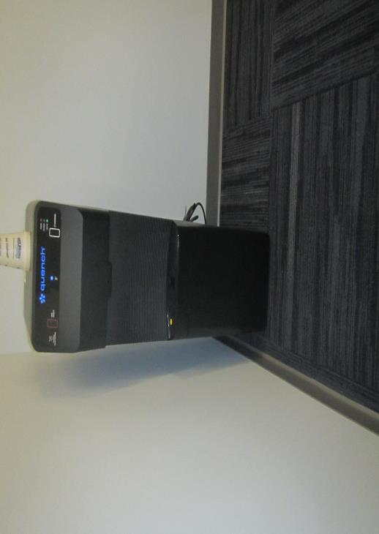

**Water cooler on carpet**

**Picture 6**

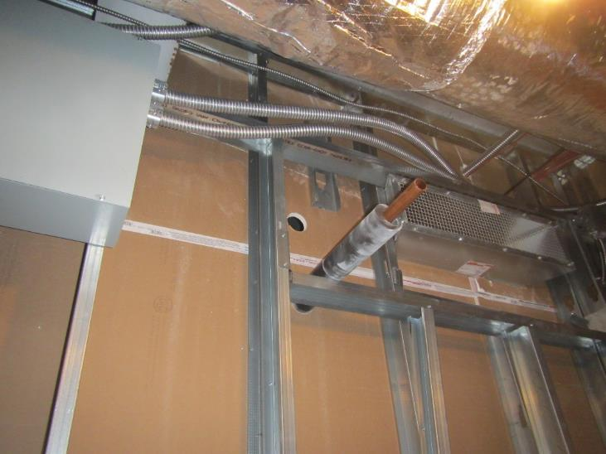

**Open duct with DOR HVAC that is open on renovation side of floor**

**Picture 7**

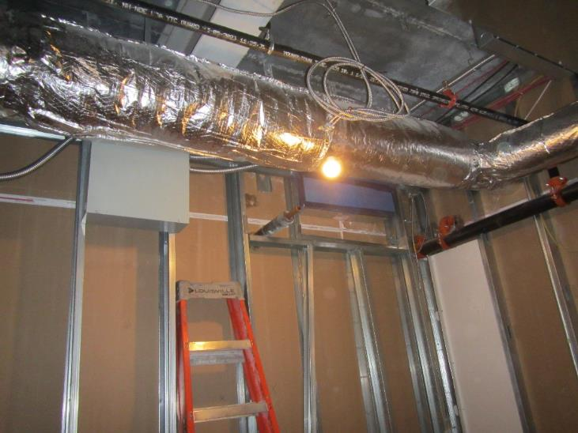

**Sealed duct previously opened in Picture 6**

**Picture 8**

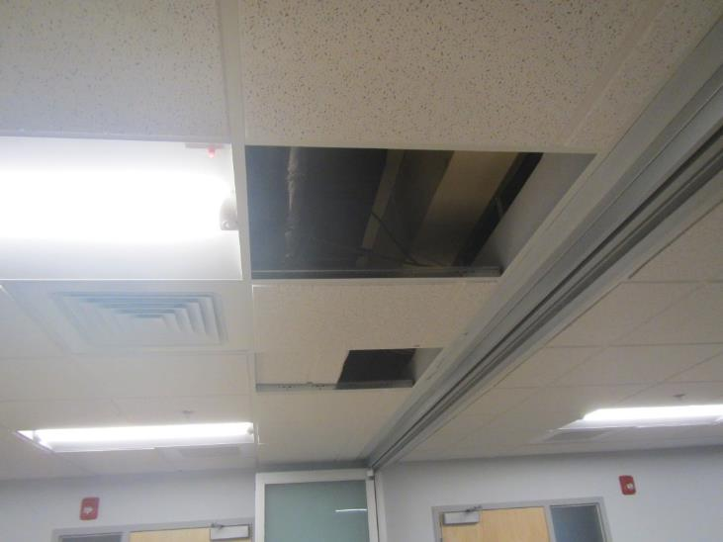

**Missing ceiling tiles in the office**

| **Location/ Room** | **Carbon**  **Dioxide**  **(ppm)** | **Carbon Monoxide**  **(ppm)** | **Temp**  **(°F)** | **Relative**  **Humidity**  **(%)** | **PM2.5**  **(****µg/m3)** | **TVOCs (ppm)** | **Occupants**  **in Room** | **Windows**  **Openable** | **Ventilation** | | **Remarks** |
| --- | --- | --- | --- | --- | --- | --- | --- | --- | --- | --- | --- |
| **Supply** | **Exhaust** |
| Background | 451 | ND | 73 | 82 | 28 | ND |  |  |  |  | Overcast, 5 mph wind |
| 2313 | 549 | ND | 69 | 57 | 57 | ND | 3 | N | Y | Y | Missing ceiling tiles |
| 2328 | 446 | ND | 71 | 52 | 7 | ND | 0 | N | Y | Y | CAC |
| 2334 | 810 | ND | 74 | 60 | 5 | ND | 1 | N | Y | Y |  |
| 2335 | 774 | ND | 72 | 62 | 5 | ND | 1 | N | Y | Y |  |
| 2340 | 706 | ND | 72 | 64 | 5 | ND | 0 | N | Y | N |  |
| 2341 | 693 | ND | 72 | 56 | 6 | ND | 0 | N | Y | N |  |
| 2342 | 903 | ND | 72 | 65 | 8 | ND | 1 | N | Y | Y |  |
| Copy Area | 502 | ND | 71 | 56 | 5 | ND | 0 | N | N | N | Mail machine, CAC, NC |
| Cubicles 1,2,14,15 | 805 | ND | 72 | 64 | 3 | ND | 2 | Y | Y | Y |  |
| Cubicles 16,17 | 771 | ND | 72 | 69 | 5 | ND | 1 | Y | Y | Y |  |
| Cubicles 18,19 | 771 | ND | 72 | 64 | 6 | ND | 1 | Y | Y | Y |  |
| Cubicles 20-25 | 754 | ND | 72 | 63 | 4 | ND | 1 | Y | Y | Y |  |
| Cubicles 25 & 26 | 532 | ND | 70 | 63 | 6 | ND | 0 | N | Y | Y |  |
| Cubicles 27,28,29 | 510 | ND | 70 | 62 | 7 | ND | 0 | N | Y | Y |  |
| Cubicles 3,4,12,13 | 793 | ND | 72 | 64 | 6 | ND | 2 | Y | Y | Y |  |
| Cubicles 30,31,36,37 | 535 | ND | 70 | 61 | 8 | ND | 0 | N | Y | Y |  |
| Cubicles 32,33,38,39,42 | 501 | ND | 70 | 62 | 7 | ND | 0 | N | Y | Y |  |
| Cubicles 34,35,40,41 | 534 | ND | 70 | 62 | 10 | ND | 0 | N | Y | Y |  |
| Cubicles 43-45 | 535 | ND | 70 | 61 | 5 | ND | 0 | N | Y | Y | Water cooler on carpet |
| Cubicles 5-11 | 770 | ND | 71 | 64 | 5 | ND | 4 | Y | Y | Y |  |
| Interview Room #1 | 744 | ND | 72 | 60 | 7 | ND | 0 | N | Y | Y | Employee side |
| Interview Room #1 | 605 | ND | 70 | 56 | 5 | ND | 0 | N | Y | Y | Public side |
| Interview Room #2 | 705 | ND | 71 | 60 | 5 | ND | 0 | N | Y | Y | Employee side, open ceiling tile |
| Interview Room #2 | 622 | ND | 70 | 57 | 7 | ND | 0 | N | Y | Y | Public side |
| Kitchen | 528 | ND | 72 | 53 | 9 | ND | 0 | N | N | N | Refrigerator, microwave, water cooler, CAC, NC |
| Lockers | 547 | ND | 71 | 57 | 5 | ND | 0 | N | Y | Y |  |
| Meeting room in waiting area | 673 | ND | 70 | 56 | 8 | ND | 0 | N | Y | N | CAC |
| Men’s restroom | 573 | ND | 74 | 68 | 9 | ND | 0 | N | Y | Y | Missing ceiling tiles |
| Photocopier Area | 799 | ND | 72 | 62 | 6 | ND | 0 | N | Y | Y | Water-damaged ceiling tile, CAC |
| Reception Desk | 598 | ND | 69 | 56 | 6 | ND | 1 | N | Y | Y | CAC, photocopier |
| Server Room | 500 | ND | 70 | 61 | ND | ND | 0 | N | Y | Y | NC |
| Supply Room | 666 | ND | 73 | 60 | 6 | ND | 0 | N | Y | Y |  |
| Supply Room | 523 | ND | 71 | 57 | 5 | ND | 0 | N | Y | N | NC |
| Waiting Area | 663 | ND | 71 | 55 | 8 | ND | 1 | N | Y | Y |  |
| Wellness Room | 560 | ND | 68 | 59 | 4 | ND | 0 | N | Y | N | CAC, NC |
| Women’s restroom | 540 | ND | 75 | 65 | 7 | ND | 0 | N | Y | Y | Missing ceiling tiles |

# EXECUTIVE SUMMARY

**INDOOR AIR QUALITY ASSESSMENT**

Renovations While Occupied

**Massachusetts Department of Revenue**

**18 Chestnut Street**

**Worcester, MA**

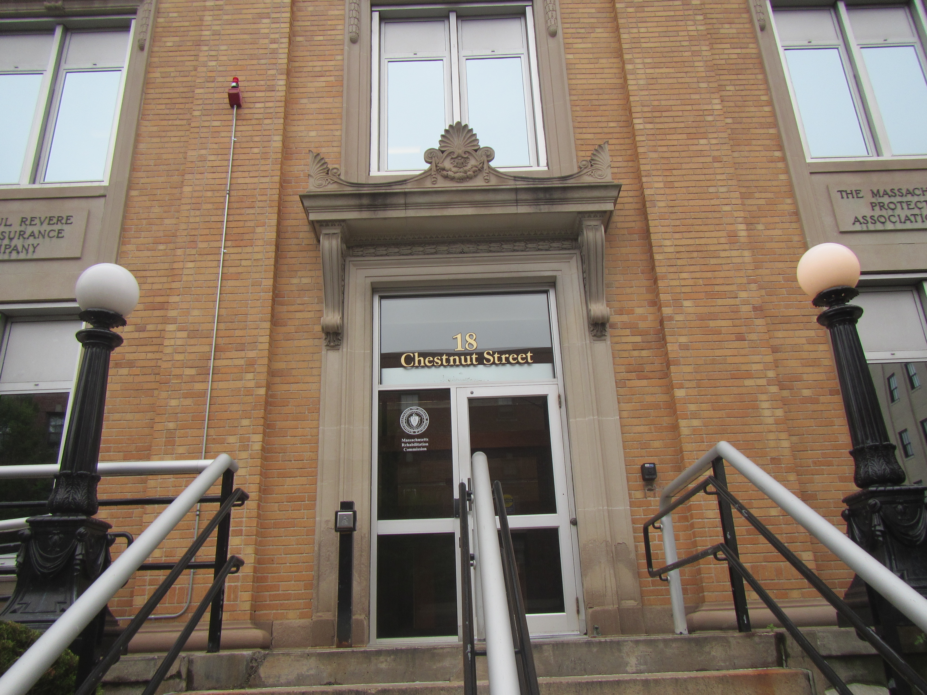

Prepared by:

Massachusetts Department of Public Health

Bureau of Climate and Environmental Health

Indoor Air Quality Program

July 2024

The Massachusetts Department of Public Health (MDPH), Bureau of Climate & Environmental Health, Indoor Air Quality Program conducted an evaluation at the Department of Revenue (DOR) office at 18 Chestnut Street in Worcester, MA to assess indoor air quality (IAQ) related to construction/renovation activities. IAQ staff assessed whether contaminants generated from construction/renovation were migrating into DOR-occupied areas in the building.

At the time of this assessment, renovations involved drilling holes in the cement floor and cutting metal using rotary saws. Both activities are likely sources of airborne dust, fumes, and vapors which could migrate into occupied areas if the renovation site was not contained or depressurized consistent with BCEH IAQ recommendations [Construction and renovation generated pollutants in occupied buildings | Mass.gov](https://www.mass.gov/info-details/construction-and-renovation-generated-pollutants-in-occupied-buildings).

IAQ staff noted numerous pathways for renovation-generated pollutants to migrate into occupied space. These pathways included open ductwork and spaces around utility pipes and electrical boxes in a shared wall between the DOR space and the area undergoing renovations. The existence of these pathways indicates that containment measures implemented at the time of the assessment were not sufficient to contain pollutants inside the area under renovation, which were migrating into occupied spaces. IAQ staff advised building management to seal pathways as soon as possible to reduce/prevent renovation pollutants from entering DOR space.

At the time of the visit, the following additional recommendations were made to reduce the migration of renovation-generated pollutants into occupied areas and the potential impact on indoor air quality:

* Containment procedures shall be used consistent with the most current edition of the IAQ Guidelines for Occupied Buildings Under Construction published by the Sheet Metal and Air Conditioning Contractors National Association, Inc. (SMACNA). An outline of such procedures is listed at [Construction and renovation generated pollutants in occupied buildings | Mass.gov](https://www.mass.gov/info-details/construction-and-renovation-generated-pollutants-in-occupied-buildings)
* Seal construction barriers with polyethylene plastic sheeting and duct tape in a proper manner. Consider creating dual barriers by installing polyethylene on both sides of the barrier (construction and occupied sides). Seal any utility holes in barriers separating occupied areas from the construction zone. Inspect these areas regularly (e.g., daily) to ensure integrity is maintained.
* Relocate susceptible persons and those with pre-existing medical conditions (e.g., hypersensitivity, asthma) away from areas of construction/renovations, if possible.
* Implement prudent housekeeping and work site practices to minimize exposure to renovation pollutants. Consider increasing manpower or work hours (e.g., before DOR office opens) to accommodate increase in dirt and dust accumulation due to construction activities. To control for dusts, a vacuum cleaner equipped with a high efficiency particulate air filter (HEPA) should be used in conjunction with wet wiping/mopping of all surfaces regularly.

An additional report, including the results of air testing and other observations, will be submitted separately.

# BACKGROUND

|  |  |
| --- | --- |
| Building: | Massachusetts Department of Revenue |
| Address: | 18 Chestnut Street, Worcester, MA |
| Assessment Requested by: | Joshua Martin, Director  Office of Facilities Management  Massachusetts Department of Revenue |
| Reason for Request: | To assess renovations on adjacent space of DOR facilities. |
| Date of Assessment: | July 24, 2024 |
| Massachusetts Department of Public Health/Bureau of Climate and Environmental Health (MDPH/BCEH) Staff Conducting Assessment: | Mike Feeney, Director, and Thomas Murphy, Inspector, IAQ Program |
| Building Description: | The DOR office is located on a recently renovated first floor. The DOR shares a wall with an office space undergoing renovations including cement floor drilling, metal cutting and installation of HVAC systems. |
| Windows: | Openable in all areas. |

# METHODS

Please refer to the IAQ Manual for methods, sampling procedures, and interpretation of results (MDPH, 2015).

# RENOVATIONS

Construction/demolition activities can produce a number of pollutants, including dirt, dust, and particulates. Construction vehicles also produce combustion products, such as carbon monoxide and particulate matter. Particles generated from construction activities can settle on horizontal surfaces. Dusts can be irritating to the eyes, nose, and respiratory tract.

A walkthrough and an assessment were conducted in and around DOR office spaces which included cubicles, individual offices, meeting rooms, a kitchen, hallways, and other areas, which may be directly impacted due to proximity to renovation sites. The renovation site was also visited, with a focus on identifying pathways for pollutants to migrate into occupied DOR office space. During this assessment, renovations observed included drilling of holes into the cement floor (Picture 1) and cutting of metal with a circular saw. Both processes generate dust, fume, vapors, and other related pollutants that should be directly vented from the renovation space.

The DOR and renovation space are separated by a single gypsum wallboard (GW) wall. Numerous openings in this shared wall were noted, including:

* A shared duct that opened into the DOR ceiling plenum (Picture 2),
* Space around utility pipes (Pictures 3 and 4),
* Space between GW and the exterior wall (Picture 5), and
* Exposed electrical boxes (Picture 6).

Of note is the open duct, which serves as the return portion of the general HVAC system. With this duct open, it is feasible that renovation-generated pollutants are captured by the DOR HVAC system and distributed further into occupied areas.

# CONCLUSIONS/RECOMMENDATIONS

A number of pathways exist for pollutants to move from areas under renovation to occupied spaces. These pathways indicate that containment measures implemented at the time of the assessment were not sufficient to contain pollutants related to renovation work. The following recommendations should be implemented to reduce the migration of renovation-generated pollutants into occupied spaces/areas and the potential impact on indoor air quality:

1. Seal any openings in the shared GW wall to prevent renovation pollutant migration if it is not already done (Pictures 7 and 8). The openings include:
   1. Open ducts
   2. Spaces around utility pipes
   3. Electrical boxes
   4. Light switches or
   5. Any observable seam or hole in or around the shared wall.
2. Place a fan blowing from inside to outside in the renovation area to exhaust air from the renovation area directly outdoors. Use of more than one fan to exhaust air through exterior windows is recommended.
   1. **Please note**: DOR office windows must be closed when these exhaust fans are operating to prevent renovation pollutants from entering DOR spaces through the windows.
3. Change HVAC system filters for DOR HVAC equipment.
4. Seal construction barriers with polyethylene plastic sheeting and duct tape in a proper manner. Consider creating dual barriers by installing polyethylene on both sides of the barrier (construction and occupied sides). Seal any utility holes in barriers separating occupied areas from the construction zone. Inspect these areas regularly (e.g., daily) to ensure integrity is maintained.
5. Use containment procedures that are consistent with the most current edition of the IAQ Guidelines for Occupied Buildings Under Construction published by the Sheet Metal and Air Conditioning Contractors National Association, Inc. (SMACNA). Guidelines include the following recommendations:
   1. Protect ductwork in a manner consistent with SMACNA guideline Duct Cleanliness for New Construction [Duct Cleanliness for New Construction Guidelines (smacna.org)](https://www.smacna.org/getattachment/c411472a-dc90-4299-bd27-13c4dc7b90a2/duct-cleanliness-for-new-construction-guidelines.pdf).
   2. Establish communications among all parties involved with building renovations to prevent potential IAQ problems. Develop a forum for occupants to express concerns about renovations as well as a program to resolve IAQ issues.
   3. Develop a notification system for building occupants, especially those immediately adjacent to construction activities, to report construction/renovation related odors and/or dust problems to the building administrator. Have these concerns relayed to the contractor in a manner to allow for a timely remediation of the problem.
   4. Schedule projects that produce large amounts of dusts, odors, and emissions during unoccupied or low occupancy periods, when possible.
   5. Disseminate scheduling information on renovation activities to all affected parties via meetings, newsletters, or weekly bulletins.
   6. Cover (i.e., tarps) or moisten dirt/debris piles to decrease aerosolization of particulates, when possible.
   7. Obtain Material Safety Data Sheets (MSDS) for all construction materials used during renovations and keep them in an area that is accessible to all individuals during periods of building operations as required by the Massachusetts Right-To-Know Act (MGL, 1983).
   8. Consult MSDS’ for any material applied to the affected area during construction including any sealant, adhesives, tile mastic, flooring and/or roofing materials. Provide proper ventilation and allow sufficient curing time as per the manufacturer’s instructions concerning these materials.

* 1. Relocate susceptible persons and those with pre-existing medical conditions (e.g., hypersensitivity, asthma) away from areas of construction/renovations, if possible.
  2. Implement prudent housekeeping and work site practices to minimize exposure to renovation pollutants. Consider increasing manpower or work hours (e.g., before DOR office opens) to accommodate the increase in dirt, dust accumulation due to construction activities. To control dust, a high efficiency particulate air filter (HEPA) equipped vacuum cleaner in conjunction with wet wiping/mopping of all surfaces is recommended.

**REFERENCES**

MDPH. 2015. Massachusetts Department of Public Health. “Indoor Air Quality Manual: Chapters I-III”. Available at: [Indoor air quality - manual and appendices | Mass.gov](https://www.mass.gov/lists/indoor-air-quality-manual-and-appendices)

MGL. 1983. Hazardous Substances Disclosure by Employers. Massachusetts General Laws. M.G.L. c. 111F. <https://malegislature.gov/Laws/GeneralLaws/PartI/TitleXVI/Chapter111F>

SMACNA. 1994. HVAC Systems Commissioning Manual. 1st ed. Sheet Metal and Air Conditioning Contractors’ National Association, Inc., Chantilly, VA.

SMACNA. 2000. Dust Cleanliness for New Construction Guidelines. 1st ed. Sheet Metal and Air Conditioning Contractors’ National Association, Inc., Chantilly, VA.

**Picture 1**

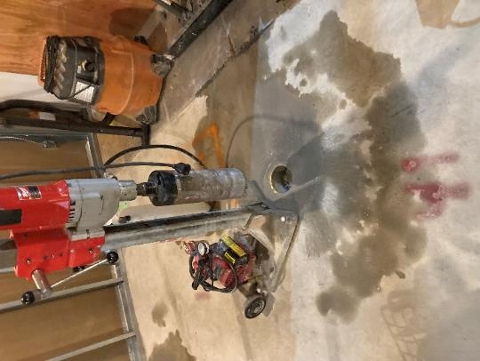

**Cement drilling in renovation space**

**Picture 2**

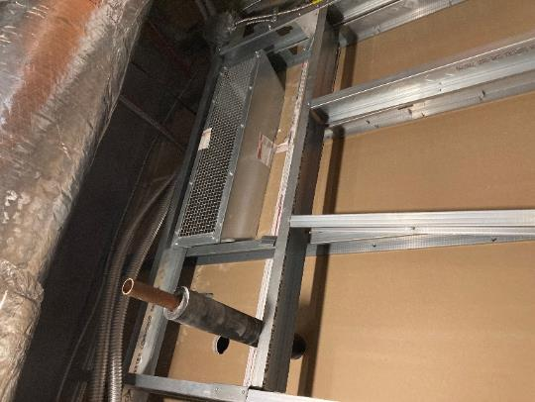

**Open duct shared with DOR HVAC that is open on renovation side of floor**

**Picture 3**

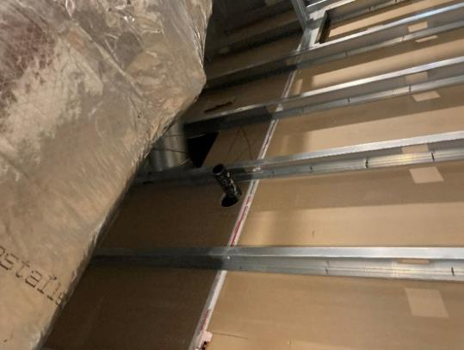

**Space around utility pipe in shared wall**

**Picture 4**

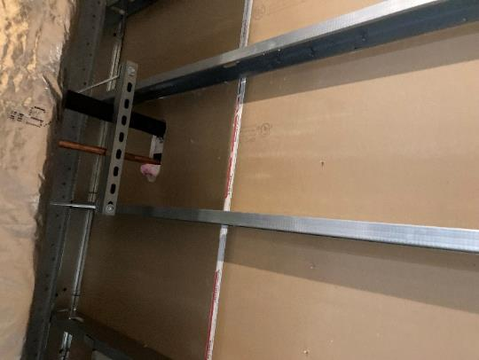

**Space around utility pipe**

**Picture 5**

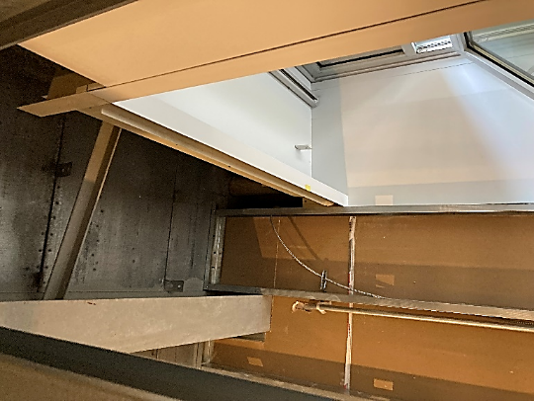

**Space between GW and exterior wall**

**Picture 6**

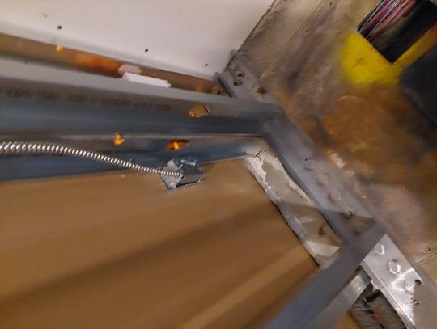

**Exposed electrical box**

**Picture 7**

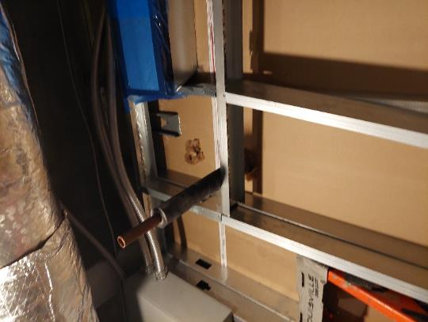

**Sealed duct previously opened in Picture 2**

**Picture 8**

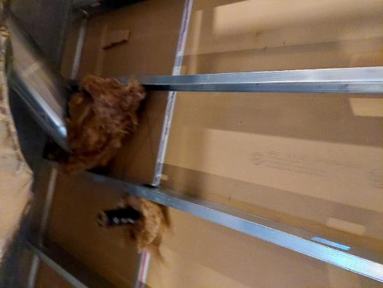

**Opening stuffed with insulation**