**INDOOR AIR QUALITY ASSESSMENT**

**Department of Revenue**

**Massachusetts Information Technology Center**

**1st, 2nd and 3rd floors**

**200 Arlington Street**

**Chelsea, MA**

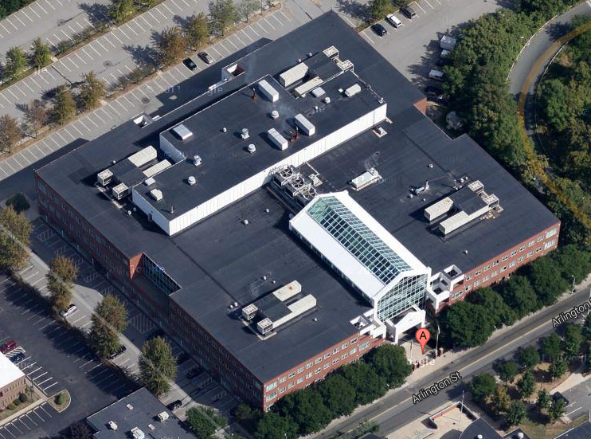

Prepared by:

Massachusetts Department of Public Health

Bureau of Climate and Environmental Health

Division of Environmental Health Regulations and Standards

January 2025

# BACKGROUND

|  |  |
| --- | --- |
| Building: | Department of Revenue (DOR) |
| Address: | Massachusetts Information Technology Center (MITC), 200 Arlington Street, Chelsea, MA |
| Assessment Requested by: | Joshua Martin, Director, Office of  Facilities Management, Massachusetts  DOR |
| Reason for Request: | General indoor air quality (IAQ) |
| Date of Assessment: | January 17, 2025 |
| Massachusetts Department of Public Health/Bureau of Climate and Environmental Health (MDPH/BCEH) Staff Conducting Assessment: | Ruth Alfasso, Environmental Engineer, and Bharathi Patimalla-Dipali, Environmental Analyst, Division of Environmental Health Regulations and Standards |
| Building Description: | The MITC is a large glass, brick, and concrete building with four floors completed in 1995. |
| Windows: | Not openable |

The MITC has been visited by BCEH staff in the past, including several full assessments of the entire building. Reports from previous assessments are available by request.

# METHODS

Please refer to the IAQ Manual for methods, sampling procedures, and interpretation of results (MDPH, 2015).

# RESULTS AND DISCUSSION

Measurements for IAQ parameters are shown in Table 1 and summarized below:

* ***Carbon dioxide*** measurements were below the MDPH guideline of 800 ppm indicating adequate fresh air in the space. Note that most areas were lightly occupied or vacant.
* ***Temperature*** was within or close to the lower end of the recommended range of 70°F to 78°F in all areas tested.
* ***Relative humidity*** was below the recommended range of 40% to 60% in all areas tested, which is common during the heating season.
* ***Carbon monoxide*** levels were non-detectable (ND) in all areas tested.
* ***Fine particulate matter (PM2.5)*** concentrations were below the National Ambient Air Quality Standard (NAAQS) level of 35 μg/m3 in all areas tested.

## Ventilation

A heating, ventilating, and air conditioning (HVAC) system has several functions. First, it provides heating and, if equipped, cooling. Second, it is a source of fresh air. Finally, an HVAC system will dilute and remove normally occurring indoor environmental pollutants by not only introducing fresh air but also filtering the airstream and ejecting stale air to the outdoors via exhaust ventilation. Even if an HVAC system is operating as designed, point sources of respiratory irritation may exist and affect symptoms in sensitive individuals. The following analysis examines and identifies components of the HVAC system and likely sources of respiratory irritant/allergen exposure due to water damage, aerosolized dust, and/or chemicals found in the indoor environment.

Fresh air is provided by air handling units (AHUs) located on the roof of the building. Air from the AHUs is filtered, heated/cooled, and delivered to rooms via ducted supply vents (Pictures 1 and 2). Air is drawn through exhaust grills (Picture 3) to be removed from the building.

The ventilation system should be on and operational to supply fresh air continuously during occupied periods. Without adequate fresh air supply and removal of stale air, common indoor air pollutants can build up and cause irritation. It is recommended that HVAC systems be re-balanced every five years to ensure adequate air systems function (SMACNA, 1994). It is not known when the last time these systems were balanced.

Thermostats are present at intervals along each floor (Picture 4). Reportedly thermostats are set remotely. Some appear to allow a short range of changes by occupants. Occupants can also report to maintenance using a web-based ticketing system if there is a temperature or other facility issue. Thermostats should be set to have the fan on during occupied periods regardless of temperature settings. Night and weekend temperature and ventilation setbacks can be used to save energy when the building is unoccupied.

## Microbial/Moisture Concerns

A few water-damaged ceiling tiles were noted (Pictures 5 and 6; Table 1). One water-damaged ceiling tile had dark staining that is likely mold growth (Picture 6); note that these tiles were in an area that is currently unoccupied. Water-damaged ceiling tiles should be replaced once the source of the leak has been repaired. Given the various locations of water-damaged tiles on ceilings not next to windows, water damage may originate from leaks from plumbing or condensation on pipes serving the HVAC or sprinkler systems. Water-damaged ceiling tiles should be replaced. During replacement, the area above the ceiling tile should be checked for additional water-damaged materials, leaking pipes, or piping/ductwork in need of insulation.

Peeling wallpaper was noted in a few areas (Picture 7; Table 1). This may indicate past water damage, exposure to high humidity, or improperly glued materials deteriorating over time. No mold or mold odors were noted in these areas, but the loose wallpaper should be removed because it is a source of dust and debris and very difficult to clean. Peeling coving along the base of the walls were also noted in a few areas (Picture 8). No other signs of water damage or mold growth was noted under coving.

Signs of past water damage to windowsills was noted (Pictures 9 and 10). The pattern of staining suggests that damage in some areas was due to leaking plant pots, and damage to other areas may be due to condensation on windows, or window leaks. None of these windowsills appeared damp at the time of the visit. Some windowsills and adjacent wood materials also were damaged or splitting, which may have resulted from previous water exposure. Split wood is more easily damaged with further water exposure and may trap debris.

Plants were observed in a few areas (Table 1). Plants can be a source of pollen and mold, which can be respiratory irritants to some individuals. Plants should be properly maintained and equipped with drip pans to prevent water damage to porous materials.

Numerous refrigerators and water dispensers were observed in carpeted areas (Pictures 11 and 12; Table 1). Offices and open areas are used for break rooms in several locations in the building. These areas have carpeting and lack direct-vented exhaust to remove odors from food preparation. Appliances may spill or leak and lead to carpet damage and microbial growth. Note that carpet tiles under the sink in Picture 11 appear to be lifting, suggesting chronic exposure to water or high humidity. Carpeting in break rooms may also accumulate crumbs and debris. It is recommended that these appliances be in areas without carpeting or on waterproof mats. One of the refrigerators’ opened had evidence of spills inside (Picture 13).

Refrigerators need to be kept clean to prevent microbial growth and odors. Other food preparation equipment was found with spills, crumbs, or other debris (Picture 14). A variety of food and related products were noted in the office. All food should be enclosed in pest-proof containers.

As noted above MDPH recommends a comfort range of 40 to 60 percent for indoor air relative humidity. Relative humidity typically drops during the winter due to low outside humidity and heating. As shown in Table 1, the relative humidity in the spaces examined ranged from 21% to 30%. A sensation of dryness and irritation is common in a low relative humidity environment. “Extremely low (below 20%) relative humidity may be associated with eye irritation [and]…may affect the mucous membranes of individuals with bronchial constriction, rhinitis, or cold and influenza related symptoms” (Arundel et al., 1986). However, MDPH does not recommend the use of humidifiers in office spaces, as humidity can be difficult to control, and humidifiers may create other indoor air quality concerns, such as the distribution of minerals from the water used into the air.

## Other IAQ Concerns

Clutter and items were found in some offices and common areas, including on floors, desks, and other surfaces (Table 1). Too many items can make it difficult for custodial staff to clean. Items should be stored neatly, off the floor, and be moved periodically for cleaning. In some areas, holiday decorating was taking place. Items/decorations should not be hung from ceilings or walls, and items draped along cubes should be moved periodically so cleaning can be conducted.

Note that in some areas, workstation walls abut exterior walls, creating narrow gaps (Picture 15). These should not be used for storage and should be cleaned periodically to reduce dust and discourage pests.

Some of the areas examined had suspended flooring, which is composed of removable squares with a gap underneath typically used for electric and data cables (Picture 16). Flooring was not removed during this visit, but on previous visits, dust, debris, trash, and rodent droppings were all noted under such flooring in this building. These areas should be cleaned periodically, particularly while the space is empty and being remodeled/refurbished. Methods that do not aerosolize materials, such as the use of a HEPA-equipped vacuum should be used during cleaning.

An examination was conducted for products that may be a source of VOCs in indoor air. Products such as dry erase markers, hand sanitizers, and other cleaners were found in many areas (Table 1). In the absence of adequate fresh air and exhaust ventilation, VOCs from these products can build up and lead to irritation of the mucous membranes or irritating odors.

Most areas of the MITC examined during this assessment are carpeted. Carpets should be cleaned regularly in accordance with Institute of Inspection, Cleaning and Restoration Certification (IICRC) recommendations (IICRC, 2012).

# CONCLUSIONS/RECOMMENDATIONS

The following are recommendations made to improve IAQ:

## Ventilation recommendations

1. Operate supply and exhaust ventilation in all areas during occupied periods.
2. Have the HVAC system balanced every 5 years in accordance with SMACNA recommendations (SMACNA, 1994).
3. Ensure filters are replaced on HVAC units at least two to four times a year or as per the manufacturers’ recommendations. If feasible, use filters with a Minimum Efficiency Rating Value (MERV) of 8 or better filter.
4. Ensure thermostats building-wide are set in a consistent manner, including any nighttime or weekend setbacks.
5. Inform occupants about how to request temperature control changes.
6. Use adjustable blinds to control thermal heating and glare due to sunlight. Consider adding blinds to areas that may need them.

## Water damage recommendations

1. Replace water-damaged ceiling tiles and monitor the areas where they occur. Look above the ceiling tiles in areas with water damage to find and repair any leaks, missing insulation, or other issues that may cause future water damage.
2. Repair/remove damaged wallpaper.
3. Repair peeling coving such as shown in Picture 8. If the wallboard beneath shows signs of moistening, repair or replace it.
4. Consider repairing or refinishing windowsills with heavy water staining or cracking, as the damage makes them difficult to clean.
5. Keep indoor plants in good condition and avoid overwatering. Ensure any plants are placed on water-resistant drip pans to prevent water damage to materials like windowsills.
6. Consider moving refrigerators and water dispensers to areas without carpeting or using a waterproof mat underneath.
7. Keep refrigerators and other food preparation appliances clean and in good condition.
8. During space planning for future renovations or upgrades, consider creating dedicated spaces for break rooms with running water, non-porous flooring, and direct-vented exhaust to prevent water damage and food odors in occupied areas.

## Other recommendations

1. Periodically clean dust from supply and return vents and fans.
2. Reduce clutter and move items periodically to allow for adequate cleaning.
3. Avoid hanging decorations from ceilings or walls and move decorations from along cube walls periodically for cleaning. Ensure any decorations from storage or outside do not carry odors or dust.
4. Clean out the day lockers periodically to prevent dust accumulation and odor.
5. Clean gaps between workstation walls and exterior walls periodically (Picture 15) and avoid using these locations for storage.
6. Periodically clean any subfloor areas and monitor for pests.
7. Use VOC-containing products in areas with good ventilation and keep them tightly closed when not in use.
8. Clean carpeting in accordance with IICRC recommendations (IICRC, 2012).
9. For buildings in New England, periods of low relative humidity during the winter are often unavoidable. Therefore, scrupulous cleaning practices should be adopted to minimize common indoor air contaminants whose irritant effects can be enhanced when the relative humidity is low. To control dust, a high efficiency particulate arrestance (HEPA) filter equipped vacuum cleaner in conjunction with wet wiping of all surfaces is recommended. Avoid the use of feather dusters. Drinking water during the day can help ease some symptoms associated with a dry environment (throat and sinus irritations).
10. Refer to resource manual and other related IAQ documents located on the MDPH’s website for further building-wide evaluations and advice on maintaining public buildings. These documents are available at: <http://mass.gov/dph/iaq>.

# REFERENCES

Arundel et al. 1986. Indirect Health Effects of Relative Humidity on Indoor Environments. Env. Health Perspectives 65:351-361.

IICRC. 2012. Institute of Inspection, Cleaning and Restoration Certification. Carpet Cleaning: FAQ.

MDPH. 2015. Massachusetts Department of Public Health. Indoor Air Quality Manual: Chapters I-III. Available at: <https://www.mass.gov/lists/indoor-air-quality-manual-and-appendices>.

SMACNA. 1994. HVAC Systems Commissioning Manual. 1st ed. Sheet Metal and Air Conditioning Contractors’ National Association, Inc., Chantilly, VA.

**Picture 1**

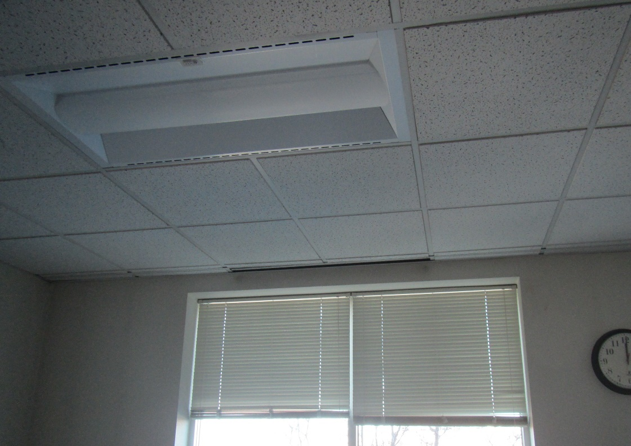

**One style of supply vent in ceiling in front of window**

**Picture 2**

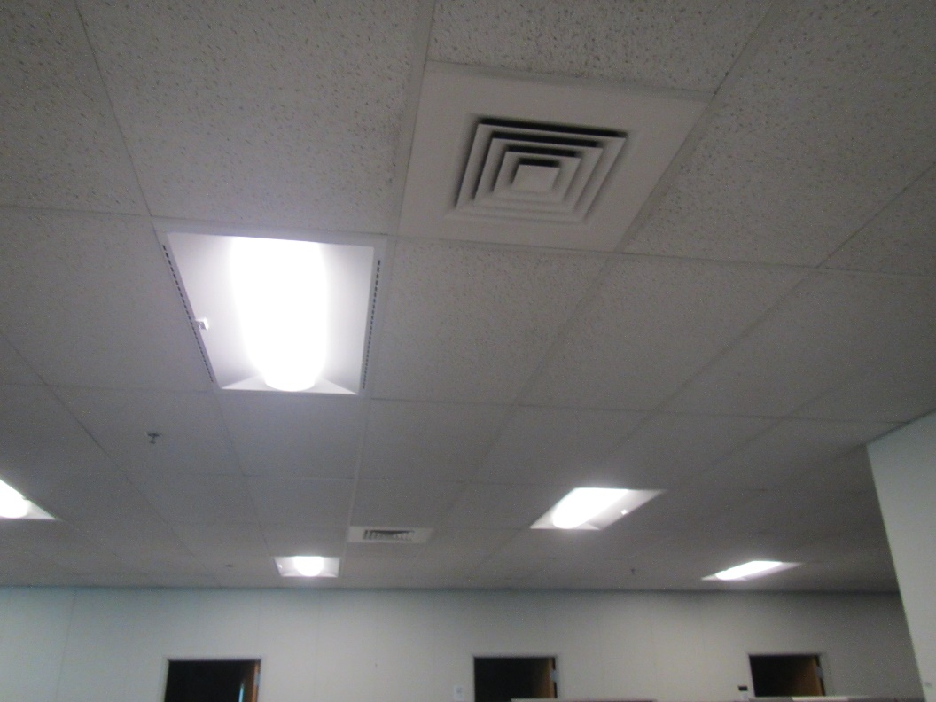

**Ceiling-mounted supply vents in open area**

**Picture 3**

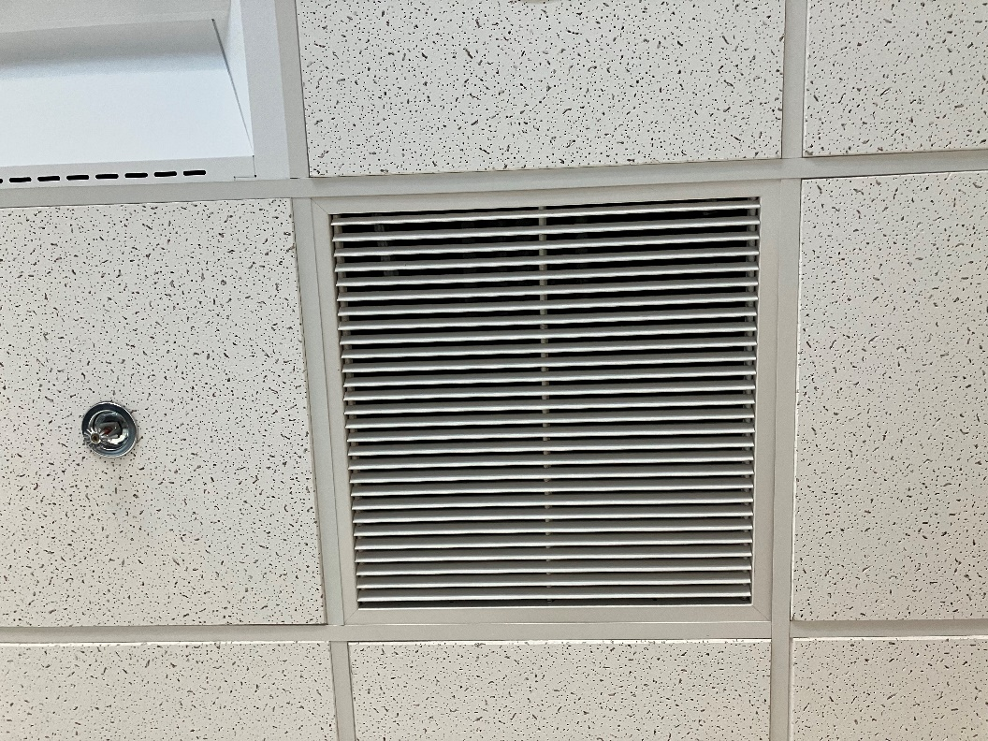

**Ceiling-mounted exhaust vent**

**Picture 4**

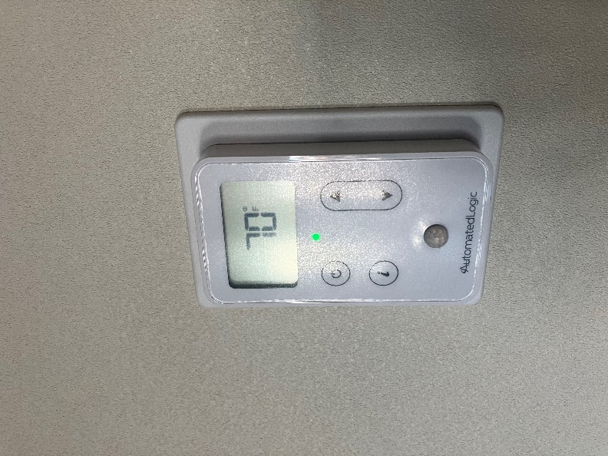

**Typical thermostat**

**Picture 5**

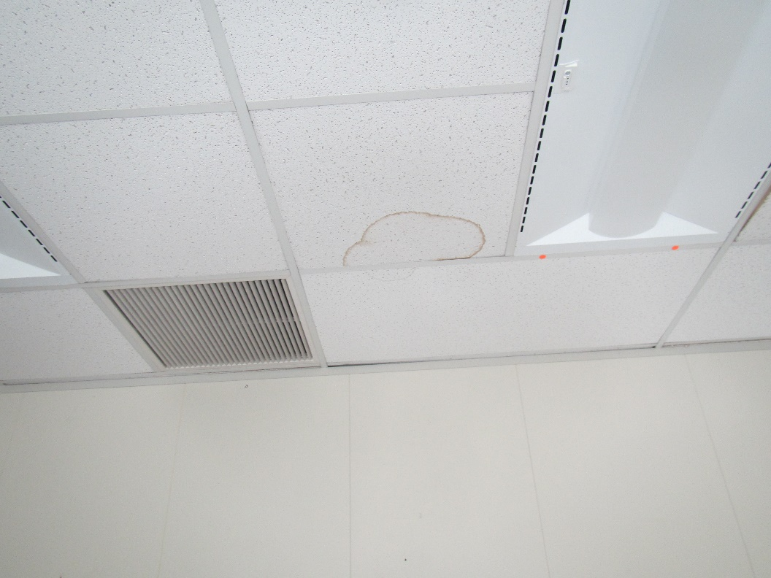

**Water-damaged ceiling tile**

**Picture 6**

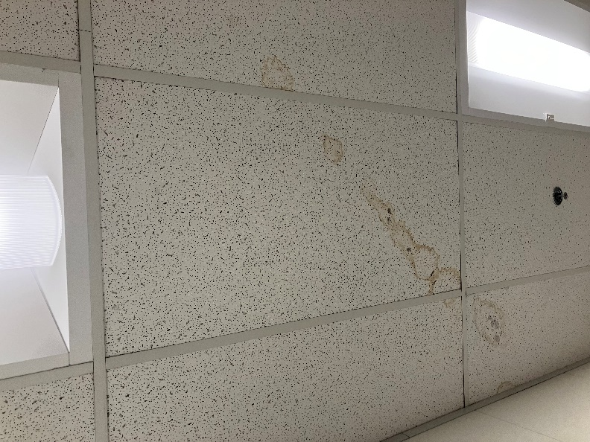

**Water-damaged ceiling tiles with dark spots that may be mold**

**Picture 7**

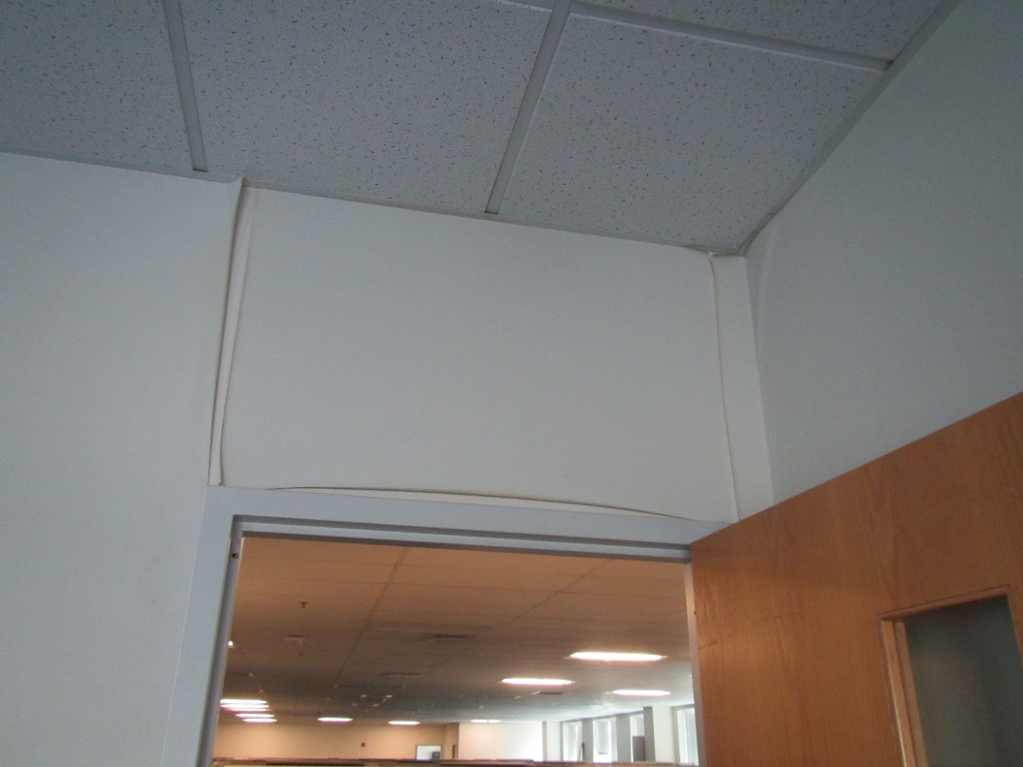

**Peeling wallpaper in an office**

**Picture 8**

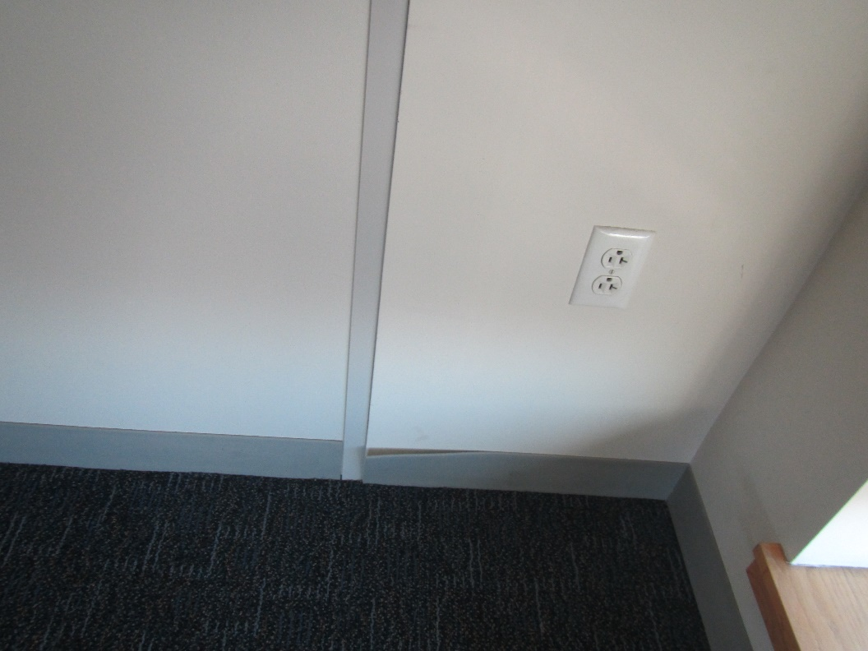

**Peeling coving at the base of a wall**

**Picture 9**

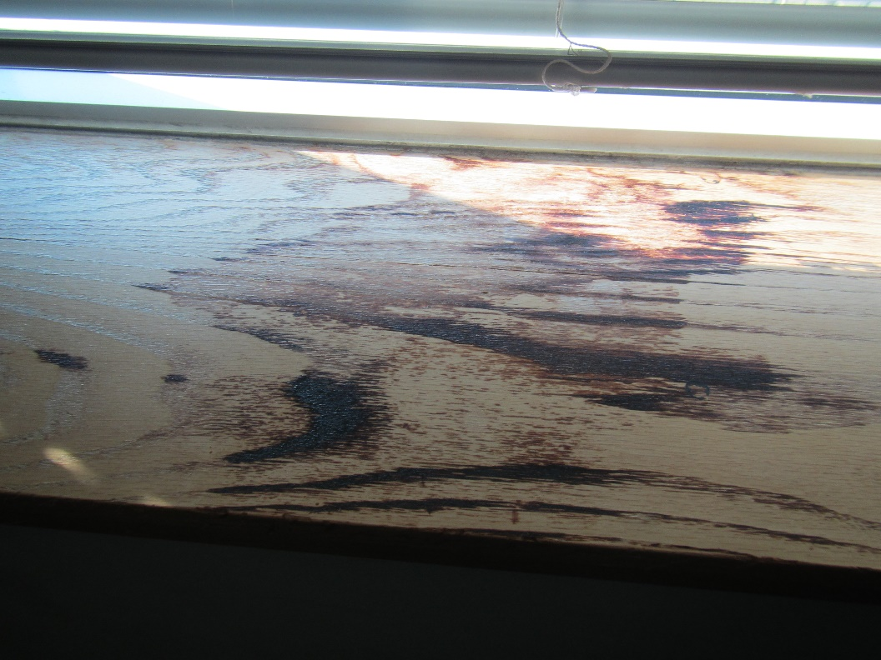

**Water-damaged windowsill**

**Picture 10**

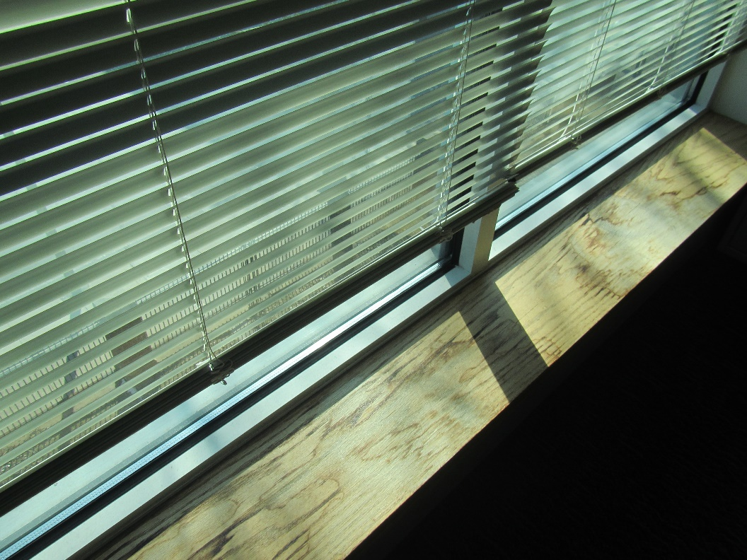

**Water-damaged windowsill with staining pattern suggesting it had been caused by plants**

**Picture 11**

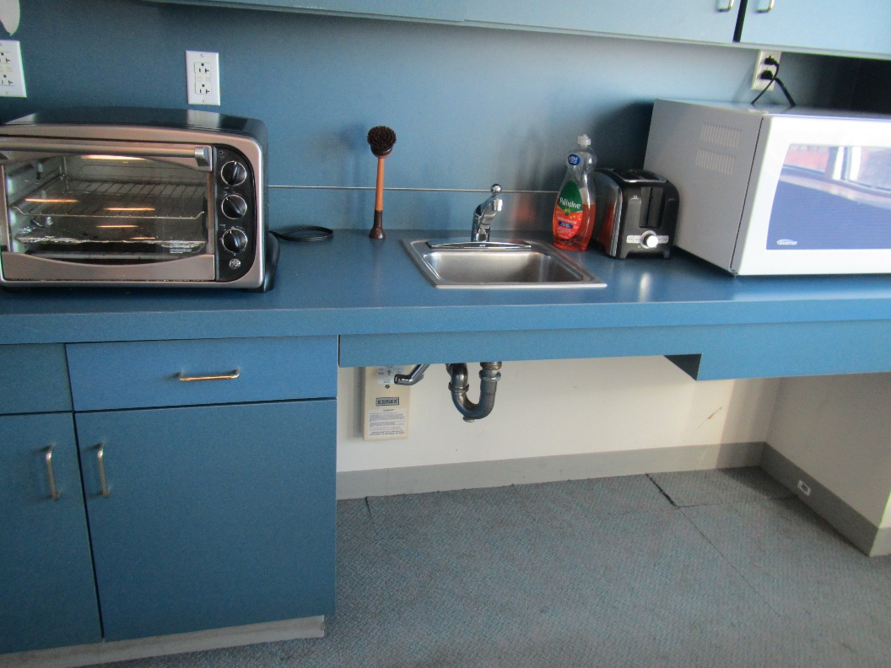

**Break room appliances in a room with carpeted floor; note lifting carpet tiles**

**Picture 12**

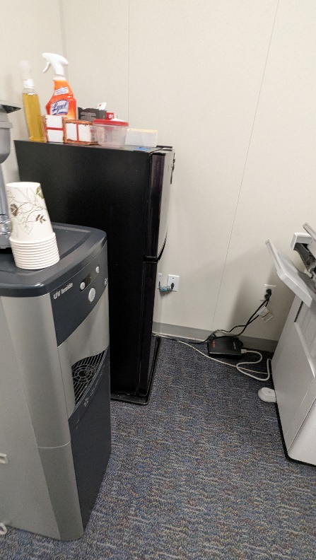

**Refrigerator and water dispenser on carpet**

**Picture 13**

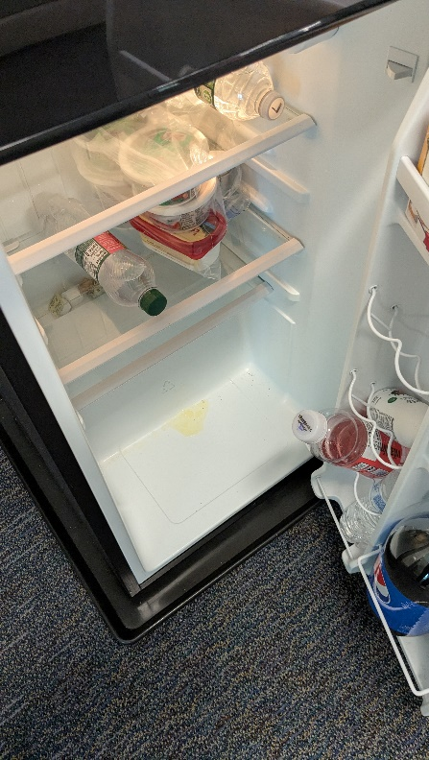

**Refrigerator with small spill inside**

**Picture 14**

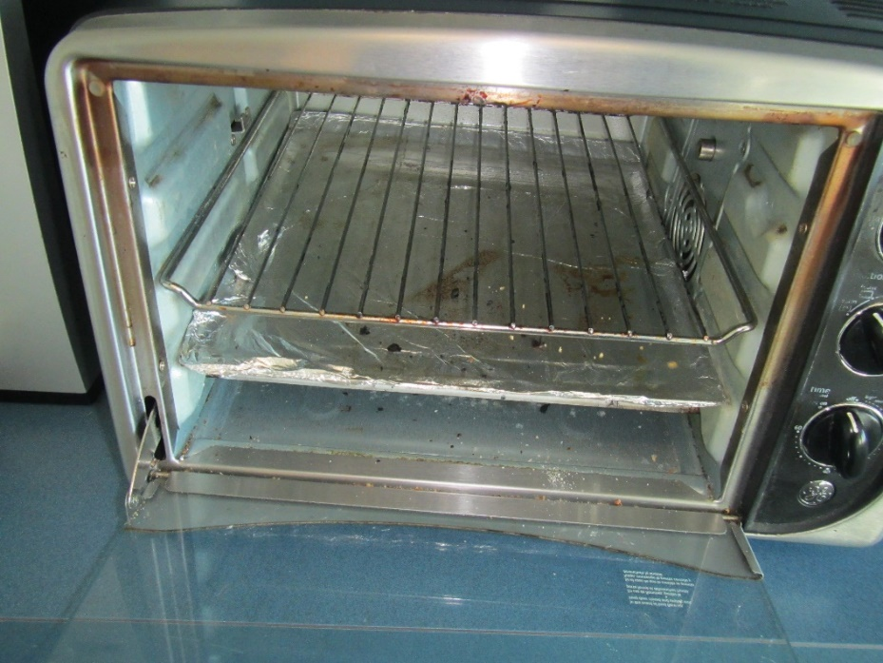

**Crumbs in toaster oven**

**Picture 15**

**Workstation walls abut exterior walls, creating narrow gaps. Space indicated by arrow.  
**

**Workstation walls abut exterior walls, creating narrow gaps (arrow).**

**Picture 16**

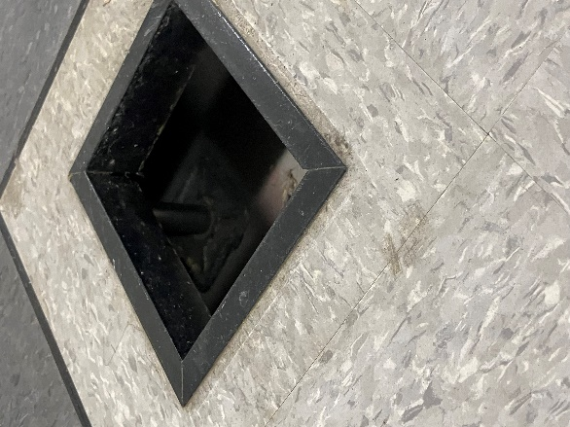

**Suspended flooring**

| **Location** | **Carbon**  **Dioxide**  **(ppm)** | **Carbon Monoxide**  **(ppm)** | **Temp**  **(°F)** | **Relative**  **Humidity**  **(%)** | **PM2.5**  **(µg/m3)** | **Occupants**  **in Room** | **Windows**  **Openable** | **Ventilation** | | **Remarks** |
| --- | --- | --- | --- | --- | --- | --- | --- | --- | --- | --- |
| **Supply** | **Exhaust** |
| Background | 455 | ND | 39 | 32 | 19 |  |  |  |  | Street level on Arlington Street, clear and cold |
| Third Floor | | | | | | | | | | |
| 004 conference | 535 | ND | 69 | 26 | ND | 0 | N | Y | Y | Peeling wallpaper on most walls, peeling coving, no signs of water damage or mold |
| 001 | 545 | ND | 69 | 27 | ND | 0 | N | Y | Y | DEM, stained windowsill, plastic partly over supply vent |
| 013 cubes | 561 | ND | 69 | 28 | ND | 0 | N | Y | Y |  |
| 035 cubes | 501 | ND | 69 | 28 | ND | 0 | N | Y | Y |  |
| 049 break | 547 | ND | 70 | 24 | ND | 0 | N | Y | Y | Carpet, fridge, micro, sink |
| 053 | 543 | ND | 69 | 27 | ND | 0 | N | Y | Y |  |
| 056 | 517 | ND | 70 | 28 | ND | 0 | N | Y | Y | DEM |
| 087 | 600 | ND | 70 | 30 | ND | 0 | N | Y | Y | WD CT |
| 3C140 | 511 | ND | 69 | 28 | ND | 0 | N | Y | Y |  |
| 3C141 | 525 | ND | 71 | 28 | ND | 0 | N | Y | Y |  |
| 3C137 | 504 | ND | 70 | 27 | ND | 0 | N | Y | Y | DEM |
| 3C133.5 | 513 | ND | 71 | 27 | ND | 0 | N | Y | Y | Broken CT, stained windowsill |
| 3C131 | 515 | ND | 72 | 26 | ND | 0 | N | Y | Y | DEM |
| 3C128 conference | 501 | ND | 72 | 26 | ND | 0 | N | Y | Y |  |
| 3C124 | 516 | ND | 73 | 25 | ND | 0 | N | Y | Y |  |
| 3C123 | 503 | ND | 73 | 24 | 2 | 0 | N | Y | Y | DEM |
| 3C120.4 | 528 | ND | 72 | 25 | ND | 0 | N | Y | Y |  |
| 3C113.9 | 528 | ND | 72 | 27 | 1 | 0 | N | Y | Y |  |
| Hallway/breakroom |  |  |  |  |  |  | N | Y | Y | WD CT, fridge, microwave, and water cooler |
| 3C112 | 528 | ND | 72 | 27 | 1 | 0 | N | Y | Y? | DEM |
| 3C108.5 | 555 | ND | 72 | 27 | 1 | 3 | N | Y | Y |  |
| 3C311 | 545 | ND | 72 | 27 | ND | 0 | N | Y | Y? |  |
| 3C110 | 539 | ND | 72 | 26 | ND | 0 | N | Y | Y | WD CT, WD windowsill |
| 3C102.6 | 527 | ND | 71 | 29 | ND | 0 | N | Y | Y |  |
| 3C102.11 | 510 | ND | 69 | 31 | ND | 0 | N | Y | Y |  |
| 3C107 conference | 523 | ND | 69 | 30 | ND | 0 | N | Y | Y | WD CT DEM |
| 3C107.7 | 515 | ND | 69 | 31 | 1 | 0 | N | Y | Y |  |
| 3C128 | 530 | ND | 77 | 25 | ND | 0 | N | Y | Y | WD CT, Cracked CT |
| 3C105 conference | 600 | ND | 69 | 32 | ND | 0 | N | Y | Y |  |
| 3B187 | 600 | ND | 70 | 30 | ND | 0 | N | Y | Y | CP, essential oil spray |
| 3B198 | 527 | ND | 71 | 23 | ND | 0 | N | Y | Y |  |
| 3B196 | 516 | ND | 71 | 24 | ND | 0 | N | Y | Y | DEM |
| 3B190.6 | 538 | ND | 71 | 26 | ND | 0 | N | Y | Y |  |
| 3B189 | 538 | ND | 71 | 26 | ND | 0 | N | Y | Y | CP, PF – dusty |
| 3B184 | 520 | ND | 69 | 28 | ND | 0 | N | Y | Y |  |
| 3A180.5 | 520 | ND | 69 | 28 | ND | 0 | N | Y | Y |  |
| 3B203.3 | 520 | ND | 70 | 27 | ND | 0 | N | Y | Y |  |
| 3B205 | 545 | ND | 70 | 27 | ND | 0 | N | Y | Y | Items, used dishes |
| 3B208 | 524 | ND | 70 | 26 | ND | 0 | N | Y | Y | PF, HS, food |
| 3B214 conference | 526 | ND | 70 | 26 | ND | 0 | N | Y | Y | Items hanging from ceiling (not attached above grid) |
| 3B209.3 | 530 | ND | 70 | 29 | ND | 0 | N | Y | Y | Dirty PF |
| 3D221 | 511 | ND | 70 | 23 | ND | 0 | N | Y | Y |  |
| 3D217 | 523 | ND | 70 | 22 | ND | 0 | N | Y | Y | WD CT, DEM |
| 3D219.2 | 513 | ND | 70 | 22 | ND | 0 | N | Y | Y | PF, CP |
| 3D222.2 | 513 | ND | 70 | 21 | ND | 0 | N | Y | Y |  |
| 3D224 | 510 | ND | 70 | 22 | 2 | 0 | N | Y | Y |  |
| 3D227.2 | 515 | ND | 70 | 21 | 1 | 0 | N | Y | Y |  |
| 3D228.9 | 523 | ND | 70 | 21 | 1 | 1 | N | Y | Y | DEM |
| 3D230 | 517 | ND | 70 | 21 | 1 | 0 | N | Y | Y | Boxes on floor, DEM |
| 3D231 | 510 | ND | 71 | 21 | ND | 0 | N | Y | Y | Boxes, PFs |
| 3D233.2 | 518 | ND | 71 | 21 | ND | 0 | N | Y | Y | WD windowsill |
| 3D241 | 510 | ND | 71 | 22 | ND | 0 | N | Y | Y | PF, DEM, WD windowsill |
| 3D243.7 | 553 | ND | 72 | 21 | 1 | 0 | N | Y | Y |  |
| 3D247 conference | 521 | ND | 72 | 21 | ND | 0 | N | Y | Y |  |
| 3D228.4 | 510 | ND | 70 | 23 | ND | 1 | N | Y | Y |  |
| 3D234 | 500 | ND | 71 | 24 | ND | 0 | N | Y | Y |  |
| 3D236 | 520 | ND | 70 | 23 | ND | 0 | N | Y | Y |  |
| Second floor | | | | | | | | | | |
| 2C201 | 536 | ND | 70 | 28 | ND | 0 | N | Y | Y |  |
| 2C202 conference | 500 | ND | 69 | 28 | ND | 0 | N | Y | Y | DEM |
| 2C217 | 506 | ND | 69 | 29 | 1 | 0 | N | Y | Y |  |
| 2C 18-2C open area | 497 | ND | 69 | 28 | ND | 0 | N | Y | Y | 2 WD CT, perfume odor |
| 2C225 | 519 | ND | 71 | 27 | ND | 0 | N | Y | Y | HS |
| 2C229 | 510 | ND | 71 | 27 | ND | 0 | N | Y | Y | HS |
| W2C235.4 | 501 | ND | 72 | 27 | ND | 0 | N | Y | Y |  |
| W2C241.4 | 502 | ND | 73 | 26 | ND | 0 | N | Y | Y |  |
| 2C246 conference | 518 | ND | 72 | 27 | 1 | 0 | N | Y | Y |  |
| 2C208 | 513 | ND | 70 | 30 | ND | 0 | N | Y | Y |  |
| 2C221 | 515 | ND | 70 | 30 | ND | 0 | N | Y | Y | New exhaust grills |
| 2C226 | 515 | ND | 71 | 30 | ND | 0 | N | Y | Y |  |
| 2C238 | 515 | ND | 73 | 29 | ND | 0 | N | Y | Y |  |
| First floor | | | | | | | | | | |
| 10 meeting | 513 | ND | 70 | 20 | 1 | 0 | N | Y | Y | NC, missing CT |
| New executive office | 507 | ND | 70 | 21 | 1 | 0 | N | Y | Y | Under renovations |
| 1C training | 546 | ND | 69 | 27 | ND | 0 | N | Y | Y | Suspended flooring, WD CT – one may have mold spotting |
| 1A126 | 567 | ND | 69 | 24 | ND | 0 | N | Y | Y | Coffee fridge, microwave |
| 1A128 conference | 590 | ND | 71 | 24 | ND | 0 | N | Y | Y |  |
| 1A184 | 565 | ND | 70 | 24 | ND | 0 | N | Y | Y | HS, suspended floor |
| 1A138 | 510 | ND | 71 | 24 | ND | 0 | N | Y | Y |  |
| 1A142.3 | 580 | ND | 72 | 22 | ND | 3 | N | Y | Y | Food/perfume odor |
| 1A149 | 559 | ND | 73 | 21 | ND | 0 | N | Y | Y | Plant, DEM |
| 1A152.3 | 571 | ND | 73 | 22 | ND | 1 | N | Y | Y | Suspended floor |
| 1A153.1 | 581 | ND | 71 | 22 | ND | 2 | N | Y | Y | Fridge in adjacent area needs defrosting |
| 1B158.1 | 614 | ND | 71 | 22 | ND | 2 | N | Y | Y | Food, fridge, micro |
| 1B160 mail | 554 | ND | 71 | 22 | ND | 1 | N | Y | Y | Mail equipment |
| Scanning area | 572 | ND | 71 | 23 | ND | 1 | N | Y | Y |  |
| 1C111 |  |  |  |  |  |  |  |  |  | WD CT, files |
| 1C102 | 533 | ND | 69 | 25 | ND | 4 | N | Y | Y | WD CT, damaged CT, microwave, fridge, DEM |
| 1C104 | 538 | ND | 69 | 26 | ND | 2 | N | Y | Y |  |
| 1A140.2 | 561 | ND | 71 | 25 | ND | 0 | N | Y | Y | Dirty stand fan |
| 1A146.3 | 575 | ND | 74 | 23 | ND | 1 | N | Y | Y |  |
| 1A152.18 | 577 | ND | 74 | 23 | ND | 1 | N | Y | Y |  |
| 1B154.15 | 618 | ND | 75 | 23 | ND | 5 | N | Y | Y |  |
| 1A133 | 570 | ND | 72 | 24 | ND | 1 | N | Y | Y |  |
| 1C111 | 558 | ND | 73 | 23 | ND | 0 | N | Y | Y | WD CT |