**INDOOR AIR QUALITY ASSESSMENT**

**Department of Revenue Office**

**540 Myles Standish Boulevard**

**Taunton, MA**

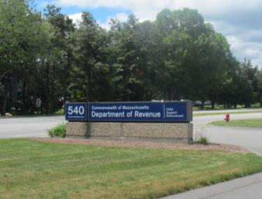

Prepared by:

Massachusetts Department of Public Health

Bureau of Environmental Health

Indoor Air Quality Program

July 2016

# Background

|  |  |
| --- | --- |
| Building: | Department of Revenue Office (DOR) |
| Address: | 540 Myles Standish Boulevard, Taunton |
| Assessment Requested by: | Joshua Martin, Deputy Director, Office of Facilities Management, Massachusetts Department of Revenue |
| Reason for Request: | General indoor air quality (IAQ) for lease renewal. |
| Date of Assessment: | June 13, 2016 |
| Massachusetts Department of Public Health/Bureau of Environmental Health (MDPH/BEH) Staff Conducting Assessment: | Ruth Alfasso, Environmental Engineer/Inspector, IAQ Program |
| Building Description: | Square brick building with a flat roof. DOR is the sole tenant. |
| Building Population: | Approximately 100 employees. |
| Year of Construction: | 1980s; DOR has been the sole tenant since 2012. |
| Windows: | Not openable |

# Methods

Please refer to the IAQ Manual for methods, sampling procedures, and interpretation of results (MDPH, 2015).

# IAQ Testing Results

The following is a summary of indoor air testing results (Table 1).

* ***Carbon dioxide levels*** were below 800 parts per million (ppm) in all but one of the 47 areas assessed, indicating adequate fresh air in the space.
* ***Temperature*** was within the recommended range of 70°F to 78°F in all areas assessed.
* ***Relative humidity*** was within or close to the lower end of the recommended range of 40% to 60% in all areas assessed.
* ***Carbon monoxide*** levels were non-detectable in all indoor areas assessed.
* ***Fine particulate matter (PM2.5)*** concentrations measured were below the National Ambient Air Quality Standard (NAAQS) level of 35 μg/m3 in all but one area assessed.

The assessment results indicate that the ventilation system is providing adequate fresh air for the occupancy in the building. Note that many areas had low occupancy which can reduce the creation of carbon dioxide. To maximize air exchange, the BEH recommends that mechanical ventilation systems operate continuously during periods of occupancy. Without the system operating as designed, normally occurring pollutants cannot be diluted or removed, allowing them to build up and lead to IAQ/comfort complaints.

## Ventilation

A heating, ventilating, and air conditioning (HVAC) system has several functions. First it provides heating and, if equipped, cooling. Second, it is a source of fresh air. Finally, an HVAC system will dilute and remove normally occurring indoor environmental pollutants by not only introducing fresh air, but by filtering the airstream and ejecting stale air to the outdoors via exhaust ventilation. Even if an HVAC system is operating as designed, point sources of respiratory irritation may exist and cause symptoms in sensitive individuals. The following analysis examines and identifies components of the HVAC system and likely sources of respiratory irritant/allergen exposure due to water damage, aerosolized dust, and/or chemicals found in the indoor environment.

Fresh air is provided by air handling units (AHUs) located on the roof. Air from the AHUs is filtered, heated/cooled, and delivered to rooms via ducted supply vents (Picture 1). Air is returned/exhausted through vents located around lights (Picture 2). Direct exhaust ventilation was present in restrooms and some conference rooms.

Additional exhaust ventilation may be useful in the kitchen/lounge and copy areas where particulates and odors may be generated. Note that there was an odor of burned food in the kitchen/lounge area, which has no direct exhaust and particulate levels exceeded the NAAQS limits of 35 μg/m3 at the time of assessment.

It is recommended that HVAC systems be re-balanced every five years to ensure adequate air systems function (SMACNA, 1994). It was unknown when the last time these systems had been balanced.

## Microbial/Moisture Concerns

Stained ceiling tiles were observed in a few places on the second floor (Picture 2; Table 1). It was reported that the roof leaks sometimes during heavy rain events. Water-damaged ceiling tiles can provide a source for mold and should be replaced after a water leak is discovered and repaired.

Plants were observed in offices (Pictures 3 and 4; Table 1). Plants can be a source of pollen and mold, which can be respiratory irritants to some individuals. Plants should be properly maintained and equipped with drip pans to prevent water damage to porous materials. Plants should also be located away from air diffusers to prevent the aerosolization of dirt, pollen, and mold. Water coolers, fountains, and small refrigerators were found located in carpeted areas where they can moisten the carpet and lead to microbial growth (Picture 5; Table 1).

Ductless air conditioning units were observed along the south side of the building (Picture 6), to help with temperature control in areas subject to solar heating. Ductless air conditioning units have condensate drains, hoses, and sometimes pumps that need to be kept in good working order to prevent stagnant water and leaks.

## Other IAQ Evaluations

Exposure to low levels of total volatile organic compounds (TVOCs) may produce eye, nose, throat, and/or respiratory irritation in some sensitive individuals. To determine if VOCs were present, BEH/IAQ staff examined rooms for products containing VOCs. BEH/IAQ staff noted air fresheners, hand sanitizers, cleaners, and dry erase materials in use within the building (Picture 7; Table 1). All of these products have the potential to be irritants to the eyes, nose, throat, and respiratory system of sensitive individuals.

The offices were mostly carpeted. Carpets should be cleaned annually (or semi-annually in soiled/high traffic areas) in accordance with Institute of Inspection, Cleaning and Restoration Certification (IICRC) recommendations, (IICRC, 2012).

In some offices, items such as paper, boxes and decorative items make it harder for custodial staff to clean. Fan blades on personal fans had settled dust and debris, which can be reaerosolized and cause irritation.

# Conclusions/Recommendations

Based on observations at the time of assessment, the following is recommended:

1. Operate supply and exhaust ventilation in all areas during occupied periods.
2. Have the HVAC system balanced every 5 years in accordance with SMACNA recommendations (SMACNA, 1994).
3. Consider having direct exhaust installed in kitchen and copy areas to remove odors and particulates generated in these areas.
4. Repair roof/plumbing leaks and replace stained ceiling tiles.
5. Keep plants in good condition, avoid overwatering, and avoid placing them on porous items such as carpets or paper.
6. Place refrigerators and water dispensing equipment in areas without carpeting or use a waterproof mat underneath them.
7. Ensure ductless air conditioning condensation collecting systems are monitored and maintained to prevent stagnant water and leaks.
8. Reduce use of cleaning products, sanitizers, and scented products.
9. Clean carpeting in accordance with IICRC recommendations (IICRC, 2012).
10. Reduce stored materials and store in an organized manner to allow for thorough cleaning.
11. Clean supply and exhaust vents and personal fans regularly to prevent aerosolization of debris.
12. Refer to resource manual and other related IAQ documents located on the MDPH’s website for further building-wide evaluations and advice on maintaining public buildings. These documents are available at: <http://mass.gov/dph/iaq>.

# References

IICRC. 2012. Institute of Inspection, Cleaning and Restoration Certification. Carpet Cleaning: FAQ. Retrieved from <http://www.iicrc.org/consumers/care/carpet-cleaning/#faq>.

MDPH. 2015. Massachusetts Department of Public Health. Indoor Air Quality Manual: Chapters I-III. Available at: <http://www.mass.gov/eohhs/gov/departments/dph/programs/environmental-health/exposure-topics/iaq/iaq-manual/>.

SMACNA. 1994. HVAC Systems Commissioning Manual. 1st ed. Sheet Metal and Air Conditioning Contractors’ National Association, Inc., Chantilly, VA.

**Picture 1**

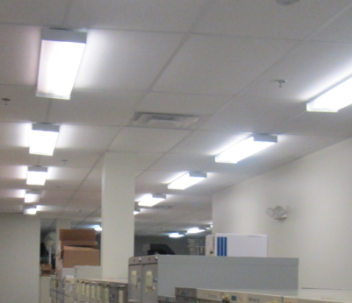

**Supply vent**

**Picture 2**

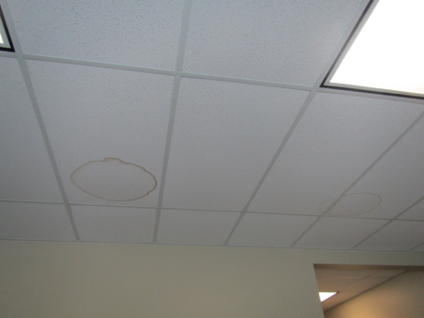

**Vent around light fixture (arrow) and water-damaged ceiling tile**

**Picture 3**

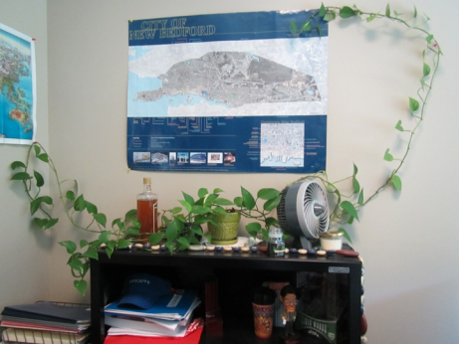

**Plant in an office and a personal fan**

**Picture 4**

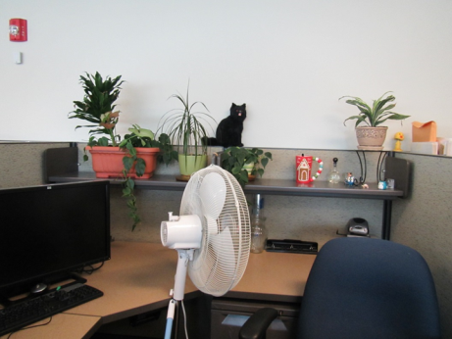

**Plants and a stand fan**

**Picture 5**

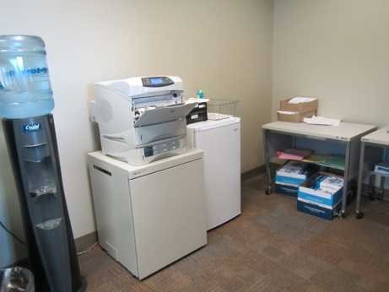

**Water cooler and small refrigerator on carpet**

**Picture 6**

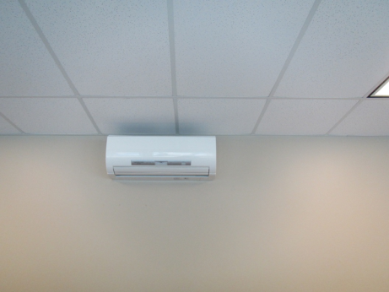

**Ductless air conditioning unit**

**Picture 7**

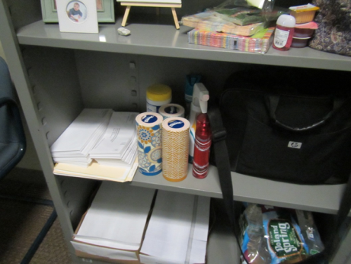

**Cleaning products/sanitizers**

| Location | Carbon  Dioxide  (ppm) | Carbon Monoxide  (ppm) | Temp  (°F) | Relative  Humidity  (%) | PM2.5  (µg/m3) | Occupants  in Room | Windows  Openable | Ventilation | | Remarks |
| --- | --- | --- | --- | --- | --- | --- | --- | --- | --- | --- |
| Supply | Exhaust |
| Background | 359 | ND | 73 | 44 | 3 |  |  |  |  | Sunny and breezy, parking lot |
| First Floor | | | | | | | | | | |
| Imaging | 662 | ND | 73 | 40 | 5 | 0 | N | Y | N | Copy and mail machines, no direct exhaust |
| Files |  |  |  |  |  |  | N | Y | Y | NC, most boxes on shelves |
| McGarry (cubicle) | 658 | ND | 73 | 45 | 13 | 2 | N | Y | Y |  |
| Levangie (cubicle) | 646 | ND | 73 | 42 | 10 | 1 | N | Y | Y | Food, CP |
| Connolly (cubicle) | 656 | ND | 74 | 42 | 3 | 1 | N | Y | Y | Plant |
| Goodmen (cubicle) | 658 | ND | 74 | 42 | 6 | 2 | N | Y | Y | PF, CP, plant |
| Pina (cubicle) | 647 | ND | 74 | 40 | 3 | 2 | N | Y | Y | Fridge on carpet, plant |
| Deputy Regional Director | 612 | ND | 74 | 40 | 9 | 1 | N | Y | Y | DO |
| Crehan (cubicle) | 612 | ND | 74 | 40 | 3 | 0 | N | Y | Y |  |
| Couto (cubicle) | 610 | ND | 74 | 40 | 2 | 3 | N | Y | Y |  |
| McKendrick (cubicle) | 581 | ND | 73 | 38 | 3 | 3-6 | N | Y | Y | Plants |
| Dolison (cubicle) | 568 | ND | 72 | 38 | 2 | 4 | N | Y | Y | PF – dusty, pest trap, food, WC on carpet |
| Maloof (cubicle) | 564 | ND | 72 | 38 | 4 | 3 | N | Y | Y | WC on carpet |
| Oberg (cubicle) | 603 | ND | 73 | 41 | 2 | 1 | N | Y | Y | CP, food |
| Women’s restroom |  |  |  |  |  | 0 | N | Y | Y |  |
| Amonal (cubicle) | 551 | ND | 71 | 40 | 4 | 1 | N | Y | Y | WC on carpet |
| Falk (cubicle) | 546 | ND | 71 | 40 | 3 | 2 | N | Y | Y | PF |
| Regional director | 552 | ND | 71 | 40 | 3 | 0 | N | Y | Y | DO, coffee |
| Second floor | | | | | | | | | | |
| Alves-Cox (cubicle) | 605 | ND | 72 | 43 | 4 | 1 | N | Y | Y | Plants |
| Computer training | 597 | ND | 73 | 43 | 3 | 0 | N | Y | Y | 18 computers, DEM |
| Lounge | 602 | ND | 73 | 43 | 34-38 | 1 | N | Y | Y | Exhaust not direct, burned popcorn odor, NC, fridge, microwave, vending |
| EICT room | 601 | ND | 73 | 41 | 3 | 0 | N | Y | Y | 3 WD-CT |
| Wolk | 603 | ND | 73 | 41 | 3 | 0 | N | Y | Y |  |
| Hassol (cubicle) | 620 | ND | 73 | 41 | 7 | 1 | N | Y | Y |  |
| Shenken (cubicle) | 613 | ND | 73 | 41 | 3 | 0 | N | Y | Y | HS, PF, items on windowsill |
| Files |  |  |  |  |  | 0 | N | Y | Y | NC, WD-CT |
| Shine | 802 | ND | 74 | 41 | 8 | 1 | N | Y | Y |  |
| Burgos | 675 | ND | 74 | 41 | 2 | 1 | N | Y | Y | Plant |
| Craveiro | 630 | ND | 74 | 41 | 2 | 0 | N | Y | Y | Plants, PF |
| Calvori-Moniz | 594 | ND | 74 | 41 | 3 | 1 | N | Y | Y | PF, DO |
| Sawyer | 638 | ND | 74 | 40 | 2 | 0 | N | Y | Y |  |
| Empty room |  |  |  |  |  |  | N | Y | Y | Items, baskets |
| Mazurck | 625 | ND | 74 | 40 | 3 | 1 | N | Y | Y | DO |
| Belizaire | 595 | ND | 75 | 40 | 3 | 1 | N | Y | Y | Space heater on |
| Power-Santisi | 606 | ND | 74 | 40 | 2 | 2 | N | Y | Y | HS |
| Regional Counsel (empty) | 611 | ND | 74 | 40 | 3 | 0 | N | Y | Y | DO |
| Panorese (cubicle) | 647 | ND | 74 | 40 | 3 | 0 | N | Y | Y |  |
| Boss (cubicle) | 566 | ND | 73 | 39 | 3 | 0 | N | Y | Y | HS |
| Vieira (cubicle) | 576 | ND | 74 | 39 | 3 | 1 | N | Y | Y |  |
| Tufo | 572 | ND | 73 | 39 | 3 | 0 | N | Y | Y | Accumulated items on wall |
| McCormick (cubicle) | 549 | ND | 73 | 40 | 3 | 1 | N | Y | Y | Plants |
| Dacey | 561 | ND | 73 | 40 | 3 | 0 | N | Y | Y | PF |
| Semedo | 566 | ND | 73 | 45 | 10 | 2 | N | Y | Y | Plants |
| HD room | 626 | ND | 73 | 40 | 2 | 0 | N | Y | Y |  |
| O’Donnell | 665 | ND | 72 | 40 | 4 | 0 | N | Y | Y | CP |
| Conference room 2 | 756 | ND | 71 | 40 | 6 | 1 | N | Y | Y | DEM |
| Vacant Office | 622 | ND | 72 | 42 | 2 | 0 | N | Y | Y | PF-dusty |
| Murray (cubicle) | 596 | ND | 73 | 42 | 5 | 3 | N | Y | Y | PF, plants, HS |
| Heyes | 612 | ND | 74 | 42 | 11 | 1 | N | Y | Y | Plant |
| Sumner (Director) | 633 | ND | 74 | 44 | 4 | 1 | N | Y | Y |  |
| Dean (cubicle) | 631 | ND | 74 | 43 | 3 | 3 | N | Y | Y | Plants, WC on carpet |
| Waiting | 633 | ND | 73 | 43 |  | 8 | N | Y | Y | Open to mezzanine area |