**INDOOR AIR QUALITY ASSESSMENT**

**Department of Revenue**

**Child Support Enforcement Office**

**100 Tradecenter Drive, Suite 760**

**Woburn, MA**

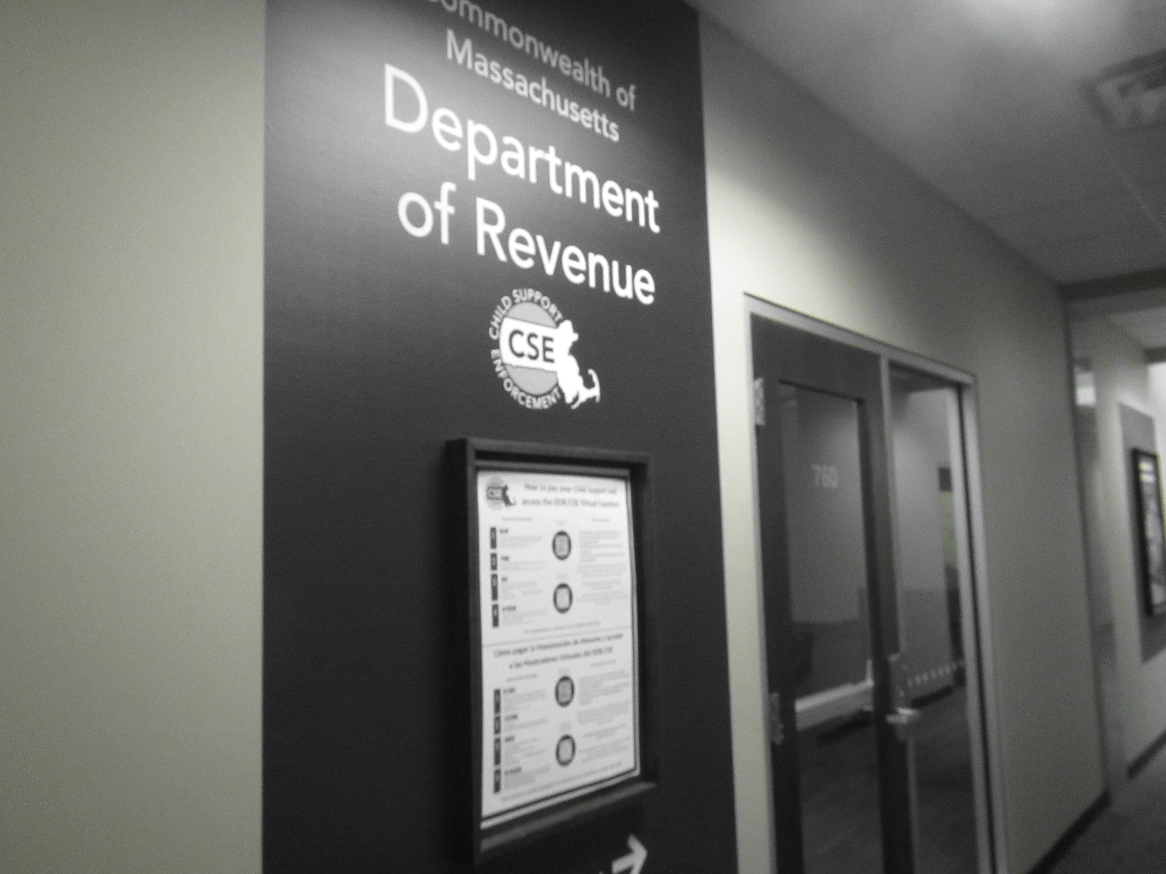

Prepared by:

Massachusetts Department of Public Health

Bureau of Environmental Health

Indoor Air Quality Program

May 2023

# BACKGROUND

|  |  |
| --- | --- |
| Building: | Department of Revenue (DOR) Child Support Enforcement Division |
| Address: | 100 Tradecenter Drive, Suite 760, Woburn, MA 01801 |
| Assessment Requested by: | Joshua Martin, Director, Office of  Facilities Management, Massachusetts  DOR |
| Reason for Request: | Part of a regular program of indoor air quality (IAQ) inspections of DOR workspaces |
| Date of Assessment: | March 24, 2023 |
| Massachusetts Department of Public Health/Bureau of Environmental Health (MDPH/BEH) Staff Conducting Assessment: | Ruth Alfasso, Environmental  Engineer/Inspector, IAQ Program |
| Building Description: | This DOR office is located in a suite on the first floor of a large office building originally built in the 1960s. The building has a flat roof with a rubber membrane. The DOR offices are primarily hoteling space, with offices, cubicles, meeting and interview rooms, and a small kitchenette. DOR has occupied space in this building for 15 years, but have been in this specific suite for about 8 months. |
| Windows: | Some windows are openable |

# METHODS

Please refer to the IAQ Manual for methods, sampling procedures, and interpretation of results (MDPH, 2015).

# RESULTS AND DISCUSSION

The following is a summary of indoor air testing results (Table 1).

* ***Carbon dioxide*** measurements were below the MDPH guideline of 800 parts per million (ppm) indicating adequate fresh air in the space. Note that few areas were occupied during the assessment; levels of carbon dioxide may increase with occupancy.
* ***Temperature*** was within the recommended range of 70°F to 78°F in all areas tested.
* ***Relative humidity*** was below the recommended range of 40% to 60% in all areas tested, which is common during the heating season.
* ***Carbon monoxide*** levels were non-detectable (ND) in all areas tested.
* ***Fine particulate matter (PM2.5)*** concentrations were below the National Ambient Air Quality Standard (NAAQS) level of 35 μg/m3 in all areas tested.

## Ventilation

Note that the DOR is moving towards a “hoteling” or “touchdown space” model for offices, where an individual checks out a desk for the day when they are in the office and has no set work location. In addition, this DOR office is open to the public on specific days per week, and almost entirely unoccupied on other days, including the day of the visit.

A heating, ventilating, and air conditioning (HVAC) system has several functions. First, it provides heating and, if equipped, cooling. Second, it is a source of fresh air. Finally, an HVAC system will dilute and remove normally occurring indoor environmental pollutants by not only introducing fresh air, but also filtering the airstream and ejecting stale air to the outdoors via exhaust ventilation. Even if an HVAC system is operating as designed, point sources of respiratory irritation may exist and affect symptoms in sensitive individuals. The following analysis examines and identifies components of the HVAC system and likely sources of respiratory irritant/allergen exposure due to water damage, aerosolized dust, and/or chemicals found in the indoor environment.

Fresh air is provided by air handling units (AHUs) that appear to be located on the roof. Air from the AHUs is filtered, heated/cooled, and delivered to rooms via ducted supply vents (Picture 1). Air is drawn through exhaust grills (Picture 2) into the ceiling plenum and returned to the AHUs.

Many offices had a supply vent and no return or exhaust vent. This typically relies on returns or exhausts in the central areas to remove stale air through undercuts beneath doors, or with doors open.

The ventilation system should be on and operating to supply fresh air continuously during occupied periods. Without adequate fresh air supply and removal of stale air, common indoor air pollutants can build up and cause irritation.

It is recommended that HVAC systems be re-balanced every five years to ensure adequate air systems function (SMACNA, 1994). These systems were reportedly last balanced in May of 2022.

Thermostats are present at intervals along each floor. The thermostats were noted to be different styles and set to different temperatures. If possible, these settings should be centrally coordinated to save energy, including setbacks for times when the space is unoccupied.

## Microbial/Moisture Concerns

No water-damaged ceiling tiles or other water-damaged materials were noted in the office. A plant was found in the lounge/kitchenette. Plants should be properly maintained and equipped with drip pans to prevent water damage to porous materials. Plants should also be located away from air diffusers to prevent the aerosolization of dirt, pollen, and mold.

Refrigerators and a sink were observed over carpet in the “Wellness room” (Picture 3), and water dispensers are located on carpet around the main workstation area (Picture 4). The lounge/kitchenette was outfitted with non-porous flooring; use of non-porous flooring in the wellness room and where water dispensers will be located should be considered during future renovations. In this space, DOR staff are no longer allowed to have small refrigerators in work areas. This will prevent spills, leaks, and spoiled food from creating odors or attracting pests.

Note that windows in this building are openable. Windows should not be opened during heavy rain or hot, humid weather, as this may lead to excess humidity indoors and potentially condensation on chilled surfaces. All windows should be tightly closed at the end of each workday.

## Other IAQ Concerns

Because of the hoteling design of this offices, there are no personal items on desks in the office, and very little clutter was found. This can make it easier for custodial staff to clean.

An examination was conducted for products that may be a source of VOCs in indoor air. Products such as dry erase markers, hand sanitizers, and other cleaners were found in offices and common areas (Picture 5; Table 1). In the absence of adequate fresh air and exhaust ventilation, VOCs from these products can build up and lead to irritation of the mucous membranes or irritating odors.

As mentioned above, most areas of this office are carpeted. Carpets should be cleaned regularly in accordance with Institute of Inspection, Cleaning and Restoration Certification (IICRC) recommendations (IICRC, 2012).

# CONCLUSIONS/RECOMMENDATIONS

The following are recommendations made to improve IAQ:

## Ventilation recommendations

1. Operate supply and exhaust ventilation in all areas during occupied periods.
2. Ensure filters are replaced on HVAC units at least twice a year. If feasible, use filters with a minimum efficiency rating value (MERV) of 8 or better.
3. Ensure thermostats office-wide are set in a consistent manner, including any nighttime or weekend setbacks.
4. Use adjustable blinds to control thermal heating and glare due to sunlight.
5. It is recommended that HVAC systems be re-balanced every five years to ensure adequate air systems function (SMACNA, 1994).

## Water damage recommendations

1. Keep indoor plants in good condition and avoid overwatering. Ensure any plants are placed on water-resistant drip pans to prevent water damage to building materials and furniture.
2. Consider moving refrigerators and water dispensers to areas without carpeting or use a waterproof mat underneath.
3. Keep refrigerators and other food-preparation appliances clean.

## Other recommendations

1. Periodically clean dust from supply and return vents, and fans.
2. Use VOC-containing products in areas with good ventilation and keep tightly closed when not in use.
3. Clean carpeting in accordance with IICRC recommendations (IICRC, 2012).
4. For buildings in New England, periods of low relative humidity during the winter are often unavoidable. Therefore, scrupulous cleaning practices should be adopted to minimize common indoor air contaminants whose irritant effects can be enhanced when the relative humidity is low. To control for dusts, a high efficiency particulate arrestance (HEPA) filter equipped vacuum cleaner in conjunction with wet wiping of all surfaces is recommended. Avoid the use of feather dusters. Drinking water during the day can help ease some symptoms associated with a dry environment (throat and sinus irritations).
5. Refer to resource manual and other related IAQ documents located on the MDPH’s website for further building-wide evaluations and advice on maintaining public buildings. These documents are available at: <http://mass.gov/dph/iaq>.

# REFERENCES

IICRC. 2012. Institute of Inspection, Cleaning and Restoration Certification. Carpet Cleaning: FAQ.

MDPH. 2015. Massachusetts Department of Public Health. Indoor Air Quality Manual: Chapters I-III. Available at: <https://www.mass.gov/lists/indoor-air-quality-manual-and-appendices>.

SMACNA. 1994. HVAC Systems Commissioning Manual. 1st ed. Sheet Metal and Air Conditioning Contractors’ National Association, Inc., Chantilly, VA.

**Picture 1**

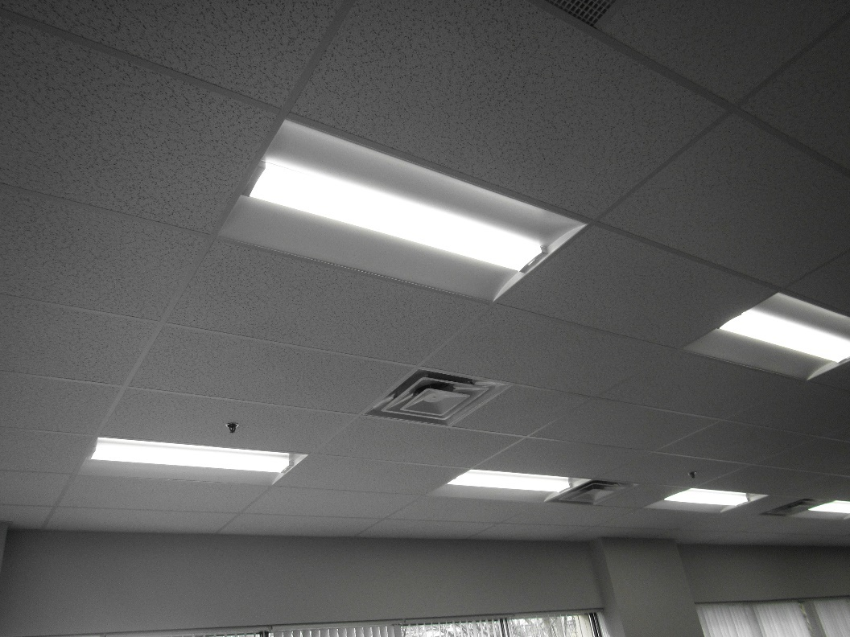

**Supply vents on the ceiling of the main workstation area**

**Picture 2**

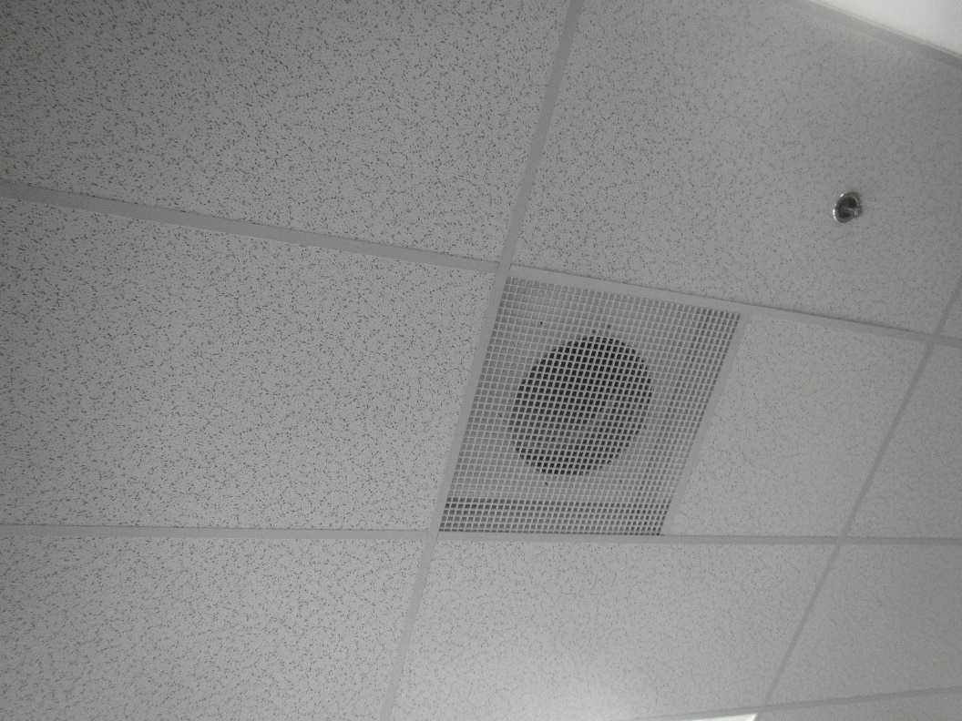

**Exhaust vent on the ceiling**

**Picture 3**

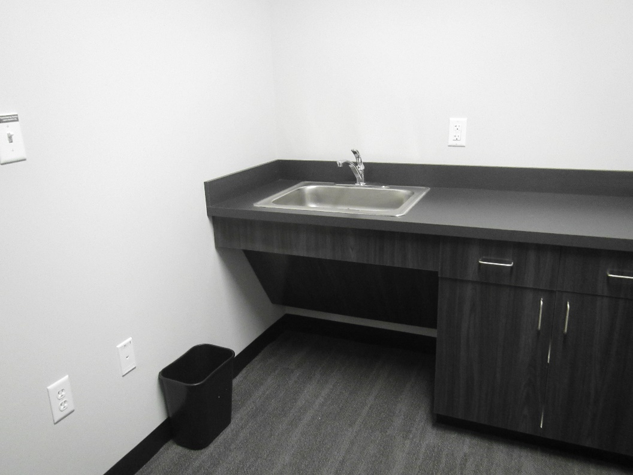

**Wellness room sink over carpet**

**Picture 4**

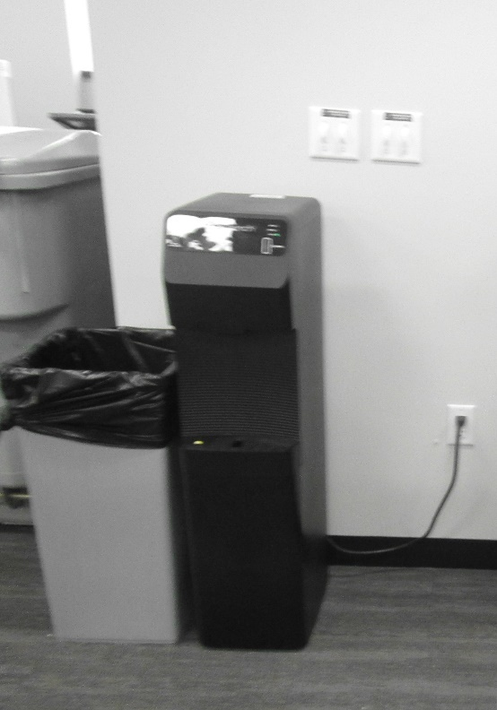

**Water dispenser on carpet**

**Picture 5**

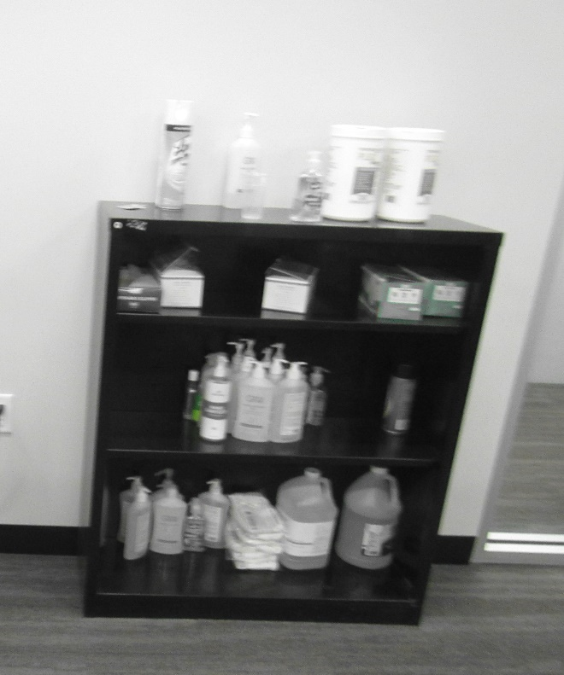

**Hand sanitizers and surface sanitizers**

| **Location** | **Carbon**  **Dioxide**  **(ppm)** | **Carbon Monoxide**  **(ppm)** | **Temp**  **(°F)** | **Relative**  **Humidity**  **(%)** | **PM2.5**  **(µg/m3)** | **Occupants**  **in Room** | **Windows**  **Openable** | **Ventilation** | | **Remarks** |
| --- | --- | --- | --- | --- | --- | --- | --- | --- | --- | --- |
| **Supply** | **Exhaust** |
| Background | 368 | ND | 53 | 41 | 3 |  |  |  |  | Mostly cloudy, in busy parking lot |
| Cube 10 | 413 | ND | 70 | 34 | 1 | 0 | Y | Y | Y |  |
| Cube 15 | 401 | ND | 70 | 34 | 1 | 0 | Y | Y | Y |  |
| Cube 1 | 419 | ND | 71 | 34 | 2 | 0 | Y | Y | Y |  |
| Office 7 | 465 | ND | 71 | 33 | 2 | 0 | N | Y | N |  |
| Office 8 | 424 | ND | 71 | 33 | 2 | 0 | N | Y | N | HS |
| Huddle 2 | 437 | ND | 71 | 32 | 3 | 0 | N | Y | Y |  |
| Huddle 1 | 453 | ND | 71 | 32 | 3 | 0 | Y | Y | Y |  |
| Conference 2 | 483 | ND | 71 | 33 | 1 | 0 | Y | Y | Y |  |
| Huddle 3 | 416 | ND | 71 | 32 | 2 | 0 | Y | Y | Y |  |
| Cube 36 | 519 | ND | 71 | 33 | 2 | 0 | Y | Y | Y |  |
| Cube 44 | 470 | ND | 71 | 33 | 2 | 0 | Y | Y | Y |  |
| Cube 41 | 418 | ND | 71 | 33 | 2 | 0 | Y | Y | Y |  |
| Cube 27 | 422 | ND | 71 | 32 | 2 | 0 | Y | Y | N |  |
| Office 6 | 412 | ND | 71 | 32 | 3 | 0 | N | Y | N |  |
| Office 4 | 578 | ND | 71 | 33 | 3 | 0 | N | Y | N | Printer, HS |
| Office 5 | 514 | ND | 71 | 32 | 4 | 0 | N | Y | N |  |
| Office 3 | 444 | ND | 71 | 31 | 2 | 0 | N | Y | N |  |
| Office 2 | 429 | ND | 71 | 31 | 1 | 0 | N | Y | N | PF |
| Interview 3 staff side | 415 | ND | 71 | 30 | 2 | 0 | N | Y | N |  |
| Interview 2 staff side | 480 | ND | 71 | 30 | 2 | 0 | N | Y | N |  |
| Interview 1 staff side | 416 | ND | 71 | 30 | 2 | 0 | N | Y | N |  |
| Kitchen/lounge | 444 | ND | 71 | 31 | 3 | 0 | Y | Y | Y | Includes what appears to be direct exhaust, NC, HS, fridge and microwave |
| Copy/mail | 601 | ND | 71 | 32 | 2 | 0 | N | Y | N | Mail and copy machines, accumulated items |
| Wellness | 450 | ND | 71 | 30 | 2 | 0 | N | Y | N | Sink and fridge on carpet |
| Office 1 | 431 | ND | 71 | 30 | 1 | 0 | N | Y | N | DEM |
| Women’s restroom |  |  |  |  |  |  | N | Y | Y |  |
| Men’s restroom |  |  |  |  |  |  | N | Y | Y |  |
| Inside reception | 430 | ND | 71 | 31 | 3 | 0 | N | Y | N |  |
| Lobby | 434 | ND | 70 | 31 | 2 | 0 | N | Y | Y | Return/exhaust next to staff door, skylight with blinds drawn |
| Interview 1, public side | 452 | ND | 70 | 31 | 2 | 0 | N | Y | N |  |
| Interview 2, public side | 450 | ND | 70 | 31 | 2 | 0 | N | Y | N | HS |
| Interview 3, public side | 475 | ND | 70 | 30 | 2 | 0 | N | Y | N | HS |