**INDOOR AIR QUALITY ASSESSMENT**

**Department of Revenue**

**1 Federal Street**

**Springfield, MA**

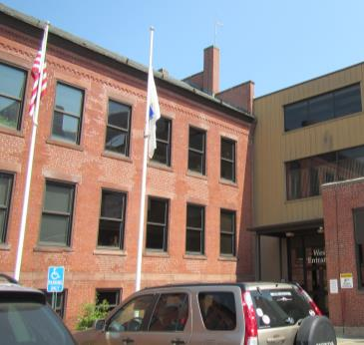

Prepared by:

Massachusetts Department of Public Health

Bureau of Environmental Health

Indoor Air Quality Program

May 2016

# Background

|  |  |
| --- | --- |
| Building: | Springfield Department of Revenue (DOR) |
| Address: | 1 Federal Street, West Entrance, 3rd Floor, Springfield, MA |
| Assessment Requested by: | Joshua Martin, Deputy Director, Office of Facilities Management, DOR |
| Reason for Request: | General indoor air quality (IAQ) |
| Date of Assessment: | May 12, 2016 |
| Massachusetts Department of Public Health/Bureau of Environmental Health (MDPH/BEH) Staff Conducting Assessment: | Ruth Alfasso, Environmental Engineer/Inspector, IAQ Program,  Cory Holmes, Environmental Analyst/Inspector, IAQ Program |
| Building Description: | Former armory building in a complex now called Springfield Technology Park. The building has brick construction with a complex roof. The DOR space is on the third floor next to the west entrance. Other office tenants are above, adjacent to, and below this office. |
| Year Built: | Established in 1794 as the Springfield Armory, in the 1800s light manufacturing. Became the Springfield Technology Park in 1996. Significantly renovated several times. |
| Building Population: | Approximately 78 staff and approximately 20 members of the public visiting daily |
| Windows: | Not openable |

# METHODS

Please refer to the IAQ Manual for methods, sampling procedures, and interpretation of results (MDPH, 2015).

# IAQ Testing Results

The following is a summary of indoor air testing results (Table 1).

* ***Carbon dioxide levels*** were below 800 parts per million (ppm) in all but one of the 33 areas tested, indicating adequate fresh air supply for the space.
* ***Temperature*** was within the recommended range of 70°F to 78°F in all areas tested.
* ***Relative humidity*** was below the recommended range of 40 to 60% in all areas tested.
* ***Carbon monoxide*** levels were non-detectable in all indoor areas tested.
* ***Fine particulate matter (PM2.5)*** concentrations measured were below the National Ambient Air Quality Standard (NAAQS) level of 35 μg/m3 in all areas tested.

This sampling indicates that there is adequate fresh air in most areas of the building.

## Ventilation

A heating, ventilating and air conditioning (HVAC) system has several functions. First it provides heating and, if equipped, cooling. Second, it is a source of fresh air. Finally, an HVAC system will dilute and remove normally occurring indoor environmental pollutants by not only introducing fresh air, but by filtering the airstream and ejecting stale air to the outdoors via exhaust ventilation. Even if an HVAC system is operating as designed, point sources of respiratory irritants may exist and cause symptoms in sensitive individuals. The following analysis examines and identifies components of the HVAC system and likely sources of respiratory irritant/allergen exposure due to water damage, aerosolized dust and/or chemicals found in the indoor environment.

Fresh air for the space is provided by air handling units (AHU) via ducts to supply vents (Pictures 1 - 3). Ducted wall-mounted or ceiling-mounted exhaust vents remove stale air (Picture 4). Draw of air from restroom exhaust vents in the men’s and women’s restrooms appeared to be weak or non-existent.

## Microbial/Moisture Concerns

A single water-damaged ceiling tile was observed in the men’s restroom (Picture 5). This likely stems from a plumbing leak in a space above. Once that leak has been repaired, the ceiling tile should be replaced.

Water coolers and small refrigerators were observed on carpeting (Picture 6). Spills and leaks from these appliances can moisten carpeting and lead to microbial growth and odors.

## Other IAQ Evaluations

### Volatile Organic Compounds (VOCs)

Exposure to low levels of total volatile organic compounds (TVOCs) may produce eye, nose, throat, and/or respiratory irritation in some sensitive individuals. To determine if VOCs were present, BEH/IAQ staff examined rooms for products containing VOCs. BEH/IAQ staff noted air fresheners, hand sanitizers, cleaners, and dry erase materials in use within the building (Table 1). All of these products have the potential to be irritants to the eyes, nose, throat, and respiratory system of sensitive individuals.

### Other conditions

Accumulated items were found stored on floors and other flat surfaces which can make it more difficult for custodial staff to clean. Some supply, exhaust vents and personal fans were found to be dusty. Dust can be reaerosolized and cause irritation; these items should be cleaned regularly.

Most offices are carpeted. Carpets should be cleaned regularly in accordance with Institute of Inspection, Cleaning and Restoration Certification (IICRC) recommendations (IICRC, 2012). According to staff, the carpeting is cleaned every six months. The next cleaning is due; however the current carpeting is planned to be replaced with carpet squares in the near future as a part of the current lease renewal so the cleaning has been postponed.

# Conclusions/Recommendations

The following recommendations are made to assist in maintaining IAQ:

1. Operate the HVAC system during all occupied periods to provide continuous fresh air and exhaust ventilation.
2. Ensure fans/motors for restroom exhaust vents are operational and on during occupied periods.
3. Continue with regular maintenance of HVAC components and filter changes at least twice a year.
4. Consider having the HVAC system balanced every 5 years for all mechanical ventilation systems, as recommended by ventilation industrial standards (SMACNA, 1994).
5. For buildings in New England, periods of low relative humidity during the winter are often unavoidable. Therefore, scrupulous cleaning practices should be adopted to minimize common indoor air contaminants whose irritant effects can be enhanced when the relative humidity is low. To control for dusts, a high efficiency particulate arrestance (HEPA) filter equipped vacuum cleaner in conjunction with wet wiping of all surfaces is recommended. Avoid the use of feather dusters. Drinking water during the day can help ease some symptoms associated with a dry environment (throat and sinus irritations).
6. Repair plumbing leaks and replace stained ceiling tiles.
7. Consider putting water dispensers and refrigerators on waterproof mats or in areas without carpeting. During carpet replacement, areas of tile may be used in places where dispensers and refrigerators will be located.
8. Keep refrigerators clean.
9. Reduce the use of VOC-containing cleaners and sanitizers.
10. Change HVAC filters regularly (2 to 4 times a year).
11. Clean supply and exhaust vents and personal fans regularly to prevent aerosolization of debris.
12. Clean carpeting and upholstered items regularly in accordance with IICRC recommendations (IICRC, 2012).
13. Consider reducing the amount of items stored in offices to make cleaning easier. Periodically move items to clean flat surfaces.
14. Refer to resource manual and other related IAQ documents located on the MDPH’s website for further building-wide evaluations and advice on maintaining public buildings. These documents are available at: <http://mass.gov/dph/iaq>.

# References

IICRC. 2012. Institute of Inspection, Cleaning and Restoration Certification. Carpet Cleaning: FAQ. Retrieved from <http://www.iicrc.org/consumers/care/carpet-cleaning/#faq>.

MDPH. 2015. Massachusetts Department of Public Health. Indoor Air Quality Manual: Chapters I-III. Available at: <http://www.mass.gov/eohhs/gov/departments/dph/programs/environmental-health/exposure-topics/iaq/iaq-manual/>.

SMACNA. 1994. HVAC Systems Commissioning Manual. 1st ed. Sheet Metal and Air Conditioning Contractors’ National Association, Inc., Chantilly, VA.

**Picture 1**

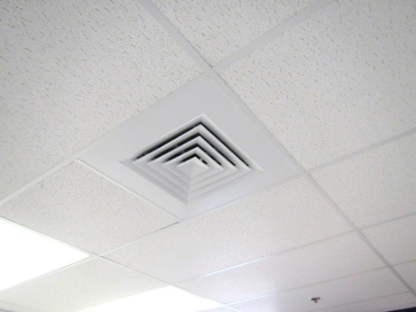

**One type of supply vent in the DOR offices**

**Picture 2**

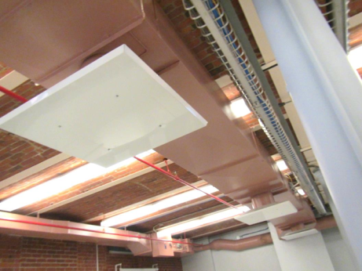

**Supply vent in open areas of the DOR office**

**Picture 3**

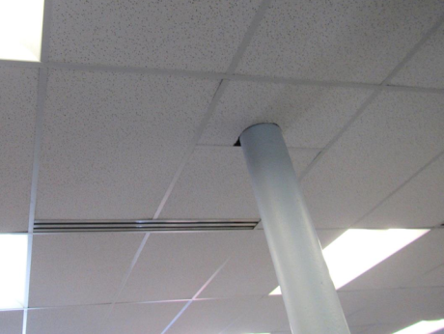

**Slot-style supply vent**

**Picture 4**

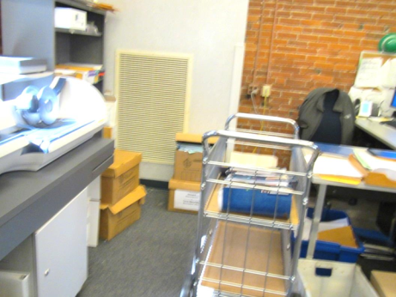

**Wall-mounted exhaust vent**

**Picture 5**

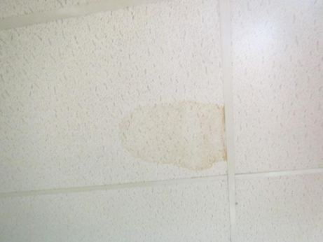

**Water-damaged ceiling tile in men’s restroom**

**Picture 6**

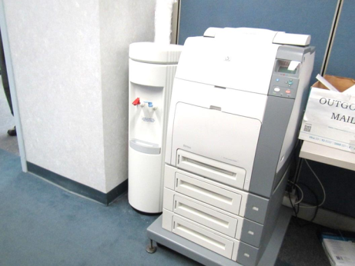

**Water cooler on carpet**

| Location | Carbon  Dioxide  (ppm) | Carbon Monoxide  (ppm) | Temp  (°F) | Relative  Humidity  (%) | PM2.5  (µg/m3) | Occupants  in Room | Windows  Openable | Ventilation | | Remarks |
| --- | --- | --- | --- | --- | --- | --- | --- | --- | --- | --- |
| Supply | Exhaust |
| Background | 344 | ND | 70 | 20 | 4 |  |  |  |  | Sunny, parking lot by road |
| Training | 459 | ND | 73 | 24 | 1 | 0 | N | Y | Y | 20 computers, NC, boxes on floor |
| Files | 539 | ND | 73 | 24 | 2 | 0 | N | Y | Y |  |
| 84 cube area | 515 | ND | 73 | 25 | 2 | 1 | N | Y | Y | PF, PC in hall |
| Conference | 502 | ND | 73 | 25 | 2 | 0 | N | Y | Y | Microwave, soft/movable wall to next room |
| Kitchen | 540 | ND | 73 | 27 | 3 | 2 | N | Y | Y | NC, fridge, microwave, toaster, food |
| Women’s rest room |  |  |  |  |  |  | N | Y | Y | CP, weak or off exhaust |
| McDonald office | 960 | ND | 73 | 27 | 2 | 0 | N | Y | Y | Shares partial wall with data room |
| Data center room |  |  |  |  |  |  | N | N | N | Warm, no supply/exhaust |
| Walpurgis cube area | 484 | ND | 73 | 25 | 3 | 0 | N | Y | Y |  |
| Kelcey cube | 478 | ND | 73 | 26 | 2 | 1 | N | Y | Y |  |
| Kostanski cube | 507 | ND | 73 | 25 | 2 | 2 | N | Y | Y | PF |
| Vaunt cube | 491 | ND | 73 | 25 | 2 | 0 | N | Y | Y | Fake plant |
| Ehiwele office | 488 | ND | 72 | 26 | 2 | 1 | N | Y | Y | DO, DEM |
| Bidus Office | 491 | ND | 73 | 26 | 2 | 1 | N | Y | Y | PF, food |
| Caruso Office | 513 | ND | 73 | 26 | 2 | 3 | N | Y | Y | PF |
| Almron office | 490 | ND | 73 | 26 | 2 | 1 | N | Y | Y | AI on windowsill, door to outside |
| Office A (Director) | 470 | ND | 72 | 26 | 2 | 0 | N | Y | Y |  |
| Unisex restroom |  |  |  |  |  |  | N | Y | Y - on | CP |
| Wyusock/Desmond cubes | 479 | ND | 73 | 26 | 2 | 0 | N | Y | Y | CP, AF |
| Allen cube | 482 | ND | 72 | 26 | 2 | 1 | N | Y | Y |  |
| Conference room | 721 | ND | 74 | 28 | 5 | 3 | N | Y | Y |  |
| Reception | 637 | ND | 73 | 28 | 4 | 2 | N | Y | Y | PC, PF |
| Dubchak | 583 | ND | 73 | 27 | 4 | 3 | N | Y | Y | PF |
| Ortiz | 537 | ND | 73 | 27 | 5 | 2 | N | Y | Y |  |
| Patino/Fax machine cubes | 550 | ND | 73 | 27 | 4 | 2 | N | Y | Y |  |
| Vazques | 554 | ND | 73 | 27 | 5 | 3 | N | Y | Y |  |
| Tryon/Greenberg | 537 | ND | 73 | 27 | 4 | 2 | N | Y | Y |  |
| Adorno/Trembley | 551 | ND | 73 | 27 | 4 | 3 | N | Y | Y |  |
| Johnson/Spratlin | 538 | ND | 73 | 27 | 4 | 2 | N | Y | Y |  |
| Moorehead | 545 | ND | 73 | 27 | 4 | 3 | N | Y | Y |  |
| Nieves/Matuszek | 493 | ND | 73 | 26 | 4 | 2 | N | Y | Y |  |
| Almodovar | 501 | ND | 73 | 27 | 4 | 0 | N | Y | Y |  |
| Listro/Levin | 500 | ND | 73 | 27 | 5 | 0 | N | Y | Y |  |
| McCollum/Landry | 488 | ND | 73 | 27 | 4 | 0 | N | Y | Y |  |
| Pappadellis | 530 | ND | 73 | 27 | 4 | 2 | N | Y | Y | DO |
| Men’s restroom |  |  |  |  |  |  |  | Y passive vent | Y | 1 WD CT |
| Interview 3 | 534 | ND | 72 | 25 | 3 | 0 | N | Y | Y |  |