INDOOR AIR QUALITY ASSESSMENT

Department of Revenue
100 Cambridge Street
7th floor, 2nd floor, and Mezzanine
Boston, Massachusetts

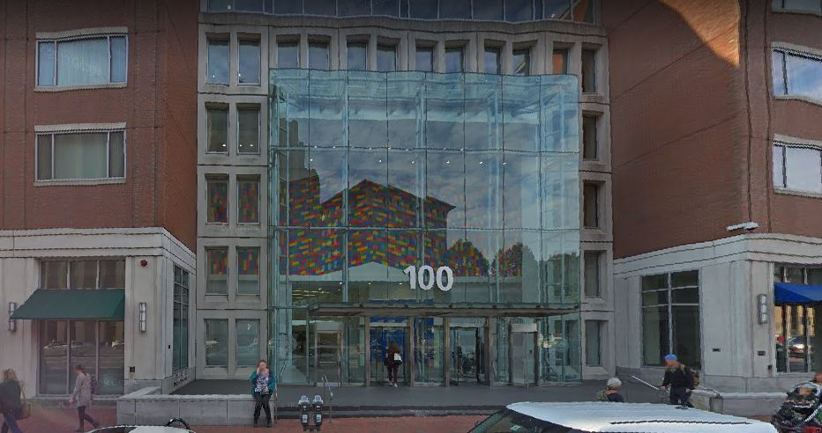

Prepared by:
Massachusetts Department of Public Health
Bureau of Environmental Health
Indoor Air Quality Program
May 2023

BACKGROUND
Building: | Department of Revenue (DOR)
Address: | 100 Cambridge Street, Boston, MA
Assessment Requested by: | Joshua Martin, Director, Office of  Facilities Management, Massachusetts  DOR
Reason for Request: | Part of a regular program of indoor air quality (IAQ) inspections of DOR workspaces
Date of Assessment: | May 11, 2023
Massachusetts Department of Public Health/Bureau of Environmental Health (MDPH/BEH) Staff Conducting Assessment: | Ruth Alfasso, Environmental  Engineer/Inspector, IAQ Program
Building Description: | The DOR occupies spaces on the 7th floor, 2nd floor, and mezzanine areas of the high-rise building at 100 Cambridge Street, Boston, also known as the Saltonstall Building, originally built in 1965, and significantly renovated in 2000. The DOR offices are primarily hoteling space, with offices, cubicles, meeting and interview rooms, copy rooms and break rooms. The 7th floor offices were remodeled approximately a year ago including new HVAC equipment and furnishings.
Windows: | Windows are not openable

METHODS
Please refer to the IAQ Manual for methods, sampling procedures, and interpretation of results (MDPH, 2015).

RESULTS AND DISCUSSION
The following is a summary of indoor air testing results (Table 1).
- Carbon dioxide measurements were below the MDPH guideline of 800 parts per million (ppm) indicating adequate fresh air in the space. Note that few areas were occupied during the assessment; levels of carbon dioxide may increase with occupancy.
- Temperature was within the recommended range of 70°F to 78°F in all areas tested.
- Relative humidity was slightly below the recommended range of 40% to 60% in all areas tested, similar to outside at the time of the assessment.
- Carbon monoxide levels were non-detectable (ND) in all areas tested.
- Fine particulate matter (PM2.5) concentrations were below the National Ambient Air Quality Standard (NAAQS) level of 35 μg/m³ in all areas tested.

Ventilation
Note that the DOR is moving towards a “hoteling” or “touchdown space” model for offices, where an individual checks out a desk for the day when they are in the office and has no set work location.
A heating, ventilating, and air conditioning (HVAC) system has several functions. First, it provides heating and, if equipped, cooling. Second, it is a source of fresh air. Finally, an HVAC system will dilute and remove normally occurring indoor environmental pollutants by not only introducing fresh air, but also filtering the airstream and ejecting stale air to the outdoors via exhaust ventilation. Even if an HVAC system is operating as designed, point sources of respiratory irritation may exist and affect symptoms in sensitive individuals. The following analysis examines and identifies components of the HVAC system and likely sources of respiratory irritant/allergen exposure due to water damage, aerosolized dust, and/or chemicals found in the indoor environment.
Fresh air is provided by air handling units (AHUs) on the roof. Air from the AHUs is filtered, heated/cooled, and delivered to rooms via ducted supply vents (Pictures 1 and 2). Air is drawn through exhaust grills (Picture 3) into the ceiling plenum and returned to the AHUs.
The ventilation system should be on and operating to supply fresh air continuously during occupied periods. Without adequate fresh air supply and removal of stale air, common indoor air pollutants can build up and cause irritation.
It is recommended that HVAC systems be re-balanced every five years to ensure adequate air systems function (SMACNA, 1994). These systems were reportedly last balanced within the last year.
Thermostats are present at intervals along each floor (Picture 4) and are connected to a building management system. Thermostat settings should be centrally coordinated to save energy, including setbacks for times when the space is unoccupied.
Sunlight was noted streaming in from windows in a few areas (Table 1). This can lead to comfort complaints and concerns about glare. The adjustable blinds (Picture 2) should be used to reduce the impact of sunlight. If the current blinds are not sufficient in some areas to reduce comfort issues, blinds that have a greater light blocking capacity can be substituted in the affected areas.

Microbial/Moisture Concerns
No water-damaged ceiling tiles or other water-damaged materials were noted in the office. Refrigerators and a sink were observed over carpet in the “Wellness Room” (Picture 5), and water dispensers are located on carpet in several areas (Picture 6). On the 7th floor, where most DOR employees at this location work, staff are no longer allowed to have small refrigerators in work areas. This will prevent spills, leaks, and spoiled food from creating odors or attracting pests. Refrigerators in break rooms and other areas should be cleaned regularly to prevent odors caused by spills and spoiled food. Food preparation equipment such as microwaves (Picture 7) and toasters should also be cleaned regularly.

Other IAQ Concerns
Because of the hoteling design of this office, there are no personal items on desks in the office, and very little clutter was found. This can make it easier for custodial staff to clean.
An examination was conducted for products that may be a source of VOCs in indoor air. Products such as dry erase markers, hand sanitizers, and other cleaners were found in offices and common areas (Picture 8; Table 1). In the absence of adequate fresh air and exhaust ventilation, VOCs from these products can build up and lead to irritation of the mucous membranes or irritating odors.
Lockers are present in this location for staff to store work-related and personal items. Lockers should be cleaned out periodically to prevent odors or pest issues due to storage of food or other items.
As mentioned above, most areas of this office are carpeted. Carpets should be cleaned regularly in accordance with Institute of Inspection, Cleaning and Restoration Certification (IICRC) recommendations (IICRC, 2012).

CONCLUSIONS/RECOMMENDATIONS
The following are recommendations made to maintain IAQ:

Ventilation recommendations
- Operate supply and exhaust ventilation in all areas during occupied periods.
- Ensure filters are replaced on HVAC units at least twice a year. If feasible, use filters with a minimum efficiency rating value (MERV) of 8 or better.
- Ensure thermostats office-wide are set in a consistent manner, including nighttime and weekend setbacks.
- Use adjustable blinds to control thermal heating and glare due to sunlight. If current blinds are insufficient to reduce comfort issues, consider upgrading blinds to those with more light-blocking ability where needed.
- It is recommended that HVAC systems be re-balanced every five years to ensure adequate air systems function (SMACNA, 1994).

Water damage recommendations
- Consider moving refrigerators and water dispensers to areas without carpeting or use a waterproof mat underneath.
- Keep refrigerators and other food-preparation appliances clean.

Other recommendations
- Periodically clean dust from supply and return vents, and fans.
- Use VOC-containing products in areas with good ventilation and keep tightly closed when not in use. Avoid products with strong scents and avoid mixing incompatible products.
- Ensure lockers are cleaned out periodically.
- Clean carpeting in accordance with IICRC recommendations (IICRC, 2012).
- For buildings in New England, periods of low relative humidity during the winter are often unavoidable. Therefore, scrupulous cleaning practices should be adopted to minimize common indoor air contaminants whose irritant effects can be enhanced when the relative humidity is low. To control dust, a high efficiency particulate arrestance (HEPA) filter equipped vacuum cleaner in conjunction with wet wiping of all surfaces is recommended. Avoid the use of feather dusters. Drinking water during the day can help ease some symptoms associated with a dry environment (throat and sinus irritations).
- Refer to resource manual and other related IAQ documents located on the MDPH’s website for further building-wide evaluations and advice on maintaining public buildings. These documents are available at: http://mass.gov/dph/iaq.

REFERENCES
IICRC. 2012. Institute of Inspection, Cleaning and Restoration Certification. Carpet Cleaning: FAQ.
MDPH. 2015. Massachusetts Department of Public Health. Indoor Air Quality Manual: Chapters I-III. Available at: https://www.mass.gov/lists/indoor-air-quality-manual-and-appendices.
SMACNA. 1994. HVAC Systems Commissioning Manual. 1st ed. Sheet Metal and Air Conditioning Contractors’ National Association, Inc., Chantilly, VA.

Picture 1
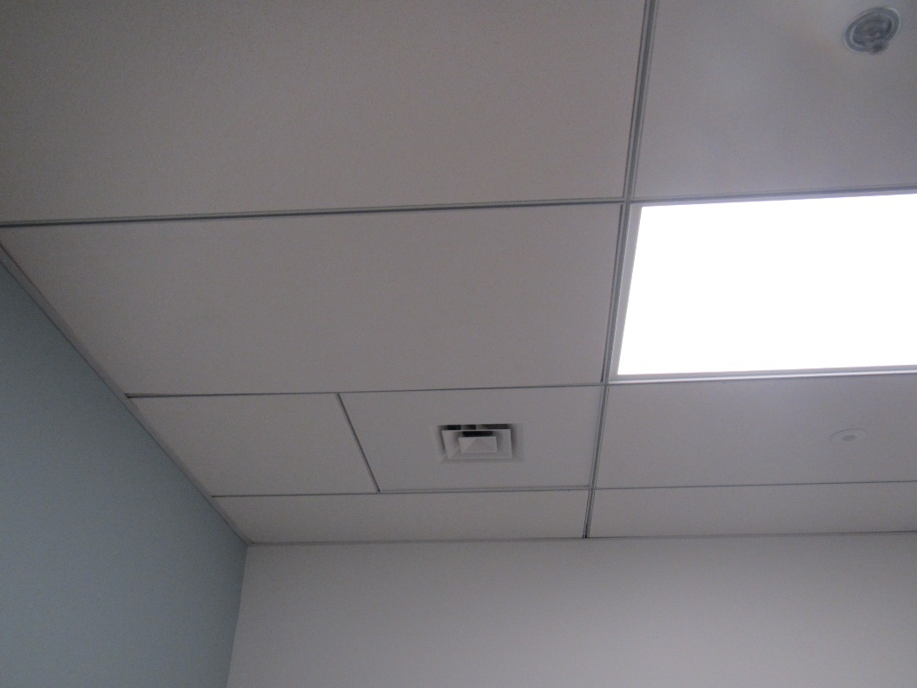
Typical supply vent
Picture 2
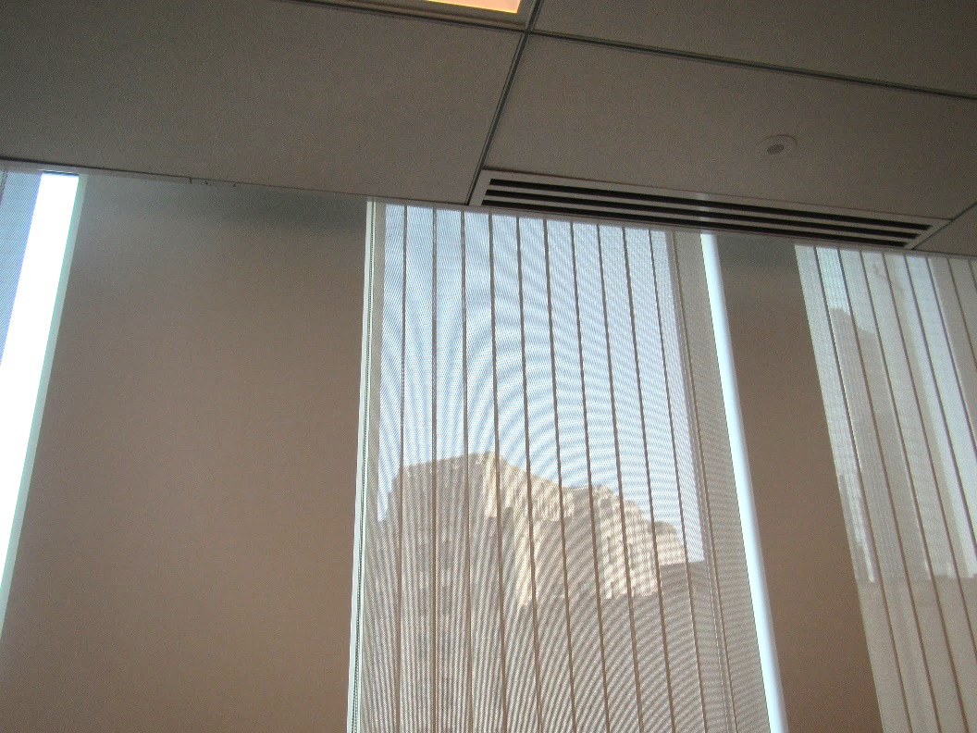
Another style of supply vent (arrow) and shades
Picture 3
One style of return vent
Picture 4
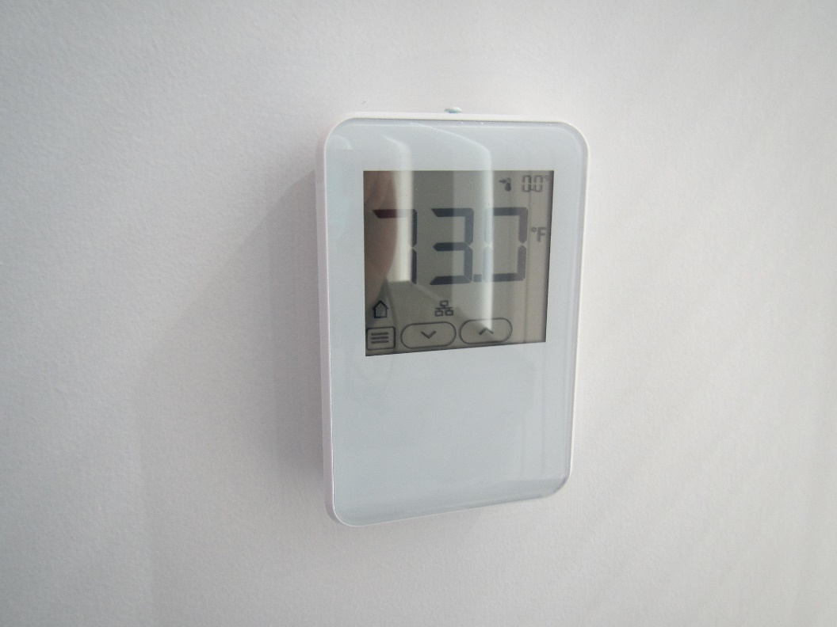
Thermostat
Picture 5
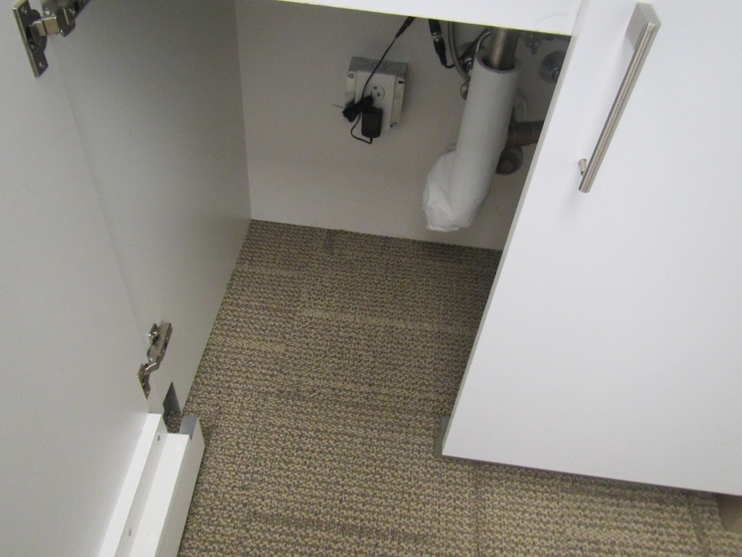
Carpeted area under sink in Wellness Room
Picture 6
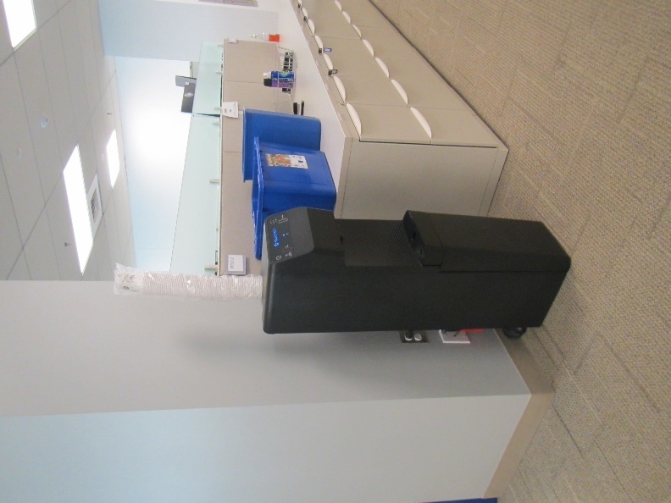
Water dispenser on carpet
Picture 7
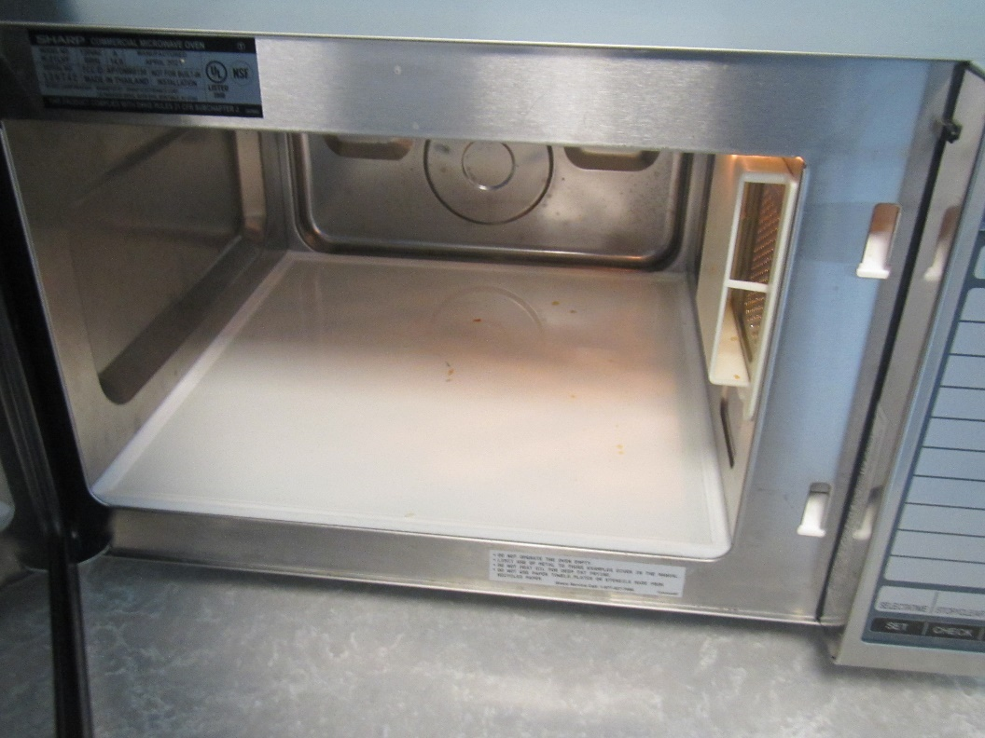
Food debris in a microwave
Picture 8
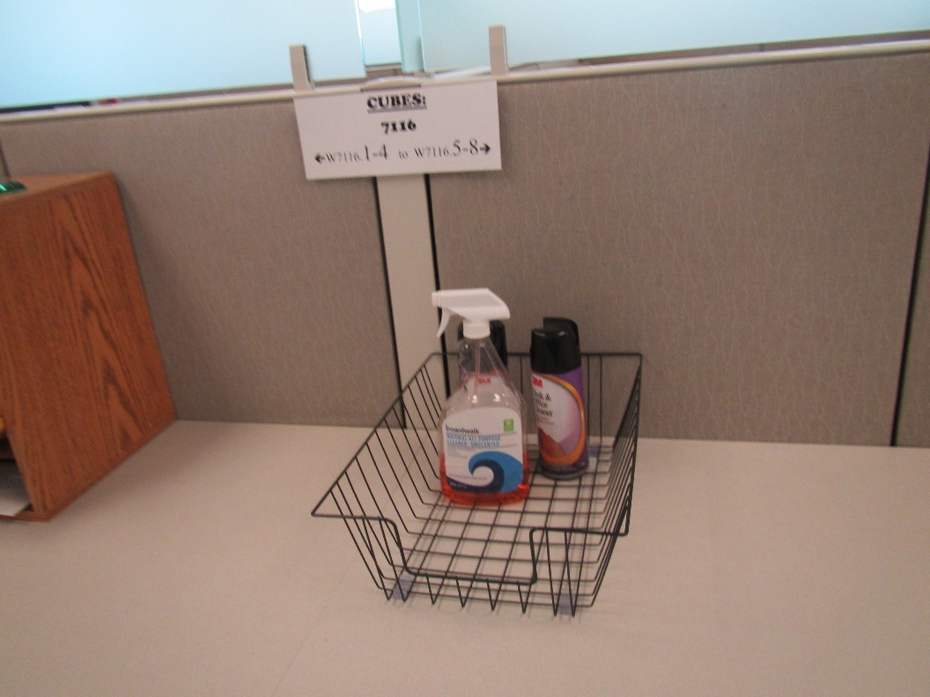
Cleaning products

Location | Carbon  Dioxide  (ppm) | Carbon Monoxide  (ppm) | Temp  (°F) | Relative  Humidity  (%) | PM2.5  (µg/m³) | Occupants  in Room | Windows  Openable | Ventilation |  | Remarks
 |  |  |  |  |  |  |  | Supply | Exhaust
Background | 404 | ND | 71 | 35 | 12 |  |  |  |  | Outside front of building, with traffic and pedestrians
7th floor
Main | 680 | ND | 75 | 32 | ND | 0 | N | Y | Y
7103 | 713 | ND | 74 | 31 | ND | 0 | N | Y | Y | Huddle room
7104 | 694 | ND | 74 | 32 | ND | 0 | N | Y | Y | Huddle room
Kitchen | 620 | ND | 75 | 31 | ND | 0 | N | Y | Y | Fridge, microwave, NC
7108 | 663 | ND | 74 | 31 | ND | 0 | N | Y | Y | Conference room, DEM
Locker area | 645 | ND | 74 | 32 | ND | 0 | N | Y | Y | CSC entrance
W7110 cubes | 652 | ND | 73 | 32 | ND | 3 | N | Y | Y | HS
7111 | 633 | ND | 73 | 33 | ND | 1 | N | Y | Y
7112 | 644 | ND | 73 | 33 | ND | 0 | N | Y | Y
7113 | 613 | ND | 73 | 33 | ND | 0 | N | Y | Y
W7115 cubes | 591 | ND | 73 | 33 | ND | 0 | N | Y | Y
W7116 cubes | 567 | ND | 73 | 32 | ND | 1 | N | Y | Y | Sunlight
W7121 cubes | 570 | ND | 73 | 32 | ND | 0 | N | Y | Y | CP
7122 | 588 | ND | 73 | 33 | ND | 1 | N | Y | Y
7117 | 589 | ND | 73 | 33 | ND | 0 | N | Y | Y | Food
7132 wellness | 645 | ND | 73 | 33 | ND | 0 | N | Y | Y | Sink and refrigerator. Carpet under sink
W7131 cubes | 649 | ND | 73 | 33 | ND | 0 | N | Y | Y
7130 | 632 | ND | 73 | 33 | ND | 1 | N | Y | Y
7129 | 630 | ND | 73 | 33 | ND | 0 | N | Y | Y
7128 | 632 | ND | 73 | 33 | ND | 0 | N | Y | Y
7127 | 618 | ND | 73 | 33 | ND | 0 | N | Y | Y
W7126 | 597 | ND | 73 | 33 | ND | 1 | N | Y | Y | Sunlight
7135 | 622 | ND | 73 | 33 | ND | 0 | N | Y | Y
7136 | 627 | ND | 73 | 33 | ND | 2 | N | Y | Y
7138 | 649 | ND | 73 | 33 | ND | 0 | N | Y | Y
7140 | 626 | ND | 73 | 33 | ND | 0 | N | Y | Y
7141 | 618 | ND | 73 | 33 | ND | 0 | N | Y | Y
W7142 cubes | 622 | ND | 73 | 33 | ND | 6 | N | Y | Y
7145 | 599 | ND | 73 | 33 | ND | 0 | N | Y | Y | Food
7146 | 591 | ND | 73 | 33 | ND | 0 | N | Y | Y
7147 | 629 | ND | 73 | 33 | ND | 0 | N | Y | Y
7149 | 614 | ND | 73 | 33 | ND | 0 | N | Y | Y | Lockers
7152 | 615 | ND | 73 | 33 | ND | 0 | N | Y | Y
W7155 | 614 | ND | 73 | 33 | ND | 1 | N | Y | Y
Copy/mail |  |  |  |  |  |  | N | Y | Y | no direct exhaust
7159 | 607 | ND | 73 | 33 | ND | 0 | N | Y | Y
7162 | 611 | ND | 73 | 33 | ND | 0 | N | Y | Y
W7164 cubes rear | 612 | ND | 73 | 33 | ND | 0 | N | Y | Y
W7164 cubes front | 647 | ND | 73 | 33 | ND | 2 | N | Y | Y
W7172 | 655 | ND | 73 | 33 | ND | 0 | N | Y | Y
W7167 | 658 | ND | 73 | 33 | ND | 3 | N | Y | Y
2nd floor
Public Waiting | 518 | ND | 72 | 33 | ND | 0 | N | Y | Y | NC
Reception | 525 | ND | 72 | 37 | ND | 0 | N | Y | Y | CP
Child support desk area | 507 | ND | 73 | 33 | ND | 1 | N | Y | Y | Water cooler and fridge on carpet
Hallway outside child support area | 485 | ND | 73 | 33 | ND | 0 | N | Y | Y | Fridge and microwave
Mezzanine
Mailroom | 506 | ND | 71 | 35 | ND | 2 | N | Y | Y | DEM, mail machines, open window to hallway
Mailroom rear room | 491 | ND | 71 | 34 | ND | 0 | N | Y | Y | CP

