INDOOR AIR QUALITY ASSESSMENT

Department of Revenue
67 Millbrook Street
Worcester, MA

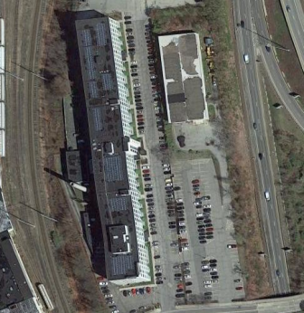

Prepared by:
Massachusetts Department of Public Health
Bureau of Environmental Health
Indoor Air Quality Program
December 2016

Background
Building: | Department of Revenue (DOR)
Address: | 67 Millbrook Street, Worcester, MA
Assessment Requested by: | Joshua Martin, Deputy Director, Office of Facilities Management, Massachusetts DOR
Reason for Request: | Lease renewal indoor air quality (IAQ) status report
Date of Assessment: | November 15, 2016
Massachusetts Department of Public Health/Bureau of Environmental Health (MDPH/BEH) Staff Conducting Assessment: | Ruth Alfasso, Environmental Engineer/Inspector, IAQ Program
Building Description: | These offices are located in the Worcester Business Center, a five-story office building that was originally constructed as a mill in 1917, repurposed as the headquarters for a shoe-manufactory in 1965, and remodeled into general office space in 2008.
Building Population: | Approximately 130 employees in three suites on the third floor.
Windows: | Not openable

Methods
Please refer to the IAQ Manual for methods, sampling procedures, and interpretation of results (MDPH, 2015).

IAQ Testing Results
The following is a summary of indoor air testing results (Table 1).
- Carbon dioxide levels were below 800 parts per million (ppm) in all areas assessed, indicating adequate fresh air in the space.
- Temperature was within the recommended range of 70°F to 78°F in all areas assessed.
- Relative humidity was below the recommended range of 40% to 60% in all areas assessed.
- Carbon monoxide levels were non-detectable in all indoor areas assessed.
- Fine particulate matter (PM2.5) concentrations measured were below the National Ambient Air Quality Standard (NAAQS) level of 35 μg/m³ in all areas assessed.

Ventilation
A heating, ventilating, and air conditioning (HVAC) system has several functions. First, it provides heating and, if equipped, cooling. Second, it is a source of fresh air. Finally, an HVAC system will dilute and remove normally occurring indoor environmental pollutants by not only introducing fresh air, but also filtering the airstream and ejecting stale air to the outdoors via exhaust ventilation. Even if an HVAC system is operating as designed, point sources of respiratory irritation may exist and affect symptoms in sensitive individuals. The following analysis examines and identifies components of the HVAC system and likely sources of respiratory irritant/allergen exposure due to water damage, aerosolized dust, and/or chemicals found in the indoor environment.
Fresh air is provided by air handling units (AHUs). Air from the AHUs is filtered, heated/cooled, and delivered to rooms via ducted supply vents (Picture 1). Air is returned/exhausted through vents in the walls or ceiling (Pictures 2 and 3).
The assessment results indicate that the ventilation system is providing adequate fresh air for the occupancy in the building. In some areas assessed, the thermostats were observed to be set to the “fan auto” setting, which does not provide a continuous source of fresh air; the “fan on” setting is preferred in occupied areas.
In the conference room, carbon dioxide sensors were located next to the thermostats to direct the ventilation system to provide more fresh air during periods of high occupancy. These should be calibrated or replaced in accordance with manufacturer’s recommendations.
In one of the unoccupied sections, the supply vent velocity was high enough to blow the blinds around which may be uncomfortable if/when the area is occupied again. It is recommended that HVAC systems be re-balanced every five years to ensure adequate air systems function (SMACNA, 1994).

Microbial/Moisture Concerns
Plants were observed in office areas (Table 1; Pictures 4 and 5). Plants can be a source of pollen and mold, which can be respiratory irritants to some individuals. Plants should be properly maintained and equipped with drip pans to prevent water damage to porous materials. Plants should also be located away from air diffusers to prevent the aerosolization of dirt, pollen, and mold.
Small refrigerators and water dispensers were observed in carpeted areas (Pictures 6 and 7). These appliances may spill or leak and lead to carpet damage and microbial growth; Picture 7 shows stained carpeting next to a refrigerator. It is recommended that these appliances be located in areas without carpeting or on waterproof mats. Carpet squares could also be replaced with tile in areas where water dispensers and refrigerators are located. Some of the refrigerators were crowded with items or had evidence of spills (Picture 8). Refrigerators should be kept clean to prevent odors and microbial growth.
A ductless air conditioning unit was observed in the computer training room (Picture 9). The condensate pump and piping that connect this unit with a drain should be inspected periodically for clogs and leaks to prevent water damage to nearby building materials.

Other IAQ Evaluations
Exposure to low levels of total volatile organic compounds (TVOCs) may produce eye, nose, throat, and/or respiratory irritation in some sensitive individuals. To determine if VOCs were present, BEH/IAQ staff examined rooms for products containing VOCs. BEH/IAQ staff noted hand sanitizers, cleaners, scented candles, and dry erase materials in use within the building (Pictures 10 and 11; Table 1). All of these products have the potential to be irritants to the eyes, nose, throat, and respiratory system of sensitive individuals.
Peeling paint was observed on ceiling beams in a few areas (Picture 12). This can create irritating dust and it is unknown if the paint may contain lead.
Cooking equipment, including toasters, microwave ovens and coffee machines were located in various parts of the office space (Picture 13). The presence of so many different pieces of cooking equipment near workstations and without direct exhaust ventilation increases the chance of food odors permeating office areas. Food areas and cooking equipment need to be kept clean to prevent odors and pests. Carpeting in these areas may trap crumbs and spills as well. Consider consolidating cooking areas into unoccupied and uncarpeted areas or protect the carpeting in these areas with a mat.
The offices were mostly carpeted. Carpets should be cleaned annually (or semi-annually in soiled/high traffic areas) in accordance with Institute of Inspection, Cleaning and Restoration Certification (IICRC) recommendations, (IICRC, 2012).
In some areas, stored materials and accumulated items make it more difficult for custodial staff to clean. Items should be stored neatly and moved periodically to allow for wet wiping and vacuuming of surfaces
Personal fans were observed in a number of areas. Fan blades to some of these units had settled dust, which can be reaerosolized when the fan is activated. Some supply and exhaust vents were also dusty (e.g., Picture 3). It was reported that cleaning of carpeting and vents was scheduled for shortly after this visit.

Conclusions/Recommendations
Based on observations at the time of assessment, the following is recommended:
- Operate supply and exhaust ventilation in all areas during occupied periods.
- Have the carbon dioxide sensors in conference rooms recalibrated or replaced in accordance with manufacturer’s recommendations.
- Check the supply vent velocity in unoccupied areas before they are to be occupied.
- Have the HVAC system balanced every 5 years in accordance with SMACNA recommendations (SMACNA, 1994).
- Keep indoor plants in good condition, avoid overwatering, and avoid placing them on porous items such as carpets or paper. Also, keep plants out of the air stream of supply vents.
- Consider locating refrigerators and water dispensers in non-carpeted areas or place on a waterproof mat.
- Clean refrigerator spills promptly and clean refrigerators out regularly to avoid odors and microbial growth.
- Inspect condensate pumps and piping for ductless air-conditioning units regularly.
- Have the peeling paint on the ceiling beams repaired.
- Ensure cooking areas/equipment are kept clean to prevent odors and pests. Consider reducing the number of areas where food is stored and locating them away from occupied areas.
- For buildings in New England, periods of low relative humidity during the winter are often unavoidable. Therefore, scrupulous cleaning practices should be adopted to minimize common indoor air contaminants whose irritant effects can be enhanced when the relative humidity is low. To control for dusts, a high efficiency particulate arrestance (HEPA) filter equipped vacuum cleaner in conjunction with wet wiping of all surfaces is recommended. Avoid the use of feather dusters. Drinking water during the day can help ease some symptoms associated with a dry environment (throat and sinus irritations).
- Change filters on AHUs on a regular schedule at least twice a year.
- Clean carpeting in accordance with IICRC recommendations (IICRC, 2012).
- Reduce accumulated materials on flat surfaces and store in an organized manner to allow for thorough cleaning.
- Clean the blades of personal fans, supply, and exhaust vents periodically to avoid aerosolizing dusts.
- Refer to resource manual and other related IAQ documents located on the MDPH’s website for further building-wide evaluations and advice on maintaining public buildings. These documents are available at: http://mass.gov/dph/iaq.

References
IICRC. 2012. Institute of Inspection, Cleaning and Restoration Certification. Carpet Cleaning: FAQ. Retrieved from http://www.iicrc.org/consumers/care/carpet-cleaning.
MDPH. 2015. Massachusetts Department of Public Health. Indoor Air Quality Manual: Chapters I-III. Available at: http://www.mass.gov/eohhs/gov/departments/dph/programs/environmental-health/exposure-topics/iaq/iaq-manual/.
SMACNA. 1994. HVAC Systems Commissioning Manual. 1st ed. Sheet Metal and Air Conditioning Contractors’ National Association, Inc., Chantilly, VA.
Picture 1
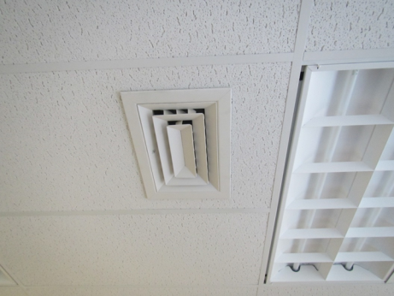
Supply vent
Picture 2
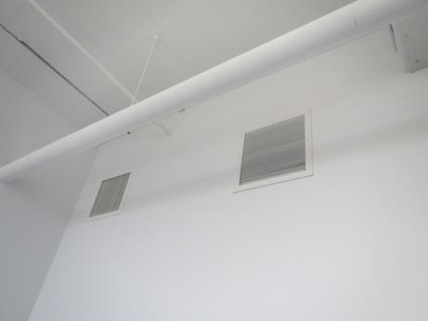
Wall-mounted exhaust vents in Local Services suite
Picture 3
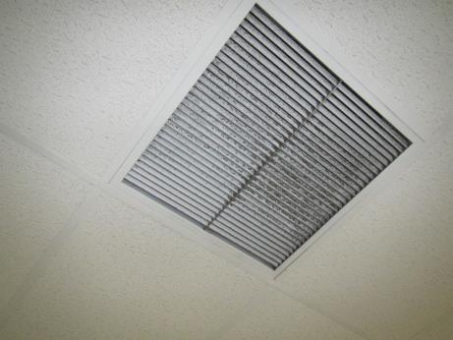
Ceiling-mounted exhaust vent in Child Support suite, note dust
Picture 4
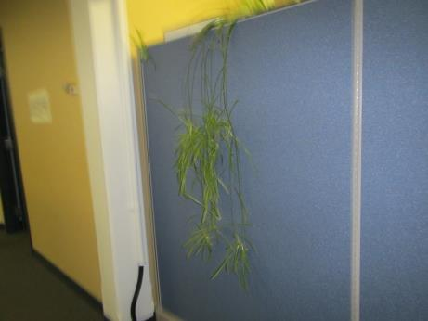
Plant overhanging cloth divider
Picture 5
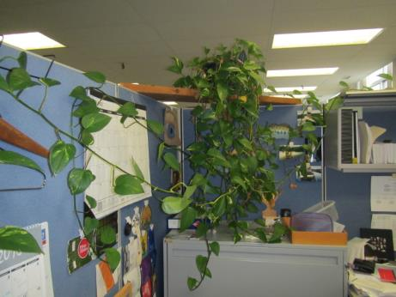
Plants in a cubicle
Picture 6
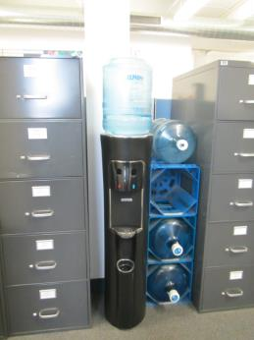
Water dispenser on carpet
Picture 7
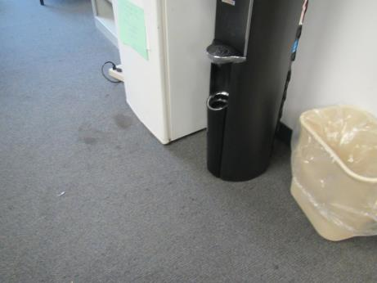
Refrigerator and water dispenser next to stained carpeting
Picture 8
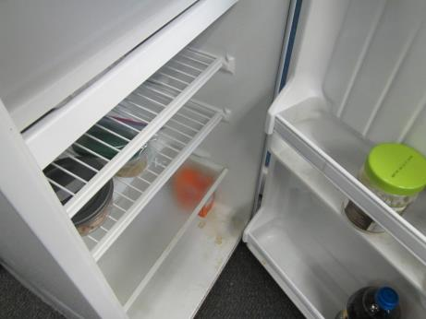
Refrigerator with evidence of spill on bottom shelf
Picture 9
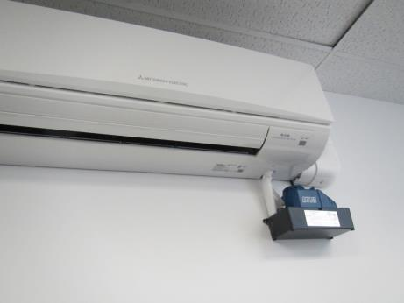
Ductless air-conditioning unit in computer training room
Picture 10
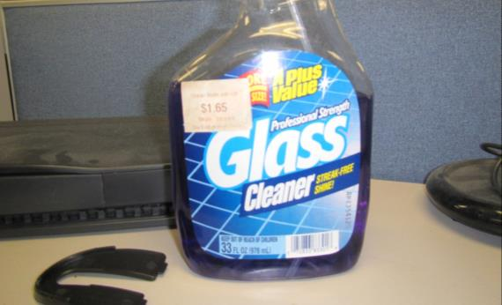
Cleaning product in an office
Picture 11
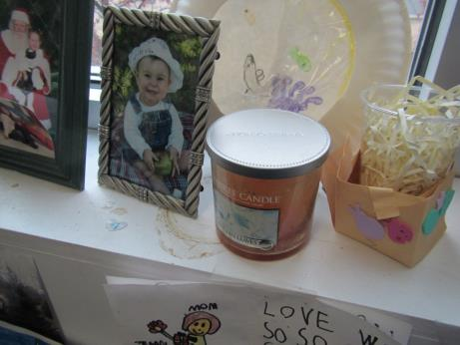
Scented candle
Picture 12
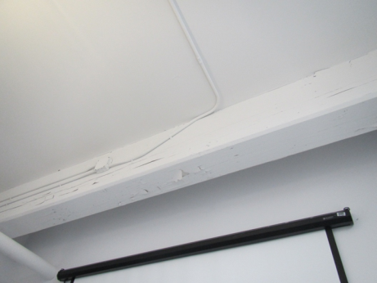
Peeling paint on a ceiling beam
Picture 13
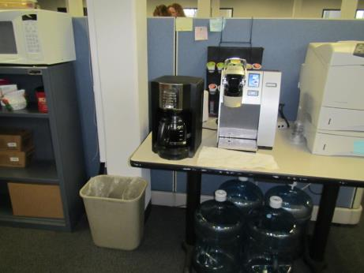
Coffee station and microwave oven

Location | Carbon  Dioxide  (ppm) | Carbon Monoxide  (ppm) | Temp  (°F) | Relative  Humidity  (%) | PM2.5  (µg/m³) | Occupants  in Room | Windows  Openable | Ventilation |  | Remarks
 |  |  |  |  |  |  |  | Supply | Exhaust
Background | 371 | 0.7 | 55 | 32 | 17 |  |  |  |  | Cool, cloudy
Local services
Waiting | 545 | ND | 71 | 25 | 10 | 1 | N | Y | Y | PF, HS
Kitchen area/storage | 516 | ND | 72 | 24 | 9 | 0 | N | N | Y | DO, PF, NC, fridge and microwave, fridge with spill inside
Office | 564 | ND | 72 | 24 | 9 | 0 | N | Y | Y | Peeling paint from ceiling beam, stand fan
Creen (cubes) | 530 | ND | 73 | 24 | 10 | 1 | N | Y | Y | WC on carpet, peeling paint on ceiling beam, paper on windowsill
Silvia (cubes) | 518 | ND | 73 | 23 | 9 | 0 | N | Y | Y | Items on windowsill
Morgan (cubes) | 505 | ND | 73 | 23 | 9 | 0 | N | Y | Y
Bliss (office) | 529 | ND | 73 | 23 | 9 | 0 | N | N | Y | DO
Photocopier area | 505 | ND | 73 | 22 | 10 | 0 | N | Y | Y | PC and printer
Paquette (cubes) | 517 | ND | 73 | 23 | 9 | 3 | N | Y | Y
Tax Offices
Waiting | 527 | ND | 74 | 21 | 8 | 0 | N | Y | Y
Vacant suite, area 1 (cubes) | 454 | ND | 73 | 20 | 10 | 0 | N | Y | Y | Peeling paint on ceiling beams, WD windowsill, stand fan
Vacation suite, area 2 (cubes) | 481 | ND | 73 | 21 | 10 | 0 | N | Y | Y | Water cooler on carpet
Casper (cubes) | 465 | ND | 73 | 21 | 10 | 0 | N | Y | Y
Donahue (cubes) | 453 | ND | 73 | 21 | 10 | 0 | N | Y | Y | HS, PF
Small conference room | 499 | ND | 73 | 21 | 9 | 0 | N | Y | Y
Pignatio (cubes) | 505 | ND | 73 | 22 | 9 | 3 | N | Y | Y | PF, fridge on carpet
Adamek (cubes) | 527 | ND | 73 | 22 | 9 | 0 | N | Y | Y | Plants
Chamboleir (cubes) | 507 | ND | 73 | 21 | 9 | 1 | N | Y | Y | Many plants, fridge on carpet
Berthiaume (cubes) | 552 | ND | 73 | 22 | 9 | 1 | N | Y | Y | PF, CP, food, fridge on carpet
Bartziewcz (cubes) | 573 | ND | 73 | 21 | 8 | 0 | N | Y | Y
Masiello (cubes) | 606 | ND | 73 | 22 | 13 | 1 | N | Y | Y
Rota (cubes) | 605 | ND | 73 | 22 | 7 | 1 | N | Y | Y
Epstein (cubes) | 531 | ND | 73 | 21 | 9 | 0 | N | Y | Y
McAuliffe (cubes) | 535 | ND | 73 | 21 | 9 | 0 | N | Y | Y
Teilor (cubes) | 535 | ND | 74 | 21 | 8 | 1 | N | Y | Y
Pollard (cubes) | 569 | ND | 74 | 22 | 9 | 3 | N | Y | Y | Fridge on carpet, fridge needs cleaning
Cavelle (cubes) | 479 | ND | 74 | 20 | 7 | 0 | N | Y | Y
Conference | 477 | ND | 73 | 20 | 7 | 0 | N | Y | Y
Office | 496 | ND | 73 | 21 | 7 | 3 | N | Y | N | DO, wrinkled carpet
Child Support office
Empty cube area 1 | 463 | ND | 73 | 21 | 11 | 0 | N | Y | Y | Vent against windows on very high velocity
Empty cube area 2 | 432 | ND | 71 | 20 | 7 | 0 | N | Y | Y
Big conference room | 540 | ND | 72 | 22 | 11 | 0 | N | Y | Y | Carbon dioxide monitor
Computer training | 495 | ND | 73 | 21 | 2 | 0 | N | Y | Y | Ductless AC unit, ajar tile, DEM, 15 computers
Office next to computer training | 475 | ND | 72 | 21 | 11 | 0 | N | Y | Y | DO
Arguijo (cubes) | 516 | ND | 71 | 21 | 10 | 1 | N | Y | Y | Plants
Interview A | 553 | ND | 72 | 21 | 10 | 0 | N | N | N | HS
Interview B | 471 | ND | 71 | 21 | 11 | 0 | N | Y | N | HS
Snyder | 468 | ND | 71 | 21 | 10 | 0 | N | Y | Y | Items, stained carpet, water cooler on carpet
Reception (inside) | 550 | ND | 72 | 21 | 10 | 2 | N | Y | Y
Procipio | 490 | ND | 72 | 21 | 10 | 1 | N | Y | Y | Mechanical room next to this area, door ajar and vent (return). Fridge and microwave
Waiting room | 544 | ND | 73 | 21 | 11 | 1 | N | Y | Y | Elevator area
Office | 493 | ND | 73 | 21 | 12 | 0 | N | Y | Y | Fridge and microwave
Piclett (cubes) | 560 | ND | 73 | 22 | 10 | 1 | N | Y | Y | AI/paper on floor, fridge on carpet
Dirlinge (cubes) | 664 | ND | 73 | 23 | 9 | 1 | N | Y | Y | DO, plants, coffee
Ruggieri (cubes) | 701 | ND | 74 | 22 | 9 | 1 | N | Y | Y
Brent (office) | 680 | ND | 74 | 22 | 10 | 1 | N | Y | Y | Plants, CP
Quinn (office) | 716 | ND | 74 | 22 | 9 | 1 | N | Y | Y | Items on windowsill, scented candle
Eaton (cubes) | 657 | ND | 74 | 21 | 9 | 0 | N | Y | Y | DEM, food, plant
McCann (cubes) | 652 | ND | 74 | 21 | 9 | 2 | N | Y | Y | Plant
Hughes (cubes) | 638 | ND | 75 | 21 | 9 | 3 | N | Y | Y | Items on walls, DEM
Colon (cubes) | 622 | ND | 75 | 21 | 9 | 3 | N | Y | Y | Plants
Maher (cubes) | 601 | ND | 74 | 20 | 9 | 1 | N | Y | Y | Plants
Anderson (cubes) | 601 | ND | 75 | 21 | 9 | 1 | N | Y | Y | Plants
Corbett (cubes) | 604 | ND | 74 | 20 | 8 | 1 | N | Y | Y
McDonald (cubes) | 564 | ND | 74 | 20 | 8 | 0 | N | Y | Y | Fan “auto”
Matthews (cubes) | 610 | ND | 74 | 21 | 9 | 0 | N | Y | Y | Many plants
Burns (cubes) | 601 | ND | 74 | 21 | 8 | 1 | N | Y | Y | Plants, coffee
Whitney (cubes) | 621 | ND | 74 | 21 | 9 | 1 | N | Y | Y
Stonette (cubes) | 626 | ND | 74 | 21 | 9 | 0 | N | Y | Y | Storage

