INDOOR AIR QUALITY ASSESSMENT

Department of Revenue
436 Dwight Street (State Office Building)
Springfield, MA

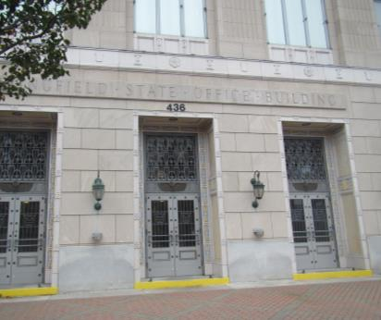

Prepared by:
Massachusetts Department of Public Health
Bureau of Environmental Health
Indoor Air Quality Program
November 2016

Background
Building: | Department of Revenue (DOR)
Address: | 436 Dwight Street, Springfield, MA
Assessment Requested by: | Joshua Martin, Deputy Director, Office of Facilities Management, Massachusetts DOR
Reason for Request: | Lease renewal indoor air quality (IAQ) status report
Date of Assessment: | October 27, 2016
Massachusetts Department of Public Health/Bureau of Environmental Health (MDPH/BEH) Staff Conducting Assessment: | Ruth Alfasso, Environmental Engineer/Inspector, IAQ Program
Building Description: | Four-story granite-faced building built in 1931. DOR offices occupy the third floor with one occupied suite on the fourth floor. The building has several other state office tenants.
Building Population: | Approximately 60 employees over the two floors
Windows: | Not openable

Methods
Please refer to the IAQ Manual for methods, sampling procedures, and interpretation of results (MDPH, 2015).

IAQ Testing Results
The following is a summary of indoor air testing results (Table 1).
- Carbon dioxide levels were below 800 parts per million (ppm) in all areas assessed, indicating adequate fresh air in the space.
- Temperature was within the recommended range of 70°F to 78°F in all areas assessed.
- Relative humidity was below the recommended range of 40% to 60% in all areas assessed.
- Carbon monoxide levels were non-detectable in all indoor areas assessed.
- Fine particulate matter (PM2.5) concentrations measured were below the National Ambient Air Quality Standard (NAAQS) level of 35 μg/m³ in all areas assessed.

Ventilation
A heating, ventilating, and air conditioning (HVAC) system has several functions. First, it provides heating and, if equipped, cooling. Second, it is a source of fresh air. Finally, an HVAC system will dilute and remove normally occurring indoor environmental pollutants by not only introducing fresh air, but also filtering the airstream and ejecting stale air to the outdoors via exhaust ventilation. Even if an HVAC system is operating as designed, point sources of respiratory irritation may exist and affect symptoms in sensitive individuals. The following analysis examines and identifies components of the HVAC system and likely sources of respiratory irritant/allergen exposure due to water damage, aerosolized dust, and/or chemicals found in the indoor environment.
Fresh air is provided by air handling units (AHUs) located on the roof. Air from the AHUs is filtered, heated/cooled, and delivered to rooms via ducted supply vents (Picture 1). Air is returned/exhausted through vents in the ceiling (Picture 2).
The assessment results indicate that the ventilation system is providing adequate fresh air for the occupancy in the building. It is recommended that HVAC systems be re-balanced every five years to ensure adequate air systems function (SMACNA, 1994). It is unknown when the last time this system was balanced. However, it was reported that components of the HVAC system had recently been replaced as a part of a series of building upgrades.

Microbial/Moisture Concerns
A few water-damaged ceiling tiles were observed on the 4th floor (Picture 3). The conditions causing the leak (e.g., roof leaks) should be fixed, and the tiles should be replaced.
Plants were observed in office areas (Table 1; Pictures 4 and 5). Plants can be a source of pollen and mold, which can be respiratory irritants to some individuals. Plants should be properly maintained and equipped with drip pans to prevent water damage to porous materials. Plants should also be located away from air diffusers to prevent the aerosolization of dirt, pollen, and mold.
Small refrigerators and water dispensers were observed in carpeted areas (Pictures 6 and 7). These appliances may spill or leak and lead to carpet damage and microbial growth. It is recommended that these appliances be located in areas without carpeting or on waterproof mats. Carpet squares could also be replaced with tile in areas where water dispensers and refrigerators are located. Some of the refrigerators were crowded with items or had evidence of spills/crumbs. Refrigerators should be kept clean to prevent odors and microbial growth.

Other IAQ Evaluations
Exposure to low levels of total volatile organic compounds (TVOCs) may produce eye, nose, throat, and/or respiratory irritation in some sensitive individuals. To determine if VOCs were present, BEH/IAQ staff examined rooms for products containing VOCs. BEH/IAQ staff noted hand sanitizers, cleaners, and dry erase materials in use within the building (Picture 8; Table 1). All of these products have the potential to be irritants to the eyes, nose, throat, and respiratory system of sensitive individuals. Photocopiers were also located next to occupied cubes; when heavily used, photocopiers can emit ozone, which is a respiratory irritant, and may also emit particulates and odors.
Cooking equipment, including toasters, microwave ovens and coffee machines were located in various parts of the office space (Pictures 8 and 9). The presence of so many different pieces of cooking equipment near workstations and without direct exhaust ventilation increases the chance of food odors permeating office areas. Food areas and cooking equipment need to be kept clean to prevent odors and pests. Carpeting in these areas may trap crumbs and spills as well. Consider consolidating cooking areas into unoccupied and uncarpeted areas or protect the carpeting in these areas with a mat.
The offices were mostly carpeted. Carpets should be cleaned annually (or semi-annually in soiled/high traffic areas) in accordance with Institute of Inspection, Cleaning and Restoration Certification (IICRC) recommendations, (IICRC, 2012).
In some areas, stored materials and accumulated items make it more difficult for custodial staff to clean. Items should be stored neatly and moved periodically to allow for wet wiping and vacuuming of surfaces. In some places, workstation walls were set up against the original exterior or interior walls of the building, leaving narrow gaps. These areas can catch dirt and debris and become a source of odors, and harborage for pests. Ensure that these areas are cleaned regularly.
Personal fans were observed in a number of areas. Fan blades to some of these units had settled dust, which can be reaerosolized when the fan is activated.
Some of the supply vents were observed to be set in ajar ceiling tiles (Picture 10). This may indicate that the tiles are not quite cut to fit around them properly, or that the plenum is pressurized. Missing and ajar tiles were observed in a few other areas as well (Picture 11). These conditions can lead to debris from the plenum space entering into occupied areas.

Conclusions/Recommendations
Based on observations at the time of assessment, the following is recommended:
- Operate supply and exhaust ventilation in all areas during occupied periods.
- Have the HVAC system balanced every 5 years in accordance with SMACNA recommendations (SMACNA, 1994).
- Repair conditions leading to water-damaged ceiling tiles, and replace the tiles.
- Keep indoor plants in good condition, avoid overwatering, and avoid placing them on porous items such as carpets or paper. Also, keep plants out of the air stream of supply vents.
- Consider locating refrigerators and water dispensers in non-carpeted areas or place on a waterproof mat.
- Clean refrigerator spills promptly and clean refrigerators out regularly to avoid odors and microbial growth.
- Ensure cooking areas/equipment are kept clean to prevent odors and pests. Consider reducing the number of areas where food is stored and locating them away from occupied areas.
- For buildings in New England, periods of low relative humidity during the winter are often unavoidable. Therefore, scrupulous cleaning practices should be adopted to minimize common indoor air contaminants whose irritant effects can be enhanced when the relative humidity is low. To control for dusts, a high efficiency particulate arrestance (HEPA) filter equipped vacuum cleaner in conjunction with wet wiping of all surfaces is recommended. Avoid the use of feather dusters. Drinking water during the day can help ease some symptoms associated with a dry environment (throat and sinus irritations).
- Change filters on AHUs on a regular schedule at least twice a year.
- Consider moving photocopiers, particularly those that are heavily used, away from occupied areas.
- Clean carpeting in accordance with IICRC recommendations (IICRC, 2012).
- Ensure hidden areas between workstations and walls get cleaned regularly.
- Reduce accumulated materials on flat surfaces and store in an organized manner to allow for thorough cleaning.
- Clean the blades of personal fans periodically to avoid aerosolizing dusts.
- Ensure missing ceiling tiles are replaced and that all tiles fit snugly into the ceiling tile system to prevent debris from the plenum from entering occupied areas.
- Refer to resource manual and other related IAQ documents located on the MDPH’s website for further building-wide evaluations and advice on maintaining public buildings. These documents are available at: http://mass.gov/dph/iaq.

References
IICRC. 2012. Institute of Inspection, Cleaning and Restoration Certification. Carpet Cleaning: FAQ. Retrieved from http://www.iicrc.org/consumers/care/carpet-cleaning.
MDPH. 2015. Massachusetts Department of Public Health. Indoor Air Quality Manual: Chapters I-III. Available at: http://www.mass.gov/eohhs/gov/departments/dph/programs/environmental-health/exposure-topics/iaq/iaq-manual/.
SMACNA. 1994. HVAC Systems Commissioning Manual. 1st ed. Sheet Metal and Air Conditioning Contractors’ National Association, Inc., Chantilly, VA.
Picture 1
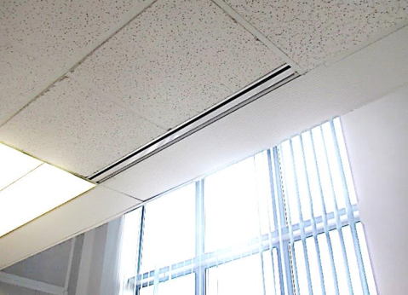
Vent for supply air
Picture 2
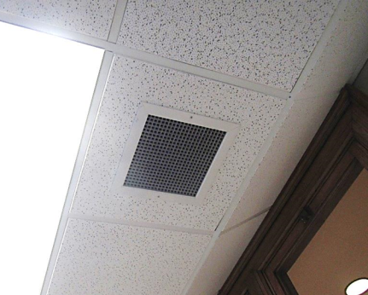
Typical exhaust vent
Picture 3
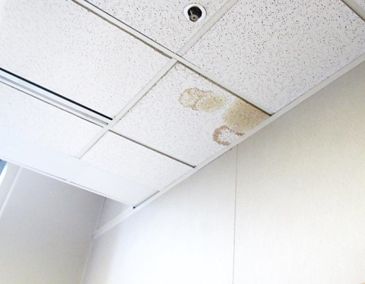
Water-damaged ceiling tiles
Picture 4
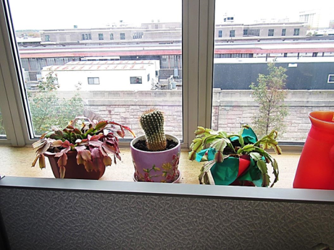
Plants on a windowsill
Picture 5
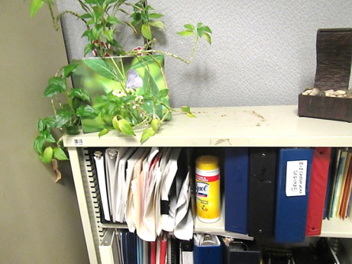
Plant on a bookshelf, note water stains
Picture 6
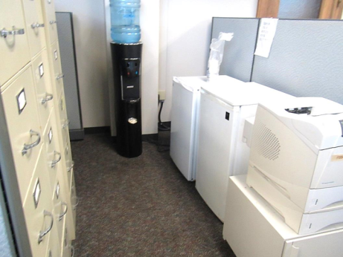
Water dispenser and two refrigerators on carpet
Picture 7
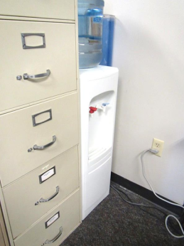
Water-dispenser on carpet in hard-to-reach area
Picture 8
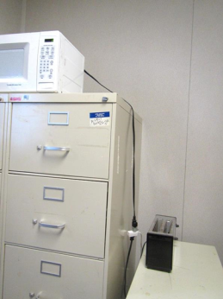
Microwave and toaster on top of office furniture
Picture 9
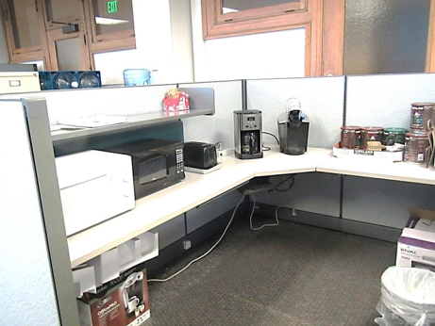
Cooking equipment in office area
Picture 10
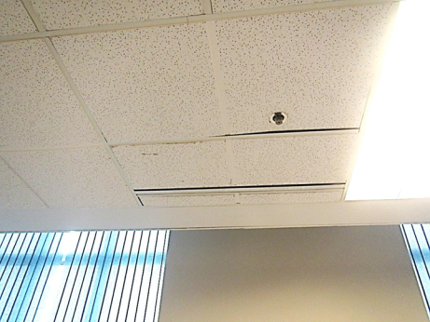
Ajar tile next to vent
Picture 11
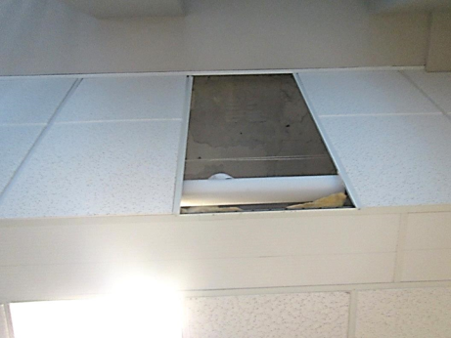
Missing ceiling tile (on side along windows)

Location | Carbon  Dioxide  (ppm) | Carbon Monoxide  (ppm) | Temp  (°F) | Relative  Humidity  (%) | PM2.5  (µg/m³) | Occupants  in Room | Windows  Openable | Ventilation |  | Remarks
 |  |  |  |  |  |  |  | Supply | Exhaust
Background | 385 | ND | 47 | 30 | 10 |  |  |  |  | Cold, cloudy, and windy
3rd floor
Mogelinski | 513 | ND | 72 | 23 | 4 | 0 | N | Y | Y | HS, items
Patel | 555 | ND | 73 | 23 | 5 | 0 | N | Y | Y
Kras | 546 | ND | 74 | 22 | 4 | 1 | N | Y | Y | WC on carpet
Slingerland | 733 | ND | 75 | 22 | 5 | 1 | N | Y | Y | CP, plants
Perry | 543 | ND | 75 | 20 | 5 | 0 | N | Y | Y | PF, CP
Tall cube | 535 | ND | 75 | 19 | 6 | 1 | N | Y | Y
St. Onge | 523 | ND | 75 | 20 | 5 | 1 | N | Y | Y
Storage | 598 | ND | 75 | 19 | 6 | 0 | N | Y | Y | Toaster
#33 | 578 | ND | 74 | 19 | 5 | 1 | N | Y | Y
cube next to #33 | 538 | ND | 75 | 20 | 5 | 1 | N | Y | Y | Cut flowers
Lorenzi | 538 | ND | 75 | 19 | 5 | 1 | N | Y | Y | HS
Vacant cube | 547 | ND | 74 | 19 | 5 | 0 | N | Y | Y | WC on carpet
Dastous | 527 | ND | 75 | 19 | 5 | 0 | N | Y | Y | DO, food
Collier | 601 | ND | 74 | 19 | 5 | 2 | N | Y | Y | Food odors
Halket | 600 | ND | 74 | 19 | 5 | 1 | N | Y | Y
Kawa | 544 | ND | 74 | 19 | 5 | 0 | N | Y | Y | CP
Cummings | 493 | ND | 74 | 19 | 5 | 1 | N | Y | Y | Food
Kulig | 495 | ND | 74 | 19 | 5 | 2 | N | Y | Y
Anderson | 491 | ND | 74 | 19 | 5 | 2 | N | Y | Y | Plants, food, CP
Bryant | 572 | ND | 74 | 19 | 5 | 2 | N | Y | Y | Plants, PF
Bush | 628 | ND | 74 | 20 | 5 | 1 | N | Y | Y | AT, CP
Thole | 589 | ND | 75 | 20 | 6 | 1 | N | Y | Y | Plants, AI, dusty PF
Jajko | 644 | ND | 74 | 19 | 5 | 1 | N | Y | Y
Maende | 560 | ND | 75 | 20 | 6 | 2 | N | Y | Y | Food, coffee, plants
Mulano | 531 | ND | 75 | 20 | 5 | 1 | N | Y | Y | Refrigerator on carpet, WC on carpet
Iovine | 617 | ND | 74 | 18 | 6 | 1 | N | Y | Y | Plant
Merrill | 543 | ND | 74 | 19 | 6 | 2 | N | Y | Y | Plants, items
Nicklaw | 532 | ND | 74 | 19 | 6 | 1 | N | Y | Y | Plant
Anzalotti | 431 | ND | 73 | 19 | 6 | 0 | N | Y | Y | Plant
Nowicki | 461 | ND | 73 | 19 | 6 | 0 | N | Y | Y | MT above window
Dietrich | 537 | ND | 73 | 20 | 6 | 1 | N | Y | Y | WC and fridge on carpet
Burns | 468 | ND | 73 | 20 | 6 | 1 | N | Y | Y | Plants
4th floor suite
Reception | 741 | ND | 73 | 21 | 6 | 0 | N | Y | Y
Conference | 700 | ND | 73 | 21 | 6 | 6 | N | Y | Y | WD CT
Andre | 600 | ND | 72 | 20 | 6 | 0 | N | Y | Y
William |  | ND | 72 | 23 | 6 | 1 | N | Y | Y | Papers/items
Wayne | 565 | ND | 72 | 19 | 6 | 0 | N | Y | Y
Bliss | 561 | ND | 72 | 20 | 6 | 1 | N | Y | Y | DO, coffee
Barbieri | 558 | ND | 71 | 20 | 7 | 0 | N | Y | Y | Items on floor
Tod | 451 | ND | 71 | 20 | 6 | 1 | N | Y | Y | PF
Storage/food | 507 | ND | 71 | 20 | 8 | 0 | N | Y | Y | WC on carpet, microwave, toaster
Unused 4th floor space next to occupied suite | 411 | ND | 71 | 20 | 6 | 0 | N | Y | Y | MT

