INDOOR AIR QUALITY ASSESSMENT

Department of Revenue
100 Trade Center Drive
Suite 760
Woburn, MA

Prepared by:
Massachusetts Department of Public Health
Bureau of Environmental Health
Indoor Air Quality Program
September 2016

Background
Building: | Department of Revenue (DOR)
Address: | 100 Trade Center Drive (Suite 760), Woburn, MA
Assessment Requested by: | Joshua Martin, Deputy Director, Office of Facilities Management, Massachusetts DOR
Reason for Request: | Lease renewal IAQ status report
Date of Assessment: | September 9, 2016
Massachusetts Department of Public Health/Bureau of Environmental Health (MDPH/BEH) Staff Conducting Assessment: | Ruth Alfasso, Environmental Engineer/Inspector, IAQ Program
Building Description: | Single-story, flat-roofed building with basement, located in an office park. The building has several other tenants including offices, medical offices and a fitness center.
Building Population: | Approximately 130 employees and regular visitors
Windows: | Openable

Methods
Please refer to the IAQ Manual for methods, sampling procedures, and interpretation of results (MDPH, 2015).

IAQ Testing Results
The following is a summary of indoor air testing results (Table 1).
- Carbon dioxide levels were below 800 parts per million (ppm) in all areas assessed, indicating adequate fresh air in the space.
- Temperature was within the recommended range of 70°F to 78°F in all areas assessed.
- Relative humidity was within the recommended range of 40% to 60% in most areas assessed, with some readings above.
- Carbon monoxide levels were non-detectable in all indoor areas assessed.
- Fine particulate matter (PM2.5) concentrations measured were below the National Ambient Air Quality Standard (NAAQS) level of 35 μg/m³ in all areas assessed.

The assessment results indicate that the ventilation system is providing adequate fresh air for the occupancy in the building. Note that some areas had low occupancy which can reduce the creation of carbon dioxide. To maximize air exchange, the BEH recommends that mechanical ventilation systems operate continuously during periods of occupancy. Without the system operating as designed, normally occurring pollutants cannot be diluted or removed, allowing them to build up and can lead to IAQ/comfort complaints.

Ventilation
A heating, ventilating, and air conditioning (HVAC) system has several functions. First it provides heating and, if equipped, cooling. Second, it is a source of fresh air. Finally, an HVAC system will dilute and remove normally occurring indoor environmental pollutants by not only introducing fresh air, but by filtering the airstream and ejecting stale air to the outdoors via exhaust ventilation. Even if an HVAC system is operating as designed, point sources of respiratory irritation may exist and cause symptoms in sensitive individuals. The following analysis examines and identifies components of the HVAC system and likely sources of respiratory irritant/allergen exposure due to water damage, aerosolized dust, and/or chemicals found in the indoor environment.
Fresh air is provided by air handling units (AHUs) located on the roof. Air from the AHUs is filtered, heated/cooled, and delivered to rooms via ducted supply vents (Picture 1). Air is returned/exhausted through vents in the ceiling (Picture 1).
It is recommended that HVAC systems be re-balanced every five years to ensure adequate air systems function (SMACNA, 1994). It was reported that this system was balanced recently as a part of the lease renewal.
Restrooms are provided with dedicated exhaust ventilation to remove odors and moisture generated in these areas. Other areas, such as the janitorial storage closet (Picture 2) and the breakroom, might benefit from the installation of direct-vented exhaust ventilation to remove odors such as cleaning chemicals and cooking which were noticeable during the visit.

Microbial/Moisture Concerns
Plants were observed in office areas (Table 1; Picture 3). Plants can be a source of pollen and mold, which can be respiratory irritants to some individuals. Plants should be properly maintained and equipped with drip pans to prevent water damage to porous materials. Plants should also be located away from air diffusers to prevent the aerosolization of dirt, pollen, and mold.
Small refrigerators and water dispensers were observed in several carpeted areas. These appliances may spill or leak and lead to carpet damage and microbial growth. In some locations, the carpet was visibly stained (Picture 4). It is recommended that these appliances be located in areas without carpeting or on waterproof mats. Carpet squares could also be replaced with tile in areas where water dispensers and refrigerators are located.
In the file storage room, boxes were located on the floor where they could become moistened by condensation if humidity is high for extended periods of time.

Other IAQ Evaluations
Exposure to low levels of total volatile organic compounds (TVOCs) may produce eye, nose, throat, and/or respiratory irritation in some sensitive individuals. To determine if VOCs were present, BEH/IAQ staff examined rooms for products containing VOCs. BEH/IAQ staff noted hand sanitizers, cleaners, and dry erase materials in use within the building (Table 1). All of these products have the potential to be irritants to the eyes, nose, throat, and respiratory system of sensitive individuals.
The offices were mostly carpeted. Carpets should be cleaned annually (or semi-annually in soiled/high traffic areas) in accordance with Institute of Inspection, Cleaning and Restoration Certification (IICRC) recommendations, (IICRC, 2012). Carpeting had reportedly been recently replaced in most areas of the office.
A feather duster was observed in the janitorial closet (Picture 5); feather dusters can aerosolize particulates and are not recommended for dust control. The use of wet wiping and high-efficiency particulate arrestance (HEPA) filter-equipped vacuum cleaners is recommended. In some offices, items such as paper, boxes and decorative items make it harder for custodial staff to clean. Personal fans and heaters were observed in many offices. Both can be a source of particulates if they are not kept clean; note heaters are not allowed per the terms of the lease.

Conclusions/Recommendations
Based on observations at the time of assessment, the following is recommended:
- Operate supply and exhaust ventilation in all areas during occupied periods.
- Have the HVAC system balanced every 5 years in accordance with SMACNA recommendations (SMACNA, 1994).
- Consider adding dedicated exhaust ventilation to areas such as janitorial closets and the breakroom to remove associated odors.
- Keep indoor plants in good condition, avoid overwatering, and avoid placing them on porous items such as carpets or paper. Also, keep plants out of the air stream of supply vents.
- Consider locating refrigerators and water dispensers in non-carpeted areas or place on a waterproof mat.
- Avoid storing porous items such as boxes on the floor.
- For buildings in New England, periods of low relative humidity during the winter are often unavoidable. Therefore, scrupulous cleaning practices should be adopted to minimize common indoor air contaminants whose irritant effects can be enhanced when the relative humidity is low. To control for dusts, a high efficiency particulate arrestance (HEPA) filter equipped vacuum cleaner in conjunction with wet wiping of all surfaces is recommended. Avoid the use of feather dusters. Drinking water during the day can help ease some symptoms associated with a dry environment (throat and sinus irritations).
- If windows are opened for fresh air, ensure they have intact screens and are tightly closed at the end of each day to prevent pest entry. Do not open windows during hot, humid weather to avoid creating conditions where condensation may occur indoors.
- Reduce the use of cleaning products, sanitizers, and scented products.
- Change filters on AHUs on a regular schedule at least twice a year.
- Clean carpeting in accordance with IICRC recommendations (IICRC, 2012).
- Reduce accumulated materials on flat surfaces and store in an organized manner to allow for thorough cleaning.
- Clean the blades of personal fans periodically to avoid aerosolizing dusts.
- Refer to resource manual and other related IAQ documents located on the MDPH’s website for further building-wide evaluations and advice on maintaining public buildings. These documents are available at: http://mass.gov/dph/iaq.

References
IICRC. 2012. Institute of Inspection, Cleaning and Restoration Certification. Carpet Cleaning: FAQ. Retrieved from http://www.iicrc.org/consumers/care/carpet-cleaning/.
MDPH. 2015. Massachusetts Department of Public Health. Indoor Air Quality Manual: Chapters I-III. Available at: http://www.mass.gov/eohhs/gov/departments/dph/programs/environmental-health/exposure-topics/iaq/iaq-manual/.
SMACNA. 1994. HVAC Systems Commissioning Manual. 1st ed. Sheet Metal and Air Conditioning Contractors’ National Association, Inc., Chantilly, VA.
Picture 1
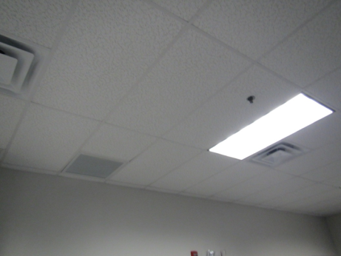
Typical supply (dark arrows) and exhaust (light arrow) vents
Picture 2
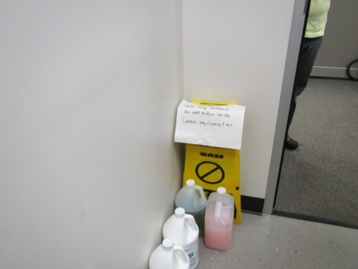
Cleaning chemicals, leading to odors in the janitorial storeroom without exhaust ventilation
Picture 3
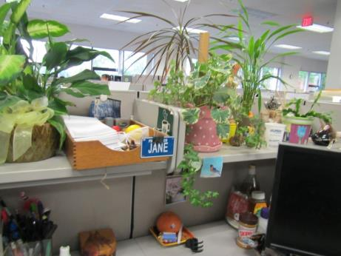
Plants in an office
Picture 4
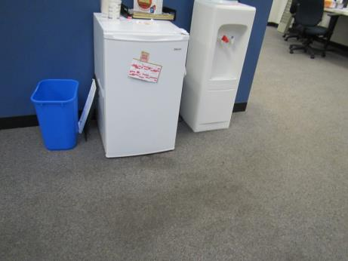
Refrigerator and water dispenser; note stained carpeting
Picture 5
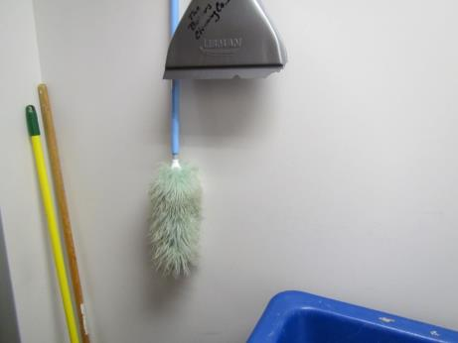
Feather duster in janitorial closet

Location | Carbon  Dioxide  (ppm) | Carbon Monoxide  (ppm) | Temp  (°F) | Relative  Humidity  (%) | PM2.5  (µg/m³) | Occupants  in Room | Windows  Openable | Ventilation |  | Remarks
 |  |  |  |  |  |  |  | Supply | Exhaust
Background | 389 | 0.6 | 77 | 89 | 28 |  |  |  |  | Cloudy, hazy, hot and humid
Office 131 | 626 | ND | 75 | 61 | 13 | 0 | N | Y | N
Breakroom | 511 | ND | 75 | 67 | 16 | 0 | Y | Y | Y | NC, food/toast odor
Conference 2 | 491 | ND | 75 | 67 | 15 | 0 | N | Y | N | DO
Mailroom | 553 | ND | 75 | 60 | 13 | 0 | N | Y | N | NC, mail equipment
Ladies room |  |  |  |  |  |  |  |  | Y
Training | 531 | ND | 75 | 67 | 16 | 0 | N | Y | Y | Computers
Training/  videoconference | 517 | ND | 75 | 67 | 17 | 0 | N | Y | Y
Files | 676 | ND | 75 | 58 | 17 | 0 | N | Y | Y | NC
Conference | 574 | ND | 73 | 54 | 11 | 0 | Y | Y | Y
Office | 601 | ND | 72 | 56 | 10 | 0 | Y | Y | N
Menton (cubes) | 617 | ND | 72 | 57 | 11 | 1 | Y | Y | Y | Plants, food, CP
Kneeland (cubes) | 607 | ND | 72 | 58 | 10 | 2 | Y | Y | Y | Plants, food
Hakaj (cubes) | 613 | ND | 72 | 58 | 11 | 1 | Y | Y | Y | Plants
Santos (cubes) | 658 | ND | 72 | 58 | 11 | 0 | Y | Y | Y | AI
Brown (cubes) | 608 | ND | 72 | 59 | 11 | 1 | Y | Y | Y | Plants, HS
Malone (office) | 615 | ND | 72 | 59 | 11 | 2 | Y | Y | Y
McNamara (office) | 602 | ND | 73 | 59 | 12 | 0 | Y | Y | N | Thermostat on auto
Dinneen (office) | 543 | ND | 72 | 60 | 15 | 0 | Y | Y | N | HS, DO
Barresi (cubes) | 550 | ND | 72 | 61 | 14 | 0 | Y | Y | Y | Plants
Musto (cubes) | 537 | ND | 72 | 61 | 15 | 0 | Y | Y | Y | PF, plants
Magee (cubes) | 710 | ND | 74 | 55 | 11 | 4 | Y | Y | Y | HS
Sanchez (cubes) | 684 | ND | 74 | 55 | 11 | 1 | Y | Y | Y | PF, heater
Magno (cubes) | 670 | ND | 74 | 56 | 11 | 1 | Y | Y | Y
DeVitto (cubes) | 671 | ND | 74 | 56 | 11 | 1 | Y | Y | Y | WC and fridge on carpet
Duarte (cubes) | 666 | ND | 75 | 55 | 10 | 2 | Y | Y | Y | Plant
Jean (cubes) | 646 | ND | 73 | 55 | 11 | 2 | Y | Y | Y | Plants, AI, heater
Aretusi (cubes) | 663 | ND | 73 | 56 | 10 | 1 | Y | Y | Y | PF, HS
Vacca (cubes) | 650 | ND | 73 | 56 | 11 | 4 | Y | Y | Y | HS, PF
Candage (cubes) | 693 | ND | 73 | 57 | 11 | 2 | Y | Y | Y | Plant
Mari (cubes) | 679 | ND | 73 | 57 | 11 | 2 | Y | Y | Y
Interview | 701 | ND | 73 | 63 | 12 | 0 | N | Y | N
Storage
# 126 office | 623 | ND | 74 | 61 | 13 | 0 | N | Y | N | Food
Prusic (cubes) | 570 | ND | 73 | 61 | 15 | 5 | Y | Y | Y | Noisy air supply
Livingston (cubes) | 586 | ND | 74 | 60 | 14 | 1 | Y | Y | Y | PF
Luongo (cubes) | 579 | ND | 75 | 59 | 14 | 1 | Y | Y | Y | Warm air
Coscia (cubes) | 572 | ND | 75 | 59 | 14 | 0 | Y | Y | Y
Cravotta (cubes) | 580 | ND | 75 | 59 | 15 | 2 | Y | Y | Y
Palumbo (cubes) | 561 | ND | 74 | 57 | 14 | 1 | Y | Y | Y | PF
Baltodano (cubes) | 592 | ND | 74 | 57 | 13 | 1 | Y | Y | Y
Nangle (cubes) | 576 | ND | 74 | 58 | 14 | 1 | Y | Y | Y | Plants, heater
Office 118 | 585 | ND | 74 | 58 | 13 | 0 | N | Y | N | DO
Holdsworth (cubes) | 632 | ND | 75 | 56 | 13 | 3 | Y | Y | Y
Zamptella (cubes) | 665 | ND | 75 | 55 | 11 | 2 | Y | Y | Y | Skylight, food

