INDOOR AIR QUALITY ASSESSMENT

Department of Revenue
90 Everett Avenue
Chelsea, MA

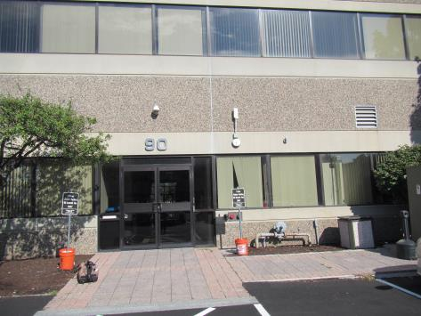

Prepared by:
Massachusetts Department of Public Health
Bureau of Environmental Health
Indoor Air Quality Program
September 2016

Background
Building: | Department of Revenue (DOR)
Address: | 90 Everett Avenue, Chelsea, MA
Assessment Requested by: | Joshua Martin, Deputy Director, Office of Facilities Management, Massachusetts DOR
Reason for Request: | Lease renewal IAQ status report
Date of Assessment: | September 14, 2016
Massachusetts Department of Public Health/Bureau of Environmental Health (MDPH/BEH) Staff Conducting Assessment: | Ruth Alfasso, Environmental Engineer/Inspector, IAQ Program
Building Description: | Four-story, flat-roofed building in an office park/mall area. DOR offices occupy the third and fourth floors of this building. The building has several other office tenants.
Building Population: | Approximately 150 employees over the two floors
Windows: | Not openable

Methods
Please refer to the IAQ Manual for methods, sampling procedures, and interpretation of results (MDPH, 2015).

IAQ Testing Results
The following is a summary of indoor air testing results (Table 1).
- Carbon dioxide levels were above 800 parts per million (ppm) in all areas assessed, indicating inadequate fresh air in the space.
- Temperature was within the recommended range of 70°F to 78°F in all areas assessed.
- Relative humidity was within the recommended range of 40% to 60% in all areas assessed.
- Carbon monoxide levels were non-detectable in all indoor areas assessed.
- Fine particulate matter (PM2.5) concentrations measured were below the National Ambient Air Quality Standard (NAAQS) level of 35 μg/m³ in all areas assessed.

Ventilation
A heating, ventilating, and air conditioning (HVAC) system has several functions. First, it provides heating and, if equipped, cooling. Second, it is a source of fresh air. Finally, an HVAC system will dilute and remove normally occurring indoor environmental pollutants by not only introducing fresh air, but also filtering the airstream and ejecting stale air to the outdoors via exhaust ventilation. Even if an HVAC system is operating as designed, point sources of respiratory irritation may exist and affect symptoms in sensitive individuals. The following analysis examines and identifies components of the HVAC system and likely sources of respiratory irritant/allergen exposure due to water damage, aerosolized dust, and/or chemicals found in the indoor environment.
Fresh air is provided by air handling units (AHUs) located on the roof. Air from the AHUs is filtered, heated/cooled, and delivered to rooms via ducted supply vents (Pictures 1 and 2). Air is returned/exhausted through vents in the ceiling (Picture 3).
The assessment results indicate that the ventilation system is not providing adequate fresh air for the occupancy in the building. At the time of the visit, air was flowing from supply vents, and the system appeared to be on in all areas examined. However the carbon dioxide readings, which ranged from 1,476 ppm to 1,716 ppm, were significantly and consistently elevated over the MDPH recommended level of 800 ppm. This indicates that the system is not bringing in sufficient fresh air during operation. The likely reasons for this involve the operation of the energy management system and the settings that determine the percent fresh air and recycled air that are being delivered to the supply vents. Fresh air dampers that are mechanically stuck closed may also lead to higher than optimal levels of carbon dioxide, however the results over the entire space are consistent, which means the cause is more likely overall system settings than a single fault.
It is recommended that HVAC systems be re-balanced every five years to ensure adequate air systems function (SMACNA, 1994). It is unknown when the last time this system was balanced.

Microbial/Moisture Concerns
A few water-damaged ceiling tiles were observed on the 4th floor. The damage appears to be from a condensation leak from a HVAC system component in the ceiling. The conditions causing the leak should be fixed, and the tiles should be replaced.
Plants were observed in office areas (Table 1; Pictures 4 and 5). Plants can be a source of pollen and mold, which can be respiratory irritants to some individuals. Plants should be properly maintained and equipped with drip pans to prevent water damage to porous materials. Plants should also be located away from air diffusers to prevent the aerosolization of dirt, pollen, and mold.
Small refrigerators and water dispensers were observed in carpeted areas (Picture 6). These appliances may spill or leak and lead to carpet damage and microbial growth. It is recommended that these appliances be located in areas without carpeting or on waterproof mats. Carpet squares could also be replaced with tile in areas where water dispensers and refrigerators are located.
One of the refrigerators in a break room had evidence of a spill inside (Picture 7). Refrigerators should be kept clean to prevent odors and microbial growth. One of the break room sink cabinet had water stains (Picture 8), which suggests that leaks or condensation is occurring. The area underneath sinks tends to be a moist environment, so storage of porous items or large amounts of items should be avoided. These areas should be checked periodically for leaks and dampness.
Plants and trees were observed very close to and touching the exterior of the building envelope (Picture 9). This can lead to deterioration of the building envelope due to root infiltration and dampness against the exterior surface. Plants can be a source of debris and pollen to air intakes. Plants should be trimmed away from the building and from overhanging the roof.

Other IAQ Evaluations
Exposure to low levels of total volatile organic compounds (TVOCs) may produce eye, nose, throat, and/or respiratory irritation in some sensitive individuals. To determine if VOCs were present, BEH/IAQ staff examined rooms for products containing VOCs. BEH/IAQ staff noted hand sanitizers, cleaners, and dry erase materials in use within the building (Picture 8; Table 1). All of these products have the potential to be irritants to the eyes, nose, throat, and respiratory system of sensitive individuals.
The offices were mostly carpeted. Carpets should be cleaned annually (or semi-annually in soiled/high traffic areas) in accordance with Institute of Inspection, Cleaning and Restoration Certification (IICRC) recommendations, (IICRC, 2012).
In some areas, stored materials and accumulated items make it more difficult for custodial staff to clean. Items should be stored neatly and moved periodically to allow for wet wiping and vacuuming of surfaces.
Personal fans were observed in a number of areas. Fan blades to some of these units had settled dust, which can be reaerosolized when the fan is activated.

Conclusions/Recommendations
Based on observations at the time of assessment, the following is recommended:
- Investigate the cause of high carbon dioxide readings, including adjustment of settings on the energy management for the HVAC system and operability of all dampers. The BEH/IAQ program can return on request to confirm that these adjustments have been successful.
- Operate supply and exhaust ventilation in all areas during occupied periods.
- Have the HVAC system balanced every 5 years in accordance with SMACNA recommendations (SMACNA, 1994).
- Repair conditions leading to ceiling leaks and water-damaged ceiling tiles, and replace the tiles.
- Keep indoor plants in good condition, avoid overwatering, and avoid placing them on porous items such as carpets or paper. Also, keep plants out of the air stream of supply vents.
- Consider locating refrigerators and water dispensers in non-carpeted areas or place on a waterproof mat.
- Clean refrigerator spills promptly and clean refrigerators out regularly to avoid odors and microbial growth.
- Avoid storing porous items or large amounts of items under sinks.
- For buildings in New England, periods of low relative humidity during the winter are often unavoidable. Therefore, scrupulous cleaning practices should be adopted to minimize common indoor air contaminants whose irritant effects can be enhanced when the relative humidity is low. To control for dusts, a high efficiency particulate arrestance (HEPA) filter equipped vacuum cleaner in conjunction with wet wiping of all surfaces is recommended. Avoid the use of feather dusters. Drinking water during the day can help ease some symptoms associated with a dry environment (throat and sinus irritations).
- Reduce the use of cleaning products, sanitizers, and scented products.
- Change filters on AHUs on a regular schedule at least twice a year.
- Clean carpeting in accordance with IICRC recommendations (IICRC, 2012).
- Reduce accumulated materials on flat surfaces and store in an organized manner to allow for thorough cleaning.
- Clean the blades of personal fans periodically to avoid aerosolizing dusts.
- Refer to resource manual and other related IAQ documents located on the MDPH’s website for further building-wide evaluations and advice on maintaining public buildings. These documents are available at: http://mass.gov/dph/iaq.

References
IICRC. 2012. Institute of Inspection, Cleaning and Restoration Certification. Carpet Cleaning: FAQ. Retrieved from http://www.iicrc.org/consumers/care/carpet-cleaning/.
MDPH. 2015. Massachusetts Department of Public Health. Indoor Air Quality Manual: Chapters I-III. Available at: http://www.mass.gov/eohhs/gov/departments/dph/programs/environmental-health/exposure-topics/iaq/iaq-manual/.
SMACNA. 1994. HVAC Systems Commissioning Manual. 1st ed. Sheet Metal and Air Conditioning Contractors’ National Association, Inc., Chantilly, VA.
Picture 1
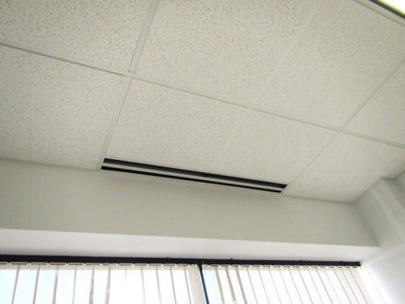
Air supply vent next to the windows
Picture 2
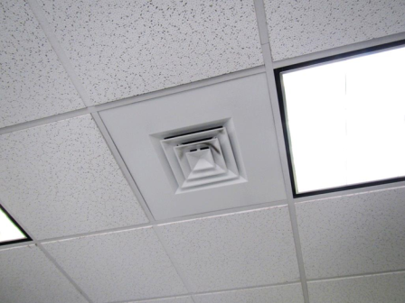
Supply vent
Picture 3
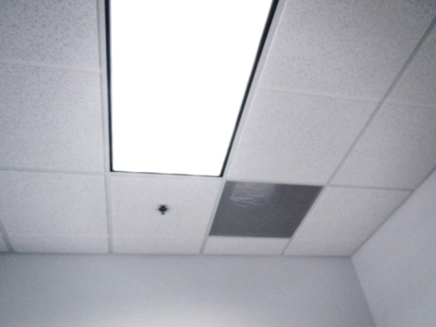
Typical exhaust vent
Picture 4
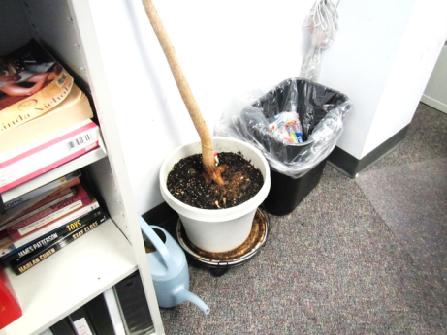
Plant drip pan in need of cleaning and undersized/overwatered
Picture 5
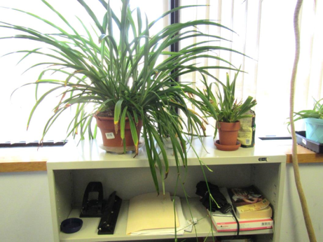
Plants in an office
Picture 6
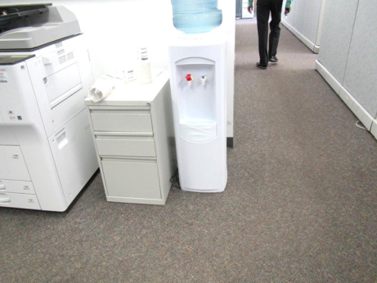
Water cooler on carpet
Picture 7
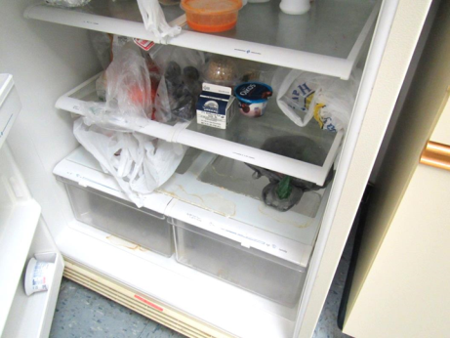
Spills/stains in the refrigerator
Picture 8
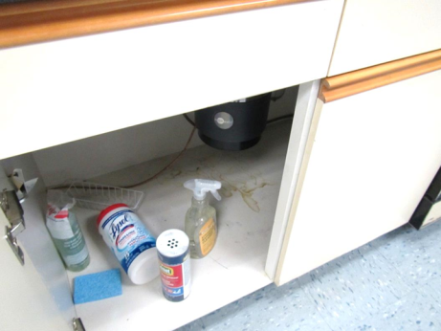
Water stains and cleaning products under sink
Picture 9
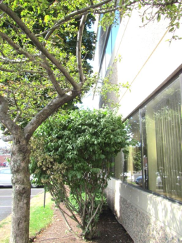
Trees and bushes against the building exterior

Location | Carbon  Dioxide  (ppm) | Carbon Monoxide  (ppm) | Temp  (°F) | Relative  Humidity  (%) | PM2.5  (µg/m³) | Occupants  in Room | Windows  Openable | Ventilation |  | Remarks
 |  |  |  |  |  |  |  | Supply | Exhaust
Background | 347 | ND | 76 | 64 | 15 |  |  |  |  | Sunny, light wind
4th floor
02 (cubes) | 1569 | ND | 74 | 55 | 4 | 0 | N | Y | Y
10 (cubes) | 1589 | ND | 74 | 57 | 4 | 1 | N | Y | Y
15 (cubes) | 1614 | ND | 74 | 57 | 4 | 3 | N | Y | Y | DEM, PC
17 (cubes) | 1587 | ND | 74 | 57 | 4 | 2 | N | Y | Y
20 (cubes) | 1578 | ND | 74 | 56 | 3 | 2 | N | Y | Y | Plants
25 (cubes) | 1712 | ND | 74 | 56 | 3 | 1 | N | Y | Y
27 (cubes) | 1565 | ND | 75 | 55 | 3 | 1 | N | Y | Y | Plants
29 (cubes) | 1675 | ND | 74 | 56 | 4 | 1 | N | Y | Y
32 (cubes) | 1702 | ND | 74 | 56 | 4 | 2 | N | Y | y
35 (cubes) | 1679 | ND | 74 | 55 | 4 | 2 | N | Y | Y | Stained carpet
39 (cubes) | 1677 | ND | 74 | 56 | 4 | 2 | N | Y | Y
401 | 1580 | ND | 74 | 54 | 3 | 1 | N | Y | Y | DEM
402 | 1545 | ND | 74 | 55 | 3 | 0 | N | Y | Y | DEM, plant, food
403 | 1581 | ND | 74 | 55 | 4 | 1 | N | Y | Y | DEM
404 | 1619 | ND | 74 | 54 | 3 | 0 | N | Y | Y | DEM
405 | 1606 | ND | 74 | 55 | 4 | 1 | N | Y | Y | DEM, recycling, plants
406 | 1589 | ND | 74 | 55 | 4 | 1 | N | Y | Y | Plants, food
407 | 1586 | ND | 74 | 57 | 3 | 0 | N | Y | Y | Plants, DEM
408 | 1602 | ND | 74 | 58 | 4 | 1 | N | Y | Y | HS
409 | 1587 | ND | 73 | 57 | 3 | 2 | N | Y | Y | DEM, plant
410 | 1572 | ND | 73 | 57 | 4 | 0 | N | Y | Y | DEM
411 | 1602 | ND | 73 | 55 | 3 | 0 | N | Y | Y | HS, PF, DEM
412 | 1550 | ND | 74 | 54 | 3 | 0 | N | Y | Y | DEM, PF
413 | 1716 | ND | 74 | 55 | 5 | 0 | N | Y | Y | DEM
414 | 1707 | ND | 74 | 56 | 4 | 2 | N | Y | Y | DEM
415 | 1716 | ND | 74 | 55 | 3 | 0 | N | Y | Y | DEM
416 | 1669 | ND | 75 | 56 | 4 | 1 | N | Y | Y | DEM
42 (cubes) | 1661 | ND | 74 | 56 | 4 | 1 | N | Y | Y
45 (cubes) | 1687 | ND | 74 | 57 | 4 | 1 | N | Y | Y
48 (cubes) | 1680 | ND | 74 | 57 | 4 | 6 | N | Y | Y
52 (cubes) | 1634 | ND | 75 | 55 | 4 | 2 | N | Y | Y | Solar gain, CP, food, AI
53 (cubes) | 1590 | ND | 74 | 54 | 4 | 2 | N | Y | Y
54 (cubes) | 1606 | ND | 74 | 57 | 6 | 3 | N | Y | Y | Solar gain
55 (cubes) | 1578 | ND | 73 | 55 | 3 | 0 | N | Y | Y | DEM, plants
57 (cubes) | 1577 | ND | 74 | 55 | 3 | 3 | N | Y | Y
64 (cubes) | 1578 | ND | 75 | 55 | 3 | 4 | N | Y | Y
65 (cubes) | 1630 | ND | 74 | 55 | 3 | 2 | N | Y | Y
Conference 2 | 1584 | ND | 73 | 55 | 3 | 2 | N | Y | Y
Kitchen | 1587 | ND | 74 | 57 | 4 | 0 | N | Y | Y | Exhaust appears to be direct, DEM, food, fridge, microwave, NC
Library | 1553 | ND | 76 | 55 | 3 | 0 | N | Y | Y
Office (no number) | 1574 | ND | 74 | 56 | 3 | 2 | N | Y | Y | DEM
Training | 1570 | ND | 74 | 54 | 4 | 0 | N | Y | Y | DEM, computers
3rd floor
Kitchen | 1511 | ND | 74 | 56 | 4 | 1 | N | Y | Y | NC, dirty fridge, stains under sink
Ladies restroom |  |  |  |  |  |  | N | Y | Y | Cleaner odors
Training | 1647 | ND | 74 | 54 |  | 2 | N | Y | Y
Conference 3-2 | 1566 | ND | 75 | 54 | 4 | 2 | N | Y | Y | Water cooler on carpet
Conference 1 | 1559 | ND | 76 | 53 | 4 | 1 | N | Y | Y
Conference 3-1 | 1500 | ND | 73 | 58 | 4 | 3 | N | Y | Y | Water cooler on carpet, DEM
04 (cubes) | 1571 | ND | 75 | 54 | 3 | 2 | N | Y | Y | Solar gain
08 (cubes) | 1595 | ND | 74 | 54 | 4 | 0 | N | Y | Y | Solar gain
15 (cubes) | 1568 | ND | 74 | 55 | 4 | 1 | N | Y | Y
19 (cubes) | 1571 | ND | 74 | 55 | 4 | 2 | N | Y | Y
22 (cubes) | 1561 | ND | 74 | 55 | 4 | 1 | N | Y | Y | Stained carpet
23 (cubes) | 1526 | ND | 74 | 55 | 4 | 2 | N | Y | Y
33 (cubes) | 1498 | ND | 74 | 56 | 4 | 1 | N | Y | Y | Water cooler on carpet
43 (cubes) | 1476 | ND | 75 | 55 | 4 | 3 | N | Y | Y | Plant
62 (cubes) | 1529 | ND | 73 | 56 | 4 | 1 | N | Y | Y
64 (cubes) | 1532 | ND | 73 | 54 | 4 | 1 | N | Y | Y | Plant
66 (cubes) | 1554 | ND | 72 | 54 | 3 | 0 | N | Y | Y
76 (cubes) | 1627 | ND | 76 | 53 | 4 | 1 | N | Y | Y
301 | 1555 | ND | 74 | 54 | 3 | 1 | N | Y | Y | DEM
302 | 1567 | ND | 75 | 52 | 3 | 0 | N | Y | Y | DEM
304 | 1588 | ND | 76 | 53 | 3 | 2 | N | Y | Y | DEM
305 | 1570 | ND | 76 | 53 | 3 | 2 | N | Y | Y | Big tree outside
306 | 1656 | ND | 76 | 53 | 4 | 1 | N | Y | Y | DEM
307 | 1589 | ND | 74 | 55 | 4 | 1 | N | Y | Y | DEM, soda cans
308 | 1599 | ND | 74 | 54 | 4 | 1 | N | Y | Y
309 | 1597 | ND | 74 | 54 | 4 | 1 | N | Y | Y | DEM
310 | 1614 | ND | 74 | 54 | 4 | 0 | N | Y | Y
311 | 1593 | ND | 74 | 54 | 4 | 2 | N | Y | Y
312 | 1523 | ND | 74 | 56 | 4 | 1 | N | Y | Y
315 | 1496 | ND | 74 | 55 | 3 | 0 | N | Y | Y | DEM
316 | 1487 | ND | 74 | 56 | 3 | 0 | N | Y | Y | DEM

