INDOOR AIR QUALITY ASSESSMENT

Department of Revenue Offices
100 Cambridge Street
7th and part of the 2nd floor
Boston, Massachusetts

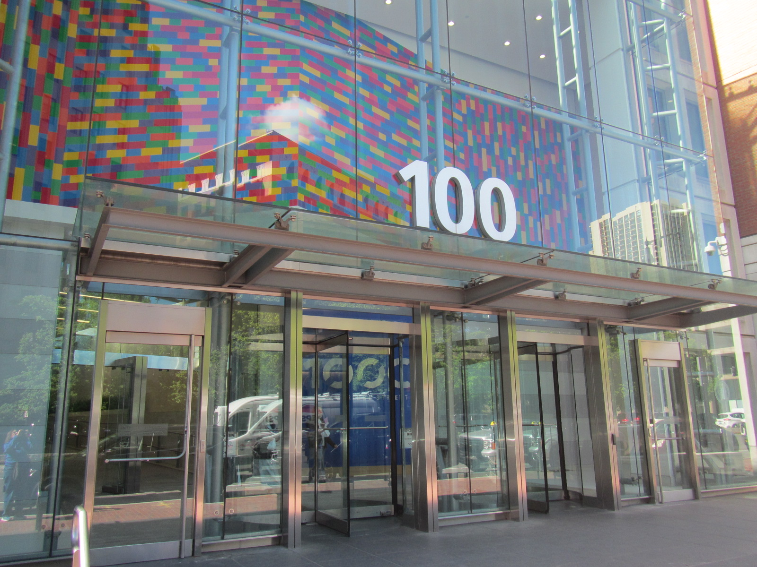

Prepared by:
Massachusetts Department of Public Health
Bureau of Climate and Environmental Health
Division of Environmental Health Regulations and Standards
May 2026

BACKGROUND
Building: | Department of Revenue (DOR) offices
Address: | 100 Cambridge Street, Boston
Assessment Requested by: | John Moore, Deputy Director, Office of Facilities Management (DOR)
Reason for Request: | General indoor air quality (IAQ)
Date of Assessment: | May 12, 2026
Massachusetts Department of Public Health/Bureau of Climate and Environmental Health (MDPH/BCEH) Staff Conducting Assessment: | Ruth Alfasso, and Amy Riordan, Division of Environmental Health Regulations and Standards (EHRS)
Building Description: | These offices are located on the 2nd and 7th floor of the Saltonstall Building, a 1960s era high-rise building in downtown Boston. The DOR has occupied this office since 2019.
Windows: | Windows are not openable in this building.

Note that this building, including the Department of Revenue spaces, has been visited before. The most recent visit was in 2023 when DOR moved to a hoteling model. The spaces had been renovated prior to that visit.

METHODS
Please refer to the IAQ Manual for methods, sampling procedures, and interpretation of results (MDPH, 2015).

RESULTS AND DISCUSSION
The following is a summary of indoor air testing results (Table 1).
- Carbon dioxide levels were below the MDPH guideline of 800 parts per million (ppm) in all, but one area assessed, indicating typical work areas have adequate ventilation for occupancy. A level slightly above 800 ppm was noted in a waiting area on the 2nd floor.
- Temperature was within the recommended range of 70°F to 78°F in all areas assessed.
- Relative humidity was below the MDPH recommended range of 40 to 60% in all areas assessed. This is reflective of outdoor conditions. Low relative humidity is common indoors during the heating season. Note that low relative humidity can lead to common symptoms such as dry skin, lips, and scalp; dry/scratchy throats and noses (nose bleeds); exacerbation of asthma, eczema, or allergies; dry/irritated eyes; and irritation of respiratory tract.
- Carbon monoxide was not detected (ND)in all areas. Carbon monoxide should not be present in a typical, indoor environment. If it is present, indoor carbon monoxide levels should be less than or equal to outdoor levels.
- Fine particulate matter (PM2.5) concentrations measured were below the National Ambient Air Quality Standard (NAAQS) level of 35 μg/m³ in all areas assessed.
- Total Volatile Organic Compounds (TVOCs) concentrations were ND in all areas tested.

Ventilation
A heating, ventilating, and air conditioning (HVAC) system has several functions. First, it provides heating and, if equipped, cooling. Second, it is a source of fresh air. Finally, an HVAC system will dilute and remove normally occurring indoor environmental pollutants by not only introducing fresh air but also filtering the airstream and ejecting stale air to the outdoors via exhaust ventilation. Even if an HVAC system is operating as designed, point sources of respiratory irritation may exist and lead to symptoms in sensitive individuals.
Fresh air is provided by air-handling units (AHUs) located on the roof. Operation of the building’s HVAC system is controlled by an automated computer system. Air from the AHUs is filtered, heated/cooled, and delivered to rooms via ducted supply vents. Air is returned/exhausted through return vents (Pictures 1 through 3). Note that supply and return vents in many spaces were the same style of vent, which makes it difficult to determine if each room had both a supply and return vent. All occupied spaces should have access to both supply and return ventilation. It is recommended that HVAC systems be re-balanced every five years to ensure adequate air systems function (SMACNA, 1994). It was reported that the system was balanced during the renovation project in 2023.
The ventilation system should be on and operational to supply fresh air continuously during occupied periods. Without adequate fresh air supply and removal of stale air, common indoor air pollutants can build up and cause irritation. Thermostats are present in this space, and some of them, in conference rooms, also have carbon dioxide measurements (Picture 4). These measurements are used to ensure the HVAC system activates at a higher setting with higher occupancy. However, the reading on this instrument was about 100 ppm higher than the reading on the Qtrak meter. Carbon dioxide sensors need to be either calibrated or replaced periodically to ensure accurate measurements; manufacturers’ instructions should be followed.

Water damage issues
A single water-damaged ceiling tile was noted on the 7th floor (Picture 5; Table 1). This water-damaged tile appears to be from the plumbing, HVAC, or sprinkler systems. No dark staining indicating mold was present. Water-damaged ceiling tiles should be replaced once an issue has been identified and repaired.
A section of coving in an office was found taped on (Picture 6). Loose coving can be a sign of water damage to wall material. This wall should be checked for additional signs of water damage (stains, odors) and repaired, after which the coving should be fastened back to the wall.
Small refrigerators (Picture 7) and water dispensers (Picture 8) were noted in carpeted areas. Leaks or spills from these appliances can damage carpeting. Large refrigerators were noted in a break room; one had spills inside (Picture 9). Note that while refrigerators in this office building are not covered by the food code, it is good practice to have a thermometer in each refrigerator that is visible to ensure refrigerated food temperatures are kept at 5ºC (41ºF) or less (US FDA, 2022). Food preparation equipment and related items were found in some offices and common areas. Food needs to be kept in tightly sealed pest-proof containers when not currently in use. All crumbs and other food debris need to be removed from surfaces and appliances such as toasters and microwaves to avoid attracting pests.
The sink in the Wellness room has a cabinet with carpet underneath it (Picture 10). Leaks or condensation can moisten this carpeting and lead to odors. During the site visit, it was reported that this room is rarely used. Sinks that are not used can have the drain traps dry out and lead to sewer odors inside the building. A drain trap is a p-shaped pipe under the sink which fills with water and provides a seal between the sewer system and occupied spaces; if sinks are unused this can dry out. Water should be run through this sink once every one to two weeks when the room is unused. Regular water flow helps prevent stagnant water, odors, and potential drain fly activity.
A stain was noted on the wall of a cloth workstation (Picture 11) where it appeared a liquid spill had occurred. Water damage to cloth such as workstation walls should be minimized, and wet areas should be dried promptly.

Other IAQ issues
The office spaces examined were mostly clean and free of personal items because staff do not have assigned desks. In one area, a large number of books were present on shelving (Picture 12) Some of the books were also found on top of the shelving. DOR facilities staff reported that items should not be stored on top of this shelving. Items on top of surfaces make it more difficult to remove dust.
Most areas in the building are carpeted. Carpeting needs to be cleaned regularly using a HEPA-equipped vacuum and deep cleaned once or twice a year.
A ceiling tile was observed to be missing or displaced in one area (Table 1), likely because of recent maintenance activity. The ceiling tile grid should be intact to prevent dust from above the ceiling tiles from falling into occupied areas. Dust was noted on the ceiling tiles in one area (Table 1). This should be cleaned.
A few air purifiers are in use in the office (Table 1). These units need to be cleaned and have the filters changed as recommended by the manufacturer. Air purifiers that may produce ozone should not be used. Air purifiers work best when the output air is near the breathing zone of occupants.
VOC testing was conducted and all results inside were ND, however, products were in use in the office that can increase VOCs in the air. Items including hand sanitizers, cleaners, and dry erase materials were noted (Table 1; Picture 13). Products with strong scents, including scent sprays and essential oils should not be used in a shared office space as many people are sensitive to fragrance compounds.
Lockers are present in this office space. There should be a program in place to ensure lockers are cleaned out periodically,

CONCLUSIONS/RECOMMENDATIONS
In view of the findings at the time of the visit, the following recommendations are made:

Ventilation recommendations
- Continue to operate supply and exhaust ventilation in all areas continuously during occupied periods.
- Have the HVAC system balanced every 5 years in accordance with SMACNA recommendations (SMACNA, 1994).
- Consider increasing both supply and exhaust ventilation to heavily occupied areas such as waiting rooms.
- Ensure all rooms have both a supply and a return vent.
- Ensure any carbon dioxide sensors are calibrated or replaced as recommended by the manufacturer to increase accuracy.
- Continue to change filters for HVAC units at least two to four times a year or as per the manufacturers’ recommendations using filters with a Minimum Efficiency Rating Value (MERV) of 8 or better.
- Periodically clean dust from supply and return vents and fans.
- For buildings in New England, periods of low relative humidity during the winter are often unavoidable. Therefore, scrupulous cleaning practices should be adopted to minimize common indoor air contaminants whose irritant effects can be enhanced when the relative humidity is low. To control dust, a high efficiency particulate air (HEPA) filter-equipped vacuum cleaner in conjunction with wet wiping of all surfaces is recommended. Avoid the use of feather dusters. Drinking water during the day can help ease some symptoms associated with a dry environment (throat and sinus irritations).

Water damage recommendations
- Replace water-damaged ceiling tiles.
- Investigate the cause of loose coving shown in Picture 6 and replace once any water damage has been repaired.
- Consider moving refrigerators and water dispensers to areas without carpeting or using a waterproof mat underneath.
- Routinely clean food/liquid stains from the refrigerator and food residues from microwaves, toasters, coffee makers, or any other appliances used to prepare or heat food.
- Consider removing carpet under the Wellness room sink.
- Ensure the sink drains in rarely used areas, such as the Wellness Room, are run with water several times per month to keep drain traps from drying out and to help prevent odors and pests.

Other recommendations
- Reduce clutter and ensure items have a location for proper storage.
- Ensure that ceiling tiles are flush in the ceiling tile grid.
- Have the carpets vacuumed regularly and deep cleaned once or twice a year.
- Use VOC-containing products with good ventilation.
- Clean and maintain air purifiers in accordance with manufacturers’ instructions including filter changes. Avoid using any units that may produce ozone.
- Ensure lockers are cleaned out periodically.
- Refer to resource manual and other related IAQ documents located on the MDPH’s website for further building-wide evaluations and advice on maintaining public buildings. These documents are available at: http://mass.gov/dph/iaq.

REFERENCES
ASHRAE. 2012. American Society of Heating, Refrigeration and Air Conditioning Engineers (ASHRAE) Standard 52.2-2012 -- Method of Testing General Ventilation Air-Cleaning Devices for Removal Efficiency by Particle Size (ANSI Approved).
MDPH. 2015. Massachusetts Department of Public Health. Indoor Air Quality Manual: Chapters I-III. Available at: https://www.mass.gov/lists/indoor-air-quality-manual-and-appendices.
SMACNA. 1994. HVAC Systems Commissioning Manual. 1st ed. Sheet Metal and Air Conditioning Contractors’ National Association, Inc., Chantilly, VA.
US FDA. 2022. 2022 Food Code. U.S. Department of Health and Human Services. U.S. Food and Drug Administration. College Park, MD January 18, 2023 Version. https://www.fda.gov/media/164194/download

Picture 1
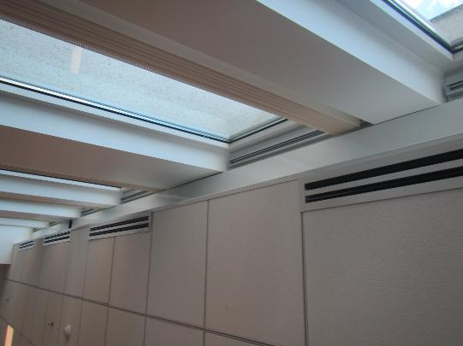
Slot-style supply vents along windows
Picture 2
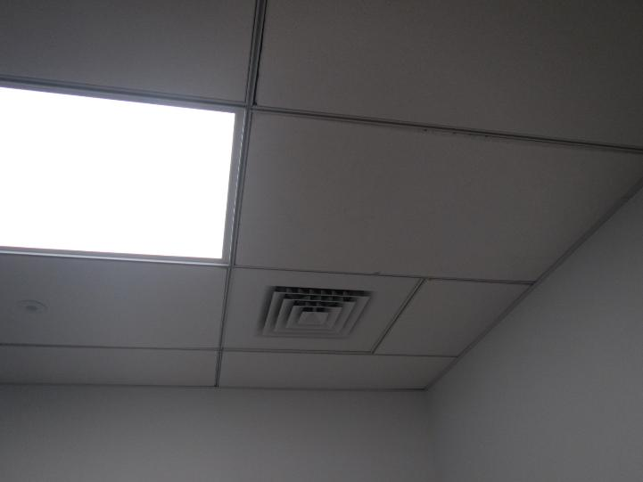
Ceiling-mounted vent that may be either a supply or return vent

Picture 3
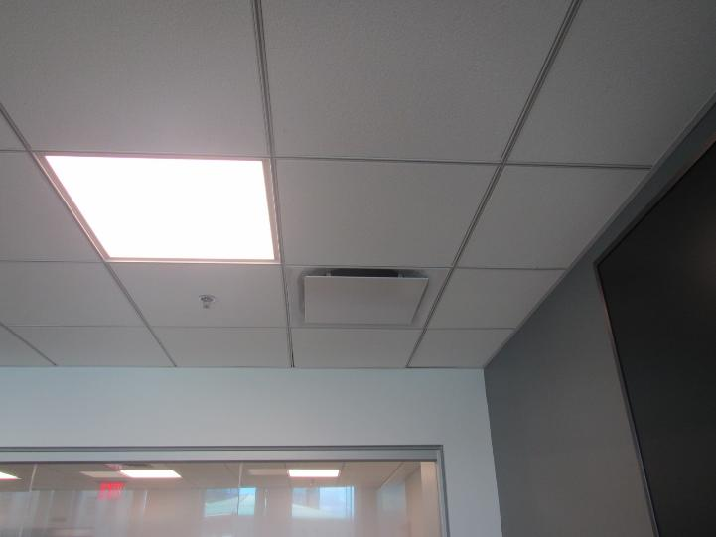
Ceiling-mounted vent that may be either a supply or return vent
Picture 4
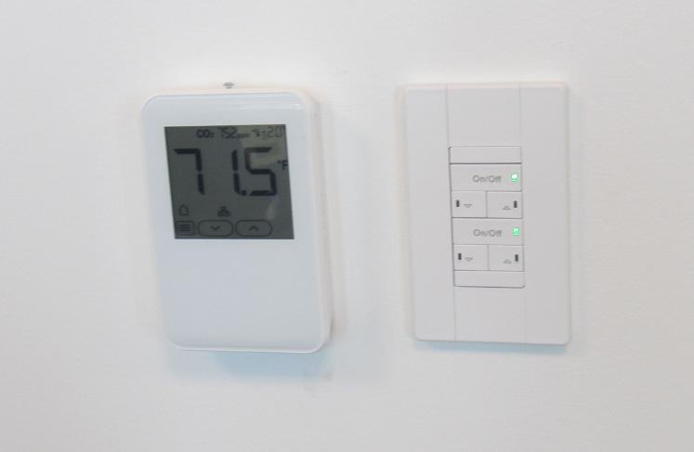
Thermostat in conference room with carbon dioxide measurement

Picture 5
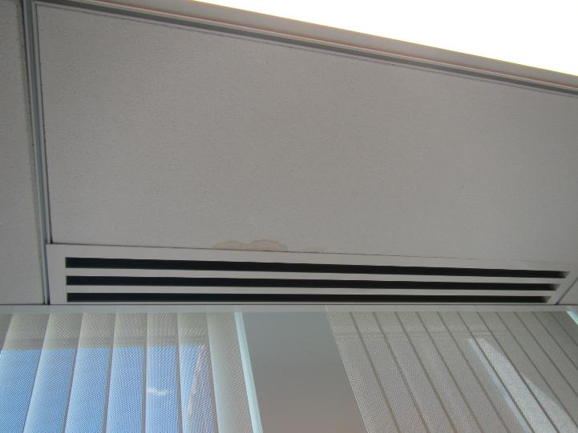
Water-damaged ceiling tile
Picture 6
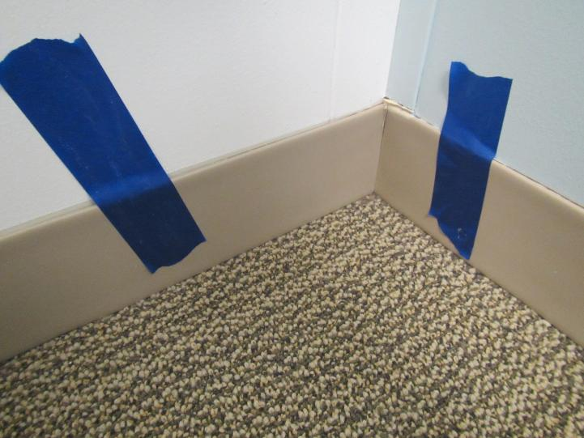
Coving taped onto the wall

Picture 7
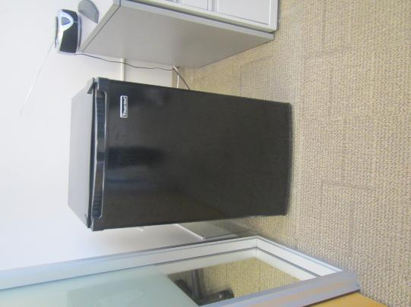
Refrigerator on carpet
Picture 8
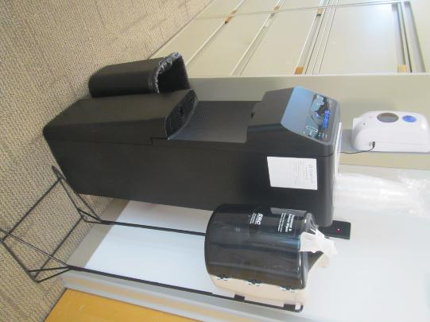
Water dispenser on carpet

Picture 9
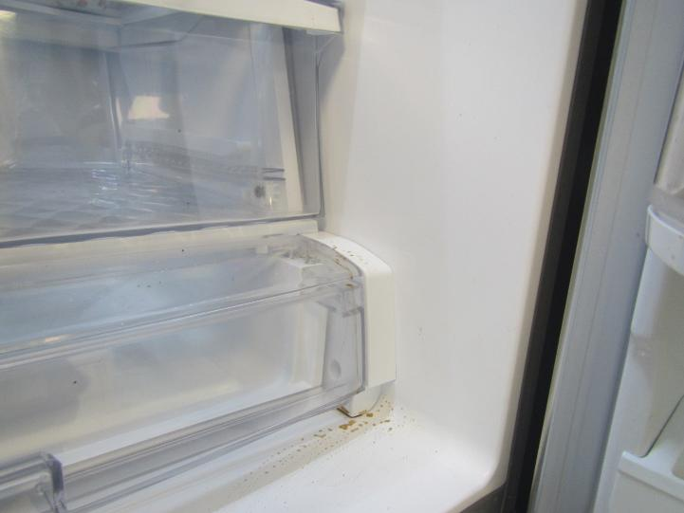
Liquid spill inside break room refrigerator
Picture 10
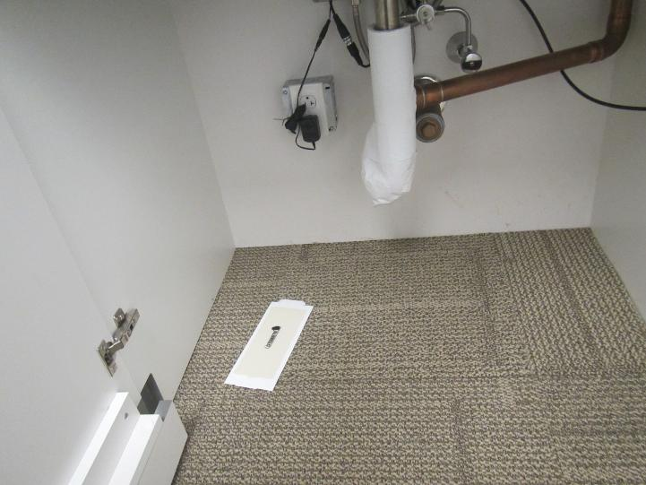
Carpeting under sink in Wellness room

Picture 11
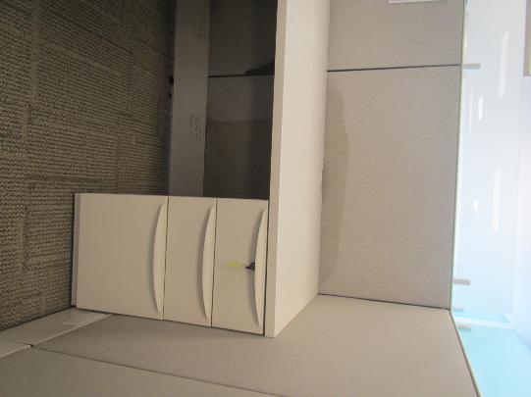
Stain on workstation wall
Picture 12
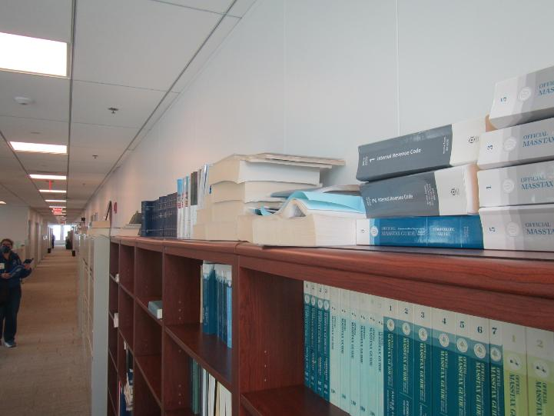
Books on top of shelving

Picture 13
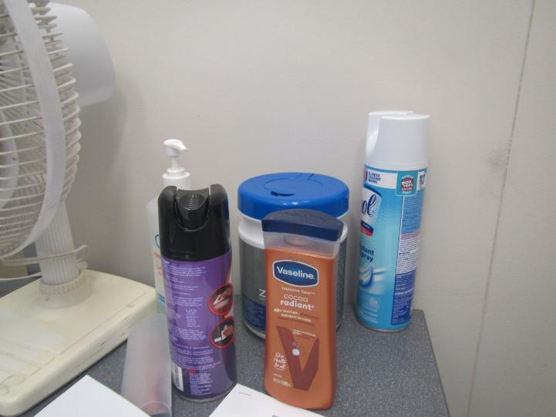
Cleaners and sanitizers

Location | Carbon  Dioxide  (ppm) | Carbon Monoxide  (ppm) | Temp  (°F) | Relative  Humidity  (%) | PM2.5  (µg/m³) | TVOC  (ppm) | Occupants  in Room | Windows  Openable | Ventilation |  | Remarks
 |  |  |  |  |  |  |  |  | Supply | Exhaust | Remarks
Background | 426 | ND | 64 | 26 | 4 | 2.6 |  |  |  |  | Busy street
Executive conference | 661 | ND | 72 | 28 | ND | ND | 0 | N | Y | Y
7104 | 636 | ND | 73 | 26 | ND | ND | 0 | N | Y | Y
77105 break room | 596 | ND | 73 | 26 | ND | ND | 0 | N | Y | Y | Not carpeted, 2 fridges, one with spill inside, microwave, mouse traps under sink
7107 | 602 | ND | 74 | 27 | ND | ND | 0 | N | Y | Y
7108 | 620 | ND | 74 | 27 | ND | ND | 0 | N | Y | Y
W7110 cubes | 591 | ND | 73 | 27 | ND | ND | 0 | N | Y | Y | Lockers
W7110 cubes | 607 | ND | 73 | 28 | ND | ND | 0 | N | Y | Y | Air purifier
7111 | 596 | ND | 73 | 27 | ND | ND | 0 | N | Y | Y
7112 | 614 | ND | 73 | 27 | ND | ND | 0 | N | Y | Y
W7115.5 cubes | 617 | ND | 74 | 26 | ND | ND | 1 | N | Y | Y
W7121.4 cubes | 617 | ND | 75 | 26 | ND | ND | 1 | N | Y | Y
7119 | 603 | ND | 75 | 25 | ND | ND | 0 | N | Y | Y
7120 | 605 | ND | 75 | 25 | ND | ND | 0 | N | Y | Y | Base coving taped down (loose when pulled)
7132 wellness | 589 | ND | 74 | 25 | ND | ND | 0 | N | Y | Y | Sink with carpet underneath, fridge
7128 | 594 | ND | 74 | 25 | ND | ND | 0 | N | Y | Y
W7126 cubes | 546 | ND | 75 | 25 | ND | ND | 0 | N | Y | Y | Old books, items on top of shelves
7134 cube area | 597 | ND | 74 | 25 | ND | ND | 0 | N | Y | Y | 1 water-damaged ceiling tile
7136 | 623 | ND | 74 | 25 | ND | ND | 1 | N | Y | Y
7138 cube area | 635 | ND | 74 | 25 | ND | ND | 0 | N | Y | Y | Personal items
7137 huddle | 618 | ND | 74 | 24 | ND | ND | 0 | N | Y | Y | Dust on ceiling near vents and one vent ajar
7143 | 592 | ND | 75 | 24 | ND | ND | 0 | N | Y | Y
7148 | 632 | ND | 75 | 25 | ND | ND | 1 just left | N | Y | Y | Food
7152 | 683 | ND | 74 | 26 | ND | ND | 0 | N | Y | Y
W7155 cubes | 625 | ND | 74 | 25 | ND | ND | 1 | N | Y | Y
7157 | 621 | ND | 74 | 25 | ND | ND | 0 | N | Y | Y
7163 conference | 644 | ND | 73 | 26 | ND | ND | 0 | N | Y | Y | Dry erase board
W7166 cubes | 645 | ND | 73 | 27 | ND | ND | 1 | N | Y | Y | Water-stained cube wall
W7167 cubes | 666 | ND | 72 | 27 | ND | ND | 2 | N | Y | Y
7170 | 668 | ND | 72 | 28 | ND | ND | 1 just left | N | Y | Y | Hand sanitizer
2nd floor waiting | 960 | ND | 73 | 29 | ND | ND | 5 | N | Y | Y
2nd floor inside reception | 745 | ND | 73 | 26 | ND | ND | 1 | N | Y | Y
Guest computer area | 670 | ND | 73 | 25 | ND | ND | 2 | N | Y | Y | Photocopier, fridge on carpet
hallway | 594 | ND | 73 | 24 | ND | ND | 0 | N | Y | Y | Missing ceiling tile, fridge and water dispenser on carpet

