INDOOR AIR QUALITY
POST-OCCUPANCY ASSESSMENT

Commonwealth of Massachusetts
Department of Revenue
540 Myles Standish Boulevard
Taunton, Massachusetts

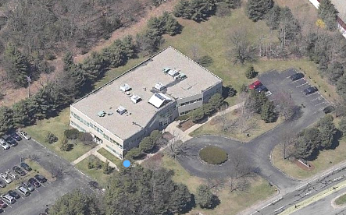

Prepared by:
Massachusetts Department of Public Health
Bureau of Environmental Health
Indoor Air Quality Program
June 2012

Background/Introduction
At the request of Gerald Covino, Project Manager, Office of Leasing, Division of Capital Asset Management (DCAM), the Massachusetts Department of Public Health (MDPH), Bureau of Environmental Health (BEH) conducted post-occupancy air testing at the Massachusetts Department of Revenue (DOR) offices located at 540 Myles Standish Boulevard, Taunton, Massachusetts. The purpose of the visit was to assess the indoor air quality (IAQ) of newly occupied space leased by Massachusetts state agencies. On April 13, 2012, a visit to conduct IAQ testing was made by Cory Holmes, Environmental Analyst/Regional Inspector for BEH’s IAQ Program.
The DOR is the sole tenant in this completely renovated, two-story brick building. DOR staff have occupied the building since February 21, 2012. The space consists of open work areas separated by cloth-covered dividers, office space, storage and common areas. The space has suspended ceiling tiles and flooring consisting of carpet squares in the majority of areas; some areas have vinyl floor tile. Windows are not openable.

Actions on MDPH Recommendations
MDPH staff previously visited the building to conduct a pre-occupancy assessment and issued a report with recommendations in February 2012 (MDPH, 2012). The following actions were taken based on recommendation in the pre-occupancy assessment:
- Filters for rooftop air handling units (AHUs) were upgraded to a higher efficiency pleated air filter (Picture 1).
- A return vent was installed in file rooms to facilitate air exchange (Picture 2).
- The restroom vent stack on the roof was extended above level of AHU fresh air intakes to prevent odor entrainment (Picture 3).

Methods
Air tests for carbon dioxide, carbon monoxide temperature and relative humidity were taken with the TSI, Q-Trak, IAQ Monitor 7565. Air tests for airborne particle matter with a diameter less than 2.5 micrometers were taken with the TSI, DUSTTRAK™ Aerosol Monitor Model 8520. BEH staff also performed visual inspection of building materials for water damage and/or microbial growth.

Results
The tests were taken during normal operations. Test results appear in Table 1 and are listed by number, function and/or occupants’ last name(s).

Discussion

Ventilation
It can be seen from Table 1 that carbon dioxide levels were below 800 parts per million (ppm) in all areas with the exception of the first floor conference room, indicating optimal air exchange at the time of testing (Table 1). Fresh air is provided by rooftop AHUs (Pictures 1 and 3). Fresh air is drawn into AHUs through a bank of pleated air filters (Picture 1), heated or cooled and delivered to occupied areas via ducted air diffusers (Picture 4). Return air is drawn into an above ceiling plenum through return grates and/or slotted vents around light fixtures and ducted back to rooftop AHUs (Pictures 2 and 4).
It was reported that training/conference rooms have auxiliary heating, ventilating and air conditioning (HVAC) controls that contain carbon dioxide sensors. Once carbon dioxide readings exceed the set-point on the sensor, the system is designed to increase air exchange. At the time of the assessment, the first floor conference room was conducting training, occupied by 30 individuals and had an elevated carbon dioxide measurement of 1,188 ppm, indicating that the set-point was too high, the system was malfunctioning or the room was over-capacity.
To maximize air exchange, the MDPH recommends that both supply and exhaust ventilation operate continuously during periods of occupancy. In order to have proper ventilation with a mechanical supply and exhaust system, the systems must be balanced to provide an adequate amount of fresh air to the interior of a room while removing stale air from the room. It is recommended that HVAC systems be re-balanced every five years to ensure adequate air systems function (SMACNA, 1994). The HVAC system balancing was reportedly balanced prior to occupancy.
The Massachusetts Building Code requires a minimum ventilation rate of 20 cubic feet per minute (cfm) per occupant of fresh outside air or have openable windows in each room (SBBRS, 1997; BOCA, 1993). The ventilation must be on at all times that the room is occupied. Providing adequate fresh air ventilation with open windows and maintaining the temperature in the comfort range during the cold weather season is impractical. Mechanical ventilation is usually required to provide adequate fresh air ventilation.
Carbon dioxide is not a problem in and of itself. It is used as an indicator of the adequacy of the fresh air ventilation. As carbon dioxide levels rise, it indicates that the ventilating system is malfunctioning or the design occupancy of the room is being exceeded. When this happens, a buildup of common indoor air pollutants can occur, leading to discomfort or health complaints. The Occupational Safety and Health Administration (OSHA) standard for carbon dioxide is 5,000 parts per million parts of air (ppm). Workers may be exposed to this level for 40 hours/week, based on a time-weighted average (OSHA, 1997).
The MDPH uses a guideline of 800 ppm for publicly occupied buildings. A guideline of 600 ppm or less is preferred in schools due to the fact that the majority of occupants are young and considered to be a more sensitive population in the evaluation of environmental health status. Inadequate ventilation and/or elevated temperatures are major causes of complaints such as respiratory, eye, nose and throat irritation, lethargy and headaches. For more information concerning carbon dioxide, please see Appendix A.
Indoor temperature measurements ranged from 72 °F to 75 °F (Table 1), which were within the MDPH recommended comfort range at the time of assessment. The MDPH recommends that indoor air temperatures be maintained in a range of 70 °F to 78 °F in order to provide for the comfort of building occupants. In many cases concerning indoor air quality, fluctuations of temperature in occupied spaces are typically experienced, even in a building with an adequate fresh air supply.
Relative humidity measurements ranged from 17 to 29 percent, which were below the MDPH recommended comfort range on the day of assessment (Table 1). The MDPH recommends a comfort range of 40 to 60 percent for indoor air relative humidity. Relative humidity levels in the building would be expected to drop during the winter months due to heating. The sensation of dryness and irritation is common in a low relative humidity environment. Low relative humidity is a very common problem during the heating season in the northeast part of the United States.

Microbial/Moisture Concerns
No evidence of leaks and/or water-damaged building materials was observed at the time of assessment.

Other Indoor Air Evaluations
Indoor air quality can be negatively influenced by the presence of respiratory irritants, such as products of combustion. The process of combustion produces a number of pollutants. Common combustion emissions include carbon monoxide, carbon dioxide, water vapor, and smoke (fine airborne particle material). Of these materials, exposure to carbon monoxide and particulate matter with a diameter of 2.5 micrometers (μm) or less (PM2.5) can produce immediate, acute health effects upon exposure. To determine whether combustion products were present in the indoor environment, BEH staff obtained measurements for carbon monoxide and PM2.5.

Carbon Monoxide
Carbon monoxide is a by-product of incomplete combustion of organic matter (e.g., gasoline, wood and tobacco). Exposure to carbon monoxide can produce immediate and acute health affects. Several air quality standards have been established to address carbon monoxide and prevent symptoms from exposure to these substances. The MDPH established a corrective action level concerning carbon monoxide in ice skating rinks that use fossil-fueled ice resurfacing equipment. If an operator of an indoor ice rink measures a carbon monoxide level over 30 ppm, taken 20 minutes after resurfacing within a rink, that operator must take actions to reduce carbon monoxide levels (MDPH, 1997).
The American Society of Heating Refrigeration and Air-Conditioning Engineers (ASHRAE) has adopted the National Ambient Air Quality Standards (NAAQS) as one set of criteria for assessing indoor air quality and monitoring of fresh air introduced by HVAC systems (ASHRAE, 1989). The NAAQS are standards established by the US EPA to protect the public health from six criteria pollutants, including carbon monoxide and particulate matter (US EPA, 2006). As recommended by ASHRAE, pollutant levels of fresh air introduced to a building should not exceed the NAAQS levels (ASHRAE, 1989). The NAAQS were adopted by reference in the Building Officials & Code Administrators (BOCA) National Mechanical Code of 1993 (BOCA, 1993), which is now an HVAC standard included in the Massachusetts State Building Code (SBBRS, 1997). According to the NAAQS, carbon monoxide levels in outdoor air should not exceed 9 ppm in an eight-hour average (US EPA, 2006).
Carbon monoxide should not be present in a typical, indoor environment. If it is present, indoor carbon monoxide levels should be less than or equal to outdoor levels. The day of the assessment, outdoor carbon monoxide concentrations were non-detect (ND) (Table 1). No measureable levels of carbon monoxide were detected in the building during the assessment (Table 1).

Particulate Matter
The US EPA has established NAAQS limits for exposure to particulate matter. Particulate matter is airborne solids that can be irritating to the eyes, nose and throat. The NAAQS originally established exposure limits to particulate matter with a diameter of 10 μm or less (PM10). According to the NAAQS, PM10 levels should not exceed 150 micrograms per cubic meter (μg/m³) in a 24-hour average (US EPA, 2006). These standards were adopted by both ASHRAE and BOCA. Since the issuance of the ASHRAE standard and BOCA Code, US EPA established a more protective standard for fine airborne particles. This more stringent PM2.5 standard requires outdoor air particle levels be maintained below 35 μg/m³ over a 24-hour average (US EPA, 2006). Although both the ASHRAE standard and BOCA Code adopted the PM10 standard for evaluating air quality, MDPH uses the more protective PM2.5 standard for evaluating airborne particulate matter concentrations in the indoor environment.
Outdoor PM2.5 was measured at 9 μg/m³ (Table 1). PM2.5 levels measured indoors ranged from 6 to 11 μg/m³ (Table 1), which were below the NAAQS PM2.5 level of 35 μg/m³. Frequently, indoor air levels of particulates (including PM2.5) can be at higher levels than those measured outdoors. A number of mechanical devices and/or activities that occur in buildings can generate particulate during normal operations. Sources of indoor airborne particulates may include but are not limited to particles generated during the operation of fan belts in the HVAC system, use of stoves and/or microwave ovens in kitchen areas; use of photocopiers, fax machines and computer printing devices; operation of an ordinary vacuum cleaner and heavy foot traffic indoors.

Volatile Organic Compounds
Indoor air concentrations can be greatly impacted by the use of products containing volatile organic compounds (VOCs). VOCs are carbon-containing substances that have the ability to evaporate at room temperature. Frequently, exposure to low levels of total VOCs (TVOCs) may produce eye, nose, throat and/or respiratory irritation in some sensitive individuals. For example, chemicals evaporating from a paint can stored at room temperature would most likely contain VOCs. In an effort to identify materials that can potentially increase indoor VOC concentrations, BEH staff examined rooms for products containing these respiratory irritants.
Of note were the use VOC-containing cleaning materials (Picture 5) to clean personal work areas. This material contains several VOCs (e.g., isopropyl alcohol and monoethanolamine) that can be irritating to the eyes, nose and throat (3M, 2000).

Conclusions/Recommendations
In view of the findings at the time of the visit, the following recommendations are made:
- Work with HVAC engineer to adjust airflow/carbon dioxide settings in first floor conference room.
- Maintain and calibrate carbon dioxide sensors for HVAC system controls in accordance with the manufacturer’s instructions.
- Consider adopting a balancing schedule of every 5 years for all mechanical ventilation systems, as recommended by ventilation industrial standards (SMACNA, 1994).
- Discontinue the use of VOC-containing cleaners and air fresheners. Less irritating materials, (soap and water) may suffice to clean in these areas.
- Refer to resource manual and other related indoor air quality documents located on the MDPH’s website for further building-wide evaluations and advice on maintaining public buildings. These documents are available at: http://mass.gov/dph/iaq.

References
3M. 2000. Material Safety Data Sheet (MSDS Document No: 10-0157-7). 3M Brand Desk and Office Cleaner 573. Minnesota Mining and Manufacturing Company. St. Paul, Minnesota.
ASHRAE. 1989. Ventilation for Acceptable Indoor Air Quality. American Society of Heating, Refrigeration and Air Conditioning Engineers. ANSI/ASHRAE 62-1989.
BOCA. 1993. The BOCA National Mechanical Code/1993. 8th ed. Building Officials and Code Administrators International, Inc., Country Club Hill, IL.
MDPH. 1997. Requirements to Maintain Air Quality in Indoor Skating Rinks (State Sanitary Code, Chapter XI). 105 CMR 675.000. Massachusetts Department of Public Health, Boston, MA.
MDPH. 2012. Indoor Air Quality Pre-Occupancy Assessment of Massachusetts Department of Revenue, 540 Myles Standish Boulevard, Taunton, MA. Massachusetts Department of Public Health, Boston, MA. February 2012.
OSHA. 1997. Limits for Air Contaminants. Occupational Safety and Health Administration. Code of Federal Regulations. 29 C.F.R 1910.1000 Table Z-1-A.
SBBRS. 1997. Mechanical Ventilation. State Board of Building Regulations and Standards. Code of Massachusetts Regulations. 780 CMR 1209.0
SMACNA. 1994. HVAC Systems Commissioning Manual. 1st ed. Sheet Metal and Air Conditioning Contractors’ National Association, Inc., Chantilly, VA.
US EPA. 2006. National Ambient Air Quality Standards (NAAQS). US Environmental Protection Agency, Office of Air Quality Planning and Standards, Washington, DC. http://www.epa.gov/air/criteria.html.
Picture 1

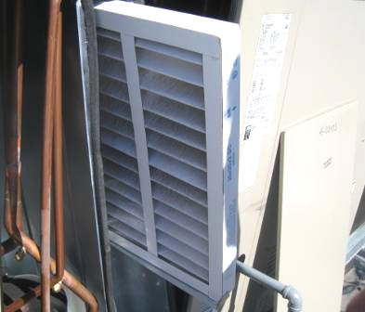

High-Efficiency Pleated Air Filters in Rooftop AHU

Picture 2

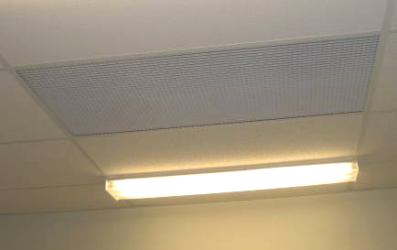

Ceiling-Mounted Return Vent in File Room

Picture 3

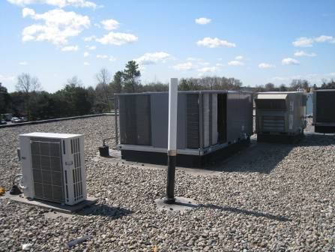

White PVC Vent Stack Extension

Picture 4

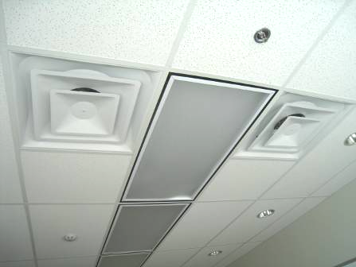

Ceiling-Mounted Supply Diffusers on Left/Right and Slotted Return Vents around Lights

Picture 5

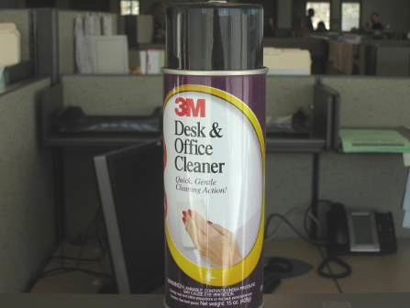

3M Office Cleaner, Note Warning at Bottom of Canister
MAY CAUSE EYE IRRITATION
Location | Carbon  Dioxide  (*ppm) | Temp  (°F) | Relative  Humidity  (%) | Carbon  Monoxide  (*ppm) | PM2.5  (µg/m³) | Occupants  in Room | Windows  Openable | Ventilation
Background | 317 | 62 | 21 | ND | 9 |  |  |  |  | Mostly sunny, cool, winds WSW 1-14 mph, gusts up to 20 mph
2nd Floor
Conference Room 225 | 462 | 74 | 23 | ND | 6 | 2 | N | Y | Y
Copy Room | 462 | 74 | 23 | ND | 7 | 0 | N | Y | Y
Dacey Office | 469 | 74 | 22 | ND | 6 | 1 | N | Y | Y | DO
230-232 | 407 | 75 | 20 | ND | 6 | 1 | N | Y | Y
234-240 | 415 | 75 | 19 | ND | 7 | 1 | N | Y | Y
244-247 | 434 | 75 | 20 | ND | 7 | 6 | N | Y | Y
250-252 | 456 | 75 | 20 | ND | 8 | 2 | N | Y | Y
Regional Council Office | 479 | 75 | 21 | ND | 7 | 1 | N | Y | Y | DO
257 Office | 495 | 74 | 21 | ND | 10 | 0 | N | Y | Y | DO
McAuliffe | 467 | 74 | 22 | ND | 8 | 0 | N | Y | Y | DO
Craveiro | 491 | 75 | 22 | ND | 7 | 1 | N | Y | Y | DO
Burges | 544 | 75 | 22 | ND | 7 | 1 | N | Y | Y
McNamara | 541 | 75 | 22 | ND | 8 | 0 | N | Y | Y
File Room | 516 | 75 | 22 | ND | 8 | 1 | N | Y | Y
268-269 | 476 | 74 | 21 | ND | 8 | 1 | N | Y | Y
270-271 | 454 | 74 | 20 | ND | 8 | 0 | N | Y | Y
273 | 460 | 74 | 21 | ND | 8 | 0 | N | Y | Y
Break Room | 510 | 75 | 21 | ND | 10 | 0 | N | Y | Y | DO
Computer Training | 463 | 74 | 21 | ND | 7 | 0 | N | Y | Y | DO
1st Floor
Regional Director | 502 | 74 | 21 | ND | 7 | 1 | N | Y | Y | DO
103 | 409 | 73 | 19 | ND | 7 | 1 | N | Y | Y
105-107 | 406 | 73 | 19 | ND | 7 | 1 | N | Y | Y
108-110 | 366 | 73 | 18 | ND | 7 | 0 | N | Y | Y
Photocopier/printer Area | 379 | 73 | 19 | ND | 7 | 0 | N | Y | Y
Mail Room | 480 | 74 | 21 | ND | 11 | 0 | N | Y | Y | Mail machines operating
Reception | 496 | 74 | 20 | ND | 8 | 1 | N | Y | Y
122 Interview Room | 464 | 74 | 20 | ND | 7 | 0 | N | Y | Y | DO
Pizzanello | 466 | 74 | 22 | ND | 7 | 0 | N | Y | Y
127-129 | 409 | 74 | 18 | ND | 7 | 0 | N | Y | Y
134 | 392 | 74 | 17 | ND | 7 | 3 | N | Y | Y
Conference Room 1 | 1188 | 73 | 29 | ND | 7 | 30 | N | Y | Y | Meeting/training being held/conducted
142 | 405 | 74 | 18 | ND | 7 | 1 | N | Y | Y
148-151 | 450 | 74 | 19 | ND | 8 | 2 | N | Y | Y
154-156 | 482 | 74 | 20 | ND | 8 | 1 | N | Y | Y
158 Deputy Regional Director | 477 | 73 | 20 | ND | 7 | 0 | N | Y | Y | DO
162 | 478 | 73 | 20 | ND | 11 | 0 | N | Y | Y
166 | 508 | 73 | 21 | ND | 8 | 3 | N | Y | Y
168 | 496 | 73 | 21 | ND | 7 | 0 | N | Y | Y
170-176 | 574 | 73 | 23 | ND | 9 | 2 | N | Y | Y
179 | 487 | 74 | 20 | ND | 8 | 1 | N | Y | Y | DO
File Room | 501 | 72 | 24 | ND | 8 | 0 | N | Y | Y

