INDOOR AIR QUALITY ASSESSMENT

Department of Revenue Office
99 South Main Street
Fall River, MA

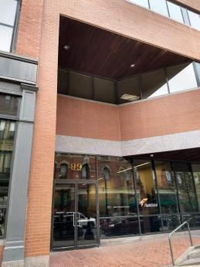

Prepared by:
Massachusetts Department of Public Health
Bureau of Environmental Health
Indoor Air Quality Program
November 2018

Background
Building: | Department of Revenue Office (DOR)
Address: | 99 South Main Street
Assessment Requested by: | Joshua Martin, Deputy Director, Office of Facilities Management, Massachusetts Department of Revenue
Reason for Request: | Post-occupancy indoor air quality (IAQ) assessment
Date of Assessment: | November 15, 2018
Massachusetts Department of Public Health/Bureau of Environmental Health (MDPH/BEH) Staff Conducting Assessment: | Ruth Alfasso, Environmental Engineer/Inspector, IAQ Program
Building Description: | Three-story brick building in downtown Fall River. DOR is a tenant on the 2nd floor. Other office tenants occupy the rest of the building.
Building Population: | Approximately 40 employees.
Year of Construction: | The building is a three-story brick office building originally constructed in the late 1800s. The building has been remodeled several times. The DOR-occupied space was fully remodeled prior to the DOR staff moving in October of 2018.
Windows: | Not openable

Methods
Please refer to the IAQ Manual for methods, sampling procedures, and interpretation of results (MDPH, 2015).

IAQ Testing Results
The following is a summary of indoor air testing results (Table 1).
- Carbon dioxide levels were below 800 parts per million (ppm) in all the areas assessed, indicating adequate fresh air in the space.
- Temperature was within or very close to the recommended range of 70°F to 78°F.
- Relative humidity was below the recommended range of 40% to 60% in all areas assessed and reflective of outdoor conditions on the day of the assessment.
- Carbon monoxide levels were non-detectable (ND) in all indoor areas assessed.
- Fine particulate matter (PM2.5) concentrations measured were below the National Ambient Air Quality Standard (NAAQS) level of 35 μg/m³ in all areas assessed.
- Total Volatile Organic Compounds (TVOCs) were ND in all areas assessed.

Ventilation
A heating, ventilating, and air conditioning (HVAC) system has several functions. First it provides heating and, if equipped, cooling. Second, it is a source of fresh air. Finally, an HVAC system will dilute and remove normally occurring indoor environmental pollutants not only by introducing fresh air, but also by filtering the airstream and ejecting stale air to the outdoors via exhaust ventilation. Even if an HVAC system is operating as designed, point sources of respiratory irritation may exist and cause symptoms in sensitive individuals. The following analysis examines and identifies components of the HVAC system and likely sources of respiratory irritant/allergen exposure from water damage, aerosolized dust, and/or chemicals found in the indoor environment.
Fresh air is provided by air-handling units (AHUs) located on the roof. Operation of the building HVAC system is controlled by an automated computer system. Air from the AHUs is filtered, heated/cooled, and delivered to rooms via ducted supply vents (Picture 1). Air is returned/exhausted through return vents (Picture 2). Note that in some areas, supply and return vents are very close together (Picture 2) which may allow supply air to short circuit directly to the return. It is recommended that HVAC systems be re-balanced every five years to ensure adequate air systems function (SMACNA, 1994). It was reported that the system was balanced prior to occupancy.

Microbial/Moisture Concerns
Several water coolers were located in carpeted areas (Picture 3). Spills or leaks from these appliances can moisten the carpet, leading to odors and microbial growth.
A few plants were observed (Table 1). Plants can be a source of pollen and mold, which can be respiratory irritants to some individuals. Plants should be properly maintained and equipped with drip pans to prevent water damage to porous materials. Plants should also be located away from air diffusers to prevent the aerosolization of dirt, pollen, and mold.
The IT/phone equipment room had a ductless air conditioning system to provide supplemental cooling (Picture 4). These units have condensate drains and pumps which may clog or leak if not maintained.

Other IAQ Evaluations
Exposure to low levels of total volatile organic compounds (TVOCs) may produce eye, nose, throat, and/or respiratory irritation in some sensitive individuals. To determine if VOCs were present, BEH/IAQ staff measured for TVOCS and examined rooms for products containing VOCs. While no TVOCs were detected (Table 1), BEH/IAQ staff noted dry erase markers, hand sanitizers, and cleaning products in use within the building (Picture 5; Table 1). All of these products have the potential to be irritants to the eyes, nose, throat, and respiratory system of sensitive individuals.
The other office areas on the second floor are currently being outfitted for another tenant. Construction operations should be conducted in accordance with Sheet Metal and Air Conditioning National Contractors Association’s IAQ Guidelines for Occupied Buildings under Construction (SMACNA, 2007) including isolation of areas under construction including the HVAC system, communication to tenants whenever potentially disruptive activities are planned, and monitoring of impacts.
The offices were mostly carpeted. Carpets should be cleaned annually (or semi-annually in soiled/high traffic areas) in accordance with Institute of Inspection, Cleaning, and Restoration Certification (IICRC) recommendations (IICRC, 2012).
Several office areas had food in them (Picture 6; Table 1). Food should be stored in tightly-sealed containers to prevent odors and pests. Kitchen equipment such as toasters, microwaves, and refrigerators should also be cleaned regularly.

Conclusions/Recommendations
Based on observations at the time of assessment, the following is recommended:
- Operate supply and return ventilation continuously (“fan on”) during occupied periods.
- Have the HVAC system balanced every 5 years in accordance with SMACNA recommendations (SMACNA, 1994).
- Consider redistributing return vents away from supply vents to prevent short circuiting of air supply.
- For buildings in New England, periods of low relative humidity during the winter are often unavoidable. Therefore, scrupulous cleaning practices should be adopted to minimize common indoor air contaminants whose irritant effects can be enhanced when the relative humidity is low. To control for dusts, a high efficiency particulate arrestance (HEPA) filter equipped vacuum cleaner in conjunction with wet wiping of all surfaces is recommended. Avoid the use of feather dusters. Drinking water during the day can help ease some symptoms associated with a dry environment (throat and sinus irritations).
- Place refrigerators and water dispensing equipment in areas without carpeting or use a waterproof mat underneath them.
- Keep plants in good condition, avoid overwatering, and avoid placing them on porous items such as carpets or paper.
- Periodically monitor the condensate drain lines/pump from the ductless air conditioner.
- Reduce use of cleaning products, sanitizers, and scented products.
- Follow the SMACNA guidance for occupied buildings with construction (SMACNA, 1995)
- Keep food in tightly sealed containers and keep kitchen equipment clean.
- Clean carpeting in accordance with IICRC recommendations (IICRC, 2012).
- Clean supply and exhaust vents, personal fans, and heaters regularly to prevent aerosolization of debris.
- Refer to resource manual and other related IAQ documents located on the MDPH’s website for further building-wide evaluations and advice on maintaining public buildings. These documents are available at: http://mass.gov/dph/iaq.

References
IICRC. 2012. Institute of Inspection, Cleaning and Restoration Certification. Carpet Cleaning: FAQ.
MDPH. 2015. Massachusetts Department of Public Health. Indoor Air Quality Manual: Chapters I-III. Available at: http://www.mass.gov/eohhs/gov/departments/dph/programs/environmental-health/exposure-topics/iaq/iaq-manual/.
SMACNA. 1994. HVAC Systems Commissioning Manual. 1st ed. Sheet Metal and Air Conditioning Contractors’ National Association, Inc., Chantilly, VA.
SMACNA. 2007. IAQ Guidelines for Occupied Buildings under Construction. 1st ed. Sheet Metal and Air Conditioning Contractors’ National Association, Inc., Chantilly, VA.

Picture 1
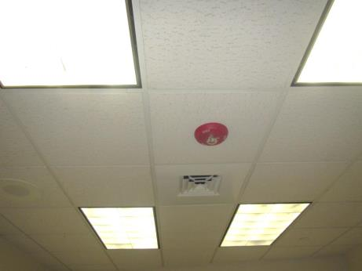
Supply vent
Picture 2
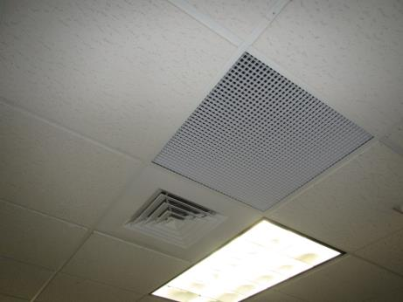
Supply and return vent adjacent to each other
Picture 3
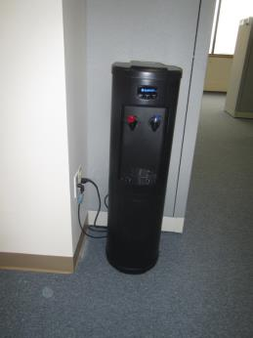
Water cooler on carpet
Picture 4
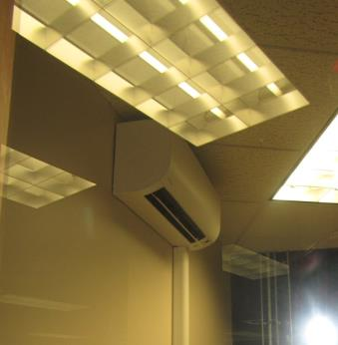
Ductless air conditioning unit
Picture 5
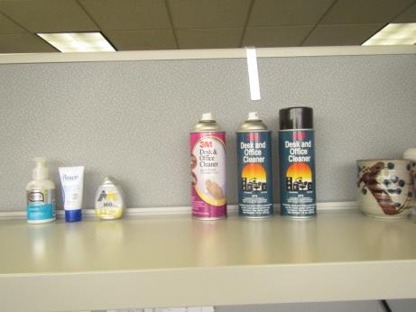
Cleaning products
Picture 6
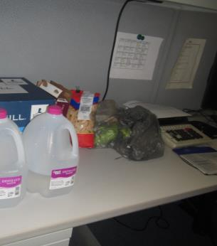
Food packaging
Location | Carbon  Dioxide  (ppm) | Carbon Monoxide  (ppm) | Temp  (°F) | Relative  Humidity  (%) | PM2.5  (µg/m³) | TVOC  (ppm) | Occupants  in Room | Windows  Openable | Ventilation |  | Remarks
 |  |  |  |  |  |  |  |  | Supply | Exhaust
Background | 443 | ND | <32 | 14 | 1 | ND |  |  |  |  | Cloudy, traffic
Conference room 1 | 604 | ND | 69 | 22 | 21 | ND | 1 | N | Y
Cube 43 | 578 | ND | 71 | 19 | ND | ND | 0 | N | Y
Copy room | 567 | ND | 72 | 19 | ND | ND | 0 | N | N |  | NC, PC
Conference room 2 | 527 | ND | 72 | 18 | ND | ND | 0 | N | Y | Y | Water cooler on carpet outside
Cube 42 | 570 | ND | 72 | 18 | ND | ND | 1 | N | Y
Office 1 | 614 | ND | 73 | 18 | 1 | ND | 1 | N | Y |  | Food
Cube 40 | 644 | ND | 73 | 18 | ND | ND | 3 | N | Y |  | HS
Cube area 38-41 | 698 | ND | 73 | 19 | ND | ND | 1 | N | Y |  | PF
Cube area 32-35 | 659 | ND | 73 | 18 | 1 | ND | 1 | N | Y | Y | CP, HS, plant, PF
Cube area 26-29 | 586 | ND | 74 | 17 | 1 | ND | 4 | N | Y | Y
Cube area 20-23 | 585 | ND | 74 | 16 | 12 | ND | 1 | N | Y | Y | PFs and stand fan
Cube area 12-18 | 566 | ND | 74 | 16 | ND | ND | 4 | N | Y | Y | HS, decorative items, food
Cube 19 | 560 | ND | 75 | 15 | ND | ND | 1 | N | Y
Cube area 9-11 | 550 | ND | 75 | 15 | ND | ND | 1 | N | Y | Y
Office 2 | 556 | ND | 75 | 15 | ND | ND | 1 | N | Y | N | Food, HS, noted trees next to window
Kitchen | 555 | ND | 75 | 16 | ND | ND | 1 | N | Y | N | Sink, fridge, microwaves, coffee maker, NC
Parenting room | 538 | ND | 74 | 15 | ND | ND | 0 | N | Y | N | Sink
Reception | 531 | ND | 74 | 15 | ND | ND | 1 | N | Y
Cube area behind reception | 571 | ND | 74 | 15 | 1 | ND | 1 | N | Y | Y | Food, PF, PC
Waiting room | 550 | ND | 74 | 15 | ND | ND | 0 | N | Y | N | 2 computers

