INDOOR AIR QUALITY ASSESSMENT

Department of Revenue
1 Federal Street
Springfield, MA

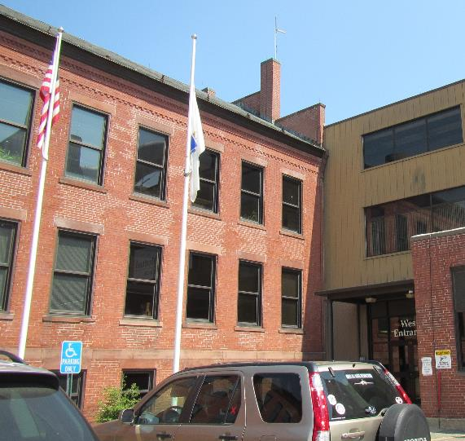

Prepared by:
Massachusetts Department of Public Health
Bureau of Environmental Health
Indoor Air Quality Program
July 2019

Background
Building: | Springfield Department of Revenue (DOR)
Address: | 1 Federal Street, West Entrance, 3rd Floor, Springfield, MA
Assessment Requested by: | Joshua Martin, Deputy Director, Office of Facilities Management, DOR
Reason for Request: | General indoor air quality (IAQ) following renovations
Date of Assessment: | July 11, 2019
Massachusetts Department of Public Health/Bureau of Environmental Health (MDPH/BEH) Staff Conducting Assessment: | Ruth Alfasso, Environmental Engineer/Inspector, IAQ Program
Building Description: | Former armory building in a complex now called Springfield Technology Park. The building has brick construction with a complex roof. The DOR space is on the third floor next to the west entrance. Other office tenants are above, adjacent to, and below this office.
Building Population: | Approximately 75 staff and approximately 20 members of the public visiting daily
Windows: | Designed as openable but sealed
This is a follow-up to a visit that was made earlier in 2019. A report from that visit is available on request.

METHODS
Please refer to the IAQ Manual for methods, sampling procedures, and interpretation of results (MDPH, 2015).

IAQ Testing Results
The following is a summary of indoor air testing results (Table 1). Note that only a small number of areas were tested during this visit.
- Carbon dioxide levels were below the MDPH guideline of 800 parts per million (ppm) in all of the areas tested, indicating adequate fresh air supply for the space.
- Temperature was within the MDPH recommended range of 70°F to 78°F in all areas tested.
- Relative humidity was within the MDPH recommended range of 40 to 60%.
- Carbon monoxide levels were non-detectable (ND) in all indoor areas tested.
- Fine particulate matter (PM2.5) concentrations measured were below the National Ambient Air Quality Standard (NAAQS) level of 35 μg/m³ in all indoor areas tested.

Ventilation
A heating, ventilating and air conditioning (HVAC) system has several functions. First it provides heating and, if equipped, cooling. Second, it is a source of fresh air. Finally, an HVAC system will dilute and remove normally occurring indoor environmental pollutants by not only introducing fresh air, but by filtering the airstream and ejecting stale air to the outdoors via exhaust ventilation. Even if an HVAC system is operating as designed, point sources of respiratory irritants may exist and cause symptoms in sensitive individuals. The following analysis examines and identifies components of the HVAC system and likely sources of respiratory irritant/allergen exposure due to water damage, aerosolized dust and/or chemicals found in the indoor environment.
Fresh air for the space is provided by air handling units (AHU) via ducts to supply vents. Ducted wall-mounted or ceiling-mounted exhaust vents remove stale air. The HVAC system is controlled using thermostats located around the office. The HVAC system was reportedly balanced as a part of recent renovations prior to the previous visit. It is recommended that HVAC systems be re-balanced every five years to ensure adequate air systems function (SMACNA, 1994).
The main reason for this return visit was to reevaluate a few areas in the front of the office that had levels above the MDPH recommended carbon dioxide level or 800 ppm during the visit earlier in 2019. These areas also had a slight musty or stale odor at that time. During this visit, all carbon dioxide levels measured were below the MDPH recommendation, and no musty or stale odors were present in the areas examined. Facility staff reported that adjustments had been made to the HVAC system in the areas examined, including changing of filters.

Microbial/Moisture Concerns
No water-damaged materials, stains or leaks were noted during this visit. It was raining outside with a high relative humidity, and relative humidity in the office space was within MDPH comfort guidelines (Table 1), indicating that the HVAC system was doing an adequate job of humidity removal.

Other IAQ Evaluations
The PM2.5 measurements outside were above the NAAQS levels of 35 μg/m³ (Table 1). Levels inside the office, however, were well below the NAAQS levels (Table 1), indicating that filters on the HVAC system are performing adequately. If outdoor air quality is frequently poor (e.g., pollution, pollen), filters may need to be changed more often.

Conclusions/Recommendations
The following recommendations are made to assist in maintaining IAQ:
- Continue to follow recommendations in the May 2019 report.
- If filters on the HVAC system are highly soiled during changes, or if outdoor air frequently has high levels of pollen or pollution, consider changing filters more frequently.
- Refer to resource manual and other related IAQ documents located on the MDPH’s website for further building-wide evaluations and advice on maintaining public buildings. These documents are available at: http://mass.gov/dph/iaq.

References
MDPH. 2015. Massachusetts Department of Public Health. Indoor Air Quality Manual: Chapters I-III. Available at: http://www.mass.gov/eohhs/gov/departments/dph/programs/environmental-health/exposure-topics/iaq/iaq-manual/.
SMACNA. 1994. HVAC Systems Commissioning Manual. 1st ed. Sheet Metal and Air Conditioning Contractors’ National Association, Inc., Chantilly, VA.
Location | Carbon  Dioxide  (ppm) | Carbon Monoxide  (ppm) | Temp  (°F) | Relative  Humidity  (%) | PM2.5  (µg/m³) | Occupants  in Room | Windows  Openable | Ventilation |  | Remarks
 |  |  |  |  |  |  |  | Supply | Exhaust
Background | 517 | 0.7 | 77 | 75 | 57 | 0 |  |  |  | Periodic showers
Waiting room | 701 | ND | 74 | 47 | 19 | 4 | N | Y | Y
Area in front of reception | 650 | ND | 72 | 49 | 13 | 0 | N | Y | Y
Interview 3, public side | 628 | ND | 72 | 50 | 13 | 0 | N | Y | Y
Interview 3, inside | 693 | ND | 73 | 52 | 12 | 0 | N | Y | Y
Interview rooms across from reception | 620 | ND | 71 | 52 | 13 | 0 | N | Y | Y

