INDOOR AIR QUALITY
LEASE RENEWAL ASSESSMENT

Commonwealth of Massachusetts
Department of Revenue/Office of Environmental Law Enforcement
218 South Main Street
Fall River, MA

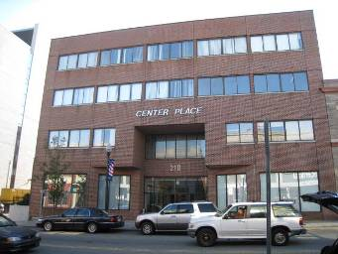

Prepared by:
Massachusetts Department of Public Health
Bureau of Environmental Health
Indoor Air Quality Program
November 2012

Background/Introduction
In response to a request from Gerry Covino, Project Manager, Division of Capital Asset Management (DCAM), the Massachusetts Department of Public Health (MDPH), Bureau of Environmental Health (BEH) conducted a pre-lease renewal indoor air quality (IAQ) assessment at 218 South Main Street, Fall River, Massachusetts. This evaluation was conducted as part of enhanced efforts to ensure acceptable IAQ of office space leased by Massachusetts state agencies. On October 22, 2012, a visit to conduct an IAQ assessment was made by Cory Holmes, Environmental Analyst/Regional Inspector for BEH’s IAQ Program.
The building is a multi-level brick structure that was originally built as a movie theater in 1940. The theater was closed in the late 1970s, renovated into office space in the late 1980s, and has undergone a number of renovations since that time. The Department of Revenue (DOR) has occupied the majority of the 3rd floor since 1991. A small portion of the 3rd floor is occupied by the Massachusetts Executive Office of Energy and Environmental Affairs, Office of Environmental Law Enforcement. State-leased space consists of offices, open work areas, conference rooms and an employee break area.

Methods
Air tests for carbon monoxide, carbon dioxide, temperature and relative humidity were taken with the TSI, Q-Trak, IAQ Monitor 7565. Air tests for airborne particle matter with a diameter less than 2.5 micrometers were taken with the TSI, DUSTTRAK™ Aerosol Monitor Model 8520. Moisture content of water-damaged building materials (wooden windowsills, gypsum wallboard, carpeting) was measured with a Delmhorst, BD-2000 Model, Moisture Detector equipped with a Delmhorst Standard Probe. BEH/IAQ staff also performed visual inspection of building materials for water damage and/or microbial growth and other conditions that may potentially impact IAQ.

Results
The offices have a combined employee population of approximately 50 with several hundred members of the public conducting business daily. Test results appear in Table 1 and are listed by function, occupant last name(s) or office numerical designation (where available).

Discussion

Ventilation
It can be seen from Table 1 that carbon dioxide levels were above 800 parts per million (ppm) in 12 of 15 areas surveyed, indicating a lack of optimal air exchange at the time of assessment. Fresh air is provided by three rooftop air-handling units (AHUs) (Picture 1). Fresh air is drawn into the AHUs through a bank of pleated air filters, heated or cooled and delivered to occupied areas via ducted air diffusers (Picture 2). Return air is drawn into ceiling-mounted vents (Picture 3) and ducted back to the rooftop AHUs.
The heating, ventilating and air-conditioning (HVAC) system is controlled by digital thermostats. Thermostats examined had a fan switch with two settings, on and auto (Picture 4). When the fan is set to on, the system provides a continuous source of air circulation and filtration. The automatic setting on the thermostat activates the HVAC system to a preset temperature. Once the preset temperature is reached, the HVAC system is deactivated. Therefore, no mechanical ventilation is provided until the thermostat re-activates the system. The MDPH typically recommends that thermostats be set to the fan on setting during occupied hours to provide continuous air circulation. During the assessment most of the thermostats were set to the fan auto setting; one thermostat was shut completely off, therefore no air circulation was being provided.
In order to have proper ventilation with a mechanical supply and exhaust system, the systems must be balanced to provide an adequate amount of fresh air to the interior of a room while removing stale air from the room. It is recommended that HVAC systems be re-balanced every five years to ensure adequate air systems function (SMACNA, 1994).
The Massachusetts Building Code requires a minimum ventilation rate of 20 cubic feet per minute (cfm) per occupant of fresh outside air or openable windows (SBBRS, 1997; BOCA, 1993). The ventilation must be on at all times that the room is occupied. Providing adequate fresh air ventilation with open windows and maintaining the temperature in the comfort range during the cold weather season is impractical. Mechanical ventilation is usually required to provide adequate fresh air ventilation.
Carbon dioxide is not a problem in and of itself. It is used as an indicator of the adequacy of the fresh air ventilation. As carbon dioxide levels rise, it indicates that the ventilating system is malfunctioning or the design occupancy of the room is being exceeded. When this happens, a buildup of common indoor air pollutants can occur, leading to discomfort or health complaints. The Occupational Safety and Health Administration (OSHA) standard for carbon dioxide is 5,000 parts per million parts of air (ppm). Workers may be exposed to this level for 40 hours/week, based on a time-weighted average (OSHA, 1997).
The MDPH uses a guideline of 800 ppm for publicly occupied buildings. A guideline of 600 ppm or less is preferred in schools due to the fact that the majority of occupants are young and considered to be a more sensitive population in the evaluation of environmental health status. Inadequate ventilation and/or elevated temperatures are major causes of complaints such as respiratory, eye, nose and throat irritation, lethargy and headaches. For more information concerning carbon dioxide, please see Appendix A.
Indoor temperatures ranged from 71°F to 77°F (Table 1), which were within the MDPH recommended comfort range at the time of assessment. The MDPH recommends that indoor air temperatures be maintained in a range of 70°F to 78°F in order to provide for the comfort of building occupants. In many cases concerning indoor air quality, fluctuations of temperature in occupied spaces are typically experienced, even in a building with an adequate fresh air supply. Temperature/comfort control issues were reported in the large conference room. DCAM, DOR and building management are in discussion to install separate controls in this area to enhance comfort. In one area a supply diffuser was sealed with plastic (Picture 5). Blocking fresh air diffusers limits the ability of the HVAC system to deliver air and causes air to back up in the duct, forcing more air out of other fresh air diffusers that are not blocked. As a result, increased airflow causes more temperature complaints as well as an increase in noise produced by the velocity of air forced through the diffusers.
Relative humidity measurements ranged from 41 to 50 percent (Table 1), which were also within the MDPH recommended comfort range. The MDPH recommends a comfort range of 40 to 60 percent for indoor air relative humidity. Several building occupants expressed that the building air felt dry. The sensation of dryness and irritation is common in a low relative humidity environment. Low relative humidity is a very common problem during the heating season in the northeast part of the United States.

Microbial/Moisture Concerns
In order for building materials to support mold growth, a source of water exposure is necessary. Bubbling/peeling paint and water-damaged windowsills were observed in several areas (Pictures 6 through 8), indicating window leaks. At the time of assessment, BEH/IAQ staff conducted moisture tests in water-damaged wooden windowsills and found several to be elevated (Table 1), necessitating their removal.
The US Environmental Protection Agency (US EPA) and the American Conference of Governmental Industrial Hygienists (ACGIH) recommend that porous materials (e.g., carpeting, fiberglass insulation) be dried with fans and heating within 24 to 48 hours of becoming wet (US EPA, 2001; ACGIH, 1989). If not dried within this time frame, mold growth may occur. Once mold has colonized porous materials, they are difficult to clean and should be removed/discarded.
Plants were observed in a few areas. Plants, soil and drip pans can serve as sources of mold/bacterial growth. Plants should be properly maintained, over-watering of plants should be avoided and drip pans should be inspected periodically for mold growth.

Other IAQ Evaluations
Indoor air quality can be negatively influenced by the presence of respiratory irritants, such as products of combustion. The process of combustion produces a number of pollutants. Common combustion emissions include carbon monoxide, carbon dioxide, water vapor, and smoke (fine airborne particle material). Of these materials, exposure to carbon monoxide and particulate matter with a diameter of 2.5 micrometers (μm) or less (PM2.5) can produce immediate, acute health effects upon exposure. To determine whether combustion products were present in the indoor environment, BEH/IAQ staff obtained measurements for carbon monoxide and PM2.5.

Carbon Monoxide
Carbon monoxide is a by-product of incomplete combustion of organic matter (e.g., gasoline, wood and tobacco). Exposure to carbon monoxide can produce immediate and acute health affects. Several air quality standards have been established to address carbon monoxide and prevent symptoms from exposure to these substances. The MDPH established a corrective action level concerning carbon monoxide in ice skating rinks that use fossil-fueled ice resurfacing equipment. If an operator of an indoor ice rink measures a carbon monoxide level over 30 ppm, taken 20 minutes after resurfacing within a rink, that operator must take actions to reduce carbon monoxide levels (MDPH, 1997).
The American Society of Heating Refrigeration and Air-Conditioning Engineers (ASHRAE) has adopted the National Ambient Air Quality Standards (NAAQS) as one set of criteria for assessing indoor air quality and monitoring of fresh air introduced by HVAC systems (ASHRAE, 1989). The NAAQS are standards established by the US EPA to protect the public health from six criteria pollutants, including carbon monoxide and particulate matter (US EPA, 2006). As recommended by ASHRAE, pollutant levels of fresh air introduced to a building should not exceed the NAAQS levels (ASHRAE, 1989). The NAAQS were adopted by reference in the Building Officials & Code Administrators (BOCA) National Mechanical Code of 1993 (BOCA, 1993), which is now an HVAC standard included in the Massachusetts State Building Code (SBBRS, 1997). According to the NAAQS, carbon monoxide levels in outdoor air should not exceed 9 ppm in an eight-hour average (US EPA, 2006).
Carbon monoxide should not be present in a typical, indoor environment. If it is present, indoor carbon monoxide levels should be less than or equal to outdoor levels. Outdoor carbon monoxide concentrations were non-detect the day of the assessment (Table 1). No measureable levels of carbon monoxide were detected in the building during the assessment (Table 1).

Particulate Matter
The US EPA has established NAAQS limits for exposure to particulate matter. Particulate matter is airborne solids that can be irritating to the eyes, nose and throat. The NAAQS originally established exposure limits to particulate matter with a diameter of 10 μm or less (PM10). According to the NAAQS, PM10 levels should not exceed 150 micrograms per cubic meter (μg/m³) in a 24-hour average (US EPA, 2006). These standards were adopted by both ASHRAE and BOCA. Since the issuance of the ASHRAE standard and BOCA Code, US EPA established a more protective standard for fine airborne particles. This more stringent PM2.5 standard requires outdoor air particle levels be maintained below 35 μg/m³ over a 24-hour average (US EPA, 2006). Although both the ASHRAE standard and BOCA Code adopted the PM10 standard for evaluating air quality, MDPH uses the more protective PM2.5 standard for evaluating airborne particulate matter concentrations in the indoor environment.
Outdoor PM2.5 was measured at 22 μg/m³ (Table 1). PM2.5 levels measured indoors ranged from 5 to 14 μg/m³ (Table 1), which were below the NAAQS PM2.5 level of 35 μg/m³. Frequently, indoor air levels of particulates (including PM2.5) can be at higher levels than those measured outdoors. A number of mechanical devices and/or activities that occur in buildings can generate particulate during normal operations. Sources of indoor airborne particulates may include but are not limited to particles generated during the operation of fan belts in the HVAC system, use of stoves and/or microwave ovens in kitchen areas; use of photocopiers, fax machines and computer printing devices; operation of an ordinary vacuum cleaner and heavy foot traffic indoors.
Lastly, DOR staff use volatile organic compound (VOC)-containing cleaning materials (Picture 9) to clean personal work areas. These materials contain several VOCs (e.g., isopropyl alcohol and monoethanolamine) that can be irritating to the eyes, nose and throat (3M, 2000).

Conclusions/Recommendations
In view of the findings at the time of the visit, the following recommendations are made:
- Ensure that all thermostats are activated and set to the fan “on” position to operate the ventilation system continuously in occupied areas during business hours.
- Continue with plans to work with building management and HVAC vendor to examine the large conference room for better temperature/comfort control.
- Remove plastic covering supply air diffusers. Work with HVAC vendor and/or building management to relocate diffuser or install an adjustable diffuser to improve comfort.
- Consider adopting a balancing schedule of every 5 years for all mechanical ventilation systems, as recommended by ventilation industrial standards (SMACNA, 1994).
- For buildings in New England, periods of low relative humidity during the winter are often unavoidable. Therefore, scrupulous cleaning practices should be adopted to minimize common indoor air contaminants whose irritant effects can be enhanced when the relative humidity is low. To control for dusts, a high efficiency particulate arrestance (HEPA) filter equipped vacuum cleaner in conjunction with wet wiping of all surfaces is recommended. Avoid the use of feather dusters. Drinking water during the day can help ease some symptoms associated with a dry environment (throat and sinus irritations).
- Ensure window leaks are repaired. Repair/replace any remaining water-damaged wooden windowsills and peeling paint. Monitor for further leaks, if leaking recurs, report to building management for prompt remediation.
- Avoid overwatering of plants. Ensure flat surfaces around plants are free of potting soil and other plant debris. Examine drip pans periodically for mold growth and disinfect with an appropriate antimicrobial where necessary. Do not place plants on porous materials (e.g., paper/cardboard).
- Consider discontinuing the use of VOC-containing cleaners. Less irritating materials, (soap and water) may suffice to clean in these areas.
- Refer to resource manual and other related indoor air quality documents located on the MDPH’s website for further building-wide evaluations and advice on maintaining public buildings. These documents are available at: http://mass.gov/dph/iaq.

References
3M. 2000. Material Safety Data Sheet (MSDS Document No: 10-0157-7). 3M Brand Desk and Office Cleaner 573. Minnesota Mining and Manufacturing Company. St. Paul, Minnesota.
ACGIH. 1989. Guidelines for the Assessment of Bioaerosols in the Indoor Environment. American Conference of Governmental Industrial Hygienists, Cincinnati, OH.
ASHRAE. 1989. Ventilation for Acceptable Indoor Air Quality. American Society of Heating, Refrigeration and Air Conditioning Engineers. ANSI/ASHRAE 62-1989.
BOCA. 1993. The BOCA National Mechanical Code/1993. 8th ed. Building Officials and Code Administrators International, Inc., Country Club Hill, IL.
MDPH. 1997. Requirements to Maintain Air Quality in Indoor Skating Rinks (State Sanitary Code, Chapter XI). 105 CMR 675.000. Massachusetts Department of Public Health, Boston, MA.
OSHA. 1997. Limits for Air Contaminants. Occupational Safety and Health Administration. Code of Federal Regulations. 29 C.F.R 1910.1000 Table Z-1-A.
SBBRS. 1997. Mechanical Ventilation. State Board of Building Regulations and Standards. Code of Massachusetts Regulations. 780 CMR 1209.0
SMACNA. 1994. HVAC Systems Commissioning Manual. 1st ed. Sheet Metal and Air Conditioning Contractors’ National Association, Inc., Chantilly, VA.
US EPA. 2001. “Mold Remediation in Schools and Commercial Buildings”. Office of Air and Radiation, Indoor Environments Division, Washington, DC. EPA 402-K-01-001. March 2001. Available at: http://www.epa.gov/iaq/molds/mold_remediation.html
US EPA. 2006. National Ambient Air Quality Standards (NAAQS). US Environmental Protection Agency, Office of Air Quality Planning and Standards, Washington, DC. http://www.epa.gov/air/criteria.html
Picture 1

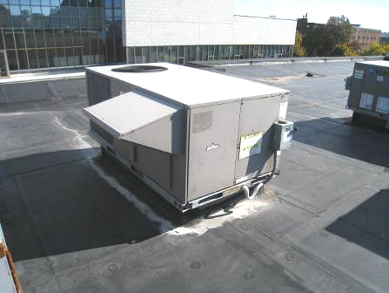

Rooftop air handling unit

Picture 2

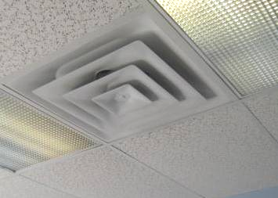

Ceiling-mounted supply diffuser

Picture 3

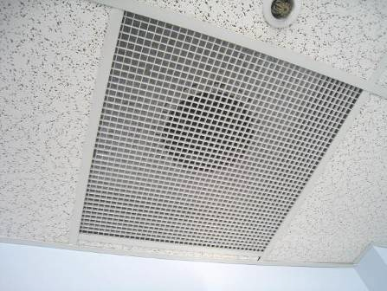

Ceiling-mounted return vent

Picture 4

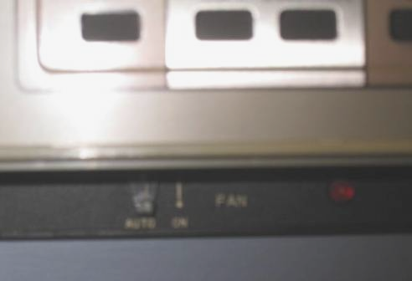

Close-up of digital thermostat with fan in “auto” setting

Picture 5

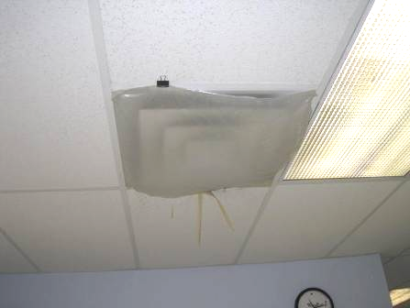

Supply diffuser sealed with plastic

Picture 6

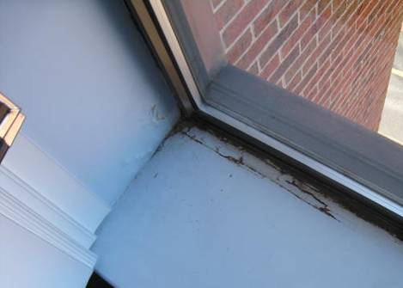

Water-damaged windowsill

Picture 7

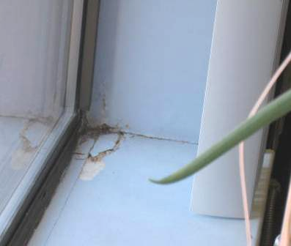

Water-damaged windowsill

Picture 8

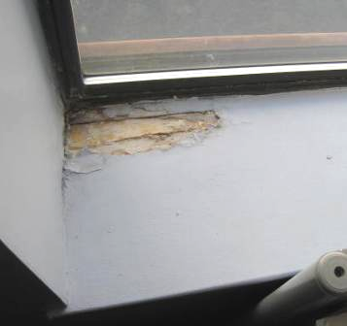

Water-damaged windowsill

Picture 9

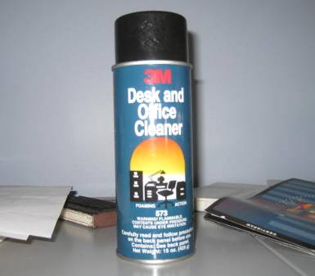

VOC-containing spray cleaner, note warning label: flammable, causes eye irritation
Location | Carbon  Dioxide  (*ppm) | Temp  (°F) | Relative  Humidity  (%) | Carbon  Monoxide  (*ppm) | PM2.5  (µg/m³) | Occupants  in Room | Windows  Openable | Ventilation |  | Remarks
Background | 404 | 59 | 55 | ND | 22 |  |  |  |  | Clear, cool, west winds 9-21 mph, gusts up to 26 mph , moderate traffic conditions
Pavao | 850 | 71 | 45 | ND | 14 | 1 | N | Y | Y
Dupuy/Dube | 851 | 72 | 49 | ND | 5 | 5 | N | Y | Y | WD windowsill-elevated moisture measurement
Maltais | 832 | 73 | 46 | ND | 5 | 5 | N | Y | Y
Clerkin | 902 | 75 | 45 | ND | 6 | 0 | N | Y | Y | Condensation btwn window panes-seal
Rota | 849 | 76 | 43 | ND | 6 | 3 | N | Y | Y
Rodrigues/McGrath | 840 | 76 | 43 | ND | 6 | 3 | N | Y | Y | WD windowsill-elevated moisture measurement
Hartnett/Sanf | 892 | 76 | 45 | ND | 6 | 4 | N | Y | Y | Supply vent sealed with plastic
Sheehan | 840 | 77 | 41 | ND | 6 | 1 | N | Y | Y
Conference Room (Small) | 810 | 75 | 41 | ND | 6 | 0 | N | Y | Y
Silvia | 833 | 75 | 42 | ND | 5 | 0 | N | Y | Y
Reception Area | 790 | 73 | 44 | ND | 6 | 1 | N | Y | Y
Arruda/Burns | 796 | 73 | 43 | ND | 6 | 3 | N | Y | Y
Conference Room | 1016 | 73 | 46 | ND | 7 | 4 | N | Y | Y | Temperature/comfort control issues
Cafeteria/breakroom | 900 | 73 | 50 | ND | 11 | 0 | N | Y | Y
Office of Environmental Law Enforcement | 712 | 73 | 43 | ND | 7 | 2 | N | Y | Y | Plants

