INDOOR AIR QUALITY ASSESSMENT

Department of Transitional Assistance
1010 Massachusetts Avenue
Boston, MA

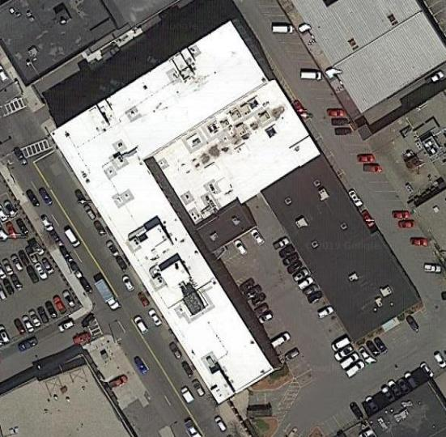

Prepared by:
Massachusetts Department of Public Health
Bureau of Environmental Health
Indoor Air Quality Program
March 2019

BACKGROUND
Building: | Department of Transitional Assistance
Address: | 1010 Massachusetts Avenue, Boston
Assessment Requested by: | Erin McCabe, EHS Facilities Deputy Director for Finance and Operations
Reason for Request: | Water damage and general indoor air quality (IAQ)
Date of Assessment: | March 11, 2019
Massachusetts Department of Public Health/Bureau of Environmental Health (MDPH/BEH) Staff Conducting Assessment: | Ruth Alfasso, Environmental Engineer/Inspector
Date Building Constructed: | Original building: 1901  Addition occupied by DTA: 1940s
Building Description: | The building is a multi-level complex. The DTA occupies a single-story addition to the building.
Windows: | Not openable, although some may have been openable in the past.

METHODS
Please refer to the IAQ Manual and appendices for methods, sampling procedures, and interpretation of results (MDPH, 2015).
Note that this building has been visited by the DPH IAQ Program several times in the past, most recently in January of 2016. Reports from the more recent previous visits can be found at: https://www.mass.gov/info-details/indoor-air-quality-reports-cities-and-towns-b

RESULTS and DISCUSSION
The following is a summary of indoor air testing results (Table 1).
- Carbon dioxide levels were above the MDPH recommended level of 800 parts per million (ppm) in more than half of the areas surveyed, which indicates a lack of air exchange in many areas.
- Temperature was within the MDPH recommended range of 70°F to 78°F in occupied areas.
- Relative humidity was below the MDPH recommended range of 40 to 60% in all areas tested, which is typical of conditions during the heating season.
- Carbon monoxide levels ranged from not detected (ND) to 2 ppm in occupied areas, and ranged from ND to 1 ppm outside.
- Particulate matter (PM2.5) concentrations measured were below the National Ambient Air Quality (NAAQS) level of 35 μg/m³ in all areas tested.

A heating, ventilating and air conditioning (HVAC) system has several functions. First it provides heating and, if equipped, cooling. Second, it is a source of fresh air. Finally, an HVAC system will dilute and remove normally-occurring indoor environmental pollutants by not only introducing fresh air, but by filtering the airstream and ejecting stale air to the outdoors via exhaust ventilation. Even if an HVAC system is operating as designed, point sources of respiratory irritation may exist and cause symptoms in sensitive individuals.
Fresh air is provided by rooftop air-handling units (AHUs) and ducted to air diffusers (Picture 1). Air is returned to the AHUs via vents into the ceiling plenum (Picture 2). AHUs are regulated by electronic thermostats in locked boxes that prevent staff from changing settings (Picture 3). It could not be determined if the fans were set to “on” as recommended during occupied periods because the settings were inaccessible. At the time of the visit, it appeared as if fresh air circulation for some areas of the office was not operating, which may account for the elevated carbon dioxide readings. A vent in an office was covered with cloth (Picture 4), possibly to reduce drafts or noise. Vents should remain unblocked. It is important that occupants have a system to make written requests for adjustments of the HVAC system to address heat, cold and noise complaints without turning off or blocking system components directly.
Note that the DTA uses closed offices, open cubicle areas, and half-walled offices with tall divider walls that go most of the way to the ceiling. Some offices lacked a supply or exhaust vent and in some cases, supply and return vents did not line up well with the locations of the tall dividers, which may limit air circulation in some areas.
To maximize air exchange, the IAQ program recommends that both supply and exhaust ventilation operate continuously during periods of occupancy. In order to have proper ventilation with a mechanical ventilation system, the systems must be balanced after installation to provide an adequate amount of fresh air to the interior of a room while removing stale air from the room. It is recommended that HVAC systems be re-balanced every five years to ensure adequate air systems function (SMACNA, 1994). It is not known when the systems were last balanced.

Microbial/Moisture Concerns
Water-damaged ceiling tiles were observed in many areas (Pictures 4 through 6; Table 1), most of which were due to roof leaks. Active leaks were occurring in some areas at the time of the assessment, likely due to recent rain and melting snow on the roof, resulting in wet ceiling tiles and water dripping into occupied areas (Picture 7). Trash cans were being used to collect water in some areas, and building maintenance staff were on site during the assessment to remove wet ceiling tiles and assess the condition of the roof. Some stained tiles appeared to be from previous or historic roof or plumbing/sprinkler leaks as well.
There was also evidence of previous water infiltration in a few offices along the edge of the building, including the security office and reception area. A wall in the security office was water-stained. Coving in the reception area could easily be pulled away from the wall, indicating previous water exposure (Picture 8), however the area was dry at the time of the assessment. In the Czolpinski office, the occupant reported that carpeting had been wet, and there was a light coating of plaster on the carpeting in the corner, suggesting that water had flowed through the exterior of the building, dissolving plaster or mortar, moistened the carpeting and then evaporated leaving plaster residue behind. Some of the areas of known or suspected water infiltration were behind the cloth and metal cubicle walls, which would prevent both detection and drying.
The US Environmental Protection Agency (US EPA) and the American Conference of Governmental Industrial Hygienists (ACGIH) recommends that porous materials (e.g., wallboard, carpeting) be dried with fans and heating within 24 to 48 hours of becoming wet (US EPA, 2008; ACGIH, 1989). If porous materials are not dried within this time frame, mold growth may occur.
Note that the DTA offices are slightly below grade. Water infiltration described above comes through the exterior walls at the base of the building. The exterior of the building is clad in an External Insulating Finishing System (EIFS) which has a lightweight insulating foam substrate and a stucco-like texture on the outside. EIFS cladding, particularly if it is built without a drainage layer, can allow water infiltration if the coating becomes damaged or discontinuous. In previous reports for this building, the EIFS near the base of the building was found in poor condition and likely contributing to water infiltration. Some of this was due to damage along the lower edge likely from contact with cars parked along the building exterior. Since that time, a layer of metal flashing was added along the bottom edge of the building (Picture 9). This material was in poor condition in some areas (Picture 10), again likely due in part to damage by vehicles or plowing. It could not be determined how the material was connected to the substrate and how it was originally sealed to be watertight. Note that snow is pushed against the building in this location. As it melts, it can be a source of water infiltration into the building. Removal of the snow against the building during periods of melting may help decrease water infiltration.
A few ductless air conditioners are used in the office (Picture 11). These reportedly have issues with condensate leaks and odors when in use. Condensate drains and pumps need to be free of leaks and clogs so that condensate can flow freely. Units should be thoroughly cleaned to reduce odors.
Plants and cut flowers were noted in some offices (Picture 12; Table 1). Plants and flowers should be well-maintained, not overwatered and use non-porous drip pans. They should be kept away from the airstream of ventilation equipment to prevent the distribution of pollen, mold, dirt and odors.
Small refrigerators were found on carpeting in some areas (Table 1). These appliances should be located in non-carpeted areas and should be kept clean and free from spills and spoiled food that can lead to odors. Note that in the lunchroom, the refrigerator was marked as “out of order” and had an odor when opened. Defunct appliances should be cleaned and removed. In the Staff Room, a refrigerator had evidence of a spill and the gasket was lightly stained with mold. Stained gaskets should be cleaned with an antimicrobial solution or replaced if they cannot be cleaned or no longer seal well.

Other Conditions
Exposure to low levels of total volatile organic compounds (TVOCs) may produce eye, nose, throat, and/or respiratory irritation in some sensitive individuals. BEH/IAQ staff examined rooms for products containing VOCs. BEH/IAQ staff noted hand sanitizers, scented products, cleaners, and dry erase materials in use within the building (Picture 13; Table 1). These products have the potential to be irritants to the eyes, nose, throat, and respiratory system of sensitive individuals.
There are copy machines/printers in the building which can produce waste heat and irritating odors. VOCs and ozone can be produced by photocopiers, particularly if the equipment is older and in frequent use. Ozone is a respiratory irritant (Schmidt Etkin, D., 1992).
In the Staff Room there was an odor of toast and the levels of PM2.5 were notably higher than the rest of the building, although still below the NAAQS limit of 35µg/m³. There was no direct vented exhaust in this room, so odors and particulates generated may be distributed to other occupied areas by the HVAC system. It is therefore even more important that cooking equipment be kept free of crumbs and debris that may lead to smoke and odors, and that cooking activities be actively monitored. Food debris may also be attractive to pests.
The MDPH recommends pleated filters with a Minimum Efficiency Reporting Value (MERV) of 8, which are adequate in filtering out pollen and mold spores (ASHRAE, 2012). Filters should also be changed two to four times a year, or per the manufacturer’s instructions.
Most areas of the DTA office are carpeted. In most areas, carpeting is many years old and is worn, wrinkled and stained (Pictures 14 and 15). The service life of carpeting is approximately 10-11 years (IICRC, 2002). Carpeting of this age and condition becomes increasingly difficult to clean and maintain and may be a source of particulate matter to the indoor environment. Carpets should be cleaned annually (or semi-annually in soiled/high traffic areas) in accordance with Institute of Inspection, Cleaning and Restoration Certification (IICRC) recommendations, (IICRC, 2012). Regular cleaning with a high efficiency particulate air (HEPA) filtered vacuum in combination with an annual cleaning will help to reduce accumulation and potential aerosolization of materials from carpeting.
In some areas, items were on floors, tabletops, bookcases and desks, and hanging from the ceiling which provide a source for dusts to accumulate (Picture 12; Table 1). These items (e.g., papers, folders, boxes) make it difficult for custodial staff to clean. Items should be relocated and/or be cleaned periodically to avoid excessive dust build up and associated irritation. Note that the configuration of some of the cubicle walls creates areas which are out of sight and difficult to access to clean (Picture 16). A build-up of debris in these areas can lead to odors, attract pests and create sources of dust which can become airborne. These areas should be cleaned on a regular schedule. It appeared that there also may be small spots of surface mold growing on the dust on the painted surface shown on the right side of Picture 16. This should be cleaned with a mild cleaning solution and water and thoroughly dried.
In many areas, supply vents, exhaust vents and personal fans were dusty (Picture 2; Table 1). This dust can be reaerosolized under certain conditions, and can also be a medium for mold growth.

RECOMMENDATIONS
In view of the findings at the time of the visit, the following recommendations are made:
- Operate the HVAC system to provide for continuous fresh air ventilation during occupied hours. Assess whether all HVAC components are operational and ensure that thermostats are set to keep the fan on during occupied hours.
- Work with staff to troubleshoot temperature control problems.
- Utilize a system to report and track maintenance issues so that concerns can be reported by staff and maintenance staff can report when issues have been resolved.
- Remove blockages from vents.
- Consider moving the location of supply or return vents to better serve offices and areas with tall dividers.
- Consider adopting a balancing schedule of every 5 years for all mechanical ventilation systems, as recommended by ventilation industrial standards (SMACNA, 1994).
- For buildings in New England, periods of low relative humidity during the winter are often unavoidable. Therefore, scrupulous cleaning practices should be adopted to minimize common indoor air contaminants whose irritant effects can be enhanced when the relative humidity is low. To control for dusts, a high efficiency particulate arrestance (HEPA) filter equipped vacuum cleaner in conjunction with wet wiping of all surfaces is recommended. Avoid the use of feather dusters. Drinking water during the day can help ease some symptoms associated with a dry environment (throat and sinus irritations).
- Work with a roofing contractor/building engineer to investigate/repair building envelope leaks.
- Until building envelope issues have been resolved, continue to address active leaks as they occur including removing and replacing stained ceiling tiles and capturing/redirecting leaks.
- Repair metal flashing along base of building and repair other damaged EIFS materials. Consider measures (curbs or bumpers) to prevent cars from hitting the building during parking and plows from damaging the building during operation.
- Dry and clean water-stained walls, carpeting and other materials. If porous items have been moistened for more than 24-48 hours or show signs of microbial colonization they should be removed and replaced. All water-damaged material should be removed in a manner consistent with recommendations listed in the US EPAs’ “Mold Remediation in Schools and Commercial Buildings” (US EPA, 2008).
- Avoid storing porous materials in areas of known leaks. Do not store porous items on the floor.
- Remove snow directly abutting building foundation when melting is occurring.
- Clean ductless air conditioning units and ensure condensate drains, pumps and associated piping/tubing is in good condition. Clean old water stains from the walls.
- Keep plants and flowers in good condition, avoid overwatering, and keep them away from the airstream of ventilation equipment.
- Keep refrigerators clean of spills and spoiled food. Clean mold-stained gaskets with an antimicrobial solution or replace. Where possible, avoid placing small refrigerators on carpet. Remove unused/unusable appliances.
- Reduce or eliminate the use of air fresheners, scented cleaners, hand sanitizers and dry erase materials to reduce irritation.
- Ensure copy machines and other appliances are used in areas with adequate ventilation and away from occupants.
- Ensure all cooking equipment is kept free of debris and crumbs that may produce odors or smoke when heated. Ensure cooking activities are monitored to avoid burning of food.
- Change filters in HVAC units at least twice a year with MERV 8 or higher filters. Clean HVAC cabinets of debris and dust when filters are changed.
- Clean supply and exhaust vents and fans regularly to remove accumulated dust/debris.
- Clean carpeting and rugs at least once per year according to IICRC recommendations (IICRC 2012).
- The majority of the carpeting in this office is beyond its service life. Continue with plans to replace carpeting, and consider use of non-porous flooring in areas subject to high traffic or potential water leaks.
- Relocate or reduce items kept in offices including papers and decorative items to allow for more thorough cleaning. Plan regular clean-outs to remove and organize items in storerooms. Clean items regularly with a wet cloth or sponge to prevent excessive dust build-up.
- Avoid hanging items from the ceiling tile system.
- Plan for regular cleaning of hidden areas like that shown in Picture 16. Remove items and debris, vacuum thoroughly and wet wipe/clean areas with dust and potential microbial growth.
- Periodically clean supply and exhaust vents of accumulated dust.
- Refer to resource manuals and other related IAQ documents for further building-wide evaluations and advice on maintaining public buildings. Copies of these materials are located on the MDPH’s website: http://mass.gov/dph/iaq.

REFERENCES
ACGIH. 1989. Guidelines for the Assessment of Bioaerosols in the Indoor Environment. American Conference of Governmental Industrial Hygienists, Cincinnati, OH.
ASHRAE. 2012. American Society of Heating, Refrigeration and Air Conditioning Engineers (ASHRAE) Standard 52.2-2012 -- Method of Testing General Ventilation Air-Cleaning Devices for Removal Efficiency by Particle Size (ANSI Approved). 2012.
IICRC. 2002. Institute of Inspection, Cleaning and Restoration Certification. A Life-Cycle Cost Analysis for Floor Coverings in School Facilities.
IICRC. 2012. Institute of Inspection Cleaning and Restoration Certification. Institute of Inspection, Cleaning and Restoration Certification. Carpet Cleaning: FAQ.
MDPH. 2015. Massachusetts Department of Public Health. Indoor Air Quality Manual: Chapters I-III. Available at: http://www.mass.gov/eohhs/gov/departments/dph/programs/environmental-health/exposure-topics/iaq/iaq-manual/.
Schmidt Etkin, D. 1992. Office Furnishings/Equipment & IAQ Health Impacts, Prevention & Mitigation. Cutter Information Corporation, Indoor Air Quality Update, Arlington, MA.
SMACNA. 1994. HVAC Systems Commissioning Manual. 1st ed. Sheet Metal and Air Conditioning Contractors’ National Association, Inc., Chantilly, VA.
US EPA. 2008. Mold Remediation in Schools and Commercial Buildings. US Environmental Protection Agency, Office of Air and Radiation, Indoor Environments Division, Washington, D.C. EPA 402-K-01-001. http://www.epa.gov/mold/mold-remediation-schools-and-commercial-buildings-guide.
Picture 1
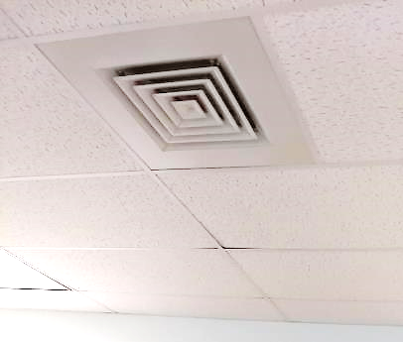
Typical supply vent
Picture 2
Return vent, note accumulated dust
Picture 3
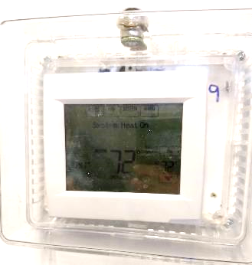
Thermostat in locked box
Picture 4
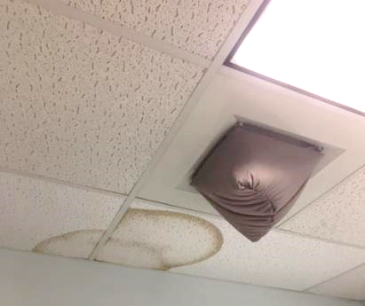
Covered vent and water-damaged ceiling tile (Picture via EOHHS)
Picture 5
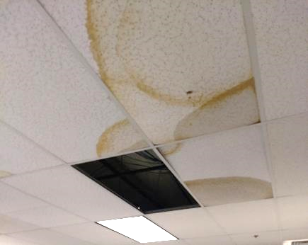
Water-damaged, wet and missing ceiling tiles
Picture 6
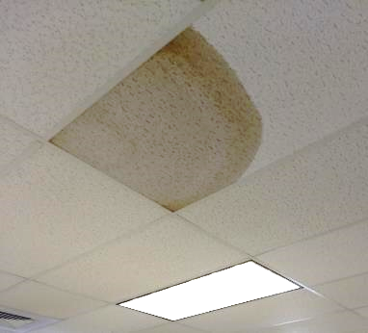
Wet ceiling tile
Picture 7
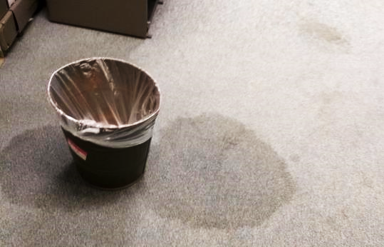
Wet carpeting due to ceiling leaks
Picture 8
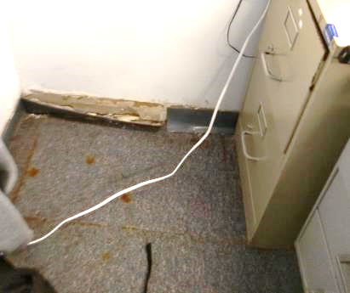
Coving no longer adhered to the wall
Picture 9
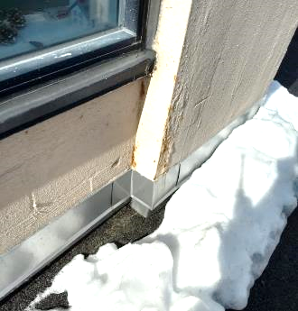
Metal flashing material at the base of EIFS wall
Picture 10
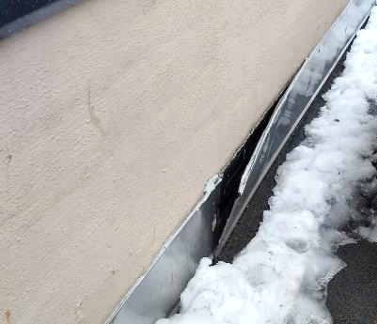
Flashing pulling/peeled away from building
Picture 11
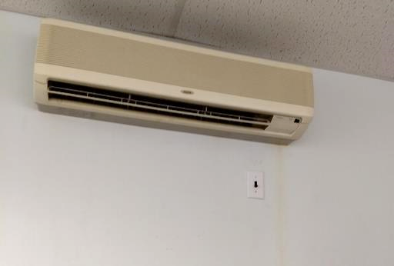
Ductlesss air conditioner with water stain from condensate
Picture 12
Plants and decorative items
Picture 13
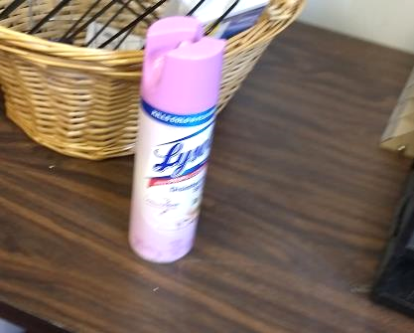
Scented air freshener
Picture 14
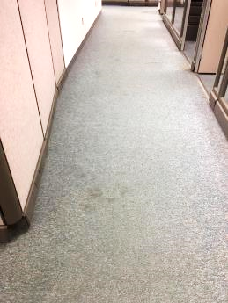
Worn carpeting (picture courtesy of EOHHS)
Picture 15
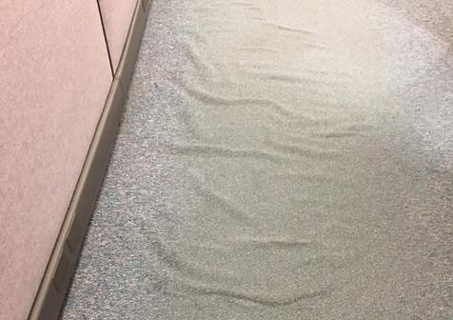
Wrinkles and wear in carpeting (picture courtesy of EOHHS)
Picture 16
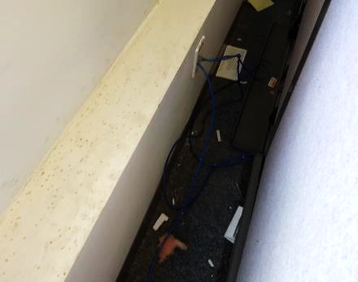
Debris, items, dust, and potential mold stains (dark spots) in channel behind cubicle walls
Location | Carbon  Dioxide  (ppm) | Carbon Monoxide  (ppm) | Temp  (°F) | Relative  Humidity  (%) | PM2.5  (µg/m³) | Occupants  in Room | Windows  Openable | Ventilation |  | Remarks
 |  |  |  |  |  |  |  | Supply | Exhaust
Background (outside) | 415 | ND - 1 | 64 | 21 | 17 |  |  |  |  | Sunny, traffic nearby
DHCD near front | 1115 | 2 | 71 | 30 | 7 | 4 | N | Y | Y | Plants, HS
Meeting/ | 1154 | 2 | 72 | 31 | 5 | 3 | N | Y | Y | DO, worn carpet, dusty exhaust
DCHD middle | 1017 | 2 | 72 | 28 | 5 | 1 | N | Y | Y | Plant, area rug
512 (1/2 wall) | 1112 | 2 | 73 | 30 | 5 | 1 | N | Y | N
Interview (1/2 wall) | 987 | 2 | 73 | 28 | 5 | 1 | N | Y | Y | Dusty exhaust
Interview (1/2 wall) | 966 | 2 | 73 | 28 | 5 | 0 | N | Y | Y | Dusty exhaust
Interview (1/2 wall) | 912 | 2 | 73 | 28 | 4 | 1 | N | Y | Y
Project homebase | 1027 | 2 | 73 | 27 | 5 | 2 | N | Y | Y | Food, refrigerator on carpet
Small office | 922 | 2 | 73 | 26 | 4 | 0 | N | Y | N | Vent covered with cloth, WD CT, soiled wall
Hall next to small office |  |  |  |  |  |  | N | Y |  | WD carpet and stained wall
Cubes | 1040 | 2 | 75 | 28 | 5 | 0 | N | Y | Y | Worn carpet
Lunch | 855 | 2 | 74 | 25 | 4 | 0 | N | Y | Y | NC, missing light cover, items hanging from ceiling, microwave, fridge is out of order and has odor when opened and mold on gasket
Cube 21 area | 869 | 2 | 74 | 27 | 2 | 1 | N | Y | Y
Cube 127 area | 870 | 2 | 75 | 26 | 5 | 2 | N | Y | Y
44 (1/2 wall) | 850 | 2 | 75 | 26 | 4 | 0 | N | Y | Y
148 (1/2 wall) | 889 | 2 | 75 | 27 | 5 | 1 | N | N | N
Cube 60 area | 938 | 2 | 75 | 27 | 5 | 0 | N | Y | Y
Coleman office | 844 | 2 | 75 | 26 | 6 | 0 | N | Y | Y | PC
Cornelio cube area | 806 | 2 | 75 | 26 | 7 | 1 | N | Y | Y
71 (1/2 wall) | 860 | 2 | 75 | 26 | 5 | 0 | N | Y | Y | Light out, cut flowers
Cube 86 area | 801 | 1 | 75 | 26 | 7 | 0 | N | Y | Y | Plants
Cube 124 area |  |  |  |  |  |  | N | Y | Y | Active leaks
Cube 77 area | 748 | 1 | 75 | 25 | 7 | 0 | N | Y | Y | WD CT
80 (1/2 wall) | 734 | 1 | 75 | 25 | 6 | 0 | N | Y | Y | Exhaust dusty, HS
Cube 83 area | 690 | 1 | 75 | 25 | 7 | 0 | N | Y | Y | DEM, area rug, worn carpet
Kogan | 713 | 1 | 73 | 28 | 7 | 0 | N | Y | Y | WD carpet, cloth wall over area with leak
Security | 872 | 1 | 73 | 27 | 9 | 1 | N | N | Y | WD wall
Reception | 697 | 1 | 73 | 26 | 7 | 3 | N | Y | Y | Rust on carpet where old safe had been, coving pulls away from wall, currently dry
Waiting | 664 | 1 | 72 | 26 | 8 | 10 | N | Y | Y | 2 wet CT, several WD CT, NC with runner carpet
Orientation Room | 631 | ND | 72 | 27 | 4 | 0 | N | Y | Y | NC, new flooring
Interview (1/2 wall) | 596 | ND | 73 | 26 | 4 | 1 | N | Y | Y
149 (1/2 wall) | 608 | ND | 73 | 27 | 3 | 0 | N | Y | Y
Snap interview 1 | 631 | ND | 73 | 26 | 3 | 2 | N | Y | Y
148 (1/2 wall) | 617 | ND | 73 | 27 | 3 | 0 | N | Y | Y | Heater
Snap interview 6 | 658 | ND | 74 | 27 | 3 | 0 | N | Y | Y | Humidifier
Snap interview 10 | 815 | 1 | 75 | 26 | 3 | 3 | N | Y | Y | WD/wet carpet, WD CT, leaking through light
Spear office | 738 | 1 | 75 | 27 | 3 | 0 | N | Y | Y | WD CT
Cube 127 area | 760 | 1 | 75 | 26 | 4 | 0 | N | Y | Y | AI
Cube 119 area | 778 | 1 | 76 | 26 | 4 | 1 | N | Y | Y
117 (1/2 wall) | 741 | 1 | 76 | 26 | 3 | 1 | N | Y | Y
102 (1/2 wall) | 755 | 1 | 76 | 26 | 1 | 1 | N | N | Y
Cube 96 area | 785 | 1 | 76 | 27 | 2 | 1 | N | Y | Y | WD CT
Cube 99 area | 789 | 1 | 76 | 25 | 2 | 3 | N | Y | Y | Plants, skylight, PC, HS
Assistant Director | 778 | 1 | 76 | 25 | 1 | 1 | N | Y | Y | Plant, vent pulling off wall
Cube 54 area | 866 | 1 | 75 | 26 | 1 | 0 | N | Y | Y | Plant, refrigerator on carpet
Cube 184 area | 849 | 1 | 76 | 26 | 1 | 2 | N | Y | Y | WD CT
Cube 47 area | 863 | 1 | 76 | 26 | 2 | 2 | N | Y | Y | AI, plants, skylight
38 (1/2 wall) | 888 | 1 | 77 | 26 | 3 | 1 | N | Y | Y | Flowers
Barthelemy | 913 | 2 | 76 | 25 | 1 | 0 | N | Y |  | CP—AF, WD CT
Conference room | 884 | 2 | 75 | 25 | 1 | 0 | N | Y | Y | Ductless air conditioner (leaks reported when used), DEM, water cooler on carpet
Community resources | 775 | 2 | 73 | 23 | ND | 0 | N | Y | Y | NC, boxes on floor
144 (1/2 wall) | 859 | 2 | 75 | 25 | 1 | 1 | N | Y | Y
Czolpinski | 1015 | 1 | 74 | 28 | 1 | 2 | N | Y | Y | Carpeting reported wet recently/previously, corner has plaster dust
Staff Room | 886 | 2 | 73 | 26 | 25 | 0 | N | Y | Y | Cooking odor, no exhaust outside building, spill in fridge and stained gasket, NC, sink reportedly backs up
Denham | 942 | 1 | 74 | 27 | ND | 1 | N | Y | N | CP

