INDOOR AIR QUALITY ASSESSMENT

Department of Transitional Assistance
Newmarket Square Office
1010 Massachusetts Avenue
Boston, MA

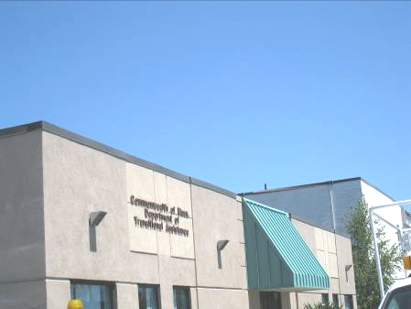

Prepared by:
Massachusetts Department of Public Health
Bureau of Environmental Health
Indoor Air Quality Program
July 2012

Background/Introduction
In response to a request from Ms. Pamela Jackson, EHS-Children, Youth and Families, the Massachusetts Department of Public Health (MDPH), Bureau of Environmental Health (BEH) conducted an indoor air quality (IAQ) evaluation at the Department of Transitional Assistance (DTA) Office at 1010 Massachusetts Avenue, Boston, Massachusetts. The request was prompted by symptoms consistent with an allergic reaction, including facial swelling and eye irritation reportedly experienced by staff near the end of March/beginning of April. On June 15, 2012, a visit to conduct an assessment was made by Sharon Lee, Environmental Analyst/Regional Inspector within BEH’s IAQ Program.
The original portion of this building was constructed in 1901. The addition occupied by the DTA was constructed in the 1940s. The DTA has occupied this space which is partially below-grade since 1994. A few windows in this area are openable.

Methods
Air tests for carbon monoxide, carbon dioxide, temperature and relative humidity were conducted with the TSI, Q-Trak, IAQ Monitor, Model 7565. Air tests for airborne particle matter with a diameter less than 2.5 micrometers were taken with the TSI, DUSTTRAK™ Aerosol Monitor Model 8520. BEH staff also performed visual inspection of building materials for water damage and/or microbial growth.

Results
The DTA has a population of approximately 100 and can be visited by 400 to 500 members of the public daily. Tests were taken during normal operations. Test results appear in Table 1, with test locations corresponding to function, location number or occupant last name.

Discussion

Ventilation
It can be seen from Table 1 that carbon dioxide levels were above 800 parts per million (ppm) in only 2 of 58 areas examined, indicating optimal air exchange in the majority of areas at the time of assessment. Rooftop air-handling units (AHUs) are ducted to air diffusers in DTA cubicle areas (Pictures 1 and 2). Offices have fresh air diffusers that pressurize the space, forcing air into hallways/cubicle areas. Air is then drawn into the ceiling plenum via return vents (Picture 3) back to the AHUs.
The Massachusetts Building Code requires that each room have a minimum ventilation rate of 20 cubic feet per minute (cfm) per occupant of fresh outside air or openable windows (SBBRS, 1997; BOCA, 1993). The ventilation must be on at all times that the room is occupied. Providing adequate fresh air ventilation with open windows and maintaining the temperature in the comfort range during the cold weather season is impractical. Mechanical ventilation is usually required to provide adequate fresh air ventilation.
Carbon dioxide is not a problem in and of itself. It is used as an indicator of the adequacy of the fresh air ventilation. As carbon dioxide levels rise, it indicates that the ventilating system is malfunctioning or the design occupancy of the room is being exceeded. When this happens, a buildup of common indoor air pollutants can occur, leading to discomfort or health complaints. The Occupational Safety and Health Administration (OSHA) standard for carbon dioxide is 5,000 parts per million parts of air (ppm). Workers may be exposed to this level for 40 hours/week, based on a time-weighted average (OSHA, 1997).
The MDPH uses a guideline of 800 ppm for publicly occupied buildings. A guideline of 600 ppm or less is preferred in schools due to the fact that the majority of occupants are young and considered to be a more sensitive population in the evaluation of environmental health status. Inadequate ventilation and/or elevated temperatures are major causes of complaints such as respiratory, eye, nose and throat irritation, lethargy and headaches. For more information concerning carbon dioxide, please see Appendix A.
Temperature readings ranged from 72 ºF to 75 ºF during the assessment, which were within the MDPH recommended comfort guidelines. The MDPH recommends that indoor air temperatures be maintained in a range of 70 ºF to 78 ºF in order to provide for the comfort of building occupants. Building occupants expressed concerns regarding uneven temperatures and control over thermostats. In many cases concerning indoor air quality, fluctuations of temperature in occupied spaces are typically experienced, even in a building with an adequate fresh air supply.
The relative humidity measured during the assessment ranged from 38 to 45 percent, which was within or slightly below the MDPH recommended comfort range in all areas surveyed. The MDPH recommends a comfort range of 40 to 60 percent for indoor air relative humidity. Relative humidity levels in the building would be expected to drop during the winter months due to heating. Relative humidity levels in the building would be expected to drop during the heating season. The sensation of dryness and irritation is common in a low relative humidity environment. Low relative humidity is a common problem during the heating season in the northeast part of the United States.

Microbial/Moisture Concerns
As mentioned, the purpose of this assessment was to examine conditions that may have been contributing to allergic reactions experienced by staff at the DTA. According to the staff, swelling around the face and eyes occurred a few months prior to the BEH assessment. It was also reported that these symptoms appeared to coincide with the presence of a specific flowering plant. When the plant was removed from a nearby desk, the symptoms improved and staff have not experienced any further complications.
BEH staff noted a number of areas with both flowering and non-flowering plants; in some cases plants were placed beneath air diffusers (Picture 4). Plants can be a source of pollen and mold, which can be respiratory irritants for some individuals. Plants should be properly maintained and equipped with drip pans to prevent water damage to porous building materials, which can lead to mold growth. Plants should also be located away from ventilation sources (e.g., air intakes, diffusers) to prevent the entrainment and/or aerosolization of dirt, pollen or mold.
Signs of water damage were observed on gypsum wallboard (GW) along the northeast side of the building, including the Assistant Directors and Director’s offices and the Institute for Community Inclusion (Pictures 5 and 6). Floor tiles and carpeting also showed signed of water damage (Pictures 7 and 8). As reported by DTA staff, water penetrates through the exterior wall during heavy rain storms. The last reported issue occurred nearly a year ago. Following a flooding event, staff reported that water was vacuumed and fans were placed in the office to dry out moistened carpet. In some areas, carpeting was also replaced. DTA staff also reported that the building management took steps to seal the building exterior to prevent future flooding events.
At the time of assessment, BEH staff observed mold growth behind vinyl coving on walls along the northeast side (Picture 9, Table 1). Moisture tests of GW were conducted in offices along this area. At the time of assessment, walls in these areas were wet (Picture 10), indicating that water from a rain storm occurring two days prior to the assessment had penetrated the building. A musty odor was also observed in the Director’s office, likely from the carpet. Some of these areas also had damaged stored materials, including boxes and files.
BEH staff observed the exterior portion of the northeast wall and noted discoloration and swelling to the bottom portions of the wall (Pictures 11 and 12), indicating moisture damage to the exterior wall system. A portion of the exterior wall was no longer adhering, exposing the wall to moisture (Picture 13). On closer inspection, the stucco-like wall appears to consist of an exterior foam insulating system (EFIS; Picture 14). EIFS “is an exterior wall cladding that utilizes rigid insulation boards on the exterior of the wall sheathing with a plaster type exterior skin”, appearing to look like stucco (Zwayer, 2007). “An EIFS wall typically consists of several layers of materials sandwiched together into a single panel, which is attached to a substrate mounted on the wall studs” (Figure 1) (FEMA, Unknown). The EIFS system appears to be a barrier wall system, which “rely primarily on the base coat portion of the exterior skin to resist water penetration” (Zwayer, 2007). In essence, the rainwater is shed by the exterior “stucco-like” surface, which functions as a drainage plane (Figure 1). However, a number of problems exist with such a system:
Problems observed with EIFS installations are primarily related to moisture intrusion. EIFS provides protection against moisture infiltration at the base coat; however, moisture migration through openings for windows, flashings and other items, or holes and cracks in the EIFS itself, have allowed for moisture invasion of EIFS clad buildings. With barrier EIFS installations, or where weather barriers and flashing are improperly installed in conjunction with wall drainage EIFS installations, moisture has entered the wall system at these locations and caused damage to the wall sheathing and framing (emphasis added) (Zwayer, 2007).
In the case of the DTA offices, it is likely that water that has penetrated through the wall has saturated and damaged the existing wall system. Rather than shedding water, the system holds water against the wall, allowing water to penetrate the building.
According to the National Institute of Building Science (NIBS), the following are problems typical of buildings clad with EIFS; these same conditions were also observed at the building:
- Failure to properly backwrap edges of EIFS at terminations and penetrations in the field of the EIFS (Picture 15); and
- Water erosion damage that has not been repaired.
Flooding also reportedly occurs in area 208/209 due to a sink/toilet clogging in the men’s room in the SNAP reception area. Staff indicated that after each incident, excess water is removed, carpeting is disinfected/steam cleaned, and fans are used to dry the area. At the time of assessment, GW was dry; however, mold growth was observed behind vinyl coving (Picture 16).
The US Environmental Protection Agency (US EPA) and the American Conference of Governmental Industrial Hygienists (ACGIH) recommend that porous materials be dried with fans and heating within 24 to 48 hours of becoming wet (US EPA, 2001; ACGIH, 1989). If not dried within this time frame, mold growth may occur.
Water dispensers were observed in a carpeted area. Spills/leaks from such appliances can be a source of moisture in carpeting that can lead to water damage and mold growth. When possible, these units should be located in tiled areas or placed on a waterproof mat.
Water-damaged/missing ceiling tiles were noted in a number of areas throughout the building. Water-damaged ceiling tiles can indicate sources of water penetration and provide a source of mold. Ceiling tiles should be replaced after a water leak is discovered and repaired. Once mold has colonized porous materials, they are difficult to clean and should be removed/discarded.

Other Indoor Air Evaluations
Indoor air quality can be negatively influenced by the presence of respiratory irritants, such as products of combustion. The process of combustion produces a number of pollutants. Common combustion emissions include carbon monoxide, carbon dioxide, water vapor, and smoke (fine airborne particle material). Of these materials, exposure to carbon monoxide and particulate matter with a diameter of 2.5 micrometers (μm) or less (PM2.5) can produce immediate, acute health effects upon exposure. To determine whether combustion products were present in the indoor environment, BEH staff obtained measurements for carbon monoxide and PM2.5.

Carbon Monoxide
Carbon monoxide is a by-product of incomplete combustion of organic matter (e.g., gasoline, wood and tobacco). Exposure to carbon monoxide can produce immediate and acute health affects. Several air quality standards have been established to address carbon monoxide and prevent symptoms from exposure to these substances. The MDPH established a corrective action level concerning carbon monoxide in ice skating rinks that use fossil-fueled ice resurfacing equipment. If an operator of an indoor ice rink measures a carbon monoxide level over 30 ppm, taken 20 minutes after resurfacing within a rink, that operator must take actions to reduce carbon monoxide levels (MDPH, 1997).
The American Society of Heating Refrigeration and Air-Conditioning Engineers (ASHRAE) has adopted the National Ambient Air Quality Standards (NAAQS) as one set of criteria for assessing indoor air quality and monitoring of fresh air introduced by HVAC systems (ASHRAE, 1989). The NAAQS are standards established by the US EPA to protect the public health from six criteria pollutants, including carbon monoxide and particulate matter (US EPA, 2006). As recommended by ASHRAE, pollutant levels of fresh air introduced to a building should not exceed the NAAQS levels (ASHRAE, 1989). The NAAQS were adopted by reference in the Building Officials & Code Administrators (BOCA) National Mechanical Code of 1993 (BOCA, 1993), which is now an HVAC standard included in the Massachusetts State Building Code (SBBRS, 1997). According to the NAAQS, carbon monoxide levels in outdoor air should not exceed 9 ppm in an eight-hour average (US EPA, 2006).
Carbon monoxide should not be present in a typical, indoor environment. If it is present, indoor carbon monoxide levels should be less than or equal to outdoor levels. Outdoor carbon monoxide concentrations were non-detect (ND) (Table 1). No measureable levels of carbon monoxide were detected in the building (Table 1).

Particulate Matter
The US EPA has established NAAQS limits for exposure to particulate matter. Particulate matter is airborne solids that can be irritating to the eyes, nose and throat. The NAAQS originally established exposure limits to particulate matter with a diameter of 10 μm or less (PM10). According to the NAAQS, PM10 levels should not exceed 150 micrograms per cubic meter (μg/m³) in a 24-hour average (US EPA, 2006). These standards were adopted by both ASHRAE and BOCA. Since the issuance of the ASHRAE standard and BOCA Code, US EPA established a more protective standard for fine airborne particles. This more stringent PM2.5 standard requires outdoor air particle levels be maintained below 35 μg/m³ over a 24-hour average (US EPA, 2006). Although both the ASHRAE standard and BOCA Code adopted the PM10 standard for evaluating air quality, MDPH uses the more protective PM2.5 standard for evaluating airborne particulate matter concentrations in the indoor environment.
Outdoor PM2.5 concentration was measured at 13 μg/m³ (Table 1). PM2.5 levels measured indoors ranged from 4 to 21 μg/m³ (Table 1), which were below the NAAQS PM2.5 level of 35 μg/m³. Frequently, indoor air levels of particulates (including PM2.5) can be at higher levels than those measured outdoors. A number of other mechanical devices and/or activities that occur indoors can generate particulate during normal operations. Sources of indoor airborne particulates may include but are not limited to particles generated during the operation of fan belts in the HVAC system, use of stoves and/or microwave ovens in kitchen areas; use of photocopiers, fax machines and computer printing devices; operation of an ordinary vacuum cleaner and heavy foot traffic indoors.

Other Conditions
Other conditions that can affect indoor air quality were observed during the assessment. Office 210 is not occupied, reportedly due to odors in the area. These odors were described as a smoke odor and are attributed to a return vent located directly above the office. It is important to note that this office is adjacent to a wall shared with a restroom in the SNAP waiting room. At the time of the assessment, BEH staff detected cigarette smoke odors in the SNAP waiting area doorway, which provides access to cubicle areas 208/209 and office 210. The most likely location of cigarette smoking is the public restroom. If the restroom exhaust ventilation system is deactivated, the ductwork is not directly vented to outdoors, or the ductwork is not continuous, cigarette smoke from restroom can then enter occupied space
Environmental Tobacco Smoke (ETS) is a mixture of gases and fine particles emitted by the burning of tobacco products and smoke exhaled by the smoker (USDHHS, 2006). ETS is a pollutant which can have a marked effect on indoor air quality and cause adverse health effects. ETS can exacerbate the frequency and severity of symptoms in those with respiratory conditions (i.e. asthma), as well as those with existing or known heart conditions. The most effective method of preventing exposure to environmental tobacco smoke is to have smoke free buildings. M.G.L. Chapter 270, Section 22 prohibits smoking in public buildings (M.G.L., 2004).
Excessive items were observed on the floor, tabletops, counters, bookcases and desks (Picture 17). Flat surfaces provide a source for dusts to accumulate, and the various items make cleaning difficult. Items should be relocated and/or be cleaned periodically to avoid excessive dust build up. In addition, dust and debris can accumulate on flat surfaces (e.g., desktops, shelving and carpets) in occupied areas and subsequently be re-aerosolized causing further irritation.
Dust/debris was observed around supply vents (Picture 2) and on personal fans. Dust/debris should be cleaned periodically to prevent re-aerosolization when fans and/or the mechanical ventilation system become reactivated.
Dry erase materials, hand sanitizers and some cleaning products (Picture 18) were observed in the DTA space. These materials contain volatile organic compounds (VOCs). Frequently, exposure to low levels of total volatile organic compounds (TVOCs) may produce eye, nose, throat and/or respiratory irritation in some sensitive individuals. Materials such as permanent markers, dry erase markers and dry erase board cleaners may contain VOCs, such as methyl isobutyl ketone, n-butyl acetate and butyl-cellusolve (Sanford, 1999), which can be irritating to the eyes, nose and throat.
An assortment of air fresheners and deodorizing materials (i.e., fragrant oil reed diffusers, plug-ins and spray canisters) were observed in a number of areas (Picture 18). Air deodorizers contain chemicals that can be irritating to the eyes, nose and throat of sensitive individuals. Many air fresheners contain 1,4-dichlorobenzene, a VOC which may cause reductions in lung function (NIH, 2006). Furthermore, deodorizing agents do not remove materials causing odors, but rather mask odors that may be present in the area.
Finally, occupants expressed concerns related to the condition of carpeting and carpet cleaning in several areas throughout the building. At the time of the assessment, BEH staff observed damaged and stained carpeting. The Institute of Inspection, Cleaning and Restoration Certification (IICRC), recommends that carpeting be cleaned annually or semi-annually in high traffic areas (IICRC, 2005). Much of the carpeting at the DTA office is original to the building. Consideration should be given to replacing the wall-to-wall carpets with carpet tiles.

Conclusions/Recommendations
Based on conditions observed at the time of assessment and reports provided by DTA staff, it appears that concerns regarding irritation/allergy symptoms were likely related to the presence of certain plants at the DTA office. As mentioned, allergies were experienced when certain plants were present, but ceased when these plants were removed. Measures should be taken to limit any exposure to suspect plants until staff can meet with an allergy specialist.
BEH staff however also observed conditions that have resulted in mold growth. Exposure to mold can exacerbate symptoms in individuals with pre-existing allergies and asthma. Mold growth in offices along the northeast side of the building is the result of water penetration through an exterior wall. Another area where mold growth was observed is in the cubicle area 208/209, where flooding periodically occurs from an adjacent bathroom. In view of the findings at the time of the visit, the following recommendations are made:
- Remove vinyl coving and examine wallboard in areas experiencing flooding.
- Remove/replace all damaged gypsum wallboard and materials within the wall cavity.
- All water-damaged/mold-colonized building materials (e.g., ceiling tiles, carpeting and GW) should be removed in a manner consistent with recommendations in “Mold Remediation in Schools and Commercial Buildings” published by the US Environmental Protection Agency (US EPA, 2001). This document is available from the US EPA website: http://www.epa.gov/iaq/molds/mold_remediation.html.
- Replace carpeting on the ground floor with a non-porous material (e.g., vinyl tile) in areas subject to repeated water damage. If carpeting is necessary, consider placing floor tiles around the perimeter of the office and/or in areas prone to damage and installing carpet tiles/squares, which can be replaced when damaged, in the remainder of the space.
- Examine and repair the EIFS wall along the northeastern side of the building. Repairs should include provision of adequate water drainage to the EIFS wall. Based on BEH staff observations, these efforts likely include installing a full drainage plane with weep holes beneath the EIFS walls and proper flashing around all windows and door frames. Please note that the only feasible manner in which to install a proper drainage plane behind the EIFS would be to remove the entire existing system.
- Clean carpeting annually or semi-annually in soiled/high traffic areas as per the recommendations of the Institute of Inspection, Cleaning and Restoration Certification (IICRC). Copies of the IICRC fact sheet can be downloaded at: http://www.cleancareseminars.com/carpet_cleaning_faq4.htm (IICRC, 2005).
- Consider a long-term plan to replace carpeting that is past its useful life as funds become available.
- Re-grade the parking area adjacent to the northeast wall in a manner that directs water away from the building.
- Discourage cigarette smoking in the restroom by posting no smoking signs prohibiting smoking. If detected, staff should contact the security guard to investigate cigarette smoke in the restroom.
- Examine the ceiling plenum near office 210, waiting room, and waiting room bathrooms to ensure that there are no breaches in ductwork on the plenum itself, which can allow odors to migrate from one area to another. Ensure bathroom and waiting room exhaust ventilation is operating during work hours.
- For buildings in New England, periods of low relative humidity during the winter are often unavoidable. Therefore, scrupulous cleaning practices should be adopted to minimize common indoor air contaminants whose irritant effects can be enhanced when the relative humidity is low. To control for dusts, a high efficiency particle arrestance (HEPA) filter-equipped vacuum cleaner in conjunction with wet wiping of all surfaces is recommended. Drinking water during the day can help ease some symptoms associated with a dry environment (throat and sinus irritations).
- Place water dispensers on tiled floor areas or on a waterproof mat.
- Relocate plants away from fresh air diffusers, and ensure plants are maintained properly. Consider reducing the number of plants throughout the building.
- Replace water-damaged and missing ceiling tiles to create a flush ceiling tile system and re-establish the ceiling plenum system.
- Reduce the amount of items stored on flat surfaces to allow for improved cleaning and dust control measures.
- Refrain from using air deodorizing materials to prevent exposure to VOCs.
- Routinely clean accumulated dust and debris periodically from the surface of supply/exhaust vents and blades of personal fans.
- Refer to resource manuals and other related indoor air quality documents for further building-wide evaluations and advice on maintaining public buildings. Copies of these materials are located on the MDPH’s website: http://mass.gov/dph/iaq.

References
ACGIH. 1989. Guidelines for the Assessment of Bioaerosols in the Indoor Environment. American Conference of Governmental Industrial Hygienists, Cincinnati, OH.
ASHRAE. 1989. Ventilation for Acceptable Indoor Air Quality. American Society of Heating, Refrigeration and Air Conditioning Engineers. ANSI/ASHRAE 62-1989.
BOCA. 1993. The BOCA National Mechanical Code/1993. 8th ed. Building Officials and Code Administrators International, Inc., Country Club Hill, IL.
FEMA. Unknown. Protecting Your Business from Wind. Federal Emergency Management Agency, Washington, DC. http://www.fema.gov/pdf/plan/prevent/howto/how2027.pdf
IICRC. 2005. Carpet Cleaning FAQ 4 Institute of Inspection, Cleaning and Restoration Certification. Institute of Inspection Cleaning and Restoration, Vancouver, WA.
M.G.L. 2004. Smoke-Free Workplace Law, Massachusetts General Laws. M.G.L. Chapter 270, section 22.
MDPH. 1997. Requirements to Maintain Air Quality in Indoor Skating Rinks (State Sanitary Code, Chapter XI). 105 CMR 675.000. Massachusetts Department of Public Health, Boston, MA.
NIH. 2006. Chemical in Many Air Fresheners May Reduce Lung Function. NIH News. National Institute of Health. July 27, 2006. http://www.nih.gov/news/pr/jul2006/niehs-27.htm
OSHA. 1997. Limits for Air Contaminants. Occupational Safety and Health Administration. Code of Federal Regulations. 29 C.F.R 1910.1000 Table Z-1-A.
Sanford. 1999. Material Safety Data Sheet (MSDS No: 198-17). Expo® Dry Erase Markers Bullet, Chisel, and Ultra Fine Tip. Sanford Corporation. Bellwood, IL.
SBBRS. 1997. Mechanical Ventilation. State Board of Building Regulations and Standards. Code of Massachusetts Regulations. 780 CMR 1209.0
U.S. Department of Health and Human Services. 2006. The Health Consequences of Involuntary Exposure to Tobacco Smoke: A Report of the Surgeon General. U.S. Department of Health and Human Services, Centers for Disease Control and Prevention, Coordinating Center for Health Promotion, National Center for Chronic Disease Prevention and Health Promotion, Office on Smoking and Health, Atlanta, GA.

US EPA. 2001. “Mold Remediation in Schools and Commercial Buildings”. Office of Air and Radiation, Indoor Environments Division, Washington, DC. EPA 402-K-01-001. March 2001. Available at: http://www.epa.gov/iaq/molds/mold_remediation.html.
US EPA. 2006. National Ambient Air Quality Standards (NAAQS). US Environmental Protection Agency, Office of Air Quality Planning and Standards, Washington, DC. http://www.epa.gov/air/criteria.html.
Zwayer, G.L. 2007. Exterior Insulation and Finish System (EIFS). National Institute of Building Sciences, Washington, DC. http://www.wbdg.org/design/env_wall_eifs.php
Picture 1

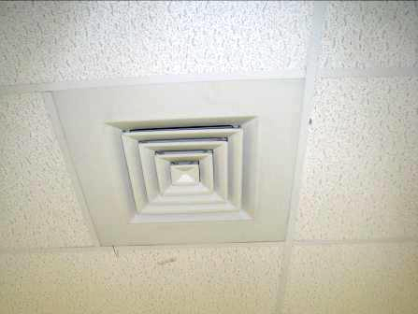

Supply vent

Picture 2

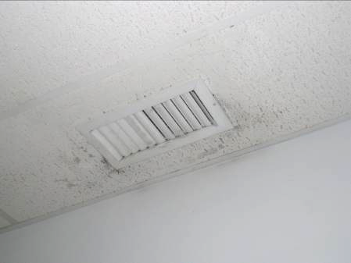

Supply vent, note surround debris on ceiling tiles

Picture 3

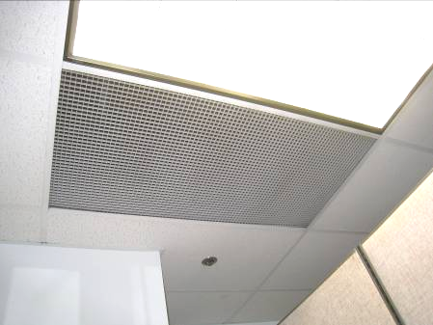

Return vent

Picture 4

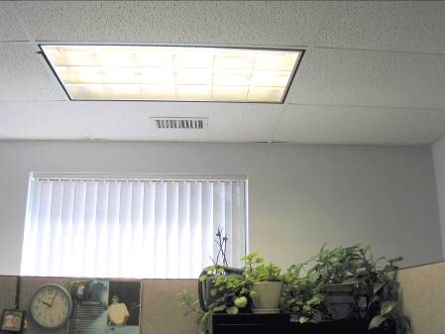

Plants located below air supply vent

Picture 5

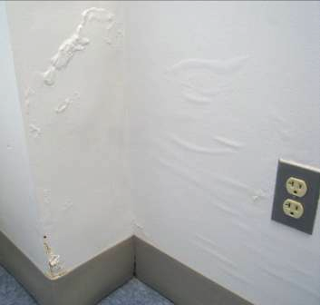

Bubbling paint

Picture 6

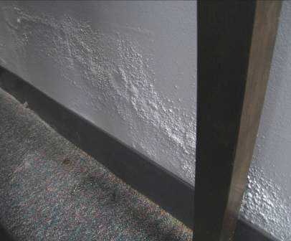

Efflorescence

Picture 7

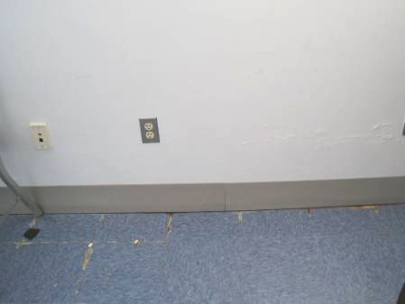

Water damage to floor, as evidenced by shift in floor tiles

Picture 8

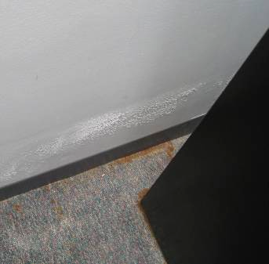

Prolonged moisture in carpet, as evidenced by staining from cabinet

Picture 9

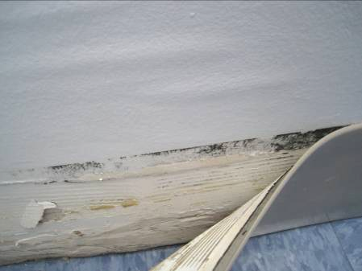

Mold growth behind coving in Institute for Community Inclusion office

Picture 10

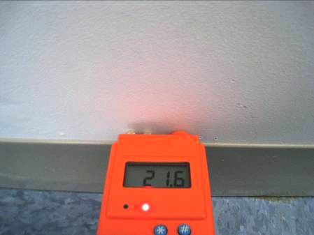

Moisture meter with red light indicating the wall was wet

Picture 11

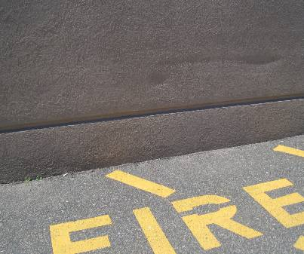

Dimpling in exterior wall panel

Picture 12

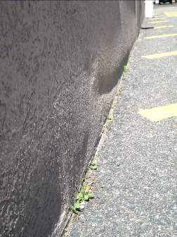

Swelling in exterior wall panel

Picture 13

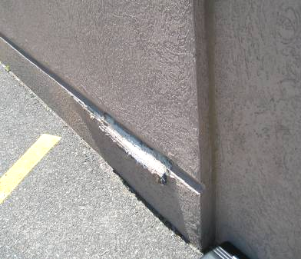

Damaged exterior wall

Picture 14

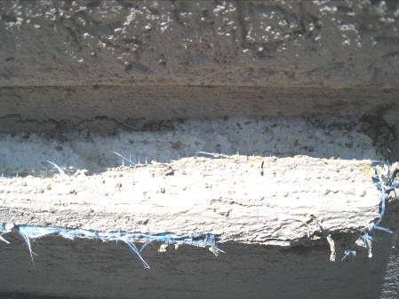

Damaged wall exposing foam panel

Picture 15

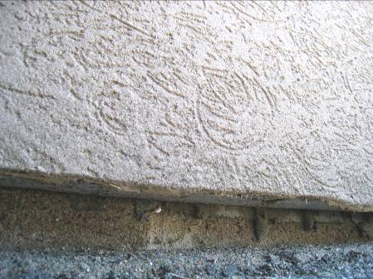

Unwrapped bottom of panel

Picture 16

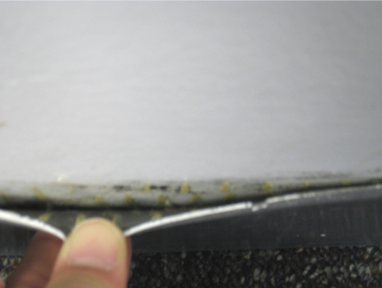

Mold growth behind coving in area 208/209

Picture 17

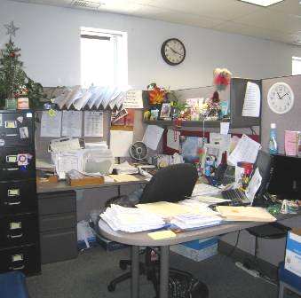

Flat surfaces covered with items/materials

Picture 18

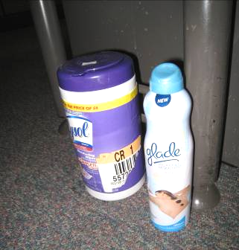

Cleaning product and air deodorizer
Location | Carbon  Dioxide  (ppm) | Carbon Monoxide  (ppm) | Temp  (°F) | Relative  Humidity  (%) | PM2.5  (µg/m³) | Occupants  in Room | Windows  Openable | Ventilation |  | Remarks
 |  |  |  |  |  |  |  | Supply | Exhaust | Remarks
Background | 397 | ND | 71 | 50 | 13
A. Kane | 720 | ND | 73 | 40 | 4 | 1 | N | Y | Y | DO
Assistant Dir.  R. Fratus | 457 | ND | 75 | 42 | 12 | 2 | Y | Y | Y | DO, PF, window gasket damaged, AD
Assistant Dir. Czolpinski | 464 | ND | 75 | 41 | 10 | 1 | Y | Y | N | DO, reported past water infiltration from exterior wall, new carpet
B. Perez | 600 | ND | 75 | 40 | 8 | 0 | N | Y | Y
Campos | 669 | ND | 73 | 42 | 5 | 1 | N | Y | N | DO
Conference room | 470 | ND | 73 | 38 | 10 | N | N | Y | Y | AC
D. Factorovich | 786 | ND | 75 | 40 | 4 | 0 | N | Y | Y | DO, plants, PF, CPs
Dir. Cunio | 569 | ND | 75 | 43 | 10 | 1 | Y | Y | N | DO, PF, AC, musty carpet, GW-moist, GW-mold growth behind coving
DTA reception | 480 | ND | 75 | 41 | 7 | 3 | N | Y | Y
DTA waiting area | 623 | ND | 75 | 42 | 21 | 3 | N | Y | Y | AD
Institute for community inclusion | 449 | ND | 75 | 43 | 12 | N | N | Y | Y | WD-GW, bubbling paint, lifting floor tiles, GW-moist, mold behind coving
Interview booths | 523 | ND | 75 | 41 | 8 | 0 | N | Y | Y | Food odors, smoke odors
IT Room | 632 | ND | 74 | 42 | 7 | 1 | N | Y | Y | DO
Kiser-Williams | 641 | ND | 73 | 42 | 5 | 0 | N | Y | Y | DO, items, plants
M. Tillinger | 741 | ND | 73 | 43 | 4 | 1 | N | Y | Y | DO, plant
Mail room | 473 | ND | 73 | 43 | 10 | N | N | Y | N | DO
Office (Next to Dir office; unoccupied) | 616 | ND | 74 | 41 | 4 | 0 | N | Y | N | DO, WD-GW, GW moist
SNAP assistant director’s office (unoccupied) | 658 | ND | 73 | 43 | 6 | 0 | N | Y | N | DO
SNAP conference room | 637 | ND | 73 | 42 | 4 | 0 | N | Y | Y | DO, cooler on carpet
SNAP ID room | 614 | ND | 75 | 44 | 7 | 0 | N | Y | N | DO, heater operating, 1 WD-CT
SNAP reception | 695 | ND | 74 | 44 | 7 | 2 | N | Y | Y | PC
SNAP waiting area | 933 | ND | 72 | 41 | 20 | 50 | N | Y | Y | Cigarette odor
Stringer | 717 | ND | 75 | 43 | 4 | 2 | N | Y | Y
T. Meoli | 693 | ND | 72 | 43 | 5 | 0 | N | Y | Y | DO
108 | 612 | ND | 75 | 41 | 7 | 0 | N | Y | Y
110 | 598 | ND | 75 | 41 | 6 | 1 | N | Y | Y | DO
111/A. Clifford/  M. McGrath | 639 | ND | 74 | 41 | 7 | 1 | N | Y | Y
113/146/213/214 | 576 | ND | 74 | 42 | 8 | 4 | N | Y | Y | PC
117/118/119/120 | 662 | ND | 74 | 41 | 7 | 3 | N | Y | Y
117/134/135 | 618 | ND | 74 | 42 | 4 | 0 | N | Y | Y | Plants
123/144/145/159 | 717 | ND | 74 | 41 | 4 | 1 | N | Y | Y
127/128/140 | 733 | ND | 74 | 42 | 6 | 1 | N | Y | Y
130/149/151/  Jackson | 750 | ND | 74 | 42 | 6 | 1 | N | Y | Y
136 | 709 | ND | 74 | 43 | 7 | 0 | N | Y | Y | DO
137/138/139 | 690 | ND | 74 | 43 | 5 | 0 | N | Y | Y | Plants, hand sanitizer
141 | 698 | ND | 74 | 43 | 6 | 0 | N | Y | Y | DO
141 | 676 | ND | 74 | 42 | 4 | 0 | N | Y | Y | DO
147 | 766 | ND | 73 | 43 | 4 | 1 | N | Y | Y | DO, PF
152 | 777 | ND | 73 | 42 | 4 | 1 | N | Y | Y | DO, PF
155/168/M. Davis/ J. Barbosa/  B. Charney | 731 | ND | 72 | 42 | 5 | 3 | N | Y | Y | Hand sanitizer/CPs, food
156/157/158 | 722 | ND | 72 | 42 | 4 | 2 | N | Y | Y | Hand sanitizer/CPs, plants
158 | 759 | ND | 73 | 42 | 4 | 0 | N | Y | Y | DO
160/161/  V. Badrikian/  B. Garcia | 705 | ND | 72 | 43 | 5 | N | N | Y | Y | Plants
163/164 | 757 | ND | 73 | 43 | 6 | 3 | N | Y | Y | Water dispenser on carpet, plants
165/189/  A. Fernandez /  J. Sanchez/ | 794 | ND | 74 | 43 | 5 | 3 | N | Y | Y
166/172/173 | 821 | ND | 75 | 41 | 4 | 4 | N | Y | Y
174/J. Francis/  A. Benson-Hayes | 726 | ND | 73 | 42 | 4 | 2 | N | Y | Y
175/183/  D. Hospedales | 728 | ND | 73 | 41 | 4 | 2 | N | Y | Y
187/188/191/  A. Buckley | 790 | ND | 73 | 44 | 4 | 2 | N | Y | Y
196/197 | 725 | ND | 74 | 42 | 5 | 1 | N | Y | Y
199 | 663 | ND | 72 | 43 | 5 | 0 | N | Y | Y
201 (unoccupied office) | 735 | ND | 74 | 44 | 5 | 0 | N | Y | Y | DO, reports of odors
202/204 | 763 | ND | 74 | 42 | 5 | 2 | N | Y | Y
204/205/206 | 781 | ND | 74 | 44 | 5 | 2 | N | Y | Y | Plants
208/209 | 744 | ND | 74 | 45 | 5 | 2 | N | Y | Y | Mold growth behind vinyl coving on GW from bathroom flooding, stained carpet
211 | 728 | ND | 74 | 43 | 5 | 0 | N | Y | Y | DO
212 | 728 | ND | 74 | 43 | 5 | 0 | N | Y | Y | DO, AD, soda can collection
216/K. Gaudet/  G. Ware | 731 | ND | 73 | 42 | 3 | 1 | N | Y | Y | PC

