INDOOR AIR QUALITY ASSESSMENT

Massachusetts Department of Children and Families
Massachusetts Department of Transitional Assistance
61 Industrial Park Road
Plymouth, Massachusetts

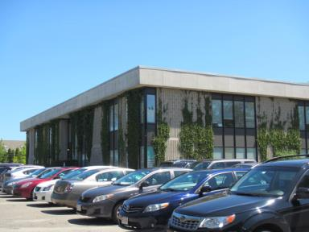

Prepared by:
Massachusetts Department of Public Health
Bureau of Environmental Health
Indoor Air Quality Program
August 2016

BACKGROUND
Building: | Department of Children and Families (DCF); Department of Transitional Assistance (DTA)
Address: | 61 Industrial Park Road, Plymouth, MA
Assessment Requested by: | Erin McCabe, Executive Office of Health & Human Services (EHS) Facilities Deputy Director for Finance and Operations
Reason for Request: | Concerns regarding contaminated/water-damaged materials due to sewage backup/toilet overflow.
Date of Assessment: | August 4, 2016
Massachusetts Department of Public Health/Bureau of Environmental Health (MDPH/BEH) Staff Conducting Assessment: | Cory Holmes and Sharon Lee, Environmental Analysts, Indoor Air Quality (IAQ) Program  Sharlene Sharif, EHS-Facilities
Date of Building Construction: | 1980s
Building Description | Two-story office building containing open work areas (cubicles), offices, and common areas. Most areas have wall-to-wall carpet. Carpet squares are in few areas.
Windows | Non-openable; un-screened openable transoms were observed in some areas

Methods
Please refer to the IAQ Manual and appendices for methods, sampling procedures, and interpretation of results (MDPH, 2015).

IAQ Testing Results
The following is a summary of indoor air testing results (Table 1).
- Carbon dioxide levels were above 800 parts per million (ppm) in 48 of 66 areas tested.
- Temperature was within or close to the recommended range of 70°F to 78°F in the areas tested.
- Relative humidity was within the recommended range of 40 to 60% in all areas tested.
- Carbon monoxide levels were non-detectable (ND) in all areas tested.
- Particulate matter (PM2.5) concentrations measured were below the National Ambient Air Quality (NAAQS) level of 35 μg/m³ in all areas tested.

Ventilation
It can be seen from Table 1 that carbon dioxide levels were above 800 parts per million (ppm) in 48 of 66 areas tested, indicating a lack of air exchange at the time of assessment. The carbon dioxide levels measure likely reflect the limited introduction of outside air, since the system was operating in air-conditioning mode. Other conditions also contributed to the lack of ventilation at the time of assessment.
A heating, ventilating, and air conditioning (HVAC) system has several functions. First it provides heating and, if equipped, cooling. Second, it is a source of fresh air. Finally, an HVAC system will dilute and remove normally occurring indoor environmental pollutants not only by introducing fresh air, but also by filtering the airstream and ejecting stale air to the outdoors via exhaust ventilation. Even if an HVAC system is operating as designed, point sources of respiratory irritation may exist and cause symptoms in sensitive individuals.
The HVAC system in this building primarily consists of several air-handling units (AHU) located on the roof (Picture 1); these units were not accessible the day of assessment. Some areas also have AHUs located in the closet. The unit observed was operating at the time of assessment; however, filters could not be examined. Conditioned air is delivered to occupied areas via ducted ceiling supply diffusers (Picture 2) and returned to the AHUs via ceiling-mounted vents (Picture 3). Return vents appear to be equipped for filters, many of which did not have them.
The HVAC system is controlled by digital thermostats. Thermostats examined had a fan switch with two settings, on and auto. When the fan is set to on, the system provides a continuous source of air circulation and filtration. The automatic setting on the thermostat activates the HVAC system at a pre-set temperature. Once the pre-set temperature is reached, the HVAC system is deactivated. Therefore, no mechanical ventilation is provided until the thermostat re-activates the system. At the time of assessment, most thermostat fan settings were in the “auto” position (Picture 4). As mentioned, this thermostat setting can limit airflow. The MDPH typically recommends that thermostats be set to the fan on setting during occupied hours to provide continuous air circulation.
In one instance, a thermostat on the 2nd floor was found completely deactivated (Table 1, Picture 5). With the thermostat set to the “off” setting, no fresh air was supplied to this area. To maximize air exchange, the BEH recommends that mechanical ventilation systems operate continuously during periods of occupancy. Without the ventilation system operating as designed, normally occurring pollutants cannot be diluted or removed, causing them to build up and lead to IAQ/comfort complaints.
Restrooms have exhaust vents that are connected to rooftop exhaust fans. Exhaust ventilation in these areas are designed to remove moisture and odors. Exhaust vents in restrooms on the 2nd floor DTA area did not appear to be drawing air, which results in stagnant air and increased humidity.

Microbial/Moisture Concerns
As mentioned, the assessment was prompted by concerns related to a toilet/sewage overflow in the first floor restrooms. As stated previously on August 2, 2016 visit, on site and via emails, porous building materials (e.g., gypsum wallboard, carpeting) exposed to black water should be removed since it cannot be readily cleaned (IICRC, 1999). During the August 4, 2016 visit, carpet coving outside the flooded bathroom area on the first floor was pulled back and visible mold growth was observed on the gypsum wallboard (Picture 6).
Other signs of water damage were also observed. A number of areas in the building had water-damaged ceiling tiles (Table 1, Picture 7). Stained or damaged ceiling tiles indicate roof or plumbing leaks. Tiles should be replaced once leaks are found and repaired. An active leak was reported in the 2nd floor DTA area 218 as indicated by damaged tiles and a bucket to collect rain water (Picture 8). Leaks should be repaired and monitored.
The United States Environmental Protection Agency (US EPA) and the American Conference of Governmental Industrial Hygienists (ACGIH) recommend that porous materials be dried with fans and heating within 24 to 48 hours of becoming wet (US EPA, 2008; ACGIH, 1989). If porous materials are not dried within this time frame, they should be removed and discarded.
Visible mold growth was also observed on refrigerator/freezer gaskets in employee breakrooms (Pictures 9 and 10). Cardboard boxes were observed stored directly on the floor of the Records room (Picture 11), which can absorb water from condensation on the cool floor surface.
Plants were observed in some offices and open areas. Plants can be a source of pollen and mold, which can be respiratory irritants to some individuals. Plants should be properly maintained, over-watering of plants should be avoided, and drip pans should be inspected periodically for mold growth and cleaned or replaced as necessary.
Water dispensing equipment and small refrigerators were observed in carpeted areas (Table 1). In a few instances, carpets appeared to be stained from refrigerator leaks (Picture 12). Spills or leaks from this equipment can moisten carpet and lead to microbial growth and carpet degradation.

Volatile Organic Compounds
Indoor air concentrations can be greatly impacted by the use of products containing volatile organic compounds (VOCs). VOCs are carbon-containing substances that have the ability to evaporate at room temperature. Total volatile organic compounds (TVOCs) can result in eye and respiratory irritation if exposure occurs. For example, chemicals evaporating from a paint can stored at room temperature would most likely contain VOCs. In an effort to identify materials that can potentially increase indoor VOC concentrations, BEH/IAQ staff examined rooms for products containing these respiratory irritants.
Hand sanitizers, air deodorizers, and cleaning products were observed in several offices and common areas. Hand sanitizer products may contain ethyl alcohol and/or isopropyl alcohol, which are highly volatile and may be irritating to the eyes and nose. Deodorizers contain chemicals/fragrances to which some people may be sensitive.

Other IAQ Evaluations
Other conditions that can affect IAQ were observed during the assessment. Most areas in the offices are carpeted; the Institute of Inspection, Cleaning, and Restoration Certification (IICRC), recommends that carpeting be cleaned annually (or semi-annually in soiled high traffic areas) (IICRC, 2012).
Personal fans, supply and return vents were observed to be dusty and/or covered with cobwebs. Dust/debris on these items can be reaerosolized and cause eye/respiratory irritation when these equipment are activated.
In some offices, a large number of items were on flat surfaces (e.g., floors, windowsills, tabletops), which provide a source for dusts to accumulate. These items (e.g., papers, folders, boxes) make it difficult for areas to be cleaned. Items should be relocated and/or be cleaned periodically to avoid excessive dust build up. In addition, dust and debris can accumulate on flat surfaces (e.g., desktops, shelving and carpets) in occupied areas and subsequently be re-aerosolized causing further irritation.

Conclusions/Recommendations
The following recommendations were previously issued on-site at the time of the initial assessment (as well as email) by IAQ Director, Mike Feeney on August 2, 2016, and reiterated below:
- Remediate all previously water-damaged porous materials in accordance with IICRC Standards http://www.iicrc.org/consumers/care/water-damage/ and in accordance with EPA Guidelines for Mold Remediation in Schools and Commercial Buildings (US EPA, 2001) https://www.epa.gov/mold/mold-remediation-schools-and-commercial-buildings-guide.
- Identify the source of the sewage pipe blockage and have the interior of the sewer pipe be examined to ascertain if it is damaged. Until the source of the blockage is identified and remedied, this backup will continue to occur.
- If possible, relocate susceptible persons and those with pre-existing medical conditions (e.g., hypersensitivity, asthma) away from the general areas of remediation until completion.
- Implement prudent housekeeping and work site practices to minimize exposure to remediation dusts and spores. This may include construction barriers, sealing off areas, and temporarily relocating furniture and supplies. To control for dusts, a high efficiency particulate air filter (HEPA) equipped vacuum cleaner is recommended. Non-porous materials should be disinfected with an appropriate antimicrobial agent. Non-porous surfaces should also be cleaned with soap and water after disinfection.

In view of the findings at the time of the August 4, 2016 visit, the following General IAQ recommendations are made:
- Ensure thermostats are activated and set fan to the “on” position to provide continuous air circulation/filtration during business hours.
- Contact an HVAC engineer to determine if all return vents should be outfitted with filters and replace as necessary.
- Inspect restroom exhaust vents for proper function, and make repairs as needed.
- Consider adopting a balancing schedule of every 5 years for all mechanical ventilation systems, as recommended by ventilation industrial standards (SMACNA, 1994).
- For buildings in New England, periods of low relative humidity during the winter are often unavoidable. Therefore, scrupulous cleaning practices should be adopted to minimize common indoor air contaminants whose irritant effects can be enhanced when the relative humidity is low. To control for dusts, a high efficiency particulate arrestance (HEPA) filter equipped vacuum cleaner in conjunction with wet wiping of all surfaces is recommended. Avoid the use of feather dusters. Drinking water during the day can help ease some symptoms associated with a dry environment (throat and sinus irritations).
- Replace water-damaged ceiling tiles after a leak is discovered and repaired. Staff should be encouraged to report building leaks to management for prompt remediation.
- Ensure that procedures are in place for occupants to report leaks, wet tiles, and other maintenance conditions so that issues can be resolved promptly.
- Clean and disinfect interior of refrigerators and freezers with mild detergent or antimicrobial agent. Consider replacing mold-contaminated gaskets. Clean spilled food promptly, and clean out the refrigerator of expired items on a regular schedule.
- Do not store cardboard boxes directly on floors; store on shelfing/off the ground to prevent moistening/mold growth.
- Consider placing water dispensers and refrigerators on non-carpeted areas or place a waterproof mat underneath them.
- Maintain indoor plants, use non-porous drips pans, and prevent overwatering.
- Relocate or consider reducing the amount of stored materials in offices to allow for more thorough cleaning. Move items from floors when possible. Clean items regularly with a wet cloth or sponge to prevent excessive dust build-up. Consider coordinating between staff and maintenance personnel to conduct quarterly clean-up activities.
- Reduce the use of products containing VOCs.
- Clean carpeting annually or semi-annually in soiled high traffic areas as per the recommendations of the Institute of Inspection, Cleaning, and Restoration Certification (IICRC, 2012).
- Clean personal fans, supply, and exhaust and return vents periodically of accumulated dust. If surrounding ceiling tiles cannot be cleaned, replace.
- Refer to resource manuals and other related indoor air quality documents for further building-wide evaluations and advice on maintaining public buildings. Copies of these materials are located on the MDPH’s website: http://mass.gov/dph/iaq.

References
ACGIH. 1989. Guidelines for the Assessment of Bioaerosols in the Indoor Environment. American Conference of Governmental Industrial Hygienists, Cincinnati, OH.
Institute of Inspection Cleaning and Restoration Certification (IICRC). 1999. IICRC S500. Standard and Reference Guide for Professional Water Damage Restoration, 2nd Edition. Institute of Inspection Cleaning and Restoration Certification, Vancouver, WA.
Institute of Inspection Cleaning and Restoration Certification (IICRC). 2012. Institute of Inspection, Cleaning and Restoration Certification. Carpet Cleaning: FAQ. Retrieved from http://www.iicrc.org/consumers/care/carpet-cleaning/#faq.
Massachusetts Department of Public Health (MDPH). 2015. Massachusetts Department of Public Health Indoor Air Quality Manual: Chapters I-III. Available at: http://www.mass.gov/eohhs/gov/departments/dph/programs/environmental-health/exposure-topics/iaq/iaq-manual/.
SMACNA. 1995. IAQ Guidelines for Occupied Buildings Under Construction. 1st ed. Sheet Metal and Air Conditioning Contractors’ National Association, Inc., Chantilly, VA.
US EPA. 2008. “Mold Remediation in Schools and Commercial Buildings”. Office of Air and Radiation, Indoor Environments Division, Washington, DC. EPA 402-K-01-001. September 2008. Available at: http://www.epa.gov/mold/mold-remediation-schools-and-commercial-buildings-guide.
Picture 1
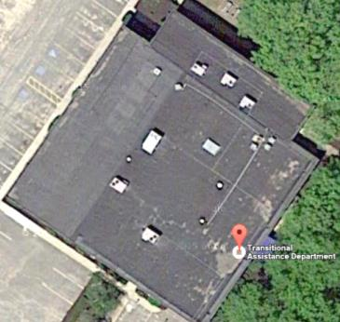
Rooftop air handling units (Source: Google Maps)
Picture 2
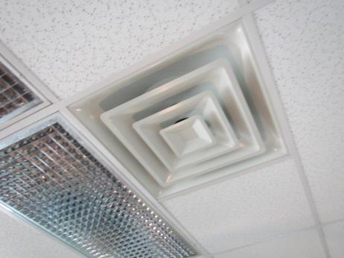
Supply diffuser
Picture 3
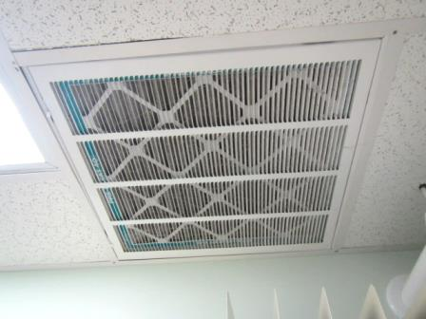
Return vent with filter
Picture 4
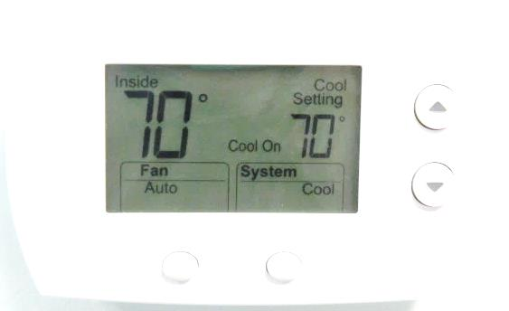
Digital thermostat, note fan “Auto” setting
Picture 5
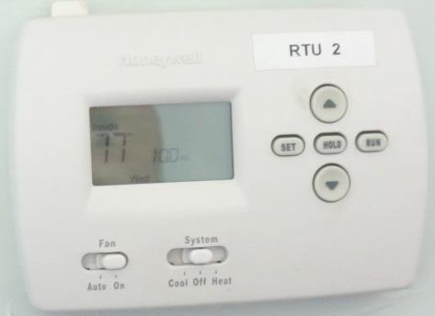
Digital thermostat, note system in the “Off” setting
Picture 6
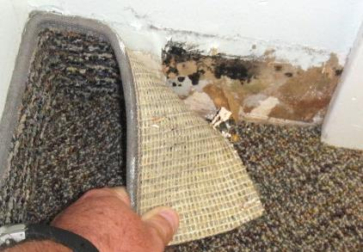
Visible mold growth (dark staining) behind carpet coving on gypsum wallboard outside bathroom where flooding occurred
Picture 7
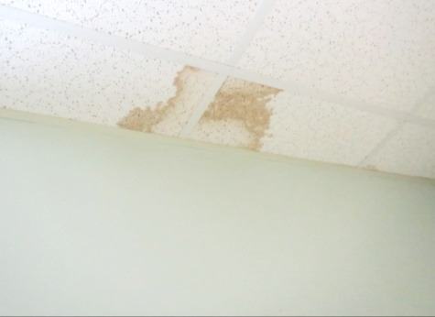
Water-damaged ceiling tiles
Picture 8
Bucket on 2nd floor DTA area catching rain water/leaks
Picture 9
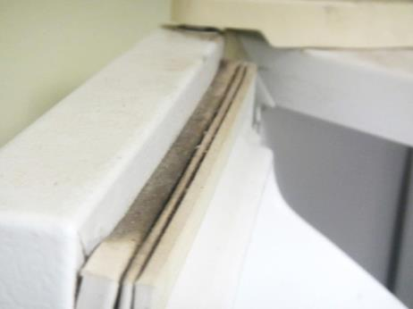
Mold growth on gasket of refrigerator in employee breakroom
Picture 10
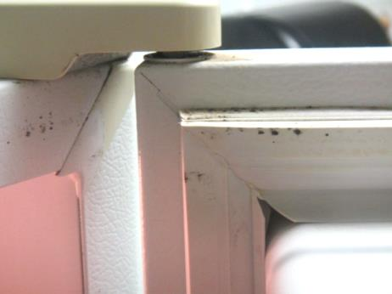
Mold growth on gasket of refrigerator in employee breakroom
Picture 11
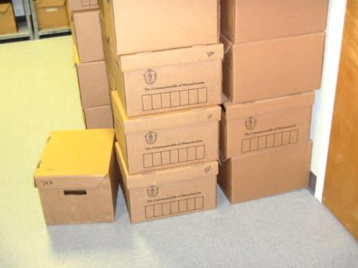
Cardboard boxes directly on floor of records room
Picture 12
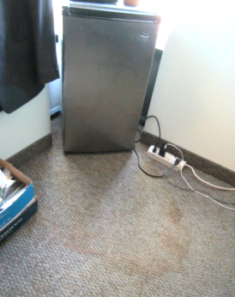
Carpet stained, likely from refrigerator
Location | Carbon  Dioxide  (ppm) | Carbon Monoxide  (ppm) | Temp  (°F) | Relative  Humidity  (%) | PM2.5  (µg/m³) | Occupants  in Room | Windows  Openable | Ventilation |  | Remarks
 |  |  |  |  |  |  |  | Supply | Exhaust
Background | 379 | ND | 85 | 44 | 10 |  |  |  |  | Sunny, clear
DCF
103 | 748 | ND | 72 | 52 | 19 | 0 | Y | Y | Y | DO, plants, CPs, refrigerator, AD
109 | 1122 | ND | 70 | 55 | 11 | 1 | N | Y | Y | DO, HS, items on floor
112 | 1069 | ND | 73 | 52 | 4 | 2 | N | Y | Y | Dust/debris/cobwebs on vents
113 | 1097 | ND | 70 | 51 | 5 | 0 | N | Y | Y | 1 WD-CT: corner
120 | 1175 | ND | 72 | 54 | 11 | 0 | N | Y | Y | Rusty pipe, dust/cobwebs
121 | 1152 | ND | 73 | 50 | 11 | 0 | N | Y | Y | Refrigerator, CPs, DO, items on floor
123 | 1176 | ND | 74 | 51 | 1 | 4 | N | Y | N | DO
126 | 1195 | ND | 74 | 49 | 11 | 0 | N | Y | Y | Plants, PF-dusty, refrigerator on carpet, DO
127 | 1102 | ND | 73 | 51 | 11 | 0 | N | Y | Y | Refrigerator on carpet, 1 WD-CT, PF-dusty
131 | 807 | ND | 71 | 53 | 14 | 1 | N | Y | N | DO, items on floor
132 | 918 | ND | 70 | 53 | 14 | 1 | N | Y | N | DO, PF
182 | 685 | ND | 72 | 56 | 15 | 0 | Y | Y | Y  Dusty | 1 WD-CT, refrigerator on carpet, door catches on carpet
201 | 1140 | ND | 77 | 46 | 19 | 1 | N | Y | N | Fridge on carpet, carpet stained, DO
206 | 913 | ND | 72 | 47 | 11 | 0 | N | Y | N | Fridge on carpet, DO
207 | 926 | ND | 70 | 52 | 4 | 0 | N | Y | N | DO
209 | 1004 | ND | 71 | 50 | 5 | 1 | N | Y | N
210 | 1090 | ND | 72 | 47 | 11 | 1 | N | Y | N | Plants, fridge on carpet, DO
211 | 1008 | ND | 71 | 52 | 4 | 0 | N | Y | N
212 | 1160 | ND | 75 | 42 | 14 | 1 | N | Y | N | Plants
213 | 995 | ND | 75 | 44 | 17 | 1 | N | Y | N | DO
215 | 981 | ND | 75 | 45 | 15 | 1 | N | Y | N | DO
216 | 1003 | ND | 75 | 45 | 18 | 1 | N | Y | N | CPs
2nd Floor women’s room |  |  | 76 | 49 | 18 | 1 | N | N | Y  Dusty | AD, DO
2nd Floor restroom 219 |  |  | 75 | 46 |  |  | N | N | Y  Dusty | AD
Adolescent Unit A | 973 | ND | 73 | 47 | 14 | 0 | Y | Y | N | Fridge on carpet/cardboard, ajar CT, CPs, plants
Adolescent Unit B | 1006 | ND | 74 | 52 | 5 | 1 | N | Y | Y | Thermostat – OFF
Adoption Unit | 685 | ND | 68 | 57 | 5 | 2 | N | Y | N | Microwave/Fridge, AD, spray cleaner
Break room | 1075 | ND | 72 | 51 | 4 | 0 | N | N | N | Thermostat fan “auto”
Break room | 946 | ND | 76 | 48 | 6 | 1 | N | Y | N | Mold on refrigerator gasket
Conference room (223/224) | 827 | ND | 75 | 49 | 6 | 0 | N | Y | Y | Dust/debris on vents
Conference room (first floor) | 988 | ND | 70 | 49 | 13 | 0 | N | Y | N
DCF Lobby | 1126 | ND | 73 | 47 | 11 | 2 | N | Y | N
DCF Records room | 927 | ND | 68 | 55 | 4 | 0 | N | Y | Y | Thermostat fan “auto”, dust/debris/cobwebs on vents
Family Resource Unit | 881 | ND | 73 | 56 | 7 | 3 | N | Y | N | WD CT-corner
Family visiting room | 1184 | ND | 71 | 48 | 11 | 0 | N | Y | Y | 1 WD-CT
Intake Family Resources | 1272 | ND | 74 | 55 | 3 | 3 | N | Y | Y
Intake Unit A | 1135 | ND | 75 | 48 | 11 | 3 | N | Y | Y | Plants on carpet, food items, refrigerator on carpet
Intake Unit B | 1214 | ND | 75 | 47 | 11 | 3 | Y | Y | Y | PF, items on windows, window sills dusty, refrigerator on carpet, plants, items on floor, CPs, two open utility access boxes
Interview room 1 | 1152 | ND | 72 | 48 | 11 | 0 | N | Y | Y
Lead Unit | 1015 | ND | 69 | 49 | 15 | 2 | N | Y | N | DEM, 1 WD-CT
Ongoing Unit A | 765 | ND | 72 | 53 | 16 | 1 | Y  Open | Y | N | Plants, CPs, refrigerator on carpet, insects reported
Ongoing Unit B | 1074 | ND | 76 | 46 | 5 | 1 | N | Y | N | Dust/debris on vents
STS Unit | 1178 | ND | 73 | 54 | 4 | 4 | N | Y | Y
Unit C | 981 | ND | 75 | 47 | 18 | 2 | Y | Y | Y | Items on floor, fridge on carpet
Unit E | 1118 | ND | 71 | 55 | 4 | 3 | N | Y | Y | Stained/discolored carpet, PF, microwave/fridge
Unit F | 959 | ND | 76 | 48 | 5 | 1 | N | Y | N | Accumulated items
Unit G | 993 | ND | 75 | 47 | 18 | 2 | Y | Y | Y
Unit H | 938 | ND | 72 | 47 | 11 | 2 | N | Y | N
Unit I | 1063 | ND | 76 | 46 | 4 | 1 | N | Y | Y | Dust/debris on vents
DTA
218 | 833 | ND | 72 | 56 | 6 | 0 | N | Y | N | 2 WD-CT: leak/rain bucket
227 | 795 | ND | 73 | 52 | 15 | 2 | N | Y | Y
Amaral | 647 | ND | 73 | 54 | 6 | 1 | N | Y | N | AD, DO
Break room | 760 | ND | 72 | 54 | 6 | 0 | N | Y | N | DO
Case Manager area | 812 | ND | 73 | 54 | 7 | 3 | N | Y | Y
Cubicles opposite Winters’ office | 772 | ND | 73 | 50 | 13 | 0 | N | Y | Y | Plants, AD
DTA conference room | 705 | ND | 73 | 50 | 17 | 5 | N | Y | Y | DEM, DO
DTA lobby | 718 | ND | 74 | 49 | 21 | 6 | N | Y | Y | AD
DTA printer/forms Area | 783 | ND | 74 | 50 | 14 | 0 | N | Y | Y | Plants, AD, PF
DTA reception | 647 | ND | 74 | 49 | 16 | 1 | N | Y | N
DTA women’s room |  |  | 74 | 52 | 30 | 1 | N | N | Y  Off | AD
Ibraham | 692 | ND | 75 | 46 | 15 | 1 | N | Y | N | DO
LaMarche/Purtell | 652 | ND | 75 | 47 | 15 | 0 | N | Y | N
Main work area (North) | 823 | ND | 72 | 45 | 6 | 5 | N | Y | Y
Maloun/Barros | 765 | ND | 73 | 50 | 16 | 2 | N | Y | N
Men’s room |  |  |  |  |  |  | N | N | Y | No draw from exhaust vent
Stabinch/Murphy | 834 | ND | 73 | 51 | 18 | 3 | N | Y | Y
Sullivan/Zaniboni | 652 | ND | 74 | 48 | 18 | 2 | N | Y | Y | HS, plants
Taddeo | 684 | ND | 73 | 44 | 8 | 2 | N | Y | Y
Vendor’s office | 815 | ND | 72 | 51 | 12 | 1 | N | Y | N | DO, items
Winters’ office | 775 | ND | 74 | 50 | 14 | 0 | N | Y | Y | Plants, AD, PF

