INDOOR AIR QUALITY
POST-OCCUPANCY ASSESSMENT

Department of Transitional Assistance,
and Department of Children and Families
80 Everett Avenue
Chelsea, MA

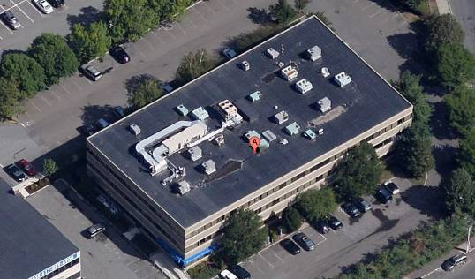

Prepared by:
Massachusetts Department of Public Health
Bureau of Environmental Health
Indoor Air Quality Program
June 2014

Background/Introduction
At the request of Bill Kelly, Project Manager, Office of Leasing, Division of Capital Asset Management and Maintenance (DCAMM), the Massachusetts Department of Public Health (MDPH), Bureau of Environmental Health (BEH) conducted post-occupancy air testing at the Department of Transitional Assistance (DTA) and Department of Children and Families (DCF) offices at 80 Everett Avenue in Chelsea, MA. The purpose of the post-occupancy testing was to assess the indoor air quality (IAQ) of newly occupied space leased by Massachusetts state agencies. On April 29, 2014, a visit to space newly occupied by DTA/DCF was made by Ruth Alfasso, Environmental Engineer/Inspector within BEH’s IAQ Program.
The building has three stories and was originally constructed as office space. Areas examined during this assessment were on the first and second floors, which have been newly remodeled and occupied since March 2014; the third floor and portions of the second floor have been occupied by DTA and DCF staff for several years prior to March 2014. The areas examined contain offices, open work areas, half-wall divided offices, conference rooms, file and storage rooms, kitchen areas, waiting areas and small hearing rooms. The space has suspended ceiling tiles. The majority of areas have carpet tiles. Windows are not openable.

Methods
Air tests for carbon dioxide, carbon monoxide, temperature and relative humidity were taken with the TSI, Q-Trak, IAQ Monitor 7565. Air tests for airborne particle matter with a diameter less than 2.5 micrometers were taken with the TSI, DUSTTRAK™ Aerosol Monitor Model 8520. Screening for volatile organic compounds was conducted using a RAE Systems Mini-RAE 2000 Photo Ionization Detector. BEH/IAQ staff also performed visual inspection of building materials for water damage and/or microbial growth.

Results
The DTA offices examined have an employee population of approximately 25; the DCF offices have a population of approximately 70. Members of the public also visit these offices daily. Tests were taken during normal operations and test results appear in Table 1.

Discussion

Ventilation
It can be seen from Table 1, that carbon dioxide levels were above 800 parts per million (ppm) in 20 of 59 areas tested. These results indicate a lack of air exchange in about a third of the areas tested at the time of assessment, the majority of which were in the DTA offices on the first floor.
The heating, ventilation and air-conditioning system (HVAC) consists of air handling units (AHUs) located on the roof, which draw in outside air and heat/cool it. Fresh air is delivered to spaces via ceiling-mounted supply vents (Picture 1). Return air is drawn into an above-ceiling plenum via ceiling grates (Picture 2) and space around light fixtures and ducted back to AHUs. Supplemental cooling in some areas, including the data room, is provided by wall-mounted ductless air-conditioning (AC) units.
The HVAC system is controlled by digital thermostats. Thermostats examined were in “occupied” mode (Picture 3), in accordance with a weekly timer. It could not be determined if the “occupied” mode provided for continual air circulation during occupied hours or if this was just used to determine the temperature settings for the building. When the system fans are continually on, as recommended during occupied hours, the system provides a continuous source of air circulation and filtration. An “automatic” setting would instead activate the HVAC system based on pre-set temperature and only supply fresh/filtered air when heating or cooling was called for in the space. Settings for these thermostats should be investigated and adjusted to allow for additional fresh air circulation, particularly in the first floor DTA area.
In some offices, exhaust vents were observed to be close to office doors, which had been left open (Picture 2). This may allow for air to be drawn into offices from the hallways rather than exhausting air from the offices.
Exhaust ventilation in restrooms is provided by dedicated exhaust vents, which are reportedly connected to fans on the roof. Several of the exhaust vents examined were not drawing air, indicating that the exhaust fans were not operating (Table 1). Without an operating exhaust system, moisture and odors can build up in restrooms. One of the exhaust vents examine was ajar from the ceiling tile system as well.
To maximize air exchange, the MDPH recommends that both supply and exhaust ventilation operate continuously during periods of occupancy. In order to have proper ventilation with a mechanical supply and exhaust system, the systems must be balanced to provide an adequate amount of fresh air to the interior of a room while removing stale air from the room. It is recommended that HVAC systems be re-balanced every five years to ensure adequate air systems function (SMACNA, 1994). Balancing information for the systems was not available.
Minimum design ventilation rates are mandated by the Massachusetts State Building Code (MSBC). Until 2011, the minimum ventilation rate in Massachusetts was higher for both occupied office spaces and general classrooms, with similar requirements for other occupied spaces (BOCA, 1993). The current version of the MSBC, promulgated in 2011 by the State Board of Building Regulations and Standards (SBBRS), adopted the 2009 International Mechanical Code (IMC) to set minimum ventilation rates. Please note that the MSBC is a minimum standard that is not health-based. At lower rates of cubic feet per minute (cfm) per occupant of fresh air, carbon dioxide levels would be expected to rise significantly. A ventilation rate of 20 cfm per occupant of fresh air provides optimal air exchange resulting in carbon dioxide levels at or below 800 ppm in the indoor environment in each area measured. MDPH recommends that carbon dioxide levels be maintained at 800 ppm or below. This is because most environmental and occupational health scientists involved with research on IAQ and health effects have documented significant increases in indoor air quality complaints and/or health effects when carbon dioxide levels rise above the MDPH guidelines of 800 ppm for schools, office buildings and other occupied spaces (Sundell et al., 2011). The ventilation must be on at all times that the room is occupied. Providing adequate fresh air ventilation with open windows and maintaining the temperature in the comfort range during the cold weather season is impractical. Mechanical ventilation is usually required to provide adequate fresh air ventilation.
Carbon dioxide is not a problem in and of itself. It is used as an indicator of the adequacy of the fresh air ventilation. As carbon dioxide levels rise, it indicates that the ventilating system is malfunctioning or the design occupancy of the room is being exceeded. When this happens, a buildup of common indoor air pollutants can occur, leading to discomfort or health complaints. The Occupational Safety and Health Administration (OSHA) standard for carbon dioxide is 5,000 parts per million parts of air (ppm). Workers may be exposed to this level for 40 hours/week, based on a time-weighted average (OSHA, 1997).
The MDPH uses a guideline of 800 ppm for publicly occupied buildings. A guideline of 600 ppm or less is preferred in schools due to the fact that the majority of occupants are young and considered to be a more sensitive population in the evaluation of environmental health status. Inadequate ventilation and/or elevated temperatures are major causes of complaints such as respiratory, eye, nose and throat irritation, lethargy and headaches. For more information concerning carbon dioxide, please see Appendix A.
Temperature readings during the assessment ranged from 69° F to 74° F, which were within or close to the MDPH recommended comfort range (Table 1). The MDPH recommends that indoor air temperatures be maintained in a range of 70° F to 78° F in order to provide for the comfort of building occupants. In many cases concerning indoor air quality, fluctuations of temperature in occupied spaces are typically experienced, even in a building with an adequate fresh air supply.
The relative humidity at the time of assessment ranged from 27 to 39 percent (Table 1), which was below the MDPH recommended comfort range. The MDPH recommends a comfort range of 40 to 60 percent for indoor air relative humidity. The sensation of dryness and irritation is common in a low relative humidity environment. Low relative humidity is a very common problem during the heating season in the northeast part of the United States. It is of note that relative humidity measurements in the first floor DTA area were higher than those in other areas of the building. This suggests that not only is insufficient fresh air being delivered to this portion of the building, but that there may be insufficient exhaust ventilation to remove occupant-generated moisture.

Microbial/Moisture Concerns
A few water-damaged ceiling tiles were observed (Picture 4; Table 1). Water-damaged ceiling tiles indicate a leak from plumbing or the building envelope and can be a source of mold. Damaged ceiling tiles should be replaced after a leak is discovered and repaired. There were also reports of water infiltrating through windows during heavy rain events. While no water-damaged windowsills or nearby materials were observed, areas subject to potential water infiltration should be kept clear of items, particularly porous items, which may become damaged. Many windowsills were used to store papers, binders and other porous materials (Picture 5).
Plants were observed in some areas (Table 1). Plants should be properly maintained and equipped with drip pans. Plants should be located away from ventilation sources to prevent aerosolization of dirt, pollen or mold. Plants should not be placed on carpets or other porous materials, since water damage to porous materials may lead to microbial growth.
BEH/IAQ staff observed water coolers and refrigerators on carpeted surfaces (Picture 6). Spills or leaks from this equipment can moisten carpet and lead to microbial growth and carpet degradation. MDPH typically recommends placing rubber mats or non-porous flooring (e.g., vinyl tile) beneath this equipment to protect the porous carpet from leaks and spills. In addition, the kitchen area on the second floor is carpeted (Picture 7). Carpeting in kitchens may be subject to leaks, spills and accumulations of food debris, which may attract pests.
As mentioned, ductless AC units were observed in data areas. These units have a condensation drain hose that needs to be directed outside or to an appropriate drain to ensure that water does not spill or become stagnant, which can lead to microbial growth and odors.
In some of the storage/file rooms and other areas, boxes were observed to be stored on the floor. If humidity levels in the building increase during the warm summer months, floors may be subject to condensation, which would moisten cardboard and other porous items, causing damage and potentially leading to microbial growth. Stored porous items should be on shelves or contained in non-porous totes or other containers.
BEH/IAQ staff examined the exterior of the building to identify breaches in the building envelope and/or other issues that could provide sources of water penetration. Plants and shrubbery were observed growing in close proximity to the foundation (Pictures 8 and 9), which can allow moisture and pollen to be drawn into the building if windows are not tight. These conditions can also undermine the integrity of the building envelope and provide a means of water entry by capillary action into the building through exterior walls, foundation concrete and masonry (Lstiburek & Brennan, 2001). In addition, breaches in exterior areas can provide a means of drafts and pest entry into the building.

Other Indoor Air Evaluations
Indoor air quality can be negatively influenced by the presence of respiratory irritants, such as products of combustion. The process of combustion produces a number of pollutants. Common combustion emissions include carbon monoxide, carbon dioxide, water vapor, and smoke (fine airborne particle material). Of these materials, exposure to carbon monoxide and particulate matter with a diameter of 2.5 micrometers (μm) or less (PM2.5) can produce immediate, acute health effects upon exposure. To determine whether combustion products were present in the indoor environment, BEH/IAQ staff obtained measurements for carbon monoxide and PM2.5.

Carbon Monoxide
Carbon monoxide is a by-product of incomplete combustion of organic matter (e.g., gasoline, wood and tobacco). Exposure to carbon monoxide can produce immediate and acute health affects. Several air quality standards have been established to address carbon monoxide and prevent symptoms from exposure to these substances. The MDPH established a corrective action level concerning carbon monoxide in ice skating rinks that use fossil-fueled ice resurfacing equipment. If an operator of an indoor ice rink measures a carbon monoxide level over 30 ppm, taken 20 minutes after resurfacing within a rink, that operator must take actions to reduce carbon monoxide levels (MDPH, 1997).
The American Society of Heating Refrigeration and Air Conditioning Engineers (ASHRAE) has adopted the National Ambient Air Quality Standards (NAAQS) as one set of criteria for assessing indoor air quality and monitoring of fresh air introduced by HVAC systems (ASHRAE, 1989). The NAAQS are standards established by the US EPA to protect the public health from six criteria pollutants, including carbon monoxide and particulate matter (US EPA, 2006). As recommended by ASHRAE, pollutant levels of fresh air introduced to a building should not exceed the NAAQS levels (ASHRAE, 1989). The NAAQS were adopted by reference in the Building Officials & Code Administrators (BOCA) National Mechanical Code of 1993 (BOCA, 1993), which is now an HVAC standard included in the Massachusetts State Building Code (SBBRS, 2011). According to the NAAQS, carbon monoxide levels in outdoor air should not exceed 9 ppm in an eight-hour average (US EPA, 2006).
Carbon monoxide should not be present in a typical, indoor environment. If it is present, indoor carbon monoxide levels should be less than or equal to outdoor levels. Outdoor carbon monoxide concentrations were measured at 1.3 ppm the day of assessment (Table 1). No measureable levels of carbon monoxide (non-detect; ND) were detected in the building during the assessment (Table 1).

Particulate Matter
The US EPA has established NAAQS limits for exposure to particulate matter. Particulate matter includes airborne solids, which can result in eye and respiratory irritation if exposure occurs. The NAAQS originally established exposure limits to particulate matter with a diameter of 10 μm or less (PM10). According to the NAAQS, PM10 levels should not exceed 150 micrograms per cubic meter (μg/m³) in a 24-hour average (US EPA, 2006). These standards were adopted by both ASHRAE and BOCA. Since the issuance of the ASHRAE standard and BOCA Code, US EPA established a more protective standard for fine airborne particles. This more stringent PM2.5 standard requires outdoor air particle levels be maintained below 35 μg/m³ over a 24-hour average (US EPA, 2006). Although both the ASHRAE standard and BOCA Code adopted the PM10 standard for evaluating air quality, MDPH uses the more protective PM2.5 standard for evaluating airborne particulate matter concentrations in the indoor environment.
Outdoor PM2.5 was measured at 10 μg/m³ (Table 1) on the day of the visit. PM2.5 levels measured indoors ranged from ND to 4 μg/m³ (Table 1), which were below the NAAQS PM2.5 level of 35 μg/m³. Frequently, indoor air levels of particulates (including PM2.5) can be at higher levels than those measured outdoors. A number of mechanical devices and/or activities that occur in buildings can generate particulate matter during normal operations. Sources of indoor airborne particulates may include but are not limited to particles generated during the operation of fan belts in the HVAC system, use of stoves and/or microwave ovens in kitchen areas; use of photocopiers, fax machines and computer printing devices; operation of an ordinary vacuum cleaner and heavy foot traffic indoors.

Volatile Organic Compounds
Indoor air concentrations can be greatly impacted by the use of products containing volatile organic compounds (VOCs). VOCs are carbon-containing substances that have the ability to evaporate at room temperature. Total volatile organic compounds (TVOCs) can result in eye and respiratory irritation if exposure occurs. For example, chemicals evaporating from a paint can stored at room temperature would most likely contain VOCs. In order to determine if VOCs were present, testing for TVOCs was conducted. Outdoor TVOC concentrations were ND on the day of assessment (Table 1). No measureable levels of TVOCs were detected in the building during the assessment (Table 1).
There are several photocopiers in the building. Photocopiers can be sources of pollutants such as VOCs, ozone, heat and odors, particularly if the equipment is older and in frequent use. Both VOCs and ozone are respiratory irritants (Schmidt Etkin, 1992). Photocopiers should be kept in well ventilated rooms, and should be located near windows or exhaust vents.
Hand sanitizer was found in some offices and common areas (Table 1). Hand sanitizers may contain ethyl alcohol and/or isopropyl alcohol, which are highly volatile and may be irritating to the eyes and nose. Sanitizing products may also contain fragrances to which some people may be sensitive.
Air fresheners and deodorizing materials were observed in some areas (Table 1). Air deodorizers contain chemicals that can be irritating to the eyes, nose and throat of sensitive individuals. Many air fresheners contain 1,4-dichlorobenzene, a VOC which may cause reductions in lung function (NIH, 2006). Importantly, deodorizing agents do not remove materials causing odors, but rather mask odors that may be present in the area.
Some areas contained dry erase boards and related materials (Table 1). Materials such as dry erase markers and dry erase board cleaners may contain VOCs, such as methyl isobutyl ketone, n-butyl acetate and butyl-cellusolve (Sanford, 1999), which can be irritating to the eyes, nose and throat.

Other Conditions
It was reported that when the building was renovated to house the DTA and DCF offices, additional office space was made by converting a second-floor atrium into offices. There was concern regarding airflow and the tightness of the building envelope in this area however there were no apparent water stains or damage noted at the time of the assessment. Occupants should report any concerns regarding drafts or air circulation to building management.
Other conditions that can affect indoor air quality were observed during the assessment. Most areas in the DTA space are covered with new carpet tiles. The Institute of Inspection, Cleaning and Restoration Certification (IICRC), recommends that carpeting be cleaned annually (or semi-annually in soiled high traffic areas) (IICRC, 2005).
Plush and upholstered furniture and plush toys were observed in some areas (Picture 10). Upholstered furniture pillows and cushions are covered with fabrics that are exposed to human skin. This type of contact can leave oils, perspiration, hair and skin cells. Dust mites feed upon human skin cells and excrete waste products that contain allergens. In addition, if relative humidity levels increase above 60 percent, dust mites tend to proliferate (US EPA, 1992). In order to remove dust mites and other pollutants, frequent vacuuming of upholstered furniture is recommended (Berry, 1994). It is also recommended that upholstered furniture be professionally cleaned on an annual basis. If an excessively dusty environment exists due to outdoor conditions or indoor activities (e.g., renovations), cleaning frequency should be increased (every six months) (IICRC, 2000).
In some areas, accumulation of items, including papers, boxes and personal items were found stored on desks, tables and counters (Picture 11). Decorative items, including plush and organic items were also observed. Large numbers of items provide a source for dusts to accumulate. These items make it difficult for custodial staff to clean. Items should be relocated and/or cleaned periodically to avoid excessive dust build up. Stored clothing and other items were observed loosely held in plastic bags, many of which were open with items spilling out to the floor (Picture 12). Stored clothing can provide harborage for pests and is also subject to dust accumulation. Items should be stored in well-sealed containers such as plastic totes. Items were also observed hanging from the ceiling tiles systems in a few places. Disturbance of the ceiling tile systems can dislodge dust and debris and these items are difficult to keep clean.
Food and food preparation equipment were also noted in some areas (Picture 11; Table 1). The use of this equipment can provide a source of particulates and odors, particularly if the equipment is not kept clean. Food/debris remaining on heating elements can burn the next time the items are used, producing smoke and odors. In addition, unsealed food, including crumbs remaining on food-preparation equipment, can be attractive to pests.

Conclusions/Recommendations
In view of the findings at the time of the visit, the following recommendations are made:
- Thermostats should be programmed such that the fan/air circulation is ON during business hours to provide adequate ventilation throughout the building. Ensure fresh air louvers on AHUs are working properly and adjust to increase outside air intake as needed.
- Operate and maintain HVAC systems in accordance with manufacturer’s recommendations, including regular filter changes/cleaning of all AHUs and ACs.
- Ensure restroom exhaust vents are operating to remove moisture and odors, make repairs as necessary.
- Consider adopting a balancing schedule of every 5 years for all mechanical ventilation systems, as recommended by ventilation industrial standards (SMACNA, 1994).
- For buildings in New England, periods of low relative humidity during the winter are often unavoidable. Therefore, scrupulous cleaning practices should be adopted to minimize common indoor air contaminants whose irritant effects can be enhanced when the relative humidity is low. To control for dusts, a high efficiency particulate arrestance (HEPA) filter equipped vacuum cleaner in conjunction with wet wiping of all surfaces is recommended. Avoid the use of feather dusters. Drinking water during the day can help ease some symptoms associated with a dry environment (throat and sinus irritations).
- Ensure roof/plumbing leaks are repaired and replace any remaining water-damaged ceiling tiles. Examine the area above these tiles for mold growth. Disinfect areas of water leaks with an appropriate antimicrobial, as needed.
- Ensure plants have drip pans and avoid over-watering. Examine drip pans periodically for mold growth. Disinfect with an appropriate antimicrobial where necessary.
- Place protective rubber mats beneath water coolers and water fountains or use non-porous flooring to prevent damage to carpeting.
- Consider replacing the carpeting in the kitchen with non-porous floor tile.
- Work with building management to help identify window leaks. Make repairs as necessary to the exterior of the building to prevent water penetration.
- Store porous items such as cardboard boxes off the floor and away from windowsills.
- Ensure that condensation drain hoses from ductless AC units drain properly; inspect periodically for leaks.
- Ensure plants, trees and shrubs are located at least five feet away from exterior walls/foundation of the building.
- Avoid the use of scented products such as air deodorizers and fresheners.
- Clean dry-erase marker trays of accumulated dust and debris regularly using a damp cloth.
- Consider reducing, consolidating or relocating items and papers to allow for more thorough cleaning.
- Clean carpeting annually or semi-annually in soiled high traffic areas as per the recommendations of the Institute of Inspection, Cleaning and Restoration Certification (IICRC, 2005). Copies of the IICRC fact sheet can be downloaded at: cleancareseminars.net.
- Clean/vacuum upholstered furniture and plush toys on a regular basis (e.g., annually/semi-annually such as carpets) to remove dust and debris.
- Refrain from hanging items from the suspended ceiling tile system.
- Ensure that food is kept tightly sealed and food preparation equipment is cleaned regularly to prevent smoke, odors and attracting of pests.
- Refer to resource manual and other related indoor air quality documents located on the MDPH’s website for further building-wide evaluations and advice on maintaining public buildings. These documents are available at: http://mass.gov/dph/iaq.

References
ASHRAE. 1989. Ventilation for Acceptable Indoor Air Quality. American Society of Heating, Refrigeration and Air Conditioning Engineers. ANSI/ASHRAE 62-1989.
Berry, M.A. 1994. Protecting the Built Environment: Cleaning for Health. Michael A. Berry, Chapel Hill, NC.
BOCA. 1993. The BOCA National Mechanical Code/1993. 8th ed. Building Officials and Code Administrators International, Inc., Country Club Hill, IL.
IICRC. 2000. IICRC S001. Reference Guideline for Professional On-Location Cleaning of Textile Floor Covering Materials. Institute of Inspection, Cleaning and Restoration Certification. Institute of Inspection Cleaning and Restoration, Vancouver, WA.
IICRC. 2005. Carpet Cleaning FAQ 4 Institute of Inspection, Cleaning and Restoration Certification. Institute of Inspection Cleaning and Restoration, Vancouver, WA.
Lstiburek, J. & Brennan, T. 2001. Read This Before You Design, Build or Renovate. Building Science Corporation, Westford, MA. U.S. Department of Housing and Urban Development, Region I, Boston, MA.
MDPH. 1997. Requirements to Maintain Air Quality in Indoor Skating Rinks (State Sanitary Code, Chapter XI). 105 CMR 675.000. Massachusetts Department of Public Health, Boston, MA.
NIH. 2006. Chemical in Many Air Fresheners May Reduce Lung Function. NIH News. National Institute of Health. July 27, 2006. http://www.nih.gov/news/pr/jul2006/niehs-27.htm
OSHA. 1997. Limits for Air Contaminants. Occupational Safety and Health Administration. Code of Federal Regulations. 29 C.F.R 1910.1000 Table Z-1-A.
Sanford. 1999. Material Safety Data Sheet (MSDS No: 198-17). Expo® Dry Erase Markers Bullet, Chisel, and Ultra Fine Tip. Sanford Corporation, Bellwood, IL.
SBBRS. 2011. Mechanical Ventilation. State Board of Building Regulations and Standards. Code of Massachusetts Regulations, 8th edition. 780 CMR 1209.0.
Schmidt Etkin, D. 1992. Office Furnishings/Equipment & IAQ Health Impacts, Prevention & Mitigation. Cutter Information Corporation, Indoor Air Quality Update, Arlington, MA.
SMACNA. 1994. HVAC Systems Commissioning Manual. 1st ed. Sheet Metal and Air Conditioning Contractors’ National Association, Inc., Chantilly, VA.
Sundell. 2011. Sundell, J., H. Levin, W. W. Nazaroff, W. S. Cain, W. J. Fisk, D. T. Grimsrud, F. Gyntelberg, Y. Li, A. K. Persily, A. C. Pickering, J. M. Samet, J. D. Spengler, S. T. Taylor, and C. J. Weschler. Ventilation rates and health: multidisciplinary review of the scientific literature. Indoor Air, Volume 21: pp 191–204.
US EPA. 1992. Indoor Biological Pollutants. US Environmental Protection Agency, Environmental Criteria and Assessment Office, Office of Health and Environmental Assessment, research Triangle Park, NC. EPA 600/8-91/202. January 1992
US EPA. 2006. National Ambient Air Quality Standards (NAAQS). US Environmental Protection Agency, Office of Air Quality Planning and Standards, Washington, DC. http://www.epa.gov/air/criteria.html.

Picture 1
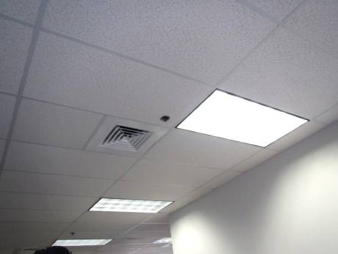
Ceiling-mounted supply vent
Picture 2
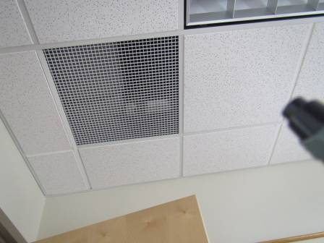
Ceiling-mounted return grate; note proximity to room door

Picture 3
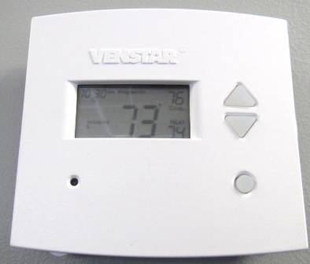
Thermostat in “occupied” mode
Picture 4
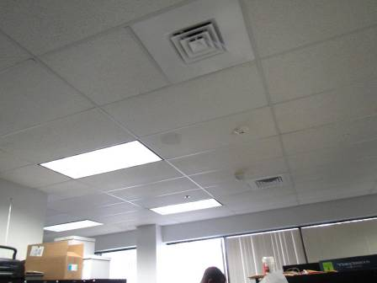
Water-damaged ceiling tile
Picture 5
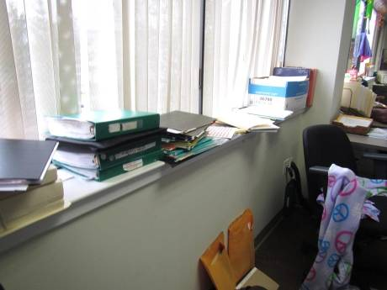
Porous items stored on windowsill
Picture 6
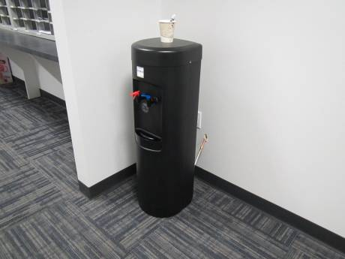
Water dispenser on carpet
Picture 7
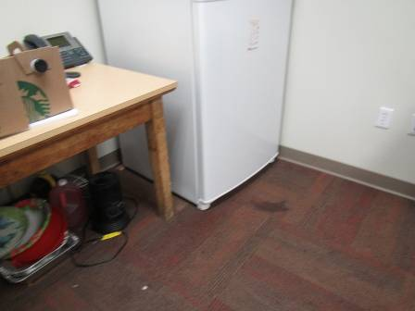
Refrigerator on carpet in kitchen area; note water stain in front of refrigerator
Picture 8
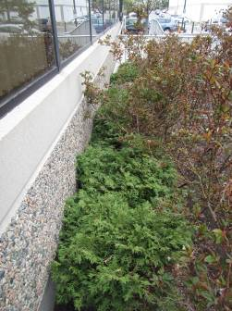
Shrubbery against the foundation

Picture 9
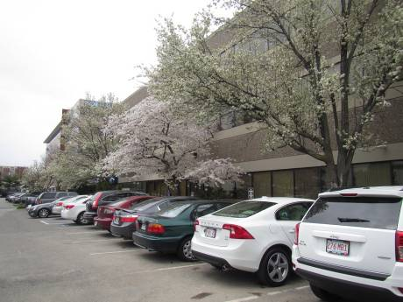
Flowering trees up against windows
Picture 10
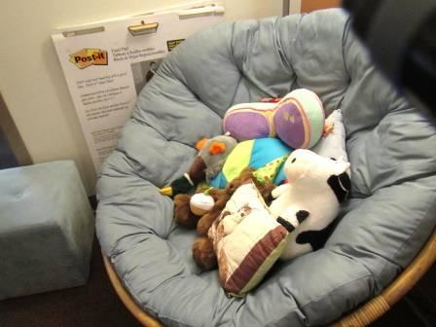
Plush items and upholstered furniture
Picture 11
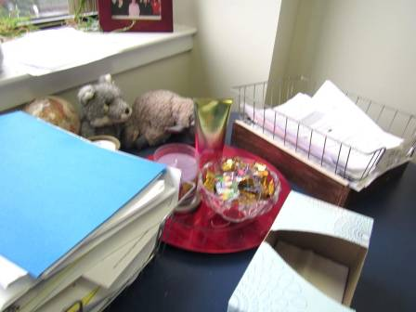
Items including food in an office
Picture 12
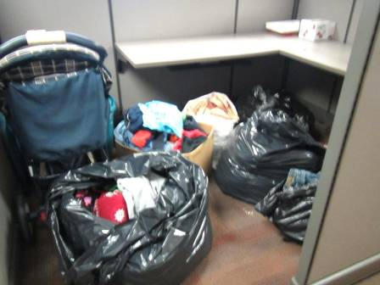
Clothing stored in plastic bags

Location | Carbon  Dioxide  (ppm) | Carbon Monoxide  (ppm) | Temp  (°F) | Relative  Humidity  (%) | PM2.5  (µg/m³) | TVOC  (ppm) | Occupants  in Room | Windows  Openable | Ventilation |  | Remarks
 |  |  |  |  |  |  |  |  | Supply | Exhaust | Remarks
Background | 398 | 1.3 | 51 | 33 | 10 | ND |  |  |  |  | breezy
DCF first floor
101 adolescent visitation | 634 | ND | 69 | 31 | 1 | ND | 0 | N | Y | Y
102 children’s visitation | 584 | ND | 69 | 30 | 1 | ND | 0 | N | Y | Y | NC
103 hearing | 640 | ND | 70 | 30 | 2 | ND | 0 | N |  |  | Old table
105 hearing room | 635 | ND | 69 | 31 | 2 | ND | 0 | N | Y | N | DO
106 hearing | 583 | ND | 69 | 30 | 2 | ND | 0 | N
112 open office area | 561 | ND | 71 | 28 | 2 | ND | 0 | N |  |  | Storage
114 | 644 | ND | 72 | 27 | 2 | ND | 0 | N |  |  | DO, fridge, plant
117 | 752 | ND | 73 | 33 | 1 | ND | 1 | N | Y | Y | HS
Cube area | 695 | ND | 74 | 30 | ND | ND | 3 | N | Y | Y | Items
File room |  |  |  |  |  |  |  | N | Y | N | Boxes on the floor, NC
Lobby | 664 | ND | 70 | 31 | 1 | ND | 7 | N | Y | Y | NC
Lobby restroom |  |  |  |  |  |  |  | N | Y | Y on
reception | 615 | ND | 71 | 30 | 3 | ND | 1 | N |  |  | Mailing equipment
DTA 1st floor
132 cubes | 1160 | ND | 71 | 37 | 4 | ND | 1 | N | Y | Y
133 cubes | 1156 | ND | 71 | 37 | 4 | ND | 1 | N | Y | Y
135 cubes | 1178 | ND | 71 | 37 | 4 | ND | 1 | N | Y | Y | Food, heater,
141 cubes | 1217 | ND | 73 | 34 | 2 | ND | 0 | N | Y | Y | HS
142 | 1171 | ND | 72 | 35 | 4 | ND | 1 | N | Y | Y
142 cubes | 1274 | ND | 73 | 34 | 2 | ND | 1 | N | Y | Y
143 half wall | 1140 | ND | 72 | 34 | 3 | ND | 0 | N | Y | Y | Items
145 half wall | 1081 | ND | 73 | 32 | 4 | ND | 1 | N | Y | Y
146 Connors | 1139 | ND | 72 | 36 | 3 | ND | 2 | N | Y | Y
150 cubes | 1272 | ND | 73 | 34 | 3 | ND | 2 | N | Y | Y | Adaptive devices
153 cubes | 1170 | ND | 73 | 33 | 3 | ND | 0 | N | Y | Y
155 half wall | 1213 | ND | 73 | 33 | 3 | ND | 1 | N | Y | Y
156 cubes | 1262 | ND | 73 | 34 | 2 | ND | 1 | N | Y | Y | PF
157 cubes | 1205 | ND | 73 | 33 | 3 | ND | 1 | N | Y | Y | PF
158 half wall | 1080 | ND | 74 | 33 | 3 | ND | 0 | N | Y | Y | Coffee pot, vacant area
Area director | 1229 | ND | 70 | 39 | 4 | ND | 4 | N | Y | Y | DO, DEM
File room | 1650 | ND | 73 | 33 | 3 | ND | 5 | N | Y | Y | NC, 1 WD CT, PF
Ladies room |  |  |  |  |  |  |  | N | Y | Y | Odor, CP/AF 2 AT, exhaust off/not working
2nd floor, DCF
102 vacant office | 669 | ND | 70 | 37 | ND | ND | 0 | N | Y | Y
210 conference | 698 | ND | 71 | 31 | ND | ND | 0 | N | Y | Y
Adriani | 715 | ND | 70 | 31 | ND | ND | 1 | N | Y | Y
Area Director | 799 | ND | 72 | 30 | ND | ND | 1 | N | Y | Y | DO, fridge, plush items
Barrantes cube area | 622 | ND | 70 | 28 | ND | ND | 2 | N | Y | Y | Area rugs, CP, items hanging from ceiling
Brown office | 652 | ND | 71 | 29 | ND | ND | 0 | N | Y | Y | DO
Case Management supervisor | 782 | ND | 72 | 29 | ND | ND | 1 | N | Y | Y | Perfume odor
Closed records |  |  |  |  |  |  |  | N | Y | N | NC, boxes on floor
Crenan | 747 | ND | 71 | 31 | ND | ND | 0 | N | Y | Y | Vinegar, plants, items on sill, plush rugs, hanging items
Cube area next to 210 | 629 | ND | 71 | 30 | ND | ND | 0 | N | Y | Y | DEM
Cube next to Brown | 678 | ND | 72 | 30 | ND | ND | 0 | N | Y | Y | Plants
Davis | 747 | ND | 72 | 29 | ND | ND | 1 | N | Y | Y | Reported periodic smoke smell, fridge, PF dusty
Dominque (cubes) | 605 | ND | 69 | 30 | 1 | ND | 2 | N | Y | Y | Items including items on windowsill
Fatima | 790 | ND | 72 | 30 | ND | ND | 0 | N | Y | Y | Heater
Fernandez-Castro | 680 | ND | 71 | 29 | ND | ND | 1 | N | Y | Y | Plants
Goudreau | 620 | ND | 72 | 29 | ND | ND | 1 | N | Y | Y | Fridge on carpet, DO, PF
Harbor area | 661 | ND | 69 | 31 | 1 | ND | 3 | N | Y | Y | Items, plush furniture, personal fan
Harbor Cube area | 603 | ND | 70 | 29 | ND | ND | 0 | N | Y | Y | CP, plants
Kitchen | 632 | ND | 72 | 28 | ND | ND | 0 | N | Y | Y | Fridge on carpet (kitchen is carpeted)
Kobos (cubes) | 802 | ND | 72 | 31 | ND | ND | 4 | N | Y | Y | Remarked as drafty
Ladies room |  |  |  |  |  |  |  | N | Y | Y | Exhaust off/not functioning, plants, odor, CP
Lopes | 764 | ND | 71 | 31 | ND | ND | 0 | N | Y | Y
Lux office | 692 | ND | 71 | 31 | ND | ND | 0 | N | Y | Y | Fridge, PF, plants
Mauro | 743 | ND | 71 | 32 | 1 | ND | 3 | N | Y | Y | Plants, HS, food, scented candle
McMorrow | 798 | ND | 71 | 31 | ND | ND | 1 | N | Y | Y | Items
MDF |  |  |  |  |  |  |  | N | N | Y | Messy, dedicated AC wall-mounted
Moriarity (cubes) | 857 | ND | 71 | 32 | ND | ND | 1 | N | Y | Y | Items
Mulvey (office) | 881 | ND | 72 | 31 | ND | ND | 2 | N | Y | Y | CP, used to be an atrium area
Quinn (office) | 650 | ND | 72 | 30 | ND | ND | 0 | N | Y | Y | Microwave, coffeepot, DO
Records |  |  |  |  |  |  |  | N |  |  | Files, binders, boxes on floor
Salmon | 761 | ND | 71 | 30 | 1 | ND | 0 | N | Y | Y | Fridge on carpet, microwave, plants
Small conference room | 650 | ND | 72 | 29 | ND | ND | 0 | N | Y | Y
Totter (office) | 600 | ND | 69 | 30 | 1 | ND | 1 | N | Y | Y | Fridge on carpet, shovel, PF
Vacant cubes | 650 | ND | 70 | 31 | 1 | ND | 0 | N | Y | Y | Storage of clothing
Vacant cubes | 667 | ND | 70 | 30 | 1 | ND | 0 | N | Y | Y

