INDOOR AIR QUALITY
POST-OCCUPANCY ASSESSMENT

Department of Transitional Assistance
160 West Rodney French Boulevard
New Bedford, Massachusetts

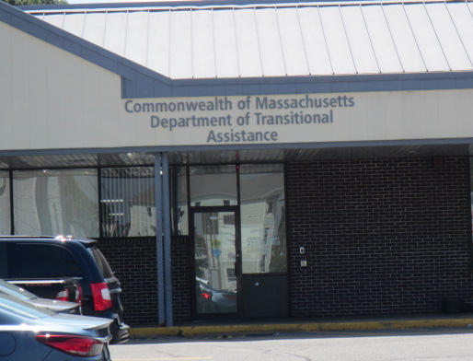

Prepared by:
Massachusetts Department of Public Health
Bureau of Environmental Health
Indoor Air Quality Program
February 2017

Background
Building: | Department of Transitional Assistance (DTA)
Address: | 160 West Rodney French Boulevard, New Bedford, MA
Division of Capital Asset Management and Maintenance (DCAMM) Project Manager: | Jamie Merrill Blood
Date of Post-Occupancy Assessment: | January 30, 2017
Massachusetts Department of Public Health/Bureau of Environmental Health (MDPH/BEH) Staff Conducting Assessment: | Cory Holmes, Environmental Analyst/Inspector, Indoor Air Quality (IAQ) Program
Date of Building Construction/Renovation | Mid 1960s, recent renovations over the summer  of 2016
Building Description: | The recently renovated space is used as a training facility and work space for training staff.
Windows: | Not openable

Methods
Please refer to the IAQ Manual for methods, sampling procedures, and interpretation of results (MDPH, 2015).

IAQ Testing Results
The following is a summary of indoor air testing results (Table 1).
- Carbon dioxide levels were below the MDPH guideline of 800 parts per million (ppm) in all areas.
- Temperature was within or close to the lower end of the recommended range of 70°F to 78°F.
- Relative humidity was below the recommended range of 40% to 60% in all areas, which was reflective of outdoor conditions at the time of assessment.
- Carbon monoxide levels were non-detectable in all areas assessed.
- Fine particulate matter (PM2.5) concentrations measured were below the National Ambient Air Quality Standard (NAAQS) level of 35 micrograms per cubic meter (μg/m³) in all areas assessed.

Ventilation
The heating, ventilation and air conditioning (HVAC) system consists of rooftop air handling units (AHUs). The space utilizes a ducted supply system (Picture 1) to deliver conditioned air, and an above the ceiling plenum which draws return air through ceiling grates (Picture 1). The conference room did not have any return grates installed at the time of this assessment.
The Training Staff Work/Cube area does not have a direct means of supply ventilation, relying on infiltration of air from the adjacent hallway via an open archway (Picture 2). The hallway is outfitted with two supply vents; however they are located around the corner from the training staff work area (Picture 3). The portion of the hallway directly outside the Training Staff Work area has no supply vents (Picture 4).

Recommendations
In view of the findings at the time of the assessment, the following recommendations are made:
- Install a return grill in the conference room.
- Relocate one of the supply vents in the hallway near the restrooms (Picture 4), to outside the Training Staff Work/Cube area hallway (Picture 3).
- Consider adopting a balancing schedule of every 5 years for all mechanical ventilation systems, as recommended by ventilation industrial standards (SMACNA, 1994).
- Change AHU filters (using MERV 8 or higher filters) a minimum of twice per year (e.g., between heating/cooling seasons) or as per the manufacturer’s instructions.
- Clean carpeting annually or semi-annually in soiled high traffic areas as per the recommendations of the Institute of Inspection, Cleaning and Restoration Certification (IICRC, 2012).
- Refer to resource manual and other related indoor air quality documents located on the MDPH’s website for further building-wide evaluations and advice on maintaining public buildings. These documents are available at http://mass.gov/dph/iaq.

References
IICRC. 2012. Institute of Inspection, Cleaning and Restoration Certification. Carpet Cleaning: FAQ. Retrieved from http://www.iicrc.org/consumers/care/carpet-cleaning.
MDPH. 2015. Massachusetts Department of Public Health. Indoor Air Quality Manual: Chapters I-III. Available at: http://www.mass.gov/eohhs/gov/departments/dph/programs/environmental-health/exposure-topics/iaq/iaq-manual/.
SMACNA. 1994. HVAC Systems Commissioning Manual. 1st ed. Sheet Metal and Air Conditioning Contractors’ National Association, Inc., Chantilly, VA.
Picture 1
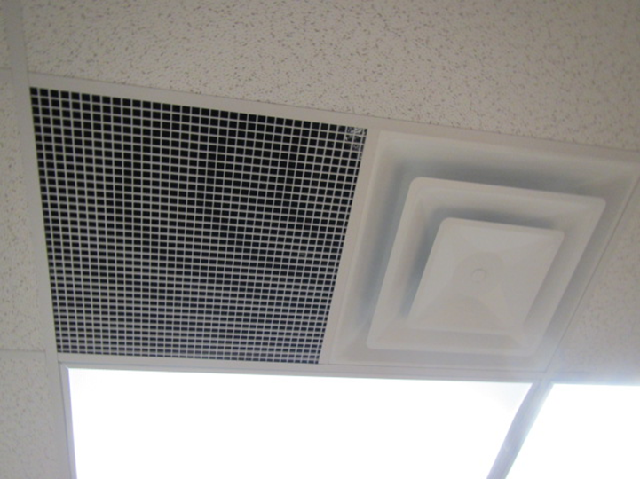
Supply diffuser (right) and return grill (left)
Picture 2
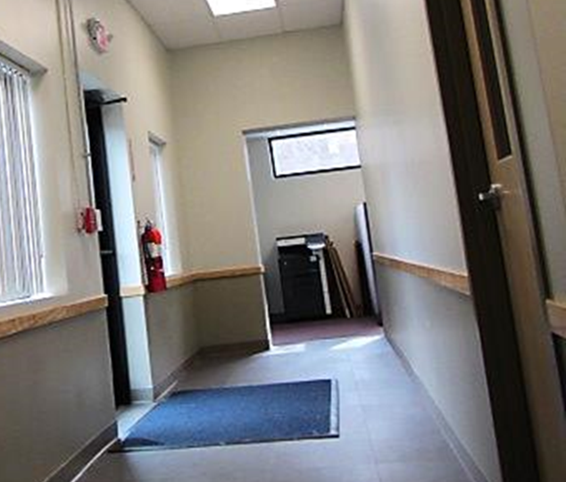
Open design of Training Staff Work/Cube area for passive air infiltration
Picture 3
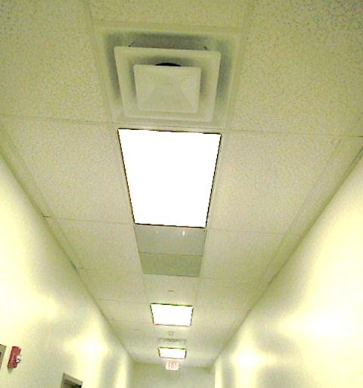
Hallway area near restrooms with two supply vents (arrows), around the corner from Training Staff Work/Cube area
Picture 4
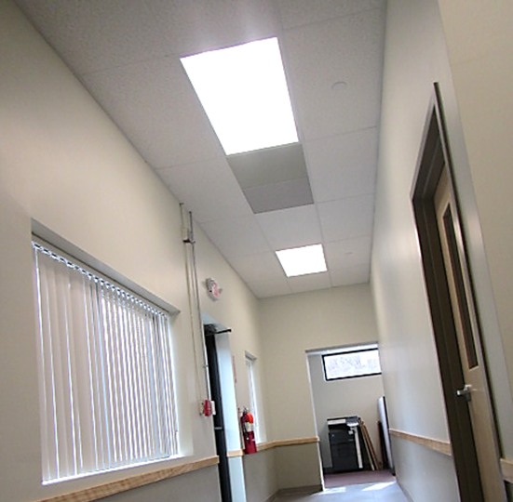
Hallway directly outside Training Staff Work/Cube area; no supply vents
Location | Carbon  Dioxide  (ppm) | Temp  (°F) | Relative  Humidity  (%) | Carbon  Monoxide  (ppm) | PM2.5  (µg/m³) | Occupants  in Room | Windows  Openable | Ventilation  Supply Exhaust |  | Comments
Background | 393 | 42 | 18 | ND | 17 |  |  |  |  | Cloudy, windy
Conference Room | 748 | 68 | 27 | ND | 6 | 0 | N | Y | N | No return grate installed
Break Room | 753 | 68 | 25 | ND | 7 | 0 | N | Y | Y
Hallway | 779 | 68 | 24 | ND | 6 | 0 | N | Y | Y | 2 supply vents outside of Training Room, none adjacent to Training Staff work area
Training Room | 798 | 68 | 26 | ND | 7 | 11 | N | Y | Y
Kitchen | 726 | 69 | 23 | ND | 8 | 0 | N | Y | Y
Training Staff Work/Cube Area | 772 | 70 | 23 | ND | 8 | 0 | N | N | N | Open doorway, passive air infiltration from hallway, wall-mounted air conditioner

