INDOOR AIR QUALITY ASSESSMENT

Massachusetts Department of Transitional Assistance
473 Main Street
Fitchburg, Massachusetts

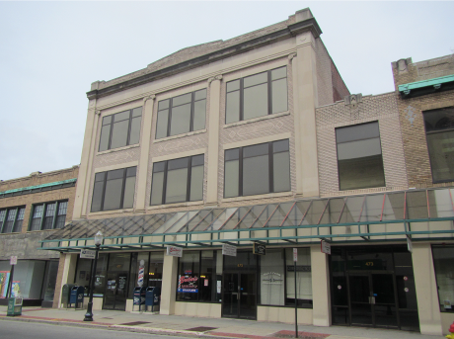

Prepared by:
Massachusetts Department of Public Health
Bureau of Environmental Health
Indoor Air Quality Program
July 2014

Background/Introduction
At the request of Rhett Cavicchi, Director of Labor Relations for the Massachusetts Executive Office of Health and Human Services (EOHHS), the Massachusetts Department of Public Health (MDPH), Bureau of Environmental Health (BEH) provided assistance and consultation regarding indoor air quality concerns at the Department of Transitional Assistance (DTA), 473 Main Street, Fitchburg, Massachusetts. The assessment was prompted by health concerns related to indoor air quality (IAQ) conditions throughout the building and mold. On April 18, 2014, a visit to conduct an indoor air quality (IAQ) assessment was made to the DTA by Michael Feeney, Director of BEH’s IAQ Program and Kathleen Gilmore, Environmental Analyst/Regional Inspector for the BEH/IAQ Program.
BEH/IAQ staff previously visited this building in February, 2010 to conduct an IAQ assessment and a copy of the report is available at: www.mass.gov/dph/iaq or on request. Appendix A contains a summary of recommendations/actions made at that time and taken in response to the previous report.
The DTA is located on the second floor of a three-story, brick building built in the early 1900s. The DTA has occupied the space since 1998. The space consists of offices, cubicles with cloth dividers and storage areas. Floors are carpeted in most areas.

Methods
Air tests for carbon dioxide, carbon monoxide, temperature and relative humidity were conducted with the TSI, Q-Trak, IAQ Monitor, Model 7565. Air tests for airborne particle matter with a diameter less than 2.5 micrometers were taken with the TSI, DUSTTRAK™ Aerosol Monitor Model 8520. BEH/IAQ staff also performed visual inspection of building materials for water damage and/or microbial growth.

Results
The DTA has as employee population of approximately 40 and can be visited by over 100 people on a daily basis. Tests were taken under normal operating conditions and results appear in Table 1.

Discussion

Ventilation
It can be seen from Table 1 that carbon dioxide levels were above 800 parts per million (ppm), indicating inadequate air exchange in all areas surveyed. It is important to note that several areas were empty/sparsely populated at the time carbon dioxide measurements were taken, which can greatly reduce carbon dioxide levels. Carbon dioxide levels would be expected to increase with full occupancy.
Mechanical ventilation is provided by an air-handling unit (AHU) on the roof of the building. Fresh air is drawn into the AHU through an intake vent and delivered to occupied areas via ceiling-mounted supply vents (Picture 1). Return air is drawn into an above-ceiling plenum via ceiling grates (Picture 2) and ducted back to the AHU. Weak or nonexistent air flow was detected in many locations from both supply and exhaust vents (Table 1), indicating either the zones to which they were connected were not calling for air circulation, or that they were in need of maintenance. Of note, a return vent located above Room 289 (cubicle space) was found to be back drafting, bringing cold air into the office space rather than exhausting air from the area. Without adequate supply and exhaust ventilation, odors, moisture, excess heat and environmental pollutants can accumulate, leading to indoor air/comfort complaints.
To maximize air exchange, the MDPH recommends that both supply and exhaust ventilation operate continuously during periods of building occupancy. In order to have proper ventilation with a mechanical supply and exhaust system, the systems must be balanced to provide an adequate amount of fresh air to the interior of a room while removing stale air from the room. It is recommended that HVAC systems be re-balanced every five years to ensure adequate air systems function (SMACNA, 1994). The date of the last balancing of these systems was not available at the time of the assessment.
Minimum design ventilation rates are mandated by the Massachusetts State Building Code (MSBC). Until 2011, the minimum ventilation rate in Massachusetts was higher for both occupied office spaces and general classrooms, with similar requirements for other occupied spaces (BOCA, 1993). The current version of the MSBC, promulgated in 2011 by the State Board of Building Regulations and Standards (SBBRS), adopted the 2009 International Mechanical Code (IMC) to set minimum ventilation rates. Please note that the MSBC is a minimum standard that is not health-based. At lower rates of cubic feet per minute (cfm) per occupant of fresh air, carbon dioxide levels would be expected to rise significantly. A ventilation rate of 20 cfm per occupant of fresh air provides optimal air exchange resulting in carbon dioxide levels at or below 800 ppm in the indoor environment in each area measured. MDPH recommends that carbon dioxide levels be maintained at 800 ppm or below. This is because most environmental and occupational health scientists involved with research on IAQ and health effects have documented significant increases in indoor air quality complaints and/or health effects when carbon dioxide levels rise above the MDPH guidelines of 800 ppm for schools, office buildings and other occupied spaces (Sundell et al., 2011). The ventilation must be on at all times that the room is occupied. Providing adequate fresh air ventilation with open windows and maintaining the temperature in the comfort range during the cold weather season is impractical. Mechanical ventilation is usually required to provide adequate fresh air ventilation.
Carbon dioxide is not a problem in and of itself. It is used as an indicator of the adequacy of the fresh air ventilation. As carbon dioxide levels rise, it indicates that the ventilating system is malfunctioning or the design occupancy of the room is being exceeded. When this happens, a buildup of common indoor air pollutants can occur, leading to discomfort or health complaints. The Occupational Safety and Health Administration (OSHA) standard for carbon dioxide is 5,000 parts per million parts of air (ppm). Workers may be exposed to this level for 40 hours/week, based on a time-weighted average (OSHA, 1997).
The MDPH uses a guideline of 800 ppm for publicly occupied buildings. A guideline of 600 ppm or less is preferred in schools due to the fact that the majority of occupants are young and considered to be a more sensitive population in the evaluation of environmental health status. Inadequate ventilation and/or elevated temperatures are major causes of complaints such as respiratory, eye, nose and throat irritation, lethargy and headaches. For more information concerning carbon dioxide, please see Appendix B.
Temperature readings during the assessment ranged from 71° F to 74° F which were within the MDPH recommended comfort range (Table 1). The MDPH recommends that indoor air temperatures be maintained in a range of 70° F to 78° F in order to provide for the comfort of building occupants. In many cases concerning indoor air quality, fluctuations of temperature in occupied spaces are typically experienced, even in a building with an adequate fresh air supply.
The relative humidity at the time of the assessment ranged from 24 to 32 percent (Table 1), which was below the MDPH recommended comfort range. The MDPH recommends a comfort range of 40 to 60 percent for indoor air relative humidity. Relative humidity levels in the building would be expected to drop during the winter months due to heating. The sensation of dryness and irritation is common in a low relative humidity environment. Low relative humidity is a very common problem during the heating season in the northeast part of the United States.

Microbial/Moisture Concerns
As mentioned in the MDPH IAQ 2010 report (Appendix A), the DTA was subject to chronic water penetration in the central area of the office space due to damaged/detached rubber membrane on the roof and standing water which resulted in water penetration/damage from the AHU into the interior DTA office space. During the 2014 visit, BEH/IAQ staff observed that conditions in the central area of the office space had not improved since the 2010 assessment. Ceiling tiles in the central area above Room 286 (cubicle) were observed to be water-damaged (Picture 3). A hose was also observed extending from the exhaust ductwork that terminated into a barrel (Pictures 4 and 5) reportedly to collect water drainage from roof leaks into the building. Although BEH/IAQ staff observed no water accumulation and the barrel was dry at the time of the assessment, the source of water leaks in this area should be identified and repaired. Water-damaged ceiling tiles should be replaced after the water leak is identified and repaired and monitored for future leaks.
The US EPA and the American Conference of Governmental Industrial Hygienists (ACGIH) recommend that porous materials be dried with fans and heating within 24 to 48 hours of becoming wet (US EPA, 2001; ACGIH, 1989). If porous materials are not dried within this time frame, mold growth may occur. Once mold has colonized porous materials, they are difficult to clean and should be removed and discarded.
Plants were observed in several areas (Picture 6; Table 1). Plants should be properly maintained and equipped with drip pans. Plants should be located away from ventilation sources to prevent aerosolization of dirt, pollen or mold. Plants should not be placed on carpets or other porous materials, since water damage to porous materials may lead to microbial growth.

Other Indoor Air Evaluations
Indoor air quality can be negatively influenced by the presence of respiratory irritants, such as products of combustion. The process of combustion produces a number of pollutants. Common combustion emissions include carbon monoxide, carbon dioxide, water vapor, and smoke (fine airborne particle material). Of these materials, exposure to carbon monoxide and particulate matter with a diameter of 2.5 micrometers (μm) or less (PM2.5) can produce immediate, acute health effects upon exposure. To determine whether combustion products were present in the indoor environment, BEH/IAQ staff obtained measurements for carbon monoxide and PM2.5.

Carbon Monoxide
Carbon monoxide is a by-product of incomplete combustion of organic matter (e.g., gasoline, wood and tobacco). Exposure to carbon monoxide can produce immediate and acute health affects. Several air quality standards have been established to address carbon monoxide and prevent symptoms from exposure to these substances. The MDPH established a corrective action level concerning carbon monoxide in ice skating rinks that use fossil-fueled ice resurfacing equipment. If an operator of an indoor ice rink measures a carbon monoxide level over 30 ppm, taken 20 minutes after resurfacing within a rink, that operator must take actions to reduce carbon monoxide levels (MDPH, 1997).
The American Society of Heating Refrigeration and Air-Conditioning Engineers (ASHRAE) has adopted the National Ambient Air Quality Standards (NAAQS) as one set of criteria for assessing indoor air quality and monitoring of fresh air introduced by HVAC systems (ASHRAE, 1989). The NAAQS are standards established by the US EPA to protect the public health from six criteria pollutants, including carbon monoxide and particulate matter (US EPA, 2006). As recommended by ASHRAE, pollutant levels of fresh air introduced to a building should not exceed the NAAQS levels (ASHRAE, 1989). The NAAQS were adopted by reference in the Building Officials & Code Administrators (BOCA) National Mechanical Code of 1993 (BOCA, 1993), which is now an HVAC standard included in the Massachusetts State Building Code (SBBRS, 2011). According to the NAAQS, carbon monoxide levels in outdoor air should not exceed 9 ppm in an eight-hour average (US EPA, 2006).
Carbon monoxide should not be present in a typical, indoor environment. If it is present, indoor carbon monoxide levels should be less than or equal to outdoor levels. On the day of the assessment, outdoor carbon monoxide concentrations were non-detect (ND) (Table 1). No measureable levels of carbon monoxide were detected in the building during the assessment (Table 1).

Particulate Matter
The US EPA has established NAAQS limits for exposure to particulate matter. Particulate matter includes airborne solids, which can result in eye and respiratory irritation if exposure occurs. The NAAQS originally established exposure limits to particulate matter with a diameter of 10 μm or less (PM10). According to the NAAQS, PM10 levels should not exceed 150 micrograms per cubic meter (μg/m³) in a 24-hour average (US EPA, 2006). These standards were adopted by both ASHRAE and BOCA. Since the issuance of the ASHRAE standard and BOCA Code, US EPA established a more protective standard for fine airborne particles. This more stringent PM2.5 standard requires outdoor air particle levels be maintained below 35 μg/m³ over a 24-hour average (US EPA, 2006). Although both the ASHRAE standard and BOCA Code adopted the PM10 standard for evaluating air quality, MDPH uses the more protective PM2.5 standard for evaluating airborne particulate matter concentrations in the indoor environment.
Outdoor PM2.5 concentrations measured 16 μg/m³ on the day of the visit (Table 1). PM2.5 levels measured indoors ranged from 12 to 18 μg/m³ (Table 1), which were below the NAAQS PM2.5 level of 35 μg/m³. Frequently, indoor air levels of particulates (including PM2.5) can be at higher levels than those measured outdoors. A number of mechanical devices and/or activities that occur in buildings can generate particulate during normal operations. Sources of indoor airborne particulates may include but are not limited to particles generated during the operation of fan belts in the HVAC system, use of stoves and/or microwave ovens in kitchen areas; use of photocopiers, fax machines and computer printing devices; operation of an ordinary vacuum cleaner and heavy foot traffic indoors.

Volatile Organic Compounds
Indoor air concentrations can be greatly impacted by the use of products containing volatile organic compounds (VOCs). VOCs are carbon-containing substances that have the ability to evaporate at room temperature. Frequently, exposure to low levels of total VOCs (TVOCs) may produce eye, nose, throat and/or respiratory irritation in some sensitive individuals. For example, chemicals evaporating from a paint can stored at room temperature would most likely contain VOCs. In an effort to identify materials that can potentially increase indoor VOC concentrations, BEH/IAQ staff examined the office space for products containing respiratory irritants.
Hand sanitizer was observed in some areas (Table 1; Picture 7). Hand sanitizer products may contain ethyl alcohol and/or isopropyl alcohol which are highly volatile and may be irritating to the eyes and nose, and may also contain fragrances to which some people may be sensitive.
There are a few photocopiers in the building. Photocopiers can be sources of pollutants such as VOCs, ozone, heat and odors, particularly if the equipment is older and in frequent use. Both VOCs and ozone are respiratory irritants (Schmidt Etkin, 1992). Photocopiers and laminators should be kept in well ventilated rooms, and should be located near windows or exhaust vents.

Other Conditions
BEH/IAQ staff observed accumulated dust/debris on air diffusers, exhaust vents, personal fans (Picture 8) and along the top of cloth dividers. If exhaust/return vents are not functioning, back drafting can occur, which can re-aerosolize accumulated dust particles. Re-activated supply vents can re-aerosolize dust accumulated on louvers and adjacent surfaces causing further irritation. Diffusers, vents and fans should be cleaned periodically in order to prevent dust/debris from being aerosolized and redistributed throughout the room.
Most of the DTA space consists of cubicles with cloth dividers. Plush toys were also observed in some areas (Pictures 9 and 10). Upholstery and plush toys are covered with fabrics that may be exposed to human skin. This type of contact can leave oils, perspiration, hair and skin cells. Dust mites feed upon human skin cells and excrete waste products that contain allergens. In addition, if relative humidity levels increase above 60 percent, dust mites tend to proliferate (US EPA, 1992). In order to remove dust mites and other pollutants, frequent vacuuming of upholstered furniture is recommended (Berry, 1994). It is also recommended that upholstered furniture be professionally cleaned on an annual basis. If an excessively dusty environment exists due to outdoor conditions or indoor activities (e.g., renovations), cleaning frequency should be increased (every six months) (IICRC, 2000).
Floors in most rooms of the DTA are covered by wall-to-wall carpeting. It was not clear whether a carpet cleaning program is in place at the DTA. The Institute of Inspection, Cleaning and Restoration Certification (IICRC), recommends that carpeting be cleaned annually (or semi-annually in soiled high traffic areas) (IICRC, 2012). If the carpeting is beyond its service life, consideration should be given towards replacement.

Conclusions/Recommendations
Based on measurements and observations during the 2010 and 2014 assessments, indoor air quality issues in the DTA appear to be related to the heating, ventilation and cooling (HVAC) system and roof membrane. The following recommendations are made to improve indoor air quality:
- Implement all the recommendations made in the previous 2010 MDPH assessment (Appendix A).
- Building management should work with an HVAC engineering firm to make repairs to the AHU and determine appropriate heating/cooling settings and adjust thermostat and fan settings in the DTA office space.
- Consider adopting a balancing schedule of every 5 years for all mechanical ventilation systems, as recommended by ventilation industrial standards (SMACNA, 1994).
- Identify sources of water damage in the central portion of the office space. Ensure roof leaks are repaired and replace water-damaged ceiling tiles. Examine above and around these areas for mold growth. Disinfect areas of water leaks with an appropriate antimicrobial.
- Ensure plants have drip pans and avoid over-watering. Examine drip pans periodically for mold growth. Disinfect with an appropriate antimicrobial where necessary.
- For buildings in New England, periods of low relative humidity during the winter are often unavoidable. Therefore, scrupulous cleaning practices should be adopted to minimize common indoor air contaminants whose irritant effects can be enhanced when the relative humidity is low. To control for dusts, a high efficiency particulate arrestance (HEPA) filter equipped vacuum cleaner in conjunction with wet wiping of all surfaces is recommended. Avoid the use of feather dusters. Drinking water during the day can help ease some symptoms associated with a dry environment (throat and sinus irritations).
- Clean supply/exhaust vents and personal fans regularly to prevent dust accumulation.
- Clean plush toys and upholstered furniture frequently to remove dust and mites.
- Clean carpeting annually (or semi-annually in soiled high traffic areas) as per the recommendations of the Institute of Inspection, Cleaning and Restoration Certification (IICRC, 2012). Consider a schedule for replacing worn carpeting that is beyond its service life. Copies of the IICRC fact sheet are available at: http://www.iicrc.org/consumers/care/carpet-cleaning/#faq.
- Refer to resource manual and other related indoor air quality documents located on the MDPH’s website for further building-wide evaluations and advice on maintaining public buildings. These documents are available at: http://mass.gov/dph/iaq.
References

ACGIH. 1989. Guidelines for the Assessment of Bioaerosols in the Indoor Environment. American Conference of Governmental Industrial Hygienists, Cincinnati, OH.
ASHRAE. 1989. Ventilation for Acceptable Indoor Air Quality. American Society of Heating, Refrigeration and Air Conditioning Engineers. ANSI/ASHRAE 62-1989.
Berry, M.A. 1994. Protecting the Built Environment: Cleaning for Health. Michael A. Berry, Chapel Hill, NC.
BOCA. 1993. The BOCA National Mechanical Code/1993. 8th ed. Building Officials and Code Administrators International, Inc., Country Club Hill, IL.

IICRC. 2000. IICRC S001. Reference Guideline for Professional On-Location Cleaning of Textile Floor Covering Materials. Institute of Inspection, Cleaning and Restoration Certification. Institute of Inspection Cleaning and Restoration, Vancouver, WA.

(IICRC). 2012. Institute of Inspection, Cleaning and Restoration Certification. Carpet Cleaning: FAQ. Retrieved from http://www.iicrc.org/consumers/care/carpet-cleaning/#faq.

MDPH. 1997. Requirements to Maintain Air Quality in Indoor Skating Rinks (State Sanitary Code, Chapter XI). 105 CMR 675.000. Massachusetts Department of Public Health, Boston, MA.
OSHA. 1997. Limits for Air Contaminants. Occupational Safety and Health Administration. Code of Federal Regulations. 29 C.F.R 1910.1000 Table Z-1-A.

SBBRS. 2011. Mechanical Ventilation. State Board of Building Regulations and Standards. Code of Massachusetts Regulations, 8th edition. 780 CMR 1209.0.
Schmidt Etkin, D. 1992. Office Furnishings/Equipment & IAQ Health Impacts, Prevention & Mitigation. Cutter Information Corporation, Indoor Air Quality Update, Arlington, MA.
SMACNA. 1994. HVAC Systems Commissioning Manual. 1st ed. Sheet Metal and Air Conditioning Contractors’ National Association, Inc., Chantilly, VA.

Sundell. 2011. Sundell, J., H. Levin, W. W. Nazaroff, W. S. Cain, W. J. Fisk, D. T. Grimsrud, F. Gyntelberg, Y. Li, A. K. Persily, A. C. Pickering, J. M. Samet, J. D. Spengler, S. T. Taylor, and C. J. Weschler. Ventilation rates and health: multidisciplinary review of the scientific literature. Indoor Air, Volume 21: pp 191–204.
US EPA. 1992. Indoor Biological Pollutants. US Environmental Protection Agency, Environmental Criteria and Assessment Office, Office of Health and Environmental Assessment, research Triangle Park, NC. EPA 600/8-91/202. January 1992.

US EPA. 2001. Mold Remediation in Schools and Commercial Buildings. US Environmental Protection Agency, Office of Air and Radiation, Indoor Environments Division, Washington, D.C. EPA 402-K-01-001. March 2001.
US EPA. 2006. National Ambient Air Quality Standards (NAAQS). US Environmental Protection Agency, Office of Air Quality Planning and Standards, Washington, DC. http://www.epa.gov/air/criteria.html.
Picture 1

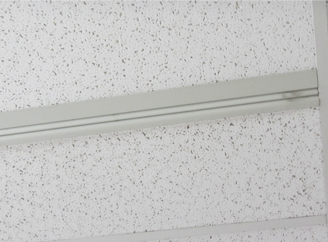

Fresh air supply vent

Picture 2

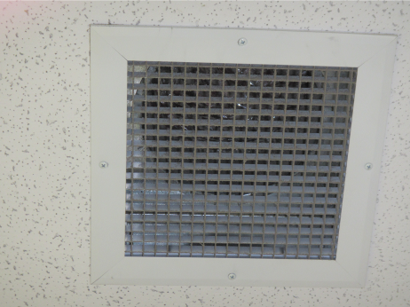

Return vent
Picture 3

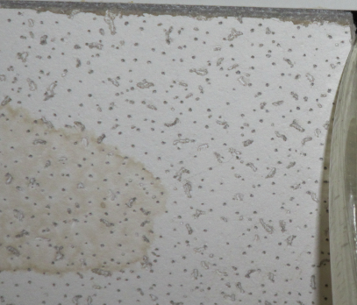

Water-damaged ceiling tile above Room 286

Picture 4

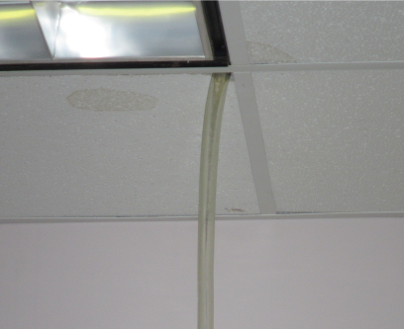

Drainage hose extending from ceiling plenum above room 286

Picture 5

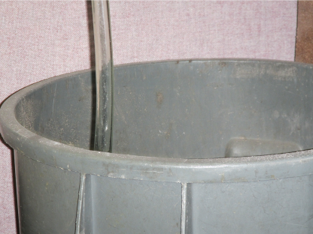

Drainage hose terminating into a barrel in room 286

Picture 6

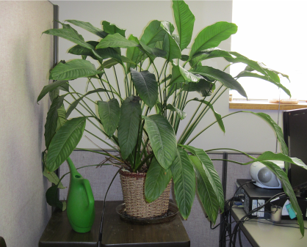

Plant located in office

Picture 7

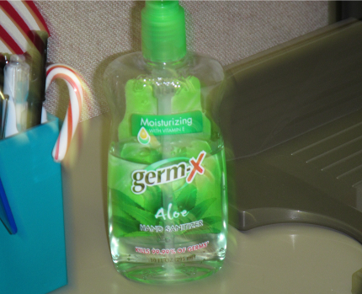

Hand sanitizer

Picture 8

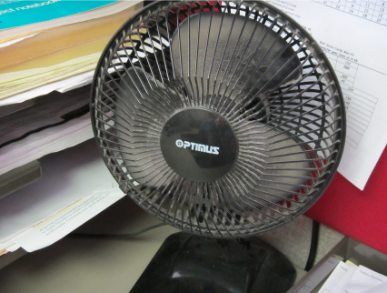

Dust and debris on personal fan

Picture 9

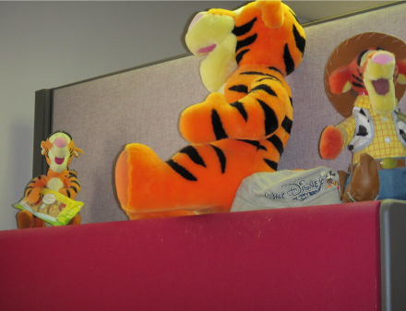

Plush toys in office space

Location/ Room | Carbon  Dioxide  (ppm) | Carbon Monoxide  (ppm) | Temp  (°F) | Relative  Humidity  (%) |  | Occupants  In Room | Windows  Openable | Ventilation |  | Remarks
 |  |  |  |  | PM2.5  (µg/m³) | Occupants  In Room | Windows  Openable | Supply | Exhaust | Remarks
Background | 399 | ND | 49 | 64 | 16 |  |  |  |  | Cloudy
Mail room | 842 | ND | 73 | 25 | 13 | 0 | N | Y | N | DO, NC
Conference  room | 900 | ND | 74 | 26 | 13 | 1 | N | Y  off | Y  off | DO, WD-CT
Copy room | 1035 | ND | 73 | 28 | 14 | 0 | N | Y | Y  off | DO, NC
Interview room | 950 | ND | 72 | 24 | 12 | 0 | N | Y  off | Y  off | DO
Reception | 1050 | ND | 71 | 31 | 12 | 2 | N | Y | Y | DO, PF
Waiting room | 877 | ND | 72 | 26 | 13 | 2 | N | Y | Y
Women’s restroom | 1023 | ND | 72 | 25 | 13 | 2 | N | N | Y
Form room | 950 | ND | 73 | 28 | 12 | 0 | N | Y  off | Y | DO, NC
204 | 1168 | ND | 73 | 31 | 12 | 0 | N | Y  off | Y  off | DO
208 | 979 | ND | 71 | 31 | 12 | 2 | N | Y | Y | DO
209 | 942 | ND | 71 | 31 | 12 | 0 | N | Y | N | DO, WD-CTs (2)
215 | 1070 | ND | 73 | 31 | 14 | 1 | N | Y  off | N | DO, WD-CT, PF, plants, hand sanitizer, microwave
216 | 988 | ND | 72 | 27 | 13 | 1 | N | Y  off | N
219 | 973 | ND | 72 | 26 | 12 | 0 | N | Y  off | N
220 | 822 | ND | 73 | 26 | 13 | 0 | N | Y  off | Y
260 | 870 | ND | 73 | 27 | 12 | 0 | N | Y  off | Y
261 | 997 | ND | 72 | 26 | 18 | 0 | N | Y | N | Plants, plush toys/stuffed animals
264 | 989 | ND | 72 | 25 | 17 | 0 | N | Y  off | Y
265 | 921 | ND | 73 | 28 | 12 | 0 | N | Y | N
266 | 837 | ND | 72 | 27 | 13 | 1 | N | Y | N
268 | 994 | ND | 73 | 25 | 12 | 0 | N | Y  off | N | DO, Plants, hand sanitizer, toy dolls
269 | 899 | ND | 72 | 25 | 12 | 0 | N | Y | Y
272 | 1001 | ND | 73 | 26 | 13 | 0 | N | Y  off | N
273 | 991 | ND | 73 | 25 | 12 | 1 | N | Y  off | N | Plants, PF dirty
274 | 1032 | ND | 72 | 27 | 12 | 0 | N | Y  off | Y  off
276 | 915 | ND | 72 | 26 | 14 | 1 | N | Y  off | N | PF dirty
277 | 962 | ND | 74 | 28 | 13 | 1 | N | Y  off | N | Plants, PF dirty, hand sanitizer, plush toys/stuffed animals
286 | 1091 | ND | 72 | 27 | 14 | 0 | N | Y | Y  off | Drain hose from exhaust duct into barrel. No moisture/water
288 | 1100 | ND | 72 | 28 | 14 | 1 | N | Y  off | N
289 | 1109 | ND | 71 | 28 | 14 | 0 | N | Y | Y | Exhaust vent back-drafting air
293 | 902 | ND | 74 | 26 | 13 | 1 | N | Y | N | WD-CT
294 | 903 | ND | 72 | 27 | 13 | 1 | N | Y  off | N
296 | 874 | ND | 74 | 25 | 12 | 4 | N | Y | Y | DO
297 | 962 | ND | 74 | 26 | 12 | 1 | N | Y  off | N
298 | 1077 | ND | 73 | 26 | 14 | 0 | N | Y  off | Y  off
300 | 976 | ND | 74 | 28 | 12 | 3 | N | Y  off | Y | DO, PF, hand sanitizer
304 | 1143 | ND | 74 | 30 | 12 | 2 | N | Y  off | N
305 | 1271 | ND | 73 | 32 | 12 | 2 | N | Y | N

Actions on MDPH Recommendations
Department of Transitional Assistance
473 Main Street, Fitchburg, MA

The following is a status report of action(s) taken on recommendations made in the February 10, 2010 MDPH IAQ report (in bold) based on documents, photographs and observations of the MDPH BEH/IAQ staff.
Contact an HVAC engineering firm to assess whether the current AHU configuration is providing air distribution in an adequate manner, make repairs/adjustments as needed.
Action: It was not known if actions were taken on this recommendation. The mechanical ventilation system was either not operating or malfunctioning. Fresh airflow from supply vents and to return vents was low or nonexistent.
Consider adopting a balancing schedule of every 5 years for all mechanical ventilation systems, as recommended by ventilation industrial standards (SMACNA, 1994).
Action: The date of the last balancing of these systems was not known at the time of the assessment.
Eliminate standing water from the roof. Make roof repairs to eliminate bulging and membrane damage.
Action: Not completed. It was not known if actions were taken on this recommendation. Roof leaks and water damage were observed in the DTA office space.
Ensure roof drains are routinely inspected and maintained.
Action: It was not known if actions were taken on this recommendation.

Ensure leaks are repaired and replace water-damaged ceiling tiles. Examine the area above and around these areas for mold growth. Disinfect areas of water leaks with an appropriate antimicrobial.
Action: Water-damaged ceiling tiles and evidence of water leaks were observed in central areas of the office space.
Ensure that all cracked and broken ceiling tiles are replaced and that they fit snugly within their frames.
- Action: No missing ceiling tiles were observed in the office space.
In order to reduce glare and the flickering of fluorescent lights, it is recommended that each workstation have a light with an incandescent light bulb. Incandescent lamps do not flicker and also emit chromatic light, which will help to both wash out the fluorescent light flickering and monochromatic light.
- Action: Completed. Incandescent lamps had been installed.
- For buildings in New England, periods of low relative humidity during the winter are often unavoidable. Therefore, scrupulous cleaning practices should be adopted to minimize common indoor air contaminants whose irritant effects can be enhanced when the relative humidity is low. To control for dusts, a high efficiency particulate arrestance (HEPA) filter equipped vacuum cleaner in conjunction with wet wiping of all surfaces is recommended. Avoid the use of feather dusters. Drinking water during the day can help ease some symptoms associated with a dry environment (throat and sinus irritations).

- Action: Dust and debris were noted on supply and return vents, personal fans and along the top of cloth dividers. It was not known if a HEPA filter vacuum is used in the building.

