INDOOR AIR QUALITY ASSESSMENT

Department of Transitional Assistance
131 Davidson Street
Lowell, Massachusetts

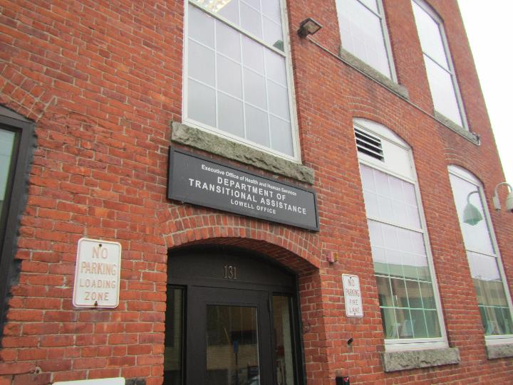

Prepared by:
Massachusetts Department of Public Health
Bureau of Environmental Health
Indoor Air Quality Program
July 2019

Background
Building: | Department of Transitional Assistance (DTA)
Address: | 131 Davidson Street, Lowell, MA
Agency Contact: | Rochelle Brunson, Space & Facility Management Specialist, DTA
Reason for Request: | General indoor air quality (IAQ) concerns
Date of Assessment: | June 13, 2019
Massachusetts Department of Public Health/Bureau of Environmental Health (MDPH/BEH) Staff Conducting Assessment: | Jason Dustin, Environmental Analyst/Inspector, IAQ Program
Building Description: | The DTA space is located in a four-story brick building that was originally constructed as a factory/warehouse in the early 1900’s. The space is composed of private offices, open work areas and conference rooms. Most areas have carpet tile and dropped ceiling tiles.
Windows: | Windows are not openable.

The IAQ Program has visited this building previously. Reports of previous visits are available upon request.

Methods
Please refer to the IAQ Manual for methods, sampling procedures, and interpretation of results (MDPH, 2015).

Results
The following is a summary of indoor air testing results (Table 1).
- Carbon dioxide levels were below the MDPH guideline of 800 parts per million (ppm) in all areas assessed.
- Temperature was within the MDPH recommended range of 70°F to 78°F in all areas.
- Relative humidity was within the MDPH recommended range of 40% to 60% in all areas.
- Carbon monoxide levels were non-detectable (ND) in all indoor areas assessed.
- Fine particulate matter (PM2.5) concentrations measured were below the National Ambient Air Quality Standard (NAAQS) level of 35 micrograms per cubic meter (μg/m³) in all occupied areas.
- Total Volatile Organic Compounds (TVOCs) were ND in all areas.

Discussion

Ventilation
A heating, ventilating, and air conditioning (HVAC) system has several functions. First it provides heating and, if equipped, cooling. Second, it is a source of fresh air. Finally, an HVAC system will dilute and remove normally occurring indoor environmental pollutants by not only introducing fresh air, but by filtering the airstream and ejecting stale air to the outdoors via exhaust ventilation. Even if an HVAC system is operating as designed, point sources of respiratory irritation may exist and cause symptoms in sensitive individuals.
The HVAC system in this space consists of large rooftop air handling units (AHUs) that draw in fresh air from intakes on the roof. Supply air is ducted to ceiling-mounted diffusers throughout the space (Picture 1). Air is brought back to the AHUs through return vents (Picture 2). Property management reported that the rooftop AHUs are under contract for maintenance and regular filter changes.
To maximize air exchange, the MDPH recommends that both supply and exhaust ventilation operate continuously during periods of occupancy. The thermostats should continue to be set with the fan “on” and NOT the fan “auto” setting. This will continue to allow fresh air into the space regardless of whether the thermostat is calling for heat or cooling. This is important since windows are not openable and thermostats may not be calling for heat or cooling in the spring and fall swing seasons.
In order to have proper ventilation with a mechanical supply and exhaust system, the systems must be balanced to provide an adequate amount of fresh air to the interior of a room while removing stale air from the room. It is recommended that HVAC systems be re-balanced every five years to ensure adequate air systems function (SMACNA, 1994). The DTA completed the HVAC system balancing in 2018.

Microbial/Moisture Concerns
A few water-damaged ceiling tiles were noted in the first floor women’s restroom (Picture 3). Ceiling tiles are porous and are susceptible to microbial growth if exposed to chronic moisture. These tiles should be replaced after leaks are repaired.
Some soiled carpet tiles were noted on the first floor (Picture 4). Carpeting is considered a porous material so that if it is not cleaned and dried promptly, spills and water damage can be a source of microbial colonization and odors especially in carpet that is not regularly cleaned with a high efficiency particulate arrestance (HEPA) filter equipped vacuum cleaner.
A small refrigerator was noted directly on carpeting (Picture 5). These appliances may have leaks or condensation which can cause water damage to the carpeting beneath the unit.
Indoor plants were observed in some areas (Picture 6). Plants can be a source of pollen and mold, which can be respiratory irritants to some individuals. Plants should be properly maintained and equipped with drip pans and should be located away from air diffusers to prevent the aerosolization of dirt, pollen and mold.
DTA staff reported that one of the newer windows had a leak during driving rain events. Building management reportedly dried the wet area with fans and sealed the leaking window. No further leaks were reported in this area since repairs were made. No musty odors or visual signs of mold were detected anywhere in the DTA space at the time of this assessment.

Other Conditions
Hand sanitizers and scented cleaning products were noted in some areas of the office space. These products can cause irritation of the eyes, nose and respiratory system of some individuals (Pictures 7 to 9).
Some housekeeping issues need improvement. Dust was observed on most flat surfaces in the space (Picture 10). Also, spaces between cubicle walls and the exterior walls are accumulating dust/debris (Picture 11). Surfaces should be wet wiped and carpeting should be HEPA vacuumed regularly to avoid aerosolizing settled dust which can have irritant effects. Extreme low humidity in winter months can exacerbate this issue. Some areas have large amounts of accumulated items which can interfere with proper cleaning.
Some personal fans and supply/exhaust diffusers were noted to be dusty (Picture 12). These should be regularly wet wiped to avoid aerosolizing the accumulated dust.
Most flooring is covered with carpet tile. The Institute of Inspection, Cleaning and Restoration Certification (IICRC), recommends that carpeting be cleaned annually (or semi-annually in soiled high traffic areas) (IICRC, 2012).
A room storage room on the first floor was noted to have large gaps around the door frame (Picture 13). It was also noted that bees get into this room likely through gaps around the window frames (Pictures 14). Bees and other pests will be allowed to enter occupied space through the large door gaps until they are repaired.

Conclusions/Recommendations
Based on the observations made during the visit, the following is recommended:
- Continue to operate the HVAC system to provide for continuous fresh air ventilation during occupied hours. Ensure that all thermostats are set to the fan “on” setting. If occupants complain of drafts then methods to deflect air streams can be considered (e.g., changing diffuser style).
- Remove any water-damaged ceiling tiles (e.g., women’s 1st floor restroom) and replace new. Monitor the area for any new leaking and make any necessary repairs.
- Replace any water-damaged or soiled carpet tiles (areas on first floor).
- Regularly clean personal fans and exhaust/supply vents of any accumulated dust.
- Reduce or eliminate the use of scented cleaners, hand sanitizers, and personal air fresheners.
- Properly maintain plants, including drip pans, to prevent water damage to porous materials. Plants should also be located away from air diffusers to prevent the aerosolization of dirt, pollen, and mold.
- Repair any gaps around window frames or other pathways in storage area which may be allowing bees into that room. Also install tight-fitting weather stripping/door sweep to the door leading to this room.
- Wet wipe flat surfaces and HEPA vacuum carpeting daily.
- Refrain from storing accumulated items on flat surfaces as this will interfere with proper cleaning.
- Clean carpeting at least once per year according to IICRC recommendations (IICRC 2012).
- Continue to change filters for HVAC equipment 2-4 times a year. Continue to use pleated filters of MERV 8 (or higher), which are adequate in filtering out pollen and mold spores (ASHRAE, 2012), if these can be used with current equipment.
- Put small refrigerator on water proof mat or relocate to non-carpeted area.
- Consider adopting a balancing schedule of every 5 years for all mechanical ventilation systems, as recommended by ventilation industrial standards (SMACNA, 1994).
- For buildings in New England, periods of low relative humidity during the winter are often unavoidable. Therefore, scrupulous cleaning practices should be adopted to minimize common indoor air contaminants whose irritant effects can be enhanced when the relative humidity is low. To control for dusts, a high efficiency particulate arrestance (HEPA) filter equipped vacuum cleaner in conjunction with wet wiping of all surfaces is recommended. Avoid the use of feather dusters. Drinking water during the day can help ease some symptoms associated with a dry environment (throat and sinus irritations).
- Refer to resource manuals and other related IAQ documents for further building-wide evaluations and advice on maintaining public buildings. Copies of these materials are located on the MDPH’s website: http://mass.gov/dph/iaq.

References
ASHRAE. 2012. American Society of Heating, Refrigeration and Air Conditioning Engineers (ASHRAE) Standard 52.2-2012 -- Method of Testing General Ventilation Air-Cleaning Devices for Removal Efficiency by Particle Size (ANSI Approved).
IICRC. 2012. Institute of Inspection Cleaning and Restoration Certification. Institute of Inspection, Cleaning and Restoration Certification. Carpet Cleaning: FAQ. Retrieved from https://www.iicrc.org/general/custom.asp?page=SANSIIICRCS100.
MDPH. 2015. Massachusetts Department of Public Health. “Indoor Air Quality Manual: Chapters I-III”. Available at: http://www.mass.gov/eohhs/gov/departments/dph/programs/environmental-health/exposure-topics/iaq/iaq-manual/.
SMACNA. 1994. HVAC Systems Commissioning Manual. 1st ed. Sheet Metal and Air Conditioning Contractors’ National Association, Inc., Chantilly, VA.
Picture 1
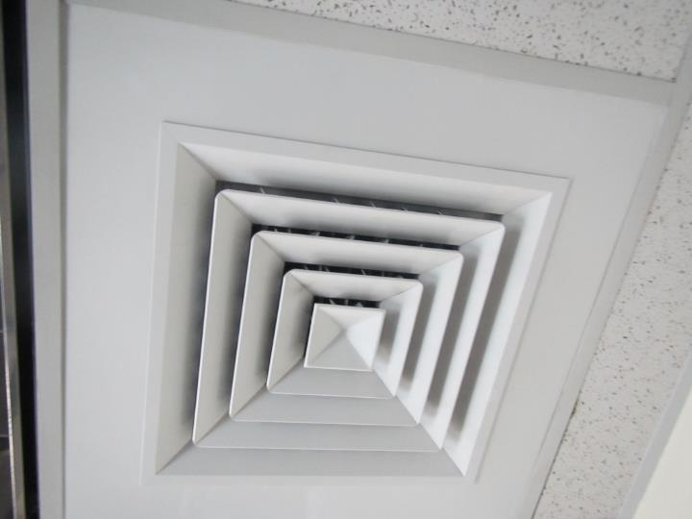
Ceiling-mounted supply air diffuser
Picture 2
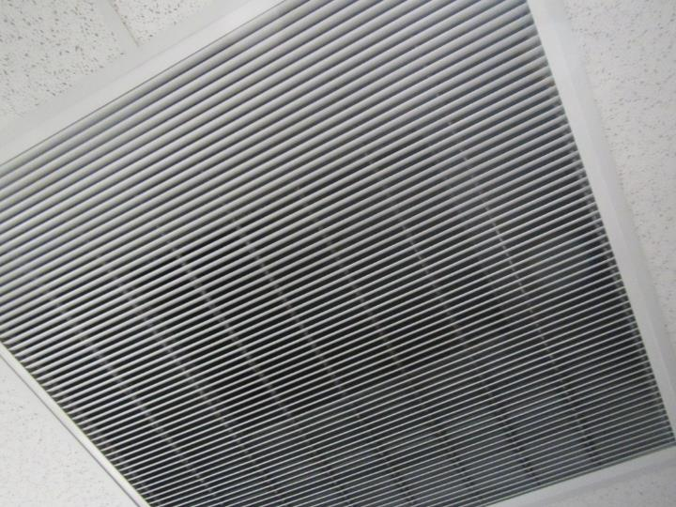
Ceiling-mounted return air vent
Picture 3
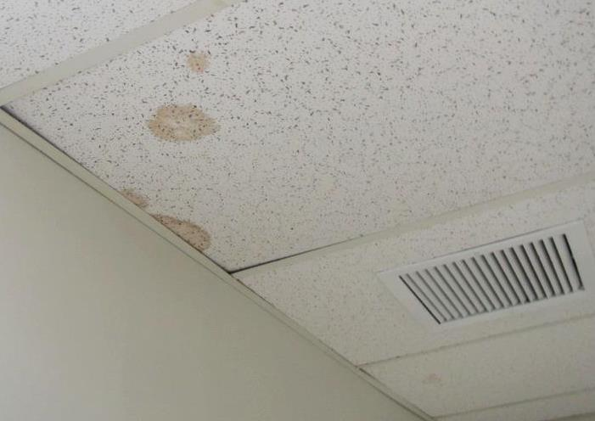
Water-damaged ceiling tiles in women’s first floor bathroom
Picture 4
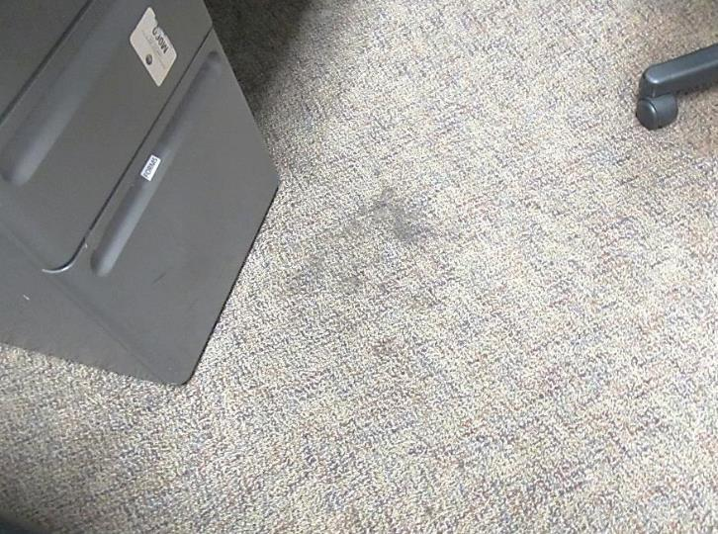
Soiled carpet tiles on first floor
Picture 5
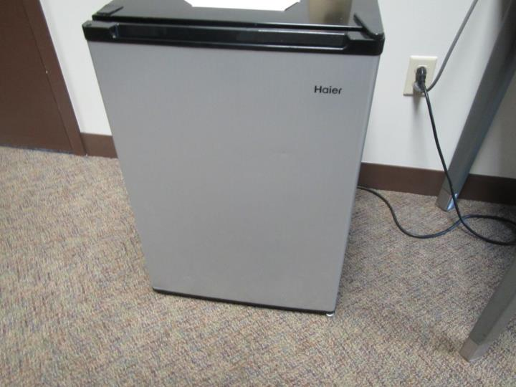
Refrigerator located directly on carpet (1st floor)
Picture 6
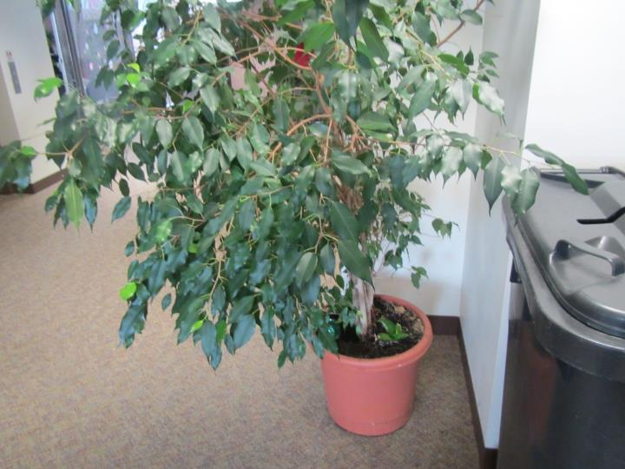
Plant located on carpeting
Picture 7
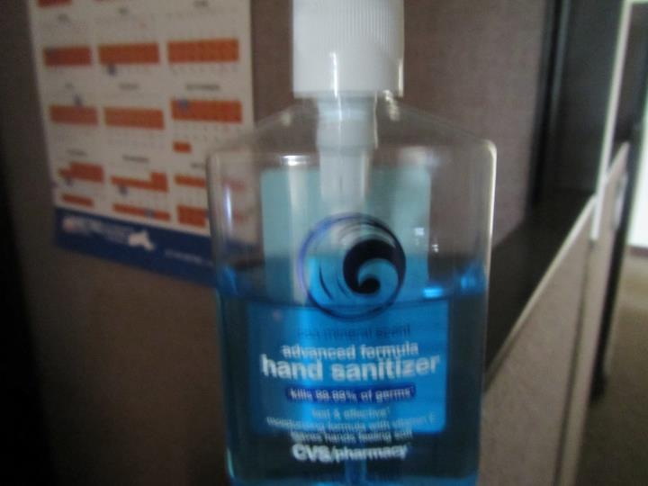
Scented hand sanitizer in office area
Picture 8
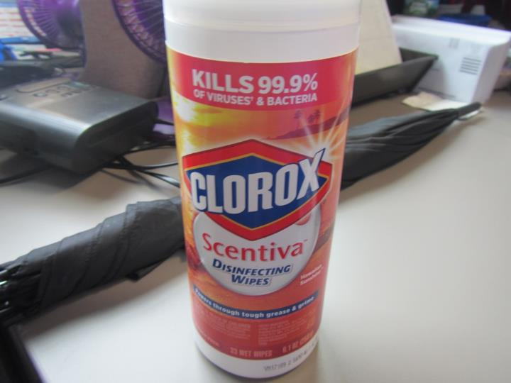
Cleaning wipes containing fragrances and VOCs
Picture 9
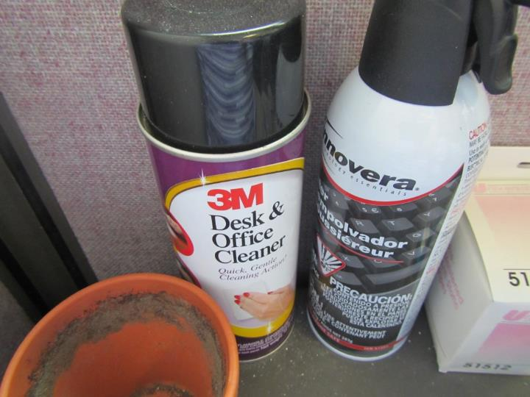
Cleaning products in office area (note planter with decaying soil/plant debris)
Picture 10
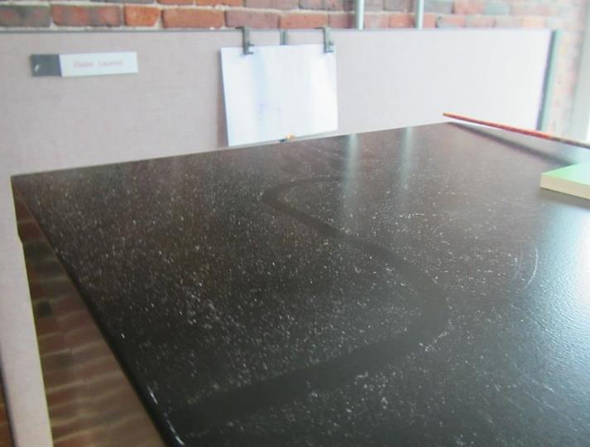
Accumulated dust on file cabinet
Picture 11
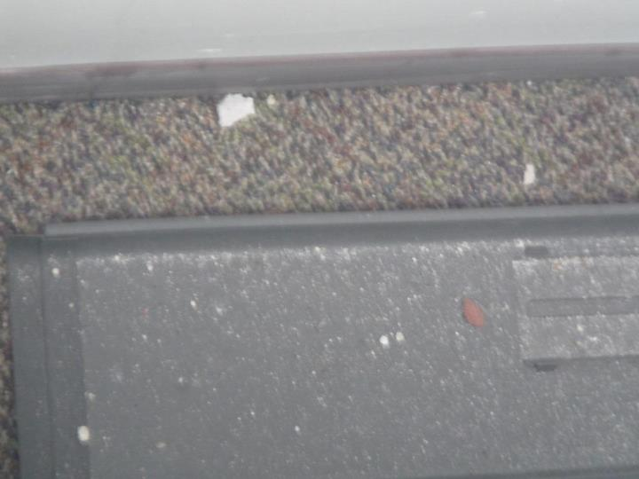
Dust/debris in space between cubicle and exterior wall
Picture 12
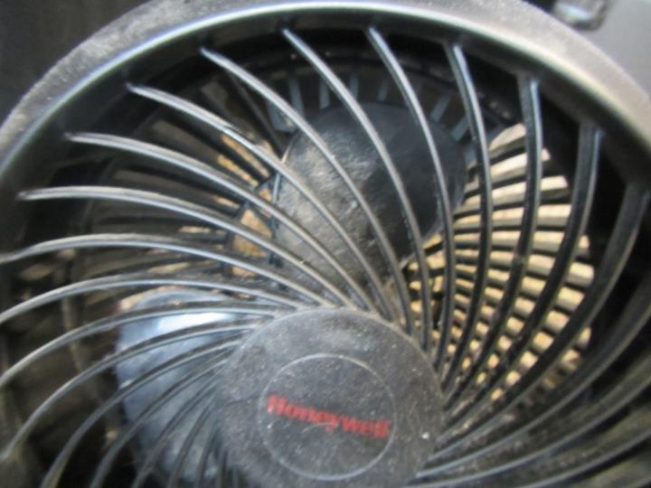
Personal fan with accumulated dust
Picture 13
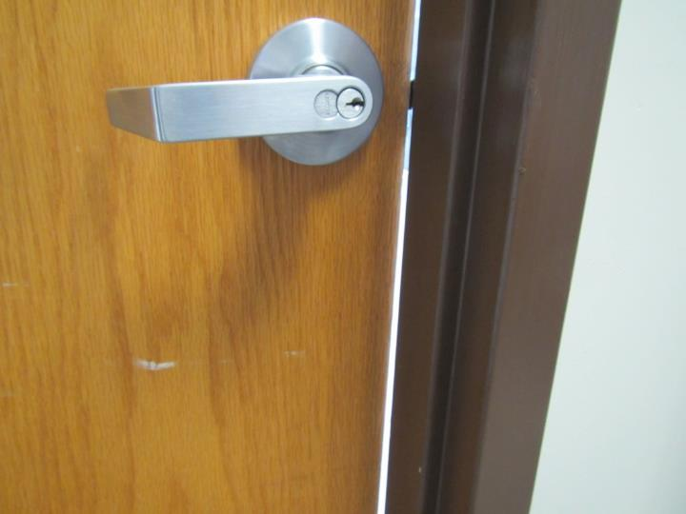
Large gaps around door leading to storage room
Picture 14
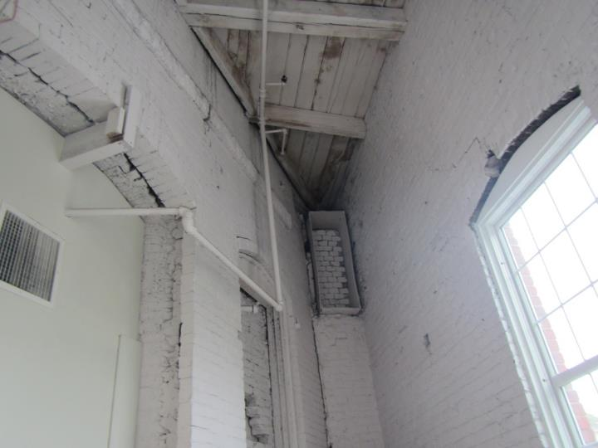
Gaps around windows and other pathways in brickwork in storage room
Location | Carbon  Dioxide  (ppm) | Carbon Monoxide  (ppm) | Temp  (°F) | Relative  Humidity  (%) | PM2.5  (µg/m³) | TVOC  (ppm) | Occupants  in Room | Windows  Openable | Ventilation |  | Remarks
 |  |  |  |  |  |  |  |  | Supply | Exhaust
Background | 402 | ND | 64 | 83 | 13 | ND | - | - | - | - | Intermittent light rain
301 | 562 | ND | 75 | 48 | 1 | ND | 2 | N | Y | Y | Plant, carpet tiles
302 | 525 | ND | 74 | 48 | 1 | ND | 1 | N | Y | Y | Plant
303 open cubicles | 533 | ND | 74 | 48 | 1 | ND | 1 | N | Y | Y | CPs
304 open cubicles | 518 | ND | 74 | 48 | 1 | ND | 1 | N | Y | Y | CPs
306 open cubicles | 505 | ND | 73 | 48 | 1 | ND | 0 | N | Y | Y | Plant, HS
308 | 503 | ND | 73 | 49 | 1 | ND | 0 | N | Y | Y | Plant, PF
321A Break room | 475 | ND | 72 | 49 | 1 | ND | 0 | N | Y | Y
316 open cubicles | 477 | ND | 72 | 49 | 2 | ND | 1 | N | Y | Y
314 open cubicles | 508 | ND | 72 | 49 | 1 | ND | 1 | N | Y | Y
312 | 510 | ND | 72 | 49 | 1 | ND | 0 | N | Y | Y
311 | 505 | ND | 72 | 50 | 1 | ND | 1 | N | Y | Y | Half wall office
318 open cubicles | 487 | ND | 72 | 50 | 1 | ND | 0 | N | Y | Y | HS
328 open cubicles | 472 | ND | 73 | 49 | 2 | ND | 0 | N | Y | Y | Plant, CPs, HS, PF, dusty file cabinet and behind cubicle wall
329 open cubicles | 506 | ND | 73 | 48 | 1 | ND | 0 | N | Y | Y | CPs, dusty surfaces
333 | 481 | ND | 74 | 48 | 1 | ND | 2 | N | Y | Y | Plants, half wall office
331 open cubicles | 487 | ND | 74 | 48 | 1 | ND | 0 | N | Y | Y | Empty
337A conference | 489 | ND | 74 | 47 | 1 | ND | 2 | N | Y | Y
Stairwell | 482 | ND | 74 | 49 | 3 | ND | 0 | N | N | N
233 open cubicles | 471 | ND | 74 | 47 | 1 | ND | 0 | N | Y | Y | Carpet tiles
235 open cubicles | 493 | ND | 74 | 47 | 1 | ND | 1 | N | Y | Y
236 | 475 | ND | 74 | 47 | 1 | ND | 0 | N | Y | Y | AI, half wall office
238 | 485 | ND | 74 | 47 | 2 | ND | 0 | N | Y | Y | AI, half wall office
239 open cubicles | 505 | ND | 74 | 47 | 1 | ND | 1 | N | Y | Y | Carpet
240 open cubicles | 486 | ND | 74 | 47 | 1 | ND | 1 | N | Y | Y
214 open cubicles | 476 | ND | 74 | 47 | 1 | ND | 1 | N | Y | Y
215 | 493 | ND | 74 | 47 | 2 | ND | 1 | N | Y | Y | PH
216 | 517 | ND | 74 | 47 | 1 | ND | 1 | N | Y | Y
217 | 489 | ND | 74 | 47 | 1 | ND | 1 | N | Y | Y | HS
212 open cubicles | 515 | ND | 74 | 47 | 1 | ND | 1 | N | Y | Y
211 open cubicles | 499 | ND | 74 | 47 | 1 | ND | 0 | N | Y | Y | PH, PF
209 open cubicles | 522 | ND | 75 | 47 | 1 | ND | 0 | N | Y | Y | AI, PF
208 open cubicles | 509 | ND | 75 | 47 | 1 | ND | 1 | N | Y | Y | PH
205 open cubicles | 502 | ND | 75 | 47 | 1 | ND | 0 | N | Y | Y
204 open cubicles | 497 | ND | 75 | 47 | 1 | ND | 0 | N | Y | Y
Half wall conference room | 490 | ND | 74 | 47 | 2 | ND | 0 | N | Y | Y | Ajar tile
222 | 491 | ND | 74 | 47 | 1 | ND | 0 | N | Y | Y | HS, AI
223 | 495 | ND | 74 | 48 | 1 | ND | 0 | N | Y | Y | DEM
242 open cubicles | 510 | ND | 73 | 49 | 1 | ND | 0 | N | Y | Y
260 | 512 | ND | 73 | 49 | 1 | ND | 2 | N | Y | Y | Plants x 5, AI
259 | 504 | ND | 73 | 49 | 2 | ND | 0 | N | Y | Y | Plant, half wall office
258 open cubicles | 499 | ND | 73 | 49 | 1 | ND | 1 | N | Y | Y
256 open cubicles | 502 | ND | 73 | 49 | 2 | ND | 0 | N | Y | Y | HS
254 open cubicles | 495 | ND | 73 | 49 | 2 | ND | 1 | N | Y | Y
228 open cubicles | 482 | ND | 73 | 48 | 1 | ND | 1 | N | Y | Y
245 open cubicles | 496 | ND | 73 | 48 | 1 | ND | 0 | N | Y | Y
225 open cubicles | 542 | ND | 74 | 48 | 2 | ND | 0 | N | Y | Y | HS, air freshener odor?
243 | 527 | ND | 74 | 48 | 2 | ND | 0 | N | Y | Y | Plant
207 | 512 | ND | 74 | 48 | 1 | ND | 1 | N | Y | Y
221 | 504 | ND | 74 | 48 | 1 | ND | 1 | N | Y | Y
219 | 503 | ND | 74 | 48 | 1 | ND | 1 | N | Y | Y
Reception (inner) | 504 | ND | 73 | 48 | 1 | ND | 3 | N | Y | Y | PC
EBT Room | 512 | ND | 74 | 48 | 1 | ND | 2 | N | Y | Y
118 | 505 | ND | 73 | 49 | 2 | ND | 0 | N | Y | Y | Plants, HS
121 | 505 | ND | 74 | 48 | 1 | ND | 2 | N | Y | Y
Storage room | - | - | - | - | - | - | - | N | Y | N | Dead bees, gaps around window frames, gaps around door to room
Interview 112 | 460 | ND | 74 | 48 | 2 | ND | 0 | N | Y | Y | Tile flooring
Interview 111 | 475 | ND | 73 | 48 | 2 | ND | 0 | N | Y | Y | CPs
Interview 113 | 473 | ND | 73 | 49 | 2 | ND | 0 | N | Y | Y
Interview 110 | 478 | ND | 73 | 49 | 3 | ND | 1 | N | Y | Y
Interview 115 | 504 | ND | 73 | 49 | 3 | ND | 0 | N | Y | Y | HS
Interview 109 | 508 | ND | 73 | 49 | 3 | ND | 1 | N | Y | Y
Interview 108 | 512 | ND | 73 | 49 | 3 | ND | 1 | N | Y | Y | HS
Inner waiting area | 510 | ND | 73 | 49 | 3 | ND | 3 | N | Y | Y
Interview 107 | 522 | ND | 73 | 49 | 3 | ND | 0 | N | Y | Y | HS
Interview 106 | 513 | ND | 73 | 49 | 3 | ND | 0 | N | Y | Y | AI
105 | 519 | ND | 74 | 49 | 2 | ND | 4 | N | Y | Y | PC
Main reception | 516 | ND | 74 | 49 | 2 | ND | 9 | N | Y | Y | Tile flooring
101 | 488 | ND | 72 | 49 | 3 | ND | 0 | N | Y | Y
100 | 471 | ND | 72 | 50 | 2 | ND | 0 | N | Y | Y

