INDOOR AIR QUALITY ASSESSMENT

Massachusetts Department of Transitional Assistance
473 Main Street
Fitchburg, Massachusetts

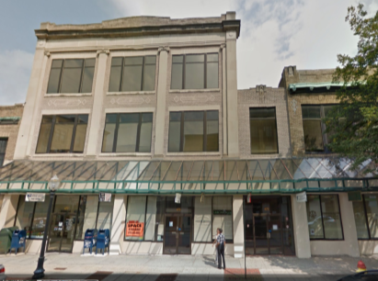

Prepared by:
Massachusetts Department of Public Health
Bureau of Environmental Health
Indoor Air Quality Program
March 2017

Executive Summary
The main issue prompting this assessment was mold concerns due to roof/plumbing leaks. Although there was evidence of water damage, no visible mold growth on building materials was observed. Many areas of the roof were reportedly recently repaired.

Background
Building: | Massachusetts Department of Transitional Assistance (DTA)
Address: | 473 Main Street, Fitchburg, MA
Assessment Requested by: | Cory Thomas, Field Operations, Executive Office of Health and Human Services (EOHHS)
Reason for Request: | Mold concerns and general indoor air quality (IAQ)
Date of Assessment: | March 9, 2017
Massachusetts Department of Public Health/Bureau of Environmental Health (MDPH/BEH) Staff Conducting Assessment: | Cory Holmes, Environmental Analyst/Inspector, IAQ Program
Building Description: | The DTA is located on the second floor and part of the first floor of a three-story, brick building built in the early 1900s. The DTA has occupied the space since 1998. The space consists of offices, cubicles with cloth dividers, and storage areas. Floors are carpeted in most areas.
Windows: | There are no openable windows in the space.

Methods
Please refer to the IAQ Manual and appendices for methods, sampling procedures, and interpretation of results (MDPH, 2015).

Results and Discussion
The following is a summary of indoor air testing results (Table 1).
- Carbon dioxide measurements were below the MDPH recommended level of 800 parts per million (ppm) in all but two areas surveyed, indicating adequate exchange in the large majority of spaces tested.
- Temperature was within or very close to the MDPH recommended range of 70°F to 78°F in areas tested at the time of assessment.
- Relative humidity was below the MDPH recommended range of 40 to 60% in all areas tested, which is typical for weather conditions in the winter.
- Carbon monoxide levels were non-detectable in all areas tested.
- Particulate matter (PM2.5) concentrations measured were below the National Ambient Air Quality (NAAQS) level of 35 μg/m³ in all areas tested.

Ventilation
A heating, ventilating and air-conditioning (HVAC) system has several functions. First it provides heating and, if equipped, cooling. Second, it is a source of fresh air. Finally, an HVAC system will dilute and remove normally occurring indoor environmental pollutants by not only introducing fresh air, but also filtering the airstream and ejecting stale air to the outdoors via exhaust ventilation.
Mechanical ventilation is provided by an air-handling unit (AHU) on the roof of the building (Picture 1). Fresh air is drawn into the AHU through an intake vent and delivered to occupied areas via ceiling-mounted supply vents (Pictures 2 and 3). Return air is drawn into the ceiling plenum via ceiling grates (Picture 4) and then ducted back to the AHU. The AHU is equipped with filters of a Minimum Efficiency Reporting Value (MERV) of 8 (Picture 5), which are adequate in filtering out pollen and mold spores (ASHRAE, 2012).
Testing results suggest that sufficient fresh air is being introduced into the space for the current occupancy with a few exceptions (the first floor conference room and area 219). The HVAC systems should be operated in the fan “on” mode for continuous air circulation and filtration during occupied periods, and adjustments made to increase fresh air as needed.
Although temperature measurements were within/close to MDPH recommendations at the time of assessment, occupants expressed a number of temperature/comfort complaints. It was reported by building maintenance personnel that in many areas, slotted diffusers (Picture 3) were being replaced by multi-directional diffusers with airflow adjustment capabilities (Picture 2), which have improved comfort. Also affecting comfort in the space is overheating by solar gain in areas near windows. Blinds should be adjusted as needed to reduce solar heating; a tinted solar film can be applied to windows for a more permanent solution.
It is important to note that relative humidity levels in the building would be expected to be low during the winter months due to atmospheric conditions and heating. Low relative humidity can lead to common symptoms such as: dry skin, lips, and scalp; dry/scratchy throats and noses (nose bleeds); exacerbation of asthma, eczema, or allergies; dry/irritated eyes; and irritation of respiratory tract.
In order to have proper ventilation with a mechanical HVAC system, the system must be balanced to provide an adequate amount of fresh air to the interior of a room while removing stale air from the room. It is recommended that existing ventilation systems be re-balanced every five years to ensure adequate air systems function (SMACNA, 1994). It was not known when the last balancing of the HVAC system occurred.

Microbial/Moisture Concerns
In order for building materials to support mold growth, a source of water exposure is necessary. Water-damaged ceiling tiles were seen in several areas (Table 1, Picture 6). Water-damaged ceiling tiles indicate leaks from either the roof or plumbing system and can provide a source for mold growth. These tiles should be replaced after a water leak is discovered and repaired. It was reported by building maintenance personnel that during the extreme snowfall of 2015, crews were hired to shovel off the roof and damaged the rubber membrane in many areas. This damage has since been repaired (Picture 7).
BEH/IAQ staff examined several areas of concern, including the ceiling plenum (above ceiling tiles) in office 221 and cubicle 286. No existing water damage or visible mold growth was observed. A plastic bowl was placed on top of a light fixture in area 286, (Picture 8), presumably to catch water from the HVAC unit which poses an electrical/safety hazard.
The US Environmental Protection Agency (US EPA) and the American Conference of Governmental Industrial Hygienists (ACGIH) recommends that porous materials (e.g., wallboard, carpeting, ceiling tiles) be dried with fans and heating within 24 to 48 hours of becoming wet (US EPA, 2008; ACGIH, 1989). If porous materials are not dried within this time frame, mold growth may occur. Once mold has colonized porous materials, they are difficult to clean and should be removed.
Water coolers were observed on carpeting (Picture 9). Consideration should be made to place waterproof mats in these areas or to remove carpet and install non-permeable floor tiles to prevent damage and/or mold growth due to spills or leaks.
Plants were observed in a few areas (Table 1). Plants can be a source of pollen and mold, which can be respiratory irritants to some individuals. Plants should be properly maintained and equipped with drip pans and should be located away from air diffusers to prevent the aerosolization of dirt, pollen, and mold.
Visible mold growth was observed on the outside of the refrigerator and on gaskets in the employee breakroom (Pictures 10 through 12). If these gaskets cannot be cleaned adequately, they should be replaced.

Other Conditions
In a number of areas, items were observed on the floor, windowsills, tabletops, counters, bookcases and desks. The large number of items stored provides a source for dusts to accumulate. These items (e.g., papers, folders, boxes) make it difficult for custodial staff to clean. Items should be relocated and/or be cleaned periodically to avoid excessive dust build up. In addition, dust can accumulate on flat surfaces (e.g., desktops, windowsills and carpets) in occupied areas and subsequently be re-aerosolized causing further irritation.
Several supply/return vents, sprinkler heads and portable fans were observed to have accumulated dust/debris (Pictures 2-4, 13 and 14). Operation of this equipment can re-aerosolize accumulated dust particles.
Many areas contained old worn carpeting that appeared to be past its useful life (Table1; Pictures 15 and 16). The Institute of Inspection, Cleaning, and Restoration Certification (IICRC), recommends that carpeting be cleaned annually, or semi-annually in high-traffic areas (IICRC, 2012). Since the average lifespan of carpeting is approximately eleven years (Bishop, 2002), consideration should be given to planning the installation of new flooring.
Finally, mercury-containing thermostats were observed within the space (Picture 17). The mercury in these thermostats is enclosed in an airtight glass ampoule. While the mercury is not evaporating into the environment when intact, these glass ampoules pose a hazard by accidental breakage. If broken, mercury could be released into the indoor environment resulting in building evacuation, exposure of occupants to mercury vapor, and a costly hazardous material clean up/remediation.

Conclusions and Recommendations
In view of the findings at the time of the visit, the following recommendations are made:
- To improve IAQ/comfort, document areas (with input from DTA staff and managers) of temperature and airflow complaints to work with HVAC control company and building management to adjust HVAC the system to improve circulation and increase outside air intake/exhaust capabilities.
- Continue to install adjustable multi-directional supply vents where needed to assist with comfort control.
- Operate HVAC system in fan “on” mode in all areas during occupied hours instead of “auto” to provide continuous circulation and filtration.
- Continue to change rooftop AHU filters on a quarterly basis using MERV 8 filters, which are adequate to filter out pollen and mold spores (ASHRAE, 2012).
- Have the HVAC system re-balanced, as recommended (every 5 years) in accordance with SMACNA recommendations (SMACNA, 1994).
- Use blinds to reduce solar heating; consider applying a tinted film where needed for a more permanent solution.
- For buildings in New England, periods of low relative humidity during the winter are often unavoidable. Therefore, scrupulous cleaning practices should be adopted to minimize common indoor air contaminants whose irritant effects can be enhanced when the relative humidity is low. To control for dusts, a high efficiency particulate arrestance (HEPA) filter-equipped vacuum cleaner in conjunction with wet wiping of all surfaces is recommended. Avoid the use of feather dusters. Drinking water during the day can help ease some symptoms associated with a dry environment (throat and sinus irritation).
- Replace water-damaged ceiling tiles once source of moisture is repaired.
- Contact HVAC engineering firm for advice on how to adequately address leak above the ceiling of area 286 (Picture 8) to prevent further damage and electrical/safety hazard.
- Consider installing non-porous floor tiles or use plastic mats below water coolers to prevent damage to carpeting.
- Keep plants in good condition, avoid overwatering, and remove from the airstream of heating and ventilation equipment.
- Clean and disinfect refrigerator and gaskets with mild detergent or antimicrobial agent. Clean spilled food promptly, and clean out refrigerators of expired items on a regular schedule. If gaskets cannot be adequately cleaned, replace.
- Consider reducing the amount of stored materials to allow for more thorough cleaning. Clean items regularly with a wet cloth or sponge to prevent excessive dust build-up.
- Clean personal fans, supply, exhaust, and return vents periodically of accumulated dust. If surrounding ceiling tiles cannot be cleaned, replace.
- Great care should be taken when cleaning sprinkler heads, contact building management to override system if necessary to avoid activating.
- Replace old/stained/worn carpeting throughout the building.
- Clean existing carpeting annually (or semi-annually in soiled high traffic areas) as per the recommendations of the Institute of Inspection, Cleaning and Restoration Certification (IICRC).
- Consider replacing mercury-containing thermostats with digital/programmable thermostats to improve temperature control. Have the mercury-containing items removed for proper disposal.
- Refer to resource manual and other related IAQ documents located on the MDPH’s website for further building-wide evaluations and advice on maintaining public buildings. These documents are available at http://mass.gov/dph/iaq.

REFERENCES
ACGIH. 1989. Guidelines for the Assessment of Bioaerosols in the Indoor Environment. American Conference of Governmental Industrial Hygienists, Cincinnati, OH.
ASHRAE. 2012. American Society of Heating, Refrigeration and Air Conditioning Engineers (ASHRAE) Standard 52.2-2012 -- Method of Testing General Ventilation Air-Cleaning Devices for Removal Efficiency by Particle Size (ANSI Approved). 2012.
Bishop. 2002. Bishop, J. & Institute of Inspection, Cleaning and Restoration Certification. A Life Cycle Cost Analysis for Floor Coverings in School Facilities.
IICRC. 2012. Institute of Inspection Cleaning and Restoration Certification. Institute of Inspection, Cleaning and Restoration Certification. Carpet Cleaning: FAQ. Retrieved from http://www.iicrc.org/consumers/care/carpet-cleaning.
MDPH. 2015. Massachusetts Department of Public Health. Massachusetts Department of Public Health Indoor Air Quality Manual: Chapters I-III. Available at: http://www.mass.gov/eohhs/gov/departments/dph/programs/environmental-health/exposure-topics/iaq/iaq-manual/.
SMACNA. 1994. HVAC Systems Commissioning Manual. 1st ed. Sheet Metal and Air Conditioning Contractors’ National Association, Inc., Chantilly, VA
US EPA. 2008. “Mold Remediation in Schools and Commercial Buildings”. Office of Air and Radiation, Indoor Environments Division, Washington, DC. EPA 402-K-01-001. September 2008. Available at: http://www.epa.gov/mold/mold-remediation-schools-and-commercial-buildings-guide.
Picture 1
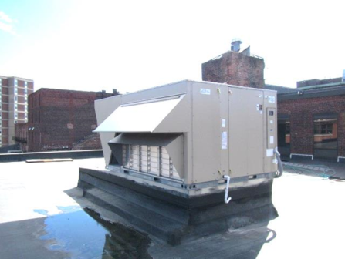
Rooftop air handling unit
Picture 2
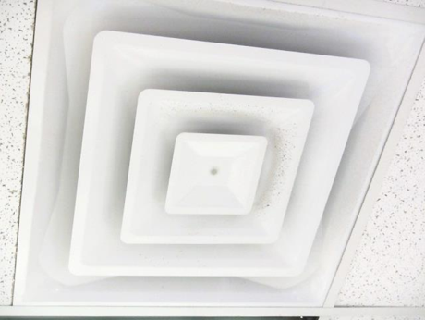
Supply diffuser, note accumulated dust/debris on louvers
Picture 3
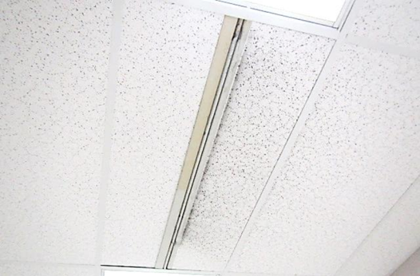
Slotted supply diffuser
Picture 4
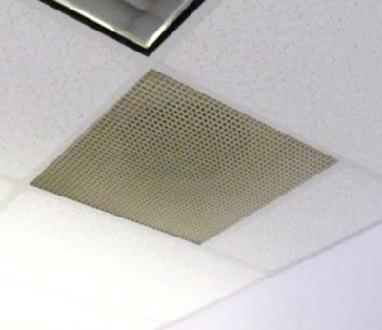
Return grill
Picture 5
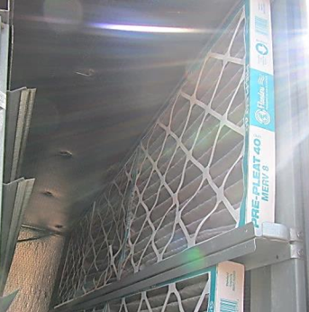
Pleated MERV 8 filters in AHU
Picture 6
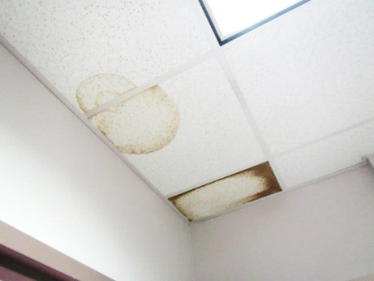
Water-damaged ceiling tiles in office 221
Picture 7
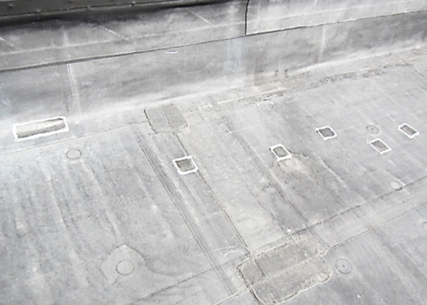
Roof patches (squares)
Picture 8
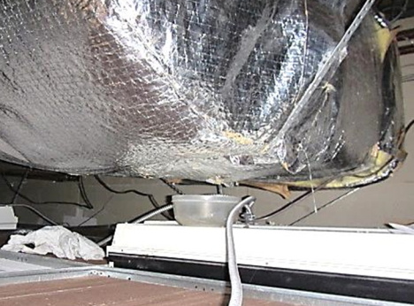
Plastic bowl on top of lighting fixture to catch water from HVAC unit
Picture 9
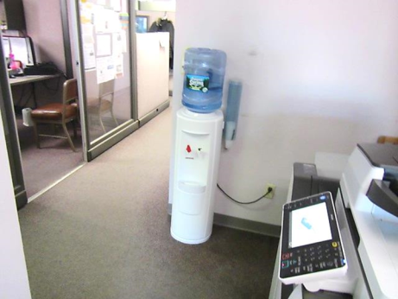
Water cooler on carpet
Picture 10
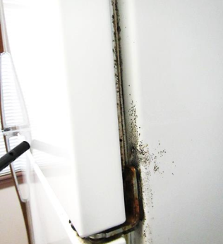
Mold growth (dark staining) on outside of refrigerator/gaskets in breakroom
Picture 11
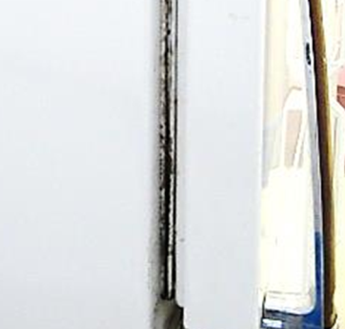
Mold growth (dark staining) on outside of refrigerator/gaskets in breakroom
Picture 12
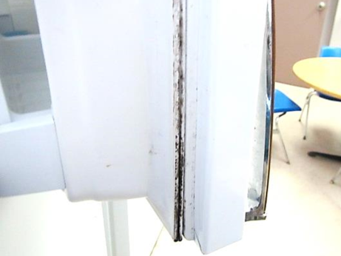
Mold growth (dark staining) on outside of refrigerator/gaskets in breakroom
Picture 13
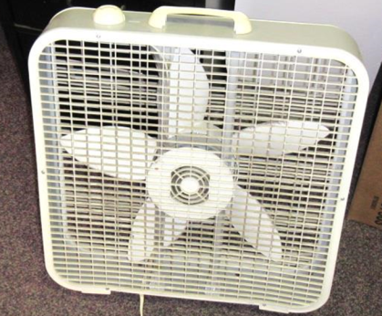
Portable fan in need of cleaning
Picture 14
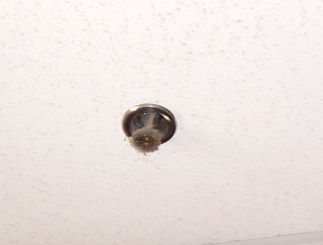
Dust/debris accumulation on sprinkler head
Picture 15
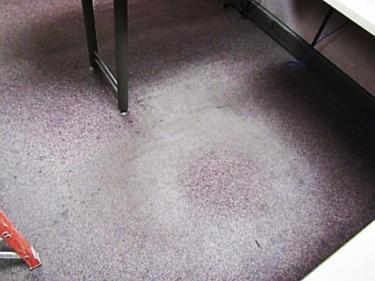
Old/worn/stained carpeting
Picture 16
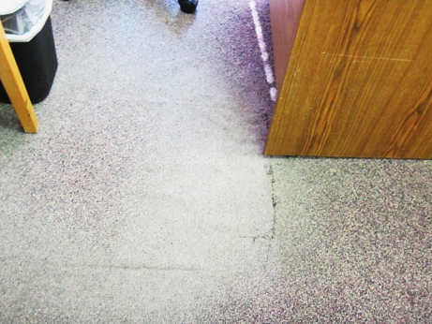
Old/worn/stained carpeting
Picture 17
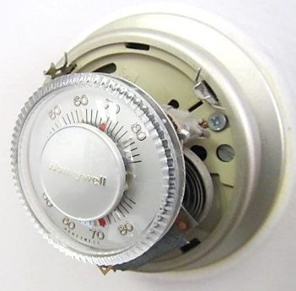
Mercury-containing thermostat/glass ampoule (arrow)

Location | Carbon  Dioxide  (ppm) | Carbon Monoxide  (ppm) | Temp  (°F) | Relative  Humidity  (%) | PM2.5  (µg/m³) | Occupants  in Room | Windows  Openable | Ventilation |  | Remarks
 |  |  |  |  |  |  |  | Supply | Exhaust
Background | 385 | ND | 48 | 21 | 25 |  |  |  |  | Sunny, cool, windy
101 Staff Lounge | 732 | ND | 73 | 19 | 9 | 2 | N | Y | Y | Visible mold on refrigerator
102 Conference Room | 1066 | ND | 71 | 23 | 5 | 0 | N | Y | Y
103 | 738 | ND | 71 | 21 | 7 | 0 | N | Y | Y
216 | 498 | ND | 77 | 11 | 4 | 0 | N | Y | Y | WD CT-corner, PF, temp complaints
218 | 557 | ND | 77 | 12 | 5 | 0 | N | Y | Y | 3 WD CTs, PF-dusty
219 | 836 | ND | 76 | 17 | 4 | 2 | N | Y | Y | Dust/debris vents
220 Supplies | 536 | ND | 75 | 12 | 3 | 0 | N | Y | Y
221 | 645 | ND | 75 | 10 | 6 | 0 | N | Y | Y | WD CT-dry, no visible mold above CTs, dust/debris vents
258 | 511 | ND | 76 | 12 | 3 | 0 | N | Y | N | HS, plants
260-264 | 510 | ND | 77 | 12 | 3 | 4 | N | Y | Y | PF, PC, water cooler on carpet
266 | 540 | ND | 76 | 12 | 4 | 2 | N | Y | N | Water cooler on carpet
266-275 | 535 | ND | 76 | 12 | 4 | 0 | N | Y | Y | WD CT near window (272)
276-278 | 510 | ND | 76 | 12 | 3 | 0 | N | Y | N
279-287 | 562 | ND | 76 | 12 | 5 | 0 | N | Y | Y | PF, plant, heat complaints/PC-other side of divider
283-285 | 542 | ND | 76 | 12 | 3 | 2 | N | Y | Y | 1 WD CT
286 | 574 | ND | 76 | 13 | 5 | 0 | N | Y | Y | Area of WD/leaks, bowl on elec/light above CT to catch leaks from HVAC unit
289-290 | 495 | ND | 75 | 11 | 3 | 0 | N | Y | Y | Dust/debris vent
292-294 | 539 | ND | 75 | 12 | 3 | 0 | N | Y | N | Plant
295-296 | 581 | ND | 75 | 13 | 4 | 0 | N | Y | Y
297-301 | 536 | ND | 76 | 12 | 3 | 0 | N | Y | Y
300 | 558 | ND | 79 | 11 | 3 | 0 | N | Y | Y | PF, plant, 1 WD CT, old/damaged carpeting
302-306 | 752 | ND | 78 | 13 | 4 | 1 | N | Y | Y | Solar glare, damaged carpeting
Area Director’s Office | 633 | ND | 72 | 18 | 3 | 3 | N | Y | Y
Lobby | 693 | ND | 76 | 12 | 3 | 15 | N | Y | Y | PF, dust/debris vents
Paper Storage | 574 | ND | 76 | 12 | 3 | 0 | N | Y | N | Soiled CT, dust/debris
Reception | 552 | ND | 78 | 10 | 4 | 2 | N | Y | Y | Dust/debris vents, PF, PC

