INDOOR AIR QUALITY ASSESSMENT

Department of Transitional Assistance
9 Walnut Street
Worcester, Massachusetts

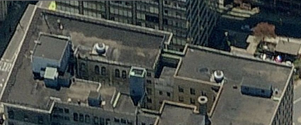

Prepared by:
Massachusetts Department of Public Health
Bureau of Environmental Health
Indoor Air Quality Program
June 2012

Background/Introduction
At the request of Gilles Quintal, Project Manager, Division of Capital Asset Management (DCAM), the Massachusetts Department of Public Health (MDPH), Bureau of Environmental Health (BEH) conducted an assessment related to mold concerns at the Department of Transitional Assistance (DTA) office located at 9 Walnut Street, Worcester, Massachusetts. On December 8, 2011, Michael Feeney, Director of BEH’s IAQ Program and Sharon Lee, Analyst/Inspector for the IAQ Program visited the DTA office to conduct the assessment.
The DTA is located on the fourth floor of a multi-story high-rise that was constructed during the 1930s or 1940s. At a later date, the buildings at 9 Walnut Street and 340 Main Street were joined by a bridge floor that is now used as office space. DTA has occupied the space since 1996. Windows are openable throughout the building.
The DTA office has had previous IAQ assessments by BEH relating to ongoing issues with roof leakage (MDPH 2006; MDPH 2011). Prior to this assessment, building management had the “short roof” repaired due to leaks and water-damaged building materials were removed from this area around stained brickwork. This area of the building, primarily around windows, was the focus of the investigation.

Methods
BEH staff performed a visual inspection of interior building materials for water damage and/or microbial growth as well as the exterior of the building. Moisture content of porous building materials was measured with a Tramex Encounter Plus, Non-Destructive Moisture Meter.

Results
The DTA houses approximately 82 staff and can be visited by up to 100 members of the general public daily.

Discussion
The concern was dark discoloration of bricks in the corner and below the windowsill (Pictures 1 and 2), which was thought to be mold growth. The window was located behind water-damaged gypsum wallboard (GW) noted in previous BEH IAQ assessments of the DTA offices (MDPH, 2006; MDPH, 2011). The GW had been removed following the 2011 assessment, exposing the window. The window had been bricked-in during a previous renovation.
In order for mold to grow on building materials, several conditions need to be present, chiefly a carbon source for the mold to colonize and a source of moisture. A number of conditions and tests conducted by BEH staff on the brick indicate that the stains are unlikely to be mold growth.
      - Brick consists of sandy clay, or silicate of alumina, usually containing small quantities of lime, magnesia and iron oxide (Kidder, F. E., 1906). The percentage of each constituent can vary, however none of the listed materials contain carbon on which mold can proliferate.
      - BEH staff conducted moisture sampling on and around the stained brick using a non-invasive moisture meter (Picture 3). All materials evaluated had no measurable moisture content (i.e., they were dry).
      - In an effort to ascertain the nature of the staining, BEH staff used a knife blade to scrape the surface of the brick. No particles could be produced using this method, indicating that the stain is within the brick material and not on its surface.
      - BEH staff also attempted to remove materials from the stained brick using alcohol wipes. No residue could be removed from the brick, further supporting the theory that the stain is ingrained within the matrix of the brick.
      - No evidence of water penetration was observed in the form of efflorescence. Efflorescence is a characteristic sign of water damage to brick and mortar, but it is not mold growth. As moisture penetrates and works its way through mortar, brick or plaster, water-soluble compounds dissolve, creating a solution. As the solution moves to the surface of the material, the water evaporates, leaving behind white, powdery mineral deposits. Without efflorescence, the likelihood of chronic water penetration through the sealed-in window is remote.
      - Lastly, the wall in which the sealed-in window exists is along what is now an interior wall, which was created when the bridge between 340 Main Street and 9 Walnut Street was constructed and is therefore not exposed to outdoor weather.

Conclusions/Recommendations
Based on these observations, it does not appear that the stain on the brick is mold. Therefore there is no opportunity for mold/particulate to become aerosolized. It is likely that the stain occurred when the window was exposed to the outdoor elements prior to the construction of the building bridge. In view of these findings at the time of the visit, the following conclusions and recommendations are provided:
- Continue monitoring the bridge roof for sign of water penetration.
- Refer to resource manual and other related indoor air quality documents located on the MDPH’s website for further building-wide evaluations and advice on maintaining public buildings. These documents are available at: http://mass.gov/dph/iaq.

References
Kidder, F. E. 1906. Building Construction and Superintendence. William T. Comstock Publishers. http://chestofbooks.com/architecture/Construction-Superintendence/215-Composition-of-Bricks.html
MDPH. 2006. Indoor Air Quality Assessment of Massachusetts Department of Transitional Assistance, Worcester Regional Office. Massachusetts Department of Public Health, Boston, MA. October 2006.
MDPH. 2011. Indoor Air Quality Reassessment of Massachusetts Department of Transitional Assistance, Worcester Regional Office. Massachusetts Department of Public Health, Boston, MA. April 2011.
Picture 1

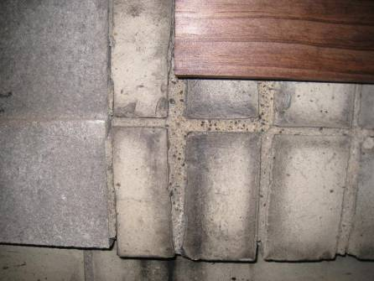

Discolored Brick

Picture 2

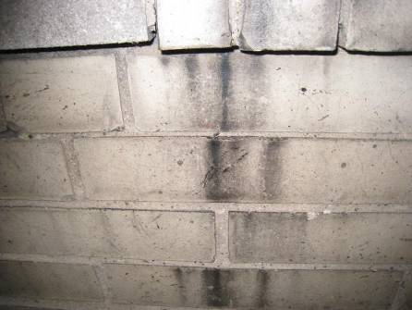

Discolored Brick

Picture 3

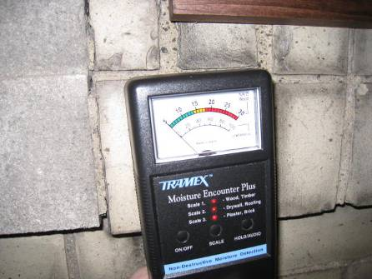

Moisture Measurement of Brick, Showing Non-Detectable Moisture Reading

