INDOOR AIR QUALITY ASSESSMENT

Massachusetts Department of Transitional Assistance
Shetland Park Office Complex
35 Congress Street
Salem, Massachusetts

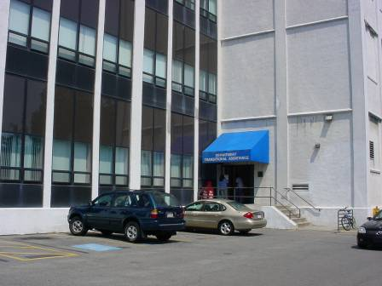

Prepared by:
Massachusetts Department of Public Health
Bureau of Environmental Health
Indoor Air Quality Program
April 2011

Background/Introduction
At the request of Doug Shatkin, Human Resources Director for the Massachusetts Executive Office of Health and Human Services’ (EOHHS) Department of Children, Youth and Families (DCYF), the Massachusetts Department of Public Health (MDPH), Bureau of Environmental Health (BEH) provided assistance and consultation regarding indoor air quality concerns at the offices for the Massachusetts Department of Transitional Assistance (DTA). The DTA occupies ground floor space in a building located in the Shetland Park Office Complex at 35 Congress Street, Salem, Massachusetts. On December 1, 2010, a visit to conduct an indoor air quality assessment was made to the DTA offices by Sharon Lee, an Environmental Analyst/Indoor Air Quality (IAQ) Inspector within BEH’s IAQ Program.
The Shetland Park Complex at 35 Congress Street is a four-story office building, originally constructed in the early 1930s. The building was renovated in the mid-1990s, prior to occupancy by state offices. The DTA occupies space on the ground floor. Windows are openable throughout the building.
The DTA was previously visited by the BEH in April 2008. A report detailing conditions at the time of the assessment as well as recommendations for improving IAQ can be found in a report released in May 2008 (MDPH, 2008).

Methods
Air tests for carbon dioxide, carbon monoxide, temperature and relative humidity were taken with the TSI, Q-TRAK™ IAQ Monitor, Model 8551. Air tests for airborne particle matter with a diameter less than 2.5 micrometers (PM2.5) were taken with the TSI, DUSTTRAK™ Aerosol Monitor Model 8520. BEH staff also performed a visual inspection of building materials for water damage and/or microbial growth.

Results
The DTA Salem office has employee population of approximately 120 and can be visited by up to 200 individuals daily. Tests were taken during normal operations and appear in Table 1.

Discussion

Ventilation
It can be seen from Table 1 that carbon dioxide levels were below 800 parts per million (ppm) in all but one of 69 areas surveyed, indicating adequate air exchange at the time of the assessment. Fresh, heated air is supplied by air-handling units (AHUs) equipped with high-efficiency pleated air filters. Fresh air is drawn into the AHUs through fresh air intakes located on the exterior of the building and provided to occupied areas via ceiling-mounted air diffusers (Picture 1). Return air is drawn into a ceiling plenum and returned to AHUs. AHUs were operating in occupied areas at the time of the assessment.
To maximize air exchange, the MDPH recommends that both supply and exhaust ventilation operate continuously during periods of occupancy. In order to have proper ventilation with a mechanical supply and exhaust system, the systems must be balanced to provide an adequate amount of fresh air to the interior of a room while removing stale air from the room. It is recommended that the heating, ventilating and air-conditioning (HVAC) systems be re-balanced every five years to ensure adequate air systems function (SMACNA, 1994). The date of the last balancing was not available at the time of the assessment.
The Massachusetts Building Code requires that each area have a minimum ventilation rate of 20 cubic feet per minute (cfm) per occupant of fresh outside air or openable windows (SBBRS, 1997; BOCA, 1993). The ventilation must be on at all times that the room is occupied. Providing adequate fresh air ventilation with open windows and maintaining the temperature in the comfort range during the cold weather season is impractical. Mechanical ventilation is usually required to provide adequate fresh air ventilation.
Carbon dioxide is not a problem in and of itself. It is used as an indicator of the adequacy of the fresh air ventilation. As carbon dioxide levels rise, it indicates that the ventilating system is malfunctioning or the design occupancy of the room is being exceeded. When this happens, a buildup of common indoor air pollutants can occur, leading to discomfort or health complaints. The Occupational Safety and Health Administration (OSHA) standard for carbon dioxide is 5,000 parts per million parts of air (ppm). Workers may be exposed to this level for 40 hours/week, based on a time-weighted average (OSHA, 1997).
The MDPH uses a guideline of 800 ppm for publicly occupied buildings. A guideline of 600 ppm or less is preferred in schools due to the fact that the majority of occupants are young and considered to be a more sensitive population in the evaluation of environmental health status. Inadequate ventilation and/or elevated temperatures are major causes of complaints such as respiratory, eye, nose and throat irritation, lethargy and headaches. For more information concerning carbon dioxide, please see Appendix A.
Temperature readings ranged from 68º F to 76 º F, which were within the MDPH recommended comfort guidelines in all but one area surveyed during the assessment. The MDPH recommends that indoor air temperatures be maintained in a range of 70 º F to 78 º F in order to provide for the comfort of building occupants. A number of DTA staff members occupying offices/cubicles expressed heat concerns, while those occupying space in offices along building’s exterior expressed cold complaints. Occupants should work with Shetland Park Building Management via DTA management to identify chronic problem areas to improve temperature/comfort in the building. In many cases concerning indoor air quality, fluctuations of temperature in occupied spaces are typically experienced, even in a building with an adequate fresh air supply.
The relative humidity measured in the building during the assessment ranged from 33 to 46 percent, which was within or slightly below the MDPH recommended comfort range in all areas surveyed. The MDPH recommends a comfort range of 40 to 60 percent for indoor air relative humidity. Relative humidity levels in the building would be expected to drop during the winter months due to heating. The sensation of dryness and irritation is common in a low relative humidity environment. Low relative humidity is a very common problem during the heating season in the northeast part of the United States.

Microbial/Moisture Concerns
As discussed in previous reports regarding this building and offices at the 35 Congress St location, the building is prone to weather/moisture due to its design and location/orientation (MDPH, 2007; MDPH, 2008). The exterior wall system of this building is typical of industrial buildings of this sort, consisting of brickwork that lacks a curtain wall, making it prone to water penetration. Furthermore, the DTA offices are located in the southwest corner on the ground floor of the building, which is the windward side of the structure.

BEH staff detected a slight musty odor near cubicles 144/147, which is near a door leading to a stairwell. The stairwell and the building meet to form a perpendicular angle that can allow precipitation/moisture to accumulate in this corner, particularly during southwesterly driven storms. This can result in water penetration to the DTA space as well as the stairwell.
Water penetrating the exterior wall can result in moisture accumulation and damage to interior building materials (i.e., carpeting, flooring, gypsum wallboard). Conditions that lead to entrapment of moisture in building materials can lead to chronic dampening and the colonization of mold of such materials. No signs of mold colonization were observed at the time of this assessment. If musty odors are present in the wall cavity of the building, they can penetrate into occupied spaces through breaches/spaces around the floor and other openings including electrical outlets.
As mentioned, access to a stairwell is also located in this area. Portions of this stairwell are carpeted. Repeated moistening of the carpet either via water penetration through the exterior wall or by general foot traffic can result in odors.
Furthermore, BEH staff observed a bug screen installed on a vent for the AHU servicing this space (Picture 2). This bug screen also collects dust and debris. During wind-driven rain or periods of high humidity, materials collected against the screen can become moistened and produce odors, which can be distributed to the DTA space when the mechanical ventilation system is in operation.
Water-damaged ceiling tiles were observed in some areas, primarily near exterior walls (Picture 3: Table 1). The location of these water-damaged tiles suggests that water is penetrating either through the building exterior or from roof drainage. Water-damaged ceiling tiles can provide a source of mold and should be replaced after a leak is discovered and repaired.
A water cooler was located over a carpeted area (Picture 4). Overflow of the water basin or spills that often occur can moisten carpeting, leading to mold growth. It is also important that catch basins of water coolers be cleaned regularly as stagnant water can be a source of odors. Further, materials (i.e., dust) collected in the water can provide a medium for mold growth.
The US Environmental Protection Agency (US EPA) and the American Conference of Governmental Industrial Hygienists (ACGIH) recommends that porous materials be dried with fans and heating within 24 to 48 hours of becoming wet (US EPA, 2001; ACGIH, 1989). If porous materials are not dried within this time frame, mold growth may occur. Water-damaged porous materials cannot be adequately cleaned to remove mold growth. The application of a mildewcide to moldy porous materials is not recommended.
Plants were observed in several areas (Picture 5; Table 1). Plants should be properly maintained and equipped with drip pans. Plants should also be located away from ventilation sources to prevent aerosolization of dirt, pollen or mold. Finally, they should not be placed on porous materials, since water damage to porous materials may lead to microbial growth.

Other IAQ Evaluations
Indoor air quality can be negatively influenced by the presence of respiratory irritants, such as products of combustion. The process of combustion produces a number of pollutants. Common combustion emissions include carbon monoxide, carbon dioxide, water vapor and smoke (fine airborne particle material). Of these materials, exposure to carbon monoxide and particulate matter with a diameter of 2.5 micrometers (μm) or less (PM2.5) can produce immediate, acute health effects upon exposure. To determine whether combustion products were present in the indoor environment, BEH staff obtained measurements for carbon monoxide and PM2.5.

Carbon Monoxide
Carbon monoxide is a by-product of incomplete combustion of organic matter (e.g., gasoline, wood and tobacco). Exposure to carbon monoxide can produce immediate and acute health affects. Several air quality standards have been established to address carbon monoxide and prevent symptoms from exposure to these substances. The MDPH established a corrective action level concerning carbon monoxide in ice skating rinks that use fossil-fueled ice resurfacing equipment. If an operator of an indoor ice rink measures a carbon monoxide level over 30 ppm, taken 20 minutes after resurfacing within a rink, that operator must take actions to reduce carbon monoxide levels (MDPH, 1997).
The American Society of Heating Refrigeration and Air-Conditioning Engineers (ASHRAE) has adopted the National Ambient Air Quality Standards (NAAQS) as one set of criteria for assessing indoor air quality and monitoring of fresh air introduced by HVAC systems (ASHRAE, 1989). The NAAQS are standards established by the US EPA to protect the public health from six criteria pollutants, including carbon monoxide and particulate matter (US EPA, 2006). As recommended by ASHRAE, pollutant levels of fresh air introduced to a building should not exceed the NAAQS levels (ASHRAE, 1989). The NAAQS were adopted by reference in the Building Officials & Code Administrators (BOCA) National Mechanical Code of 1993 (BOCA, 1993), which is now an HVAC standard included in the Massachusetts State Building Code (SBBRS, 1997). According to the NAAQS, carbon monoxide levels in outdoor air should not exceed 9 ppm in an eight-hour average (US EPA, 2006).
Carbon monoxide should not be present in a typical, indoor environment. If it is present, indoor carbon monoxide levels should be less than or equal to outdoor levels. Outdoor carbon monoxide concentrations were non-detect (ND) at the time of the assessment (Table 1). No measureable levels of carbon monoxide were detected inside the building during the assessment (Table 1).

Particulate Matter
The US EPA has established NAAQS limits for exposure to particulate matter. Particulate matter is airborne solids that can be irritating to the eyes, nose and throat. The NAAQS originally established exposure limits to particulate matter with a diameter of 10 μm or less (PM10). According to the NAAQS, PM10 levels should not exceed 150 micrograms per cubic meter (μg/m³) in a 24-hour average (US EPA, 2006). These standards were adopted by both ASHRAE and BOCA. Since the issuance of the ASHRAE standard and BOCA Code, US EPA established a more protective standard for fine airborne particles. This more stringent PM2.5 standard requires outdoor air particle levels be maintained below 35 μg/m³ over a 24-hour average (US EPA, 2006). Although both the ASHRAE standard and BOCA Code adopted the PM10 standard for evaluating air quality, MDPH uses the more protective PM2.5 standard for evaluating airborne particulate matter concentrations in the indoor environment.
Outdoor PM2.5 concentrations the day of the assessment were measured at 8 μg/m³. PM2.5 levels measured inside the building ranged from 5 to 10 μg/m³ (Table 1). Both indoor and outdoor PM 2.5 levels were below the NAAQS PM2.5 level of 35 μg/m³. Frequently, indoor air levels of particulates (including PM2.5) can be at higher levels than those measured outdoors. A number of activities that occur indoors and/or mechanical devices can generate particulate during normal operations. Sources of indoor airborne particulates may include but are not limited to particles generated during the operation of fan belts in the HVAC system, use of stoves and/or microwave ovens in kitchen areas; use of photocopiers, fax machines and computer printing devices; operation of an ordinary vacuum cleaner and heavy foot traffic indoors.

Volatile Organic Compounds
Indoor air concentrations can be greatly impacted by the use of products containing volatile organic compounds (VOCs). VOCs are carbon-containing substances that have the ability to evaporate at room temperature. Frequently, exposure to low levels of total VOCs (TVOCs) may produce eye, nose, throat and/or respiratory irritation in some sensitive individuals. For example, chemicals evaporating from a paint can stored at room temperature would most likely contain VOCs.
Cleaning products were observed in a number of areas (Picture 6). Cleaning products contain VOCs and other chemicals. These chemicals can be irritating to the eyes, nose and throat. Additionally, a Material Safety Data Sheet (MSDS) should be available at a central location for each product in the event of an emergency.
Air fresheners and deodorizing materials were observed in a number of areas. Air deodorizers contain chemicals that can be irritating to the eyes, nose and throat of sensitive individuals. Many air fresheners contain 1,4-dichlorobenzene, a VOC which may cause reductions in lung function (NIH, 2006). Furthermore, deodorizing agents do not remove materials causing odors, but rather mask odors that may be present in the area.

Other Conditions
Other conditions that can affect indoor air quality were observed during the assessment. Dust/debris was observed accumulated on supply vents (Picture 1), as well as on the fan blades of personal fans. Vents and fans should be cleaned periodically to prevent dust/debris from being aerosolized and redistributed throughout the room.
An air purifier was observed in an office. These are normally equipped with filters, which should be cleaned or changed as per the manufacturer’s instructions to avoid the build-up and re-aerosolization of dirt, dust and particulate matter. Air purifiers should also be placed near the breathing zone of the room to maximize efficacy.
Light could be seen penetrating through breaches in the mechanical room doors (Pictures 7 and 8). These breaches can allow moisture and pests to enter the building. Moisture penetrating this area can result in dampening of materials, creating odors.

Conclusions/Recommendations
Based on conditions observed at this time coupled with reports from other MDPH assessments, it appears that some changes have been made to improve indoor air quality at the DTA space (e.g., improved ventilation). However, conditions relating to water damage/musty odors from the building still persist. Based on this and previous assessments, the following recommendations are provided to improve air quality:
- Implement measures/recommendations to address water infiltration through the building envelope as outlined in previous reports if not already completed (MDPH, 2007; MDPH, 2008).
- Remove bug screen currently installed over vent and replace with a bird screen. Clean vent and screen periodically to prevent accumulation of debris.
- Examine masonry around the building’s exterior, especially at southwest facing corners (i.e., corner formed by exterior wall and stairwell outside cubicles 144/147). Repoint masonry to prevent water penetration.
- Remove carpeting in stairwell and replace with non-porous flooring (i.e., tiles).
- Seal breaches the mechanical room.
- Alert Shetland Park Management to presence of water-damaged ceiling tiles to identify source of leak. Once repaired change ceiling tiles and monitor for further leaks.
- Seal any breaches in floor and insulate around electrical outlets to eliminate drafts and odor migration into occupied areas.
- Consider reducing the set point of the thermostat to increase comfort of DTA staff. Consider installing baseboard radiators in offices along the building’s exterior to provide auxiliary heating. In areas where radiators are present, consider increasing heat provided by these elements.
- For buildings in New England, periods of low relative humidity during the winter are often unavoidable. Therefore, scrupulous cleaning practices should be adopted to minimize common indoor air contaminants whose irritant effects can be enhanced when the relative humidity is low. Drinking water during the day can help ease some symptoms associated with a dry environment (throat and sinus irritations). Consider obtaining a vacuum cleaner equipped with a high efficiency particulate arrestance (HEPA) filter to trap respirable dusts.
- Consider decreasing the number of plants in the office space. Relocate plants from the airstream of ventilation sources.
- Install a water impervious mat (e.g., rubber, plastic) under water coolers to prevent water damage to carpeting.
- Refrain from using air deodorizers to prevent exposure to VOCs.
- Ensure personal fans and ceiling vents are cleaned periodically to prevent aerosolization of dusts collected on fan blades.
- Ensure filters for air purifiers are changed per manufacturer’s recommendation.
- Refer to resource manual and other related indoor air quality documents located on the MDPH’s website for further building-wide evaluations and advice on maintaining public buildings. These documents are available at: http://mass.gov/dph/iaq.

References
ACGIH. 1989. Guidelines for the Assessment of Bioaerosols in the Indoor Environment. American Conference of Governmental Industrial Hygienists, Cincinnati, OH.
ASHRAE. 1989. Ventilation for Acceptable Indoor Air Quality. American Society of Heating, Refrigeration and Air Conditioning Engineers. ANSI/ASHRAE 62-1989
BOCA. 1993. The BOCA National Mechanical Code-1993. 8th ed. Building Officials & Code Administrators International, Inc., Country Club Hills, IL.
Mass. Act. 2000. An Act Protecting Children and families from Harmful Pesticides. 2000 Mass Acts c. 85 sec. 6E.
MDFA. 1996. Integrated Pest Management Kit for Building Managers. Massachusetts Department of Food and Agriculture, Pesticide Bureau, Boston, MA.
MDPH. 1997. Requirements to Maintain Air Quality in Indoor Skating Rinks (State Sanitary Code, Chapter XI). 105 CMR 675.000. Massachusetts Department of Public Health, Boston, MA.
MDPH. 2007. Indoor Air Quality Assessment: Department of Transitional Assistance/Massachusetts Rehabilitation Commission, Salem, Massachusetts. Massachusetts Department of Public Health, Bureau of Environmental Health, Boston, MA.
MDPH. 2008. Indoor Air Quality Assessment: Department of Transitional Assistance, Salem, Massachusetts. Massachusetts Department of Public Health, Bureau of Environmental Health, Boston, MA.
NIH. 2006. Chemical in Many Air Fresheners May Reduce Lung Function. NIH News. National Institute of Health. July 27, 2006. http://www.nih.gov/news/pr/jul2006/niehs-27.htm
OSHA. 1997. Limits for Air Contaminants. Occupational Safety and Health Administration. Code of Federal Regulations. 29 C.F.R 1910.1000 Table Z-1-A.
SBBRS. 1997. Mechanical Ventilation. State Board of Building Regulations and Standards. Code of Massachusetts Regulations. 780 CMR 1209.0
SMACNA. 1994. HVAC Systems Commissioning Manual. 1st ed. Sheet Metal and Air Conditioning Contractors’ National Association, Inc., Chantilly, VA
US EPA. 1992. Indoor Biological Pollutants. US Environmental Protection Agency, Environmental Criteria and Assessment Office, Office of Health and Environmental Assessment, research Triangle Park, NC. EPA 600/8-91/202 January 1992.
US EPA. 2001. Mold Remediation in Schools and Commercial Buildings. US Environmental Protection Agency, Office of Air and Radiation, Indoor Environments Division, Washington, D.C. EPA 402-K-01-001. March 2001. http://www.epa.gov/iaq/molds/mold_remediation.html
US EPA. 2006. National Ambient Air Quality Standards (NAAQS). US Environmental Protection Agency, Office of Air Quality Planning and Standards, Washington, DC. http://www.epa.gov/air/criteria.html.
Picture 1

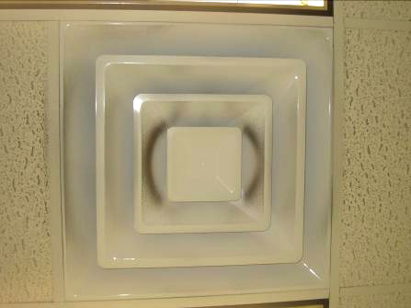

Supply vent, note dust

Picture 2

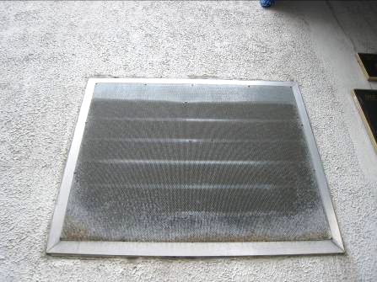

Bug screen on vent, note accumulated debris

Picture 3

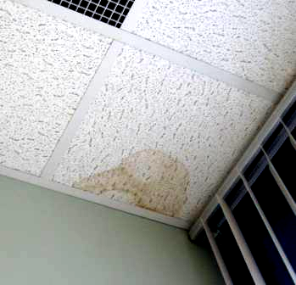

Water-damaged ceiling tile

Picture 4

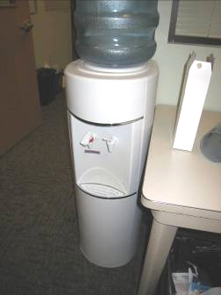

Water cooler on carpet

Picture 5



Plants in close proximity to supply vent

Picture 6

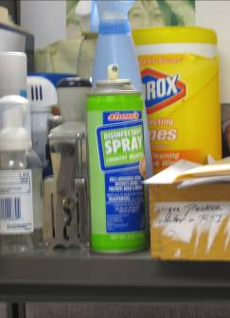

Various cleaning products

Picture 7

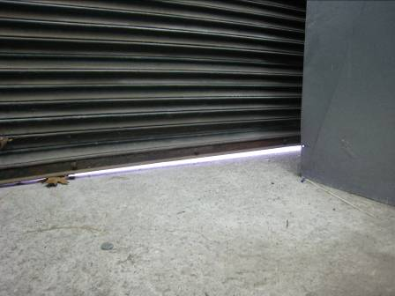

Light penetrating from garage door in mechanical room
Picture 8

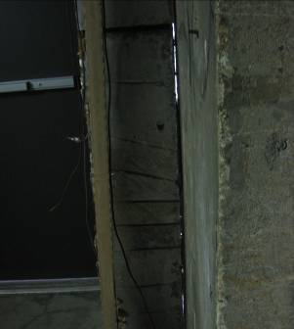

Light penetrating through wall door in mechanical room
Location | Carbon  Dioxide  (ppm) | Carbon Monoxide  (ppm) | Temp  (°F) | Relative  Humidity  (%) | PM2.5  (µg/m3) | Occupants  in Room | Windows  Openable | Ventilation |  | Remarks
 |  |  |  |  |  |  |  | Supply | Exhaust | Remarks
Outside  (Background) | 412 | ND | 43 | 71 | 8 |  |  |  |  | overcast
Receptionist | 682 | ND | 74 | 37 | 6 | 4 | N | Y | N | DO
8 (conference) | 621 | ND | 75 | 36 | 5 | 0 | N | Y | Y | DO
9 (supply) | 728 | ND | 75 | 41 | 5 | 0 | N | Y |  | DO
10  (training room) | 655 | ND | 74 | 40 | 6 | 0 | Y | Y | Y | Thermostat
11  (staff lounge) | 681 | ND | 73 | 42 | 8 | 2 | Y | Y |  | DO, Plants
12 | 633 | ND | 72 | 41 | 6 | 1 | N | Y | N | DO
13 (Assistant Director’s office) | 704 | ND | 68 | 46 | 5 | 0 | Y | Y | Y | DO, 1 WD-CT
14/15/20 | 638 | ND | 70 | 45 | 5 | 1 | N | Y
17/18 | 738 | ND | 70 | 43 | 5 | 3 | N | Y
21/22/23/24 | 694 | ND | 72 | 37 | 5 | 4 | N | Y |  | PF, CPs, items
26/27/28/29 | 682 | ND | 73 | 40 | 6 | 4 | N | Y |  | PF, CPs, plant
30 | 746 | ND | 73 | 40 | 7 | 1 | N | Y
31 | 734 | ND | 74 | 39 | 6 | 0 | N | Y |  | Plants, DO
37/38 | 733 | ND | 74 | 39 | 7 | 4 | N | Y |  | CPs
39/40 | 708 | ND | 73 | 40 | 8 | 2 | N | Y |  | DO
41 | 589 | ND | 75 | 35 | 5 | 1 | N | Y | Y | DO, 1 WD-CT
42 | 588 | ND | 75 | 35 | 5 | 0 | N | Y
44/43 | 645 | ND | 75 | 36 | 5 | 0 | N | Y |  | Plants
57/80 | 664 | ND | 76 | 35 | 5 | 1 | N | Y
61 | 555 | ND | 74 | 35 | 6 | 0 | N | Y |  | DO
63/64 | 602 | ND | 74 | 35 | 6 | 1 | N | Y
65 | 721 | ND | 75 | 36 | 6 | 2 | N | Y |  | DO, items
67/68 | 671 | ND | 72 | 37 | 6 | 2 | N | Y
69 | 705 | ND | 71 | 43 | 6 | 0 | N | Y |  | PF, DO
69 | 651 | ND | 72 | 37 | 6 | 0 | N | Y
70 | 640 | ND | 73 | 37 | 6 | 1 | N | Y
71/72 | 685 | ND | 73 | 38 | 6 | 2 | N | Y
73 | 635 | ND | 72 | 38 | 6 | 1 | N | Y |  | DO
74 | 619 | ND | 72 | 37 | 6 | 2 | N | Y
76/77 | 600 | ND | 74 | 35 | 6 | 0 | N | Y |  | Plants
78 | 605 | ND | 75 | 35 | 5 | 3 | N | Y |  | PF, plants
79/58/59 | 688 | ND | 75 | 35 | 5 | 6 | N | Y |  | DO
97 | 625 | ND | 75 | 33 | 5 | 0 | N | Y
98 | 574 | ND | 75 | 40 | 6 | 1 | N | Y |  | AD
99 | 632 | ND | 75 | 36 | 5 | 0 | N | Y |  | Plants
100/101 | 552 | ND | 72 | 37 | 5 | 0 | N | Y
102 | 566 | ND | 72 | 37 | 6 | 0 | N | Y
103 | 716 | ND | 72 | 37 | 6 | 3 | N | Y |  | DO
104 | 647 | ND | 71 | 37 | 5 | 0 | N | Y
105 | 626 | ND | 71 | 38 | 5 | 0 | N | Y
106 | 655 | ND | 71 | 39 | 5 | 1 | N | Y
107 | 666 | ND | 71 | 38 | 6 | 4 | N | Y
108 | 676 | ND | 71 | 38 | 6 | 1 | N | Y |  | DO
109/110 | 630 | ND | 71 | 37 | 6 | 1 | N | Y
111/112 | 645 | ND | 71 | 38 | 6 | 1 | N | Y
113 | 612 | ND | 71 | 38 | 6 | 1 | N | Y |  | DO
114 | 712 | ND | 72 | 39 | 7 | 2 | N | Y |  | DO
117 | 707 | ND | 72 | 37 | 6 | 2 | N | Y
118 | 615 | ND | 73 | 37 | 5 | 0 | N | Y
119 | 579 | ND | 72 | 38 | 6 | 0 | N | Y | N | DO
120 | 659 | ND | 74 | 36 | 5 | 0 | N | Y |  | DO
121 | 581 | ND | 75 | 36 | 6 | 2 | N | Y |  | DO
122  (waiting room | 814 | ND | 71 | 43 | 10 | ~30 | N | Y | Y
136 | 691 | ND | 73 | 38 | 5 | 0 | N | Y
137 | 665 | ND | 73 | 37 | 5 | 0 | N | Y
138 | 653 | ND | 73 | 38 | 5 | 1 | N | Y
139 | 683 | ND | 73 | 38 | 6 | 1 | N | Y |  | DO
140 | 688 | ND | 73 | 37 | 7 | 1 | N | Y
142 | 663 | ND | 73 | 37 | 5 | 1 | N | Y
144 | 718 | ND | 74 | 36 | 6 | 1 | N | Y |  | Slight musty odor
145 | 700 | ND | 74 | 36 | 6 | 1 | N | Y
146 | 692 | ND | 74 | 37 | 6 | 1 | N | Y |  | Copier, plants
147 | 705 | ND | 74 | 36 | 6 | 0 | N | Y |  | Plants, PF
148 | 681 | ND | 74 | 38 | 7 | 1 | N | Y
149 | 695 | ND | 74 | 36 | 6 | 1 | N | Y
151 | 620 | ND | 72 | 39 | 6 | 0 | Y | Y | Y | DO
152 | 625 | ND | 72 | 38 | 5 | 3 | Y | Y | Y
153 | 753 | ND | 74 | 39 | 6 | 2 | Y | Y | N | DO, space heater
167 | 606 | ND | 73 | 37 | 6 | 1 | Y | Y |  | DO

