INDOOR AIR QUALITY ASSESSMENT

Massachusetts Department of Transitional Assistance
Dudley Square Office
2201 Washington Street
Roxbury, Massachusetts 02119

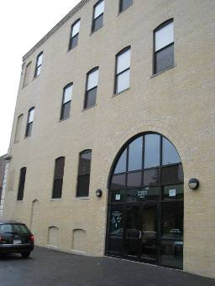

Prepared by:
Massachusetts Department of Public Health
Bureau of Environmental Health
Indoor Air Quality Program
October 2009

Background/Introduction
At the request of Doug Shatkin, Human Resources Director, Office of Children, Youth and Families, the Massachusetts Department of Public Health (MDPH), Bureau of Environmental Health (BEH) provided assistance and consultation regarding indoor air quality at the Massachusetts Department of Transitional Assistance (DTA), Dudley Square Office located at 2201 Washington Street, Roxbury, Massachusetts. The request was prompted by complaints of unpleasant odors and insufficient air circulation within the office space. A visit to conduct an indoor air assessment was made to the Dudley Square DTA office on July 1, 2009 by Sharon Lee and James Tobin, Environmental Analysts/Inspectors for BEH’s Indoor Air Quality (IAQ) Program. Ms. Lee and Mr. Tobin were accompanied by Allison O’Donnell, Intern, IAQ Program.
The building is a three-story, brick building. The DTA took residence at this location 2 years ago and occupies the ground floor, 2nd floor and portions of 3rd floor. Building renovations took place prior to DTA occupancy. Windows are not openable within DTA office with the exception of one side of the 2nd floor.
Methods
Air tests for carbon dioxide, temperature, relative humidity and carbon monoxide were conducted with the TSI, Q-Trak, IAQ Monitor, Model 7565. Air tests for airborne particle matter with a diameter less than 2.5 micrometers were taken with the TSI, DUSTTRAK™ Aerosol Monitor Model 8520. BEH staff also performed visual inspection of building materials for water damage and/or microbial growth.
Results
The Dudley Square DTA office has an employee population of approximately 100 and is visited by approximately 300 members of the public daily. Tests were taken during normal operations and results appear in Table 1.
Discussion
Ventilation
It can be seen from Table 1 that carbon dioxide levels were above 800 parts per million (ppm) in 7 of 78 areas, indicating adequate air exchange in the building at the time of the assessment. However, it is important to note that the ground floor office space had 6 of the 7 areas with carbon dioxide levels above 800 ppm (Table 1), including the waiting room, family housing and reception area. These areas are frequented by a number of people daily. Occupants complained of insufficient air circulation within the office space of the ground floor. BEH staff noted a limited number of air diffusers and return grates on the ground floor. BEH staff also observed unpleasant odors lingering throughout the ground floor areas (Table 1).
The heating, ventilating and air conditioning (HVAC) system consists of rooftop air handling units (AHUs), which draw outside air through air intakes and distribute it to occupied areas via ceiling-mounted air diffusers (Pictures 1 and 2). Return air is drawn through grates and ducted back to the rooftop AHUs (Picture 3). At the time of assessment, the AHU servicing the ground floor was reportedly turned off. All other AHUs were reportedly operating.
Please note, local airflow to each air diffuser is controlled by a variable air volume (VAV) box. Each VAV box has a set of thermostat-controlled dampers that open or close to regulate the amount of fresh air provided, depending on the temperature demand for a serviced area. Thermostats that control the VAV boxes have fan settings of “on” and “automatic” (Picture 4). The majority of thermostats were set to the fan “auto” setting. The “automatic” setting on the thermostat activates the HVAC system at a preset temperature. Once the thermostat detects that the preset temperature has been reached, the VAV box dampers close until heating or cooling is needed. During times that the temperature of a space is adequate, the VAV box closes its damper and limits the amount of fresh air. If the thermostat calls for the HVAC system to provide heat, the AHU fresh air intake damper would close to increase the temperature of the air in the ductwork and occupied spaces. Airflow would be noted from the ceiling air diffusers because the VAV box dampers are open, but fresh air supply would be limited by the closing of the rooftop fresh air intake damper and heated air would be circulated.
While it has the advantage of energy conservation and lower operating costs, VAV box systems may cause problems of insufficient outside air supply particularly if they are set to fan “ auto”. Once the temperature requirement is met, airflow drops. Airflow can drop to zero in poorly performing HVAC systems (Plog, Niland and Quinlan, 1996). Consideration should be given to increasing the fresh air supplied to the VAV boxes servicing the ground floor areas to improve ventilation to the area and operating the thermostats with the fan setting in the “on” position to provide continuous airflow, which is recommended by the MDPH. Without proper ventilation, normally existing indoor pollutants as well as odors can accumulate, which can lead to complaints.
Interferences with airflow were observed in the form of modifications to HVAC components. In several areas, supply diffusers were covered by cardboard/paper and tape (Picture 5). This alteration can create an imbalance in the system, resulting in uneven heating/cooling conditions leading to occupant discomfort.
To maximize air exchange, the MDPH recommends that both supply and exhaust ventilation operate continuously during periods of occupancy. In order to have proper ventilation with a mechanical supply and exhaust system, the systems must be balanced to provide an adequate amount of fresh air to the interior of a room while removing stale air from the room. It is recommended that HVAC systems be re-balanced every five years to ensure adequate air systems function (SMACNA, 1994).
The Massachusetts Building Code requires that each room have a minimum ventilation rate of 20 cubic feet per minute (cfm) per occupant of fresh outside air or openable windows (SBBRS, 1997; BOCA, 1993). The ventilation must be on at all times that the room is occupied. Providing adequate fresh air ventilation with open windows and maintaining the temperature in the comfort range during the cold weather season is impractical. Mechanical ventilation is usually required to provide adequate fresh air ventilation.
Carbon dioxide is not a problem in and of itself. It is used as an indicator of the adequacy of the fresh air ventilation. As carbon dioxide levels rise, it indicates that the ventilating system is malfunctioning or the design occupancy of the room is being exceeded. When this happens, a buildup of common indoor air pollutants can occur, leading to discomfort or health complaints. The Occupational Safety and Health Administration (OSHA) standard for carbon dioxide is 5,000 parts per million parts of air (ppm). Workers may be exposed to this level for 40 hours/week, based on a time-weighted average (OSHA, 1997).
The MDPH uses a guideline of 800 ppm for publicly occupied buildings. A guideline of 600 ppm or less is preferred in schools due to the fact that the majority of occupants are young and considered to be a more sensitive population in the evaluation of environmental health status. Inadequate ventilation and/or elevated temperatures are major causes of complaints such as respiratory, eye, nose and throat irritation, lethargy and headaches. For more information concerning carbon dioxide, consult Appendix A.
Indoor temperature measurements ranged from 68º F to 76º F, which were within or on the low end of the MDPH recommended comfort range (Table 1). The MDPH recommends that indoor air temperatures be maintained in a range of 70º F to 78º F in order to provide for the comfort of building occupants. In many cases concerning indoor air quality, fluctuations of temperature in occupied spaces are typically experienced, even in a building with an adequate fresh air supply.
The relative humidity in the building ranged from 49 to 68 percent, which was within the MDPH recommended comfort range in the majority of areas on the day of the assessment (Table 1). The areas with elevated relative humidity included the ground floor waiting room, family housing and reception area. The MDPH recommends a comfort range of 40 to 60 percent for indoor air relative humidity. Relative humidity levels in the building would be expected to drop during the winter months due to heating. The sensation of dryness and irritation is common in a low relative humidity environment. Low relative humidity is a very common problem during the heating season in the northeast part of the United States.
Microbial/Moisture Concerns
BEH staff examined building materials for water damage and/or microbial growth. In order for building materials to support mold growth, a source of water exposure is necessary. Identification and elimination of the source of water moistening building materials is necessary to control mold growth.
During a roof examination, BEH staff found water pooling around the AHUs (Pictures 6 and 7). Pooling water is an indication of inadequate draining. Debris was observed in some roof drains, preventing proper drainage. In addition, the roof was not graded in a manner that aided drainage (i.e. drain at highest point) in some areas. Freezing and thawing of pooling water during winter months can damage the roof, causing leaks and subsequent water penetration to the interior of the building. Pooling water can also become stagnant, which can lead to mold and bacterial growth or serve as a breeding ground for mosquitoes.
BEH staff examined the building to identify breaches in the building envelope that could provide a source of water penetration. BEH identified the following conditions:
- Exterior brick and mortar was damaged and/or missing (Pictures 8 and 9); and
- Efflorescence on interior brick (Picture 10).
These conditions indicate that water has penetrated through the building envelope. Moisture laden air can infiltrate through breaches and condense on building materials. A heavy and/or continuous water exposure to the building exterior can undermine the integrity of the building envelope and provide a means of water entry into the building via capillary action through foundation concrete and masonry (Lstiburek & Brennan, 2001).
A number of areas had water-damaged ceiling tiles, which can indicate leaks from the roof or plumbing system. Water-damaged ceiling tiles can indicate sources of water penetration and provide a source of mold growth. Ceiling tiles should be replaced after a water leak is discovered and repaired.
Water coolers were located over carpet in several areas (Picture 11). Overflow of the water basin or spills that often occur can moisten carpeting, which can lead to mold growth. It is also important that the catch basins of water coolers be cleaned regularly as stagnant water can be a source of odors, and materials (i.e., dust) collected in the water can provide a medium for mold growth.
The US Environmental Protection Agency (US EPA) and the American Conference of Governmental Industrial Hygienists (ACGIH) recommend that porous materials be dried with fans and heating within 24 to 48 hours of becoming wet (US EPA, 2001; ACGIH, 1989). If not dried within this time frame, mold growth may occur. Once mold has colonized porous materials, they are difficult to clean and should be removed and discarded.
Several areas had a number of plants (Picture 12). Plants can be a source of pollen and mold, which can serve as respiratory irritants for some sensitive individuals. Plants should be properly maintained and equipped with drip pans to prevent water damage to porous building materials, which can lead to mold growth. Plants should also be located away from ventilation sources to prevent the aerosolization of dirt, pollen or mold.
Aquariums were also located in some areas. Aquariums should be properly maintained to prevent microbial/algae growth, which can emit unpleasant odors.
Other IAQ Evaluations
Indoor air quality can be negatively influenced by the presence of respiratory irritants, such as products of combustion. The process of combustion produces a number of pollutants. Common combustion emissions include carbon monoxide, carbon dioxide, water vapor and smoke (fine airborne particle material). Of these materials, exposure to carbon monoxide and particulate matter with a diameter of 2.5 micrometers (μm) or less (PM2.5) can produce immediate, acute health effects upon exposure. To determine whether combustion products were present in the indoor environment, BEH staff obtained measurements for carbon monoxide and PM2.5.

Carbon Monoxide
Carbon monoxide is a by-product of incomplete combustion of organic matter (e.g., gasoline, wood and tobacco). Exposure to carbon monoxide can produce immediate and acute health effects. Several air quality standards have been established to address carbon monoxide and prevent symptoms from exposure to these substances. The MDPH established a corrective action level concerning carbon monoxide in ice skating rinks that use fossil-fueled ice resurfacing equipment. If an operator of an indoor ice rink measures a carbon monoxide level over 30 ppm, taken 20 minutes after resurfacing within a rink, that operator must take actions to reduce carbon monoxide levels (MDPH, 1997).
The American Society of Heating Refrigeration and Air-Conditioning Engineers (ASHRAE) has adopted the National Ambient Air Quality Standards (NAAQS) as one set of criteria for assessing indoor air quality and monitoring of fresh air introduced by HVAC systems (ASHRAE, 1989). The NAAQS are standards established by the US EPA to protect the public health from six criteria pollutants, including carbon monoxide and particulate matter (US EPA, 2006). As recommended by ASHRAE, pollutant levels of fresh air introduced to a building should not exceed the NAAQS levels (ASHRAE, 1989). The NAAQS were adopted by reference in the Building Officials & Code Administrators (BOCA) National Mechanical Code of 1993 (BOCA, 1993), which is now an HVAC standard included in the Massachusetts State Building Code (SBBRS, 1997). According to the NAAQS, carbon monoxide levels in outdoor air should not exceed 9 ppm in an eight-hour average (US EPA, 2006).
Carbon monoxide should not be present in a typical, indoor environment. If it is present, indoor carbon monoxide levels should be less than or equal to outdoor levels. Outdoor carbon monoxide concentrations were non-detect (ND) at the time of the assessment (Table 1). Carbon monoxide levels measured within the office space were also ND (Table 1).

Particulate Matter (PM2.5)
The US EPA has established NAAQS limits for exposure to particulate matter. Particulate matter is airborne solids that can be irritating to the eyes, nose and throat. The NAAQS originally established exposure limits to particulate matter with a diameter of 10 μm or less (PM10). According to the NAAQS, PM10 levels should not exceed 150 microgram per cubic meter (μg/m³) in a 24-hour average (US EPA, 2006). These standards were adopted by both ASHRAE and BOCA. Since the issuance of the ASHRAE standard and BOCA Code, US EPA established a more protective standard for fine airborne particles. This more stringent PM2.5 standard requires outdoor air particle levels be maintained below 35 μg/m³ over a 24-hour average (US EPA, 2006). Although both the ASHRAE standard and BOCA Code adopted the PM10 standard for evaluating air quality, MDPH uses the more protective PM2.5 standard for evaluating airborne particulate matter concentrations in the indoor environment.
Outdoor PM2.5 concentrations the day of the assessment were measured at 29 μg/m³. PM2.5 levels measured inside the DTA office floors ranged from 15 to 31 μg/m³. Both indoor and outdoor PM2.5 levels were below the NAAQS PM2.5 level of 35 μg/m³. Frequently, indoor air levels of particulates (including PM2.5) can be at higher levels than those measured outdoors. A number of mechanical devices and/or activities that occur in buildings can generate particulate during normal operations. Sources of indoor airborne particulates may include but are not limited to: particles generated during the operation of fan belts in the HVAC system; cooking in the cafeteria stoves and microwave ovens; use of photocopiers, fax machines and computer printing devices; operation of an ordinary vacuum cleaner; and, heavy foot traffic indoors.
Volatile Organic Compounds
Indoor air concentrations can be greatly impacted by the use of products containing volatile organic compounds (VOCs). VOCs are carbon-containing substances that have the ability to evaporate at room temperature. Frequently, exposure to low levels of total VOCs (TVOCs) may produce eye, nose, throat and/or respiratory irritation in some sensitive individuals. For example, chemicals evaporating from a paint can stored at room temperature would most likely contain VOCs. In an effort to identify materials that can potentially increase indoor VOC concentrations, BEH staff examined the office space for products containing these respiratory irritants.
Cleaning products were observed in areas throughout the building (Picture 13). Cleaning products contain VOCs and other chemicals that can be irritating to the eyes, nose and throat of sensitive individuals. These products should be properly labeled and stored with a Material Safety Data Sheet (MSDS) at a central location.
Several areas contained dry erase boards and related materials. Materials such as dry erase markers and dry erase board cleaners may contain VOCs, such as methyl isobutyl ketone, n-butyl acetate and butyl-cellusolve (Sanford, 1999), which can be irritating to the eyes, nose and throat.
Air fresheners and deodorizers were in use in several areas. Air fresheners and deodorizers contain chemicals that can be irritating to the eyes, nose and throat of sensitive individuals. Many air fresheners contain 1,4-dichlorobenzene, a VOC which may cause reductions in lung function (NIH, 2006). Furthermore, deodorizing agents do not remove materials causing odors, but rather mask odors that may be present in the area. Use of these materials may indicate that odors may be accumulating due to lack of adequate ventilation in these access areas.
Photocopiers are located throughout the office space. Photocopiers can be a source of pollutants including VOCs, waste heat, odors and ozone, particularly if the equipment is older and in frequent use. Ozone is a respiratory irritant (Schmidt Etkin, 1992). It is important that areas containing photocopiers are equipped with exhaust ventilation. Without adequate exhaust ventilation, these pollutants can accumulate in the room leading to indoor air quality and comfort complaints.
Other Conditions
Other conditions that can affect indoor air quality were observed during the assessment. In several areas, items were observed on windowsills, tabletops, counters, bookcases and desks. The large number of items stored in offices and rooms provides a source for dusts to accumulate. These items (e.g., papers, folders, boxes) make it difficult for custodial staff to clean. Items should be relocated and/or be cleaned periodically to avoid excessive dust build up. In addition, these materials can accumulate on flat surfaces (e.g., desktops, shelving and carpets) in occupied areas and subsequently be re-aerosolized causing further irritation.
BEH staff examined the AHUs on the roof. BEH noted an a roof drain for the ground floor AHU (Picture 14). In this condition, the intake can draw in odors from the drain and/or moisture-laden air and introduce them into the indoor environment. Office staff from the ground floor have reported sewer-like odors, which they attributed to the AHU. At the time of assessment, building maintenance was considering installing a rubber flapper to prevent odors from escaping the roof drain and becoming entrained in the system. If odors from the drain continue to be detected in the office space, it may be necessary to duct the roof drain up and away from the air intake. An alternate solution would relocate the fresh air supply to the opposite side of the AHU or duct the fresh air supply outwards and away from the drain (Picture 15). It should also be noted that the fiberglass insulation on the AHU duct was damaged and exposed (Picture 16). The integrity of the insulation is compromised by repeated exposure to water and holes by which the original wrap was fastened around the duct. The insulation must be replaced and the duct re-wrapped to allow for proper insulation of the ductwork.
Lastly, a number of supply air diffusers, exhaust vents and personal fans in several areas were observed to have accumulated dust/debris (Picture 17). Re-activated supply vents/fans can aerosolize dust accumulated on fan blades/housing. If exhaust vents are not functioning, backdrafting can occur, which can re-aerosolize dust particles.
Conclusions/Recommendations
Reports of lack of ventilation and odors in the DTA offices appear to be due to lack of continuous supply and exhaust ventilation related to the VAV box and thermostat settings coupled with the location of a roof drain below the fresh air intake for the ground floor AHU. In view of the findings at the time of the assessment, the following recommendations are made to improve indoor air quality:
- Operate HVAC system throughout the building continuously during periods of occupancy. Set thermostat for AHUs to the fan “on” setting in order to provide continuous airflow throughout the office space.
- Increase fresh air supply to the VAV boxes.
- Consider adding air diffusers and return grates to the ground floor office space to improve air circulation.
- Remove obstructions from air diffusers.
- Determine whether the installation of a rubber flapper on the roof drains is sufficient to prevent odor entrainment in the AHUs. If odors persist, relocate (or re-duct) the fresh air intake for the ground floor AHU to the opposite side, away from the roof drain.
- Consider install charcoal-activated filters in rooftop AHUs to filter out or reduce vehicle exhaust odors.
- Consider working with an HVAC vendor and building management to examine the configuration of floor space and the placement of diffusers/thermostats/sensors as a means to improve air circulation and thermal comfort/temperature control in the DTA offices.
- Consider adopting a balancing schedule of every 5 years for all mechanical ventilation systems, as recommended by ventilation industrial standards (SMACNA, 1994).
- For buildings in New England, periods of low relative humidity during the winter are often unavoidable. Therefore, scrupulous cleaning practices should be adopted to minimize common indoor air contaminants whose irritant effects can be enhanced when the relative humidity is low. To control for dusts, a high efficiency particulate arrestance (HEPA) filter equipped vacuum cleaner in conjunction with wet wiping of all surfaces is recommended. Avoid the use of feather dusters. Drinking water during the day can help ease some symptoms associated with a dry environment (throat and sinus irritations).
- Replace damaged ductwork insulation and rewrap appropriately to prevent future damage to insulation.
- Remove debris from roof drains to ensure proper drainage. Take additional measures to prevent water from pooling on the roof.
- Consider having exterior walls re-pointed and waterproofed to prevent water intrusion. This measure should include a full building envelope evaluation.
- Repair any existing water leaks and replace any remaining water-damaged ceiling tiles. Examine the area above these tiles for mold growth. Disinfect areas of water leaks with an appropriate antimicrobial, as needed.
- Provide nonabsorbent mats beneath water coolers to prevent water damage to carpeting.
- Ensure plants have drip pans. Examine drip pans periodically for mold growth and disinfect with an appropriate antimicrobial where necessary. Move plants away from the air stream of ventilation sources.
- Store cleaning products properly with a MSDS at a central location.
- Refrain from using air fresheners or other air deodorizers to prevent exposure to VOCs.
- Provide exhaust ventilation to areas containing photocopiers to prevent the accumulation of pollutants.
- Relocate or consider reducing the amount of materials stored in classrooms to allow for more thorough cleaning of classrooms. Clean items regularly with a wet cloth or sponge to prevent excessive dust build-up.
- Clean accumulated dust and debris periodically from air diffusers, return grates and blades of personal fans.
- Refer to resource manual and other related indoor air quality documents located on the MDPH’s website for further building-wide evaluations and advice on maintaining public buildings. These documents are available at: http://mass.gov/dph/iaq.
References
ACGIH. 1989. Guidelines for the Assessment of Bioaerosols in the Indoor Environment. American Conference of Governmental Industrial Hygienists, Cincinnati, OH.
ASHRAE. 1989. Ventilation for Acceptable Indoor Air Quality. American Society of Heating, Refrigeration and Air Conditioning Engineers. ANSI/ASHRAE 62-1989.
BOCA. 1993. The BOCA National Mechanical Code/1993. 8th ed. Building Officials & Code Administrators International, Inc., Country Club Hills, IL.
Lstiburek, J. & Brennan, T. 2001. Read This Before You Design, Build or Renovate. Building Science Corporation, Westford, MA. U.S. Department of Housing and Urban Development, Region I, Boston, MA
MDPH. 1997. Requirements to Maintain Air Quality in Indoor Skating Rinks (State Sanitary Code, Chapter XI). 105 CMR 675.000. Massachusetts Department of Public Health, Boston, MA.
NIH. 2006. Chemical in Many Air Fresheners May Reduce Lung Function. NIH News. National Institute of Health. July 27, 2006. http://www.nih.gov/news/pr/jul2006/niehs-27.htm
OSHA. 1997. Limits for Air Contaminants. Occupational Safety and Health Administration. Code of Federal Regulations. 29 C.F.R 1910.1000 Table Z-1-A.
Plog, B., Niland, J. and Quinlan, P., eds. Fundamentals of Industrial Hygiene. 4th ed. Illinois: National Safety Council, 1996.
Sanford. 1999. Material Safety Data Sheet (MSDS No: 198-17). Expo® Dry Erase Markers Bullet, Chisel, and Ultra Fine Tip. Sanford Corporation. Bellwood, IL.
SBBRS. 1997. Mechanical Ventilation. State Board of Building Regulations and Standards. Code of Massachusetts Regulations. 780 CMR 1209.0
Schmidt Etkin, D. 1992. Office Furnishings/Equipment & IAQ Health Impacts, Prevention & Mitigation. Cutter Information Corporation, Indoor Air Quality Update, Arlington, MA.
SMACNA. 1994. HVAC Systems Commissioning Manual. 1st ed. Sheet Metal and Air Conditioning Contractors’ National Association, Inc., Chantilly, VA.
US EPA. 2001. “Mold Remediation in Schools and Commercial Buildings”. Office of Air and Radiation, Indoor Environments Division, Washington, DC. EPA 402-K-01-001. March 2001. Available at: http://www.epa.gov/iaq/molds/mold_remediation.html.
US EPA. 2006. National Ambient Air Quality Standards (NAAQS). US Environmental Protection Agency, Office of Air Quality Planning and Standards, Washington, DC. http://www.epa.gov/air/criteria.html.
Picture 1

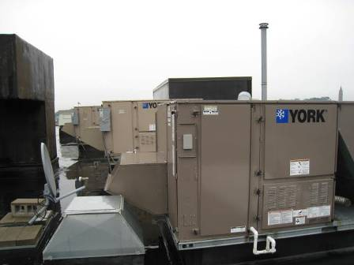

Rooftop Air Handling Units

Picture 2

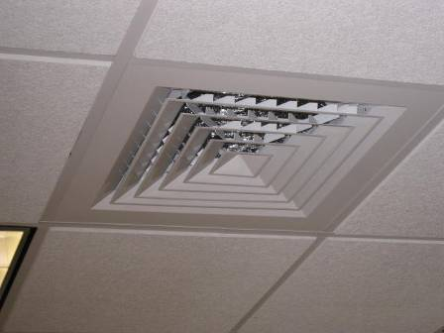

Supply Air Diffusers

Picture 3

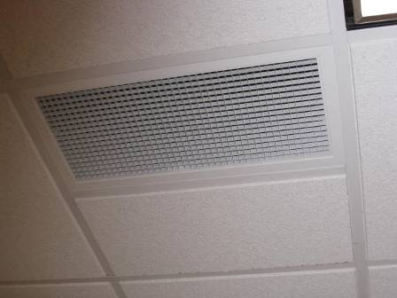

Return Air Grate

Picture 4

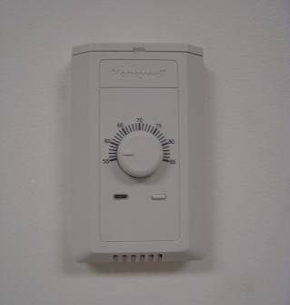

HVAC Thermostat

Picture 5

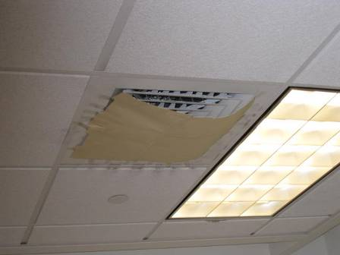

Supply Air Diffuser Covered by Cardboard

Picture 6

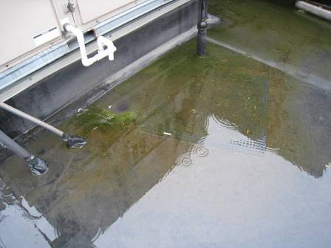

Pooling Water on Roof around Air Handling Units

Picture 7

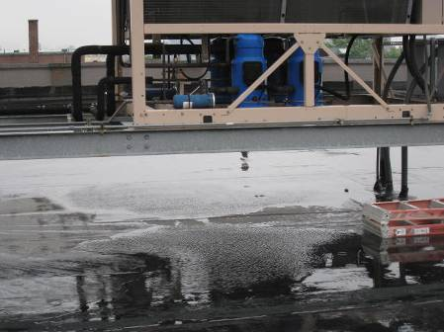

Pooling on the Roof

Picture 8

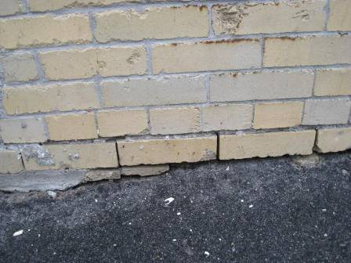

Damaged Exterior Brick and Mortar

Picture 9

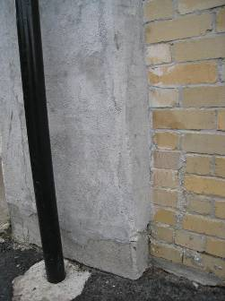

Damaged Exterior Brick and Mortar

Picture 10

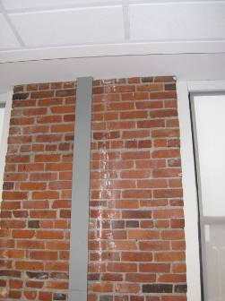

Efflorescence on Interior Brick

Picture 11

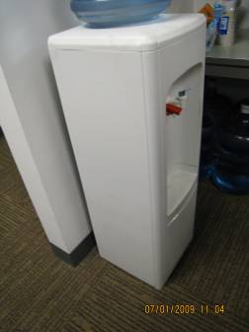

Water Cooler on Carpet

Picture 12

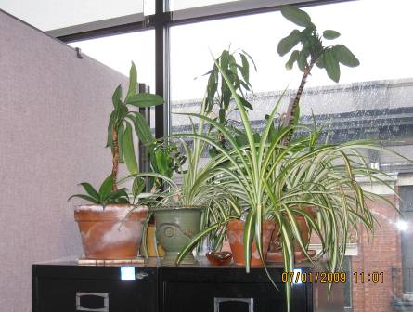

Plants in the Office Space

Picture 13

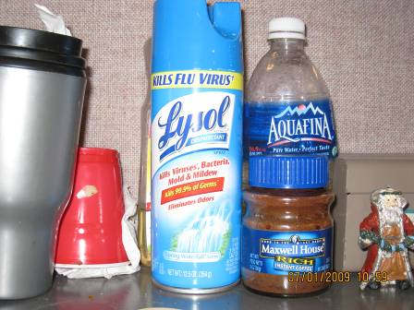

Cleaning Products

Picture 14

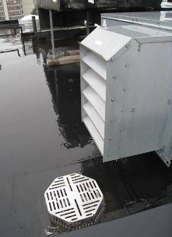

AHU Intake Above Roof Drain

Picture 15

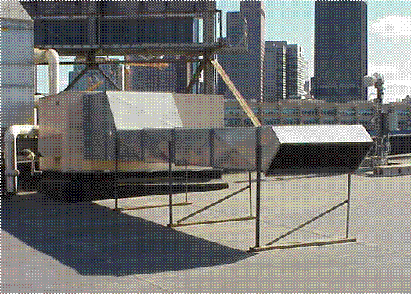

Example of Fresh Air Supply ducted outwards, 239 Causeway St, Boston, MA

Picture 16

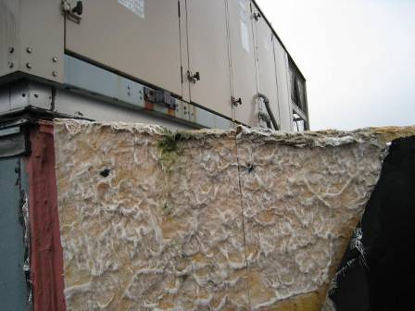

Fiberglass Insulation Damaged and Exposed

Picture 17

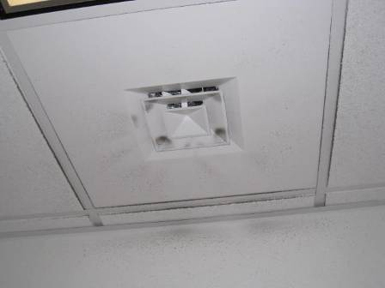

Dirt and Dust on Air Diffuser
Location/ Room | Occupants in Room | Temp (°F) | Relative Humidity (%) | Carbon Dioxide (ppm) | Carbon Monoxide(ppm) | PM2.5 (µg/m³) | Windows Openable | Ventilation |  | Remarks
 |  |  |  |  |  |  |  | Supply | Exhaust | Remarks
outdoors |  | 62 | 100 | 371 | ND | 29 |  |  |  | Raining, Overcast
3rd Floor
3rd floor conference room #2 | 0 | 69 | 54 | 434 | ND | 23 | N | Y | Y | DEM, DO, slight plastic odor, plastic tie in radiator
226/314 | 2 | 68 | 54 | 427 | ND | 23 | N | Y | Y | Plants, PF, Lysol spray
318 | 0 | 69 | 55 | 469 | ND | 21 | N | Y | Y | PF – dusty, DO
251 | 2 | 69 | 55 | 474 | ND | 20 | N | Y | Y | Plants
225 | 0 | 69 | 56 | 538 | ND | 23 | N | Y | Y | Plants, DO
073 | 4 | 70 | 54 | 467 | ND | 22 | N | Y | Y | Lunch odors, bubbler on carpet
323 | 1 | 71 | 51 | 498 | ND | 19 | N | Y | Y | Plants, PF, DO
231 | 0 | 71 | 51 | 472 | ND | 19 | N | Y | Y | PC, plants
252 | 0 | 71 | 52 | 455 | ND | 19 | N | Y  Dust | Y  Items hanging | Plants
Outside Harris’ Office | 0 | 71 | 51 | 458 | ND | 18 | N | Y | Y | WD CT, PC, PF
251 | 0 | 71 | 51 | 431 | ND | 18 | N | Y | Y
Harris’ Office | 1 | 71 | 52 | 485 | ND | 18 | N | Y | Y  In office | DO
Dog Blanket Office | 2 | 71 | 52 | 466 | ND | 18 | N | Y  In office | Y | Plants
Outside bathroom | 0 | 71 | 56 | 626 | ND | 27 | N | N | N | Water fountain over carpet. Vent down hallway
3rd floor bathroom, women’s |  |  |  |  |  | 28 | N | N | Y | 10 WD CT, automatic AD spray
3rd floor elevator hallway | 2 | 72 | 51 | 869 | ND | 27 | N | Y | N
2nd Floor
34 | 10 | 74 | 51 | 682 | ND | 18 | Y | Y | Y | Efflorescence on brick wall, musty odor
212 | 0 | 73 | 51 | 711 | ND | 20 | Y | Y | Y | DO, AD, musty odor
048 | 2 | 73 | 51 | 674 | ND | 18 | Y | N | N | PC
210 | 0 | 73 | 51 | 693 | ND | 18 | Y | Y | Y | DO
22 | 2 | 73 | 50 | 668 | ND | 23 |  |  |  | Bubbler on carpet, plants, CP, PF
Back corner, 2nd floor | 0 | 72 | 51 | 550 | ND | 19 | N | Y | N | items, DO
Telecommunication |  | 71 | 50 | 521 | ND | 18 |  |  |  | DO
30 | 1 | 71 | 51 | 601 | ND | 19 | N | Y | Y | Temperature complaints, plants, items cluttered
6/77 | 2 | 71 | 52 | 533 | ND | 24 | N | Y | Y | items
Cubes outside bathrooms on 2nd floor | 6 | 72 | 52 | 547 | ND | 23 | N | Y | Y | CP
Lunch room | 1 | 73 | 51 | 515 | ND | 25 | N | Y | Y | Microwaves, vending machines, DO, WD CTs
244 | 3 | 73 | 49 | 498 | ND | 23 | N | Y | N | Aqua, odor from PC
42 | 4 | 71 | 49 | 504 | ND | 24 | N | Y | N | PC odors
284 | 2 | 71 | 50 | 492 | ND | 24 | N | Y | Y
290 | 2 | 71 | 51 | 467 | ND | 22 | N | Y | Y
Bobadilla’s Office | 3 | 73 | 51 | 702 | ND | 17 | Y | Y | Y
024 | 1 | 73 | 51 | 634 | ND | 15 | Y | Y  cardboard | Y | DO
058 | 4 | 72 | 51 | 663 | ND | 16 | N | Y | Y
032 | 1 | 72 | 52 | 689 | ND | 16 | N | Y | Y
201 | 0 | 73 | 51 | 656 | ND | 17 | N | Y  outside office | Y | DO, PF
Hearing room | 1 | 72 | 53 | 751 | ND | 18 | N | Y | N
025 | 2 | 71 | 51 | 554 | ND | 18 | N | Y | Y
076 | 1 | 71 | 52 | 534 | ND | 19 | N | Y  In office |  | DO
267 | 1 | 71 | 52 | 498 | ND | 19 | N | Y  In office |  | DO
Outside 266 | 2 | 71 | 52 | 531 | ND | 18 | N | Y | Y
266 | 0 | 72 | 51 | 494 | ND | 19 | N | Y  In office | Y | AD
Outside 268 | 2 | 72 | 51 | 503 | ND | 17 | N | Y | Y | PF
268/081 | 0 | 72 | 51 | 492 | ND | 17 | N | Y  In office | Y | DO
269 | 0 | 72 | 51 | 572 | ND | 18 | N | Y | Y | DO, PF
Outside 271 | 0 | 72 | 51 | 507 | ND | 19 | N | Y | Y
271 | 1 | 72 | 51 | 489 | ND | 19 | N | Y | Y
270 | 3 | 72 | 51 | 528 | ND | 19 | N | Y  In office  cardboard | Y
085 | 4 | 72 | 49 | 486 | ND | 18 | N | Y | Y
070/273 | 0 | 72 | 50 | 478 | ND | 19 | N | Y | Y | DO
080/274 | 1 | 72 | 49 | 479 | ND | 19 | N | Y  In office  cardboard | Y | DO
275 | 0 | 72 | 50 | 465 | ND | 19 | N | Y | Y | PFs, DO
079 | 2 | 71 | 51 | 457 | ND | 19 | N | Y | Y | Plants, PF
Ground Floor
Waiting room | 40 | 74 | 67 | 1201 | ND | 31 | N | Y | Y | smoke doors, only one exhaust vent for entire space
LL conf | 0 | 72 | 64 | 858 | ND | 20 | N | Y | Y | Body odors, smoke odors
LL reception | 4 | 75 | 61 | 1020 | ND | 21 | N | Y | N | Odors usually reported in this area, AHU turned off
LL copy room | 1 | 75 | 58 | 803 | ND | 20 | N | Y | N | PC, DO
Photo ID | 0 | 76 | 56 | 662 | ND | 20 | N | Y  dust | N | DO
Interview #2 | 0 | 76 | 55 | 629 | ND | 23 | N | Y  dust | N | DO
071 | 0 | 75 | 56 | 623 | ND | 21 | N | Y | N | thermostat set to 50
117 | 2 | 75 | 55 | 621 | ND | 24 | N | Y | Y
136 | 2 | 74 | 55 | 557 | ND | 25 | N | Y | Y
125 | 3 | 74 | 56 | 555 | ND | 24 | N | Y | Y
Cubes near stair 1 (basement) | 0 | 73 | 57 | 550 | ND | 22 | N | Y | Y
118/056 | 0 | 73 | 57 | 535 | ND | 24 | N | Y | Y
135 | 0 | 73 | 58 | 583 | ND | 24 | N | Y | Y
039/122 | 0 | 72 | 58 | 554 | ND | 20 | N | Y | Y | PC, bubbler
Family Housing | 7 | 73 | 68 | 971 | ND | 25 | N | Y | Y
Group Rm 1 (006) | 1 | 71 | 65 | 805 | ND | 24 | N | Y | Y
Copy/mail room | 0 | 74 | 57 | 654 | ND | 17 | N | Y | Y  above door | DO
025 | 3 | 75 | 56 | 568 | ND | 19 | N |  |  | PC
031 | 0 | 74 | 54 | 546 | ND | 18 | N | Y  In office |  | DO
Prescott | 1 | 74 | 55 | 568 | ND | 19 | N | Y | N | DO
023 | 0 | 74 | 56 | 555 | ND | 18 | N |  |  | DO, Plants
040 | 0 | 74 | 55 | 563 | ND | 18 | N | Y | Y | PC
033 | 1 | 74 | 56 | 578 | ND | 19 | N | Y | N | DO
104 | 0 | 73 | 56 | 531 | ND | 19 | N | Y  In office
126 | 1 | 73 | 55 | 541 | ND | 18 | N | Y | Y
034 | 0 | 72 | 57 | 534 | ND | 19 | N | Y  In office |  | DO

As moisture penetrates and works its way through building materials (e.g., masonry), water-soluble compounds dissolve, creating a solution. As this solution moves to the surface, the water evaporates, leaving behind white, powdery mineral deposits known as efflorescence.

