INDOOR AIR QUALITY ASSESSMENT

Massachusetts Department of Transitional Assistance
473 Main Street
Fitchburg, Massachusetts

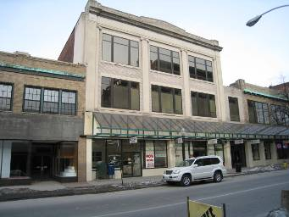

Prepared by:
Massachusetts Department of Public Health
Bureau of Environmental Health
Indoor Air Quality Program
June 2010

Background/Introduction
At the request of Doug Shatkin, Human Resources Director for the Massachusetts Executive Office of Health and Human Services (EOHHS), the Massachusetts Department of Public Health (MDPH), Bureau of Environmental Health (BEH) provided assistance and consultation regarding indoor air quality concerns at the Department of Transitional Assistance (DTA), 473 Main Street, Fitchburg, Massachusetts. The request was prompted by employee concerns related to water damage and migraine headaches. On February 5, 2010, a visit to conduct an assessment was made to the DTA by Michael Feeney, Director of BEH’s Indoor Air Quality (IAQ) Program.
The DTA is located on the second floor of a three-story, brick building built in the early 1900s. The DTA has occupied the space since 1998. Windows are not openable.

Methods
Air tests for carbon monoxide, carbon dioxide, temperature and relative humidity were conducted with the TSI, Q-Trak, IAQ Monitor, Model 8551. BEH staff also performed visual inspection of building materials for water damage and/or microbial growth.

Results
The DTA has as employee population of approximately 40 and can be visited by over 100 people on a daily basis. Tests were taken under normal operating conditions and results appear in Table 1.

Discussion

Ventilation
It can be seen from Table 1 that carbon dioxide levels were above 800 parts per million (ppm) in 9 of 29 areas, indicating adequate air exchange in two-thirds of the areas surveyed. It is important to note that several areas were empty/sparsely populated at the time carbon dioxide measurements were taken, which can greatly reduce carbon dioxide levels. Carbon dioxide levels would be expected to increase with full occupancy. Mechanical ventilation is provided by a large rooftop air handling unit (AHU) (Picture 1). Fresh air is supplied to occupied areas via ducted air diffusers and stale air is removed by a ducted exhaust system.
To maximize air exchange, the MDPH recommends that both supply and exhaust ventilation operate continuously during periods of building occupancy. In order to have proper ventilation with a mechanical supply and exhaust system, the systems must be balanced to provide an adequate amount of fresh air to the interior of a room while removing stale air from the room. It is recommended that HVAC systems be re-balanced every five years to ensure adequate air systems function (SMACNA, 1994). The date of the last balancing of these systems was not available at the time of the assessment.
The Massachusetts Building Code requires a minimum ventilation rate of 20 cubic feet per minute (cfm) per occupant of fresh outside air or have openable windows in each room (SBBRS, 1997; BOCA, 1993). The ventilation must be on at all times that the room is occupied. Providing adequate fresh air ventilation with open windows and maintaining the temperature in the comfort range during the cold weather season is impractical. Mechanical ventilation is usually required to provide adequate fresh air ventilation.
Carbon dioxide is not a problem in and of itself. It is used as an indicator of the adequacy of the fresh air ventilation. As carbon dioxide levels rise, it indicates that the ventilating system is malfunctioning or the design occupancy of the room is being exceeded. When this happens, a buildup of common indoor air pollutants can occur, leading to discomfort or health complaints. The Occupational Safety and Health Administration (OSHA) standard for carbon dioxide is 5,000 parts per million parts of air (ppm). Workers may be exposed to this level for 40 hours/week, based on a time-weighted average (OSHA, 1997).
The MDPH uses a guideline of 800 ppm for publicly occupied buildings. A guideline of 600 ppm or less is preferred in schools due to the fact that the majority of occupants are young and considered to be a more sensitive population in the evaluation of environmental health status. Inadequate ventilation and/or elevated temperatures are major causes of complaints such as respiratory, eye, nose and throat irritation, lethargy and headaches. For more information concerning carbon dioxide, consult Appendix A.
Temperature measurements in the building ranged from 72° F to 76° F, which were within the MDPH recommended comfort range in all areas surveyed (Table 1). The MDPH recommends that indoor air temperatures be maintained in a range of 70º F to 78º F in order to provide for the comfort of building occupants. In many cases concerning indoor air quality, fluctuations of temperature in occupied spaces are typically experienced, even in a building with an adequate fresh air supply.
The relative humidity measured in the building ranged from 10 to 13 percent at the time of the assessment, which was below the MDPH recommended comfort range (Table 1). The MDPH recommends a comfort range of 40 to 60 percent for indoor air relative humidity. The sensation of dryness and irritation is common in a low relative humidity environment. Low relative humidity is a very common problem during the heating season in the northeast part of the United States.

Microbial/Moisture Concerns
Several potential sources of water damage and/or mold growth were observed at the time of the assessment. Standing water was evident on the rubber membrane roof (Pictures 1 through 4). In addition, the rubber membrane had become detached from the roof decking, creating a bulging effect (Picture 4). The freezing and thawing of water during winter months can lead to roof leaks and subsequent water penetration through seams and/or membrane damage into the interior of the building. This phenomenon has occurred in the central area of the office space where chronic water leaks reportedly occur over desks. The location of this chronic water penetration is directly below the AHU on the roof, where frozen puddles of water were observed (Picture 1). The pooling water is likely damaging the roof membrane resulting in water penetration down the ductwork and wetting ceiling tiles.
Upon entering the building, a musty odor was detected. Ceiling tiles in the hallway adjacent to a skylight showed significant water damage and discoloration (Picture 5). Water-damaged ceiling tiles can indicate sources of water penetration and provide a source of mold. Ceiling tiles should be replaced after a water leak is discovered and repaired.
The US Environmental Protection Agency (US EPA) and the American Conference of Governmental Industrial Hygienists (ACGIH) recommend that porous materials (e.g., ceiling tiles, carpeting) be dried with fans and heating within 24 to 48 hours of becoming wet (US EPA, 2001; ACGIH, 1989). If not dried within this time frame, mold growth may occur. Once mold has colonized porous materials they are difficult to clean and should be removed/discarded.

Other IAQ Evaluations
Indoor air quality can be negatively influenced by the presence of respiratory irritants, such as products of combustion. The process of combustion produces a number of pollutants. Common combustion emissions include carbon monoxide, carbon dioxide, water vapor, and smoke (fine airborne particle material). Of these materials, exposure to carbon monoxide can produce immediate, acute health effects upon exposure. To determine whether combustion products were present in the indoor environment, BEH staff obtained measurements for carbon monoxide.

Carbon Monoxide
Carbon monoxide is a by-product of incomplete combustion of organic matter (e.g., gasoline, wood and tobacco). Exposure to carbon monoxide can produce immediate and acute health effects. Several air quality standards have been established to address carbon monoxide and prevent symptoms from exposure. The MDPH established a corrective action level concerning carbon monoxide in ice skating rinks that use fossil-fueled ice resurfacing equipment. If an operator of an indoor ice rink measures a carbon monoxide level over 30 ppm, taken 20 minutes after resurfacing within a rink, that operator must take actions to reduce carbon monoxide levels (MDPH, 1997).
The American Society of Heating Refrigeration and Air-Conditioning Engineers (ASHRAE) has adopted the National Ambient Air Quality Standards (NAAQS) as one set of criteria for assessing indoor air quality and monitoring of fresh air introduced by HVAC systems (ASHRAE, 1989). The NAAQS are standards established by the US EPA to protect the public health from six criteria pollutants, including carbon monoxide and particulate matter (US EPA, 2006). As recommended by ASHRAE, pollutant levels of fresh air introduced to a building should not exceed the NAAQS levels (ASHRAE, 1989). The NAAQS were adopted by reference in the Building Officials & Code Administrators (BOCA) National Mechanical Code of 1993 (BOCA, 1993), which is now an HVAC standard included in the Massachusetts State Building Code (SBBRS, 1997). According to the NAAQS, carbon monoxide levels in outdoor air should not exceed 9 ppm in an eight-hour average (US EPA, 2006).
Carbon monoxide should not be present in a typical, indoor environment. If it is present, indoor carbon monoxide levels should be less than or equal to outdoor levels. Outdoor carbon monoxide concentrations were non-detect (ND) the day of the assessment (Table 1). No measureable levels of carbon monoxide were detected in the building during the assessment (Table 1).

Other Conditions
Over the course of this assessment, building occupants complained about headaches that get worse as the day progresses. This phenomenon appears to be most problematic in the core office space, which does not have any access to natural light. Windows are located at the front and rear of the floor. A possible contributing source for such symptoms may involve the existing fluorescent lighting. Unshielded fluorescent lights can produce glare which can cause eye strain. The light fixtures within the building are bare bulbs without a lens that directs the light downward onto workstations. It is also important to note that older magnetic ballast systems have fluorescent lights that will flicker, which is associated with increased incidence of headaches and eye strain (Newsham et al., 2004).
In addition, if the fluorescent lights tend to produce a light of a single color, eye strain and resulting headaches may occur (Figure 1). BEH staff observed the light system in the ceiling of the building “flickering” during operation and the light bulbs tend to emit green spectrum light. In this situation, the existence of glare and flickering monochromatic light can have a significant influence on the development of eye strain and headaches. At the time of the assessment, both the ceiling mounted fluorescent lights as well as workstation florescent lights had this flickering problem.

Conclusions/Recommendations
In view of the findings at the time of the assessment, the following recommendations are made.
- Contact an HVAC engineering firm to assess whether the current AHU configuration is providing air distribution in an adequate manner, make repairs/adjustments as needed.
- Consider adopting a balancing schedule of every 5 years for all mechanical ventilation systems, as recommended by ventilation industrial standards (SMACNA, 1994).
- Eliminate standing water from the roof. Make roof repairs to eliminate bulging and membrane damage.
- Ensure roof drains are routinely inspected and maintained.
- Ensure leaks are repaired and replace water-damaged ceiling tiles. Examine the area above and around these areas for mold growth. Disinfect areas of water leaks with an appropriate antimicrobial.
- Ensure that all cracked and broken ceiling tiles are replaced and that they fit snugly within their frames.
- In order to reduce glare and the flickering of fluorescent lights, it is recommended that each workstation have a light with an incandescent light bulb. Incandescent lamps do not flicker and also emit chromatic light, which will help to both wash out the fluorescent light flickering and monochromatic light.
- For buildings in New England, periods of low relative humidity during the winter are often unavoidable. Therefore, scrupulous cleaning practices should be adopted to minimize common indoor air contaminants whose irritant effects can be enhanced when the relative humidity is low. To control for dusts, a high efficiency particulate arrestance (HEPA) filter equipped vacuum cleaner in conjunction with wet wiping of all surfaces is recommended. Avoid the use of feather dusters. Drinking water during the day can help ease some symptoms associated with a dry environment (throat and sinus irritations).
- Refer to resource manual and other related indoor air quality documents located on the MDPH’s website for further building-wide evaluations and advice on maintaining public buildings. These documents are available at: http://mass.gov/dph/iaq.

References

ACGIH. 1989. Guidelines for the Assessment of Bioaerosols in the Indoor Environment. American Conference of Governmental Industrial Hygienists, Cincinnati, OH.
ASHRAE. 1989. Ventilation for Acceptable Indoor Air Quality. American Society of Heating, Refrigeration and Air Conditioning Engineers. ANSI/ASHRAE 62-1989.
BOCA. 1993. The BOCA National Mechanical Code/1993. 8th ed. Building Officials and Code Administrators International, Inc., Country Club Hill, IL.

MDPH. 1997. Requirements to Maintain Air Quality in Indoor Skating Rinks (State Sanitary Code, Chapter XI). 105 CMR 675.000. Massachusetts Department of Public Health, Boston, MA.
Newsham, G.R.; Veitch, J.A.; Reinhart, C.F. and Sander, D.M. 2004. Lighting Design for Open Offices. NRC CNRC Construction Technology Update.. No. 62, Oct. 2004. http://www.nrc-cnrc.gc.ca/eng/ibp/irc/ctus/ctus-n62.html

OSHA. 1997. Limits for Air Contaminants. Occupational Safety and Health Administration. Code of Federal Regulations. 29 C.F.R 1910.1000 Table Z-1-A.

SBBRS. 1997. Mechanical Ventilation. State Board of Building Regulations and Standards. Code of Massachusetts Regulations. 780 CMR 1209.0.
SMACNA. 1994. HVAC Systems Commissioning Manual. 1st ed. Sheet Metal and Air Conditioning Contractors’ National Association, Inc., Chantilly, VA.

US EPA. 2001. Mold Remediation in Schools and Commercial Buildings. US Environmental Protection Agency, Office of Air and Radiation, Indoor Environments Division, Washington, D.C. EPA 402-K-01-001. March 2001.
US EPA. 2006. National Ambient Air Quality Standards (NAAQS). US Environmental Protection Agency, Office of Air Quality Planning and Standards, Washington, DC. http://www.epa.gov/air/criteria.html.
Figure 1
Typical Florescent Lighting Schematic for Office Use

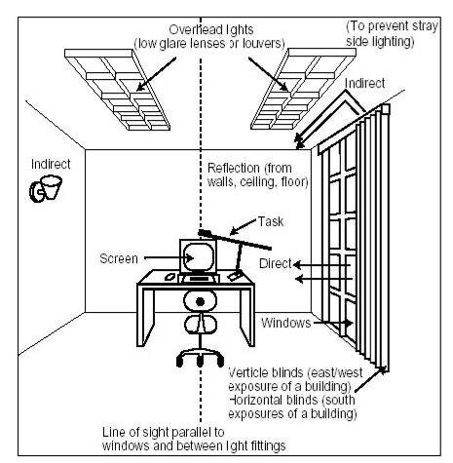
OSHA. 1997 Working Safely with Video Display Terminals.
US Dept of Labor, Washington DC. OSHA 3092
Picture 1

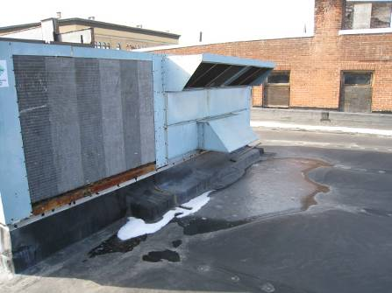

Rooftop AHU, Note Standing Water in Close Proximity to Unit

Picture 2

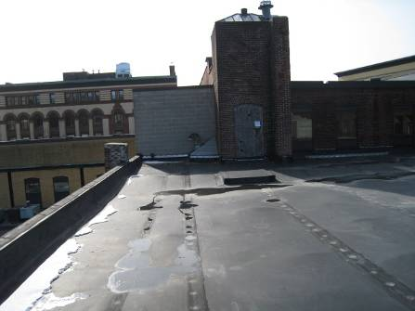

Standing Water on Roof

Picture 3

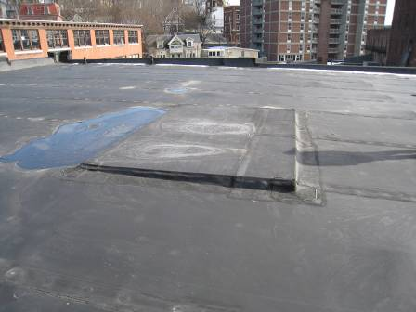

Standing Water on Roof

Picture 4

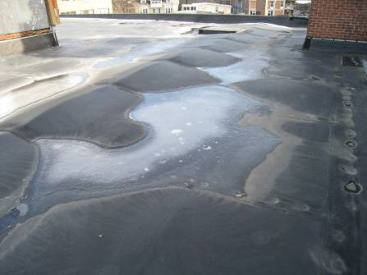

Standing Water and Bulging Roof Membrane

Picture 5

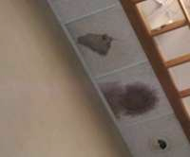

Water-Damaged Ceiling Tile and Wall
Location | Carbon  Dioxide  (*ppm) | Carbon  Monoxide  (*ppm) | Temp  °(F) | Relative  Humidity  (%) | Occupants  in Room | Windows  Openable | Ventilation |  | Remarks
 |  |  |  |  |  |  | Supply | Exhaust | Remarks
Outdoors Background) | 356 | ND | 36 | 31
284 | 783 | ND | 75 | 12 | 1 | No | Yes | Yes
218 | 734 | ND | 74 | 11 | 0 | No | Yes | Yes
260 | 725 | ND | 74 | 11 | 1 | No | Yes | Yes
219 | 688 | ND | 76 | 11 | 0 | No | Yes | Yes
220 | 798 | ND | 75 | 10 | 1 | No | Yes | Yes
294 | 754 | ND | 75 | 10 | 1 | No | Yes | Yes
208 | 770 | ND | 74 | 12 | 1 | No | Yes | Yes
Interview room | 788 | ND | 75 | 11 | 1 | No | Yes | Yes | Door open
297 | 796 | ND | 73 | 13 | 1 | No | Yes | Yes
298 | 778 | ND | 73 | 13 | 1 | No | Yes | Yes
202 | 786 | ND | 74 | 12 | 2 | No | Yes | Yes
204 | 715 | ND | 75 | 11 | 1 | No | Yes | Yes
205 | 682 | ND | 74 | 10 | 0 | No | Yes | Yes
Reception | 740 | ND | 74 | 11 | 2 | No | Yes | Yes | Door open
Waiting room | 863 | ND | 75 | 13 | 7 | No | Yes | Yes
292 | 734 | ND | 74 | 11 | 1 | No | Yes | Yes
216 | 744 | ND | 72 | 12 | 0 | No | Yes | Yes
266 | 812 | ND | 72 | 12 | 2 | No | Yes | Yes
265 | 786 | ND | 73 | 12 | 1 | No | Yes | Yes | Door open
268 | 822 | ND | 73 | 12 | 1 | No | Yes | Yes | Door open
269 | 813 | ND | 73 | 12 | 1 | No | Yes | Yes
274 | 821 | ND | 73 | 12 | 1 | No | Yes | Yes
272 | 826 | ND | 73 | 13 | 1 | No | Yes | Yes
273 | 807 | ND | 73 | 12 | 0 | No | Yes | Yes
277 | 779 | ND | 73 | 12 | 0 | No | Yes | Yes
Form room | 717 | ND | 73 | 11 | 0 | No | Yes | Yes | Door open
288 | 782 | ND | 73 | 12 | 2 | No | Yes | Yes
286 | 879 | ND | 74 | 13 | 2 | No | Yes | Yes
289 | 921 | ND | 73 | 12 | 2 | No | Yes | Yes

