**POST-OCCUPANCY**

**INDOOR AIR QUALITY ASSESSMENT**

**Department of Transitional Assistance**

**1567 N. Main Street**

**Fall River, MA**

Exterior view of 1567 N. Main Street
Fall River, MA


Prepared by:

Massachusetts Department of Public Health

Bureau of Climate and Environmental Health

Division of Environmental Health and Standards

June 2025

# BACKGROUND

|  |  |
| --- | --- |
| Building: | Department of Transitional Assistance (DTA) |
| Address: | 1567 N. Main Street, Fall River, MA |
| Assessment Requested by: | William McGowan, Project Manager, Division of Capital Asset Management & Maintenance (DCAMM), Office of Leasing and State Office Planning |
| Reason for Request: | Post-occupancy indoor air quality (IAQ) assessment of leased space |
| Date of Assessment: | May 29, 2025 |
| **Massachusetts Department of Public Health/Bureau of Climate and Environmental Health/Division of Environmental Health Regulations and Standards (MDPH/BCEH/EHRS) Staff Conducting Assessment:** | Cory Holmes, Senior Advisor for Indoor Air Quality Inspections, Audits, Outreach, and Training |
| Building Description: | The DTA occupies the ground floor of a two-story brick office building that formerly served as a mill. The renovated space has new carpet tiles, painted gypsum wallboard, and suspended ceiling tiles. |
| Windows: | Windows in the space are openable |

# METHODS

Please refer to the IAQ Manual for methods, sampling procedures, and interpretation of results (MDPH, 2015).

# RESULTS AND DISCUSSION

The following is a summary of indoor air testing results (Table 1).

* ***Carbon dioxide*** measurements were above the MDPH guideline of 800 parts per million (ppm) in several areas assessed (Table 1), which indicates that additional fresh air would be beneficial for the occupancy.
* ***Temperature*** was within the recommended range of 70°F to 78°F in all areas tested.
* ***Relative humidity*** was within the recommended range of 40% to 60% in all areas tested.
* ***Carbon monoxide*** levels were non-detectable (ND) in all areas tested.
* ***Fine particulate matter (PM2.5)*** concentrations were below the National Ambient Air Quality Standard (NAAQS) level of 35 μg/m3 in all areas tested.
* ***Total Volatile Organic Compounds (TVOC)*** were ND in all areas tested.

## Ventilation

A heating, ventilation, and air conditioning (HVAC) system has several functions. First, it provides heating and, if equipped, cooling. Second, it is a source of fresh air. Finally, an HVAC system will dilute and remove normally occurring indoor environmental pollutants by not only introducing fresh air, but also filtering the airstream and ejecting stale air to the outdoors via exhaust ventilation. Even if an HVAC system is operating as designed, point sources of respiratory irritation may exist and affect symptoms in sensitive individuals.

The HVAC system uses air handling units (AHU) on the roof. Fresh air is drawn into the units, conditioned, and delivered to offices and other areas through ceiling-mounted supply vents (Picture 1). Air is drawn through passive exhaust grills into the ceiling plenum (Picture 1) and returned to the AHUs.

The MDPH IAQ program recommends that filters be changed 2-4 times a year (or in accordance with the manufactures recommendations) and be at least minimum efficiency reporting value (MERV) 8, or higher if the equipment can handle them without a degradation in airflow, as these are adequate to filter out pollen, mold, and similar particulates (ASHRAE, 2012).

## Microbial/Moisture Concerns

Visible mold growth was observed on the refrigerator/freezer gaskets in Kitchen 124 (Pictures 2 and 3). Congealed food residue was also observed in a storage tray at the bottom of the fridge (Picture 4).

## Other IAQ Concerns

Some areas in this office have carpet squares. Carpeting should be vacuumed regularly with a high efficiency particulate arrestance (HEPA) filter equipped vacuum cleaner and cleaned annually (or semi-annually in soiled/high traffic areas) in accordance with Institute of Inspection, Cleaning and Restoration Certification (IICRC) recommendations (IICRC, 2012).

In several areas, efflorescence on interior brickwork was noted (Picture 5; Table 1), which is made up of minerals from the brick and mortar that have dissolved and then deposited on the interior surface of the wall. While efflorescence is not mold, it indicates current/previous water penetration and should be monitored and cleaned periodically. It is also important to note that no elevated levels of PM2.5 were measured in the breathing zone, indicating that this debris consists of larger particles that are not suspended in the air (i.e., an inhalation exposure).

Finally, the exhaust vent in the all-gender restroom off the lobby was not drawing air. The men’s restroom adjacent to it could not be evaluated because it was occupied at the time of assessment. Restroom exhaust ventilation is important to remove odors and excess moisture.

# RECOMMENDATIONS

The following are recommendations made to improve IAQ:

1. Operate supply and exhaust ventilation in all areas during occupied periods.
2. Increase fresh air supply to areas above the MDPH recommended guideline of 800 ppm carbon dioxide.
3. Ensure filters are replaced on HVAC units at least twice a year. Use filters with a minimum efficiency rating value (MERV) of 8 or better.
4. It is recommended that HVAC systems be re-balanced every five years to ensure adequate air systems function (SMACNA, 1994).
5. Clean efflorescence from walls, floors and flat surfaces as needed with a HEPA-equipped vacuum cleaner or wet wiping method.
6. Inspect and clean refrigerator/freezer gaskets periodically, if they cannot be adequately cleaned, replace. Clean and disinfect dirty tray at bottom of refrigerator.
7. Clean carpeting annually (or semi-annually in soiled/high traffic areas) in accordance with IICRC recommendations (IICRC, 2012).
8. Inspect restroom exhaust vents for proper function, make repairs as necessary.
9. Refer to resource manual and other related IAQ documents located on the MDPH’s website for further building-wide evaluations and advice on maintaining public buildings. These documents are available at: <http://mass.gov/dph/iaq>.

# REFERENCES

ASHRAE. 2012. American Society of Heating, Refrigeration and Air Conditioning Engineers (ASHRAE) Standard 52.2-2012 – Method of Testing General Ventilation Air-Cleaning Devices for Removal Efficiency by Particle Size (ANSI Approved).

ICRC. 2012. Institute of Inspection, Cleaning and Restoration Certification. Carpet Cleaning: FAQ.

MDPH. 2015. Massachusetts Department of Public Health. Indoor Air Quality Manual: Chapters I-III. Available at: <https://www.mass.gov/lists/indoor-air-quality-manual-and-appendices>.

SMACNA. 1994. HVAC Systems Commissioning Manual. 1st ed. Sheet Metal and Air Conditioning Contractors’ National Association, Inc., Chantilly, VA.

**Picture 1**

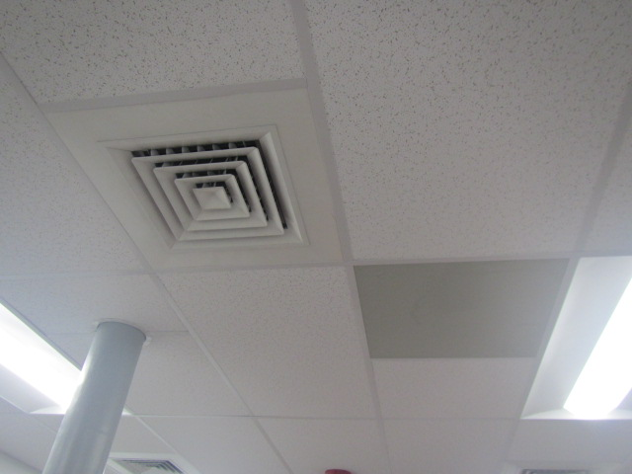

**Supply diffuser on left, return vent on right**

**Picture 2**

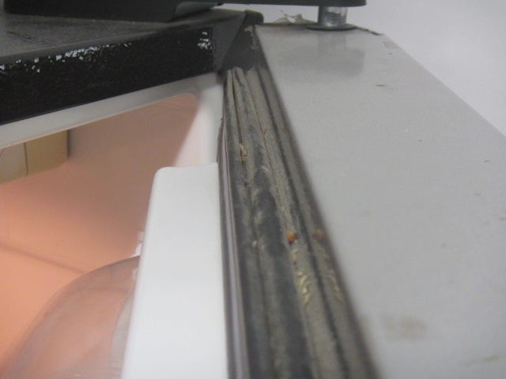

**Mold growth, dust and debris on freezer gasket**

**Picture 3**

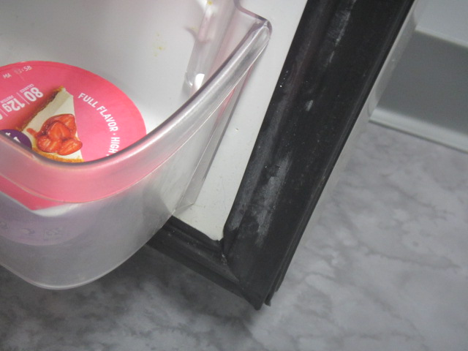

**Mold growth, dust and debris on refrigerator gasket**

**Picture 4**

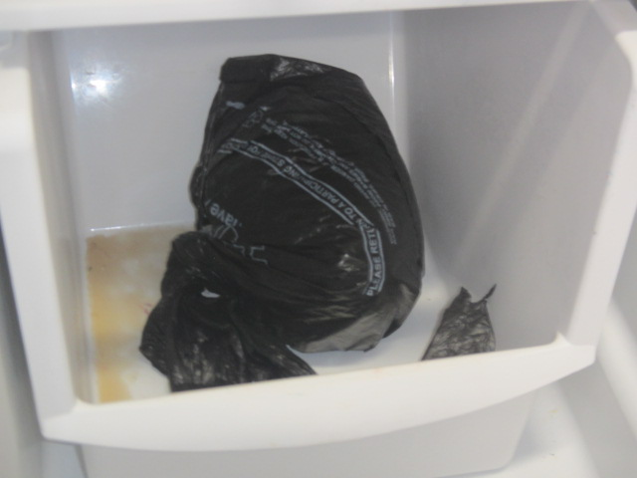

**Congealed food residue in storage tray at bottom of refrigerator**

**Picture 5**

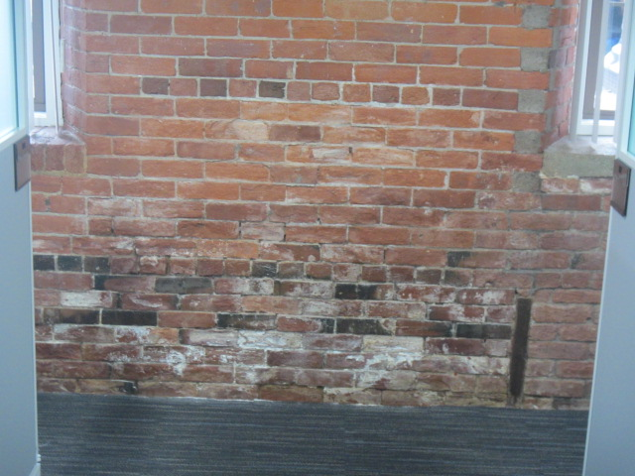

**Efflorescence (mineral deposits) on interior brickwork**

| **Location** | **Carbon**  **Dioxide**  **(ppm)** | **Carbon Monoxide**  **(ppm)** | **Temp**  **(°F)** | **Relative**  **Humidity**  **(%)** | **PM2.5**  **(µg/m3)** | **TVOC**  **(ppm)** | **Occupants**  **in Room** | **Windows**  **Openable** | **Ventilation** | | **Remarks** |
| --- | --- | --- | --- | --- | --- | --- | --- | --- | --- | --- | --- |
| **Supply** | **Exhaust** |
| Background | 419 | ND | 67 | 100 | ND | ND |  |  |  |  | Wet, rainy, moderate traffic in downtown area |
| Lobby | 586 | ND | 73 | 58 | 1 | ND | 5 | Y | Y | Y |  |
| All Gender Restroom |  |  |  |  |  |  |  | N | N | Y | No draw from exhaust vent |
| Reception | 679 | ND | 73 | 54 | 1 | ND | 2 | N | Y | Y |  |
| 103-105 | 734 | ND | 72 | 55 | ND | ND | 1 | Y | Y | Y |  |
| 106-111 | 729 | ND | 72 | 55 | ND | ND | 2 | Y | Y | Y | Efflorescence on brick |
| 112-115 | 753 | ND | 73 | 55 | ND | ND | 2 | Y | Y | Y | Efflorescence on brick |
| Men’s Restroom |  |  |  |  |  |  |  | N | Y | Y |  |
| Women’s Restroom |  |  |  |  |  |  |  | N | Y | Y |  |
| 119-122 | 815 | ND | 72 | 54 | ND | ND | 1 | N | Y | Y |  |
| 124 Kitchen | 688 | ND | 73 | 54 | ND | ND | 0 | N | Y | Y | Mold/debris on freezer/fridge gasket, congealed food liquid bottom of fridge |
| Orientation Room | 778 | ND | 73 | 59 | 1 | ND | 0 | N | Y | Y |  |
| 125 | 848 | ND | 73 | 53 | 2 | ND | 0 | N | Y | Y |  |
| 126 | 662 | ND | 73 | 52 | 1 | ND | 0 | N | Y | Y |  |
| 128 | 870 | ND | 72 | 55 | ND | ND | 0 | N | Y | Y |  |
| 129 | 711 | ND | 72 | 53 | ND | ND | 0 | N | Y | Y |  |
| 130-136 | 868 | ND | 73 | 52 | 1 | ND | 3 | N | Y | Y |  |
| 132-138 | 834 | ND | 73 | 53 | 1 | ND | 1 | N | Y | Y |  |
| 140 | 916 | ND | 73 | 54 | ND | ND | 0 | N | Y | N |  |
| 141 | 790 | ND | 73 | 54 | 2 | ND | 2 | N | Y | N |  |
| 143 Breakroom | 655 | ND | 73 | 54 | 1 | ND | 0 | N | Y | N |  |
| 144 Restroom |  |  |  |  |  |  |  | N | Y | Y |  |
| 147 | 610 | ND | 71 | 59 | 2 | ND | 1 | Y | Y | Y |  |
| 149 | 701 | ND | 73 | 53 | 2 | ND | 0 | N | Y | N |  |
| 150 | 608 | ND | 72 | 55 | 1 | ND | 0 | N | Y | N |  |
| 151 | 585 | ND | 72 | 56 | 1 | ND | 0 | N | Y | Y |  |
| 153 | 848 | ND | 73 | 57 | 1 | ND | 1 | N | Y | Y |  |
| 155 | 565 | ND | 72 | 56 | 1 | ND | 0 | N | Y | N |  |
| Snap Room | 524 | ND | 73 | 57 | ND | ND | 0 | N | Y | Y |  |
| 158 | 514 | ND | 73 | 58 | ND | ND | 0 | N | Y | N |  |
| 159 | 506 | ND | 72 | 58 | ND | ND | 0 | N | Y | N |  |
| 160 | 520 | ND | 73 | 58 | ND | ND | 1 | N | Y | N |  |
| 162 | 504 | ND | 73 | 58 | ND | ND | 0 | Y | Y | N | Efflorescence on brick |
| 165 | 514 | ND | 73 | 57 | ND | ND | 1 | N | Y | N |  |
| 167 | 512 | ND | 73 | 57 | ND | ND | 0 | Y | Y | N | Efflorescence on brick |