INDOOR AIR QUALITY
POST-OCCUPANCY ASSESSMENT

Department of Transitional Assistance
245 Commercial Street
Malden, MA

Prepared by:
Massachusetts Department of Public Health
Bureau of Environmental Health
Indoor Air Quality Program
May 2014

Background/Introduction
At the request of David Devine, Project Manager, Office of Leasing, Division of Capital Asset Management and Maintenance (DCAMM), the Massachusetts Department of Public Health (MDPH), Bureau of Environmental Health (BEH) conducted post-occupancy air testing at the Department of Transitional Assistance (DTA), 245 Commercial Street, Malden, MA. The purpose of the post-occupancy testing was to assess the indoor air quality (IAQ) of newly occupied space leased by Massachusetts state agencies. On April 24, 2014, a visit to the DTA was made by Ruth Alfasso, Environmental Engineer/Inspector and Jason Dustin Environmental Analyst/Inspector within BEH’s IAQ Program.
The building is a two-story brick building constructed in 1975. At the time of the visit, the DTA was the sole tenant of the building. The first floor contains offices, open work areas, half-wall divided offices, conference rooms, file rooms, kitchen area, waiting area and small hearing rooms; a smaller footprint second floor contains a rarely-used large conference room and storage space. According to the property manager, Marc Gattineri, the building was previously used as a warehouse. The space has been completely renovated and DTA staff have occupied the building since March 2014. The space has suspended ceiling tiles apart from two skylights. The majority of areas have carpet tiles. Windows are not openable.

Methods
Air tests for carbon dioxide, carbon monoxide, temperature and relative humidity were taken with the TSI, Q-Trak, IAQ Monitor 7565. Air tests for airborne particle matter with a diameter less than 2.5 micrometers were taken with the TSI, DUSTTRAK™ Aerosol Monitor Model 8520. Screening for volatile organic compounds was conducted using a RAE Systems Mini-RAE 2000 Photo Ionization Detector. BEH/IAQ staff also performed visual inspection of building materials for water damage and/or microbial growth.

Results
The DTA has an employee population of approximately 35, and up to 80 people may visit the building on a daily basis. Tests were taken during normal operations and test results appear in Table 1.

Discussion

Ventilation
It can be seen from Table 1 that carbon dioxide levels were above 800 parts per million (ppm) in 36 of 39 areas tested, indicating a lack of air exchange at the time of assessment. The heating, ventilation and air-conditioning system (HVAC) consists of air handling units (AHUs; Picture 1) located on the roof, which draw in outside air and heat/cool it. Fresh air is delivered to spaces via ceiling-mounted supply vents. Return air is drawn into an above-ceiling plenum via ceiling grates (Picture 2) and ducted back to AHUs. Supplemental heating in some areas is provided by electric heating units. Supplemental cooling in some areas, including the data room, is provided by wall-mounted ductless air-conditioning (AC) units. The AHUs and other units are new to the building and were installed as part of the DTA renovations.
The HVAC system is controlled by digital thermostats. Thermostats examined had a fan switch with two settings, on and auto. When the fan is set to “on”, the system provides a continuous source of air circulation and filtration. The “auto” setting on the thermostat activates the HVAC system at a pre-set temperature. Once the pre-set temperature is reached, the HVAC system is deactivated. Therefore, no mechanical ventilation is provided until the thermostat re-activates the system. At the time of assessment, most thermostat fan settings were in the “auto” position (Picture 3). The MDPH typically recommends that thermostats be set to the fan “on” setting during occupied hours to provide continuous air circulation. In addition, if thermostats are shut off, no fresh air would be supplied to these areas while in this setting. This can lead to IAQ/comfort complaints due to lack of air exchange, particularly since windows are not openable and the HVAC system is the sole source of fresh, outside air.
To maximize air exchange, the MDPH recommends that both supply and exhaust ventilation operate continuously during periods of occupancy. In order to have proper ventilation with a mechanical supply and exhaust system, the systems must be balanced to provide an adequate amount of fresh air to the interior of a room while removing stale air from the room. It is recommended that HVAC systems be re-balanced every five years to ensure adequate air systems function (SMACNA, 1994). Reportedly, the new HVAC system was balanced prior to DTA occupancy.
Minimum design ventilation rates are mandated by the Massachusetts State Building Code (MSBC). Until 2011, the minimum ventilation rate in Massachusetts was higher for both occupied office spaces and general classrooms, with similar requirements for other occupied spaces (BOCA, 1993). The current version of the MSBC, promulgated in 2011 by the State Board of Building Regulations and Standards (SBBRS), adopted the 2009 International Mechanical Code (IMC) to set minimum ventilation rates. Please note that the MSBC is a minimum standard that is not health-based. At lower rates of cubic feet per minute (cfm) per occupant of fresh air, carbon dioxide levels would be expected to rise significantly. A ventilation rate of 20 cfm per occupant of fresh air provides optimal air exchange resulting in carbon dioxide levels at or below 800 ppm in the indoor environment in each area measured. MDPH recommends that carbon dioxide levels be maintained at 800 ppm or below. This is because most environmental and occupational health scientists involved with research on IAQ and health effects have documented significant increases in indoor air quality complaints and/or health effects when carbon dioxide levels rise above the MDPH guidelines of 800 ppm for schools, office buildings and other occupied spaces (Sundell et al., 2011). The ventilation must be on at all times that the room is occupied. Providing adequate fresh air ventilation with open windows and maintaining the temperature in the comfort range during the cold weather season is impractical. Mechanical ventilation is usually required to provide adequate fresh air ventilation.
Carbon dioxide is not a problem in and of itself. It is used as an indicator of the adequacy of the fresh air ventilation. As carbon dioxide levels rise, it indicates that the ventilating system is malfunctioning or the design occupancy of the room is being exceeded. When this happens, a buildup of common indoor air pollutants can occur, leading to discomfort or health complaints. The Occupational Safety and Health Administration (OSHA) standard for carbon dioxide is 5,000 parts per million parts of air (ppm). Workers may be exposed to this level for 40 hours/week, based on a time-weighted average (OSHA, 1997).
The MDPH uses a guideline of 800 ppm for publicly occupied buildings. A guideline of 600 ppm or less is preferred in schools due to the fact that the majority of occupants are young and considered to be a more sensitive population in the evaluation of environmental health status. Inadequate ventilation and/or elevated temperatures are major causes of complaints such as respiratory, eye, nose and throat irritation, lethargy and headaches. For more information concerning carbon dioxide, please see Appendix A.
Temperature readings during the assessment ranged from 69° F to 76° F, which were within or close to the MDPH recommended comfort range (Table 1). The MDPH recommends that indoor air temperatures be maintained in a range of 70° F to 78° F in order to provide for the comfort of building occupants. In many cases concerning indoor air quality, fluctuations of temperature in occupied spaces are typically experienced, even in a building with an adequate fresh air supply.
The relative humidity at the time of the assessment ranged from 22 to 31 percent (Table 1), which was below the MDPH recommended comfort range. The MDPH recommends a comfort range of 40 to 60 percent for indoor air relative humidity. The sensation of dryness and irritation is common in a low relative humidity environment. Low relative humidity is a very common problem during the heating season in the northeast part of the United States.

Microbial/Moisture Concerns
No evidence of leaks and/or water-damaged building materials was observed during the assessment. The building renovation included the installation of a new rubber membrane roof (Picture 4).
Plants were observed in some areas (Table 1). Plants should be properly maintained and equipped with drip pans. Plants should be located away from ventilation sources to prevent aerosolization of dirt, pollen or mold. Plants should not be placed on carpets or other porous materials (Picture 5), since water damage to porous materials may lead to microbial growth.
BEH/IAQ staff observed a water cooler and water fountains on/over carpeted surfaces (Pictures 6 and 7). Spills or leaks from this equipment can moisten carpet and lead to microbial growth and degradation of the carpet. MDPH typically recommends placing rubber mats or non-porous flooring (e.g., vinyl tile) beneath this equipment to protect the porous carpet from leaks and spills.

Other Indoor Air Evaluations
Indoor air quality can be negatively influenced by the presence of respiratory irritants, such as products of combustion. The process of combustion produces a number of pollutants. Common combustion emissions include carbon monoxide, carbon dioxide, water vapor, and smoke (fine airborne particle material). Of these materials, exposure to carbon monoxide and particulate matter with a diameter of 2.5 micrometers (μm) or less (PM2.5) can produce immediate, acute health effects upon exposure. To determine whether combustion products were present in the indoor environment, BEH/IAQ staff obtained measurements for carbon monoxide and PM2.5.

Carbon Monoxide
Carbon monoxide is a by-product of incomplete combustion of organic matter (e.g., gasoline, wood and tobacco). Exposure to carbon monoxide can produce immediate and acute health affects. Several air quality standards have been established to address carbon monoxide and prevent symptoms from exposure to these substances. The MDPH established a corrective action level concerning carbon monoxide in ice skating rinks that use fossil-fueled ice resurfacing equipment. If an operator of an indoor ice rink measures a carbon monoxide level over 30 ppm, taken 20 minutes after resurfacing within a rink, that operator must take actions to reduce carbon monoxide levels (MDPH, 1997).
The American Society of Heating Refrigeration and Air Conditioning Engineers (ASHRAE) has adopted the National Ambient Air Quality Standards (NAAQS) as one set of criteria for assessing indoor air quality and monitoring of fresh air introduced by HVAC systems (ASHRAE, 1989). The NAAQS are standards established by the US EPA to protect the public health from six criteria pollutants, including carbon monoxide and particulate matter (US EPA, 2006). As recommended by ASHRAE, pollutant levels of fresh air introduced to a building should not exceed the NAAQS levels (ASHRAE, 1989). The NAAQS were adopted by reference in the Building Officials & Code Administrators (BOCA) National Mechanical Code of 1993 (BOCA, 1993), which is now an HVAC standard included in the Massachusetts State Building Code (SBBRS, 2011). According to the NAAQS, carbon monoxide levels in outdoor air should not exceed 9 ppm in an eight-hour average (US EPA, 2006).
Carbon monoxide should not be present in a typical, indoor environment. If it is present, indoor carbon monoxide levels should be less than or equal to outdoor levels. Outdoor carbon monoxide concentrations were non-detect (ND) the day of assessment (Table 1). No measureable levels of carbon monoxide were detected in the building during the assessment (Table 1).

Particulate Matter
The US EPA has established NAAQS limits for exposure to particulate matter. Particulate matter includes airborne solids, which can result in eye and respiratory irritation if exposure occurs. The NAAQS originally established exposure limits to particulate matter with a diameter of 10 μm or less (PM10). According to the NAAQS, PM10 levels should not exceed 150 micrograms per cubic meter (μg/m³) in a 24-hour average (US EPA, 2006). These standards were adopted by both ASHRAE and BOCA. Since the issuance of the ASHRAE standard and BOCA Code, US EPA established a more protective standard for fine airborne particles. This more stringent PM2.5 standard requires outdoor air particle levels be maintained below 35 μg/m³ over a 24-hour average (US EPA, 2006). Although both the ASHRAE standard and BOCA Code adopted the PM10 standard for evaluating air quality, MDPH uses the more protective PM2.5 standard for evaluating airborne particulate matter concentrations in the indoor environment.
Outdoor PM2.5 was measured at 2 μg/m³ (Table 1) on the day of the visit. PM2.5 levels measured indoors ranged from ND to 4 μg/m³ (Table 1), which were below the NAAQS PM2.5 level of 35 μg/m³. Frequently, indoor air levels of particulates (including PM2.5) can be at higher levels than those measured outdoors. A number of mechanical devices and/or activities that occur in buildings can generate particulate matter during normal operations. Sources of indoor airborne particulates may include but are not limited to particles generated during the operation of fan belts in the HVAC system, use of stoves and/or microwave ovens in kitchen areas; use of photocopiers, fax machines and computer printing devices; operation of an ordinary vacuum cleaner and heavy foot traffic indoors.

Volatile Organic Compounds
Indoor air concentrations can be greatly impacted by the use of products containing volatile organic compounds (VOCs). VOCs are carbon-containing substances that have the ability to evaporate at room temperature. Total volatile organic compounds (TVOCs) can result in eye and respiratory irritation if exposure occurs. For example, chemicals evaporating from a paint can stored at room temperature would most likely contain VOCs. In order to determine if VOCs were present, testing for TVOCs was conducted. Outdoor TVOC concentrations were ND on the day of assessment (Table 1). No measureable levels of TVOCs were detected in the building during the assessment (Table 1).
There are several photocopiers in the building. Photocopiers can be sources of pollutants such as VOCs, ozone, heat and odors, particularly if the equipment is older and in frequent use. Both VOCs and ozone are respiratory irritants (Schmidt Etkin, 1992). Photocopiers should be kept in well ventilated rooms, and should be located near windows or exhaust vents.
In a few locations, odors typical of new furnishings were detected. New furnishing odors will dissipate over time, in addition continued ventilation of the office space will reduce these odors.
Hand sanitizer was found in some offices and common areas (Table 1). Hand sanitizers may contain ethyl alcohol and/or isopropyl alcohol, which are highly volatile and may be irritating to the eyes and nose. Sanitizing products may also contain fragrances to which some people may be sensitive.
Air fresheners and deodorizing materials were observed in some areas (Table 1). Air deodorizers contain chemicals that can be irritating to the eyes, nose and throat of sensitive individuals. Many air fresheners contain 1,4-dichlorobenzene, a VOC which may cause reductions in lung function (NIH, 2006). Furthermore, deodorizing agents do not remove materials causing odors, but rather mask odors that may be present in the area.
One room contained a dry erase board and related materials (Picture 8; Table 1). Materials such as dry erase markers and dry erase board cleaners may contain VOCs, such as methyl isobutyl ketone, n-butyl acetate and butyl-cellusolve (Sanford, 1999), which can be irritating to the eyes, nose and throat.

Other Conditions
Other conditions that can affect indoor air quality were observed during the assessment. Most areas in the DTA space are covered with new carpet tiles. The Institute of Inspection, Cleaning and Restoration Certification (IICRC), recommends that carpeting be cleaned annually (or semi-annually in soiled high traffic areas) (IICRC, 2005).
In some areas, accumulation of items, including papers, boxes and personal items were found stored on desks, tables and counters. Decorative items, including plush and organic items were also observed. Large numbers of items provide a source for dusts to accumulate. These items make it difficult for custodial staff to clean. Items should be relocated and/or cleaned periodically to avoid excessive dust build up.

Conclusions/Recommendations
In view of the findings at the time of the visit, the following recommendations are made:
- The fan setting on all thermostats should remain in the “ON” setting during business hours to provide adequate ventilation throughout the building. Ensure fresh air louvers on AHUs are working properly and adjust to increase outside air intake as needed.
- Operate and maintain HVAC systems in accordance with manufacturer’s recommendations, including regular filter changes/cleaning of all AHUs and ACs.
- Consider adopting a balancing schedule of every 5 years for all mechanical ventilation systems, as recommended by ventilation industrial standards (SMACNA, 1994).
- For buildings in New England, periods of low relative humidity during the winter are often unavoidable. Therefore, scrupulous cleaning practices should be adopted to minimize common indoor air contaminants whose irritant effects can be enhanced when the relative humidity is low. To control for dusts, a high efficiency particulate arrestance (HEPA) filter equipped vacuum cleaner in conjunction with wet wiping of all surfaces is recommended. Avoid the use of feather dusters. Drinking water during the day can help ease some symptoms associated with a dry environment (throat and sinus irritations).
- Ensure plants have drip pans and avoid over-watering. Examine drip pans periodically for mold growth. Disinfect with an appropriate antimicrobial where necessary.
- Place protective rubber mats beneath water coolers and water fountains or use non-porous flooring to prevent damage to carpeting.
- Avoid the use of scented products such as air deodorizers and fresheners.
- Clean dry-erase marker trays of accumulated dust and debris regularly using a damp cloth.
- Consider reducing, consolidating or relocating items and papers to allow for more thorough cleaning.
- Clean carpeting annually or semi-annually in soiled high traffic areas as per the recommendations of the Institute of Inspection, Cleaning and Restoration Certification (IICRC, 2005). Copies of the IICRC fact sheet can be downloaded at: http://1.cleancareseminars.net/?page_id=185.
- Refer to resource manual and other related indoor air quality documents located on the MDPH’s website for further building-wide evaluations and advice on maintaining public buildings. These documents are available at: http://mass.gov/dph/iaq.

References
ASHRAE. 1989. Ventilation for Acceptable Indoor Air Quality. American Society of Heating, Refrigeration and Air Conditioning Engineers. ANSI/ASHRAE 62-1989.
BOCA. 1993. The BOCA National Mechanical Code/1993. 8th ed. Building Officials and Code Administrators International, Inc., Country Club Hill, IL.
IICRC. 2005. Carpet Cleaning FAQ 4 Institute of Inspection, Cleaning and Restoration Certification. Institute of Inspection Cleaning and Restoration, Vancouver, WA.
MDPH. 1997. Requirements to Maintain Air Quality in Indoor Skating Rinks (State Sanitary Code, Chapter XI). 105 CMR 675.000. Massachusetts Department of Public Health, Boston, MA.
NIH. 2006. Chemical in Many Air Fresheners May Reduce Lung Function. NIH News. National Institute of Health. July 27, 2006. http://www.nih.gov/news/pr/jul2006/niehs-27.htm
OSHA. 1997. Limits for Air Contaminants. Occupational Safety and Health Administration. Code of Federal Regulations. 29 C.F.R 1910.1000 Table Z-1-A.
Sanford. 1999. Material Safety Data Sheet (MSDS No: 198-17). Expo® Dry Erase Markers Bullet, Chisel, and Ultra Fine Tip. Sanford Corporation, Bellwood, IL.
SBBRS. 2011. Mechanical Ventilation. State Board of Building Regulations and Standards. Code of Massachusetts Regulations, 8th edition. 780 CMR 1209.0.
Schmidt Etkin, D. 1992. Office Furnishings/Equipment & IAQ Health Impacts, Prevention & Mitigation. Cutter Information Corporation, Indoor Air Quality Update, Arlington, MA.
SMACNA. 1994. HVAC Systems Commissioning Manual. 1st ed. Sheet Metal and Air Conditioning Contractors’ National Association, Inc., Chantilly, VA.
Sundell. 2011. Sundell, J., H. Levin, W. W. Nazaroff, W. S. Cain, W. J. Fisk, D. T. Grimsrud, F. Gyntelberg, Y. Li, A. K. Persily, A. C. Pickering, J. M. Samet, J. D. Spengler, S. T. Taylor, and C. J. Weschler. Ventilation rates and health: multidisciplinary review of the scientific literature. Indoor Air, Volume 21: pp 191–204.
US EPA. 2006. National Ambient Air Quality Standards (NAAQS). US Environmental Protection Agency, Office of Air Quality Planning and Standards, Washington, DC. http://www.epa.gov/air/criteria.html.
Picture 1
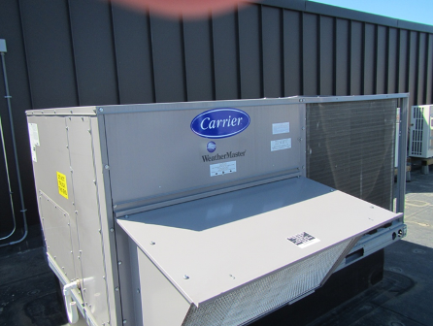
Air handling unit
Picture 2
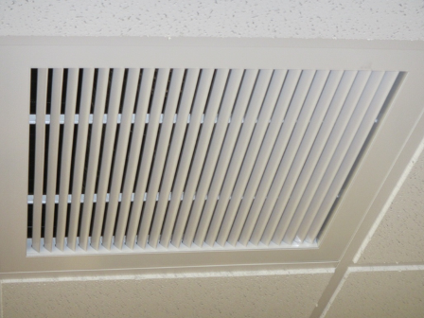
Return air grate

Picture 3
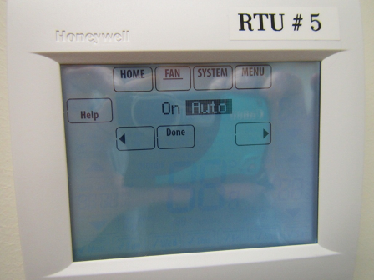
Thermostat with fan set to “auto”
Picture 4
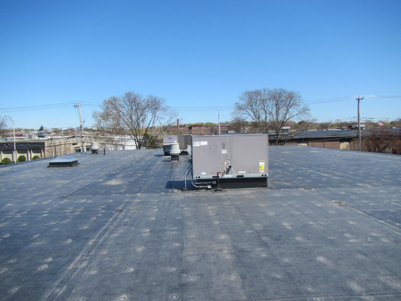
New rubber membrane roof

Picture 5
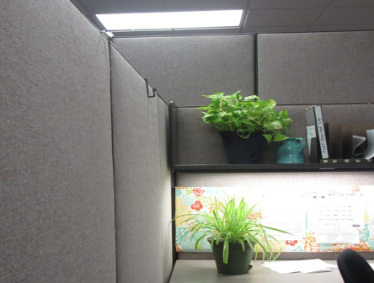
Plants on or near porous surfaces
Picture 6
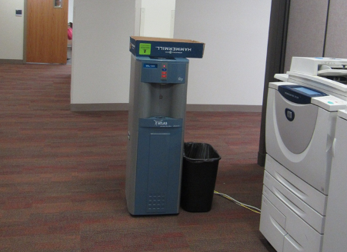
Water cooler on carpet

Picture 7
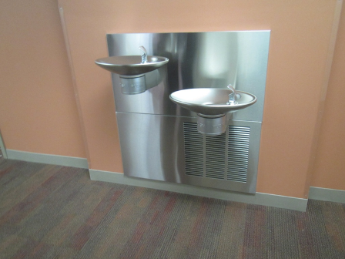
Water fountain over carpet
Picture 8
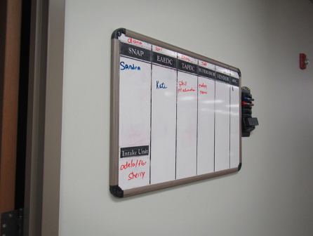
Dry erase board
Location | Carbon  Dioxide  (ppm) | Carbon Monoxide  (ppm) | Temp  (°F) | Relative  Humidity  (%) | TVOCs  (ppm) | PM2.5  (µg/m³) | Occupants  in Room | Windows  Openable | Ventilation |  |  | Remarks
 |  |  |  |  |  |  |  |  | Intake | Exhaust |  | Remarks
Background | 385 | ND | 58 | 20 | ND | 2 |  |  |  |  |  | Very windy
#102 | 993 | ND | 73 | 31 | ND | 1 | 0 | N | Y |  | Y | Carpet odor
#104 (hearing room) | 966 | ND | 74 | 30 | ND | 2 | 0 | N | Y |  | N
#175 (half wall) | 939 | ND | 74 | 23 | ND | 1 | 0 | N | N |  | Y | PF
1st floor files | 764 | ND | 75 | 23 | ND | 1 | 1 | N | Y |  | Y | NC
Alfoni-Homebase | 884 | ND | 75 | 22 | ND | 1 | 0 | N | Y |  | Y
Auterio | 826 | ND | 71 | 25 | ND | 2 | 3 | N | Y |  | Y
Bazidane | 875 | ND | 75 | 22 | ND | 1 | 1 | N | Y |  | Y | PF, HS
Bourgeois | 980 | ND | 76 | 24 | ND | 2 | 0 | N | Y |  | Y | Cut flowers, boxes
Cavanaugh |  |  |  |  |  |  |  |  |  |  |  | PF, dusty
Clark | 972 | ND | 76 | 24 | ND | 2 | 0 | N | Y |  | N | Feather duster
Conners (half wall office) | 884 | ND | 72 | 25 | ND | 3 | 1 | N | Y |  | Y
Fiander | 983 | ND | 76 | 23 | ND | 1 | 1 | N | Y |  | Y | PF
French (half wall) | 1122 | ND | 75 | 24 | ND | 4 | 0 | N | Y |  | Y | Plants
Guenard | 905 | ND | 75 | 23 | ND | 2 | 1 | N | Y |  | N
Harris (half wall) | 918 | ND | 75 | 23 | ND | 3 | 1 | N | Y |  | N
Hayward | 924 | ND | 75 | 23 | ND | 1 | 1 | N | Y |  | Y | HS
Hong | 806 | ND | 71 | 25 | ND | 3 | 1 | N | Y |  | Y
Horton | 1069 | ND | 75 | 24 | ND | 1 | 0 | N | Y |  | Y | Plants, food
Hosman | 952 | ND | 73 | 30 | ND | 3 | 3 | N | Y |  | N | DO, HS, AD, plants
ID office | 1100 | ND | 76 | 25 | ND | 2 | 0 | N | Y |  | N
Irvine (half wall) | 1130 | ND | 76 | 24 | ND | 1 | 1 | N | N |  | N | DO, items hanging from CT
Kitchen | 1206 | ND |  |  | ND | 3 | 8 | N | Y |  |  | NC, microwave, sink, toaster, fridge,, DO
Kotherithara | 936 | ND | 75 | 23 | ND | 1 | 1 | N | N |  | N | Artificial flowers
Lehane | 981 | ND | 76 | 25 | ND | 2 | 1 | N | Y |  | N
Mail-Reception | 996 | ND | 75 | 24 | ND | 1 | 1 | N | N |  | N | DEM
Martell | 916 | ND | 75 | 23 | ND | 2 | 1 | N | Y |  | N | Plants, HS
Montalvo (half wall) | 858 | ND | 74 | 23 | ND | 1 | 0 | N | Y |  | N
Negranti | 829 | ND | 71 | 25 | ND | 3 | 1 | N | Y |  | Y | Heater (on)
O’Brien | 815 | ND | 70 | 25 | ND | 3 | 1 | N | Y |  | Y | PF, stack of recycling (cans/bottles)
Office next to Martell (half wall) | 903 | ND | 75 | 22 | ND | 1 | 0 | N | N |  | Y
Outside conference room | 763 | ND | 73 | 24 | ND | 2 | 0 | N | Y |  | Y | Carpet, new chairs, bike
Perea | 1149 | ND | 75 | 23 | ND | 1 | 0 | N | Y |  | Y | Accumulated items on surfaces, plush dolls
Ray | 865 | ND | 74 | 22 | ND | 2 | 0 | N | Y |  | N | AD
Scotti | 979 | ND | 76 | 23 | ND | 1 | 0 | N | Y |  | Y
Valentin (half wall) | 928 | ND | 76 | 22 | ND | 2 | 0 | N | N |  | N | DO
Wachsler | 933 | ND | 76 | 22 | ND | 1 | 1 | N | Y |  | Y | Accumulated items on surfaces
Waiting area | 1064 | ND | 74 | 27 | ND | 3 | 15 | N | Y |  | Y
White | 860 | ND | 71 | 28 | ND | 3 | 1 | N | Y |  | Y | Cleaning products/Lysol
Women’s restroom |  |  |  |  |  |  |  | N | N |  | Y | Pop-up AD
Upstairs conf. room | 635 | ND | 72 | 22 | ND | ND | 0 | N | Y |  | Y | New furniture smell, carpet tile
Archives Room | 808 | ND | 69 | 25 | ND | ND | 0 | N | Y |  | Y | NC

