WATER DAMAGE/MOLD INVESTIGATION

Department of Transitional Assistance
1567 North Main Street
Fall River, Massachusetts

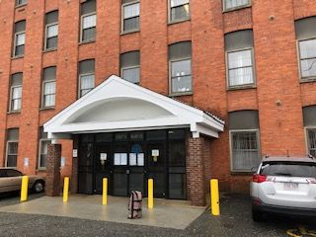

Prepared by:
Massachusetts Department of Public Health
Bureau of Environmental Health
Indoor Air Quality Program
February 2019

BACKGROUND
Building: | Department of Transitional Assistance (DTA)
Address: | 1567 North Main Street, Fall River, MA
Assessment Requested by: | Erin McCabe, EHS Facilities Deputy Director for Finance and Operations, EOHHS
Reason for Request: | Mold/water damage concerns
Date of Assessment: | February 8, 2019
Massachusetts Department of Public Health/Bureau of Environmental Health (MDPH/BEH) Staff Conducting Assessment: | Cory Holmes, Environmental Analyst/Inspector, Indoor Air Quality (IAQ) Program
Building Description: | The DTA office is on located on the first floor of a mixed use building near downtown Fall River. The office contains a mix of tile floor and carpet squares, gypsum wallboard (GW)/brick walls and suspended ceiling tiles.

IAQ Testing Results
Please refer to the IAQ Manual for methods, sampling procedures, and interpretation of results (MDPH, 2015). The following is a summary of testing results.
- Moisture Measurements were all dry (i.e., within normal parameters) at the time of assessment.

Background and Discussion
The BEH/IAQ Program was asked to examine the DTA office for the presence of water damage/mold growth, with a focus on areas that were damaged by a sprinkler head leak that reportedly occurred on Tuesday January 22, 2018 due to freezing temperatures. The leak reportedly wet carpeting in an office near the main entrance, as well as ceiling tiles and gypsum wallboard in both the main entrance and adjacent office. A flooding restoration/carpet cleaning firm (ServPro) had been contacted to perform remediation activities (i.e., drying of building materials) several hours after discovery. At the time of assessment, all porous materials tested (i.e., carpet, ceiling tiles and GW) were dry and no visible mold/associated odor was observed. Water-damaged ceiling materials were observed in the main entrance/foyer (Picture 1); however this was slated to be repaired/replaced.
In general, the US Environmental Protection Agency (US EPA) and the American Conference of Governmental Industrial Hygienists (ACGIH) recommends that porous materials (e.g., wallboard, carpeting) be dried with fans and heating within 24 to 48 hours of becoming wet (US EPA, 2008; ACGIH, 1989). If porous materials are not dried within this time frame, mold growth may occur.

Water Damage/Moisture Issues in Other Areas
BEH/IAQ Program staff were asked to examine several other areas of the building that had leaks/water damage issues, which included the following:
- Supply room: water staining on the ceiling/beams were noted where leaks are occasionally reported (Picture 2). Occupants believed that the water infiltration is related to certain wind/weather patterns, and are not plumbing related. Water staining was also noted on the brick wall (Picture 3); however this appeared to be historic damage with no reported water entry. Boxes were stored directly on the floor (Picture 4), which is not recommended due to the potential for condensation on the cool surface of the floor that can moisten cardboard and result in mold growth.
- Ladies Restroom: leaks are reported periodically over the sink and the tile there was water-damaged (Picture 5). Directly above this ceiling tile was a hole in the concrete ceiling as well as an uninsulated copper pipe (Picture 6). It is possible that any overflow from the sink directly above may leak through the hole. It is also possible that condensation may form on the uninsulated copper pipe to wet and stain the tile.
- Admin Office 165: water-damaged ceiling tiles were noted beneath ductwork, likely caused by water from the exterior leaking in (Pictures 7 and 8). This appears to be a chronic issue as shown by the holes in the GW ceiling to drain water (Picture 9).

Conclusions/Recommendations
Based on the observations made during the visit, the following recommendations are made:
- Continue with plans to replace water-damaged ceiling tiles and GW in affected areas.
- Make repairs/seal around ductwork in Admin Office 165. Remove water-damaged GW beneath duct.
- Investigate leaks in Supply Room and make repairs as needed.
- Refrain from storing porous materials (i.e., cardboard and paper) directly on floors to prevent water damage/mold growth from condensation.
- Seal hole in concrete ceiling in Ladies Room above water-damaged tile. Consider insulating pipe if condensation is a chronic issue.
- For more information on mold refer to the US EPA’s “Mold Remediation in Schools and Commercial Buildings”. Available at: http://www.epa.gov/mold/mold-remediation-schools-and-commercial-buildings-guide.
- Refer to resource manuals and other related IAQ documents for further building-wide evaluations and advice on maintaining public buildings. Copies of these materials are located on the MDPH’s website: http://mass.gov/dph/iaq.

REFERENCES
ACGIH. 1989. Guidelines for the Assessment of Bioaerosols in the Indoor Environment. American Conference of Governmental Industrial Hygienists, Cincinnati, OH.
MDPH. 2015. Massachusetts Department of Public Health. “Indoor Air Quality Manual: Chapters I-III”. Available at: http://www.mass.gov/eohhs/gov/departments/dph/programs/environmental-health/exposure-topics/iaq/iaq-manual/.
US EPA. 2008. Mold Remediation in Schools and Commercial Buildings. US Environmental Protection Agency, Office of Air and Radiation, Indoor Environments Division, Washington, D.C. EPA 402-K-01-001. http://www.epa.gov/mold/mold-remediation-schools-and-commercial-buildings-guide.
Picture 1
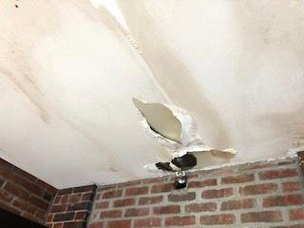
Water-damaged ceiling in main entrance/foyer
Picture 2
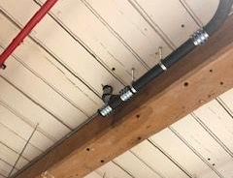
Water staining on beam (bracket) in Supply Room
Picture 3
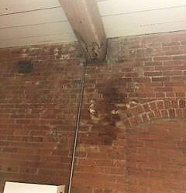
Water staining on wooden beam/brick wall in Supply Room
Picture 4
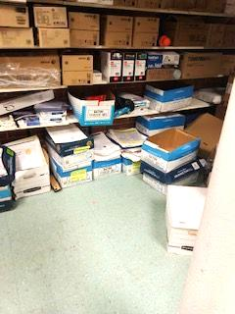
Cardboard boxes on floor of Supply Room
Picture 5
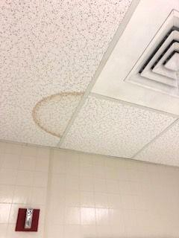
Water-damaged ceiling tile in Ladies Restroom
Picture 6
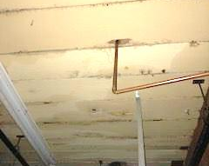
Area above water-damaged ceiling tile in Picture 5/Ladies Restroom, note hole in concrete ceiling and copper pipe
Picture 7
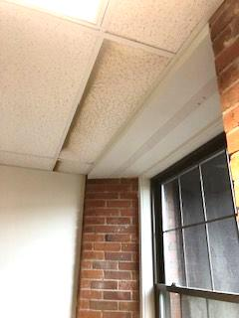
Water-damaged ceiling tiles in Admin Office 165
Picture 8
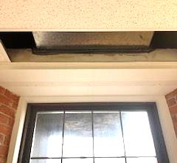
Leak around ductwork, note water-damaged GW below duct
Picture 9
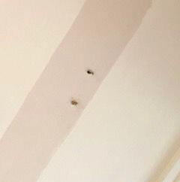
Holes in GW in Admin Office 165, presumably to drain water

