WATER DAMAGE/MOLD INVESTIGATION

Massachusetts Department of Transitional Assistance
160 W. Rodney French Blvd
New Bedford, Massachusetts

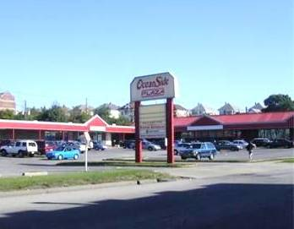

Prepared by:
Massachusetts Department of Public Health
Bureau of Environmental Health
Indoor Air Quality Program
March 2014

Background/Introduction
At the request of Mary Farrell, Property Management, Office of Leasing and State Owned Properties, Executive Office of Health and Human Services (EOHHS), a water damage/mold investigation was conducted at the Massachusetts Department of Transitional Assistance (MDTA), New Bedford Regional Office, 160 W. Rodney French Blvd., New Bedford, Massachusetts. The Massachusetts Department of Public Health (MDPH), Bureau of Environmental Health (BEH) conducted the assessment in response to concerns related to water damage and potential mold growth following several flooding incidents that have occurred within the space as well as that resulting from a former laundromat that shared a common wall with the MDTA.
On February 7, 2014, a site visit to perform an investigation was made by Cory Holmes, Environmental Analyst/Regional Inspector in BEH’s Indoor Air Quality (IAQ) Program. During the assessment, Mr. Holmes was accompanied by Ms. Erin McCabe, Field Operations Manager, EOHHS, Mr. Peter Woodford, Project Manager, Division of Capital Asset Management and Maintenance (DCAMM) and Ms. Farrell.

Methods
BEH/IAQ staff performed a visual inspection of building materials for water damage and/or microbial growth. Moisture content of porous building materials (i.e., GW and carpeting) was measured using a Delmhorst, BD-2000 Model Moisture Detector. Moisture testing results are included as Table 1.

Results and Discussion
At the time of the BEH/IAQ assessment, plans were being made to remove/replace water-damaged GW that resulted from restroom overflows that reportedly occurred in October 2013. These areas were centered around the visitors’ restrooms and adjacent office space (Pictures 1 through 4). The carpet installed in office space examined has a water/mold-resistant impermeable material on the underside. Carpeting in the adjacent Assistant Director’s office was pulled back to examine conditions beneath it; dark staining was observed that may indicate accumulated dirt/debris that may have gotten wet from moisture trapped beneath the carpet and can serve as a source of mold growth/odors (Picture 4). The area underneath this carpeting should be cleaned.
During the assessment Ms. Farrell asked BEH/IAQ staff to also examine the common wall that the MDTA shares with the space that formerly contained the laundromat (Picture 5). Although dry at the time of assessment, the vinyl base coving was failing and GW was visibly damaged beneath it (Picture 6). BEH/IAQ staff peeled back vinyl coving in regular intervals along the length of this common wall and found water damage in an approximate 10 to 15-foot section of GW and dark staining, which appeared to be visible mold growth, along the base of the wall (Pictures 7 and 8), presumably from historic water exposure from laundry equipment.
The US Environmental Protection Agency (US EPA) and the American Conference of Governmental Industrial Hygienists (ACGIH) recommends that porous materials (e.g., wallboard and carpeting) be dried with fans and heating within 24 to 48 hours of becoming wet (US EPA, 2001; ACGIH, 1989). If porous materials are not dried within this time frame, mold growth may occur.
Other water-damage issues were noted by BEH/IAQ staff. Open seams between the sink countertop and backsplash were observed in employee restrooms (Picture 9). If seams are not watertight, water can penetrate the seam, causing water damage. Water penetration and chronic exposure of porous and wood-based materials can cause these materials to swell and show other signs of water damage, and can lead to potential mold growth.
Several areas throughout the space had water-damaged ceiling tiles. Water-damaged ceiling tiles indicate leaks from either the roof or plumbing system and can provide a source for mold growth. Water-damaged ceiling tiles should be replaced after a water leak is discovered and repaired.

Other Conditions
Other conditions that can affect indoor air quality were observed during the assessment. A number of supply and exhaust/return vents had accumulated dust/debris accumulation, particularly vents in restrooms (Picture 10). Supply and exhaust vents should be cleaned periodically in order to prevent them from serving as a source of aerosolized particulates.

Conclusions/Recommendations
In view of the findings at the time of the visit, the following recommendations are made:
- Continue with plans to remove water-damaged/mold-colonized GW in visitors’ restrooms and adjacent areas in a manner consistent with recommendations found in “Mold Remediation in Schools and Commercial Buildings” published by the US Environmental Protection Agency (US EPA, 2001).
- Additional water-damaged/mold-colonized GW (~10-15 feet) outside of work spaces 105-112 along the common wall should also be removed/replaced. If further water-damaged materials are found during remediation (e.g., GW, fiberglass insulation) those materials should be removed as well.
- Due to the close proximity of areas needing remediation to public waiting areas, if it is not feasible to properly contain/isolate these areas, the work should be conducted during non-business hours.
- Remove furniture and personal items or cover employee workstations in areas of remediation to protect items and facilitate cleanup.
- Place water-damaged/mold-colonized materials in plastic bags for transport.
- Consider using a water/mold-resistant material such as cement board instead of GW in areas of chronic water leaks (e.g., restrooms, adjacent office space).
- Ensure air handling units are deactivated and seal vents temporarily in remediation areas during removal/remediation of GW.
- Ensure areas are thoroughly cleaned and vacuumed using a high efficiency particulate arrestance (HEPA) filter equipped vacuum cleaner after remediation is complete.
- Clean beneath carpeting in corner of Assistant Director’s office (Picture 4) with an antimicrobial agent.
- Clean fresh air diffusers, exhaust and return vents on a regular basis; if surrounding ceilings/tiles cannot be cleaned make repairs/replace tiles.
- Ensure roof/plumbing leaks are repaired and replace water-damaged ceiling tiles. Examine the area above and around these areas for mold growth. Disinfect areas of water leaks with an appropriate antimicrobial as needed.
- Seal breaches, seams, and spaces between sink countertops and backsplashes in restrooms to prevent water damage. Consider replacing with a one-piece molded countertop.

References
ACGIH. 1989. Guidelines for the Assessment of Bioaerosols in the Indoor Environment. American Conference of Governmental Industrial Hygienists, Cincinnati, OH.
US EPA. 2001. Mold Remediation in Schools and Commercial Buildings. US Environmental Protection Agency, Office of Air and Radiation, Indoor Environments Division, Washington, D.C. EPA 402-K-01-00. http://www.epa.gov/mold/mold_remediation.html.
Picture 1
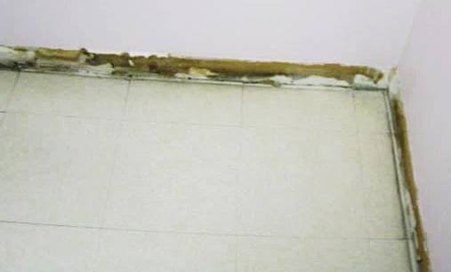
Water-damaged gypsum wallboard in visitors’ restroom, dark staining indicates likely mold growth
Picture 2
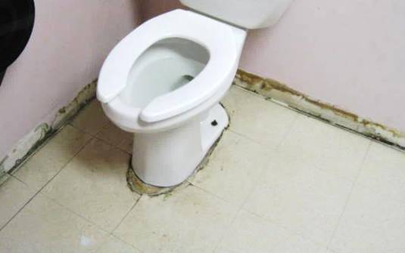
Water-damaged gypsum wallboard in visitors’ restroom, dark staining indicates likely mold growth
Picture 3
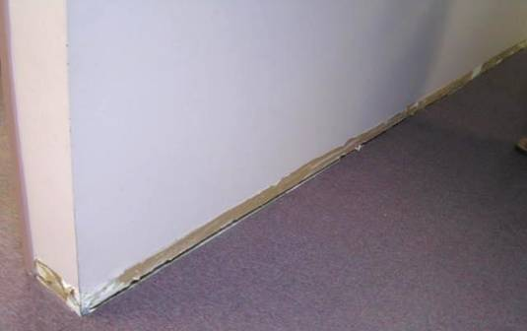
Water-damaged gypsum wallboard in office area adjacent to visitor’s restrooms
Picture 4
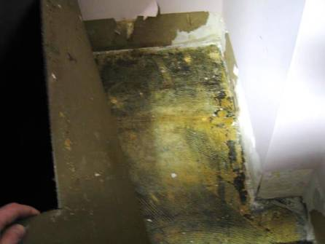
Water-damaged gypsum wallboard in Assistant Director’s office adjacent to visitors’ restrooms, note dark staining on floor and impermeable barrier on bottom of carpet
Picture 5
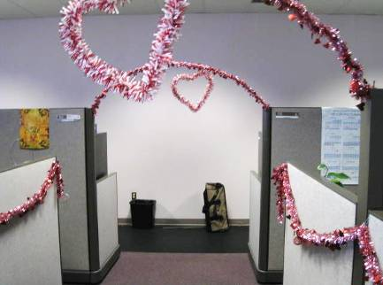
Long-view of common wall/former laundromat outside work stations 105-112 where water-damaged/mold-colonized gypsum wallboard was found
Picture 6
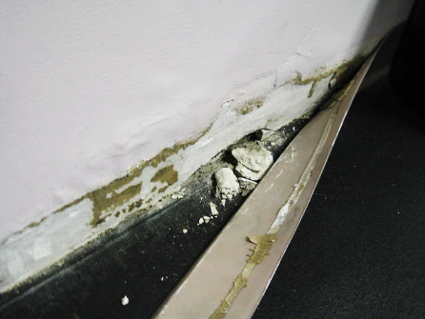
Water-damaged gypsum wallboard along common wall/former laundromat outside work stations 105-112
Picture 7
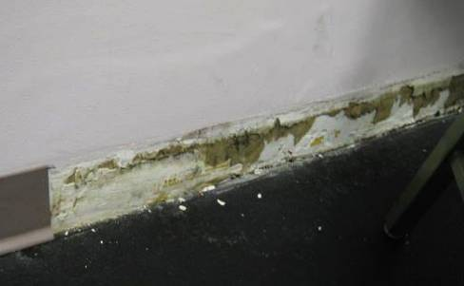
Water-damaged gypsum wallboard along common wall/former laundromat outside work stations 105-112, dark staining indicates likely mold growth
Picture 8
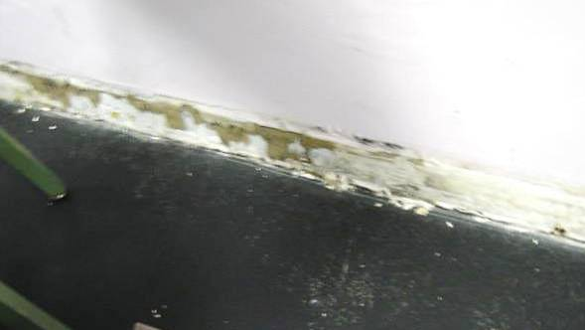
Water-damaged gypsum wallboard along common wall/former laundromat outside work stations 105-112, dark staining indicates likely mold growth
Picture 9
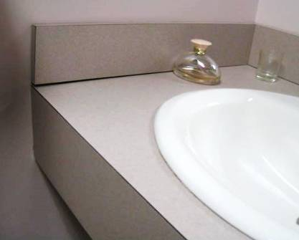
Spaces between sink countertop and backsplash in employee restroom

Picture 10
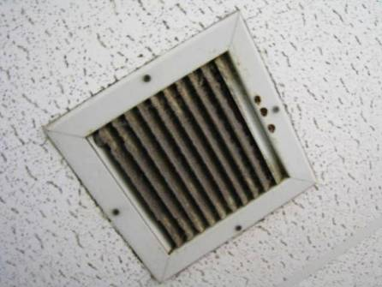
Dust/debris accumulation on employee restroom exhaust vent
Location | Moisture Testing | Comments
Men’s Visitor Restroom | GW-dry | Vinyl coving removed, WD GW, dark staining-likely mold growth, WD CT
Women’s Visitor Restroom | GW-dry | Vinyl coving removed, WD GW, dark staining-likely mold growth
Assistant Director’s Office | GW-dry, carpet-dry | Vinyl coving removed, WD, dark staining under carpet edges near corner-dirt/possible mold
Copy area | GW-dry | Vinyl coving removed
Men’s Employee Restroom | GW-dry | No visible WD GW
Women’s Employee Restroom | GW-dry | No visible WD GW, leaking sink, space between sink countertop and backsplash
Common wall (outside work area 105-112) | GW-dry | Vinyl coving failing, WD GW~10-15′, dark staining-likely mold growth, shared wall with former laundry mat

GW = gypsum wallboard WD = water-damaged CT = ceiling tiles

