INDOOR AIR QUALITY ASSESSMENT

Department of Transitional Assistance
1010 Massachusetts Avenue
Boston, MA 02118

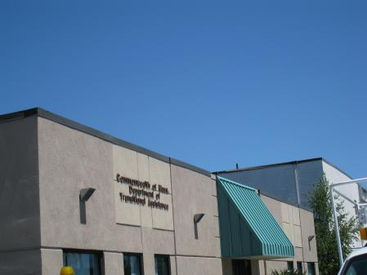

Prepared by:
Massachusetts Department of Public Health
Bureau of Environmental Health
Indoor Air Quality Program
February 2016

EXECUTIVE SUMMARY
This site visit found elevated carbon dioxide levels as a result of thermostat settings. Indoor temperatures were also outside of the comfort range due impart to air filtering into the building through leaky windows. Measures should be taken to ensure thermostats are set properly, with temperature adjustments within the recommended comfort range. A number of water damage related concerned were also identified, including plumbing related leaks and water penetration from the exterior. Measures should be taken to seal water penetration pathways and repair window gaskets.

BACKGROUND
Building: | Department of Transitional Assistance (DTA)
Address: | 1010 Massachusetts Avenue, Boston, MA
Assessment Requested by: | Christopher Silva, Director of Administrative Operations, DTA
Reason for Request: | Concerns related to general air quality and water damage
Date of Assessment: | January 4, 2016  The building was previously visited by MDPH/BEH staff in 2012.
Massachusetts Department of Public Health/Bureau of Environmental Health (MDPH/BEH) Staff Conducting Assessment: | Sharon Lee, Environmental Analyst, Indoor Air Quality (IAQ) Program
Date Building Constructed: | Original building: 1901  Addition occupied by DTA: 1940s
Building Description: | The building is a multi-level complex. The DTA occupies a single-story addition to the building.
Building Population: | The space occupied by approximately 100 employees. Members of the public visit daily.
Windows: | Not openable

METHODS
Please refer to the IAQ Manual for methods, sampling procedures, and interpretation of results (MDPH, 2015).

RESULTS and DISCUSSION
The following is a summary of indoor air testing result (Table 1).
- Carbon dioxide levels were above the MDPH recommended level of 800 parts per million (ppm) in more than half the areas surveyed, indicating inadequate air exchange.
- Temperature was within the MDPH recommended range of 70°F to 78°F in the majority of areas surveyed. In some areas, particularly cubicles along the north window, temperatures were measured at 69°F, below the comfort range. The IT/server room temperature was 81°F, which also was above the MDPH recommended comfort range.
- Relative humidity was below the MDPH recommended range of 40 to 60% in all areas tested.
- Carbon monoxide levels were non-detectable in all areas tested.
- Particulate matter (PM2.5) concentrations measured were below the National Ambient Air Quality (NAAQS) limit of 35 μg/m³ in all areas tested.

Ventilation
Fresh air is provided by rooftop air-handling units (AHUs) and ducted to air diffusers in DTA cubicle areas and offices (Picture 1). Air is returned to the AHUs via vents into the ceiling plenum (Picture 2). DTA staff reported thermal comfort concerns, particularly in areas adjacent to windows. AHUs are regulated by thermostats, which staff reportedly adjust to improve comfort. At the time of assessment, the temperature settings for some thermostats were beyond the MDPH recommended comfort range. Additionally, some thermostats were not set to the correct time, day, occupant, or recommended fan settings. The BEH/IAQ program recommends that thermostats be set to the fan “on” setting rather than “automatic” setting during occupied periods to provide continual air circulation.

Microbial/Moisture Concerns
A previous assessment was conducted by BEH/IAQ staff in 2012. At that time, staff observed water-damaged materials (e.g. wallboard and carpeting) resulting from water penetrating the building through the breaches/damage to the exterior insulation and finishing system (EIFS) wall system. During this most recent visit, BEH/IAQ staff observed flashing installed along the base of the northeast exterior wall to prevent water from entering the building. Flashing in some areas was damaged or no longer adhered to exterior wall (Pictures 3 and 4). It should be also noted that damaged EIFS was observed on exterior walls lacking flashing (Picture 5); damage to exterior walls create opportunities for pests and water to enter the building.
Wallboard and carpeting that were damaged at the time of the previous assessment had been replaced in some office areas; however, vinyl coving typically located at the base of wallboards was missing (Picture 6). Base coving creates a finishing that protects walls and reduces pathways for rodents and pests.
While water-damaged materials in some areas were replaced, evidence of historic damage was observed in other areas. For example, water-damaged wallboard and carpeting was observed in the SNAP reception office. Wall coving was observed peeling away from the wallboard due to repeated water damage, and potential mold growth was also observed (Pictures 7 and 8). Carpet tiles in this area appear to be installed on top of previously existing carpet, which had signs of water damage.
Additional conditions relating to water damage observed at the DTA include:
- Water-damaged ceiling tiles in a number of areas (Picture 9), reportedly damaged by a rainstorm that occurred the week prior to the BEH/IAQ site visit. The source of water was reportedly blockage to a downspout, resulting in a roof leak. In observing the conditions of the roof, it appears that the roof is not continuously flat (Picture 10). As a result, a portion of the roof serves as a basin allowing water and debris to accumulate. Additionally, a seam where two rubber membranes overlap runs along this area; this seam can allow water to enter the building.
- Water damage in the kitchen area and surrounding hallways, reportedly from a clog in the kitchen drain pipe trap. No visible damage was observed in sink cabinets; however, carpeting and wallboard in the hallway behind the kitchen appeared stained (Picture 11). Staff should refrain from emptying food materials and coffee grinds directly into the sink.
- Black staining indicating mold growth on tape residue on a metal panel within an office (Table 1; Picture 12). It appears that tape was used to seal the access panel door. Rusting was observed on the metal panel indicating repeated water exposure. Dust and other materials trapped in the tape for the door were likely exposed to moisture, resulting in the mold growth and staining observed.
- Water dispensers on carpeting, which can be leak/spill and cause water damage.
- Pealing/chipping paint in some window bays, likely due to water infiltration or condensation (Picture 13).
- Failing gaskets, observed in windows throughout the building (Picture 14), which can contribute to water infiltration and drafts.
- Breach/gap between the backsplash and the sink countertop (Picture 15).
- Staining below the air-conditioning unit in the conference room, reportedly from condensation (Picture 16).
- Plants in some areas (Table 1).
- A humidifier in one office.
- Damaged floor tiles in kitchen (Picture 17). These tiles should be replaced to prevent tripping hazards and to ensure a flat, cleanable surface is maintained.
The US Environmental Protection Agency (US EPA) and the American Conference of Governmental Industrial Hygienists (ACGIH) recommends that porous materials be dried with fans and heating within 24 to 48 hours of becoming wet (US EPA, 2001; ACGIH, 1989). If porous materials are not dried within this time frame, mold growth may occur. Cleaning cannot adequately remove mold growth from water-damaged porous materials. The application of a mildewcide to mold contaminated, porous materials is not recommended.

Other IAQ Evaluations
Cleaning products, air freshening sprays, and scented products were also observed in a number of areas. Deodorizing agents do not remove materials causing odors, but rather mask odors that may be present in the area. Cleaners and scented products contain chemicals that can be irritating to the eyes, nose, and throat of sensitive individuals. Additionally, many air fresheners contain 1,4-dichlorobenzene, a VOC which may cause reductions in lung function (NIH, 2006).
Photocopiers at the DTA were not located in proximity to return vents or dedicated exhausts. Instead, it was located below a supply vent (Picture 18); air from the vent can circulate VOCs and ozone produced by the photocopier. VOCs and ozone are respiratory irritants. Without appropriate removal, heat, chemicals, and odors produced by photocopiers can persist in the indoor environment.
Many areas of the DTA office are carpeted, some of which is stained, worn, and frayed due to use and age (Picture 19). The Institute of Inspection, Cleaning, and Restoration Certification (IICRC) recommends that carpeting be cleaned annually (or semi-annually in soiled high traffic areas) (IICRC, 2012).
Items were observed hanging from ceiling tile system. Ajar ceiling tiles were also observed in some areas (Table 1). The ceiling tile system should remain flush (e.g. ceiling tiles intact, hanging items removed) to ensure the integrity of the ceiling plenum system and to prevent dust and debris that may accumulate from on ceiling tiles from settling on flat surfaces in occupant areas.
A supply vent in an assistant director’s office was not secured to the ceiling (Table 1; Picture 20). Measures should be taken to secure the vent to prevent injury and allow for proper air flow.

CONCLUSIONS/RECOMMENDATIONS
Based on conditions observed at the time of assessment, the following short-term and long-term recommendations are provided.

Short-term Recommendations
- Adjust thermostats to the correct time, day, and occupant setting. Limit temperature adjustments so that temperatures remain within the MDPH recommended temperature range of 70°F to 78°F.
- Operate thermostats in the fan ‘on’ setting during occupied periods to improve air movement.
- Assess flashing installed into the building’s EIFS wall system. Repair/replace damaged flashing to prevent water infiltration.
- Cove base should be installed to seal breaches between the floor and wallboard as shown in Picture 6, which can serve as pathways for rodents and other pests.
- Repair/replace water-damaged carpet and wallboard in the SNAP reception office.
- Replace ceiling tiles after a water leak is discovered and repaired.
- Install a fine mesh strainer in the kitchen sink to prevent debris from washing into drains.
- Consider using a video camera line inspection to examine the interior of the kitchen sink pipe and determine whether other causes may be contributing to repeated drain line backups, slow drains, or clogs.
- Repair the sink backsplash to prevent water penetration.
- Remove tape residue and clean area around metal panel shown in Picture 12. Monitor office for future leaks.
- Place tray below water dispensers to collect water from spills/leaks.
- Vacuum paint chips from damaged windows.
- Reinstall/repair rubber gaskets in windows. Periodically examine windows to ensure gaskets are in place.
- Consider sealing windows with silicon caulking to reduce draft/heat loss and maintain indoor temperatures within the comfort range throughout the building.
- Monitor downspouts to ensure proper drainage, which would prevent water build-up on the roof.
- Periodically examine seams to the rubber roof membrane to ensure integrity of the system.
- Contact a heating, ventilation, and air-conditioning technician to service the air-conditioning unit in the conference room and determine whether the unit is appropriate for size of room. Ensure that the condensate lines are clean and removing condensation to the outdoors.
- Maintain plants and drip pans. Plants should be located away from ventilation sources to prevent aerosolization of dirt, pollen, or mold.
- Place humidifier at breathing level and away from walls and other porous materials. Maintain the unit per manufacturer’s instructions to prevent microbial growth in the water vessel.
- Repair floor tiles in kitchen.
- Reframe from using air deodorizers, which contain eye and respiratory irritants.
- Label and store cleaning products in an appropriate area. Ensure Material Safety Data Sheets (MSDSs) are available at a central location for each product in the event of an emergency.
- Relocate photocopiers near exhaust vents or openable windows to allow removal or dilution of VOCs and ozone generated by the equipment.
- Vacuum carpets with a high efficiency particulate air (HEPA) filtered vacuum and conduct an annual cleaning to reduce accumulation and potential aerosolization of materials from carpeting.
- Remove items hanging from the ceiling tile system to prevent movement of dust and debris from above ceiling tiles into occupant space.
- Secure the supply vent in the Assistant Director’s Office.

Long-term Recommendations
- Replace carpeting with carpet tiles throughout the building to prevent aerosolization of carpet fibers, which occurs when there is high traffic on aged carpet. Fraying or damaged carpet can be an irritant source.
- Consider installing flashing in EIFS wall exteriors where it is not currently present.

REFERENCES
IICRC. 2012. Carpet Cleaning FAQ 4 Institute of Inspection, Cleaning and Restoration Certification. Institute of Inspection Cleaning and Restoration, Vancouver, WA.
Massachusetts Department of Public Health. (MDPH). 2015. “Indoor Air Quality Manual: Chapters I-III”. Available from http://www.mass.gov/eohhs/gov/departments/dph/programs/environmental-health/exposure-topics/iaq/iaq-manual/
NIH. 2006. Chemical in Many Air Fresheners May Reduce Lung Function. NIH News. National Institute of Health. July 27, 2006. http://www.nih.gov/news/pr/jul2006/niehs-27.htm
Picture

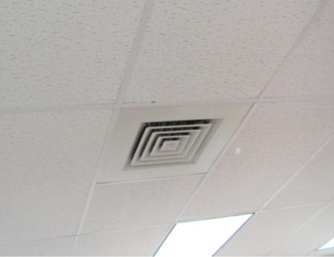

Ceiling-mounted supply vent

Picture

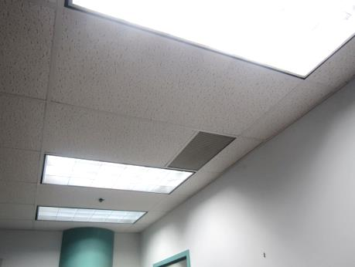

Ceiling-mounted return vent

Picture
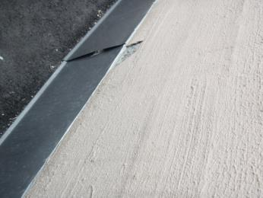

Damage to EIFS wall and flashing installed around building exterior

Picture
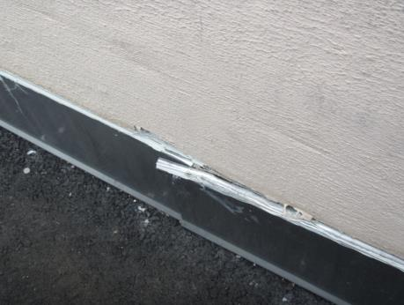

Damage to flashing installed into EIFS building exterior

Picture

\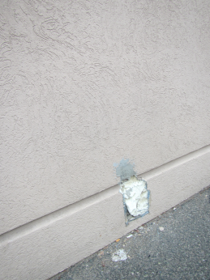

Damaged EIFS exterior surface

Picture

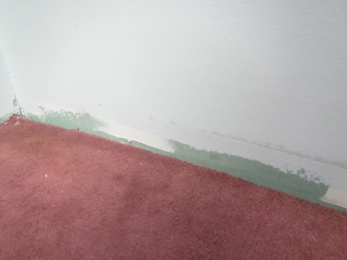

Wall with missing base coving
Picture

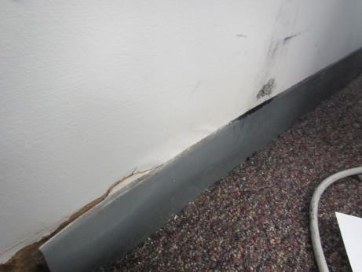

Peeling/damaged coving indicative of water damage

Picture

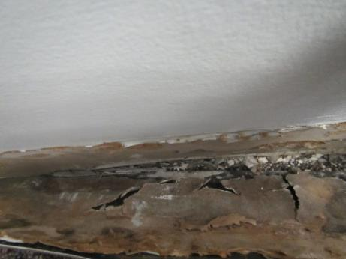

Black staining from mold growth
Picture

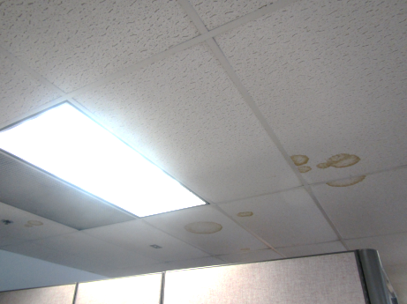

Water-damaged ceiling tiles

Picture

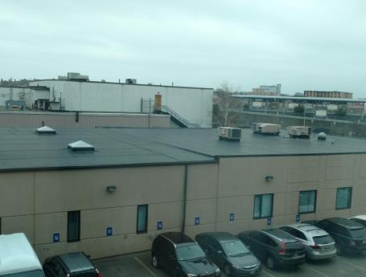

Discontinuous roof which creates a water catchment area
Picture

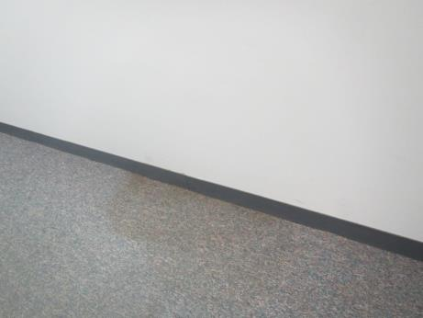

Stained carpeting in hallway behind kitchen sink

Picture

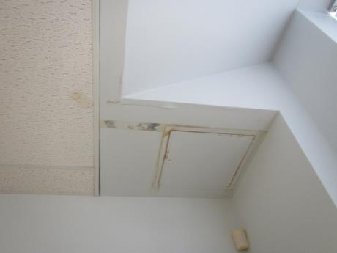

Rusting and staining from historic water leak
Picture

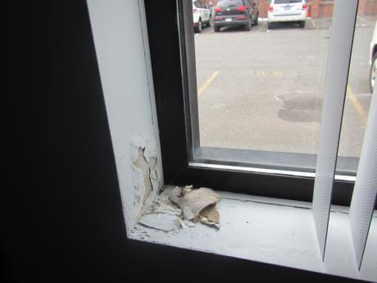

Peeling, chipping, and bubbled paint from water infiltration

Picture

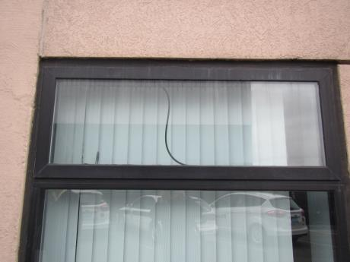

Failing window gasket
Picture

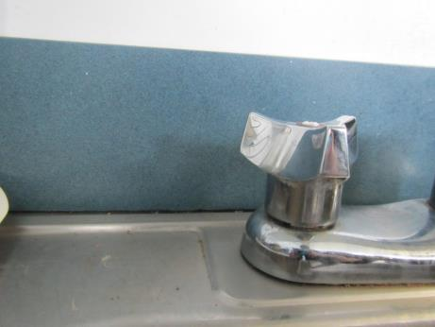

Breach between sink countertop and backsplash

Picture

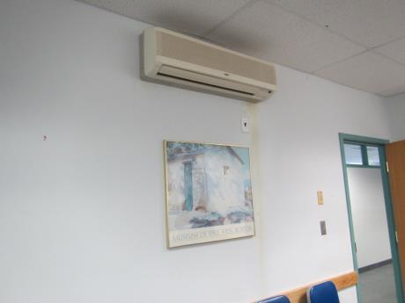

Staining below air conditioner in conference room
Picture

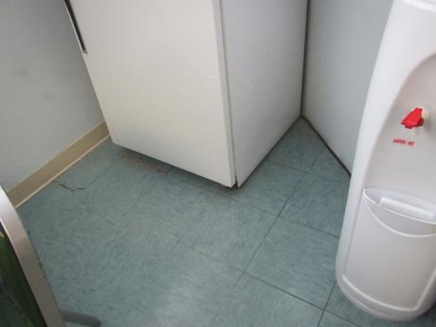

Kitchen floor tiles no longer adhered to floor

Picture

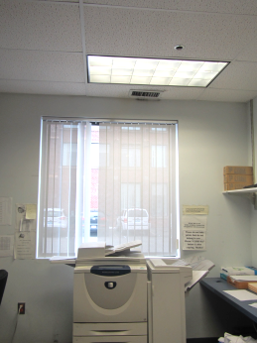

Photocopier located directly below supply vent
Picture

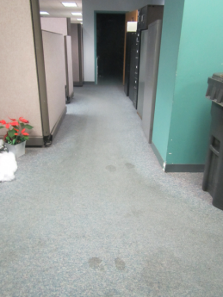

Worn and stained carpeting

Picture

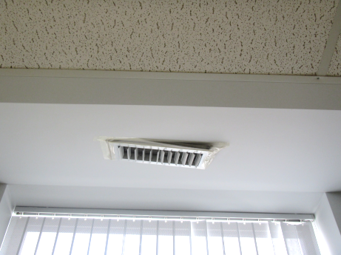

Unsecured supply vent in an assistant director’s office
Location | Carbon  Dioxide  (ppm) | Carbon Monoxide  (ppm) | Temp  (°F) | Relative  Humidity  (%) | PM2.5  (µg/m³) | Occupants  in Room | Windows  Openable | Ventilation |  | Remarks
 |  |  |  |  |  |  |  | Supply | Exhaust
Background | 385 | 1 | 26 | 59 | 19 |  |  |  |  | Slightly overcast
Kitchen | 685 | ND | 70 | 17 | 4 | 3 | N | Y | N | DO, historic WD-floor tiles, breach-sink backsplash, reported leakage from pipe back up, refrigerator
Conference room | 669 | ND | 71 | 15 | 4 | 0 | N | Y | Y | DEM, wall-mounted AC: evidence of leak, DO
Asst. Director, Sheils | 766 | ND | 71 | 15 | 5 | 1 | N | Y | n | DO, damaged window gasket
Asst. Director, Czolpinski | 688 | ND | 71 | 15 | 5 | 1 | N | Y | Y | DO, WD-CT
Mail area | 744 | ND | 72 | 17 | 5 | 0 | N | Y | N | ND, WD-CTs hallway area
Director’s office | 729 | ND | 72 | 15 | 5 | 1 | N | Y | N | Wall-mounted AC, DO
146/Kim | 770 | ND | 72 | 16 | 5 | 1 | N | Y | Y | WD-CTs
Server room/IT | 940 | ND | 81 | 16 | 5 | 0 | N | Y | N | DO
Badrikian/Miranda/134 | 813 | ND | 74 | 16 | 5 | 3 | N | Y | Y | WD-CTs, plants, food items
Office (near Badrikian/Miranda) | 791 | ND | 74 | 15 | 7 | 1 | N | Y | N | DO
120/Ignokwe/ Massicot | 780 | ND | 73 | 14 | 5 | 2 | N | Y | Y
Fernandez | 797 | ND | 73 | 15 | 5 | 0 | N | Y | Y
Andrade/Bondreau | 780 | ND | 74 | 15 | 8 | 2 | N | Y | Y | WD-CTs
Hodges/Davis | 806 | ND | 75 | 15 | 5 | 4 | N | Y | Y | WD-CTs
Alley | 810 | ND | 74 | 15 | 5 | 2 | N | Y | Y | Items hanging from CT
Hanna/Sanchez | 825 | ND | 73 | 16 | 8 | 5 | N | Y | Y
Grace | 861 | ND | 74 | 15 | 8 | 4 | N | Y | Y
deAndrade | 851 | ND | 72 | 15 | 8 | 4 | N | Y | Y | Plants, fragrances
207/208 | 900 | ND | 70 | 19 | 8 | 0 | N | Y | Y | WD-CTs historic WD windows
Asst Director, Campos | 820 | ND | 70 | 17 | 8 | 1 | N | Y ajar | N | Plants, DO
Barthelemy office | 758 | ND | 69 | 16 | 6 | 0 | N | Y | N | WD near drop trap, humidifier
Vending area |  |  |  |  |  |  |  |  |  | AT, WD-CTs, water bubbler tray – standing water
158 | 713 | ND | 72 | 15 | 8 | 1 | N | Y | Y | Carpet condition
Cash reception | 777 | ND | 72 | 15 | 8 | 1 | N | Y | Y
Office within cash reception | 781 | ND | 73 | 15 | 8 | 1 | N | Y | N
Copy office | 817 | ND | 73 | 15 | 8 | 1 | N | Y | N | Copier – no exhaust, DEM
File room | 811 | ND | 75 | 13 | 8 | 0 | N | Y | Y | DO, accessibility issues
161 | 891 | ND | 74 | 15 | 8 | 4 | N | Y | Y | WD-CTs, plants
Office next to SNAP reception | 887 | ND | 75 | 15 | 10 | 0 | N | Y | N | WD windowsills, space heater
SNAP reception | 966 | ND | 76 | 15 | 13 | 3 | N | Y Dusty | Y | DO, copier – located below supply vent, cleaners, WD carpet
Interview room 8 | 904 | ND | 75 | 13 | 8 | 0 | N | Y | N | DO
Interview room 3 | 831 | ND | 73 | 13 | 10 | 0 | N | Y | N | DO
Waiting room overflow | 849 | ND | 73 | 17 | 20 | 10 | N | Y | N

